Barcelona Pavilion
Name: Sara Izzidien (2403678)
Word count: 1,050
(excluding long citations and reference list)

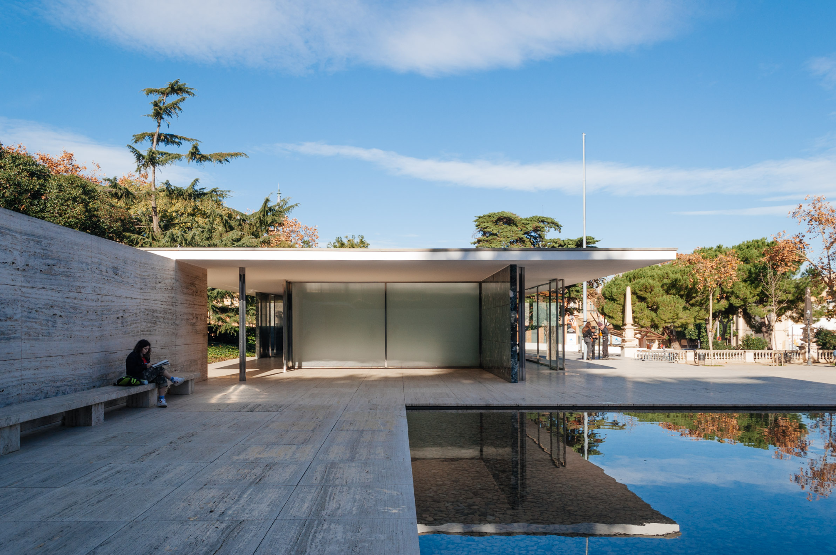

Historical background
The Barcelona Pavilion was designed by architect Ludwig Mies van der Rohe and designer Lilly Reich in 1929; it was constructed as the German national pavilion for the 1929 Barcelona International Exhibition. The pavilion aimed to be a space representing the new Germany, no longer restrained by old monarchal and conservative outcomes. Opposing pavilions in other countries, which showed displays of national achievements, the German pavilion lacked exhibits, resulting in the building focusing on higher things. This was the first time since World War I that Germany could present itself outside its borders; the pavilion was dedicated to discarding Germany's old ideologies and promoting the modern and rather progressive outcomes (MIES, 2014, p.138). Following the shutdown of the Barcelona Pavilion, it was disassembled in 1930. However, in due course, the significance of the building increased, showcasing Mies’s work throughout his career, which led towards its reconstruction (Miesbcn.com, Pavilion, 2019). 1980, almost 50 years later, Oriol Bohigas, the leader of the urban planning sector at the Barcelona city council, set the rebuilding of the Pavilion on the same site and selected architects Cristian Cirici, Ignasi de Solà-Morales, and Fernando Ramos to analyse, design, and be responsible for the reconstruction of the Pavilion (MIES, 2014, p.138).

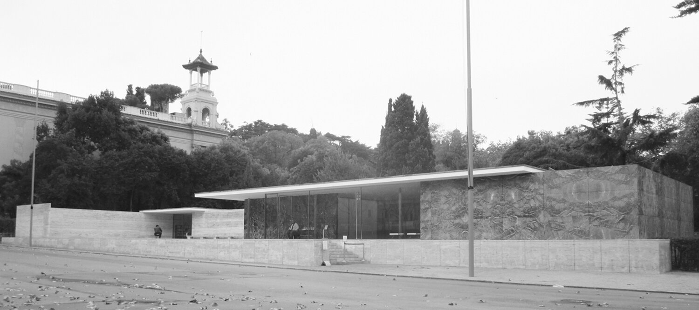
Fig. 1: (sahgb.org, N/A, showing the first Barcelona Pavilion)

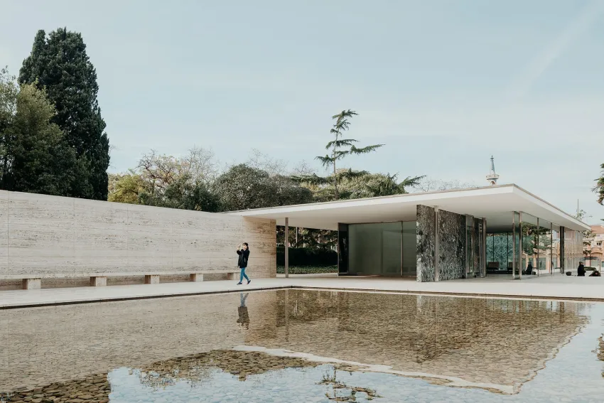
Fig. 2: (https://archeyes.com/?s=barcelona+pavilion, showing the exterior of the reconstructed pavilion)
Fig. 3: (https://miesbcn.com/, showing the interior of the pavilion)
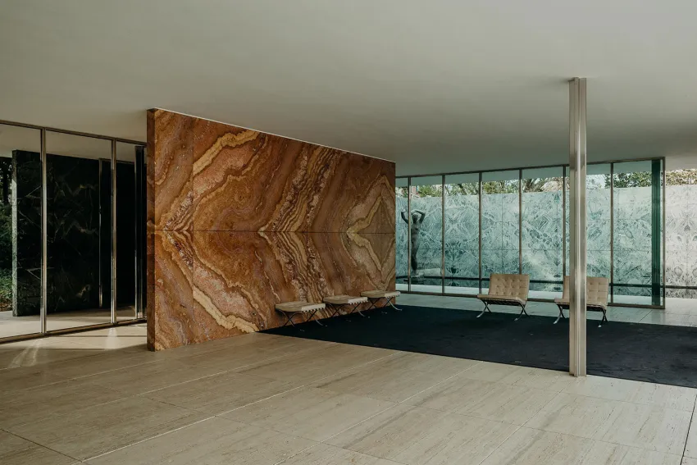

Fig. 4: (Archdaily.com/,showing axonometric of the pavilion)
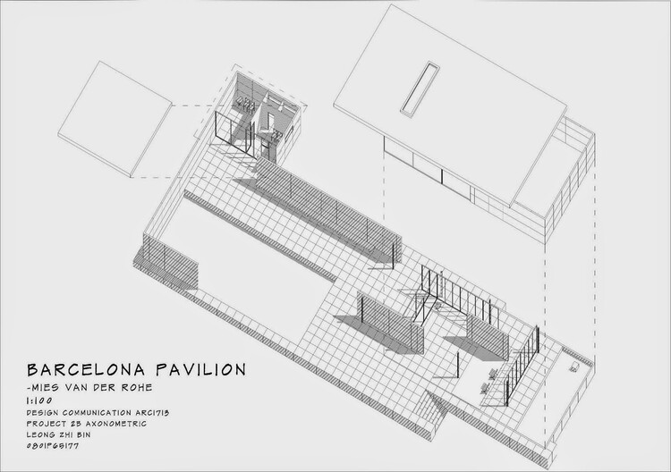

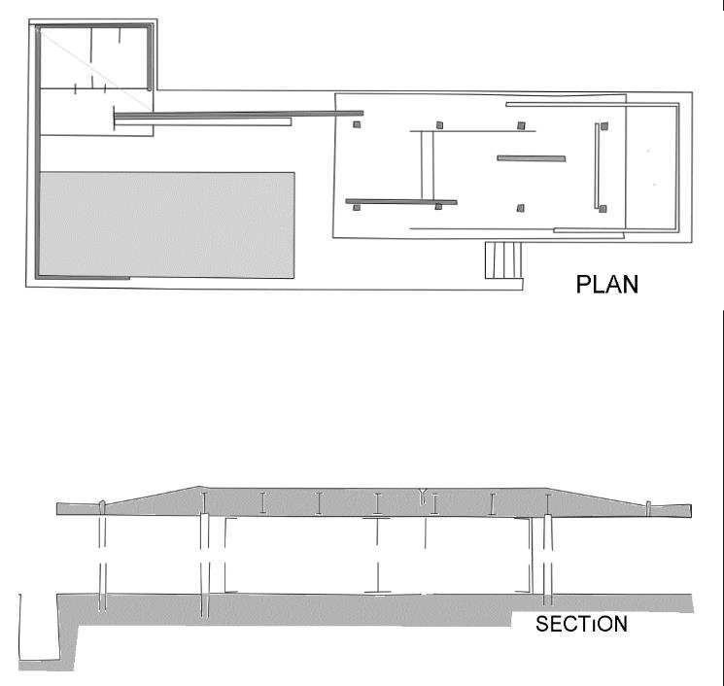
Fig. 5: (researchgate.net, 2012)

Plan and section
Above is a floor plan and section of the Barcelona Pavilion. The pavilion is open plan and with no restrictions. Parallel to the main pool are stairs that bring guests to an open space before arriving at the building. The Pavilion’s plan is made up of a rectangular space, which is taken up by the large pool for the most part. The building doesn’t have a direct entrance or exit, which makes it fluid and freeform for visitors. The pavilion doesn’t consist of rooms and is separated by various slabs of different organic and industrial materials; these walls merge with open spaces, which creates a continuous space between the inside and outside. The walls are distributed randomly, which leaves lots of space to explore. There is a smaller pool along the right side of the building, which creates a link between indoors and outdoors. The rectangular roof structure is supported by 8 metal cruciform pillars, which are 4 L profiles bolted together (see fig. 7) (https://www.youtube.com/watch?v=hr9KR6t_mEM, 2020). The roof is low and cantilevered, which creates the impression that the building is extending into the outdoors. Mies enabled the pavilion to be free of any distractions, which helps visitors grasp the beauty of its simplicity. The interior of the building doesn’t include more than a single sculpture and specially designed furniture. In terms of lighting, the pavilion doesn’t include any lights, but since the pavilion is an extremely open space building and includes lots of glass, it allows natural light through. In addition, sunlight reflects on natural materials such as travertine, making them especially bright and becoming their source of light.

Materials
The materials used in the reconstruction of the pavilion create a juxtaposition due to Van der Rohe utilising a combination of natural and industrial materials. The roof is made of reinforced concrete (architecture-history.org, N/A). White travertine marble surrounds the building, forming the outer layer. Green alpine marble and ancient green marble engulf the enclosures at the entrance as well as the smaller of the two pools. The interior wall in the main space is rust-coloured onyx. Reminiscent of many of Van Der Rohe’s projects, steel has been used in the supporting columns and window frames. The rear pool’s floor is covered in glass, while the front pool is covered in white pebbles, contrasting in texture. The water enables a connection with the pavilion and nature as it reflects all of its surroundings. The statue at the smaller pool is a bronze (see fig. 6) (c20society.org.uk, 2003). The materials used were the same ones used in the previous Barcelona Pavilion. Mies Van der Rohe and Lily Reich specifically designed the ‘Barcelona chair’ for the pavilion, made up of leather and metal. (Miesbcn.com, Pavilion, 2019).

Fig. 6: (ribapix.com, showing the smaller pool and sculpture titled ‘Dawn’)
Fig. 7: (Arch daily, showing a section drawing of the metal pillars)
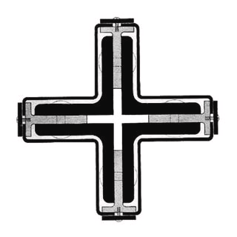
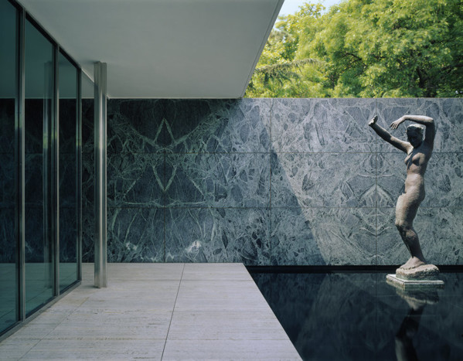

Ideas and theories underpinning the design
The 1929 Barcelona Pavilion had sincere ideas behind it. Artist Justus Bier stated that the building's only ostensible function was ‘to house receptions’; its deeper ideology, however, as George Von Schnizel, commissioner general for the German pavilion, put it, was that the pavilion was to be a space representing the new Germany, no longer restrained by old monarchal and conservative outcomes. The pavilion aimed to represent what Germans could do, what they were, and how they felt at the time. It aimed to deliver the message that they didn’t want anything but clarity, simplicity, and honesty. (MIES, 2014, p.138). Alongside the building representing a newer style of architecture at the time, it aimed to represent Germany’s post-World War I intention of peace. The sculpture in the building, which had to be reproduced for the reconstructed pavilion, built by George Kolbe and named ‘Dawn’, shows a woman raising her arms to shield from the sun’s rays, which represents the ‘morning’ and also the connection with different places, as it’s placed both inside and outside, reflecting off both the pool, marble, and glass. The newer Barcelona Pavilion is a symbol that reflects the modern architectural movement, minimalism within an open space, and the fluid connection between inside and outside space. (Miesbcn.com, Pavilion, 2019).

Conclusion:
The Barcelona Pavilion has successfully attained the aims that Mies and Lily Reich set to achieve when it was being built; it has undoubtedly become one of the most influential and significant examples of modern architecture for valid reasons, and it previously managed to represent the positive side of Germany post-World War I. The use of some of the most unique materials that combine with the forced space in the pavilion allows it to be an unrepeatable experience within itself. The pavilion forms a fluid connection between nature and itself throughout the glass and water reflections alongside the empty spaces. Due to the minimalist approach to the interior and exterior of the pavilion, every detail serves a purpose; whether it’s the bronze statue or the Barcelona chair, every bit combines to create a sensational pavilion. To this day, the Barcelona Pavilion is one of the best examples of 20th-century modernist architecture that focuses on the building rather than its contents. (Jonathan Glancey, bbc.co.uk, 2014).

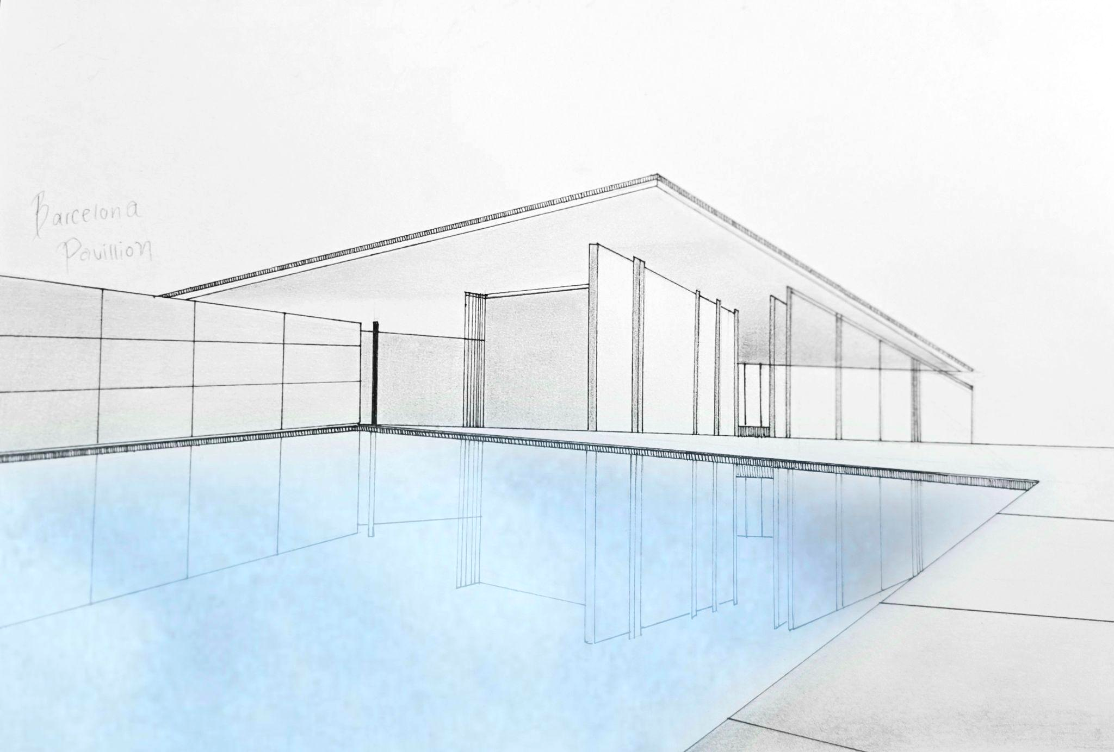
Fig. 8: (Image: Sara Izzidien, showing drawing of the Barcelona Pavilion with the front pool)

Fig. 9: (Image: Sara Izzidien, showing drawing of the Barcelona Pavilion in negative colour to show details)
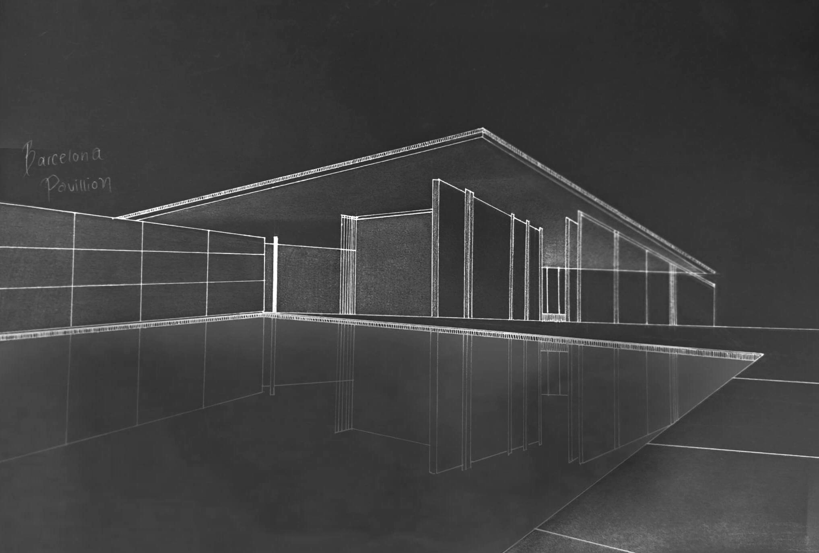

Reference list

1. (MIES, Detlef Mertins, 2014, p.138) [Accessed 25/3/25]

2. (Miesbcn.com, Pavilion, 2019) [Accessed 25/3/25]

3.(MIES, Detlef Mertins, 2014, p.138) [Accessed 25/3/25]

4. (https://www.youtube.com/watch?v=hr9KR6t_mEM, 2020) [Accessed 28/3/25]

5. (c20society.org.uk, 2003) [Accessed 28/3/25]

6. (Miesbcn.com, Pavilion, 2019) [Accessed 25/3/25]

7. (MIES, Detlef Mertins, 2014, p.138) [Accessed 25/3/25]

8. (Miesbcn.com, Pavilion, 2019) [Accessed 25/3/25]

9. (Jonathan Glancey, bbc.co.uk, 2014) [Accessed 30/3/25]

Figure 1: (https://www.sahgb.org.uk/architecturesarchives/barcelonapavilion, showing the first Barcelona Pavilion) [Accessed

Figure 2: (https://archeyes.com/?s=barcelona+pavilion, showing the exterior of the pavilion)

Figure 3: (https://miesbcn.com/, showing the interior of the pavilion)

Figure 4: (archdaily.com/ showing axonometric of the pavilion)

Figure 5: (researchgate.net, 2012)

Figure 6: (ribapix.com, showing the smaller pool and sculpture titled ‘Dawn’)

Figure 7: (Arch daily, showing a section drawing of the metal pillars)

Figure 8: (Image: Sara Izzidien, showing drawing of the Barcelona Pavilion with the front pool)

Figure 9: (Image: Sara Izzidien, showing drawing of the Barcelona Pavilion in negative colour to show details)

