

Assessment 1 – Reading Task Template
PART 1: Upload your photo of your A3 in-class notes here:
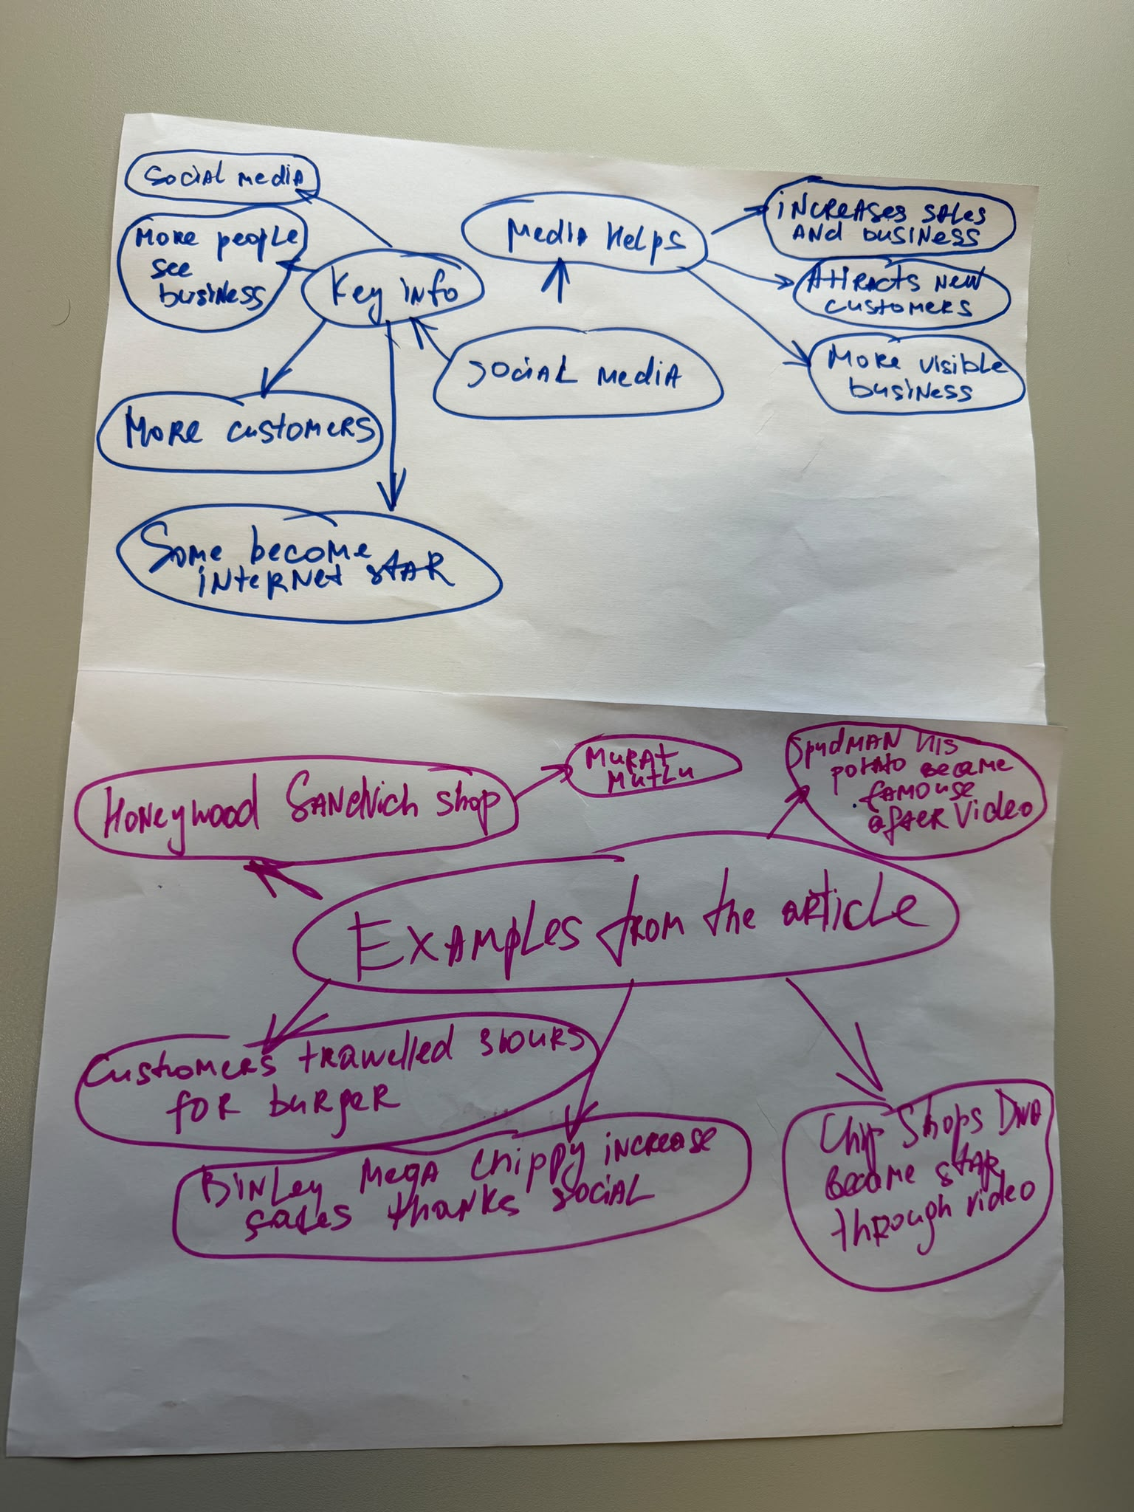

PART 2:
- Answer every question below in 1-3 full sentences.
- Use your own words. Do not use generative AI to answer these questions.
- Include a specific detail from the text when askbed.
1. What people are being referred to in this context?
Murat Mutlu - owner of Honeywood Sandwich Shop.
Ben Newman (known as “Spudman”) - owner of jacket potato stall.
Destiny Harold (known as “Chip Shop Diva”) - staff of a fish and chip shop.
Chloe Huggins and Ross Bliss - owners of a mobile beauty business.
Kristy Chamberlain - owner of Krystals Boutique.
Linda Hunter (known as “Lindy Loo”) - owner of an online clothing shop.
Faye Martin - marketing expert.
2. What is their activity?
They are posting videos on TikTok and Instagram.
They market their businesses online.
They attract customers from different countries.
They sell goods, food and beauty services.
They use social media to promote their businesses.
3. How do businesses change due to social media?
They get much more publicity.
Their sales rise.
They earn more.
They get customers from abroad.
Some businesses stop selling their products locally.
REMINDER
- The main idea is the overall message of the whole text.
- A key point helps to explain the main idea.
- A specific detail or example from the text shows that the key point is true.

- What is the main idea of the whole text?
Social media can help small business to became successful and to find new customers

- What is one key point that supports the main idea, and which specific example from the text shows this?
Social helps business attract new clients.
Honeywood Sandwich Shop became famous thanks for TikTok and his customers travelled 3 hours to buy his burger.

- What is a different key point that supports the main idea, and which specific example from the text shows this?
Social media can increase a business sales.

- Which part of the text do you think is most important, and why?
I think that most important part is about social media because can help increase business. This is important because it helps small business to grow.

Reflection:
- What did you find difficult in this task (including in-class components), and why was it difficult?
I foud to difficult to identify the kay points because the text contained a lot of information.

- What helped you with this difficulty, and how did it help you?
Reading the text carefully and looling for exempeles that can halp me to understand more.

