

Work Based Learning – Submission 2 – Reflective Journal



Student name and ID: James Cullen (P151951).
Course: Construction Management.
Company name and address: Dwr Cymru Welsh Water, 1st Floor, Glien House, Glien Road, Johnstown, Carmarthen SA31 3RB.
Contact name and number: Dai Kirk (Dave.Kirk@dwrcymru.com, 07881907532).

As per the learning contract this interim submission will focus on the period between 02/09/19 and 06/12/19, which represents the period in which the scheme commenced work on site.
This period provided ample opportunity for learning in a number of fields. Most significantly was confronting the sheer scale and scope of the project. Generally, schemes would have one team or crew working on site on one asset at a time, while the works taking place in Sandfields necessitated 4 crews of 5 men and support staff working simultaneously. This provided challenges – working on behalf of Welsh Water requires the upmost professional attitude as well as knowledge of all relevant DCWW procedures. Monitoring these teams and forming a relationship with the operatives and foremen was a key starting point.
Technical aspects surrounding the undertaking provided further routes for acquiring knowledge. A monitoring system was engaging the use of ‘Control Point LTD’, to oversee quality of fusion welding 2 lengths of water main pipe together for which training was provided. It is the first time the software has been used by DCWW.
Furthermore, other unfamiliar DCWW procedures were put into action. These included the use of a ‘Boil Notice’, whereby residents were pre-warned to boil their water while the water mains being installed were being commissioned before a sample was taken to ensure the water’s quality.
A highlight of the first period of the scheme was the first section of renewed water main being put into commission. This pipe in Handel Avenue, Sandfields was laid in early September and the all clear for residents to begin using water fed by it was given on the 17th. The works site is pictured below:

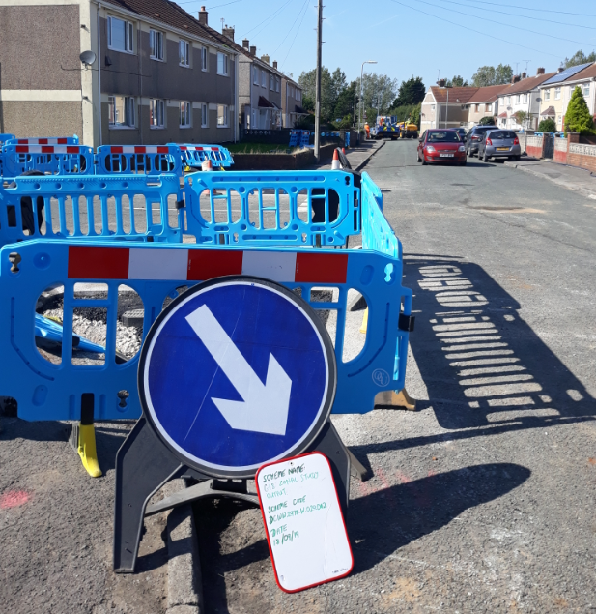
(Image 3: View of Handel Avenue, Sandfields, Port Talbot 18/09/19)

This necessitated a lot of planning and working to a deadline to ensure that customers were inconvenienced for as little time as possible. The health and safety implications of a swift process are also very apparent.
Furthermore, several site audits were carried out within this period, with the aim of setting expectations upon the crews of the required level site safety compliance at this early stage. A section of the ‘CTRD’ inspection form is pictured:

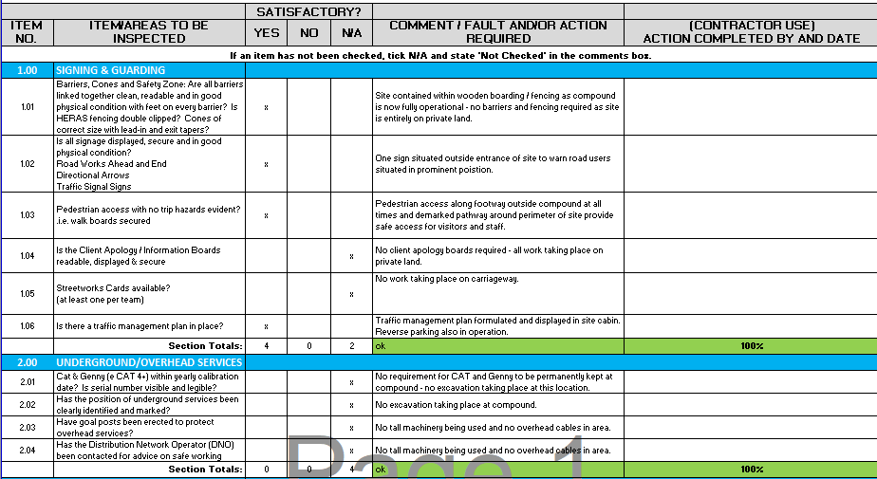

(Image 4: View of section of DCWW ‘‘CTRD’ form 12/09/19)

The most challenging aspect of the scheme in its early stages was acclimatising the workload. The monitoring of all operatives on site, liaising with multiple stakeholders, attending meetings, reporting on progress and ensuring adherence to procedures all contributed to this factor. However, this did provide an insight into what to expect the in the following months and reinforced the theory that organisation is key to fulfilling the requirements of the role.
In addition, a challenging situation arose when it was discovered that some of the valves governing the current network were inoperable, resulting in work not being able to commence in certain areas such as Silver Avenue. While a swift solution was found, it is possible the problem may be repeated throughout the scheme. Measures will be implemented to ensure the programme is not majorly impacted.
Overall this period appears to have complied with the goals and aims set out with the learning contract and provide a sound basis for continuing to work on the project.

Reference List

- DCWW, Water UK (2017), Capital Site Inspection (CTR D – CAF 509), UK.

List of images

Front page top:
- Image 1: DCWW (2019) Dwr Cymru Welsh Water logo, https://www.dwrcymru.com/, accessed 10/11/19.
Front page bottom:
- Image 2: UWTSD (2019) University of Wales Trinity Saint Davids logo, https://www.uwtsd.ac.uk/courses/, accessed 10/11/19.
- Image 3: Cullen (2019), View of Handel Avenue, Sandfields, authors own collection.
- Image 4: Cullen, DCWW (2019), View of CTRD form completed for work on G18 zonal study scheme, authors own collection.

