Sabrina Malek

BUSINESS REPORT

Contents
Introduction 2
Datasets Description 3
Findings 4
1.0 Changes of sales and profits over time for both main categories of goods sold and significant subcategories 4
2.0 Trends, forecasts and basket analyses 8
2.1 Trend Lines and Forecast 8
2.2 Market Basket Analysis 9
Business Recommendations 10
1.0 SWOT Analysis 10
2.0 Recommendations 10
Conclusion 11

Introduction

This report describes the change of sales and profits of main categories and subcategories of goods sold with forecasted sales from 2002 to 2004 in Europe. Several graphs will be produced and described to visualize the change of sales and profits over specified time. Trend lines will be added to show the pattern between data points in the graph. Forecasts for future data will be estimated based on the graph’s trend lines from October 2003 until April 2004.

Datasets Description

The data set shows that there are many attributes related to Adventureworks’ production, sales, human resources and shipping data from 2001 to 2004. The data set includes the customer’s first name, last name, middle name and suffix under a table called “Person_Contact”. Production’s data are shown under “Production_Product”. Class, color, name of product, product line, product number and style are all categorized under Production. Products are then categorized into various different categories, such as accessories, bikes, clothing and components. Every product category has their own subcategories. For example, under ‘Accessories’, there are Bike Racks, Bottles and Cages, Cleaners, Helmets, Hydration Packs, Locks, Pumps, and Tires and Tubes subcategories. The same principle applies on ‘Bikes’, ‘Clothing’, and ‘Components’. Mountain Bikes, Road Bikes, and Touring Bikes are categorized under ‘Bikes’ while Bib-Shorts, Caps, Gloves, Jerseys, Shorts, Socks, Tights and Vests are categorized under ‘Clothing’. Subcategories under ‘Components’ include Bottom Brackets, Brakes, Chains, Cranksets, and Derailleurs.
Adventureworks’ sales were recorded under 3 different tables. The first table, “Sales_SalesOrderHeader” includes attributes such as customer’s Account Number, Due Date, Order Date, Purchase Order Number, Sales Order Number, and Ship Date. The second table, “Sales_SalesTerritory” include more important attributes, such as Country Region Code, Group and Name of Country/Region. All attributes define the region or country Adventureworks have sold their products. The third table, “Sales_SpecialOffer” focuses more on the special offers, where Adventureworks cut their product’s prices during special seasons. Attributes such as Category, Description, and Type categorizes the special offer’s data according to its characteristics.
Production’s list price and standard cost are listed under “Production_Product” table. “Sales_SalesOrderDetail” includes measures such as Line Total, Order Quantity, Unit Price, and Unit Price Discount. Attributes such as Freight, Online Order Flag, Status, Sub Total, Tax Amount, and Total Due are included under table, “Sales_SalesOrderHeader”. Special offers of various products have a table dedicated to measure the discount under “Sales_SpecialOffer”.

Findings

Changes of sales and profits over time for both main categories of goods sold and significant subcategories

Sales are calculated by multiplying the order quantity with the difference of unit price and unit price discount. The formula is as follows:
$$Sales=\left[Order Quantity\right]*(\left[Unit Price\right]-\left[Unit Price Discount\right])$$
Profits are then derived from Sales. Difference of Sales and Standard Cost equals to Profits. The formula is as follows:
$$Profits=\left[Sales\right]-[Standard Cost]$$

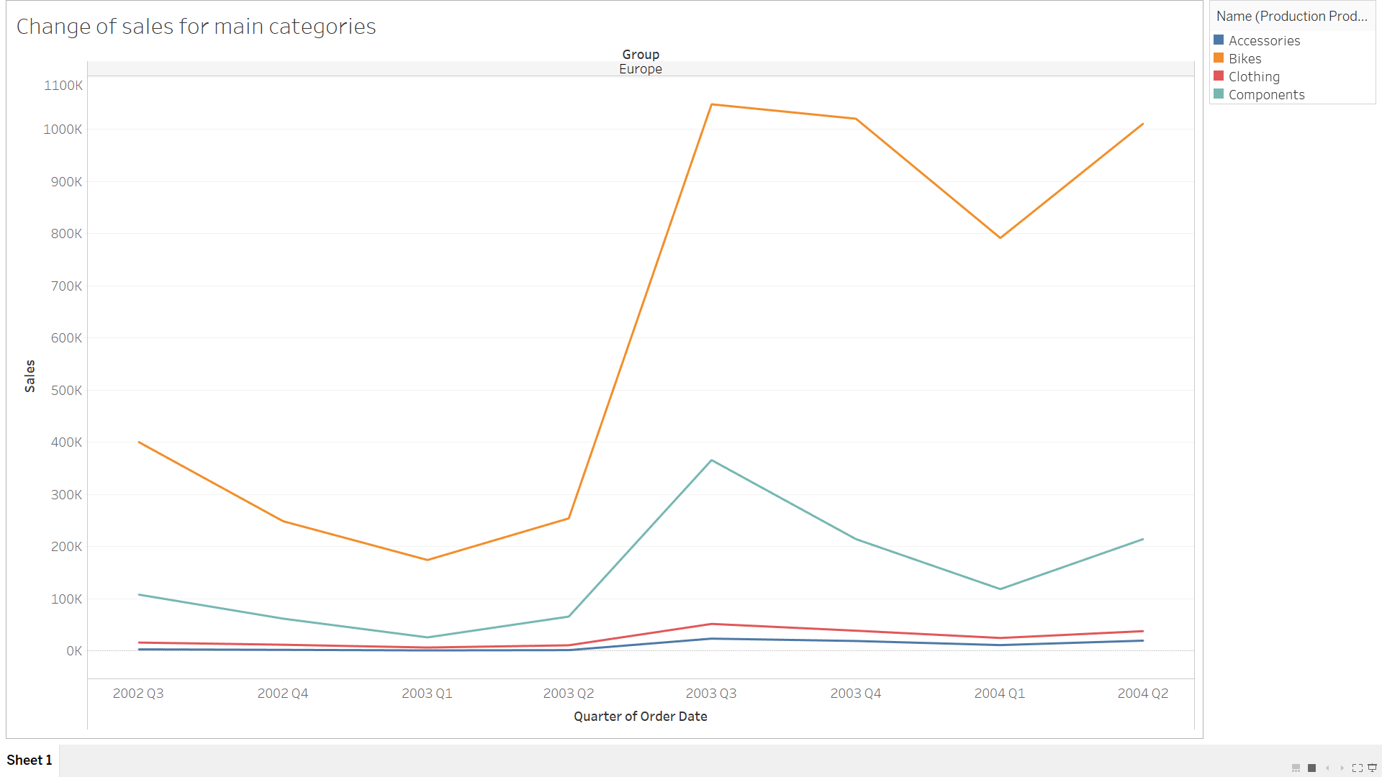
Figure 1.1: Change of sales over time for main categories of goods sold

Figure 1.1 shows change of sales from third quarter of 2002 until second quarter of 2004. Highest sales were from selling bikes, as it spikes from 300 thousand sales to almost 1.1 million sales in the middle of 2003. However, the sales declined from third quarter of 2002 before the sudden increase. After reaching its peak, bikes’ sales slowed down causing a slight decrease from third to fourth quarter of 2003. It then continued to decrease significantly until the first quarter of 2004, where the turning point of sales occurs. Sales for bikes continue to increase steadily from the first quarter of 2004. Components make the second highest record in sales, starting at 100 thousand sales during the first quarter of its release. It fell slightly for the next two quarters, before increasing gradually during the third quarter of 2003. Similar to bikes, components experienced a fall right after its peak, losing almost 200 thousand of sales compared to the previous two quarters. Its sales then climbed moderately after the first quarter of 2004. Both accessories and clothing experience similar trends of number of sales. Their sales remains constant from third quarter in 2002 until the second quarter in 2003 before experiencing a slight increase during the third quarter of 2003. Both products then had slight decrease before maintaining their sales from third quarter of 2003 until second quarter of 2004.

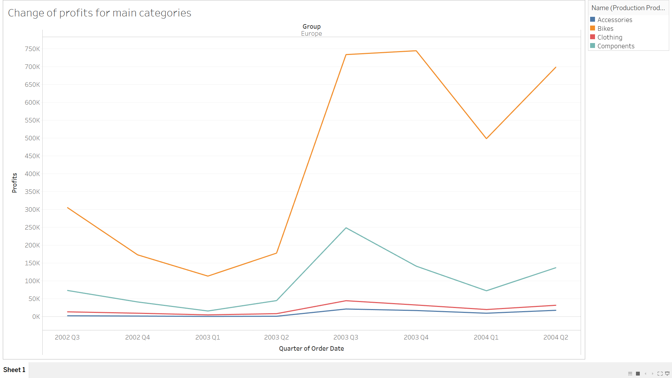 Figure 1.2: Change of profits over time for main categories of goods sold

In Figure 1.2, it is shown that Adventureworks’ profits in Europe have declined from the third quarter of 2002 until the first quarter of 2003 for all productions. The profit for ‘Bikes’ decreased steeply during the aforementioned period of time. However, all productions’ profits rose rapidly after the second quarter of 2003. Bikes reached its second highest profits around the third quarter of 2003. Then, it increased slightly between the third quarter and the fourth quarter of 2003. The profits then fell quickly during the first quarter of 2004 before increasing steadily until the next quarter. Component’s profits face the same declination from 2002’s third quarter until the first quarter of 2003. It then increased gradually until third quarter of 2003 before dropping significantly throughout the next two quarters. The profits then increased gradually after the first quarter of 2004. Component’s profits reached its peak around third quarter of 2003. Both accessories and clothing maintain their profits between third quarter of 2002 to second quarter of 2003. Their profits rose slightly during the third quarter of 2003 before dropping at the end 2003.

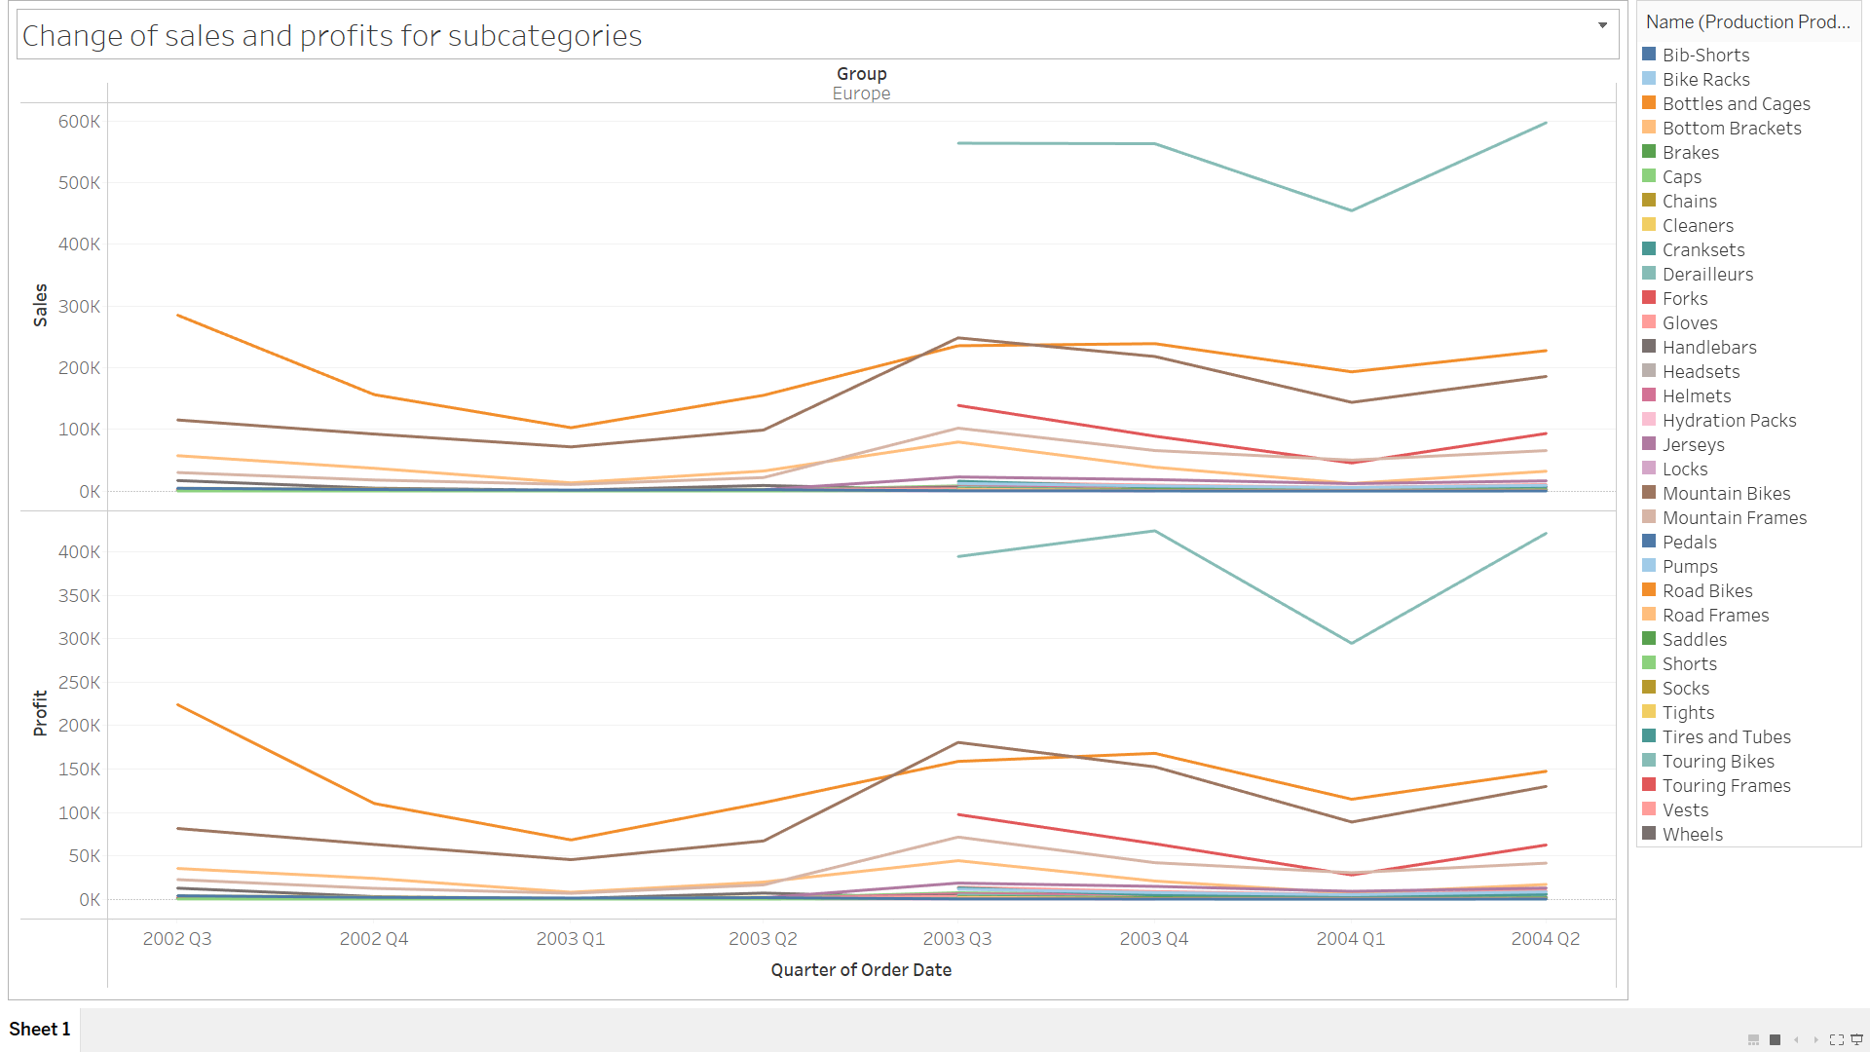
Figure 1.3: Change of sales and profits over time for subcategories

Figure 1.3 shows change of sales and profits over time for 33 different subcategories. Adventureworks started producing touring bikes, touring frames, and cranksets a year later than other products. Touring bikes’ sales and profits are recorded as the highest among other products. Wheels were discontinued from production at the end of year 2003. Most products experience a fall in sales and profits during the first quarter of 2003 before rising gradually until reaching their peak around the third and fourth quarter of 2003. All of them experienced a fall once again in the first quarter of 2004. Their sales and profits began to rise significantly afterwards.

Trends, forecasts and basket analyses

2.1 Trend Lines and Forecast

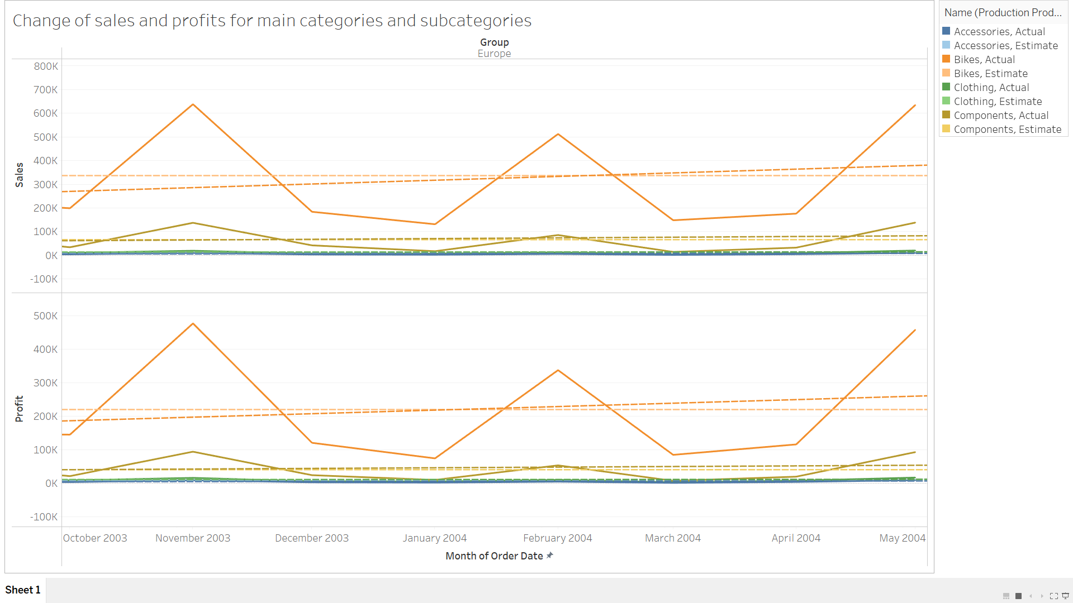
Figure 2.1: Trend Lines and Forecast

Figure 2.1 shows the trend lines and forecast lines for change of sales and profits for main categories from October 2003 to May 2004. A linear trend line is added to different products’ graph to describe the pattern of the data points. Forecast is also added to show the estimated values for future data. The number of bikes sold over time is higher than accessories, clothing, and components. Thus, it creates a positive trend line. The estimated data for bikes’ sales and profits are slightly positive. Components had slightly lower sales compared to bikes, leading the trend lines to be lower. However, the trend line is positive, showing the increasing number of sales and profits over time. The estimated trend line for components for future data is slightly lower than the actual trend line. Both accessories and clothing maintained constant number of sales and profits, which resulted both actual and estimated trend line to be almost similar.

2.2 Market Basket Analysis

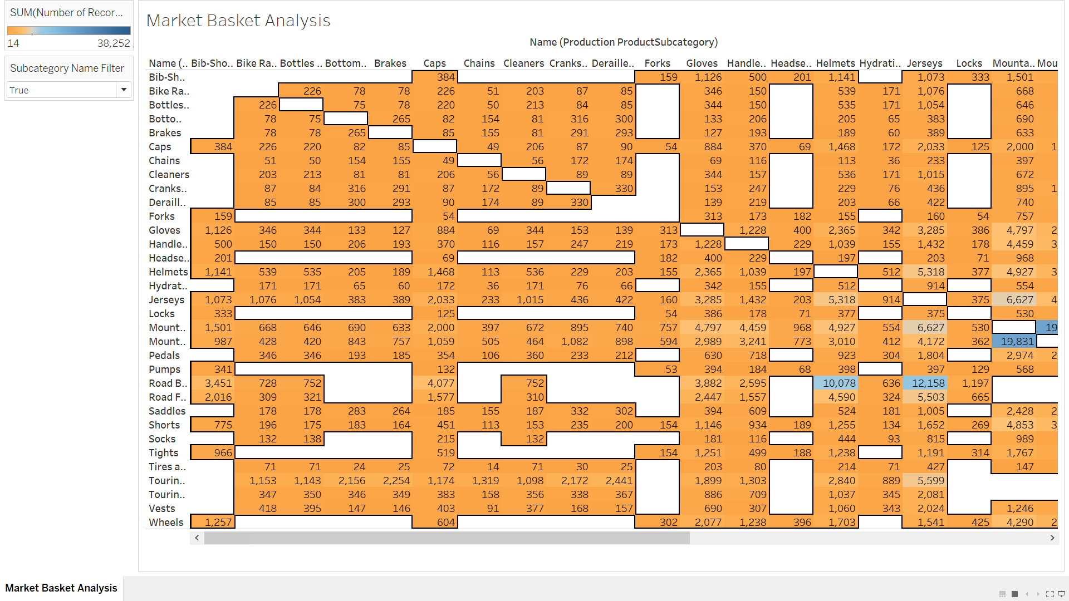
Figure 2.2: Market Basket Analysis
Figure 2.2 shows Market Basket Analysis for subcategories of goods sold by Adventureworks. Market Basket Analysis makes visualizing relationships between products purchased by customers easier.

Business Recommendations

SWOT Analysis

Strengths  - Location:  Sales in France is better than Germany  - Weather:  Profits peaked during sunny season  - Season:  Most products were sold during Summer and Autumn | Weaknesses  - Categories of goods sold:  Accessories and components rarely contribute to good sales  - Advertising:  Not much advertisement was done to other products to boost up the sales
Opportunities  - Sell items according to seasons:  Some products have higher sales during specific seasons, such as touring bikes  - Promotions:  Items bought together can be promoted together | Threats  - Production:  Production of low sales products such as accessories and components might increase the standard costs.

2.0 Recommendations

Both sales and profits for category ‘Bikes’ shown in visualizations above proves that they are Adventureworks’ best-selling products. Products under ‘Bikes’ include Mountain Bikes, Road Bikes, and Touring Bikes. Touring Bikes are the most profitable product sold by Adventureworks. Therefore, production of Touring Bikes should be increased to achieve higher profits. Low-profitable products such as Bib-Shorts, Caps, Gloves, Jerseys, Bike Racks, Bottles and Cages should be produced less. Sales of these products remained low for a long period of time. Mountain Bikes and Road Bikes are more popular in France. Therefore, these products should be promoted more in other European countries, such as Germany. Adventureworks may focus more on profitable categories, such as Bikes and Components, rather than Accessories and Clothings. Both Accessories and Clothings have not positively impacted the sales and profits for the company over two years. During Summer and Autumn, sales and profits for all products’ categories peaked. Bikes and Components makes significant increase in sales and profits. Therefore, productions for both categories can be increased for higher sales. Based on Market Basket Analysis, Road Frames and Road Bikes are often bought together. With a record of 38,252 times customers bought these products together, it shows that these products can be promotional items. Road Frames and Road Bikes can be promoted together to boost up sales for both products.

Conclusion

In conclusion, the change of sales and profits over time fluctuates. Most products reached their highest sales around third quarter of 2003, but experienced a fall beforehand. Adventureworks makes 400 thousand profits by selling Bikes, and around 200 thousand by selling Components. Adventureworks’ future sales and profits are estimated to be positive throughout next 12 months.

