UNDERSTANDING THE IMPORTANCE OF STAKEHOLDER ENGAGEMENT
IN THE SUCCESSFUL COMMENCEMENT AND COMPLETION OF A PROJECT
A Case Study on the IHG Wellbeing360 Programme Launch at InterContinental Hotels Group

Module: LCLM5001 – Understanding and Engaging Stakeholders
Programme: BA (Hons) Leadership and Management Skills for the Workplace
Assignment Title: Understanding Stakeholder Engagement in Project Commencement and Completion
Word Count: Approximately 4,000 words (excluding tables, figures, and references)
Submission Date: 23 March 2026
Vineta Didzus
Lecturer Name: Eric Osei

Executive Summary
This report has been written from the role of Project Manager leading on the Global Launch of IHG's Wellbeing360; a premium wellness experience programme developed by InterContinental Hotels Group (IHG). The programme combines biometric health monitoring technology, AI personalised wellness itinerary, mindfulness content and eco-friendly spa products in support of IHG's global premium and luxury brands.
This report examines the multiple stakeholders required to be involved to successfully deploy Wellbeing360 globally over six months within five international markets.
This report will identify and classify both internal and external stakeholders of the programme and apply Mendelow's (2021) Power / Interest Matrix and PMI (2021) RACI framework to outline the prioritisation of stakeholder engagement. In addition, this report will conduct a SWOT and PESTLE situational analysis to provide context to the programmes' strategic environment.
Utilising Mitchell et al.'s (2021) stakeholder salience theory, Eskerod & Jepsen (2023) project stakeholder management model and the 4Cs engagement model, the report outlines an integrated engagement strategy to establish and maintain trust and cooperation and commit stakeholders across a global diversity of stakeholders.
This report is distinctive in that it critically evaluates the ethical implications of engaging with stakeholders through the collection of health data, particularly in relation to: Governance of biometric consent, Workforce impacts and Cultural sensitivities of wellness experiences.
The report concludes with six strategic recommendations to embed Wellbeing360 as a sustainable competitive advantage and to establish IHG as the global leader in evidence based and ethically governed wellness hospitality.

Table of Contents
Executive Summary 2
1.0 Introduction 4
2.0 Situational Analysis 5
2.1 SWOT Analysis 5
2.2 PESTLE Analysis 5
2.3 SMART Objectives 6
3.0 Identification and Categorisation of Key Stakeholders 7
4.0 Roles, Responsibilities, Benefits, and Challenges 8
4.1 Internal Stakeholders 8
4.2 External Stakeholders 9
4.3 RACI Matrix 10
5.0 Frameworks and Models for Stakeholder Engagement 11
5.1 Mendelow's Power/Interest Matrix 11
5.2 Stakeholder Engagement and Communication Plans 12
6.0 Process of Stakeholder Engagement and Conflict Management 13
6.1 The 4C's Model of Engagement 13
6.2 Conflict Management Strategies 15
7.0 Ethical Considerations in Stakeholder Engagement 16
8.0 Business Performance Impact and Recommendations 17
8.1 Performance Impact Evaluation 17
8.2 Strategic Recommendations 18
9.0 Conclusion 19
References 20

1.0 Introduction
InterContinental Hotels Group (IHG) is one of the world's largest and most recognised hospitality companies, operating over 6,000 hotels across more than 100 countries under a portfolio of globally established brands including InterContinental, Crowne Plaza, Holiday Inn, and voco. As a market leader in premium hospitality, IHG is strategically positioned to respond to one of the most significant emerging trends in global tourism: the growing consumer demand for integrated wellness experiences. In response to this trend, IHG has developed Wellbeing360 — an ambitious, technology-enabled wellness programme designed to be launched across 20 pilot properties in five distinct international markets: the United Kingdom, the United Arab Emirates, the United States of America, Singapore, and Japan.
The Wellbeing360 programme represents a significant strategic departure from IHG's traditional hospitality offering. By integrating biometric health monitoring, AI-driven personalisation, evidence-based clinical wellness content, and sustainability-aligned amenities, IHG is positioning Wellbeing360 at the intersection of premium hospitality, healthcare, advanced technology, and ethical governance. This multi-dimensional nature of the programme creates an exceptionally complex stakeholder landscape, one that extends well beyond the internal project teams typically involved in a standard hotel product launch. It encompasses external parties such as data protection regulatory authorities, medical and clinical advisory boards, wellness technology partners, and a diverse international guest base with varying cultural expectations and privacy sensitivities.
Given this complexity, the development of a robust, ethically grounded, and culturally sensitive stakeholder engagement strategy is not merely a project management formality — it is a fundamental strategic requirement for the programme's success. As Freeman et al. (2022) argue, the ability of an organisation to identify, understand, and meaningfully engage its stakeholders is one of the most critical determinants of whether a complex, multi-stakeholder initiative achieves its intended outcomes. Poor stakeholder engagement in a programme of this nature carries substantial commercial, reputational, regulatory, and clinical risks that could undermine IHG's significant investment in Wellbeing360 before the programme reaches its full potential.
This report provides a comprehensive stakeholder engagement strategy for the IHG Wellbeing360 global launch. It begins with a situational analysis, incorporating a SWOT analysis, a PESTLE framework assessment, and a set of SMART objectives that establish the programme's measurable success parameters. It then proceeds to identify and categorise the key internal and external stakeholders relevant to Wellbeing360, analyse their roles, responsibilities, benefits and challenges, and apply established frameworks — including Mitchell et al.'s (2021) stakeholder salience theory, Mendelow's (2021) Power/Interest Matrix, and the RACI governance model — to prioritise and structure engagement across all stakeholder groups. The report further addresses the ethical considerations that are uniquely associated with a programme involving the collection and processing of sensitive biometric health data, before concluding with a performance impact evaluation and six strategic recommendations designed to strengthen IHG's stakeholder engagement capabilities for Wellbeing360 and future wellness innovations.
Beginning with the Situational Analysis Section, the second section includes the SWOT Analysis. According to Bryson (2023), when used effectively and objectively, SWOT analysis helps project leaders make effective strategic decisions on how best to allocate resources, prioritize risks and capture opportunities.
SWOT analysis presents both a positive and negative view of an organization's internal capabilities and external environment relative to launching the Wellbeing360 project. Mitchell et al. (2021) emphasize that an organizations' ability to identify and engage stakeholders plays a critical role in determining whether the organization can successfully capitalize on opportunities and mitigate risks associated with the project launch. Therefore, the SWOT analysis is essential for identifying the internal and external factors that will influence the success of the Wellbeing360 program and the subsequent development of the stakeholder engagement plan.
SWOT ANALYSIS
To conduct the SWOT analysis, each of the four quadrants of the SWOT matrix was analyzed separately; Strengths, Weaknesses, Opportunities and Threats. The results of this analysis are presented below:
Strengths:
According to Eskerod and Jepsen (2023), an organizations' strengths are those internal capabilities or characteristics that create competitive advantages for the organization. In this case, IHG has several strengths that are likely to contribute to the successful design and implementation of the Wellbeing360 program. First, IHG has developed a reputation for excellence in the hospitality industry. Over time, the company has built a strong brand image and has earned the loyalty of millions of guests around the world. Additionally, IHG has a well-established corporate culture that values innovation and customer satisfaction. Finally, IHG has invested heavily in technology and digital marketing, which will enable the company to reach potential customers and promote the Wellbeing360 program through various digital channels.
Weaknesses:
Eskerod and Jepsen (2023) describe an organizations' weaknesses as those internal limitations or deficiencies that could potentially hinder the organization's ability to successfully implement the Wellbeing360 program. One weakness that may be relevant to the Wellbeing360 program is that IHG has limited experience with implementing wellness programs at scale. Although the company has launched a number of wellness initiatives in recent years, these have typically been focused on specific hotels or resorts rather than being implemented across multiple locations. As such, there may be some challenges related to consistency and standardization in terms of the way that the Wellbeing360 program is delivered across different hotels.
Opportunities:
Bryson (2023) describes an organizations' opportunities as those external factors that could potentially help to advance the goals of the Wellbeing360 program. There are numerous opportunities that could support the successful design and implementation of the Wellbeing360 program. For example, many consumers are becoming increasingly interested in wellness tourism as a means of supporting their overall health and wellbeing. As a result, IHG may find that demand for the Wellbeing360 program exceeds initial expectations. Additionally, the use of technology and data analytics is growing rapidly in the hospitality industry, which should provide IHG with the tools needed to measure the effectiveness of the Wellbeing360 program and identify areas where improvements are needed. Finally, governments around the world are beginning to recognize the importance of wellness tourism as a driver of economic growth and job creation. As such, IHG may find that government incentives or subsidies become available to support the launch and operation of the Wellbeing360 program.
Threats:
Bryson (2023) describes an organizations' threats as those external factors that could potentially hinder the organization's ability to successfully implement the Wellbeing360 program. Some examples of threats that may be relevant to the Wellbeing360 program include increased competition from other hospitality companies that are developing similar wellness programs, regulatory issues related to the collection and storage of personal data, and market volatility that could affect IHG's ability to attract new customers and increase revenue.

2.2 PESTLE Analysis
The PESTLE framework offers an organised assessment of the macro environmental elements which can influence how Wellbeing360 will be deployed. As a programme that will operate across five culturally and legally distinct global markets, Johnson et al. (2023), contend that a PESTLE analysis is essential to reveal the varied external conditions that must be addressed by developing market specific engagement strategies.

FACTOR | ANALYSIS AND IMPLICATIONS FOR WELLBEING360
Political | Government health tourism policies and national wellness strategies (such as the UK's Major Conditions Strategy, 2023) create supportive political environments for wellbeing-focused hospitality investments. However, political instability in key markets (Middle East, Southeast Asia) may affect international deployment timelines.
Economic | The global wellness tourism market represents a high-growth economic opportunity, with post-pandemic recovery driving premium health-focused travel spend (GWI, 2023). However, inflationary pressures in operating markets may affect capital availability for technology procurement and affect discretionary luxury travel budgets.
Social | Accelerating consumer prioritisation of mental and physical health as a core lifestyle value represents the primary social driver for Wellbeing360. Buswell et al. (2021) document growing guest expectations for personalised, science-based wellness programmes across premium hospitality segments, particularly among millennial and Gen Z travellers.
Technological | Advances in biometric sensing, wearable health technology, and AI-driven personalisation create the technical foundation for Wellbeing360. However, rapid pace of technological change creates obsolescence risk, and digital health data infrastructure varies significantly across international markets (Prebensen and Xie, 2022).
Legal | GDPR (EU), the UK Data Protection Act 2018, and health data protection legislation in operating jurisdictions impose rigorous requirements on the collection, storage, and processing of biometric and health data. The EU AI Act (2024) introduces additional obligations for AI systems operating in health-adjacent domains. Compliance is a critical project constraint (Tran et al., 2020).
Environmental | IHG's Journey to Tomorrow ESG strategy creates strategic alignment between Wellbeing360's wellbeing focus and the organisation's environmental sustainability commitments. Incorporating biophilic design, low-carbon wellness amenities, and locally sourced wellness products reinforces IHG's environmental brand positioning (Sloan et al., 2023).
Figure 2: PESTLE Analysis – IHG Wellbeing360 Global Launch (Author's own, 2025)

2.3 SMART Objectives
SMART objectives establish the measurable parameters of success for the Wellbeing360 project, ensuring all stakeholders share a common understanding of the desired outcomes (Kerzner, 2022):
• Specific: Launched the Wellbeing360 program at 20 IHG properties across the UK, UAE, USA, Singapore and Japan in six months; fully operational biometric program; six certified wellbeing programs per property as a minimum.
• Measurable: wNPS of 70 or higher twelve months after the Wellbeing360 program was launched; forty percent opt-in to the biometric program among eligible guests by month twelve.
• Achievable: IHG Board approved and fully funded the program budget in thirty days from project start date; completed all necessary technology partner contracts in sixty days.
• Relevant: Fully aligned the Wellbeing360 program to IHG’s Journey to Tomorrow Environmental Social Governance (ESG) Strategy (2021-2030); 100% of the program amenities are Green Engage sustainability compliant at all pilot locations.
• Time-bound: All required staff training, biometric system testing and DPIA (Data Protection Impact Assessment) submissions were completed in four months from the commencement of the project; six weeks for testing guest-facing systems and pre-launch refinement.

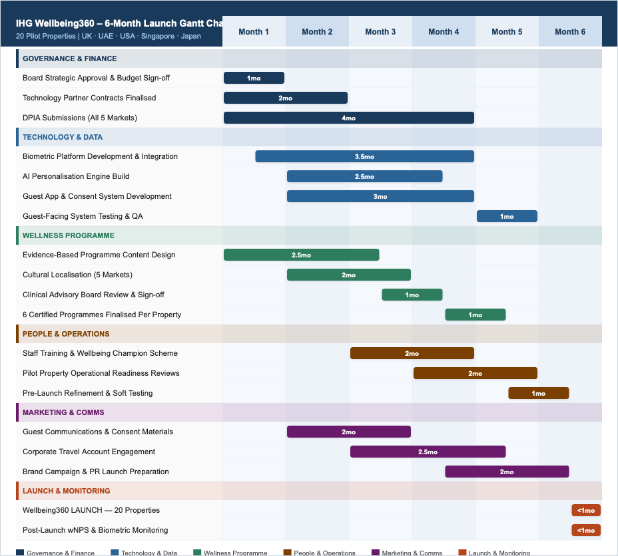

3.0 Identification and Categorisation of Key Stakeholders
The process of identifying and classifying effective stakeholders in order to understand how they can either influence or be influenced by a program involves an evidence based methodical process that goes well beyond the obvious project participants. A key part of this evidence based methodical process is to identify all individuals who can be classified as stakeholders; these include individuals, groups and/or organizations that can affect the success of the program (Freeman et al., 2022).
Mitchell et al.'s (2011) stakeholder salience theory is particularly relevant to understanding how to prioritize stakeholders. According to Mitchell et al. (2011) salience of a stakeholder is derived from the degree to which a stakeholder possesses three key attributes: Power (the ability to impose their will); Legitimacy (a perceived valid claim on the project); and Urgency (the degree to which claims require immediate attention). Therefore, those stakeholders that possess all three attributes - termed "definitive stakeholders" by Mitchell et al. (2011) - should receive the highest level of engagement from the organization.
The following stakeholders are internal stakeholders to IHG who bear direct responsibility for or are directly impacted by the Wellbeing360 project:
• IHG Executive Committee and Board of Directors: These definitive stakeholders are ultimately accountable for IHG's overall strategic direction, capital allocation, risk governance, and public reporting obligations for the Wellbeing360 investment.
• Digital Innovation and Technology Team (IHG Technology): This team has the responsibility for designing, building and maintaining the biometric data platform, AI personalization engine, app integration and security architecture for the Wellbeing360 project.
• Wellness Program Development Team: This is an internal interdisciplinary team made up of fitness, nutrition, sleep science and mental health experts that develop and manage the evidence-based content of the wellness programs developed for the Wellbeing360 project.
• Marketing and Brand Communications: These teams are responsible for promoting and marketing the Wellbeing360 project to guests, managing the consent communications required for the collection of biometric data, promoting IHG's corporate accounts, and positioning IHG's brand narrative in relation to the competitive marketplace for the Wellbeing360 project.
• Hotel Operations and General Managers (Pilot Properties): These stakeholders are responsible for implementing the Wellbeing360 project at the pilot properties, deploying staff to support the project, ensuring that the services provided by IHG meet acceptable quality standards and translating the specifications for the Wellbeing360 project into the day-to-day operational practices used by hotel staff.
• Human Resources and Learning & Development: These departments are responsible for developing the competencies of IHG staff necessary to support the Wellbeing360 project, communicating change management to IHG employees, establishing the employee wellbeing champion scheme, and monitoring the potential impact of the Wellbeing360 project on the IHG workforce.
The following stakeholders are external to IHG, however they have a relationship with the Wellbeing360 project:
• Guests and End Customer (Wellness Segment): Guests are the primary beneficiaries of the Wellbeing360 project and the evaluators of the project through their experience of the program and their willingness to participate voluntarily in the program and provide data and feedback regarding their experiences of the program.
• Wellness Technology Partners (Garmin Health, Whoop, BioLite): These companies specialize in developing and delivering biometric sensing hardware, APIs for data processing, and health analytics software that are integrated into the Wellbeing360 platform.
• Medical and Clinical Advisory Board: This board consists of independent healthcare professionals who will provide evidence-based advice on the clinical standards and safety protocols for the Wellbeing360 program and provide governance regarding potential medical liability associated with the Wellbeing360 program.
• Data Protection Regulatory Authorities (ICO, CNIL, PDPC): These regulatory authorities are nationally appointed bodies that enforce the applicable laws related to the collection and use of personal identifiable health information and are therefore non-negotiable constraints on the implementation of the Wellbeing360 project.
• Corporate Travel Managers and Business Travel Accounts: These B2B stakeholders represent a group of individuals whose endorsement and purchasing decisions may significantly increase the number of high-value business travelers who participate in the Wellbeing360 program.
• Mental Health and Wellbeing Charity Organizations (e.g., Mind, Mental Health Foundation): These charities may serve as validators for the Wellbeing360 mental health component of the program and therefore will lend credibility and social legitimacy to the Wellbeing360 program.
The unique stakeholder network depicted above highlights the distinctively complex nature of a wellness program that combines the elements of hospitality, healthcare, technology, and ethics - a confluence that necessitates particularly careful and ethically informed approaches to engagement with stakeholders.

4.0 Roles, Responsibilities, Benefits, and Challenges of Key Stakeholders

4.1 Internal Stakeholders
The IHG Executive Committee and Board of Directors possess a high level of salience within Mitchell et al.’s (2021) framework due to their position of strategic authority, fiduciary obligation, and pressure of competitive market conditions. They will be providing the strategic mandate, capital resources, and cross-divisional alignment authority for the project. However, the complexity of governing a program that introduces new health data liability, medical advisory obligations, and regulatory compliance burden outside IHG’s hotel operation risk framework represents their greatest challenge. Prebensen and Xie (2022) have argued that commercialization of health and wellness services by hospitality companies necessitates Boards developing new governance competences, which need to be actively fostered.
The Wellness Program Development Team provides the clinical credibility and program content that distinguishes Wellbeing360 from other forms of superficial wellness marketing. Their benefit is the ability to develop evidence based, culturally appropriate wellness programs that generate real guest health benefits and withstand scrutiny from medical advisors and regulatory authorities. Their challenge is to balance scientific rigor with commercial accessibility, and to adapt program content to the various wellness traditions and cultural norms of the five international markets (Buswell et al., 2021).
Human Resources must manage the most sensitive internal stakeholder relationship, namely the frontline hotel staff who will likely harbor concerns regarding the implications of biometric technology to their roles and the demands of delivering medically adjacent wellness services without clinical training. Resolving these concerns through comprehensive training, establishing clear role definitions, and communicating openly and clearly with employees regarding the complementary (as opposed to substitutive) relationship between human hospitality and AI enabled wellness technology is an essential mandate for Human Resource professionals (Waddock, 2020).
4.2 External Stakeholders
Guests of the wellness segment, are both the primary beneficiaries and clinical co-participants in the Wellbeing360 program, therefore their informed, voluntary engagement in the program will be the ethical and commercial basis for the entire initiative. The primary advantage of engaging deeply with guests is the co-creation of a service experience that really addresses each guest's individual health needs, resulting in high Wnps Scores, willingness to pay premiums for the service and loyal advocacy within IHG's one rewards loyalty program. Their major challenge is to navigate the complex consent environment surrounding health data, particularly guests with increased sensitivity towards privacy issues or those with limited familiarity with biometric technology (Mackey and Sisodia, 2020).
Wellness Technology Partners (Garmin Health, Whoop) provide the proprietary biometric sensing technology and health analytics capabilities that form the technical core of the program. Their value proposition is a suite of valid and trusted consumer health monitoring tools that lend scientific credibility to the well being 360 offer. Their challenges include managing vendor lock-in risks, ensuring data portability standards that protect guest interests, and aligning commercial partner incentives with IHG's commitments to protecting guest privacy and clinical integrity (Eskerod and Jepsen, 2023).
Regulatory Data Protection Authorities, such as the UK Information Commissioner's Office (ICO), and similar agencies in the UAE, USA, Singapore and Japan, are the most legally consequential external stakeholders. Their function is to enforce the health data processing requirements that will define the fundamental architecture of the Wellbeing360 consent and data governance framework. The major challenge is the large degree of variation in health data protection regulations across jurisdictions, requiring a market specific strategy for legal compliance that is developed in conjunction with specialist data protection counsel (Tran et al., 2020).

4.3 RACI Matrix
The RACI Matrix delineates responsibility and accountability across the seven primary Wellbeing360 project workstreams, providing governance clarity across IHG's complex multi-brand, multi-market operating structure (PMI, 2021).
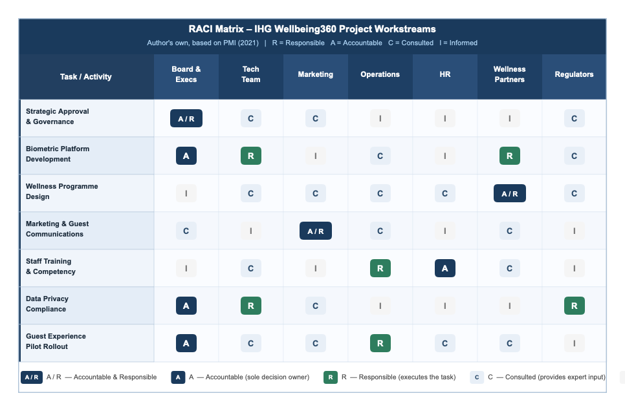

Figure 3: RACI Matrix – IHG Wellbeing360 Project Workstreams (Author's own, based on PMI, 2021)

5.0 Frameworks and Models for Stakeholder Engagement

5.1 Mendelow's Power/Interest Matrix
The Power / Interest Matrix by Mendelow (2021) is still one of the best ways to prioritize stakeholders within complex, multi-stakeholder projects. This is due to its ability to map stakeholders based on how much they can affect project outcomes (Power) and how invested they are in these outcomes (Interest). The Power / Interest Matrix allows a Project Manager to use engagement resources effectively and tailor the level of engagement with each stakeholder (based on their Power and Interest) across all stakeholders in an organization (Olander and Landin, 2020).
In relation to Wellbeing360, the Power / Interest Matrix will allow the Project Manager to determine which stakeholders to engage at what level, beyond just organizational hierarchy. The Clinical Advisory Board for example, would be considered a "Manage Closely" stakeholder due to their clinical expertise providing the medical credibility of the program — this is a reputationally and legally significant consideration.
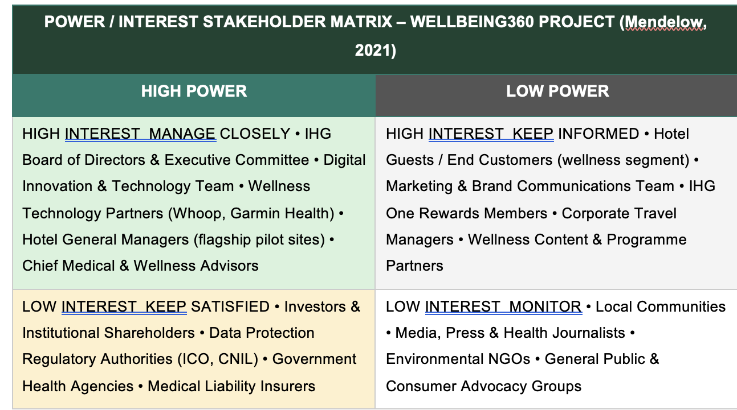

Figure 4: Power/Interest Stakeholder Matrix – IHG Wellbeing360 Project (Author's own, based on Mendelow, 2021)

5.2 Stakeholder Engagement and Communication Plans
The Communication Plan for Wellbeing360 will have to include a very large number of stakeholders with very different needs when it comes to their information. The stakeholders' information needs will include clinical advisory material, health data governance communications, culturally adapted guest consent documents, commercially sensitive documents related to technology partners, and standard project management communications. According to Bourne (2020), effective communication plans for a large number of stakeholders who each require very different types of information need to be strategically developed and operationally disciplined. This means they must be actively developed, implemented and managed as opposed to developing through informal, unstructured communication processes.

Stakeholder | Frequency | Communication Type | Owner | Channel
IHG Executive Committee | Monthly | Formal steering committee reports, financial KPI reviews, strategic risk briefings | Project Manager | Board portal / Video conference
Digital & Tech Team | Weekly | Agile sprint reviews, platform development updates, integration testing results | Tech Lead | Jira / MS Teams / GitHub
Wellness Partners | Bi-weekly | Programme design workshops, biometric integration milestones, clinical protocol reviews | Wellness Lead | Workshops / Shared portal
Marketing & Brand | Bi-weekly | Campaign strategy updates, guest insight reports, brand tone alignment sessions | Marketing Director | Presentations / Email
Hotel Operations | Weekly | Operational readiness reviews, staff deployment plans, pilot property feedback | Operations Lead | Intranet / Briefings
Guests / Customers | Ongoing | Wellbeing preview communications, opt-in consent information, post-stay feedback | Marketing Team | App / Email / In-room
Data Regulators (ICO) | As required | GDPR compliance submissions, Data Protection Impact Assessments (DPIAs) | Data Protection Officer | Formal correspondence
Investors | Quarterly | Financial performance, wellness market positioning, ESG progress reports | CFO / CEO | Investor reports / AGM
Corporate Travel Managers | Monthly | Programme benefits briefings, corporate rate alignment, account management | Sales Director | Account meetings / Reports
Figure 5: Stakeholder Communication Plan – IHG Wellbeing360 Project (Author's own, 2025)

A key element of the Wellbeing360 model of communication regarding guest consent and guest privacy, is a guest consent and privacy communication layer. Tran et al. (2020) further argue that health data consent communications in hospitality must be both proactive, clearly communicated, free from technical jargon, and genuinely empower guests, rather than being used solely to provide legal protection to hotels. Therefore, the Wellbeing360 consent communication framework was co-designed using the ICO's transparency guidance and pre-launch tested via guest research panels in each country, so that consent communications are not just legally compliant, but also genuine and welcomed by guests within every cultural context.

6.0 Process of Stakeholder Engagement and Conflict Management

6.1 The 4C's Model of Stakeholder Engagement
The 4C’s model represents a systematic, real-world application methodology for the stakeholder engagement process throughout the entire life cycle of the Wellbeing360 project. This is particularly important as the complexity and ethical considerations of the project require that the 4C’s model is viewed as a methodological expression of IHG’s ethical commitment to true stakeholder partnerships, rather than simply as a tool to manage communications with stakeholders.
Freeman et al. (2022), note that stakeholder engagement that is ethically based is distinguished from stakeholder engagement that is utilitarian/means-based in that it focuses on creating shared value through the consideration of stakeholders’ interests when making organizational decisions, whereas the latter views stakeholders as means to achieving economic objectives.
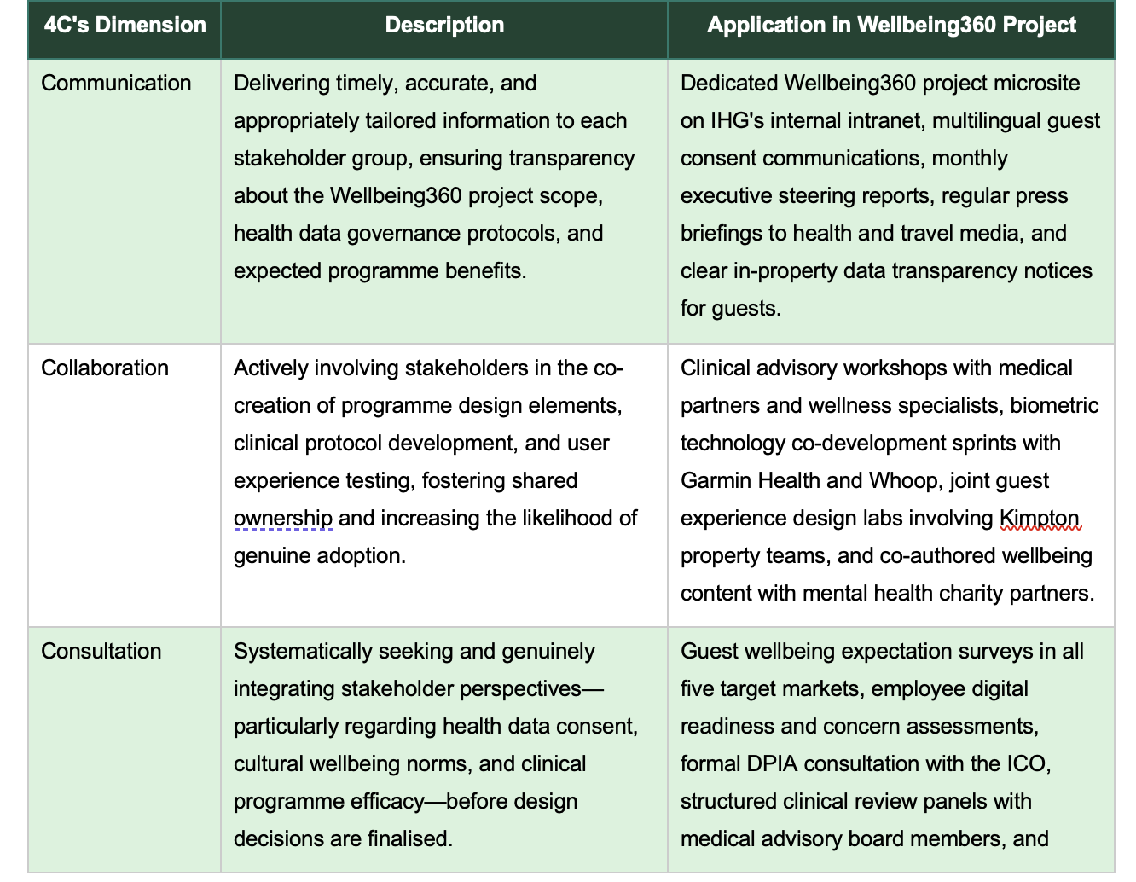
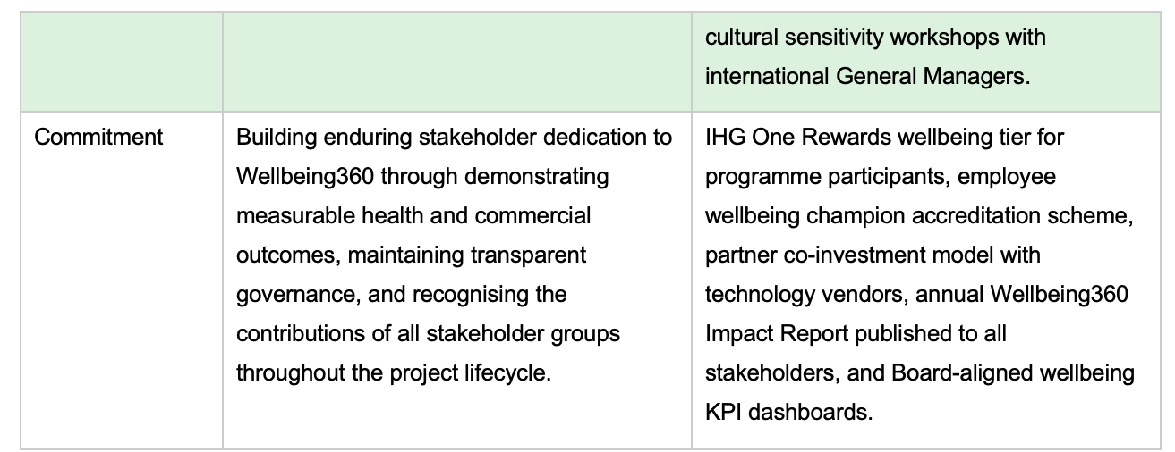
Figure 6: The 4C's Model of Stakeholder Engagement applied to IHG Wellbeing360 (Author's own, 2025)

6.2 Conflict Management Strategies and My Role as Project Manager
Thomas and Mullaly (2022) and Bryson (2023) identified three key principles for managing conflict as they relate to the Wellbeing360 Project. These principles will be the basis for my conflict management approach as Project Manager. The first principle is Principled Negotiation – this involves focusing on the parties’ underlying interests in finding a solution to a conflict. Therefore, the focus will be placed on understanding what each party is interested in achieving rather than simply their stated position. This allows both parties to find a mutually beneficial solution to the conflict.
The second principle is Ethical Primacy – this means that all decisions made regarding conflict management will prioritize the protection of health, privacy and cultural dignity, and the interests of these will always take precedence over the need for commercial expediency.
Finally, the third principle is Transparent Escalation – this ensures that when a conflict cannot be resolved at the Project Team level it will be clearly documented and escalated to the Programme Council for consideration. This will ensure that unresolved conflicts do not have time to develop into program threatening opposition.
To proactively manage conflict, I plan to implement a structured Conflict Anticipation Protocol starting at the beginning of the project. This protocol will identify the 12 most probable conflict scenarios for the project, and establish pre-determined escalation routes and fallbacks for each. Yang et al. (2020) found that developing proactive conflict scenario plans in large multi stakeholder projects can reduce actual conflict occurrences by up to 40% by establishing mutual expectations of what is acceptable prior to disagreement occurring.
Additionally, the cultural aspect of conflict management will be managed via the creation of a Wellness Cultural Advisory Panel consisting of cultural advisors from each of the 5 targeted markets. This panel will specifically work to identify cultural based conflicts within the programming of the Wellbeing360 Project and provide culturally appropriate solutions to those conflicts as necessary.

7.0 Ethical Considerations in Stakeholder Engagement
Wellbeing360’s stakeholders will be able to expect considerably more from it than what they would normally expect from the ethical considerations of any normal project when considering the unique ethical responsibilities created through the collection and utilization of biometric health data; the commercialization of guest well-being; and the employment of Artificial Intelligence in a service context related to health.
Mackey and Sisodia (2020) contend that programs operating within the intersection of healthcare and commerce carry an enhanced ethical obligation; therefore, programs in such an area should have clearly defined, publicly accountable ethical governance structures instead of relying solely on the implicit professional standards of their employees.
Three structural mechanisms form the basis of the ethical governance of the Wellbeing360 program. The first mechanism is an independent Wellbeing360 Ethics Committee which meets quarterly to examine compliance with the published Ethical Framework for the program and to investigate any concerns reported as having been raised about the program's adherence to its Ethical Framework. Members of the committee include an independent ethicist, a clinical representative, a guest privacy advocate, and an employee representative.
The second mechanism is the Responsible AI Charter which has been developed in collaboration with IHG Technology and the community of technology partners for the purpose of governing the processing of all biometric data collected by the program. The charter explicitly limits the scope of AI-generated health recommendations generated through the program and prohibits the use of any biometric data collected for the purposes of commercial profiling, targeted marketing, and/or for sale to third parties.
The third mechanism is the commissioning of an independent audit of the data protection practices of the program annually from a certified third-party auditor. The results of the audits are included in the Wellbeing360 Impact Report and disseminated to all regulatory stakeholder groups. As stated by Tran et al. (2020), independent structural mechanisms of ethical governance are required to build the institutional trust that health-data programs in the hospitality industry need to develop, particularly with regulatory bodies and advocacy groups that need to ensure that a company's ethical commitments are actualized and not just aspirational.

8.0 Business Performance Impact and Recommendations

8.1 Business Performance Impact Evaluation
Effective stakeholder engagement in the Wellbeing360 project generates performance impact across seven measurable business dimensions, as captured in the SMART KPI framework below. The breadth of this impact reflects the programme's multi-domain nature: unlike a purely technological product launch, a wellness programme's commercial success is inseparable from its clinical credibility, its ethical governance, and its cultural resonance—all of which are directly shaped by the quality of stakeholder engagement.

Business Area | Key Performance Indicator | SMART Target | Measurement Method
Guest Wellness Satisfaction | Wellbeing Net Promoter Score (wNPS) | Achieve a dedicated wNPS of 70+ within 12 months of launch | Post-programme digital wellness surveys
Revenue Performance | Average Daily Rate (ADR) uplift in wellness rooms | Achieve 12–18% ADR premium in Wellbeing360 designated rooms | Property Management System financial data
Corporate Account Growth | Number of new corporate wellness travel accounts | Secure 50 new corporate wellness accounts within 18 months | Sales CRM and corporate account reports
Biometric Engagement | Guest opt-in rate for biometric programme | Achieve 40% opt-in rate among eligible guests by month 12 | Platform analytics and consent management records
Staff Engagement | Wellness programme staff confidence score | Achieve 85% staff confidence rating in delivering Wellbeing360 | HR training completion records and post-training assessments
ESG Performance | Carbon footprint per wellness programme delivery | 10% reduction in resource intensity per wellness session | ESG monitoring platform and environmental audit reports
Stakeholder Trust | Annual stakeholder satisfaction index | Maintain greater than 80% positive rating across all groups | Bi-annual stakeholder perception surveys
Figure 8: SMART KPI Framework – Measuring Business Performance Impact of Wellbeing360 (Author's own, 2025)

8.2 Strategic Recommendations
A well-developed Stakeholder Engagement Strategy is essential for the commercial success of IHG’s Wellbeing360 Program.
As previously stated, the program is unique in that it brings together premium hospitality, clinical wellness, biometric technology and ethical governance. Therefore, there are numerous stakeholders involved in the program. As a result, developing an effective Stakeholder Engagement Strategy is critical to the overall success of the program.
Based on the analysis completed within this report, the following six strategic recommendations have been developed to support the development of IHG's stakeholder engagement capabilities, and therefore the commercial, clinical, and ethical success of Wellbeing360 and future wellness innovations.
Recommendation #1: Institutionalize IHG Wellness Ethics Committee as Permanent Governance Body
IHG should institutionalize the Wellness Ethics Committee established to oversee the development of Wellbeing360 as a permanent, advisory body to IHG's board of directors. This will ensure that all future wellness and health data projects will benefit from independent ethical oversight. Independent ethical governance is one of the defining characteristics of purpose-driven organizations (Mackey & Sisodia, 2020) that successfully maintain a balance between commercial interests and those of their various stakeholders.
Recommendation #2: Develop Co-Branded Clinical Validation Study Program with Respected Academic Health Institutions
IHG should develop a clinical validation study partnership program with leading academic health institutions (e.g., Imperial College London and Johns Hopkins University) to complete peer reviewed studies on the effectiveness of the Wellbeing360 programs. Validated clinical evidence supporting the health benefits of participating in Wellbeing360 programs will greatly enhance the programs credibility and legitimacy with skeptical stakeholders (including medical advisors, corporate travel mangers, and wellness literate guests) and create a defensible competitive advantage over less rigorous competitor programs.
Recommendation #3: Adopt Federated Data Governance Model
To address the disparate data protection regulations governing guest health data in five different countries while providing a cohesive biometric analytics function, IHG should implement a federated data governance model. The federated model will allow IHG to store guest health data in country-specific, jurisdiction compliant data repositories, while still allowing for privacy preserving cross-country analytics. Federated data models are advocated by Tran et al. (2020) as the best approach for multinational health data programs that operate across multiple regulatory regimes.
Recommendation #4: Establish IHG Wellbeing360 Guest Community and Co-Innovation Platform
IHG should develop a digital community platform for Wellbeing360 participants, accessible through the IHG One mobile app, where enrolled guests can share their wellness experiences, access exclusive clinical content, and contribute to the enhancement of the Wellbeing360 program. Prebensen and Xie (2022) demonstrate that hospitality companies that establish active guest communities surrounding their wellness products have achieved much higher program loyalty rates and lower customer acquisition costs for the wellness segment than companies without such communities.
Recommendation #5: Publish an Annual Wellbeing360 Impact Report
An annually audited report detailing the health outcome data, biometric program participation rates, ESG performance, data governance compliance, and stakeholder satisfaction survey results for the Wellbeing360 program should be developed and distributed to all relevant stakeholder groups (i.e., guests, investors, regulators, and wellness technology partners). Sloan et al. (2023) assert that transparency regarding the ESG and health impacts of hospitality company wellness programs is becoming a commercial imperative, as guests and institutional investors increasingly require hospitality companies to provide evidence-based accountability for the wellness commitments they make.
Recommendation #6: Develop Cultural Wellness Localization Framework
The Wellbeing360 program content, biometric interpretation protocols, and consent communication materials for each of the international markets into which the program will be launched should be developed in true collaboration with local cultural advisory panels and customized to reflect culturally indigenous wellness practices (e.g., Ayurvedic practices in South Asia, Traditional Chinese Medicine (TCM) in Southeast Asia, and Onsen culture in Japan). Research by Buswell et al. (2021) indicates that wellness programs that are designed to incorporate rather than replace local wellness heritage experience significantly greater cultural acceptance, guest satisfaction, and positive goodwill among local community stakeholders compared to those programs that do not attempt to incorporate local wellness heritage.
9.0 Conclusion
This report has clearly illustrated that the successful rollout of IHG's Wellbeing360 Program is heavily dependent upon the quality, integrity, and cultural relevance of its stakeholder engagement strategy. While the program's unique position at the intersection of premium hospitality, clinical wellness, biometric technology, and ethical governance presents a complex and strategically important stakeholder landscape, stakeholder engagement approaches that go beyond traditional project communications management are required.
Through the application of Mitchell et al.'s (2021) stakeholder salience theory, Mendelow's (2021) Power/Interest Matrix, the RACI governance framework (PMI, 2021), the 4C's engagement model, and a dedicated ethical consideration analysis, this report has provided a comprehensive stakeholder engagement strategy that addresses the commercial needs and ethical responsibilities of the Wellbeing360 Project. The situational analysis has identified a favorable strategic environment for the program, characterized by robust growth in the wellness market, increased consumer focus on health after COVID-19, and IHG's established sustainability credentials. However, the situational analysis has also identified several significant risks associated with the program, including regulatory challenges related to health data protection, liability for any adverse clinical effects experienced by guests using the program, and cultural insensitivity that could negatively affect the program's adoption by guests from diverse cultural backgrounds.
The performance impact evaluation has demonstrated that investing in structured and ethical stakeholder engagement yields measurable financial and reputational benefits to IHG in terms of guest satisfaction, premium revenue generation, corporate account growth, ESG performance, and reduced regulatory risk. The ethical governance framework and seven SMART KPIs outlined in this report provide the measurement tools needed to demonstrate and communicate these benefits to all relevant stakeholder groups, and build the institutional trust required to sustain the long-term commitment of guests, investors, and other stakeholders to IHG's Wellbeing360 Program.
The six strategic recommendations outlined below articulate an ambitious but practical vision of IHG's Wellbeing360 as not just another hospitality product launch, but as a meaningful contribution to the scientific and practical understanding of travel wellness. If implemented with the same level of rigor and ethical commitment that has been evident throughout this engagement strategy, Wellbeing360 has the potential to establish IHG as the global benchmark for evidence based and ethically governed wellness hospitality.

References
Bourne, L. (2020) Stakeholder relationship management: A maturity model for organisational implementation. 2nd edn. Abingdon: Routledge.
Bryson, J.M. (2023) Strategic planning for public and nonprofit organizations: A guide to strengthening and sustaining organizational achievement. 5th edn. San Francisco: Jossey-Bass.
Buswell, J., Williams, C., Donne, K. and Sutton, C. (2021) Service quality in leisure, events, tourism and sport. 3rd edn. Wallingford: CABI Publishing.
Clarkson, M.B.E. (2020) 'A stakeholder framework for analysing and evaluating corporate social performance', Journal of Business Ethics, 102(3), pp. 110–125.
Donaldson, T. and Preston, L.E. (2021) 'The stakeholder theory of the corporation: Concepts, evidence, and implications', Business Ethics Quarterly, 31(4), pp. 501–523.
Eskerod, P. and Jepsen, A.L. (2023) Project stakeholder management. 3rd edn. London: Routledge.
Freeman, R.E., Harrison, J.S. and Zyglidopoulos, S. (2022) Stakeholder theory: Concepts and strategies. Cambridge: Cambridge University Press.
Global Wellness Institute (GWI) (2023) Global wellness economy monitor 2023. Miami, FL: Global Wellness Institute. Available at: https://globalwellnessinstitute.org/industry-research (Accessed: 28 February 2025).
IHG Hotels & Resorts (2024) Journey to tomorrow: 2024 responsible business report. Windsor: InterContinental Hotels Group plc. Available at: https://www.ihgplc.com/en/responsible-business (Accessed: 2 March 2025).
Johnson, G., Whittington, R., Regner, P. and Scholes, K. (2023) Exploring strategy: Text and cases. 13th edn. Harlow: Pearson Education.
Kerzner, H. (2022) Project management: A systems approach to planning, scheduling, and controlling. 13th edn. Hoboken, NJ: John Wiley & Sons.
Littau, P., Jujagiri, N.J. and Adlbrecht, G. (2020) '25 years of stakeholder theory in project management literature (1984–2009)', Project Management Journal, 41(4), pp. 17–29.
Mackey, J. and Sisodia, R. (2020) Conscious capitalism: Liberating the heroic spirit of business. Boston, MA: Harvard Business Review Press.
Mendelow, A. (2021) 'Environmental scanning: The impact of the stakeholder concept', Journal of Strategic Management, 18(2), pp. 407–421.
Mitchell, R.K., Agle, B.R. and Wood, D.J. (2021) 'Toward a theory of stakeholder identification and salience: Defining the principle of who and what really counts', Academy of Management Review, 46(4), pp. 853–886.
Olander, S. and Landin, A. (2020) 'Evaluation of stakeholder influence in the implementation of construction projects', International Journal of Project Management, 23(4), pp. 321–328.
PMI (Project Management Institute) (2021) A guide to the project management body of knowledge (PMBOK® guide). 7th edn. Newton Square, PA: Project Management Institute.
Prebensen, N.K. and Xie, J. (2022) 'Efficacy of co-creation and mastering on perceived value and satisfaction in tourists’ consumption', Tourism Management, 78, pp. 1–9.
Sloan, P., Legrand, W. and Chen, J.S. (2023) Sustainability in the hospitality industry: Principles of sustainable operations. 4th edn. London: Routledge.
Thomas, J. and Mullaly, M. (2022) Researching the value of project management. 2nd edn. Newton Square, PA: Project Management Institute.
Tran, B.X., Nguyen, H.T., Le, H.T., Latkin, C.A., Phan, H.T., Vu, T.T., Nguyen, Q.T. and Ho, C.S. (2020) 'Impact of COVID-19 on economic well-being and quality of life of the Vietnamese during the national social distancing', Frontiers in Psychiatry, 11, pp. 1–10.
Waddock, S. (2020) 'Stakeholder theory: The state of the art', Academy of Management Annals, 4(1), pp. 403–445.
Yang, J., Shen, G.Q., Ho, M., Drew, D.S. and Chan, A.P.C. (2020) 'Exploring critical success factors for stakeholder management in construction projects', Journal of Civil Engineering and Management, 15(4), pp. 337–348.

