  Component One:  What are the key skills required when working in the housekeeping team? 750 words (+/- 10%)  Contribution to Overall Module Assessment: 25% | Student No: | Marina Georgiana Hogea  2131351
 | Module Title: | Operating Hotel Facilities
 | Module Code: | BMIH4006
 | Lecturer: | Lola Villard

Component 1
Introduction
The portfolio will focus on the personal skills that I have to poses to be a part of the team of housekeeping services. Behavioural skills are necessary for this job and these behavioural skills will be the reason for customer satisfaction. The portfolio has also mentioned the detailed study of those behavioural skills and the way these are going to affect the housekeeper’s job.

Key skills necessary for working within a housekeeping team
Communication skills
Communication is an essential skill for the housekeeping job and I have possessed the skills. I like to communicate with different people of different cultures (betterteam, 2022). Housekeepers have to communicate with the guests on regular basis. They have to understand the problems and requirements of the guests through thoughtful communication. Communication is also needed for maintaining collaboration among the housekeeping team members. And this is another importance of communication skills. It will be right for me to be part of the housekeeping team of an organisation. I will be able to collaborate with the team members and try to provide the best service, which will be demanded by the customers.
Flexibility
The housekeepers have to be flexible with the unusual time schedules of work. I am ready to be flexible with the schedule that I will be provided with. Late night shift and early morning duty shifts are very common for housekeepers. Even the housekeepers have to be flexible with their workload and diversity of the job on the need of the guests. The housekeepers also have to be flexible with the different behaviour of their guests. I will be able to adapt myself to this job type and be ready to work during any working hours. I will also be able to adjust to additional duties and the guests’ behaviours as well.
Showing courtesy to the guests
The responsibility of a housekeeping team is to serve their guests and show courtesy to them. I have the personality to give regard to people and this is a significant key skill to being part of a housekeeping team (Alvarez, 2021). I have to be patient with the demands of the housekeeping services such as serving towels, cutleries, drinking water, and toilet necessities on the demands of the guests. I will try to understand the necessities of my guests and provide for those needs by showing courtesy to them.
Accuracy
The housekeepers have to do a detail-oriented job due to please their guests. The housekeepers have to organise the object in an organised manner. They have to clean the bed sheets, floor, bathrooms and other appliances as well. The minor details will keep their guests delighted and they will like to visit there again. So, accuracy in the job is one of the significant criteria in the housekeeping job. I will do my job accurately and keep my attention on minor details. I will keep the necessities clean and organised so that they will be appropriate for the guests.
Customer Service
Customer service is one of the significant skills that I have while working in the housekeeping team. It will be important to make sure that using my abilities I will be able to provide feasible services to the customers. It is also essential to remember that if the customers are not happy with the cleaning services, then this will bring an adverse impact on my career as a housekeeper. For example, if the customer is not satisfied and feels the bedsheets are not changed on a regular basis they will raise complaints. Another example includes the ineffective arrangement of the rooms by neither removing garbage nor restocking the bathroom essentials like soaps, shampoos and so on. Therefore using my skills of potent cleaning and rearranging the rooms will definitely solve the issues of unsatisfactory customer service (Bridger, 2018).

Honesty
Honesty is the core skill that I have inculcated when I will be working with the housekeeping team. It is an important aspect since I will have to manage the chores within the organisation. Starting from cleaning to maintaining all the equipment within the industry, as a member of housekeeping I will be responsible for taking care of all the factors. Therefore, not being able to accept any kind of fault will compromise the career of a successful housekeeper. For example, if the management finds any kind of damage like a broken window, torn curtains, stains of the bedsheets and so on in return does not get an honest acceptance of those faults. Then this will impact the overall housekeeping team. Therefore to avoid this, I will make sure to properly maintain all the equipment, yet in case of any error I will be honest and accept my fault.

Conclusion
The portfolio has mentioned the significant key skills of the housekeeper services. Skills like communication, team collaboration and flexible behaviours are the key skills of housekeepers. Honesty, cleanliness and accuracy are the reason for customer satisfaction with this service. These skills are posed by me so I am an eligible candidate to be a part of the housekeeping team.

Word Count

Component Two:
Contribution to Overall Module Assessment: 25%
In this scenario – You have just been promoted to team leader for a floor within the hotel. A guest complains that on their arrival, their room had not been properly cleaned. Create an action plan and answer the following questions.

Problem | Why did it happen? | What are you going to do? | How will you prevent this from happening in the future? | What measures would you introduce to improve team effectiveness?
Linens have big patches of stains spread in multiple places all over the bed sheet (Casado, 2012). | The first reason was washing the white lines along with the coloured sheets that caused the white linen to get stained, from colour leakage. Another reason for stained linen was due to the food and beverage being spilt on the white sheets (Fallon, and Rutherford, 2010). | To resolve this problem I will check the bedrooms and then replace the stained clines with clean ones before the guests arrive. | To prevent the linens from getting stained in the future, the first thing I will do is wash the white lines separately from that of the coloured ones, so there are no colours released from the coloured sheets. Next, I will completely avoid using the sheets that have food stains over them and rather discard the sheets | I will make sure to guide my team members to use separate washing machines to avoid stain issues. Further, I will guide my team members to discard and keep a check on the stained sheets from the stack so that they can only use the fresh and clean sheets.
There are multiple marks all over the floor. These were stain marks as well as scratch marks. | The floors get marks since many of the guests have the habit of spilling food all over the floor. The next reason is that the kids play on the floor and end up scratching on the floor. | To resolve this issue I will check the floor and make my team members clean the floor of food spills. In case of scratches, I will inform the maintenance team to renovate the floor. | In order to prevent floor marks in future I will make my team regularly check the floors all over the room. | Before making reservations for any room I will instruct my teammates to properly check the rooms and make necessary changes in regard to damaged floors.
There was an insufficient amount of toiletries in the washrooms, causing inconvenience to the guests (Ferdinand, and Kitchin. 2017). | There were fewer toiletries in the storage facility which caused this problem (Johnston et al., 2022) | I will ask my team to start filling the washroom with the toiletries left in the storage so that the guest will not have any discomfort. | In order to avoid this situation in the future I will make sure to keep the list of items from the storage to avoid such failures in the future. | I will convey to my team to always stay updated on the whereabouts of toiletries and to inform me beforehand in case any item is fewer in number so they can be refilled before they get over.
The washrooms were left uncleaned (Rogers, 2008) . | The staff missed cleaning the washrooms in time (Whiting, and Symon, 2020). | I will keep my team regularly engaged in cleaning the toilets every day for at least two times a day. | To prevent this error I will ask my team to always check the toilets twice a day before and after the guests go and enter the room. | I will guide each one of the members to respectively keep tabs on the washrooms on each floor, to avoid missing out on any toilet
The rooms were dusty including the furniture and crockeries Jacob et al, 2021). | Improper dusting and vacuuming of the rooms including the furniture caused this issue . | I will make the team use a vacuum cleaner at all times whenever there is the slightest dust. | In order to prevent this in the future I will ensure to check the rooms personally and keep a note before my team does. | I will make sure my team takes a proper survey of all the rooms, so in case they miss any spots, I will be guiding them properly.

Component Three:
Contribution to Overall Module Assessment: 50%
Your task is to create and prepare a presentation following the detailed scenario provided below.

As the floor housekeeping manager and given the recent guest complaints you need to put together a basic training presentation for your colleagues within the housekeeping team to get the best out of them, ensure that brand standard is being achieved and that Health and Safety procedures are also being followed.

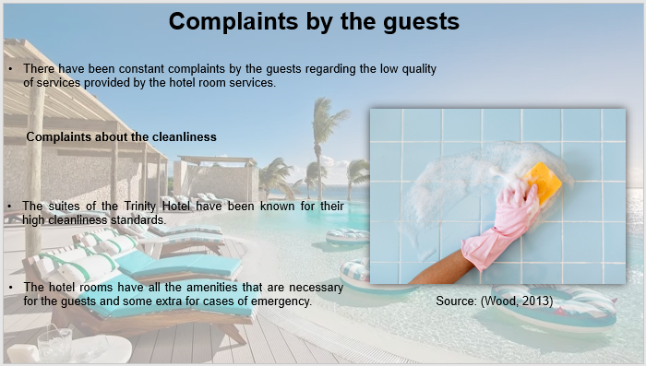

Training Notes:
Complaints by the guests
There have been constant complaints by the guests regarding the low quality of services provided by the hotel room services. The complaints have all been centred around the quality of amenities that are provided to them. The other complaints surrounding the behaviour and humility of the service personnel.
Complaints about the cleanliness
The suites of the Trinity Hotel have been known for their high cleanliness standards. The hotel rooms have all the amenities that are necessary for the guests and some extra for cases of emergency. The recent feedback from the guests in the hotel has been a cause of stress for the hotel management. The standards provided by the hotel have been degrading and the drapes and the linen that the hotel rooms have become old and yellowish stains are visible throughout them. This shows carelessness in the laundry department. The cleanliness of the floor and the room has also been lacking and there have been complaints of irregularities in the cleaning services as well. The complaints have been becoming more and more frequent as the carelessness of the staff is being pointed out by the guests. This has managed to decrease the perception of people about the standards maintained by the hotel and compromised its brand image.

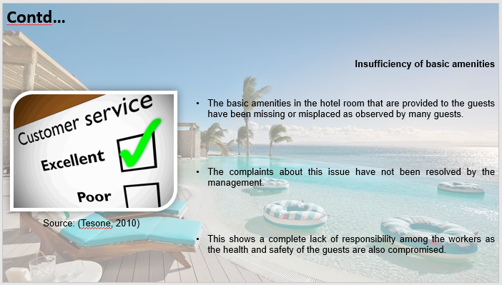

Training Notes:
Insufficiency of basic amenities
The basic amenities in the hotel room that are provided to the guests have been missing or misplaced as observed by many guests. This has enraged many of them as the complaints have been neglected in most of the cases as the guests were trying to become more agitated due to the lack of sincerity in the service personnel. Basic amenities like the toiletries like soaps and shampoo have not been available for the guests when they arrived in their rooms. The complaints about this issue have not been resolved by the management. This shows a complete lack of responsibility among the workers as the health and safety of the guests are also compromised.

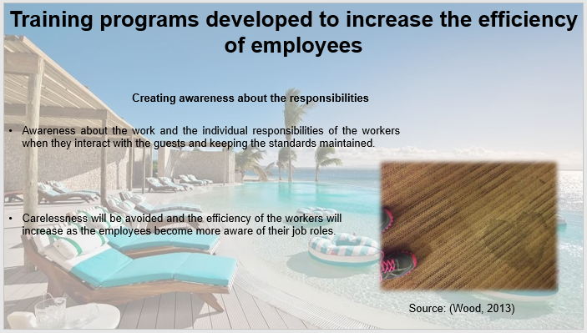

Training Notes:
Training programs developed to increase the efficiency of employees
Creating awareness about the responsibilities
Awareness about the work and the individual responsibilities of the workers when they interact with the guests and keeping the standards maintained. The lack of awareness about the work and the extent of responsibilities creates issues sometimes that are observed in the individual work of the employees (FinancesOnline, 2022). A training program that will have all the responsibilities according to the job role is to be developed so that the employees can understand their work responsibilities clearly and hence the complaints will eventually subside. Carelessness will be avoided and the efficiency of the workers will increase as the employees become more aware of their job roles.

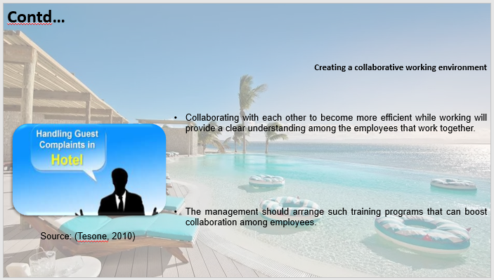

Training Notes:
Creating a collaborative working environment
Collaborating with each other to become more efficient while working will provide a clear understanding among the employees that work together and will ensure that the issues about working efficiency will be resolved readily. The management should arrange such training programs that can boost collaboration among employees and will be effective in increasing the productivity of the employees as a whole (TheHartford, 2022). Training employees to properly communicate among themselves will increase the efficiency of the room service personnel as they become more and more engaged in their work. This will also provide insight to employees in their respective roles in a work where collaboration is required.

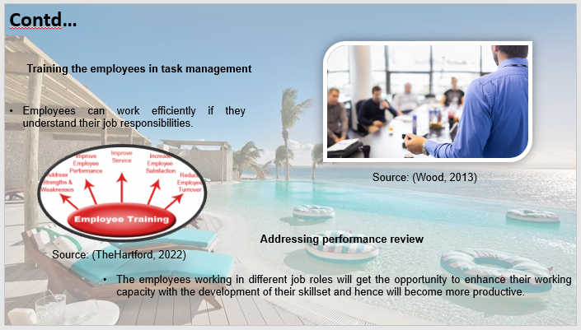

Training Notes:
Training the employees in task management
Employees can work efficiently if they understand their job responsibilities. This is a prerequisite while task management is also a prominent skill that the employees have to know so that they can manage their work efficiently and increase their productivity. The productivity of the employees will increase by training them through a program that will help them create a routine for helping them increase their efficiency in effectively managing their work. The effective management of the work will lead to the employees developing a proper sense around their work and hence the productivity at work will the boosted.
Addressing performance review
The individual performance of the employees should be monitored and a performance review should be created so as work on the individual issues that the employees face while working and hence affecting the overall work of the whole staff. The performance review of the employees will be used by the management to develop the skills of the employees that are relevant to the work in their job role (Sharma et al, 2019). The employees working in different job roles will get the opportunity to enhance their working capacity with the development of their skillset and hence will become more productive.

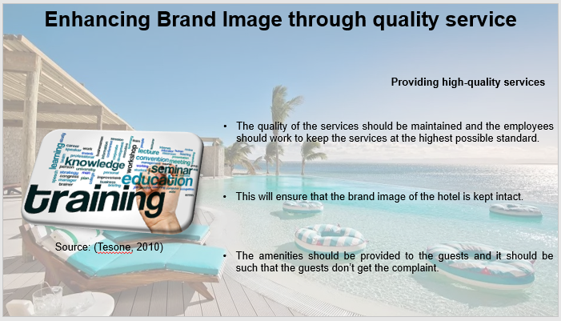

Training Notes:
Enhancing Brand Image through quality service
Providing high-quality services
The quality of the services should be maintained and the employees should work to keep the services at the highest possible standard. This will ensure that the brand image of the hotel is kept intact. The amenities should be provided to the guests and it should be such that the guests don’t get the complaint. Developing a training program that teaches all this should be undertaken where all the standard procedures of providing services to the guests should be clearly dictated to the service personnel. The training program should also include a standard procedure brochure that should be handed down to the employees explaining their job role and the things they are expected of while serving the guests.

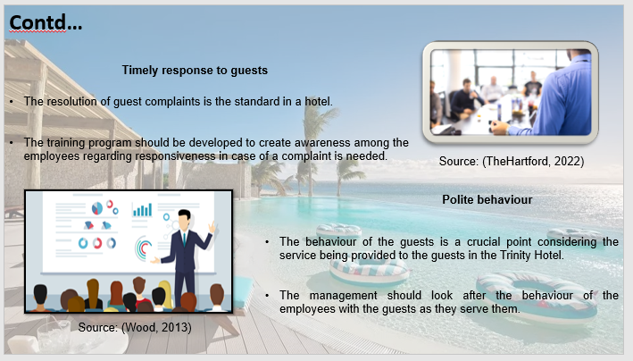

Training Notes:
Timely response to guests
The resolution of guest complaints is the standard in a hotel. However, in case there is a complaint, it should be resolved with readiness and as soon as possible to instil the idea into the mind of the guest about the alertness about comfort at the Trinity Hotel they get (Tesone, 2010). The training program should be developed to create awareness among the employees regarding responsiveness in case of a complaint is needed. This will be done by developing a training program that increases alertness among the employees as they work.
Polite behaviour
The behaviour of the guests is a crucial point considering the service being provided to the guests in the Trinity Hotel. The management should look after the behaviour of the employees with the guests as they serve them. The politeness in the behaviour of the employees while serving the guests will provide a boost to the brand image of the organisation. The guests will be satisfied and will provide good feedback to the hotel (Wood, 2013). Ensuring good behaviour from the employees should be done by the management by creating a training program that teaches basic humility and the way to engage guests in a polite manner. This will give the employees an insight into the mannerism that is associated with being in room service at Trinity Hotel.

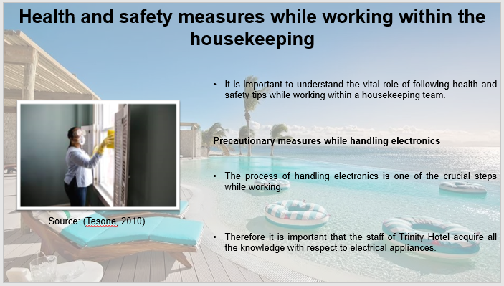

Training Notes:
Health and safety measures while working within the housekeeping
It is important to understand the vital role of following health and safety tips while working within a housekeeping team. Several tips and factors are included that can facilitate the proper handling of equipment.
Precautionary measures while handling electronics
The process of handling electronics is one of the crucial steps while working. Therefore it is important that the staff of Trinity Hotel acquire all the knowledge with respect to electrical appliances. The first thing to remember is to never leave any of the electrical cleaning appliances unattended. Next, the staff must make sure to never use electric items while handling water. This care should be specially taken care of while cleaning the bathrooms and arranging the appliances like hair drier and so on. Additionally, the staff must make sure to regularly keep checking for damaged cables and not get into direct contact with the exposed and broken wires.

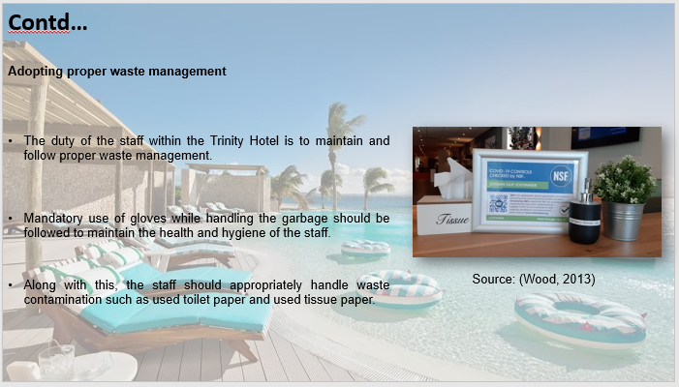

Training Notes:
Proper usage of the basic procedures
Several factors are included while taking care of the general procedures within Trinity Hotel. One such factor is the proper handling of fire and emergency measures. It is the duty of housekeeping staff to keep emergency equipment such as fire extinguishers on each floor of the hotel. Additionally, the staff must have a standard operating procedure for the Fire Evacuation plan and they must be followed in times of emergency. Apart from this, the staff must also make sure to not leave harmful toxic substances lying around. This should be mainly followed so as to avoid children near such substances.

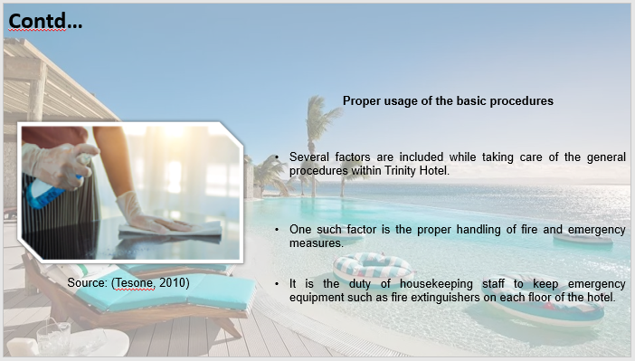

Training Notes:

References

Alvarez, M., (2021). 4 Traits of Good Housekeeping Staff. [Online] Available at: https://www.gigworx.com/blog/4-traits-of-good-housekeeping-staff [Accessed 23 01 2022].
betterteam, (2022). Housekeeper Job Description. [Online] Available at: https://www.betterteam.com/housekeeper-job-description [Accessed 23 01 2023].
Bridger, E. (2018) Employee engagement: a practical introduction. 2nd ed. HR Fundamentals. London: CIPD and Kogan Page.
Casado, M. (2012) Housekeeping Management. London: Wiley.
Fallon, M. & Rutherford, D. (2010) Hotel Management and Operations. London: Pearson
Ferdinand, N. and Kitchin, P. (2017) Events Management - An International Approach. 2nd ed. London: SAGE Publications Ltd.
FinancesOnline, (2022). Productivity Training: 8 Ways to Train Your Employees. [Online] Available at: https://financesonline.com/productivity-training/ [Accessed 23 01 2023].
Jacob, J., Thomas, M.N. and Nundy, S., (2021). Patient feedback on the quality of care they receive in hospitals in the UK: Is it possible to replicate this in India?. Journal of Medical Evidence, 2(2), p.191.
Johnston, R., Clark, G. & Shulver, M. (2012) Service Operations Management. London: Pearson. Jones, T. (2010) Professional Management of Housekeeping Operations. London: Wiley.
Rogers, T. (2008) Conferences and conventions a global industry (2nd ed., Events management series). Oxford ; Boston: Butterworth-Heinemann.
Sharma, N.E., Chaudhary, N.E. and Singh, V.K.E., (2019). Management techniques for employee engagement in contemporary organizations. Business Science Reference/IGI Global.
Tesone, D., (2010). Principles of management for the hospitality industry. Routledge.
TheHartford, (2022). How to Push Performance With Training Programs. [Online] Available at: https://www.thehartford.com/business-insurance/strategy/employee-performance/improving-performance [Accessed 23 01 2023].
Tram, B.T.A., (2022). Solutions to Enhance the Quality of the Housekeeping Department: Natural Homestay, Hoi An, Viet Nam.
Whiting, R. and Symon, G., (2020). Digi-housekeeping: the invisible work of flexibility. Work, employment and society, 34(6), pp.1079-1096.
Wood, R.C., (2013). Key concepts in hospitality management. Key Concepts in Hospitality Management, pp.1-200.

