Reflective review though learning journey

14th June 2019
University of Wales Trinity Saint Davis

To open a successful business education is very important this why starting university is a such big opportunity to progress. During the course I conduct on myself analysis like SOWT I recognize my SMART goal and acknowledge which type of leaning sty I am. All those expirees will have very big impact on my plans to open transport and delivery business.

I’m writing this assignment to reflect my learning journey “structured and supported process to develop the capacity of individuals to reflect upon their own learning and achievement and to plan for their own personal, educational and career development”(NCIHE, 1997) I am 35 yours old I am a father and provider for my family who decide that he will take is future in his hands, to do so I have one goal to be the owner of successfully running transport/ express delivery business. To achieve this goal my personal development plan begins with reeducating myself. I have made a decision to studying at University of Wales Trinity Saint Davis business camp and I choose to study skills of work place to help me develop myself. This is my first step to learn how to achieve my goal of having my own business. Education in business is very import gives us the opportunity to know how to understand and run business effectively.

To become a successful owner of good running business is good to have high education, it is not necessary according to statistic as only 20% of entrepreneurs has high education degree, but also can be a main reason to run your business successfully if you have right background (Schror H, 2006) which in my case is very important because I do not have any business-oriented education and this course is the best opportunity for me to learn how to start and how to run my own business.
As we learned that self awareness is very important, is the first setup towards our goals, allows you to know yourself better understanding your emotions, strengths your behavior, recognizing which type of person you are which leaning style will be best for you. And knowing you self understanding your needs helps you to direct your carrier in the right way. (path way to happiness)

I have learned already that to achieve my goal I need to make it to be S.M.A.R.T

-Specific, according to growing delivery market the express industry simplifies and speeds up the process of carrying products. It organizes collection, generally at the end of the business day, enables the recipient access to data on the advancement of deliveries from pick-up to shipment and gives evidence of service.(Oxford Economic Forecasting,2005) I chose to start transport and delivery business, I will be contracted by places for example like amazon build connections and bring as much costumers as is possible.
-Measurable, I will educate myself in business area which will be, finishing “Skills of work place” course, I will make connections to expand my business.
-Achievable, realistically thinking to achieve this goal I need to educate myself in this area, and safe enough money to buy my first van.
-Relevant, achieving my goal will have big impact on my family as having my one business it will help me to provide better for my dependent.
-Time-bound, I want to start my business on the begin of October 2019, this is the perfect time for delivery, as it is the beginning of Christmas shopping madness. And by October 2020 I’m planning to have at least 2 more Vans working for me.
(MindTools

To measure and acknowledge yourself assessment and build good personal development plan is important to use a right tool like conducting analysis, models and theories.

1. SWOT analyses is one of the best ways to be aware of ourselves better, helps you to analyze our strengths, weaknesses, opportunities and thread, during Professional Career Development Program module I have learn how to analyze myself basic on SWOT.

“SWOT Analysis is a useful technique for understanding your Strengths and Weaknesses, and for identifying both the Opportunities open to you and the Threats you face” (MindTools)
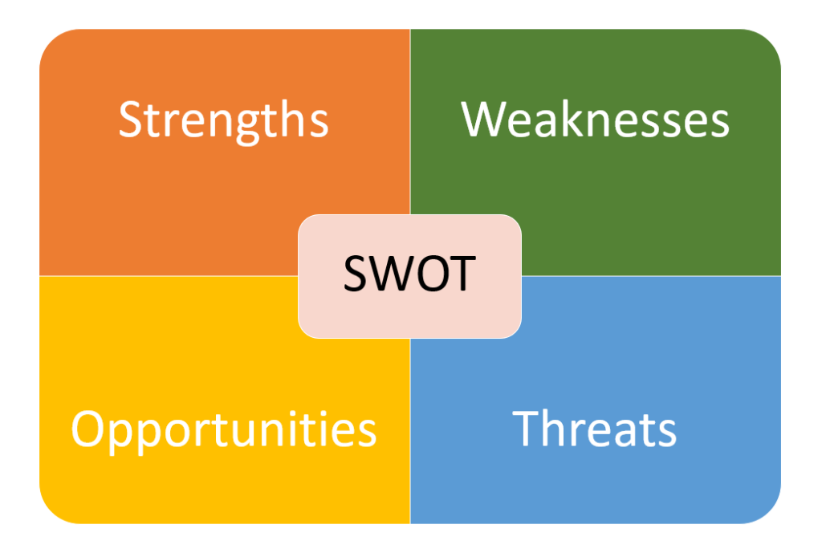

“Created in the mid-20th century by Albert Humphrey, a business consultant, SWOT analysis is one of the most used self-improvement methods in the business world nowadays”(Ceta, 2018)

After putting myself through SWOT analyses I can say my strengths are: being well organized, a good skill to make sure delivery will be on time, paying attention to details, observative, being in control in critical situations and I’m very confident that those are very good skills to run a business.
There are also weakness like not being patient and new growing business specially need patient, time is important to build connections in transport, and sometime can take a bit longer then we expecting so that brings us to another of my weekends which is quitting if there is not quick results and sings of development perspectives, I’m most likely to quit on beginning. Fear of failure a fear of losing if the business not succeed more we have to loos bigger the fear it is . For example, the capital of the company will be all our savings then more careful we will be to invest the money. ( Sebetlela, 2017)

And this is another of my weakness which can have big impact on running a business, I am putting a lot of hard work to overcome my weakness and one of the best ways is to understand them.
In 21st century express delivery industry is one of the most growing areas of business in the world. Growing economy and people's needs makes delivery business expanding (Oxford Economic Forecasting,2005) and for me this is the biggest opportunity to star my own business. Unfortunately, they are also threats to my business plan as well, like we already know that express delivery industry is growing that of course bring bigger competition on the market and not having strong financial support I’m facing a threat to my plan.
Using your SWOT analysis gives advantage of yourself awarnes and trough conversion strategies you can covert your weaknesses to your strength and opportunities.
Being a business owner means to have to employee people and is important to know how people around, seeing you and in business area those people around are your employees and business partners.
Conducting Johari window model on yourself which I learn during my classes is a perfect way to understand and to be self awareness about how the people around think and feel about you. this think is very important because helps you to build connection with your staff and gain their trust. understanding your staff and kipping them happy is an important tool to your business success.

2. Leaning style
During the course so far, I have learned about my learning ability, according to Honey and Mumford (1992) my leaning style is Theorist. This shows the fact that I adapt and integrate observations into complex but logically theories.
Thinking my plans through a step by step calculated way, trying to assimilate disparate facts in to coherent theories.
Putting the learning stile in action to help to help me build a prosper business is a real proof of my learning style, always asking if “does it make sense?’’ “How does this fit with that?”
Always relying on basic assumptions, principles, theories, models and systems thinking. (University of Leicester)
A different learning style which is very adequate for me is kinaesthetic according to VARK model by Fleming and Mills (1992). Although evaluated as a distinct category in VARK, learning through kinesthetics is a measurement method based on the mixture of different sensory features. Kinaesthetic type is more likely to experience something through the aspect of physical motion while studying, such as touching, feeling, holding, performing, and moving. They prefer working hands, practical, project and real experience. ( Vark-leaning)
This is another strong point in the success of my business because will always keep me in touch with I want to do, I will always be in physical contact, holding, handling goods I transport.
This way I can get the experience and find out the real problems and how to fix them.

3. GO MAD Making a difference this thinking model has been developed by Andy Gilbert and Ian Chakroverty. According to the book (Gilbert, 2005. pp.21-28) the model based on sevens key principles:
- What is the reason why you want to make difference
- Define your goal
- Priorities and plan your moves
- Believe in yourself that you can make a difference
- Involve people around you
- take person responsibility
- Take action
Anyone can make a differences no matter who you are how intelligent and educate or what job you do there is always good time to GO MAD. Looking from this perspective I believe that I can GO MAD. Based on this model I present my plan to achieve better life. To do so I will build good running transport/ delivery business. first of all, I need to buy my first van and establish the logistic. I feel confident that my plan will work I’m taking the responsibility and risks. In order to know the area better I have been consulting my plan with experience friend, if everything will go according to the plan that I will measure my success with receiving high income
counting money :)

I am confident with My plan
I assume the risk and consequences
guided by a friend with experience

having a good running transport business
buying a van, establish the logistic
better life

To conclude my learning journey, I can say that starting University of Wales Trinity Saint Davis having very big impact on my life. Doing my research to complete this assignment I have gather many useful knowledges, I understood how transportation market is working and what difficulties can I find as an owner of the business. Also gave my bigger and newer perspectives about this industry. After putting myself through SWOT analysis and recognizant my SMART goal and realize my learning style I understood what, where and how to become a stronger individua, this will help me with my business plan and will considerably increase the chance of having a successful business. SWOT analysis helped me to discover new strengths and weaknesses, and also made me self aware and shaped a NEW Me.
SWOT analysis also helped Me to understand about the external factors what I can not control them, but I can do a better analysis on opportunities and threats.
Another important thing which I became aware of from my SWOT analysis is that I need to find in my strengths that particular strength which makes me different from my competitors. Making my goal SMART gives me better chances of achieving as carefully planning and analyzing the outcome makes it more realistic. I want to make a difference in my life, to support this I believe that my goal is achievable.

Bibliography

- Ceta,N (2018) SWOT Analysis – What is it and How to do it. Available at: https://tallyfy.com/swot-analysis/ (Acceded: 11th June 2019)

- Gilbert, A. (2005) Go MAD – The Art of Making A Difference, Norflock: Biddles.

- Oxford Economic Forecasting. (March 2005),THE IMPACT OF THE EXPRESS DELIVERY INDUSTRY ON THE GLOBAL ECONOMY, pp 3. Oxford: Oxford Economic Forecasting

- Oxford Economic Forecasting. (March 2005),THE IMPACT OF THE EXPRESS DELIVERY INDUSTRY ON THE GLOBAL ECONOMY, Oxford: Oxford Economic Forecasting

- Mind Tools. (2018) How to set SMART goals [video]. Available at; https://www.youtube.com/watch?v=OXA6gfzFA24 ( Acceded: 10th June 2019)

- Mind Tools, SWOT Analysis, Discover New Opportunities, Manage and Eliminate Threats. Available at: https://www.mindtools.com/pages/article/newTMC_05.htm ( Acceded on 7th June 2019)

- NCIHE (1997). Higher education in the learning society (The Dearing Report).London: NCIHE.

- Path to happiness, available at:https://www.pathwaytohappiness.com/self-awareness.htm, (accessed on 07th June 2019)

- Sebetlela, M. (2017) Fear of Failure: How to Overcome It. Morrisville: Lulu Press

- SCHROR H, 2006, The profile of the successful entrepreneur, Factors of Business Success, pp 8

- University of Leicester, Honey and Mumford. Available at: https://www2.le.ac.uk/departments/doctoralcollege/training/eresources/teaching/theories/honey-mumford. (Acceded: 12th June 2019);

- Vark-learn, The Dark Modalities .Availebe at :http://vark-learn.com/introduction-to-vark/the-vark-modalities/

