Gabor Jonas
Student Number: 1705136
Course: Web Development HND
Module Name: ACCA4006 PROGRAMMING II
Date: 2018/03/23

Table of Contents
PART A (UNDERSTANDING) 3
Description of subdividing problems into function 3
PART B (TESTING) 4
PART C (IMPLEMENTATION) 12
Exercise 1 12
Exercise 2 17
Exercise 3 17
Appendices 18
Appendix 1 18
Appendix 2 23
Appendix 3 28

PART A (UNDERSTANDING)

Description of subdividing problems into function

Example: Gomoku game
Description
The game is played using a 15x15 grid board. The players place X or O on the board. The winner is the first player who form a chain of five sign horizontally vertically or diagonally.
Problems:
How is the board represented?
- Multidimensional array declaration pattern
- This function doesn’t return any value, just fills the array with initialising values
Char board [15][15];
Void InitialiseBoard();
How is the board displayed?
- Display -> printf
- 2d array -> Multidimensional array counting loop pattern
- This function doesn’t return any value, just fills the array with initialising values
Void DisplayBoard();
How can the user input location?
- Input ->scanf
- X and Y coordinates -> generic problem
- This function returns the number read from user
Int ReadNumber();
Adding X or O to the board?
- 2d array -> Multidimensional array counting loop pattern
- This function doesn’t return any value, but needs the x and y coordinates
Void AddToBoard(int x, int y)
How to check who is the winner?
- Check for specific values in array if they are the same -> branch pattern
- This function doesn’t return any value, just checks the board and displays winner
Void CheckChainOfFive();

PART B (TESTING)

Problem 1
Source code included in Appendix 1
Problem 1 test
1 | User enters menu option
Description |  | The user enters a valid option number
 |  | Test Steps:
1 | Message displayed asking user to enter number
2 | The number 1 is entered  The number 2 is entered  The number 3 is entered

Response |  | The program should not produce an error message and should continue to next step
Status |  |  | Date |  |  | Description
Pass |  |  | 23/03/18 10.00 |  |  | Passed

2 | User enters invalid menu option
Description |  | The user enters a value that is neither a number nor a valid option
 |  | Test Steps:
1 | Message displayed asking user to enter number
2 | Enter values that are not numbers:  a, a1, 1a  Enter a number that is not an option:  44  Enter negative number:  -5
3 | Re-enter an invalid number or option

Response |  | For invalid numbers the program should display an error message and ask the user to re-enter a number  For an invalid option number, the program should display an error message and telling the user the option was invalid and the user should be asked to enter another menu option choice.
Status |  |  | Date |  |  | Description
Fail |  |  | 23/03/18 10.15 |  |  | A warning message was not displayed when 1a was entered

Problem 1 description

Problem 2
Problem 2 test
1 | User enters keyword to quit
Description |  | The user enters a valid keyword
 |  | Test Steps:
1 | Message displayed asking user to confirm quitting
2 | User enter YES, Yes, yes or y

Response |  | The program should not produce an error message and should display Quitting
Status |  |  | Date |  |  | Description
Pass |  |  | 23/03/18 10.30 |  |  | Quitting message was displayed for YES
Fail |  |  | 23/03/18 10.30 |  |  | Quitting message was not displayed for Yes, yes, y
Pass |  |  | 23/03/18 10.45 |  |  | Quitting message was displayed for all keyword

2 | User enters keyword to quit
Description |  | The user enters an invalid keyword
 |  | Test Steps:
1 | Message displayed asking user to confirm quitting
2 | User enter text\numbers that are not YES, Yes, yes or y

Response |  | The program should not display “quitting”, and should return to the menu
Status |  |  | Date |  |  | Description
Pass |  |  | 23/03/18 11.00 |  |  | The program didn’t display “quitting” and returned to the menu

Problem 2 description
In IsQuitting method only returns true if the string in response variable is “YES”
Problem 1 solution:
Adding “Yes”, “Yes”, “yes” and “y” as acceptable condition to the if statement. If one of them is true, quit variable is set true and returned at the end of the method

Screenshots:
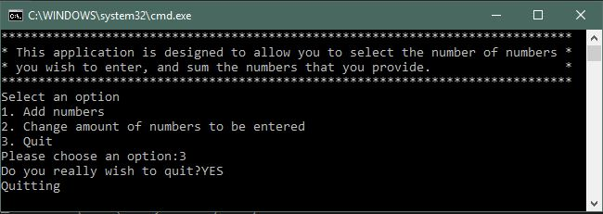
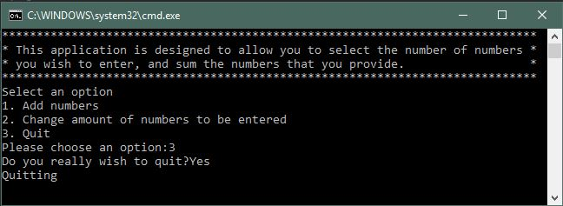
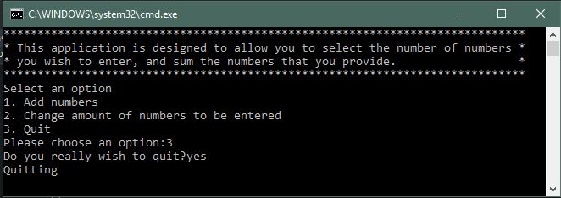
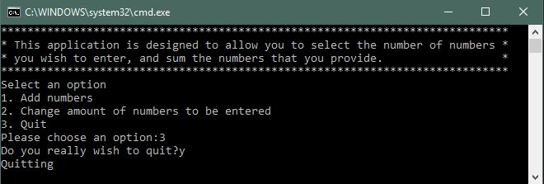
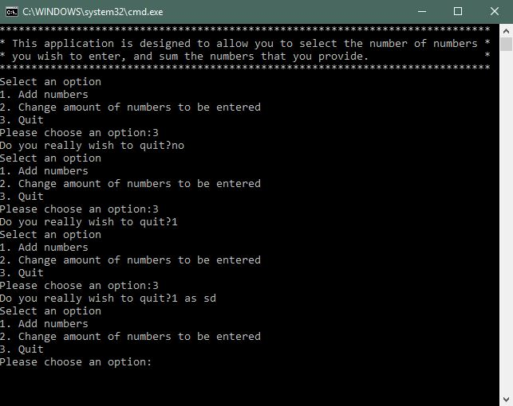

Problem 3 test
1 | Result is displayed correctly
Description |  | The result is longer than 1 digit
 |  | Test Steps:
1 | Message displayed asking user to enter number
2 | One-digit numbers entered  More than one-digit numbers entered

Response |  | The program should display the result with hash lines around it correctly
Status |  |  | Date |  |  | Description
Pass |  |  | 23/03/18 12.00 |  |  | The program displays the result with hash lines around it correctly when the result is one digit
Fail |  |  | 23/03/18 12.00 |  |  | The program displays the result with hash lines around it incorrectly when the result is more than one digit
Pass |  |  | 23/03/18 12.15 |  |  | The program displays the result with hash lines around it correctly when the result is more than one digit

Problem 3 description
DisplayResult method is responsible for displaying the result. The number # characters in the first two and the last two is 79. The result is displayed in the third line in the middle. The number of characters on the left and the right-hand side is always 39. If the result is one digit, the line will be 79 characters long, if two or more, the line will be longer and displayed in the next line.
Problem 3 solution
18 # displayed on the left and the right-hand side, the result in the middle, and spaces in between. The length of the spaces depends on the length of the result. The length if the spaces calculated as:
- (full line width – (length of # on the left + length of # on the right) – length of the result) / sides
- Display 18 #
- If the number length is even display required number of space with a for loop
- Display result
- If the number length is uneven display required number of space with a for loop +1 otherwise the full length wouldn’t be 79 characters long
- Display 18#

Screenshots
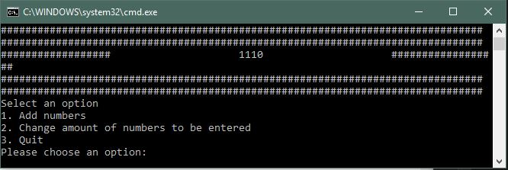
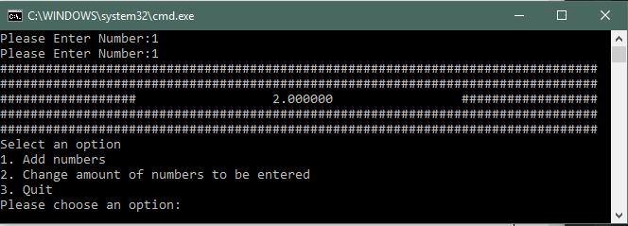

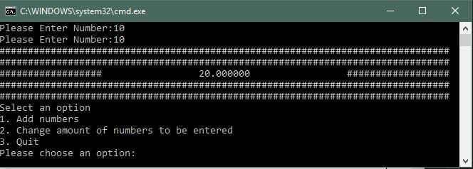

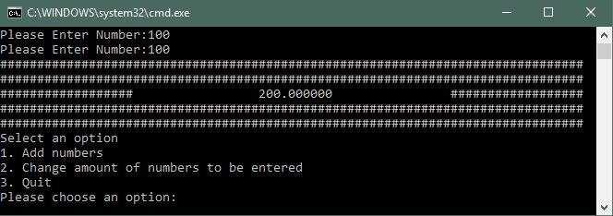
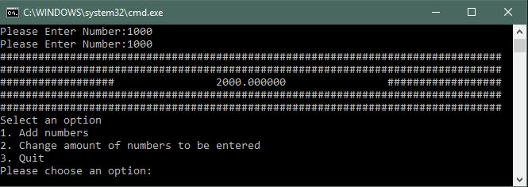

Problem 4
Problem 4 test
1 | User enters valid number to add together
Description |  | The user enters a valid number to add together
 |  | Test Steps:
1 | Message displayed asking user to enter number
2 | The number 3 is entered  The number -5 is entered  The number 1.5 is entered

Response |  | The program should not produce an error message and should display correct result
Status |  | Date |  |  | Description
Fail |  | 23/03/18 12.30 |  |  | Incorrect result displayed when decimal number/ numbers entered
Pass |  | 23/03/18 12.30 |  |  | Correct result displayed when negative numbers entered
Pass |  | 23/03/18 12.45 |  |  | Correct result displayed when decimal number/ numbers entered
Problem description
Numbers to add together can only be whole numbers
Problem solution
Using ReadDouble method instead of ReadInteger, the numbers and result will be stored in a double type variable.
Screenshots
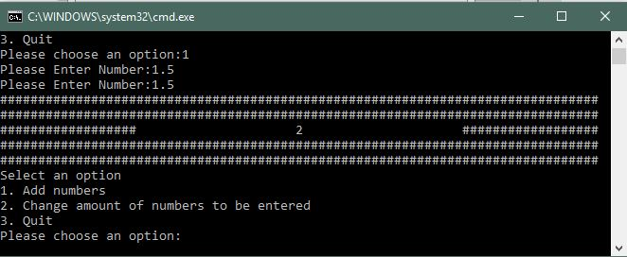
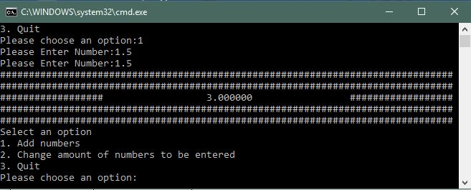

PART C (IMPLEMENTATION)

Exercise 1
Source code included in Appendix 2
Identified problems
- Displaying text
- Input number
- Keep track of number of attempts
- Generating random number
- Check if number entered is valid
- Check if attempt left
- Asking user for number until not won or attempt left
- Give a hint
Description of the solution
ConsolGame Class
NumberToGuess
Generates a random number using random library and returns it. The returned value will be used in the Main function.
ReadNumber
Displays text, asks user for number, ignores values that are not numbers. If the user inputs any value, the number of attempts will be decreased.
DecreaseNumberOfAttempts
Decrease _numberOfAttempts variable by one anytime it’s called. If number if attempts is less than one, sets _ifWin variable to false.
GiveAHint
If the players number and the computers number matches “You won” is displayed and setting _ifWin variable to true.
If the players number and the computers number doesn’t match and no more attempts left, “You lost” is displayed and setting _ifWin variable to false.
If the computers number is positive:
users guess is positive, but the difference is either more than ten, “The number is positive” hint is displayed.
users guess is negative, but the difference is either more than ten, “The number is positive” hint is displayed.
Users guess is larger than the computers, than the difference will be positive and checked if it’s in 2,5, or 10 range.
Users guess is smaller than the computers, than the difference will be negative and checked if it’s in 2,5, or 10 range.
If the computers number is negative:
Users guess is larger than the computers, than the difference will be negative and checked if it’s in 2,5, or 10 range.
Users guess is smaller than the computers, than the difference will be positive and checked if it’s in 2,5, or 10 range.
users guess is negative, and the difference is more than ten “The number is negative” hint is displayed.
users guess is positive, and the difference is more than ten “The number is negative” hint is displayed.
Main function
The program runs while the user has enough attempts or not won.
The number of attempts is displayed
User is asked to enter a guess
Calling GiveAHint method with the random number and the users number
If no more attempts left, “You lost” is displayed.
Testing solution
1 | User enters guess number
Description |  | The user enters a valid number
 |  | Test Steps:
1 | Message displayed asking user to guess
2 | Number entered

Response |  | The program should display a hint and displays correct number of attempts
Status |  |  | Date |  |  | Description
Pass |  |  | 23/03/18 13.00 |  |  | The program displays a hint and correct number of attempts

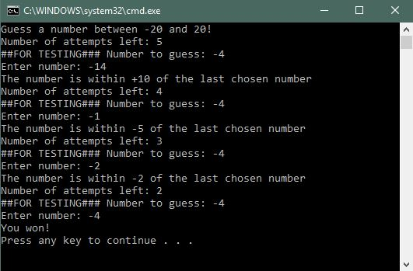
2 | User enters invalid value
Description |  | The user enters an invalid guess
 |  | Test Steps:
1 | Message displayed asking user to guess
2 | The user enters values that are not number  a, a1, 1a
3 | Re-enter an invalid value

Response |  | The program should display an error message and ask the user to re-enter a number. For invalid value, the program should decrease the number of attempts
Status |  |  | Date |  |  | Description
Pass |  |  | 23/03/18 13.15 |  |  | The program displays error message and correct number of attempts when a, a1 entered
Fail |  |  | 23/03/18 13.15 |  |  | The program doesn’t display error message when 1a entered.

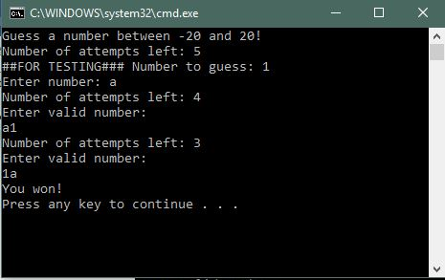

3 | Users number matches secret number
Description |  | The user enters a number that matches the secret number
 |  | Test Steps:
1 | Message displayed asking user to guess
2 | The user enters a number that matches the secret number

Response |  | The program should display “You win”
Status |  |  | Date |  |  | Description
Pass |  |  | 23/03/18 13.30 |  |  | The program displays “You win”

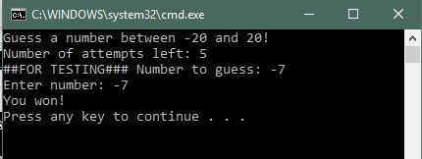

4 | Users runs out of attempts
Description |  | The user has 5 attempts, the program should display “You lost”. Invalid values considered as guess
 |  | Test Steps:
1 | Message displayed asking user to guess
2 | The user enters a valid or invalid value

Response |  | The program should display “You lost” after 5 guesses and the user should lose an attempt after every input
Status |  |  | Date |  |  | Description
Pass |  |  | 23/03/18 13.45 |  |  | The program displays “You lost” after 5 guesses and the user should lose an attempt after every input

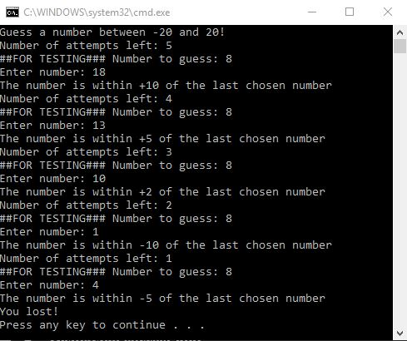

5 | Displaying correct hint
Description |  | When the user enters number, correct hint has to be displayed. For testing purposes, the secret number is displayed.
 |  | Test Steps:
1 | Message displayed asking user to guess
2 | The program should display correct hint:  Whether the number is positive or negative  If the number is within +/- 10 of the last chosen number  If the number is within +/- 5 of the last chosen number  If the number is within +/- 2 of the last chosen number

Response |  | The program should display correct hint
Status |  |  | Date |  |  | Description
Pass |  |  | 23/03/18 14.00 |  |  | The program displays the correct hint

Exercise 2

Exercise 3
Source code included in Appendix 3
Identified problems
- Displaying text
- Input column number
- Check if the column is not full
- Drop the coin
- Place the coin on the free row nearest the bottom of the grid
- Check if any of the user won

Appendices

Appendix 1
Console.h
#pragma once
#pragma warning(disable:4996)
#include <conio.h>
#include <string>

using namespace std;

class Console
{
// Attributes
// NONE

// Constructors
// NONE

// Properties
// NONE

// Methods
public:
string ReadString();
int ReadInteger();
double ReadDouble();
void Print(string text);
void PrintLine(string line);
void Pause(void);

private:
void ClearInputBuffer();
};

Console.cpp
#include "Console.h"

string Console::ReadString()
{
char text[100];

scanf("%99[^\n]s", text);
ClearInputBuffer();

return (string)text;
}

int Console::ReadInteger()
{
int number;

scanf("%i", &number);
ClearInputBuffer();

return number;
}

double Console::ReadDouble()
{
double number;

while (scanf("%lf", &number) == 0)
{
ClearInputBuffer();

printf("Please enter valid number: ");
}

ClearInputBuffer();

return number;
}

void Console::ClearInputBuffer()
{
char ch;
while ((ch = getchar()) != '\n' && ch != EOF);
}

void Console::Print(string text)
{
printf("%s", text.c_str());
}

void Console::PrintLine(string line)
{
Print(line + "\r\n");
}

void Console::Pause(void)
{
while (1) { if (_kbhit()) break; } // Pause
_getch();
}

Application.h
#pragma once
#include "Console.h"

class Application
{
// Attributes
private:
Console* _console;
int _chosenOption;
int _numNumbersReqd;

// Constructors
public:
Application(Console* console);

// Properties
// NONE

// Methods
public:
void DisplayMenu();
void ChooseOption();
bool ProcessOption();
private:
int ReadNumber(string prompt);
double ReadNumberForAddition(string prompt);
double GetTotal();
void DisplayResult(double result);
bool IsQuitting();
};

#pragma once

Application.cpp
#include "Application.h"

Application::Application(Console * console)
{
_console = console;
_chosenOption = 0;
_numNumbersReqd = 5;
}

void Application::DisplayMenu()
{
_console->PrintLine("Select an option");
_console->PrintLine("1. Add numbers");
_console->PrintLine("2. Change amount of numbers to be entered");
_console->PrintLine("3. Quit");
}

void Application::ChooseOption()
{
_chosenOption = ReadNumber("Please choose an option:");
}

int Application::ReadNumber(string prompt)
{
_console->Print(prompt);
return _console->ReadInteger();
}

double Application::ReadNumberForAddition(string prompt)
{
_console->Print(prompt);
return _console->ReadDouble();
}

bool Application::ProcessOption()
{
bool quit = false;

switch (_chosenOption)
{
case 1:
double total;
total = GetTotal();
DisplayResult(total);
break;
case 2:
_numNumbersReqd = ReadNumber("Please enter the number of numbers to be entered:");
break;
case 3:
quit = IsQuitting();
break;
default:
_console->PrintLine("Unknown option value entered");
break;
}

return quit;
}

double Application::GetTotal()
{
double total = 0;
int index;

for (index = 0; index < _numNumbersReqd; index++)
{

total = total + ReadNumberForAddition("Please Enter Number:");
}

return total;
}

void Application::DisplayResult(double result)
{
string stringResult = to_string(result);
int stringResultLength = stringResult.length();
int spaceBetweenLine = (79 - (2 * 18) - stringResultLength) / 2; //Full # width - 2 * 18# both sides, - number length

_console->PrintLine("###############################################################################");
_console->PrintLine("###############################################################################");

printf("##################");

//if the number length is even
if (stringResultLength % 2)
{
for (int i = 0; i < spaceBetweenLine; i++)
{
printf(" ");
}

printf("%s", stringResult.c_str());

for (int i = 0; i < spaceBetweenLine; i++)
{
printf(" ");
}
}

//if number length is uneven add one more space
else
{
for (int i = 0; i < spaceBetweenLine + 1; i++)
{
printf(" ");
}

printf("%s", stringResult.c_str());

for (int i = 0; i < spaceBetweenLine; i++)
{
printf(" ");
}
}

printf("##################\r\n");

_console->PrintLine("###############################################################################");
_console->PrintLine("###############################################################################");
}

bool Application::IsQuitting()
{
string response;
bool quit = false;

_console->Print("Do you really wish to quit?");

response = _console->ReadString();

if (response == "YES")
{
_console->PrintLine("Quitting");
quit = true;
}

else if (response == "yes")
{
_console->PrintLine("Quitting");
quit = true;
}

else if (response == "Y")
{
_console->PrintLine("Quitting");
quit = true;
}

else if (response == "y")
{
_console->PrintLine("Quitting");
quit = true;
}

else if (response == "Yes")
{
_console->PrintLine("Quitting");
quit = true;
}

return quit;
}

Source.cpp
#define _CRT_SECURE_NO_WARNINGS
#pragma warning(disable:4996)

#include <string>

#include "Console.h"
#include "Application.h"

using namespace std;

int main(int args, char* argv[])
{
Console* console = new Console();
Application* application = new Application(console);
bool quit = false;

console->PrintLine("*****************************************************************************");
console->PrintLine("* This application is designed to allow you to select the number of numbers *");
console->PrintLine("* you wish to enter, and sum the numbers that you provide. *");
console->PrintLine("*****************************************************************************");

while (quit == false)
{
application->DisplayMenu();
application->ChooseOption();
quit = application->ProcessOption();
}

console->Pause();

delete application;
delete console;
return 0;
}

Appendix 2

ConsolGame.h
#pragma once
#include <random>
#include <string>
using namespace std;

class ConsolGame
{
//Attributes
private:
int _numberOfAttempts;
int _playersGuess;
bool _ifWin;
//Constructor
public:
ConsolGame(int numberOfAttempts);
~ConsolGame();

//Properties
int GetNumberOfAttempts();
int GetPlayersNumber();

bool GetIfWin();

//Methods
int NumberToGuess();
void ReadNumber(string prompt);
void DecraseNumberOfAttempt();
bool IfAttemptsLeft();
void GiveAHint(int numberToGuess, int playersGuess);

};

Consolgame.cpp
#define _CRT_SECURE_NO_WARNINGS
#include "ConsolGame.h"
#include <stdio.h>
#include <string>

using namespace std;

ConsolGame::ConsolGame(int numberOfAttempts)
{
this->_numberOfAttempts = numberOfAttempts;
_ifWin = false;
}

ConsolGame::~ConsolGame()
{
}

int ConsolGame::GetNumberOfAttempts()
{
return this->_numberOfAttempts;
}

int ConsolGame::GetPlayersNumber()
{
return this->_playersGuess;
}

bool ConsolGame::GetIfWin()
{
return this->_ifWin;
}

int ConsolGame::NumberToGuess()
{
random_device rd;
mt19937 mt(rd());
uniform_int_distribution<int> randomNumber(-20, 20);

return randomNumber(mt);
}

void ConsolGame::ReadNumber(string prompt)
{
int number;
printf("%s", prompt.c_str());
if (_numberOfAttempts > 0)
{
char ch;
while (scanf("%i", &number) != 1 )
{
if (_numberOfAttempts > 1)
{
while ((ch = getchar()) != '\n' && ch != EOF);
DecraseNumberOfAttempt();
printf("Number of attempts left: %i\r\n", GetNumberOfAttempts());
printf("Enter valid number: \r\n");
}

else
{
break;
}

}
}

DecraseNumberOfAttempt();

this->_playersGuess = number;
}

void ConsolGame::DecraseNumberOfAttempt()
{

this->_numberOfAttempts = this->_numberOfAttempts - 1;

}

bool ConsolGame::IfAttemptsLeft()
{
if (_numberOfAttempts > 0)
{
return true;
}
return false;
}

void ConsolGame::GiveAHint(int numberToGuess, int playersGuess)
{

if (numberToGuess == playersGuess)
{
printf("You won!\r\n");
this->_ifWin = true;
}

if (numberToGuess > 0)
{
if (playersGuess > numberToGuess)
{
if (playersGuess - 2 <= numberToGuess == true)
{
printf("The number is within +2 of the last chosen number\r\n");
}

else if (playersGuess - 5 <= numberToGuess == true)
{
printf("The number is within +5 of the last chosen number\r\n");
}

else if (playersGuess - 10 <= numberToGuess == true)
{
printf("The number is within +10 of the last chosen number\r\n");
}
}

if (playersGuess < numberToGuess)
{
if (playersGuess + 2 >= numberToGuess == true)
{
printf("The number is within -2 of the last chosen number\r\n");
}

else if (playersGuess + 5 >= numberToGuess == true)
{
printf("The number is within -5 of the last chosen number\r\n");
}

else if (playersGuess + 10 >= numberToGuess == true)
{
printf("The number is within -10 of the last chosen number\r\n");
}
}

if ( playersGuess < 0 && playersGuess + 10 >= numberToGuess == false)
{
printf("The number is positive\r\n");
}

if (playersGuess > 0 && playersGuess - 10 > numberToGuess == true)
{
printf("The number is positive\r\n");
}
}

else if (numberToGuess < 0)
{
if (playersGuess > numberToGuess)
{
if (playersGuess - 2 <= numberToGuess == true)
{
printf("The number is within -2 of the last chosen number\r\n");
}

else if (playersGuess - 5 <= numberToGuess == true)
{
printf("The number is within -5 of the last chosen number\r\n");
}

else if (playersGuess - 10 <= numberToGuess == true)
{
printf("The number is within -10 of the last chosen number\r\n");
}
}

if (playersGuess < numberToGuess)
{
if (playersGuess + 2 >= numberToGuess == true)
{
printf("The number is within +2 of the last chosen number\r\n");
}

else if (playersGuess + 5 >= numberToGuess == true)
{
printf("The number is within +5 of the last chosen number\r\n");
}

else if (playersGuess + 10 >= numberToGuess == true)
{
printf("The number is within +10 of the last chosen number\r\n");
}
}

if (playersGuess > 0 && playersGuess - 10 <= numberToGuess == false)
{
printf("The number is negative\r\n");
}

if (playersGuess < 0 && playersGuess + 10 < numberToGuess == true)
{
printf("The number is negative\r\n");
}
}
else if (numberToGuess != playersGuess && _numberOfAttempts<1)
{
printf("You lost!\r\n");
this->_ifWin = true;
}
}
Source.cpp
#define _CRT_SECURE_NO_WARNINGS

#include <stdio.h>
#include <string>
#include "ConsolGame.h"

using namespace std;

int main(int argc, char** argv)
{

ConsolGame * GuessNumber = new ConsolGame(5); // number of attempts = 5

int numberToGuess = GuessNumber->NumberToGuess();

printf("Guess a number between -20 and 20!\r\n");

while (GuessNumber->GetIfWin() != true && GuessNumber->IfAttemptsLeft())
{
printf("Number of attempts left: %i\r\n", GuessNumber->GetNumberOfAttempts());

//FOR TESTING printf("##FOR TESTING### Number to guess: %i\r\n", numberToGuess);
GuessNumber->ReadNumber("Enter number: ");
GuessNumber->GiveAHint(numberToGuess, GuessNumber->GetPlayersNumber());

if (GuessNumber->IfAttemptsLeft() == false)
{
printf("You lost!\r\n");
}
}

return 0;
}

Appendix 3

Player.h
#pragma once
#include <string>

using namespace std;

class Player
{
//Attributes
private:
//int _rowChosen;
string _playername;
int _lastColumnChoice;

//Constructors
public:

Player(string playerName);
~Player();

//Propertys

string GetPlayerName();
int GetLastColumnChoice();
//Methods

int ReadColumnNumber(string prompt);
int ValidateColumnNumber(int columnNumber);

};

Player.cpp
#define _CRT_SECURE_NO_WARNINGS

#include "Player.h"
#include <string>
#include <stdio.h>

using namespace std;

Player::Player(string playerName)
{
this->_playername = playerName;
}

Player::~Player()
{
}

string Player::GetPlayerName()
{
return this->_playername;
}

int Player::GetLastColumnChoice()
{
return this->_lastColumnChoice;
}

int Player::ReadColumnNumber(string prompt)
{
printf("%s", prompt.c_str());
int columnNumber;
scanf("%i", &columnNumber);
//ValidateColumnNumber(columnNumber);
//this->_lastColumnChoice = columnNumber;
return columnNumber;
}

int Player::ValidateColumnNumber(int columnNumber)
{
while (columnNumber < 1 || columnNumber>7)
{
printf("Enter valid colum:\r\n");
scanf("%i", &columnNumber);
}

return columnNumber;
}

Board.h
#pragma once
#include "Player.h"
class Board
{
//Attributes
private:
int _row;
int _col;
char _board[6][7];

Player* player1;
Player* player2;

//Constructors
public:
Board();
~Board();

//Properties

char GetBoard();
void SetBoard(int value);

//Methods
Player* Board::GetPlayer(int playerNumber);
void initialiseBoard();
void DisplayBoardNumbers();
void DisplayBoard();

void DropDiscIntoColumn(int columnToDrop, char disc);
bool IfColumnFull( int columnToDrop);
int CheckDiskPosition(int i, int columnToDrop);

};

Board.cpp
#include "Board.h"
#include <stdio.h>

Board::Board()
{
player1 = new Player("Player 1");
player2 = new Player("Player 2");

this->_col = 7;
this->_row = 6;
}

Board::~Board()
{
delete player1;
delete player2;
}

Player* Board::GetPlayer(int playerNumber)
{
switch (playerNumber)
{
case 1:
return player1;
break;
case 2:
return player2;
break;
default:
return nullptr;
break;
}
}

void Board::initialiseBoard()
{
for (int i = 0; i < _row; i++)
{
for (int j = 0; j < _col; j++)
{
this->_board[i][j] = '~';
}
}
}

void Board::DisplayBoardNumbers()
{
printf("1 2 3 4 5 6 7\r\n");
}

void Board::DisplayBoard()
{
DisplayBoardNumbers();
for (int i = 0; i < _row; i++)
{
for (int j = 0; j < _col; j++)
{
printf("%c ", _board[i][j]);
}
printf("\r\n");
}
printf("\r\n");
}

void Board::DropDiscIntoColumn(int columnToDrop, char disc)
{

for (int i = 0; i < _row; i++)
{
for (int j = 0; j < _col; j++)
{
if (IfColumnFull(columnToDrop)) //if column is not full
{
int rowToDrop = CheckDiskPosition(i, columnToDrop);

this->_board[rowToDrop][columnToDrop - 1] = disc;
}

}

}
}

bool Board::IfColumnFull(int columnToDrop)
{
bool isEmpty;

if (_board[0][columnToDrop - 1] == '~')
{
isEmpty = true;
}

else
{
isEmpty = false;
}

return isEmpty;
}

int Board::CheckDiskPosition(int i, int columnToDrop)
{
int rowToDrop;

for (i = 0; i < _row; i++)
{
if (_board[i][columnToDrop - 1] == '~')
{
rowToDrop = i;
}
}

return rowToDrop;
}

Source.cpp
#define _CRT_SECURE_NO_WARNINGS

#include <stdio.h>
#include <string>
#include "Board.h"
#include "Player.h"

using namespace std;

const int rows = 7;
const int cols = 6;

int main(int argc, char** argv)
{

Board* board = new Board();

board->initialiseBoard();
board->DisplayBoard();

int columnToDrop;

while (true)
{
printf("%s\r\n", board->GetPlayer(1)->GetPlayerName().c_str());
columnToDrop = board->GetPlayer(1)->ReadColumnNumber("Enter colum: ");
board->DropDiscIntoColumn(columnToDrop, 'X');
board->DisplayBoard();

printf("%s\r\n", board->GetPlayer(2)->GetPlayerName().c_str());
columnToDrop =board->GetPlayer(2)->ReadColumnNumber("Enter colum: ");
board->DropDiscIntoColumn(columnToDrop, 'O');
board->DisplayBoard();
}

delete board;
return 0;
}

