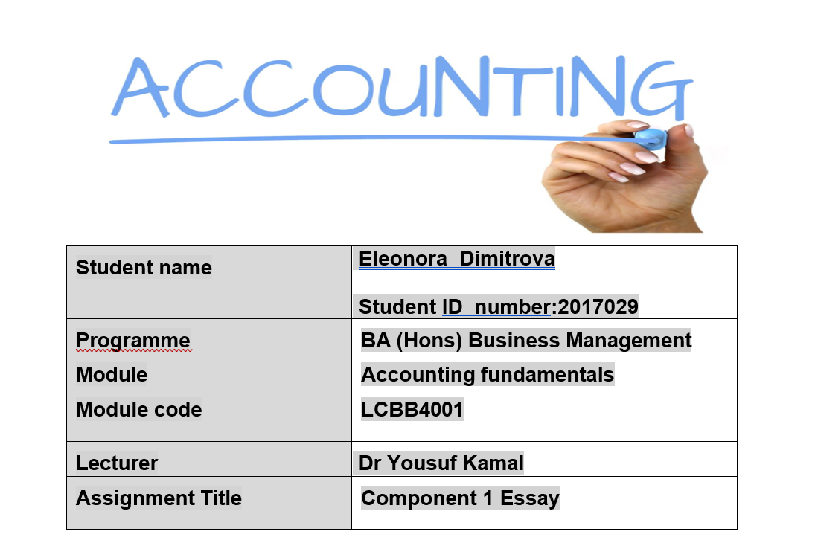

Cost accounting is a part of accounting that focuses on recording, analysing, and managing costs in an organization. It plays a key role in helping companies make informed decisions, manage costs, improve efficiency, and achieve their financial goals.

Task 1
Coopers Grocery Income statement /profit and loss statement
For the year ended on 31st of August 2023

Details | £ | £
Sales | 160,000
Less: Sales returns | (4,000)
Net sales |  | 156,000
Cost of goods sold:
Opening inventory/stock (aug1) | 3,000
Purchases | 95,000
Less: Purchase returns | (5.000)
Net purchase | 90,000
Less: Closing inventory | (2,000)
Cost of goods sold |  | (91,000)
Gross profit |  | 65,000
Less: other expense:
Rent-2,500  Less: rent prepaid 500 | 2,000
Salaries -28,000  Add: accruals 4,000 | 32,000
Depreciation | 5025
Discount received |  | 200
Discount allowed | 700
Opening Provision for doubtful debts |  | 500
Interest on loan | 1,000
Electricity and gas expense | 1,500
Vehicle Maintenance-800  Add: maintenance cost owing 200 | 1,000
Bad debt off | 800
be 5% of the closing receivables | 810
Total | 44,135 | 65,700  -44,135
Net profit /loss |  | 20,865

Coopers Grocery Statement of Financial Position (Balance sheet) 31st of August 2023
Details | £ | £
Non-current assets:
Furniture | 15,000
Depreciation 12% straight line |  | 1800
Accumulated depreciation furniture |  | 5,000
Vehicle at cost | 28,500
Accumulated Depreciation on vehicles |  | 7,000
Depreciation 15% reducing balance |  | 3,225
Total non-current asset | 26475
Current assets:
Trade receivables | 17,000
Less: Bad debt | (800)
Less: provision for bad debt | (810)
Net receivables | 15390
Bank | 5,000
Closing stock | 2,000
Prepayment of rent | 500
Total current assets | 22,890
Total assets | 49,365
Non-current liability:
5-year loan |  | 10,000
Total non-current liability |  | 10,000
Current liability:
Trade payables | 2,300
Salaries accrued | 4,000
Maintenance accrued | 200
Total current liability |  | 6,500
Total liability |  | 16,500
Capital | 25,000
Add: profit | 20,865
Less: Drawings | (13,000)
Ending owners’ equity |  | 32865
Total liability and OE |  | 49365

Task 2

Dr | 1.CASH |  |  |  | Cr
DATE | DETAILS | £ | DATE | Details | £
01-Sep | bal b/d | 300 | 03-Sep | Computer | 1000
02-Sep | Capital | 700 | 25-Sep | Wages | 800
15-Sep | Receivables | 2,600 | 26-Sep | Advertising | 500
27-Sep | Van disposal | 8,000 | 28-Sep | Bank | 6,000
 |  |  | 30-Sep | Drawings | 1,200
 |  |  |  | bal c/d | 2,100
 |  | 11,600 |  |  | 11600
 | bal b/d | 2,100

Dr | 2.DRAWINGS |  |  |  | Cr
Date | DETAILS | £ | DATE | Details | £
30-Sep | Cash | 1,200
 |  |  |  | bal c/d | 1,200
 |  | 1,200 |  |  | 1,200
 | bal b/d | 1,200

Dr | 3.CAPITAL |  |  |  | Cr
Date | Details | £ | DATE | Details | £
 |  |  | 01-Sep | b/d | 20,300
 |  |  | 02-Sep | Cash | 700
 | bal c/d | 21,000 |  | bal c/d | 21,000
 |  | 21,000 |  |  | 21,000
 |  |  |  | bal b/d | 21,000

Dr | 4,COMPUTER |  |  |  | Cr
Date | Details | £ | Date | Details | £
03-Sep | Cash | 1,000
 |  |  |  | bal c/d | 1,000
 |  | 1,000 |  |  | 1,000
 | bal b/d | 1,000

Dr | 5.BANK |  |  |  | Cr
Date | Details | £ | Date | Details | £
01-Sep | b/d | 7,000 | 04-Sep | Payables | 800
09-Sep | Receivables | 3000 | 07-Sep | Purchases | 700
28-Sep | Cash | 6000 | 11-Sep | Petrol | 350
 |  |  | 18-Sep | Insurance | 450
 |  |  |  | bal c/d | 13,700
 |  | 16,000 |  |  | 16,000
 | bal b/d | 13,700

Dr | 6.WAGES |  |  |  | Cr
Date | Details | £ | Date | Details | £
25-Sep | Cash | 800
 |  |  |  | bal c/d | 800
 |  | 800 |  |  | 800
 | bal b/d | 800

Dr | 7.Advertisement |  |  |  | Cr
Date | Details | £ | Date | Details | £
26-Sep | Cash | 500
 |  |  |  | bal c/d | 500
 |  | 500 |  |  | 500
 | bal b/d | 500

Dr | 8.Payables |  |  |  | Cr
Date | Details | £ | Date | Details | £
04-Sep | Bank | 800 | 01-Sep | b/d | 2,000
 |  |  | 20-Sep | Purchases | 1,200
 | bal c/d | 2,400
 |  | 2400 |  |  | 2400
 |  |  |  | bal b/d | 2400

Dr | 9.Purchases |  |  |  | Cr
Date | Details | £ | Date | Details | £
07-Sep | Bank | 700
20-Sep | Purchases | 1,200
 |  |  |  | bal c/d | 1900
 |  | 1900 |  |  | 1900
 | bal b/d | 1900

Dr | 10.Receivables |  |  |  | Cr
Date | Details | £ | Date | Details | £
01-Sep | b/d | 5,000 | 09-Sep | Bank | 3,000
21-Sep | Sales | 2,400 | 15-Sep | Cash | 2,600
 |  |  |  | bal c/d | 1,800
 |  | 7,400 |  |  | 7,400
 | bal b/d | 1,800

Dr | 11.Petrol |  |  |  | Cr
Date | Details | £ | Date | Details | £
11-Sep | Bank | 350
 |  |  |  | bal c/d | 350
 |  | 350 |  |  | 350
 | bal b/d | 350

Dr | 12. Insurance |  |  |  | Cr
Date | Details | £ | Date | Details | £
18-Sep | Bank | 450
 |  |  |  | bal c/d | 450
 |  | 450 |  |  | 450
 | bal b/d | 450

Dr | 13.Sales |  |  |  | Cr
Date | Details | £ | Date | Details | £
 |  |  | 21-Sep | Receivables | 2,400
 | bal c/d | 2,400
 |  | 2,400 |  |  | 2,400
 |  |  |  | bal b/d | 2400

Dr | 14.Depreciation |  |  |  | Cr
Date | Details | £ | Date | Details | £
27-Sep | Disposal | 1,000 | 01-Sep | b/d | 1,000
 |  | 1,000 |  |  | 1,000

Dr | 15.Disposals |  |  |  | Cr
Date | Details | £ | Date | Details | £
27-Sep | Van | 10,000 | 27-Sep | Depreciation | 1,000
 |  |  | 27-Sep | Cash | 8,000
 |  |  | 27-Sep | Loss on disposal | 1,000
 |  | 10,000 |  |  | 10,000

Dr | 16.Van |  |  |  | Cr
Date | Details | £ | Date | Details | £
01-Sep | b/d | 10,000 | 27-Sep | Disposal | 10,000
 |  | 10,000 |  |  | 10,000

Sonia’s Business
Trial balance
For September,2023

Sl no | Accounts title | Dr | Cr
1 | Cash | 2,100
2 | Drawings | 1,200
3 | Capital |  | 21,000
4 | Computer | 1,000
5 | Bank | 13,700
6 | Wages | 800
7 | Advertisement | 500
8 | Payables |  | 2,400
9 | Purchases | 1,900
10 | Receivables | 1,800
11 | Petrol | 350
12 | Insurance | 450
13 | Sales |  | 2,400
14 | Depreciation | 1,000
15 | Disposal | 1,000
 | Total | 25,800 | 25,800

Task 3
Double-entry accounting is a fundamental system where each financial transaction involves two entries, debits and credits, ensuring the equation Assets = Liabilities + Equity is always balanced. It is a system that revolutionized accounting and according to Sangster (2016), ‘marked the shift in bookkeeping from a mechanical task to a skilled craft’.

Double-entry accounting is used in business, nonprofits, and government to enable accurate financial reporting, auditing, compliance, budgeting, and decision-making.
It is used for:
- Financial reporting, businesses use double-entry accounting to prepare financial statements such as the balance sheet, income statement, and cash flow statement. These reports provide a clear picture of the company's financial health.

- Auditing, double-entry accounting helps auditors verify the accuracy of financial statements, ensuring transparency and accountability. Regulatory bodies often require businesses to maintain their records using this method.

- Budgeting and decision-making, it helps organizations make informed financial decisions and set budgets based on historical financial data and performance trends.
Originating in 15th-century Italy, double-entry accounting spread across Europe, modernized with computerization, and achieved global standardization through organizations like IFRS and GAAP.

References

Sangster, A. (2016). The genesis of double entry bookkeeping. The Accounting Review, 91(1), 299-315. Available at: https://publications.aaahq.org/accounting-review/article-abstract/91/1/299/3755/The-Genesis-of-Double-Entry-Bookkeeping (Accessed: 17th October 2023).

