Student Name: Gergana Nikolova Koeva
Student Number: 1906187
Lecture Name: Diya Ganguly
Module Name: Children, Young People and Families
Module Code: BMHP 5004 (LON)
Assessment Component 1

Page content
Introduction………………………………………………………………………………………3
Key Study………………………………………………………………………………………..3
Risk factors………………………………………………………………………………………5
Analysis………………………………………………………………………………………….6
Advices………………………………….………………..……………………………………...7
Conclusion…………………………………………………………………………….……..….8
References……………………………………………………………………………………...8

Introduction
In this report I will present the case study which is alarming of the vulnerability of the children in their families such as neglect and abuse with the fatal end. Will analyzed the effectiveness of the professionals involved and importance of decision making proses. In the end of the report, I will give my evaluation and recommendation.
Filicide is act of a parent killing their own child (Merriam Webster, 2020).

Key study
Mario is 4 years old boy killed by his mother. Originally, he was living with his father Patrick and Mother Marta in their own property at Herefordshire. Patrick was 35 years old and Martha was 31. Both parents of Mario were emigrants, they meet for a first time in their country and got married there. However, they were very hard-working couple and manage for a shot time of period to step on their feet and to have a good living standard. During all this time Marta was not felling emotionally stable, at times she was showing or crying with no reason. Patrick was not paying enough attention to that strange behavior, thinking it is due to the stressful time they passed through before they emigrated to United Kingdom. Soon after they arrived in UK, the family leave the council property they were living and came out of the Universal credit support. The young man and woman started their own business which was growing faster, and they had to hire employers as they could not manage, moreover Martha was in the beginning of her pregnancy with Mario (her first pregnancy).
After Martha give birth to Mario, she was very depressed, Patrick was working at all the time and did not notice the changes in his wife’s behavior. She was crying or shouting to the new-born baby, blaming him for her own problems. Sometime neighbors were listening to her voice screaming during the day and asked Patrick, if his wife is okay. He was always answering that this is probably postnatal depression and if the things continued, he would try to get professional help. Two months after the situation still remind the same than Patrick share his concern for a first time with Marta and offered her to make an appointment with her GP. The outcome of this conversation was not pleasant. She became a furious and informed him that she does not need any help as she is perfectly fine. At the same time, she realized that it is a problem with her mental health but refused to admit. She was afraid of that, the social services would take her child, if there is a proof of her mental health problems. (Spruce, H., 2016)
Martha was looking for solutions to calm herself and ended up using an alcohol secretly on daily bases. Very soon the alcohol was not enough to help her, and she was looking into another option, such as illegal staff. Yan was very close to Martha and her family as I mentioned above, and she decided to share her problems with him and ask for help. He was very “supportive “and at the same time keep her secret, moreover Yan was helping Martha to contact the dealers to supply her needs of drugs. The time was flying, Patrick was busy with the business and never noticed that his wife is in such a trouble. Yan was using the situation and making money from the drug dealers suppling Martha’s staff. During the work time when Patrick was busy, very often, he was sending Yan home to drop some shopping and to make sure that everything is fine with Martha and Mario, he never doubted his intentions. The trust Yan build in Martha was incredible, she even fell in love with him as he was very good to her, and in her mind, he was only the person she can trust. Yan was using Martha financially and sexually. She neglects Mario, living him crying all day and not changing his pads. She was blaming Mario for the state of her life. Every evening, before Patrick arrived at home, she was changing clothes and pads for the baby, so he was not noticing what is going on. Martha always excuses herself with her tiredness due to looking after the baby.

Risk factors
One year after Patrick suddenly lost his live in a car accident. Martha did not even realize what happened. As a good family “friend” Yan was always there for Martha. He arranged the funeral and all the things which needed to be done. Martha refused the emotional support offered by the social services advised by Yan. Five months after the funeral Yan moved to Marta’s house and take the control of everything including the family’s finances. Martha did not care about anything else different then the alcohol and drugs, very often she was leaving Mario alone in the property. When she was returning to the house and founding him cry, she was abusing him verbally and physically. Mario was raised in the unhealthy environment and thinking this is something normal.
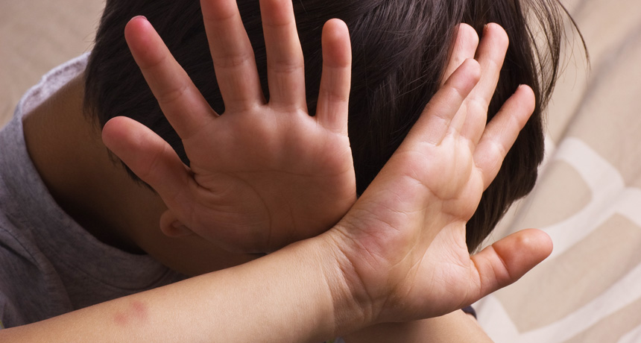Mario turn 4 years, there was no birthday party for him. Yan manages to lose all of Marta’s money and property left from her husband. Very soon the mother and the son had to move to the council property. All the money she was receiving as support, Marta was spending on drugs and alcohol, but they were not enough at all and she had to sleep around to contribute her needs. Mario was already at school. The teachers had noticed that Mario was losing weight and does not look happy as other children and advised the mother to call the GP. After a month, still nothing changes, then the school had reported this to the social services. The allocated social worker visited the family and arranged the GP to see Mario. Considering the state of the property and Martha’s behavior he referred her to the GP as well and to the local mental health team. Marta could no longer admitting her mental problems but not her addictions. She manages to convince them that she is a good mother, and all her problems are happened is just because she lost her husband. Staying with her, Mario will be in a home environment and will help her to recover as well, as she sees him as an encouragement. To prove that she is willing to change herself, she accepted the care agency to provide support with some domestic help, to make sure that she is taking her medications, to prepare Mario for school, to take him and bring him back. The allocated carer supposed to monitor and report immediately any changes or concerns. Everything was going well, or at least was looking that way. Mario was going to school, Martha was taking her medications, home was tidy etc... She became closer to the carer worker which was visiting her on daily bases, and she earn her trust. After three months the review has been done and the outcome was that the things to remind the same and there was no high risk higher than before. Mario could continue living with his mother and the support of the care agency (Action for children, 2020).
Science News (2017).
A week after Martha take her son Mario and jumped from the seventh floor of the building. They were living in the one of the flats in this building. Both was died……. Murder and suicide.

Analysis
I will start my analysis of the case above with the definition of child abuse and neglect. The maltreatment of a child or a young person is called abuse. The inflicting harm or a failing to prevent the harm in the child can be classified as an abuse or neglect. Children could be abused in a family, community, or institutions. The ignorance of the children also could be abuse. Isolation, bullying, and humiliation is called emotional abuse.
Mario, the first-born child in the family …Expected child in the normal family from the same mother and the same father. However, everything normal is finishing here. During Mario’s short childhood he had faced plenty of unfairness, abnormal treatment, verbal, physical abuse, and neglect. Mario did not have a knowledge of what the normal life is. He has been neglected by his own mother and indirectly by his own father (by ignorance). Martha has been neglecting him while was trying to solve her own mental issues and thinking of herself only, but she was not in the position to realize what she is doing. Patrick neglect Mario indirectly, because he was working too much and leave al responsibility to Marta, which obviously was unbearable for her (not in her condition).
Mario was verbally and physically abused by his mother. He was a baby, he could not even complain, he cannot even understand, he could not talk and defend himself, he was venerable. There was no one to help him. The neighbors hear Marta shooting and they inform her husband, but he did not pay enough attention. Later, in his live, when Mario was able to talk, he did not complain, even when his teachers asked him, because he was not aware, what is normal and what is abnormal. His live was always the same, always under abuse. Mario clearly was child under high risk, but his mother being manipulative, manage to deceive even the social services. No one of the institutions involved find out that she is using illegal substances. Martha, herself was a victim of abuse, because of what she was doing this to herself, and what Yan does it to her. He was abusing her financially and controlling her, by providing what she needs - drugs, alcohol and keeping her secrets. Yan was sexually abusing her. Marta allow others to abuse her sexually as well while trying to contribute her habits. The professionals involved in the case above were the social services, schoolteachers, GP, and the mental health team (Cps.gov.uk., 2020).

Advices
What have not been done appropriately, who else must be involved to be avoid the fatal conclusion? We can never predict hundred percent what would have happened, but I strongly believed that there it is a much more things which could be done to avoid the situation above. There was a lot of things screaming that something is not right. Woman who has lost her husband, acting inadequately, and refusing professional help must be monitor for long term and especially that she has a little kid. Even though she is refusing any support. Secondly, before providing her with council property, must be done an investigation, how these women become to this condition considering her previous lifestyle. Mario was seeming unhappy and obviously different than other kids at school; this is an indicator of that something is going on there. Should of be done more test and research regarding Martha’s health and more health professional to be involved. The environment for Mario should have been changed at least temporally or 24hr carer should be put on place to monitor and support. I think that Mario was neglected from the institution as well by not paying enough attention and unfortunately the end was fatal for him and his mother.

Conclusion
I have picked up this case study purposely, with the normal family. Martha and Patrick had loved each other, and achieved a high standard of leaving, but during that journey they forgot what it is the important in the life. My aim is to show how significant is the mental health and how likely is to happen something which we think that will never have happened to us. How easy the life could change the circumstances? Always must be aware what is going on whit us and our families and never to be afraid to look for a professional help on time.

References
Merriam Webster (2020) Definition of FILICIDE [Online] Available at: https://www.merriam-webster.com/dictionary/filicide/
[Accessed 10 December 2020].

Action for children (2020) Neglect law protecting children from emotional abuse [Online] Available at: https://www.actionforchildren.org.uk/support-us/campaign-with-us/neglect-law/
[Accessed 10 December 2020].

Cps.gov.uk. (2020) Child Abuse (non-sexual) - prosecution guidance | The Crown Prosecution Service [Online] Available at: https://www.cps.gov.uk/legal-guidance/child-abuse-non-sexual-prosecution-guidance/
[Accessed 11 December 2020].

Spruce, H. (2016) Signs of Abuse in... [Online] The Hub | High Speed Training. Available at: https://www.highspeedtraining.co.uk/hub/signs-abuse-children/
[Accessed 11 December 2020].

Science News (2017) Physically abused kids learn to fail at social rules for success [Online] Available at: https://www.sciencenews.org/article/physically-abused-kids-learn-fail-social-rules-success/
[Accessed 13 December 2020].

