Student Name: Leigh Yule
Student Number: 2206555
Programme of study: Product and Furniture Design Module: ADAD5003 - Research in Context
Word Count: 2426

Task: How useful are Manifestos to designers and/or design groups? Outline your discussion with reference to three key manifestos. Through careful critique, conclude your text by defining your own design values in a 10-point manifesto.

Introduction
Manifestos in design present the writers principles, standpoints and future ideologies in their creative practices. They serve as foundational pillars, shaping aspirations and influencing design processes.
In this essay I will be analysing renowned manifestos like Allan Chochinov's '1000 Words: A Manifesto for Sustainability in Design. I chose to analyse this extract as in the current climate, sustainability is a fundamental obligation. The second text I will examine is Bruce Mau's 'Incomplete Manifesto for Growth,' due to its positive outlook on design. Lastly, I will be talking about Dieter Rams' 'Ten Principles for Good Design' and this is being investigated as it’s a very significant manifesto that is effective and a good example of what my manifesto should be.
I will also be creating my own manifesto; this text will show my own personal ethos and the path towards my own aspirations and ideologies.


Allan Chochinov's '1000 Words: A Manifesto for Sustainability in Design

Allan Chochinov starts with emphasising ‘Hippocratic Before Socratic’. This is a good starting point for designers as it challenges the current situation by compelling designers to reassess their impact and prioritise sustainable and ethical practises. The first line “first do no harm” highlights the responsibility that designers have in their practise due to the huge scale of industrial design and their subsequent consequences. The manifest confronts the current consumerist cycle that we have created in the design industry, banning the production of the harmful products that pollute the world and endangers human health. It presents to us the shift in perspective by highlighting the importance of existing systems creating products that are environmentally friendly and encouraging designers to think about the recourses their using.
Within the manifesto, education is also a main focal point. This is stated in, “Institutions that stress sustainability, social responsibility, cultural adaptation, ethnography, and systems thinking are leading the way.” Chochinov is advocating for a reform in design education, stressing the importance of explaining to students’ social responsibilities and sustainability. It explains that aesthetics shouldn’t overshadow the options of environmental and ethical costs.
Moreover, the manifesto challenges the current patterns of product design by supporting the idea of repairable, transparent designs that encourage user understanding of the product. It is a better way of looking at current design methods with the fact of items being temporary or short lived. This manifesto aligns with natures recycling and reuse cycles, criticizing the prevalent over-engineering and unsustainable production methods.
This manifesto also shows the importance of how designers should prioritize ethical design decisions, as it stresses the urgency of prioritizing environmental stewardship over an anthropocentric world view, challenging creators to analyse the broader factors in all design endeavours. It puts forward that design lacks an understanding that contributes to societal and environmental degradation.
To Conclude, this manifesto serves as a callout for change in the design industry, advocating for a conscious and responsible approach that places ethical considerations, sustainability and context at the forefront of design practices. It challenges designers to move away from the status quo of consumer driven, environmentally harmful products towards an ethos that prioritises human well-being and environmental safety.

Bruce Mau's 'Incomplete Manifesto for Growth,'

This manifesto is a collection of 43 principles that serves as a guide for creative thinking and personal development. This text can be applied in daily life and this way of design practise offers a framework for creation, innovation, problem solving and personal development.
In daily life, Mau’s message encourages designers to maintain a mindset of learning and adaptation. Applying these principles to daily design use incorporates various concepts such as ‘process is more important that outcome’ which emphasises the journey and the lessons that are taught along the way rather than just focusing on the outcome. This method showcases resilience, curiosity and willingness to experiment which is crucial to product and personal development.
The next point I would like to explore is the section in the manifest where Mau says ‘’love your experiments (as you would an ugly child)”. This indicates to the audience that they should embrace failure as a means of developing skills. It also promotes risk taking and the acceptance that not every design will be perfect, this is vital for growth as a designer. This manifesto teaches a mindset shift in daily life that presents a more proactive and adventurous approach to problems as a designer.
Withing design practise, Mau’s manifesto becomes a highly significant tool to use for creativity and innovation. An example of this is the quote ‘’allow events to change you’’. This extract explains to designers to remain accepting to new experiences and to let these experiences change and mould perspectives. This very principle is invaluable in design manufacturing where changeability and responsiveness to change can lead to breakthrough ideas.
Another principle that is relevant in design practice is shown by Mau presenting the idea of ‘capture accidents. This suggests that unplanned occurrences or mistakes that can present unexpected opportunities. Within the creative world this could showcase various inspirations in errors or unintended outcomes, therefore, leading the way to innovative solutions that could not have been found in a planned process.
Another key principle that is presented is the principle of ‘process is more important that outcome’ which has significant implications in creating products. Focusing purely on the journey of design rather than focussing only on the final product allows for an ingenious approach whilst also leading to more iterative and explorative designs. This approach persuades designers to be more experimental which can allow ground-breaking designs.
Mau’s manifesto also emphasises the idea of groupwork. He wants to promote the idea of collaboration and community. ‘Collaboration’ can be fundamental in designers as they often work in groups to promote idea creation and teamwork skills leading to richer and more diverse creations.
To summarise, Mau’s ‘’ Incomplete Manifesto for Growth’’ serves as a key guide for personal development and design practise. The principles that have been showcased show a mindset of continuous learning, resilience and innovation. Within the design industry it is key to remember these principle’s as it encourages an adaptable, explorative and collaborative approach. Finally, the manifesto challenges individuals to accept change, learn from failure and to always evolve. Therefore, making this an indispensable tool in both personal and design innovation.
Dieter Rams' 'Ten Principles for Good Design'
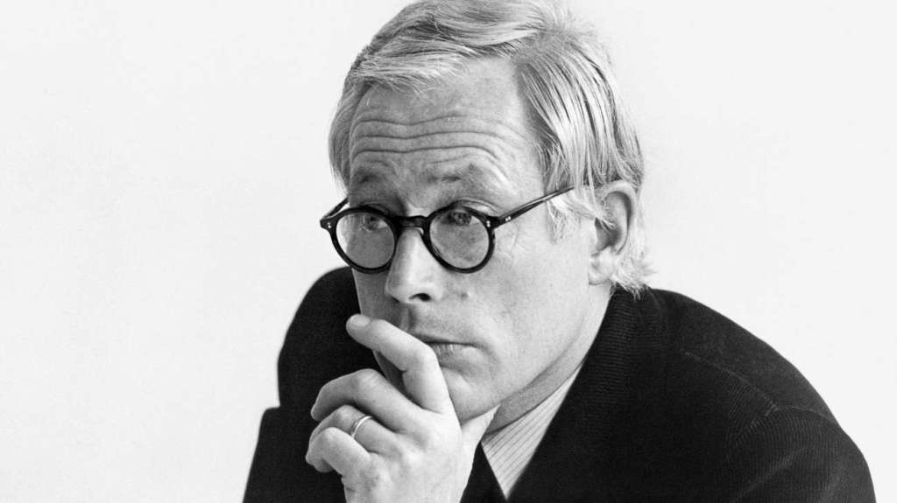
Regarding this manifesto, I aim to analyse each point made in in-depth detail that showcases why it’s a significant text that all designers should take into consideration when creating. This manifesto is very useful when it comes to design manufacturing and creation.
‘’Innovation’’
Rams focuses on the need for originality and innovation. Within this text, designers are encouraged to push the boundaries, create something new and avoid copying. This principle motivates creators to think creatively and avoid settling for the ordinary.
‘’Functionality’’
This Principle of functionality presents the idea that great design must serve a purpose. Design should be useful and practical and must adhere to meeting and enhancing the user’s experience. For example, designs should work well and solve various issues and presents that aesthetics are not important to focus on but designs that work well and solve issues are important.
‘’ Simplicity’’
The manifesto advocates the simplicity in design by showcasing clarity and ease of use within a design. This principle encourages creators to eliminate useless elements and complexity which allows consumers to easily understand and interact with the product.
‘’Longevity’’
Every great design will stand the test of time and rams stresses the importance of developing and designing a product that is durable and has a lasting value. It encourages to the users the importance of sustainability by discouraging a ‘throw-a-way culture’ and short-lived designs.
‘Honesty’
Honesty in design is being transparent about the products purpose, function and usage. Designers should avoid useless embellishments or features that deceive the user. This principle showcases a level of trust between the user and the design.
‘’Thoroughness’’
Next Rams talks about attention to detail and emphasizes that in every design there should be some level of consideration to every single aspect and even the littlest detail should be crafted with care. Therefore, thoroughness ensures an important holistic and well-rounded design approach.
‘’ Environmental friendliness’’
In 2023 we have a serious growing environment concern. In the manifesto, Rams highlights the importance for designs to have as minimal impact on the environment. Designs should always be encouraged to continuously consider sustainability and econ-friendliness in every one of their designs.
‘’Good design is as little design as possible’’.
This idea stresses the importance of the idea that designs should be simple and minimalistic, without excess or unnecessary elements that could be wasteful or confusing to the consumer. This echoes the’ ’less is more’’ approach, encouraging creators to continue to refine and strip down their designs to the essential elements.
‘’Understanding of users’’.
When designing, knowing the audience/users is a fundamental skill in this industry. Rams explains that the importance of understanding user needs and behaviours to create designs and ideas is key to truly resonate with the user and be used as their intended purpose.
Innovative use of technology
The last point explores how designers should harness technology innovatively. Whilst promoting innovation, he highlights the need to use technology thoughtfully, by making sure it genuinely enhances the design without overshadowing its purpose.
Overly to conclude, Rams manifesto serves as a highly important comprehensive framework for all designers. This piece of writing guides them to creating an impactful, user-focused, functional and endurable designs. Using these principles creators can make products that not only look aesthetically pleasing but also fulfil their purpose effectively, ethically and environmentally.
My 10-point manifesto
- Users first – Put the user at the heart of design. It is key to understanding their needs, behaviours and key areas to design and develop products that will truly serve the consumer.

- Functionality First – Functionality over aesthetics. A beautiful design is useless if it doesn’t work well or serve is use efficiently.

- Simplicity & Clarity – Embracing simplicity in design. This is key to design as clarity and ease of use to ensure that users can interact with the product intuitively.

- Sustainability & responsibility - Design with a strict commitment to sustainability and consideration to environmental issues. Using this principle will reduce environmental impacts with manufacturing, by selecting better materials, production processes and product lifecycles.

- Innovation & future-proofing – using innovation to anticipate and meet future needs. Designing products that are adaptable, advanced technologically and forward thinking is key to design revolutions and technological advancements.

- Quality & Durability – When designing, aim for an enduring quality within the product. Create products that are long lasting, reliable and have lasting value which takes away the throwaway culture we still have today, whilst reducing pollution and waste.

- Ethical Design – Practise ethical design practises, where designs are 100% transparent, honest and responsible in all aspects such as materials, production and marketing. Ensuring ethical design will be critical to also meet customer satisfaction as customers knowing the product is made ethically will impose a better user impression.

- Learn from failure – When designing use all failures to learn from and should not be forgotten about as a mistake or a wrong design could be reflected upon and show to work better than the original idea.

- Iterative Design Process – Embrace product iteration and improvement and continuously receive feedback, evolve products on real user experiences and opinions.

- Collaboration & Groupwork – use groupwork and collaboration across disciplines to enable a wider design method. Ensure to engage with a diverse selection of people within the design stake such as experts, stake holders, other designers and users to reach a holistic and well-rounded outcome.

Critique
I will now analyse each point to see how useful and fundamental it is in the design and manufacturing processes.
The first principle is putting the ‘user first’. This is important, but while prioritizing the users’ needs and what is essential, it is challenging to truly understand the wide range of user needs comprehensively. Designers may face limitations in collecting accurate user insights to every creation.
Secondly, in the manifest I state ‘’Functionality first’’ and concentrating purely on the function might neglect the emotion and psychological aesthetics and aspects of the design. There is a small balance between aesthetics and functionality and reaching this result is difficult but crucial for user satisfaction.
Next, I talk about ‘Simplicity and clarity’ and while simplicity goes into usability it can also result in oversimplification of a product. This could result in a lack of innovation or differentiation and sometimes complex issues require difficult solutions and oversimplification could destroy the products potential.
The next principle is ‘sustainability and responsibility’. This is key in current situations as it creates a better outlook on the products, however, designing sustainable products often involves a higher cost or technical constraints that could significantly impact profitability or market completeness.
‘’Innovation & Future proofing” could lead to products being alienated by existing users or disrupt existing established markets. Although balancing innovation with meeting current needs is a challenging task, if both ends of the spectrum are met then a great design will be produced.
Another principle is ‘quality and durability’. Increasing durability is key point as it could lead to an increase in higher production costs. Therefore, this could potentially make the product less accessible to certain market areas.
The 7th principle is ethical design. This can increase customer satisfaction of a product; however, this may conflict with business interests therefore raising dilemmas for creators by navigating these tensions.
‘Learning from failure’ is a great way to develop and create designs as it may be restricted in a business setting based on time and financial constraints.
The iterative design process could end up leading to time and financial constraints which could lead to delaying products launch date or risking missed market opportunities.
Lastly, I present the principle ‘Collaboration & interdisciplinary approach. This collaborative and groupwork idea might face challenges in allowing diverse views and ideas and then integrating the ideas efficiently, potentially leading to conflicts or delays in decision making.
To conclude, each principle holds a significant value to design individually. By implementing each idea to one design presents some challenges. However, if all these principles can be put into design practise, then the outcome will be highly useful, and an excellent product will be produced. Therefore, these ideas and practical constrains is the key to a successful design but constant reflection, adaptation and contextual application are vital for all designers to aim and create impactful and responsible products.

Bibliography

(No date) An incomplete manifesto for Growth - Fast Company. Available at: https://www.fastcompany.com/41082/incomplete-manifesto-growth (Accessed: 03 January 2024).
1000 words: A manifesto for sustainability in Design (no date) Core77. Available at: https://www.core77.com/posts/40586 (Accessed: 03 January 2024).
Allan Chochinov: 1000 words – A manifesto for sustainability in Design (2020) design manifestos .org. Available at: https://designmanifestos.org/allan-chochinov-1000-words-a-manifesto-for-sustainability-in-design/ (Accessed: 03 January 2024).
Beers, D. (2023) The Tyee’s most read stories of the year, The Tyee. Available at: https://thetyee.ca/News/2022/12/30/The-Tyee-Most-Read-Stories-2022/ (Accessed: 03 January 2024).
Bora (2023) Dieter rams and 10 principles for good design, Medium. Available at: https://uxdesign.cc/dieter-rams-and-ten-principles-for-good-design-61cc32bcd6e6 (Accessed: 03 January 2024).
Domingo, M.G. (2024) Dieter rams: 10 timeless commandments for good design, The Interaction Design Foundation. Available at: https://www.interaction-design.org/literature/article/dieter-rams-10-timeless-commandments-for-good-design (Accessed: 03 January 2024).
How to write a Manifesto (no date) Students Union UCL. Available at: https://studentsunionucl.org/how-to/clubs-and-societies/how-to-write-manifesto (Accessed: 03 January 2024).
Oliveira, N. (2021) Bruce Mau’s incomplete manifesto for growth: How to apply it daily, Medium. Available at: https://medium.com/melted-design/bruce-maus-incomplete-manifesto-for-growth-b08abd219402 (Accessed: 03 January 2024).
University, C.M. (no date) Home - College of Fine Arts - Carnegie Mellon University. Available at: https://www.cmu.edu/cfa/ (Accessed: 03 January 2024).
What is ‘Good’ design? A quick look at dieter rams’ ten principles. (no date) Design Museum. Available at: https://designmuseum.org/discover-design/all-stories/what-is-good-design-a-quick-look-at-dieter-rams-ten-principles (Accessed: 03 January 2024).

