
ENTERPRENEURSHIP(LCMB7004)
STUDENT NAME: RUBY
STUDEN ID NO: 2225797
LECTURER: Dr. JAYA GOPALKRISHNAN

PERSONAL REFLECTION

Table of Contents
Introduction 2
Gibb’s Reflective Model 2
Description 2
Feelings 2
Evaluation 3
Analysis 3
Conclusion 4
Action Plan 5
Conclusion 6

Introduction
A personal reflection on entrepreneurship skills is necessary for starting a new business. Gibb's reflective model would be used throughout the writing.

Gibb’s Reflective Model

Description
It is known to me after completion of the entrepreneurship module that entrepreneurs and executives need to possess a district vision. It is also important to emphasize the capacity for strategic decision-making, and the capacity to assemble and manage a strong team. Such teams and Committees needed to be formed to investigate the UK's start-up and small- and medium-sized enterprise communities. Throughout the learning experience, I have seen small businesses often face time management issues which can be resolved by prioritizing work that is necessary. The learning journey was important for me up-gradation of weak skills. I enriched myself by completing the entrepreneurship module. As my experience of working on the module, the journey of a business starts from fund management to increasing network with business associates and possible consumers. I have also gathered information from my learning journey that the business sector is currently and will continue to be for a long time to come, robust enough to fill the "seedbed" operation.

Feelings
Small businesses are often the hotbeds of innovation and entrepreneurship. They are more agile and willing to take risks, leading to the development of new products, services, and business models. This innovation fosters economic growth and competitiveness. Conducting the module has helped me to feel that the journey of a start-up may be easier if it includes some skills like time management and network building. It increases a country's economic diversity. I gathered knowledge after conducting the Introduction part that a Multifaceted Approach is needed in starting-ups. I felt during completing the module that a local economy's promotion of economic diversity depends heavily on small companies. In addition, a region's ability to withstand economic shocks can be improved by economic diversification. For instance, I have known to evaluate a firm’s sustainability after its initial three-year period in a cutthroat start-up environment. I have known from “Factors Leading to start-ups Success Beyond Three Years” that it demands a multidimensional strategy in business. This combines systematic information, analytical thinking, and the application of concepts of cutting edge. This study examines Monzo, a flourishing fintech business with headquarters in the United Kingdom, in-depth to identify the complicated aspects that led to a business’s early success.

Evaluation
I have also seen “Concrete examples of demonstratingsystematic” include regions with diversified economies that fared superior to those that were primarily dependent on one sector of the economy. Other ways of helping small businesses include 'Mopping up' joblessness by helping to create jobs and acting to local requirements. Exercising some local authority and the possibility of overcoming social disparity are done by local business persons. My experience in completing this journey has helped me to know the symbolism of anti-monopoly and taking in technological advancement is also needed. It is also known by me after completing the Entrepreneurshipmodel that, starting-ups depend on financial management. A way for each person to advance themselves in order to serve specific markets, and achieve success is associated with small business. After conducting the module, I gained knowledge that a number of both inside and outside variables affect a start-up's commercial journey‘s ability to succeed.
I have understood that a start-up's chances of success can be considerably increased by a number of factors; however, no single approach can guarantee it. I have known that locating an appropriate market is crucial where plenty of demands are seen for a service or goods. Conducting a comprehensive market study is needed before an individual sets their mind to take the initiative for further starting up a business. I have gathered data that includes trends, client needs, and difficulties that may arise after taking the initiatives of start-ups. I have also come to the point that effective leadership is essential for making a business long-lasting.

Analysis
I have understood from the module that "agile project management" is important for adaptability, and continuous improvement. It divides initiatives into smaller assignments, enabling teams to easily adjust to changes. Teams working on software development, for instance, may employ Agile or Kanban paradigms. After completing the module now I am knowledgeable about essential approaches that businesses need to go through. I gathered knowledge from my learning experience that a methodical approach to lower errors and enhance procedures. My learning experience is to add a technical method for comparing several possibilities in accordance with predefined criteria. In order to come to a well-informed decision, it entails giving criteria weights and rating possibilities. Creative and flexible start-ups are frequently those that succeed. It is crucial to be accessed to modify the item that is decided to sell. I have gathered concepts from “the concrete examples of demonstrating systems” of essentiality to respond to customer input and adjust for changes in the market.
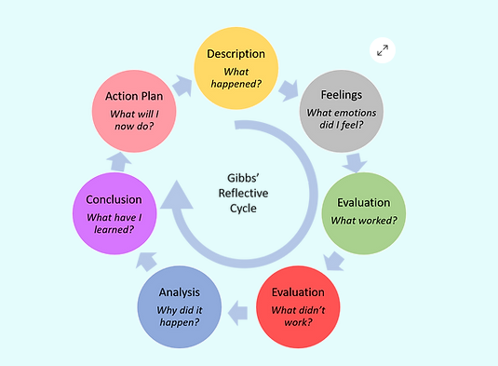
Figure 1: Gibbs Reflective Model
(Source: pmsystems.co.uk, 2023)

Conclusion
It can be concluded that working on the entrepreneurship model may benefit individuals by strengthening their skills of time management, and network building. Reflection is considered in the before-mentioned module through “Gibb’s reflective model”.

Action Plan
Needed improvements in skills | Actions to achieve skills | Needed time
Time-management | - Allocationof time with efficient balance between important work and less important work  - Prioritisation of work which helps to set the time for each task | 2 months
Network building | - Inclusion of professional behaviour  - Power of negotiation | 4 months
Table 1: Action Plan
(Source: Self-created)
Analysis of the Action Plan
Table 1 depicts the limitations related to time management and network building. These two factors have significant roles in attracting consumers and other associates in running a business. The inclusion of prioritizing things according to their needs and skills to effectively negotiate would be helpful for start-ups.

Conclusion
It can be concluded that entrepreneurship needs strategic ways in business to start-ups. Such weaknesses have been identified as a lack of network building and poor time management. The Action Plan will fix issues like lack of time management or network building by considering Gibbs's reflective model. Introduction, reflecting content through Gibb's reflective model, and a conclusion have been discussed throughout the entire reflection.

