Business Report – Comparison of Mandarin Oriental Hotel Group and Premier Inn.

Student – IOAN BLEDEA

Student ID- 2126257

Financial Management for the Hotel Industry, BMIH5007

Lecturer – TRISTAN HAWKINS

Table of contents

1. Introduction
2. Total revenue
3. Market position and growth potential
4. Financial Commitment to CSR
5. Conclusion

Introduction

Premier Inn Limited is the largest hotel chain established in the UK and was founded in 1987 by the Whitbred company under the name "Travel Inn". In 2004 Whitbred will buy the "Premier Lodge" hotels and merge them with Travel Inn hotels and in 2007 these hotels will change their name to Premier Inn. Premier Inn owns a number of over 83,500 rooms and over 840 hotels in the UK, Ireland and Germany. Premier Inn is the leading budget hotel in the UK (https://www.whitbread.co.uk/about-us/)
Mandarin Oriental Hotel Group is a hotel company that was originally founded in Asia and focuses on the promotion of luxury hotels and residences. The company has 44 hotels in 24 countries around the world. Mandarin Oriental Hotel Group was founded in 1985 by the merger of Mandarin international hotels with the Oriental hotel company. So the beginnings of this company are in the lands of the far east of Asia, from which it can be deduced that most of these hotels are found in Asian countries( https://markets.ft.com/data/equities/tearsheet/profile?s=M04:SES ).
In this report, the revenue situation, marketing strategies and the sustainability practices that the two hotel companies implement to ensure a successful development of their businesses will be analyzed by comparison. The major difference between the two hotel companies is the fact that Mandarin Oriental Hotel is a luxury brand that caters to wealthy customers, has a small number of hotels compared to Premier Inn, which operates at low costs and caters to a larger number of customers.
The explanation why Mandarin Oriental Hotel is a luxury hotel group that wants to extend its services only to rich people can be found right on the company's website. And as can be logically deduced, it has a small number of hotels in the world because the very rich customers are few in number, and in addition to that there are other luxury hotels with which they have to compete in order to satisfy the desires and appetites of the rich customers.
“Looking to the future, while we continue to grow, our aim is not to be the biggest hotel group in the world, but to be recognised as providing the very best in luxury hospitality” and also their mission is “to completely delight and satisfy our guests”( https://www.mandarinoriental.com/en/our-company/our-history)

Total revenue

The main causes that can affect the hotel industry as a whole are: pandemics, political and social instability, economic stagnation, natural disasters, etc.
From the analysis of the financial situation and the revenues of the two hotel companies for the years 2018-2022, it can be observed for the year 2000 a drastic decrease in the revenues of the 2 companies. The determining factor that caused this situation in the hotel sector was the Covid pandemic. Starting with 2021 and 2022, it can be seen from the attached tables that the income situation is gradually increasing, thus in 2023 the two companies will reach the income before the Covid pandemic.
The total revenue for Mandarin Oriental Hotel was 613,7 US$m for the year 2018, 566,5 US$m in 2019,183,7 US$m in 2020, 316,9 US$m in 2021 and 454,1 US$m for the year 2022. It is visible that comparing the years 2018 and 2019 with the year 2020, the year when the pandemic started, the revenue dropped by 70% for the Mandarin Oriental hotel in the year 2020( Annual report 2022, p.108)

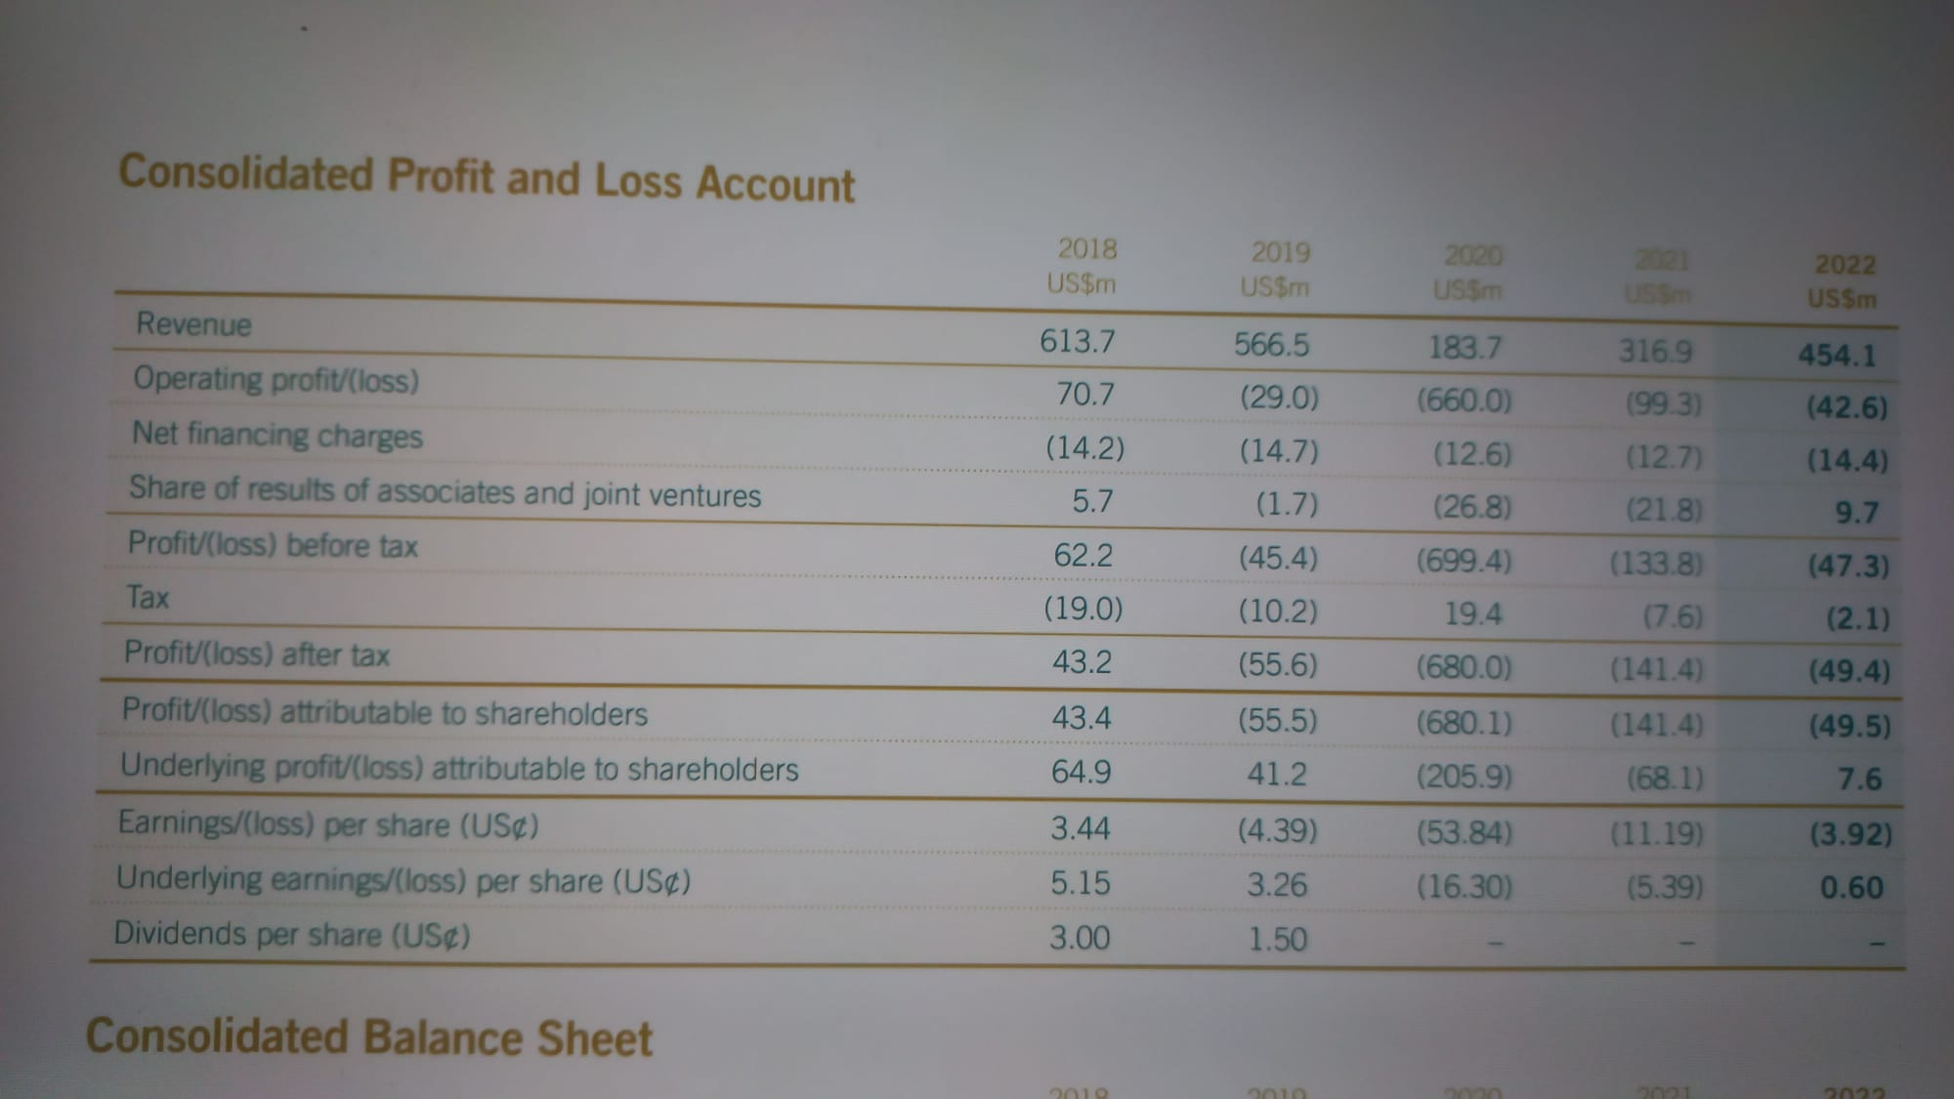
Mandarin Oriental hotel revenue for years 2018- 2022 (Annual report 2022, p.108)

The same situation of decrease in revenues for the year 2020 can be observed for the Premier Inn. The total revenue for Premier Inn for the year 2018 is 2049,1 £ m, in 2019 is 2071, 5 £m, in 2020 the revenue is 589,4 £m, in 2021 is 1703, 4 £m, and in 2022 is 2625, 2 £m. The same like in the case of Mandarin Oriental hotels, the revenue dropped by 70% for Premier Inn hotels in the year 2020, compared to the years 2018 and 2019. In the year 2022 the total revenue is higher than in 2019, but here we have to be careful, because in the UK the cost of services and utilities has increased after the covid pandemic and Brexit.( Whitbread annual report 2018-2022)
As can be seen from the data presented, the two hotel companies achieve quite high incomes in the years without external conjunctural difficulties to embarrass their activities. In a globalized society where the need to travel for business or tourism has become a habit and a necessity, the hotel industry cannot be stopped in its development, except temporarily and due to major crisis.
Another observation that can be seen from this annual reports is that although Mandarin Oriental hotel has a small number of hotels compared to Premier Inn, the total revenue for Mandarin Oriental is quite high, as a result of the high prices that customers are paying for the services offered.

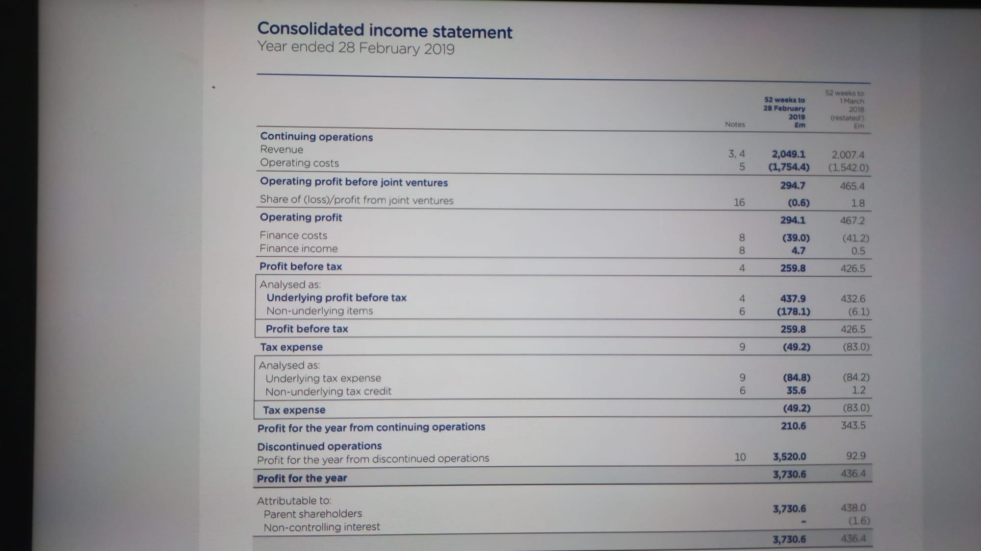
Premier Inn hotel revenue for year 2018 (Whitbread annual report 2019, p.106)

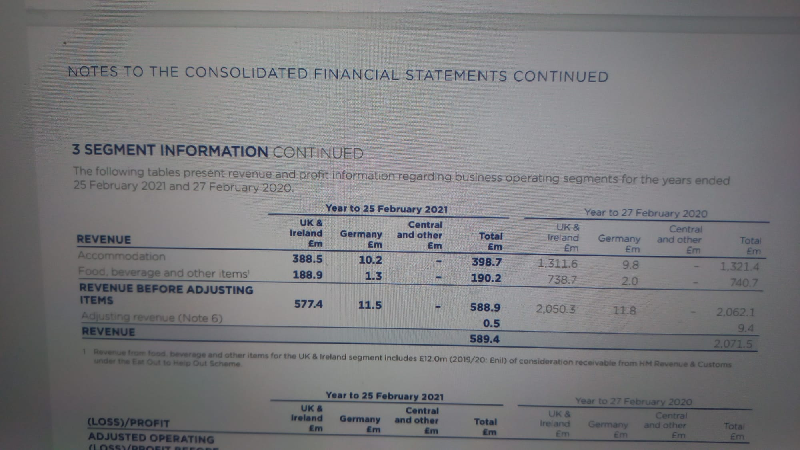
Premier Inn hotel revenue for year 2019, 2020 (Whitbread annual report 2020/2021, p.147)

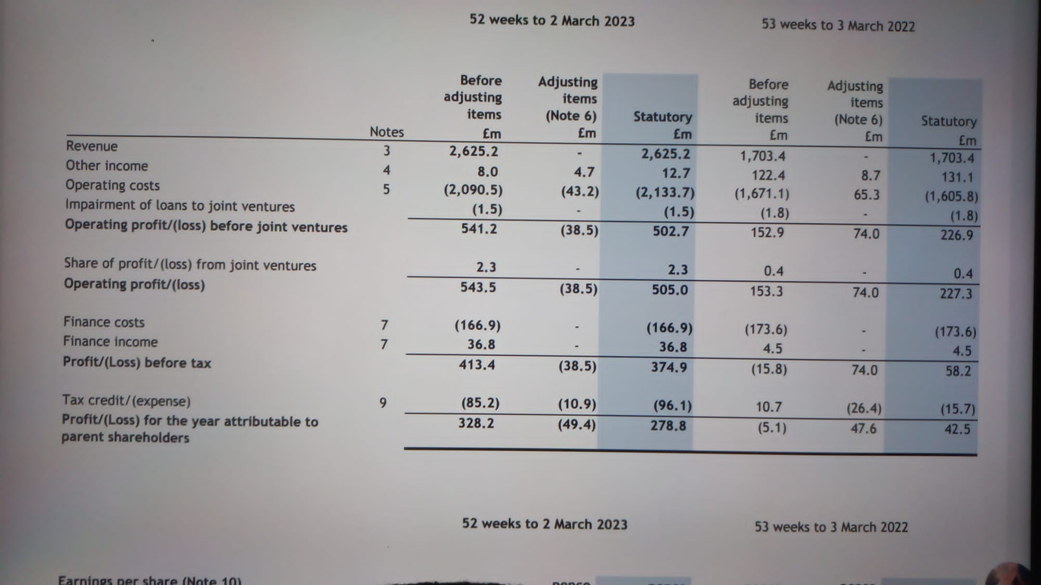
Premier Inn hotel revenue for year 2021, 2022 (Whitbread annual report 2022/2023, p.24)

Market position and growth potential

Premier Inn was named the best budget hotel brand at the Business Travel Awards 2021.
Thanks to the low prices it offers, Premier Inn is generally addressed to a wide range of customers, of all ages, both tourists and business people. Usually, Premier Inn hotels are located near airports, train stations, or locations in cities where they can be easily found by tourists. The occupancy of these hotels is around 68.3% per year, and they are sought by customers who do not have too many luxury requirements and want to spend a reasonable amount of money for the services offered by these hotels. However, the geographical area spread of these hotels is quite reduced, Premier Inn hotels can be found only in a few countries, namely the UK, Germany and Ireland and a few hotels in other countries. At the same time, certain hygiene problems were reported in some locations of the company, there were complaints regarding the housekeeping services which were not very good, as well as an exploitation of the employees who worked for this company. (https://www.howandwhat.net/swot-analysis-premier-inn-premier-inn-swot-analysis/)

Mandarin Oriental Hotel is especially aimed at customers who want luxury and quality hotel services. Most Mandarin hotels are located in Asian countries, but in recent years the company has expanded to some important cities in Europe or the USA. The number of these hotels is small, they are usually found in the most important financial capitals in Asia, such as Singapore, Tokyo, Shanghai, Bangkok, Hong Kong, Taipei, Beijing, Dubai or in the most important tourist and financial cities in Europe, such as London, Paris, Madrid, Barcelona, ​​Milan, Munich, Geneva, Istanbul.
Although the hotels are reduced numerically , the buildings of the Mandarin Oriental hotels are impressive, they stand out for their architecture and luxurious interior design. As can be seen from their geographical spread, these hotels, are located in large cities, usually financial and industrial centers or important touristic and cultural cities or centers of global fashion. Thus, by positioning in only a few but quite rich cities, the company ensures the necessary number of customers who can afford to pay for the luxurious services offered by these hotels. (https://cpp-luxury.com/mandarin-oriental-group-continues-its-strategic-expansion-aiming-to-create-legendary-hotels/).
In the last 12 months Premier Inn has acquired another 1500 rooms in the UK and it seems that for now their desire is to expand in the UK and Ireland from the 82,000 rooms they currently have up to a number of 125,000 rooms.(https://www.businesstravelnewseurope.com/Accommodation/Premier-Inn-looks-for-further-growth-in-the-UK)
Also Mandarin Oriental hotel plans to expand to locations such as Greece, the Caribbean islands, the USA, as well as opening new locations in London.( https://www.ttgmedia.com/luxury/the-luxury-segment-is-seeing-sustained-growth--mandarin-oriental-coo-on-sector-positivity-41423)
Financial Commitment to CSR

Like other big hotel companies, both Mandarin Oriental hotel and Premier Inn hotel have sustainability and environmental protection measures in their development plan. These measures are taken either because they are a legal obligation, or because certain clients are interested in sustainability policies, or simply because some managers of these hotels are aware of the need to carry out their activity while protecting the environment.
One of the common practices in hotels, as a water-saving policy, is to ask customers to use towels for several days or the linen on the beds is only changed every few days if the same guests stays in the hotel for several days. Both Mandarin Oriental Hotel and Premier Inn Hotel want to reduce carbon emissions, so these companies have installed solar panels in some locations as a source of energy or for heating water, they also planted roof gardens in some hotel location. (https://www.howandwhat.net/swot-analysis-premier-inn-premier-inn-swot-analysis/)
As it appears from the financial report for the year 2022, Mandarin Oriental Hotel aims to stop using plastic bottles, but only renewable materials, at the same time they want to reduce food waste, they also want to purchase organically produced food from local farmers or from suppliers that use production methods that are complying with environmental protection norms. Also they want to promote the green transportation methods by encouraging the vehicles that are using energy( Mandarin Oriental Annual report 2022, p.26)
So the main targets for sustainable that both company are promoting it is to reduce food waste, to reduce the water consumption , the use of green energy like solar panels, and acquisition of food produce in accordance with environmental protection norms.
Some of these measures that hotel companies promote could also be due to the fact that they reduce company costs, such as reusing towels and bed linen for several days, others are just legal obligations and companies simply feel obliged to comply with them . Some measures are taken because the customers are interested and the hotel companies want to stand out in front of the customers by promoting such measures.

Conclusions

The hotel industry experienced an important development in the last century, due to the industrial, economic and tourism development in different locations around the globe. Although the hotel industry can be affected in certain periods of economic and social crisis, natural disasters or pandemics, in a globalized society and with a sharp demographic growth, the hotel industry prospers and is always expanding. Thus there are many hotel companies, some spread globally, which try to attract a diverse number of clients in order to maximize their profits. Premier Inn and Mandarin Hotel, although they do not have a global spread like Marriott International, are an integral part of the hotel industry and represent a diversity in the range of offers available on the hotel market.
All hotel companies had a modest beginning, but thanks to the development of tourism at the global level, as well as the intensification of business trips, some hotel companies have become giants with huge profits as well as they have a continuous desire to expand and attract new customers.

REFERENCES

1.Drury C (2021) Management and Cost Accounting,
London, Prentice Hall
2.Seal W (2019) (6th Ed), Management Accounting, London, McGraw Hill
3. Walker J (2021) Introduction to Hospitality, Harlow, Pearson
4. Atrill P, McLaney (2021) Management Accounting for Decision Makers, FT Prentice Hall
5. Bhimani A, (2006) Contemporary Issues in Management Accounting , Oxford
6. Guilding,C.(2014) (3rd Edition) Accounting Essentials for Hospitality Managers, London, Routledge
7. Jagels,M. (2007) Hospitality Management Accounting, London, Wiley.
8. Seal W, Garrison RH, Noreen E (2008) Management Accounting, McGraw Hill
9. Tranter,K. Stuart-Hill,T. Parker,J. (2014) Introduction to Revenue Management for the Hospitality Industry, London, Pearson

10.Further Wild J (2018) Fundamental Accounting Principles, New York, McGraw Hill
Kotler, P. Bowen, J.T., Makes, J.C., Xie, Y & Liang, C(2006).Marketing for hospitality and tourism. New Jersey: Prentice hall

11.Kotler,P and Kartajaya,H. (2017). Marketing 4.0 :Moving from Traditional to Digital . New York: Wiley

12.Jobber, D. & Fahy J.(2012), Foundations of Marketing, London:McGraw Hill.

13.Jobber, D. & Ellis-Chadwick, F. (2012) Principles and Practice of Marketing, London, McGraw Hill 7th

14.Middleton V., Fyall A., Morgan M., (2009) Marketing in Travel and Tourism, Oxford: Butterworth Heinemann.

15.Tresidder R. and Hirst C., (2012) Marketing in Food, Hospitality, Tourism and Events.Oxford: Goodfellow.

16. Smith, P.R.& Zook, Z.E. (2020) Marketing Communications. 7th Ed, London :Kogan Page

17. https://www.whitbread.co.uk/about-us/)
18. https://www.mandarinoriental.com/en/our-company/our-history)
19.https://www.ttgmedia.com/luxury/the-luxury-segment-is-seeing-sustained-growth--mandarin-oriental-coo-on-sector-positivity-41423)
20. Mandarin Oriental Annual report 2022
21. https://www.howandwhat.net/swot-analysis-premier-inn-premier-inn-swot-analysis/
22.https://cpp-luxury.com/mandarin-oriental-group-continues-its-strategic-expansion-aiming-to-create-legendary-hotels
23. Whitbread annual report 2018-2022

