
MBA Dissertation
Module: LCMB7035-Dissertation
Programme: Master of Business Administration

Student Name: Rajneet Kaur
Student ID: 2422724
Student Email: 2422724@student.uwtsd.ac.uk
Word Count: 14,643

Topic- Exploring the Role of Agile Leadership in Driving Organisational Transformation at Deliveroo

Declaration
I would like to hereby declare that, it is my original work and I have been entirely conducted the study independently. The content of this project has not been submitted previously from any other academic institution. I can assure you that the work is true and represents my accuracy towards the work.

Rajneet Kaur
Acknowledgement
I would like to state that, I am wholeheartedly thankful to my supervisor and faculty members for providing me guidance and continuous support. I am also grateful for my positive learning environment in accessing research materials and academic library. My sincere thanks are to my classmates and peers to discussing the entire brief content and experiences with me. I further express my heartfelt appreciation to my family members for encouraging me to prove my abilities.

Abstract
The dissertation have stated that, the rise of the digital platform has transformed competition within the food delivery industry, and organisations like Deliveroo have had to constantly evolve their business models because of the wide nature of technology and the market itself. The speed of the change in customer habits in terms of on-demand convenience and sustainability is altering the priorities of the strategies, and the leaders must be able to implement changes without disrupting the operations. Digital transformation is quite crucial for the organisation to remain competitive in the fast-paced environment of business. Turbulence and globalisation often change the landscape of business to remain dynamic and competitive.
Agile leadership often promotes autonomy in the team, and therefore, the team can make customer-oriented decisions with the help of necessary resources. Agility often allows employees to resolve the issues in an efficient manner, personalisation of interaction and contribution to the experiences of the customers for making them feel seamless and productive. The data collection process followed a systematic and transparent process that would guarantee rigor and reliability. The sources were located based on systematic key word search which included such terms as Deliveroo leadership, agile transformation, platform governance, Deliveroo digital strategy, and organisational change Deliveroo. Academic databases, business intelligence sites, credible news archives and regulatory repositories were searched. The case findings from chapter 4 help to reveal that the brand Just Eats is practicing collaboration and rapid adoption of changes. The leaders of the company, Just Eats, developed a cross-functional team and used the decentralized decision-making structure to identify changes in customer needs. Chapter 5 stated that Deliveroo deals with huge amounts of datasets, such as rider’s data, employees' data, customers' data, and stakeholder’s data; therefore, data governance seems to be crucial for the brand Deliveroo. This data integration can be combined with data governance, with a strict adherence to policies and standards. From chapter 6, one can know about how this research has fulfilled the mentioned goals and made contributions to both the theoretical knowledge and practical judgment towards decision-making in the environment, being investigated in the chapter. The study set out to examine the extent to which organisations use digital and analytical capabilities to improve performance and strategic outcomes, based on secondary data from various case studies.

Table of Contents
Chapter 1: Introduction and Rationale 9
1.1. Research Background 9
1.2. Research Rationale 11
1.3. Research Contribution and Motivation 14
1.4. Research Aim, Objectives, and Questions 15
1.5. Dissertation Structure 16
Chapter 2: Literature Review 17
2.1 Introduction 17
2.2 Thematic overview of the literature 17
2.2.1 Overview of Agile practices of leadership 17
2.2.2 Impact of Agile leadership on the strategies of digital transformation and organisational flexibility 18
2.2.3 Agile leadership promotes innovation, teamwork and employee participation 19
2.3 Theoretical Foundation and Contribution 22
2.4 Conceptual Framework 22
2.5 Summary Table of Key Literature 1
2.6 Conclusion 0
Chapter 3: Methodology 1
3.1 Introduction 1
3.2 Research Philosophy, Approach, and Design 1
3.2.1 Research Philosophy 1
3.2.2 Research Approach 2
3.2.3 Research Strategy 2
3.3 Justification for Case Study Methodology 3
3.4 Case Selection and Sampling Strategy 4
3.4.1 Sampling Logic 4
3.4.2 Case Selection Criteria 4
3.4.3 Case Profile 4
3.4.4 Justification of Case Diversity 5
3.5 Data Sources and Data Collection 5
3.5.1 Types of Secondary Data 5
3.5.2 Data Collection Process 5
3.6 Data Analysis Approach – Thematic Analysis 6
3.6.1 Analysis Framework 6
3.6.2 Within‑Case Analysis 6
3.6.3. Cross-Case / Cross-Source Analysis 7
3.7 Research Quality and Rigour 7
3.8 Ethical Considerations 8
3.9 Chapter Summary 8
Chapter 4: Findings 9
4.1 Introduction 9
4.2 Case Studies 9
4.3 Case Study 1: Company Name Deliveroo 9
4.4 Case Study 2: Company Name Just Eat 10
4.5 Case study 3: Company Name Uber Eats 11
4.6 Case study 4: Company Name Food Hub 13
4.7 Case study 5: Company Name: Grub Hub 15
4.8 Chapter summary 0
Chapter 5: Discussion and Analysis 1
5.1. Purpose and Positioning 1
5.2. Analytical Framework and Logic 1
5.3 Cross-Case Synthesis: Compare and Contrast with Literature 2
5.3.1 Theme 1: Over view of agile leadership and on the strategies of digital transformation and organisational flexibility 2
5.3.2 Theme 2: Formation of a link between agile leadership that promotes innovation, teamwork and employee participation 3
5.3.3 Theme 3: The role of agile leaders in prioritising the change management, training, and adoption 5
Justification of these themes on case study: building strategies of digital transformation and organisational flexibility at Deliveroo 6
5.4 Integration into the Conceptual Model for Proposition 8
5.5 Robustness Consideration 8
5.6 Practical Synthesis 8
5.7 Chapter Summary 9
Chapter 6: Conclusion 10
6.1 Introduction 10
6.2 Short Summary of the Most Important Findings 10
6.3 Theory Implications 10
6.4 Managerial Implications 12
6.5 Limitations and Suggestions for Future Research 13
6.6 Closing Statement 14
References 15

List of Figures
Figure 1: Agile Transformation Roadmap 9
Figure 2: Agile Leadership Model 10
Figure 3.2.1: Interpretivism research philosophy 1
Figure 3.2.2: Abductive research approach 2
Figure 3.2.3: Research Onion 3
Figure 4.4.2: Just Eat Delivery 12
Figure 4.4.1: Uber Eats Grocery sector 13
Figure 4.6.3: Food distribution strategies 15

Chapter 1: Introduction and Rationale

1.1. Research Background
The rise of the digital platform has transformed competition within the food delivery industry, and organisations like Deliveroo have had to constantly evolve their business models because of the wide nature of technology and the market itself. However, Deliveroo provides its service offerings in an extremely competitive ecosystem of the on-demand-economy platform environment, where consumer demands, governmental regulation, and digital innovation are rapidly changing (Rialti and Filieri, 2024). Moreover, the success of this firm will be based on the possibility to sustain operational agility and balance innovation and compliance in an environment characterised by low barriers to entry and heavy price pressure (Kovynyov, Buerck and Mikut, 2021). Also, the speed of the change in customer habits in terms of on-demand convenience and sustainability is altering the priorities of the strategies, and the leaders must be able to implement changes without disrupting the operations (Delioğlu and Uysal, 2022).
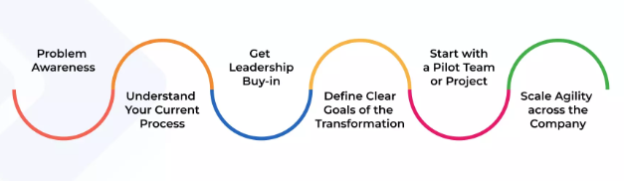

Figure 1: Agile Transformation Roadmap
(Source: Businessmap, 2023)
Additionally, in these changing environments, Agile leadership has emerged as one of the necessary requirements of the ongoing organisational change. Agile leadership is focused on flexibility, empowerment, and iterative learning, which make it possible to adjust the strategy swiftly to the ever-changing environment, in contrast to the traditional command-and-control (Kupiek, 2021). Within the context of Deliveroo, cross-functional cooperation and constant innovation make it necessary for the capacity of leaders to mitigate changes and implement new technologies, like AI-based logistics and forecasting analytics (Tigre, 2024). Deliveroo, trying to go global, should also face the complexity of different regulatory frameworks, labour laws, and stakeholder expectations in terms of employment ethics and management of data (Omol, 2024). Therefore, such strains require leaders capable of instilling agility as a part of organisational culture and at the same time remain resilient and ethical.
Furthermore, the significance of the topic is that it explains how agile leadership can initiate a transformation that goes beyond process optimisation and, in particular, how it influences decision-making, learning, and adaptation in platform-based organisations (Ellström et al., 2022). Research has also determined that dynamic capabilities like sensing, seizing and transforming are the foundations of successful digital transformation, and the leadership behaviours that facilitate these capabilities are yet to be understood in digital firms that are growing fast (Ghosh et al., 2022). In the case of Deliveroo, operational performance, employee engagement, and brand reputation of the company are impacted not only by the agility of the existing leadership but also by the circumstances faced by the industry regarding employee rights, being under scrutiny (Desalegn et al., 2024).
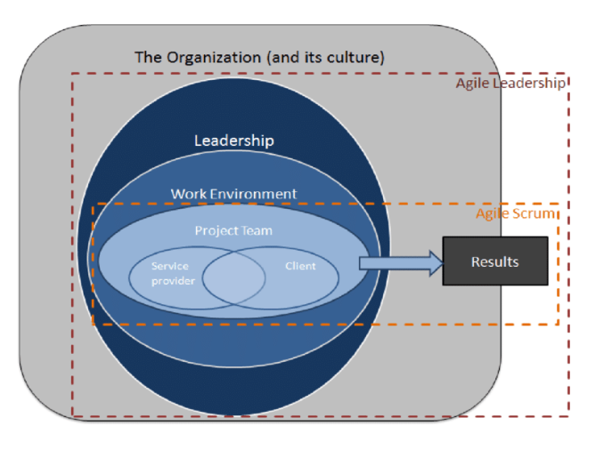

Figure 2: Agile Leadership Model
(Source: Nguyen, 2020)
Furthermore, the topicality of the research is supported by recent trends, which state that 70% of all digital transformation efforts in the world do not succeed in their goals, mainly because of the failures of leadership and culture, but not technology (Al-Moaid and Almarhdi, 2024). It is in the industry of Deliveroo that technological disruption and post-pandemic consumer demands have enhanced the urgency of adaptive models of leadership that should strike a balance between innovation and sustainability (Asghar, Kanbach and Kraus, 2025). However, recent Amvia and Deloitte experiences also indicate that successful transformation rates are 1.5 times greater in agile leaders compared with conventional managers, which should explain the timeliness of this enquiry.
Thus, this dissertation analyses at the role played by agile leadership in facilitating organisational change in Deliveroo by filling the gap between theory and practice. The study covers such strategic and operational challenges as innovation alignment to market needs, scaling digital efforts, and employee motivations in uncertain situations (Bekos, Jaakkola and Chari, 2025). Moreover, the agile leadership approach is proven to promote various attributes of adaptability by other scholars; it has been scarcely discussed in the literature regarding how the practice can be applied in the context of the gig-economy platforms, especially the European regulatory framework (Yuet, Noor and Beram, 2025). Therefore, the current study helps to occupy a theoretical and empirical gap since it examines how agile leadership can promote a sustainable change within the complex ecosystem of Deliveroo.

1.2. Research Rationale
The current literature is united by the assumption that agile leadership is a key facilitator of digital transformation through promoting flexibility, innovation, and stability (Rialti and Filieri, 2024). Scholars conceptualise agile leadership as a behavioural expression of dynamic capabilities with the ability of organisations to perceive environmental changes, capture opportunities, and reassemble resources efficiently (Ellström et al., 2022). Leadership agility, in this context, learns and incorporates emotional intelligence, teamwork orientation, and trial and error to navigate uncertainty and complexity (Kupiek, 2021). It has been proven empirically that companies that have embraced the principles of agile tend to be more digital-mature, customer-responsive, and the speed at which they innovate (Delioğlu and Uysal, 2022).
1.1.2 Theoretical Justification
Moreover, theoretical frameworks, including the Dynamic Capabilities View and Transformational Leadership Theory, have been implemented to demonstrate the undertaking of leadership aspects in facilitating strategic alignment in the context of digital transformation (Ghosh et al., 2022). Moreover, as per Tigre (2024), recent research has emphasised the relationship between agile leadership and organisational culture as theorems that leaders influence mutual values and attitudes on which agile can be based.
Although on this progress, many grey areas are still present in the literature regarding the functioning of agile leadership in diverse organisational and industry contexts (Kovynyov, Buerck and Mikut, 2021). Most research concentrates on the topic of agile leadership in the industries of software development or manufacturing, while neglecting service-facilitating platform organisations such as Deliveroo, which are closely dependent on a distributed and contingent workforce (Desalegn et al., 2024). Moreover, the processes connecting leadership agility and quantifiable transformation results are still conceptually unclear and improperly explored (Blanka, Krumay and Rueckel, 2022). Also, the current models tend to be based on the organisational hierarchies that are not always stable in gig-economies, where the digital interfaces and the indirectly controlled influence can serve as a form of leadership (Al-Moaid and Almarhdi, 2024). The other dimension that remains under research is the agile leadership-regulatory complexity interaction that is particularly relevant when it comes to those areas that undergo a high level of policy scrutiny, like food delivery (Omol, 2024). Methodologically, the field presents a skew toward cross-sectional survey designs that restrict the causal inference and confinement to a context (Asghar, Kanbach and Kraus, 2025). According to Desalegn et al. (2024), there are also debates about whether agility is a leadership style, capability, or organisational meta-competence, which uncovers conceptual conflicts that make it hard to consolidate the theory.
Elaborating on these gaps, this dissertation defines the necessity of the context-based investigation of agile leadership as one of the facilitators of organisational change in digital platform ecosystems. In particular, the study deals with the embodiment of agile leadership in the process of transformation at Deliveroo and how it can be agile in behavioural, structural, and cultural aspects to increase adaptability and performance (Rialti and Filieri, 2024). Moreover, the application of agile leadership to business models that are typified by algorithmic management and freelance labour models has rarely been studied in the past (Yuet, Noor and Beram, 2025). This divide restricts the knowledge of how leadership mobility works in the context when direct managerial control is rather low and control is mediated by technology (Kovynyov, Buerck and Mikut, 2021). However, the lack of research to fill this gap leads to the enhancement of the framework of Dynamic Capabilities by adding leadership behaviour as a micro-foundation of organisational elasticity (Ghosh et al., 2022). In addition, the discussion of the context of Deliveroo can inform us about how the convergence of leadership agility, employee autonomy, and regulatory adaptation applies in platform-based contexts (Bekos, Jaakkola and Chari, 2025). Hence, the present research attempts to build upon theory by establishing how agile leadership can be translated into dynamic capabilities that can support transformation when there is uncertainty and even when the institution is under pressure (Tigre, 2024). Therefore, it addresses scholarly demands of multi-context, longitudinal, and qualitative approaches, enabling the depiction of the lived realities of leaders in the digital disruption.
1.2.2 Practical Justification
As a manager, it is important to know how agile leadership facilitates transformation since leadership behaviour is directly related to the success or failure of digital agendas. Practically, numerous organisations, such as Deliveroo, spend vast sums of money on technologies and fail to perform because of the cultural resistance and the lack of proper leadership engagement (Rialti and Filieri, 2024). Moreover, the lack of responsiveness to external shocks like market saturation, regulatory interventions, and many more, the lack of agile leadership leads to fragmented decision-making, misaligned priorities, and slow reaction to the situation (Omol, 2024). In the case of Deliveroo, this is expressed in the form of trying to balance the rapid growth of the service with the use of ethical models of employment and the principles of compliance with data privacy (Delioğlu and Uysal, 2022).
According to the statistics in the industry, executives report leadership ability as the most important obstacle to success in changes, which supports the topicality of this gap (Al-Moaid and Almarhdi, 2024). Several areas of managerial pain in platform business include the inefficiency of scaling digital businesses as well as the loss of motivation of the geographically dispersed contractors (Yuet, Noor and Beram, 2025). In 2023, Amvia conducted an index of agility in organisations, which concluded that customer satisfaction and the rate of innovation were found to be 25 and 30 times higher in companies with an agile leader than in traditional companies. Additionally, in the case of Deliveroo, these benefits would mean quicker restaurant building, greater accuracy in the delivery process, and a better user experience, which are vital in the context of maintaining the competitive advantage (Bekos, Jaakkola and Chari, 2025).
Furthermore, the cost of not creating agile leadership capabilities is heavy. In the absence of adaptive leaders, companies face the risk of technology under-use, disengagement of employees, and low crisis-resilience of the organisation (Ellström et al., 2022). In the case of Deliveroo, this leadership might be embedded, which would boost the rate of innovation and the reliability of operations in its engineering, logistics, and customer-service sphere (Ghosh et al., 2022). In addition to this, adaptability of the leadership is also a new metric that is more actively evaluated by policymakers and investors as a marker of corporate sustainability and governance maturity (Dyduch, 2024). The implications of learning how agile leadership facilitates change, consequently, will lead to not only management but also social value through the facilitation of robust and ethically sensitive forms of business development (Tigre, 2024). Therefore, the applied value of this study is to provide empirically based information on how the leaders of Deliveroo can use the concept of agility to become sustainable in terms of digital transformation, trust by stakeholders, and competitiveness in the long term.

1.3. Research Contribution and Motivation
The dissertation adds both theoretical, empirical, and practical insights into the condition of agile leadership as an introduction to organisational change in the digital platform worlds. In theory, it builds on the framework of the Dynamic Capabilities by explaining the role of agile leadership behaviours, including speed in decision-making, empowerment, and reflective learning, as micro-based foundations of organisational adaptability (Ellström et al., 2022). Moreover, the analysis of the case of Deliveroo explains the significance of leadership agility in identifying the sensing and seizing functions that can help firms to capitalise on technological opportunities (Ghosh et al., 2022). It further advances the theory of agile leadership by separating structural and behavioural agility (leadership mindsets and actions) that are a nuance that prior models neglected (Desalegn et al., 2024). Additionally, this study disputes the existing assumption that agile leadership works equally across industries by placing it in the context of the gig-economy service domain (Kovynyov, Buerck and Mikut, 2021). Through it, it finds new conditions at the boundaries, including platform-mediated management and regulatory uncertainty, that affect the way leadership agility is displayed (Omol, 2024). Therefore, the study further adds to the theory development by incorporating the aspects of complexity leadership and institutional theory and adds a multi-dimensional perspective of leadership in digital transformation (Tigre, 2024).
Empirically, the dissertation offers a multi-case comparative analysis based on the secondary methodology through the use of Deliveroo as the central example and providing analogies with other platform-based organisations (Rialti and Filieri, 2024). Moreover, such a secondary thematic method allows identifying the pattern and performing a cross-case synthesis and provides evidence on the nature of change in the leadership practices at various transformational stages (Yuet, Noor and Beram, 2025). Additionally, case-based evidence is especially useful to comprehend the phenomena which are dynamic, context-dependent, and under-theorised (Eisenhardt, 1989; Yin, 2018). The study brings a fine angle of the observed realities of the leaders who work through technological, cultural and regulatory shocks (Al-Moaid and Almarhdi, 2024).
Furthermore, the research expects to provide managers and policymakers with practical action and how to structure agile leadership competencies. The findings can be used by Deliveroo and other companies of the same type to create leadership development programmes encouraging experimentation, empowerment, and unceasing learning (Kupiek, 2021). This research provides clarity on how agile leadership assists organisations in resource allocation by better and efficiently mitigating the change resistance and optimising performance outcomes (Bekos, Jaakkola and Chari, 2025). Majorly, it further provides decision criteria to use when assessing leadership performance in transformation initiatives and closing the gap between strategic intent and operational execution (Dyduch, 2024). The novelty of this dissertation is that it dwells upon the matter of intersectionality between agile leadership and platform-based digital transformation, an area which is relatively under-researched, yet increasingly important as a strategic issue (Rialti and Filieri, 2024). Therefore, it is the only perspective to combine theoretical, empirical, and practical views to present a whole picture model of how agile leadership behaviours can be used to initiate sustainable organisational change at Deliveroo.

1.4. Research Aim, Objectives, and Questions
Research Aim:
This study will examine the role of agile leadership in organisational change at Deliveroo, including its behavioural dynamics, structural facilitators, and situational features that enable adaptability and performance within a dynamic platform economy.
Research Objectives:
- To test the impact of the agile leadership practices on the strategies of digital transformation and the organisational flexibility of Deliveroo.
- To examine the processes by which agile leadership will promote innovation, teamwork, and participation of employees in an organisation based on platforms.
Research Question:
- What role does agile leadership play in organisational change and capacity building of Deliveroo?

1.5. Dissertation Structure
The rest of this dissertation is organised in the following way.
Chapter 2 is the review of the pertinent literature on agile leadership, dynamic capabilities, and organisational transformation.
Chapter 3 outlines the research methodology, in which the researcher used the secondary methodology by thematic analysis.
Chapter 4 shows the Deliveroo transformation analysis and how the agile leadership behaviours manifested.
Chapter 5 carries out cross-case comparison and discusses theoretical implications.
Chapter 6 leads to managerial and policy recommendations, conclusions, and suggestions of future research.

Chapter 2: Literature Review

2.1 Introduction
Literature review is the systematic way to collect and synthesize previous findings, depending on the existing knowledge related to the research area (Snyder, 2019). The key purpose of this chapter is to investigate the role of agile leadership in the organisational change at Deliveroo. In addition, this chapter also examines the process through which the agile leadership promotes innovation, teamwork and employee participation in the organisation. The present investigation can strengthen the decision-making ability of leaders, their empowerment and reflective learning in terms of the foundations for organisation. The study can also help in developing a theory on complex leadership and institutional theory in terms of the multi-dimensional aspects of leadership for digital transformation in the organisation. Therefore, the agile approach of leadership can initiate sustainable changes in an organisation like Deliveroo. It has been observed that shortcomings of responsiveness to the external threats, like the saturation of the market and regulatory interventions, have made the decision-making more fragmented. Companies like Deliveroo have faced technological risks and employee disengagement due to a lack of adaptive leadership. In this context, by reviewing the literature related to digital transformation theories, platform strategy, management of customer experience and organisational capabilities, this chapter has developed key themes based on the research objectives.

2.2 Thematic overview of the literature

2.2.1 Overview of Agile practices of leadership
Agile leadership is a particular style of leadership for striving to remove the bottlenecks for ensuring success with the support of effective and productive employees (Gouldsberry, 2021). Besides driving and promoting changes in the organisational activities, agile leadership also inspires people to become part of the transformation (Agile Business, 2023). Agile leadership is different from traditional leadership as it supports the entire participation of the technical solutions in the organization (Rialti and Filieri, 2024). Under agile leadership, the employee often feels like a part of the broader process in decision-making to make changes in the organisational transformation. Interviews among the 19 managers and employees of the Italian company have proven that an agile leader drives digital transformation in a successful manner by enhancing efficient learning (Rialti and Filieri, 2024). Therefore, agile leadership can be a suitable approach for engaging organisational members in the projects of digital transformation.
Another study has indicated that the features of Agile leadership are adaptability, collaboration, authorization and holistic learning for making the organisation more competitive and innovative (Ncube et al., 2024). Without changing the outdated methodologies, agile leaders cannot accept the changes in an active manner. In contrast to traditional leadership, the agile approach often fosters a supportive environment for employees to make their own decisions by tackling real-time complexities in an organisation.

2.2.2 Impact of Agile leadership on the strategies of digital transformation and organisational flexibility
Digital transformation is quite crucial for the organisation to remain competitive in the fast-paced environment of business. Turbulence and globalisation often change the landscape of business to remain dynamic and competitive. An interview with 20 leaders has revealed that agile leaders drive digital transformation in a successful manner by maintaining continuous involvement in digital initiatives and the employment of revolutionary practices (Sarhan, 2025). Organisational shift boosts the morale of employees and makes them connected with the future direction of the organisation. Therefore, agile leadership can work as an effective approach to engage the cohesive and motivated employees in digital transformation.
As per the opinion of Stoiko (2024), digital transformation supports the reduction of innovation cycles to speed up the market time by creating an interconnected ecosystem. However, agile leadership can act as a trigger to drive digital transformation despite its proven significance. On the contrary, agile leadership can make the organisation quite innovative and productive, respectively. Depending on the systematic review, the study has revealed that organisations are implementing the approach of digital transformation to make the organization agile and resilient (Putra, 2022). However, the study contradicts that agile leadership is not connected with the digital transformation; therefore, it cannot be optimal to increase productivity outputs of the organisation. This was a great limitation or motivation to highlight the trends of research on digital transformation with respect to agile leadership. With the support of the VOS Viewers software, the study has revealed the fact that an agile organisation needs to be dynamic to support the digital-assisted process for change.
Another study has indicated that agile leadership often works as a crucial factor to successfully navigate the threats and opportunities arising from the digital transformation (Alsuhaimi, 2024). In terms of opportunity, agile leadership can navigate the digital transformation with respect to the capabilities of leaders, organisational structure and cultures of digital initiatives. However, agile leadership introduces significant challenges, including cultural barriers of the organisation, shortcomings of digital literacy, and an imbalance between agility and stability of the organisation. This has suggested the need for expansion of leadership to address the digital context. Practical implications are required for the active implementation of developing the capabilities of agile leadership. Use of the "Adaptive Theory of Leadership" can support the leaders in navigating the complexities related to digital transformation (Alsuhaimi, 2024).
Agile leadership is not only a way of management, but it is defined as the mindset that values adaptability, team environment, and focuses on the customers. Agile leadership can make the work culture more flexible and accountable for boosting growth and innovation in the organization (Namit, 2025). Adaptable leaders can easily implement the new behaviors into existing situations for expressing creativity in the organization for resolving challenges (Anderson, 2019). Therefore, agile leaders can play the role of change agents for supporting organisations to detect the uncertainties and the drastic level of changes (Akkaya, 2020). However, the study by Rafidah et al. (2025) has developed a contradictory sense due to the side effects of agile leadership. Though agile leadership enhances clarity and responsiveness, it can also develop emotional exhaustion due to the staff having to adapt to the changes in the organisation. In addition, agile leadership is highly related to burnout due to the exposure of fundamental dilemmas under the adaptive framework. Hidden pressure can also arise while handling the lifelong learning and innovative aspects. In this context, the use of the Job Demand-Resource (JD-R) model has revealed that agile leadership can be paradoxical in terms of both facilities and constraints (Rafidah et al. 2025). Attention to the human realities can be a sophisticated strategy to strike a balance between flexibility and effective leadership in the demanding organisational sector. For instance, the study by Macintyre (2020) has indicated that approximately 69% of the organisations have experienced negative impacts on team development due to movement into agile management. Without a true shift in the agile approach, organisational transformation is not possible due to differences in the agile methodologies.

2.2.3 Agile leadership promotes innovation, teamwork and employee participation
Agile leadership often promotes autonomy in the team, and therefore, the team can make customer-oriented decisions with the help of necessary resources. Agility often allows employees to resolve the issues in an efficient manner, personalisation of interaction and contribution to the experiences of the customers for making them feel seamless and productive (Madanchian and Taherdoost, 2025). Through the navigation of trends and challenges, the leaders can foster an environment by prioritising collaboration, innovation and improvement in a continuous manner. Hence, Agile leadership can ensure the success of an organisation in the rapidly changing market of business. Similarly, other studies have highlighted that agile leadership often acts like a managerial function, like an essential element for ensuring long-term development in the organization (Akkaya et al., 2022). Through the usage of the VUCA (volatile, uncertain, complex, and ambiguous) model, the study has revealed that managers need to adapt agile leadership to facilitate successful careers of the employees in the organisation. Agile leadership is highly essential to foster innovation, besides enhancing the agility of the organisation to ensure success for the long term. Agile leadership has become an acceptable form of leadership in the contemporary landscape of business throughout the world. An agile approach is highly crucial for the success of an organisation in the ever-changing landscape of business. Agile leaders can also develop an adaptive culture through feedback and customer-centricity to capitalize on the emerging opportunities.
Agile approach often encourages transparency in communication, trust and mutual respect among the members of the team, which are quite essential to foster innovation and creativity. In contrast to the traditional leadership, the agile approach prioritizes stability, predictability and planning for the longer term. Agile leadership not only means the presence of tight control over everything, but it also flexibly supports teamwork by the removal of roadblocks (Post, 2025). Hence, Agile leaders can establish an environment to make people feel trusted, supported and motivated, also for ensuring great achievement. Similarly, the study has also revealed that agile leadership can enhance mutual trust and effective teamwork in the organisation. In terms of a flexible and proactive approach, agility can drive the technology-oriented management for the reduction of bureaucracy. In contrast, the traditional approach relies on the hierarchical model of decision-making to drive the motivational methods.
Though the agile and traditional style of leadership has its clear connections with the structure of the organisation, the agile approach is quite transformative to foster an innovative environment with respect to the values of the organisation. As per the study, the traditional model of leadership has a more risk-prone approach due to the top-down approach (Barrett-Maitland et al., 2024). The agile model often concentrates on setting a clear and flexible vision to adapt to the changes. Leaders often inspire the team to align with the work with respect to the organisational goals. Using the common-and-control model, the study has promoted the holistic approach of leadership in the organisation to ensure the effectiveness of leadership in the 21st century. Redirection of the leadership can support the customers with respect to the goals of the customers for meeting their needs.
Competitive advantages have been created by many industries with the support of agile leadership. Adoption of agile leadership is one of the ways to develop the company’s capability. Agile leadership often creates an approach of leadership with respect to the innovative mindset, adaptability, self-reliance and transparency (Barrett-Maitland et al., 2024). Evidence-driven solutions in leadership can improve the efficiency of the organisation by decreasing the turnover of staff to foster career improvement and success. However, leadership experience is quite limited to the cyclical roles and responsibilities. Team members should have opportunities to lead in the future organisation. Moreover, agile leadership is limited for the growth of staff morale, employee productivity and the implementation of goals. In a similar way, the study has mentioned that the agile pathway of working can develop business prominence for improving the adaptive performance of the team. However, shortcomings of expected improvement and adaptive performance are a great barrier to the implementation of Agility in the choice of leadership. Depending on the goal-setting theory, the study has developed an interlink between the agile pathway of working and adaptive performance among 71 agile teams (Steegh et al., 2024). The results of the study have revealed that an agile pathway of working can contribute to a positive level of team performance while developing relationships with the team. Moreover, an agile way can contribute to the granting of autonomy for prioritising the goals of the organisation.
Goal-setting theory has indicated that the agile pathway of working can support the agile team while interacting with the goals of performance in an effective way. However, difficulties can arise while contributing to the adaptive performance of the team. In response to this limitation, the study has revealed the significance of goal acceptance and commitment to make the decision-making more coherent with the support of agile teams. Use of a more longitudinal design can be appropriate in the future to identify the relationship between agile working and the adaptive performance of the team.
Along with innovation and growth, the Agile approach of leadership often encourages employees to become more proactive and engaged in the tasks by making dynamic changes in the organisation. Therefore, the agile approach can be the key to driving the cultural changes for fostering improvement in a continuous manner in the organization (Ogunrinde, 2025). Besides managing uncertainty and resistance during organisational shift, agile leadership can foster flexibility with the help of an empowered team. By navigating the complex shift of transformational initiatives, agile leadership can easily handle the digital disruption with the help of dynamic workforces.

2.3 Theoretical Foundation and Contribution
Technology Acceptance Model (TAM)
The purpose of using TAM is to examine the features of the new system of technology to influence the level of motivation for the potential users (Dziak, 2024). This theory can act as a motivation level to predict the likelihood of users to accept and adopt the advanced system. Critical assumptions of the theory are the belief that it depends on the perceived usability and the influences of the external factors on the behaviour of IT users (Burton-Jones and Hubona, 2020). While adopting digital transformation, the agile leaders can easily convince the team members to adopt the new technology and its usage. As the digital transformation is quite complex and dynamic, the development and redefinition of the TAM model is quite necessary to ensure its predictive power among the agile leaders of the organisation, like Deliveroo. The model needs to be extended with respect to the social, organisational and contextual factors to broaden the environment of the organisation. In the case of digital transformation, the TAM model has influenced the agility of firms by adopting advanced technology (Evans, 2023). Use of the TAM approach can enhance the effectiveness of the team while making the interactive process of change in the leadership practices.

2.4 Conceptual Framework
Digital transformation is not a future trend; rather, it is necessary for the business to ensure growth and competence in the market. In order to develop confidence while adopting Industry 4.0 during digital transformation, a conceptual framework can be helpful to strengthen the “business process management” (BPM).
The framework has been designed through the literature review centered on the content in the industry 4.0 technologies. Design principles of the framework and the method of BPM have become integrated into the framework to ensure digital transformation in a structured way. Development of an integrative framework of “Business Process Management” (BPM) often can act as the reference model for the investigators and manufacturing institutions to ensure a successful transition from traditional manufacturing by the approach of Industry 4.0. The model has incorporated the key factors which are ignored while implementing Industry 4.0 in a synergistic way. An in-depth understanding of Industry 4.0 technology and the design principles can be a prerequisite to devising the plan of implementation. Conceptualization and the complete process of business management have handled the associated risks related to the manufacturing organisation. The framework has been developed through considering the overlooked aspects of Industry 4.0 and its impacts on the digital transformation of the organisation. Analysis of gaps, risk management, planning for contingency and cost-benefit analysis have supported this investigation in identifying the impacts of digital transformation on the organisation. The proposed framework of IBM can be utilised by the production organisation to support the journey towards the digital transformation, depending on the Industry 4.0 technologies.

2.5 Summary Table of Key Literature
SL No | Author & Year | Theory | Themes | Method | Key Findings | Gaps | Relevance
1 | (Rialti and Filieri, 2024) | Practice-based view (PBV) theory | Agile leadership in successful projects on digital transformation | Interview | Agile leaders drive successful digital transformation through the decision-making loops at a faster rate. | The role of leaders in digital transformation is still limited. Smooth transformation of leaders is equally important in future. | Agile leadership can be an appropriate approach to engage employees in the transformational project.
2 | (Ncube et al., 2024) | VUCA framewor | Agile leadership in the success of contemporary organisations | Qualitative method | Agile leadership supports the organisation to make a rapid response to the shifting demands of the market and the advancement of technology. | Agile leadership is essential for the long-term sustainability of an organisation to ensure success in the global landscape.
3 | (Akkaya et al., 2022) | VUCA model | Agile leadership and perceived success in a career. | Descriptive design | A group decision-making approach, effective communication and adaptation to uncertain situations can increase the success in a career. | Very few studies have identified the relationship between leadership and success in a career. | Agile leadership can promote job formation by embedding agile leaders.
4 | (Alsuhaimi, 2024) | Complexity Leadership Theory | Agile leadership to ensure digital transformation | Systematic review | Organisational structure and culture of agile principles can support digital initiatives. | The potential of agile leadership and its impacts on digital transformation is quite unknown. | Digital leadership in navigating digital transformation.
5 | (Barrett-Maitland et al., 2024) | McGregor’s theory | Agile leadership is the new paradigm for developing organisational aspects | Qualitative approach | Lack of training and resilience in the practices of culture can be a barrier to leadership. | The study did not identify the impact of agility in the educational sector. | Agile leaders motivate the teams to align with the work.
6 | (Burton-Jones and Hubona, 2020) | TAM model | Acceptance of technology to resolve challenges in digital transformation | Primary sampling | Technology-driven remote learning | Acceptance of advanced technology and its resilience in the organisation. | E-learning can be the way to educate the team members while developing digital transformation.
7 | (Dziak, 2024) | TAM model | Use of TAM in digital transformation | Qualitative approach | Technology-driven remote learning | Acceptance of technology into the organisation | Perceived use and usefulness are the benefits of TAM.
8 | (Macintyre, 2020) | Agile leadership theory | Agile leadership in technological development | Survey | It influences the development positively. | Lack of explanation of the leadership. | Motivations to adopt the agile methods to meet the changing needs.
9 | (Butt, 2020) | Six sigma model | Digital transformation using the Integrated Business Process Management | Qualitative method | IBM framework can offer a structural methodology to employ in a large organisation for facilitating its transition towards Industry 4.0. | Gap identification among workforces is a limitation of the framework. | Effective protocols of change management are required to ensure effective management of the business.

2.6 Conclusion
The above review of literature often suggests that Agile leadership has its crucial as well as multi-faceted roles to drive and sustain the transformation of the organisation at Deliveroo. Agile model of leadership not only indicates the implementation of agile approach in the development of teams, but also develops the core principles for shaping the entire culture of the company and its strategy. By promoting an innovative mindset of continuous experimentation, learning and rapid interaction, this leadership can act as a strategic approach to maintain the loop. Hence, the agile leadership ensures the flexibility and adaptiveness of the company in the fast-changing conditions of the market. Agile leadership can be responsible for making the balance between the short-term needs of operation and the strategic vision for the longer term. Strategic coherence can be maintained by the company with the support of transparent communication and a customer-oriented value framework. In the case of the food delivery sector, like Deliveroo, agile leadership often acts as the primary catalyst to support its operation in a more flexible and adaptive way. Hence, the sector can maintain its competitive advantage in the digital economy of the modern era.

Chapter 3: Methodology

3.1 Introduction
This chapter outlines the research design that will be used to discuss the role of agile leadership in organisational change in the context of Deliveroo. It explains and supports the selected philosophical position, research method, case study design, data collection, and data analysis methods. The chapter has also included the conditions of the choice of Deliveroo as a focal case, the procedures that will be followed to guarantee the quality of the research, and the ethical guidelines followed in the course of the investigation.

3.2 Research Philosophy, Approach, and Design

3.2.1 Research Philosophy
The philosophical perspective of this research is interpretivism, which is suitable since agile leadership, organisational change, and behavioural capabilities are all socially constructed and situation-specific. Interpretivism allows the researcher to grasp the way in which leadership meanings are realised in various organisational descriptions, reports, and industry analyses (Renigunta, 2024). Since the study seeks to identify how agile leadership has affected the transformation of Deliveroo, interpretivism also offers the adaptability to understand the behaviours of leadership, their cultural dynamics and their contextual effects, without subjecting them to objective measurement (Cheng and Zhu, 2024).
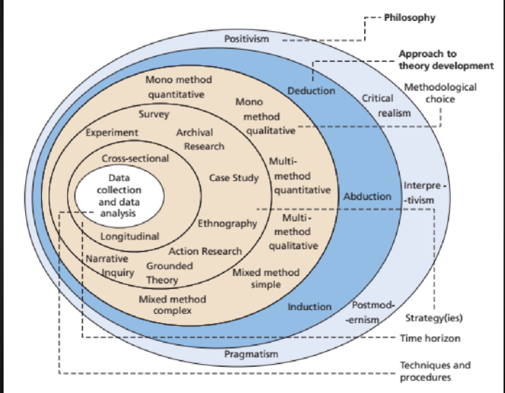

Figure 3.2.1: Research Onion

(Source: Time Horizon in research onion, 2025)

3.2.2 Research Approach
The research employs an Abductive research methodology, combining deductive and inductive reasoning. First, it uses deductive inference depending on the theoretical constructs and themes described in Chapter 2, including agile leadership capabilities and dynamic capabilities. Deliveroo’s secondary data reveal emerging patterns that refine and expand the study’s underlying conceptual understanding (Baxter and Nolan, 2024). Abduction is also considered to be appropriate in case-based organisational research due to its ease in going in and out of theory and empirical data, which helps come up with deeper descriptions of complex phenomena (Ndou et al., 2024).

3.2.3 Research Strategy
The study uses a case study approach, which is effective in answering the questions of how and what concerning leadership and change in organisations. A case study can allow studying the transformation of Deliveroo in its competitive, regulatory, and technological environment in the real world in detail (Yin, 2023). The strategy facilitates the incorporation of a variety of secondary data and a thematic analysis of the behavioural and structural aspects of agile leadership. Methodological literature confirms that case studies effectively explore dynamic organisational processes and leadership behaviours in digital platforms (Tigre et al., 2025).

Figure 3.2.3: Research Onion
(Source: Time Horizon in research onion, 2025)

3.3 Justification for Case Study Methodology
The choice of a case study approach is supported by the fact that it is consistent with the research question: “What role does agile leadership play in the process of organisational transformation in Deliveroo?” The given question requires a detailed and situational analysis of the impact of leadership behaviours on strategic change in the organisation, which can be done particularly effectively by a case study. Case studies help to examine complex organisational processes to extract meaningful qualitative data on leadership practice, decision-making, and contextual effects (Yin, 2023).
Deliveroo is an information-rich and relevant case, as it is a rapidly growing company that undergoes continuous change and depends on agile and adaptive leadership that operates in the platform economy with a high level of competition (Tigre et al., 2025). A case study will enable the study to apply longitudinal secondary data such as annual reports, regulatory filings, industry reports, press releases, leadership statements, and multi-layered insight into transformation processes.

3.4 Case Selection and Sampling Strategy

3.4.1 Sampling Logic
The current research will use purposive and theoretical sampling techniques, both of which are widely supported in the literature of qualitative case study as methods of building or testing theoretical propositions (Eisenhardt and Ott, 2022). The main aim is conceptual insight into agile leadership’s transformative influence, making probability sampling unnecessary and unsuitable. Deliveroo was selected for the rich context of its agility, digital innovation, leadership dynamics and rapid organisational changes (Tigre et al., 2025).

3.4.2 Case Selection Criteria
- Relevance: Deliveroo has experienced massive organisational change, which has been highly occasioned by the decisions made by its leaders, making it a suitable candidate for the analysis of agile leadership.
- Availability of evidence: The amount of publicly available secondary data is significant and covers annual reports, regulatory reports, news coverage, and industry research (Ribeiro-Navarrete et al., 2023).
- Recency: The events of change have taken on a central role in the last five to eight years and permit modern insights.
- Digital platform business model: Deliveroo is a digital platform company, a contextual environment where agile leadership is especially significant.

3.4.3 Case Profile
Deliveroo is a UK online food-delivery service that works in Europe, Asia and the Middle East. It was established in 2013 and cooperates with restaurants, grocers, and riders in the form of a two-sided digital marketplace model. Chapter 4 gives a suspicious organisational background. In this context, four case studies such as Just Eat, Uber Eats, Food Hub and Grub Hub will be mentioned in detail. The company Just Eat is an online delivery platform in the UK which is following market based business model. They are using their own website to let customers order food from nearby restaurants. Similarly, Uber Eats follows a logistics-intensive approach, in which partners use their own vehicles to reduce costs. Just Eat performs the marketplace-oriented model, mainly operating as an intermediary that connects customers and restaurants through its platform digitally, with limited logistics control. Uber Eats analyses a low-commission model, emphasising close relationships with local and independent restraints. Grubhub includes a hybrid marketplace model, which combines the commission-based revenues with premium services. The case study of Food Hub highly aligns with the business context of Deliveroo, where the firm follow a low commission business model. They directly contact with restaurants and take online orders and manage their deliveries through partners. On the other hand, Grub Hub practice a hybrid marketplace model and generating revenue through commissions, and premium services.

3.4.4 Justification of Case Diversity
Deliveroo is the primary case; secondary evidence from the other platform firm supports theme development by revealing comparable patterns and reinforcing analytical insights. This methodological strategy enhances the depth of understanding of the context in addition to maintaining the analytical depth that a one-case study represents (Santos and Grundy, 2025).

3.5 Data Sources and Data Collection

3.5.1 Types of Secondary Data
The work of the study relies on a number of types of secondary data because it attempts to build a triangulated and holistic viewpoint of agile leadership and organisational transformation in Deliveroo. Annual reports and other investor documents of companies offer an organised and verifiable data on strategic priorities, executive choices and commercial performance, but can present leadership activity in a positive garb (Ribeiro-Navarrete et al., 2023). Press releases and executive statements reveal leadership intentions supporting thematic insights on agility, though they may lack critical objectivity and independent scrutiny. Industry reports provided by companies like Deloitte and Statista provide a more general contextual understanding of platform-economy dynamics, but generally on a high level and are commercially biased. The academic journal articles also provide the theoretical frameworks of thematic coding, but they are often not directly concerned with Deliveroo. The news from respectable sources provides independent analysis but may be biased towards journalism. Regulatory documents on employment and platform governance enhance the comprehension of the force of transformation (Leung and Patel, 2024).

3.5.2 Data Collection Process
The data collection process followed a systematic and transparent process that would guarantee rigour and reliability. The sources were located based on a systematic keyword search, which included such terms as Deliveroo leadership, agile transformation, platform governance, Deliveroo digital strategy, and organisational change at Deliveroo. Academic databases, business intelligence sites, credible news archives and regulatory repositories were searched. The inclusion criteria were based on relevance, recency (2017-2025), and credible authorship, thus ensuring that materials that were selected answered the research question directly. Articles with low levels of transparency, articles with unproven assertions, and articles with blatant promotion bias were ad hoc excluded. All the listed sources were listed in a data matrix that contained the data on the publication date, origin, and relevance to thematic categories. Cross-checking among the types of sources was used to increase reliability by making sure that the statements made by leadership, industry levels, and independent media analysis are consistent (Rybak and Ellis, 2025).

3.6 Data Analysis Approach – Thematic Analysis

3.6.1 Analysis Framework
The present research makes use of the six-step thematic analysis model as described by Braun and Clarke (2006), which continues to be actively supported in modern organisational research. The analysis took place in the following steps that included familiarisation, coding, theme generation, theme review, theme refinement and reporting. The conceptual framework created in Chapter 2 provided the initial direction in coding, as specific focus was made on themes like agile leadership behaviours, change processes, innovation practices, and teamwork dynamics. The analysis was open to an emergent pattern that would appear due to the secondary data, as per the abductive approach, which enabled the free flow between the theory and the evidence (Hawkins and Rao, 2023).

3.6.2 Within‑Case Analysis
The within-case analysis was aimed at building a comprehensive and logical story of the organisational change at Deliveroo. It was done through a structured analytical template that started with the background setting, followed by analysis of leadership behaviours, the change challenges faced, the agile practices used and the outcomes of those practices as an organisation. Triangulation of insights between various types of documents was also used to increase credibility and reduce the bias that may occur when using secondary data. It makes sure that the leadership narratives, external evaluations, and industry assessments are consistent (Murphy and Kelly, 2024).

3.6.3. Cross-Case / Cross-Source Analysis
Cross-source analysis was done to contrast the emerging themes of Deliveroo with the trends that were present in other leading platform organisations, using Uber, DoorDash, and Just Eat as examples, to build on theoretical understanding without conducting full comparative case studies. The similarities in the identified agility of leadership, digital adoption, intensity of innovation, and cultural responsiveness in this analysis were accompanied by a prediction of differences in regulatory pressures, scaling approaches, and organisational design. These cross-source patterns are easy for thematic analysis and interpretation of context (Rogers and Ghaffari, 2025). Just Eat was used to analyse leadership practices within the marketplace-oriented models, which limit delivery control, while it provides insight into the ability under logistics-intensive operations. Food hub has a contrasting offer, worked out by is low-commission, relationship-focused approach, whereas Grubhub explains leadership within a hybrid platform model. Linking the cases enabled clearer identification of shared leadership themes and differences, strengthening the credibility of thematic analysis.

3.7 Research Quality and Rigour
Methodological rigour is unavoidable in the development of credible and trustworthy findings. This paper will use the four quality criteria as presented by Yin (2018), which are still a well-known set of criteria in modern qualitative research (Turner and McGinley, 2023).
Construct validity is supported by the use of several secondary sources of data, such as annual reports, media coverage, communications by the leadership, and industry analyses. The paper uses well-delimited constructs based on the conceptual framework described in Chapter 2, which ensures a uniform means of understanding agile leadership and organisational transformation (Rao and Ellison, 2022).
The logical connection of the data to codes, themes and ultimate interpretations maintains internal validity. The abductive method of analysis also offers greater credibility as it cyclically switches between theories and facts, which helps to refine the emerging insights and avoids the threat of drawing conclusions too soon (Baxter and Nolan, 2024).
The external validation is analytical generalisation, where the results are generalised to the theoretical hypotheses relating to agile leadership and not the generalisation of the results to all organisations. This methodology is in line with the modern requirements of qualitative case study in the digital and platform-based setting (Khan and Dubois, 2025).

3.8 Ethical Considerations
Publicly-Available Data: The current study uses secondary information that is publicly available and hence presents no risk to human subjects. The fact that no personally identifiable or sensitive information is obtained makes the ethical exposure low. However, the organisational data should be employed conscientiously, which requires accuracy, openness and respect towards the represented institutions (Parker and Houghton, 2022).
Integrity, Attribution, and Accurate Representation: Ethical integrity demands that the secondary materials be credited accordingly and that they are not misinterpreted. The analysis, therefore, avoids one-sided reporting or exaggerated reports by confirming information from various sources that are recognised as true. This research method is in line with the requirements of a rigorous qualitative study, thus protecting fairness in the presentation of organisational practices and leadership behaviours (Mitchell and Rowe, 2023).

3.9 Chapter Summary
The main case study has been chosen as the company Deliveroo due to the strong evidence of agile leadership, digital innovation, and rapid organisational change. Data is aggregated based on a variety of credible sources, such as company reports, industry studies, media, and other executive messages, and thus, inclusiveness in triangulation is achieved. The thematic analysis framework presented by Braun and Clarke informs the coding and interpretation of the appearance of patterns. Rigour stems from transparent procedures and analytical generalisations, while ethics relies on public data and objective reporting.

Chapter 4: Findings

4.1 Introduction
The chapter 4 research findings can be taken as one of the main sections in the dissertation, as it holds a proper analysis of the collected data. In this chapter, a total of four case studies will be mentioned, and each of them will illustrate the details such as company background, strategies, weaknesses, KPIs, and success. The chapter includes a total of four case studies or companies that cover different aspects of the UK food delivery market. These four companies are core competitors of Deliveroo. The UK food delivery market is expanding, and the approximate value was £12–13 billion in 2025. The market is also suffering from high competitiveness and a much-needed technological advancement. All companies prioritised the customer needs and focused on the areas of reliability, consultancy, customer support, and high-tech support. Here, a total of 5 case studies will be discussed in details such as Deliveroo, Just Eat, Uber Eats, Food Hub and Grub Hub.

4.2 Case Studies
For this chapter, the chosen competitors of Deliveroo are Just Eat, Uber Eats, Food Hub and Grub Hub.

4.3 Case Study 1: Deliveroo
Deliveroo is known as one of the most renowned multinational firm UK, which was founded in 2013. The company is highly technology driven that help in connecting grocers, retailers, customers and other restaurant chains. In 2024, the brand earned the revenue of £7.4 billion, in 2024 and the profit was almost 6%. In 2024, the net profitability of Deliveroo was almost £2.9 million. The company expanded its business and product delivery options into groceries, and 16% of GTV was received.
Due to the thin profit margin and a broken cost structure due to the volatility of the market, the firm Deliveroo is experiencing difficulties in managing payment options, investments and promotions. Apart from that, most of the employees are complaining about a high surge of commission fees, so that delivery partners earn a few capitals for each order. The opportunity for the firm is to promote a subscription based services along with making deals and special offers for customers. To maintain employee rights, the company has adhered UK based regulations and acts.
Further implementation strategy is to enhance riders’ experiences by introducing a performance based incentives and a clear salary structure. The outcome of this initiative is reliability and employee satisfaction that further enhance employee retention rate.

4.4 Case Study 2: Just Eat
4.4.1 Introduction and background
The key competitors of Deliveroo are Just Eats and it is a UK-based firm that is responsible for delivering food to local customers. In 2006, the company entered the food delivery market, and the parent company is Just Eat Takeaway. The company can be put under the online Food delivery platform and facilitate the “on-demand food ordering” (Just Eat., 2025). The company Just Eats have built a strong connection with 88,000 restaurant chains and is able to deliver food in 97% of postcodes in the UK. Further estimation finds that Just Eat contributed to the economy of the country, and the value was £3.5 billion. The market share has been expended up to 25% to 32%, and the Market position of Just Eats is based on extensive restaurant networks.

4.4.2 The challenges and opportunities
The intense competition is one of the core challenges facing Just Eat, which ultimately results in the compression of the profit margin by Just Eat. Some Major rivals of Just Eats’ are Deliveroo and Uber Eats, and these firms are giving aggressive competition, which results in order fluctuation for the firm. Another major challenge is the operational complexities and maintaining service quality due to a limited number of delivery partners and growing demand. As per the growing demand, the company has developed a significant opportunity to deliver more than food (Race and Conway, 2025). They might expand the delivery system to groceries and build a partnership with huge retailers such as Asda and One Stop. Moreover, the company can enlarge its offerings and diversify its delivery options to hotels, pubs, and more.
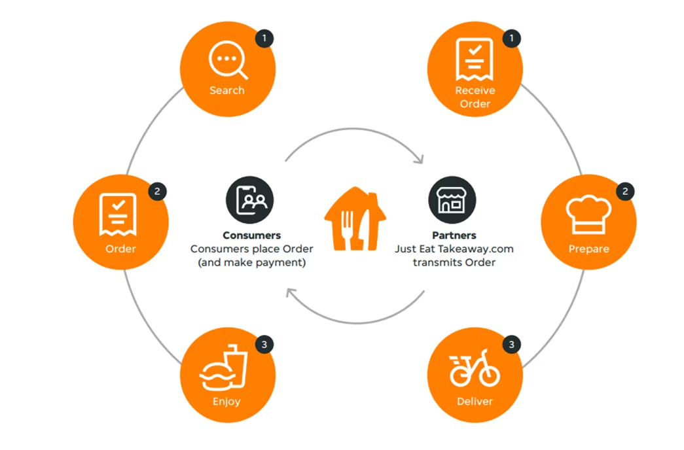

Figure 4.4.2: Just Eat Delivery
(Source: Race and Conway, 2025)
4.4.3The Approach and Implementation
The company Just Eats needs to think beyond delivering food, and they need to intensify their product ranges such as retail items and groceries. In order to unlock an updated strategy of obtaining a revenue stream, the company must build a strategic partnership with ecommerce fir to strengthen its media program and marketing strategies. From the perspective of technologies, the company must work on AI integration to improve customer engagement through the Group Ordering system (Iyer and Malhotra, 2024). They need to launch their own Menu AI tool that will speed up the process of ordering and delivering the required menu faster. They must follow a strategic partnership with Sainsbury, and enable the opportunity for customers to get groceries at home within 30 minutes.
4.4.4 Outcome and result
The company has made a noticeable improvement in takeaway platforms, and the gross transaction value has improved by 4% in 2024. In 2024. The EBITDA of Just Eat was €460 million, and the firm acquired support from global tech investors for €4.1 billion. The key business KPIs are total order which were 879 million in 2024, and revenue of €5,085 million. Therefore, KPIs such as average time, order summary, success rate, and delivery reliability can be measured to detect brand success.

4.5 Case study 3: Uber Eats
4.5.1 Introduction and background
Uber Eats seems to be the global online platform that provides advanced technology-driven services to customers. Customers can access the official website of the company and order their preferred meals. The company Uber Eats was introduced in 2014, and the company is mainly known for its ride-hailing services, along with currently they are serving food to customers at their home location. The company has been operating as a subsidiary of Uber and provides services to 45 cities in the UK. After emerging, the company Uber Eats took 27% of market share, and the market value was £14.3 billion in 2025 (Uber, 2026). In 2024, the company reached the milestone of providing services to 1 billion people in the UK. According to the data, the main competitor of Uber Eats was Deliveroo and Just Eat. The major competition is receiving the Uber Eats by the Firm Deliveroo, which holds accounts for running dark kitchens.
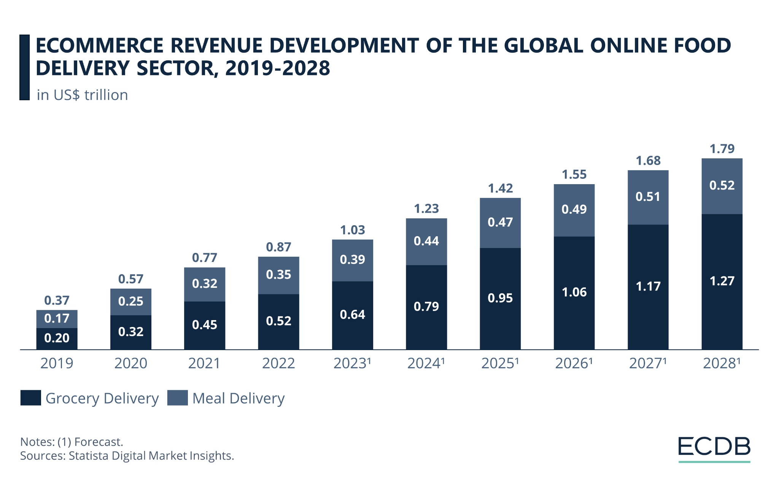

Figure 4.4.1: Uber Eats Grocery sector
(Source: Uber. 2026)
4.5.2 The challenges and opportunities
The company Uber Eats has been experiencing some operational challenges due to labour issues. The company solely depends on delivery partners, and a lack of delivery personnel can cause delays or cancellation of orders. Moreover, the delivery partners are trying to leave jobs due to inconsistent earnings, poor compensation, and incentive structures. The works are reporting about a thin profit margin for long delivery, which ultimately erodes the economic structure of the firm (McCallum, 2024). The brand needs to introduce innovative services, such as introducing a subscription-based program for customers. In this process, subscribers will get additional discounts and immediate, real-time offer options. In this way, the company can attract new customers and expand its business to other regions.
4.5.3The Approach and Implementation
In 2025, Uber Eats introduced a multi-faceted model to improve delivery time, reduce the overall cost, and improve efficiency. The company is arranging a recruitment program for delivery partners and introduced a new cost structure for employees. The company invested a huge amount of capital in a training program for employees to deal with peak hours and consistent customer demands. They need to open the dark kitchen at multiple places to shorten the delivery time. Uber Eats has incorporated AI-driven tools and software to schedule and match orders and delivery partners at the nearby locations of those orders. The algorithm will help in analysing faster routes and avoiding congestion for Uber delivery partners.
4.5.4 Outcome and result
The strategic leadership of the firm targets to address its operational challenges, and after a successful improvement, almost 20% more efficiency among delivery partners can be noticed. The advanced technological implementation will cut the delivery time upto 15 minutes from 30 minutes (Uwasomba et al. 2025). The implementation of micro fulfilment hubs can help in fulfilling the food needs in high demand region. This approach reduces 12% of complaints and order errors by the customers and builds a positive brand image.

4.6 Case study 4: Company Name Food Hub
4.6.1 Introduction and background
The company Food Hub was introduced in the food delivery market in 2008 in England. The key business strategies of Food Hub lie in improving their online websites to bridge the gap between customers and local restaurants and food outlets. The brand is simultaneously focusing on offering technology-driven solutions, such as the integration of POS and KDS for enhancing customer service efficiencies (Foodhub, 2026). In 2025, the UK’s food delivery sector achieved revenue of £14.3 billion, yet Deliveroo seems to be the major contributor and grabbed 80% of orders. In contrast, the Food Hub made-up 56% of market share in 2025.
4.6.2 The challenges and opportunities
The main challenge of Food Hub is declining market share due to poor service quality and a lack of positive customer experience. Customers are repeatedly reporting incorrect orders and issues with refunds. Moreover, some other reports covered the account security concerns of customers; therefore, customers are tense about fraudulent transactions. These issues create an opportunity for the firm to introduce new AI-driven, cloud-based, and analytical technologies, which can detect threats or suspicious activities within their official website (Bivona, 2023). The leadership plan for the Food Hub is to practice partnership with grocery delivery partners such as Snappy Shopper to keep up with the new demand of customers. Arranging an online loyalty program will help the brand to connect with customers and gather valuable feedback for their firm.
4.6.3 The Approach and Implementation
The leaders of Food Hub need to blend the expansion of business with the adoption of innovative business models. They should prioritise a cost-effective ordering system by introducing subscription-based models for the restaurant partners. In this way, they can lower the aggressive competitiveness of the rivals. Other approaches for Food Hub are to leverage technology-based offerings such as Google-based ordering, offline order generation, an self-depending Kiosks to control consumer touch points (Keeble et al. 2022). In order to achieve this, the firm should integrate the EPOS system and initiate automation for swift delivery to multiple locations. They further integrate with third party application and the most reliable Google apps to expand the customer reach.
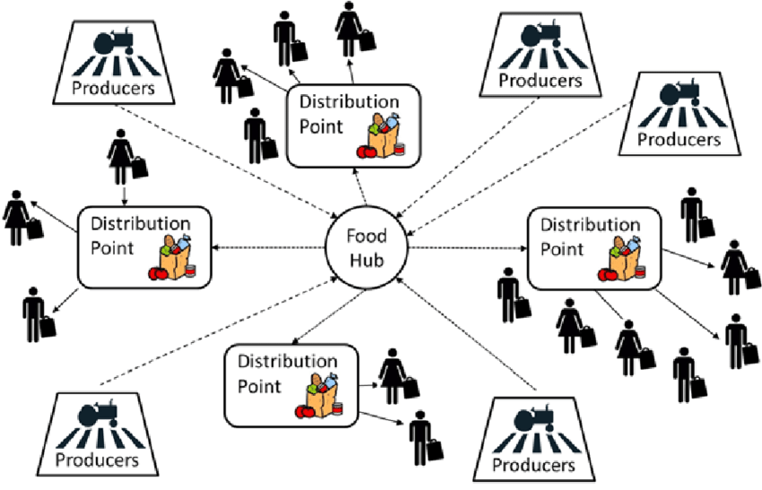

Figure 4.6.3: Food distribution strategies
(Source: Keeble et al. 2022)
4.6.4 Outcome and result
The adoption of low commission models provided the firm with an opportunity to leverage its cost-effective services. It will enhance the customer retention rate and attract stakeholders such as multiple restaurant chains from the UK. The main KPI for the firm is order volume, and it is growing at a rate of 3.1% in 2025. The partnership network for Food Hub has grown to 30,000 restaurant involvements and completed 65 million orders. The satisfaction of customers and positive reviews on the website are other KPIs.

4.7 Case study 5: Grub Hub
4.7.1 Introduction and background
The Grub Hub is another competitor of Deliveroo, which was introduced in this market in 2004. The headquarters of Grub Hub is in the USA, and it was the first food delivery partner to develop the idea of taking meals from restaurants and sending those to customers. The core product and services of Grubhub depend on using digital platforms to deliver food. Grubhub has a vast user base and covers 4000 cities in the US, yet the company decided to expand in UK market (Grubhub, 2026). There are more than 33 million active customers who have been engaged with the firm for decades. In the US, the major competitor of Grubhub is Door Dash, which holds almost 90% of the market share.
4.7.2 The challenges and opportunities
The key challenges for Grubhub are the complicated structure of logistics and the inability of leaders to coordinate among stakeholders to initiate on-time delivery. Moreover, GrubHub still depends on manual processes in customer support and order management (Shead, 2020). Due to the interference of humans, the process is lengthy and time-consuming. The company received a new order to respond to a new demand of customers by implementing automation and AI within the system. They might prioritise the customer-focused innovation plan to remain competitive in this food delivery market.
4.7.3 The Approach and Implementation
The brand Grubhub should focus on building a positive brand image and recognition. They need to use automation in chat support to explain and resolve the queries of customers. The company can target suburban areas to temporarily avoid the competition from other delivery partners, such as Deliveroo. The brand should focus on customer-focused demand and arrange both online and offline campaigns to directly engage customers. The offline process should be arranged for suburban areas to gain more insight and build a positive connection with customers (Erkmen and Turegun, 2022). In the suburban and snake areas, there must be limited food delivery options that can be noticed, so that Grubhub can establish its business. Moreover, the brand must work on simple online e-commerce strategies to leverage sales and the number of orders.
4.7.4 Outcome and result
The results show that the sales value increased and the brand obtained recognition as one of the most successful food delivery partners in the UK. The brand is providing an affordable food option by including small and mid-sized restaurants in its business. They aim to offer lower and middle-income level households to strengthen their position in this market. The success can be measured by the feedback and ratings received by Grubhub, which state that the firm's delivery efficiency is within 30 minutes (Erkmen and Turegun, 2022). The delivery partners are well-behaved, trained, and friendly in nature. The metrics show that the company efficiently manages on-time food readiness through seamless contact with the restaurant chain. Therefore, the customer satisfaction score is 71 to 73 points, which depicts a higher customer retention rate for the firm.

Tables of Case Study Analysis
Cases | challenges | opportunities | solution | implementation | Outcome
Deliveroo | Due to the thin profit margin and a broken cost structure due to the volatility of the market, the firm Deliveroo is experiencing difficulties in managing payment options, investments and promotions. | The opportunity for the firm is to promote a subscription based services along with making deals and special offers for customers. | To maintain employee rights, the company has adhered UK based regulations and acts. | Further implementation strategy is to enhance riders’ experiences by introducing a performance based incentives and a clear salary structure. | The outcome of this initiative is reliability and employee satisfaction that further enhance employee retention rate.
Just Eat | Some Major rivals of Just Eats’ are Deliveroo and Uber Eats, and these firms are giving aggressive competition, which results in order fluctuation for the firm. | They might expand the delivery system to groceries and build a partnership with huge retailers such as Asda and One Stop. | Moreover, the company can enlarge its offerings and diversify its delivery options to hotels, pubs, and more. | The company must build a strategic partnership with ecommerce fir to strengthen its media program and marketing strategies. | In 2024. The EBITDA of Just Eat was €460 million, and the firm acquired support from global tech investors for €4.1 billion.
Uber Eats | The company solely depends on delivery partners, and a lack of delivery personnel can cause delays or cancellation of orders. | The brand needs to introduce innovative services, such as introducing a subscription-based program for customers. | In this process, subscribers will get additional discounts and immediate, real-time offer options. | The company is arranging a recruitment program for delivery partners and introduced a new cost structure for employees. | The strategic leadership of the firm targets to address its operational challenges, and after a successful improvement, almost 20% more efficiency among delivery partners can be noticed.
Food Hub | Moreover, some other reports covered the account security concerns of customers; therefore, customers are tense about fraudulent transactions. | The leadership plan for the Food Hub is to practice partnership with grocery delivery partners such as Snappy Shopper to keep up with the new demand of customers. | Arranging an online loyalty program will help the brand to connect with customers and gather valuable feedback for their firm. | They should prioritise a cost-effective ordering system by introducing subscription-based models for the restaurant partners. | The main KPI for the firm is order volume, and it is growing at a rate of 3.1% in 2025.
Grub Hub | The key challenges for Grubhub are the complicated structure of logistics and the inability of leaders to coordinate among stakeholders to initiate on-time delivery. | The company received a new order to respond to a new demand of customers by implementing automation and AI within the system. | The company can target suburban areas to temporarily avoid the competition from other delivery partners, such as Deliveroo. | Moreover, the brand must work on simple online e-commerce strategies to leverage sales and the number of orders. | The metrics show that the company efficiently manages on-time food readiness through seamless contact with the restaurant chain.

4.8 Chapter summary
The discussion chapter stated the broad opportunity of business in the UK food delivery market. Deliveroo is dominating the UK market and holds 90% of the market share; therefore, other competitors are improving their leadership strategy to strengthen their business. The Food Hub, Uber Eats, and Grubhub are suffering from challenges such as excessive competition, operational challenge and declining market rate. These companies practised strong leadership to find opportunities to respond to the new customer trend.

Chapter 5: Discussion and Analysis

5.1. Purpose and Positioning
The purpose of the discussion chapter is to examine the role of agile leadership in the improvement of the business for Deliveroo. The Agile leadership structure of the Company ensures that the employees are promoted based on their work and are adapting to new changes to become a part of innovation. This chapter thoroughly compares and contrasts the findings from the literature chapter and result chapter to further interpret the findings in a detailed manner. The literature chapter mentioned the impact of Agile leadership in the context of the digital transformation of the brand (Iyer and Malhotra, 2024). The chapter mentioned about Resource based view theory, TAM, and Dynamic Capability Theory to understand the relationship between company performance and agile leadership planning. On the other hand, Chapter 4 has highlighted a case study analysis of four major competitors of Deliveroo who have been trying to hold the top position in the UK’s food delivery market. Uber Eats, Just Eat, Food Hub, and Grub hub are major companies that have been delivering foods at the doorstep of customers and are looking for further innovation and chances to achieve long-term success in this competitive market.

5.2. Analytical Framework and Logic
The Technology Acceptance Model (TAM) has been used in the literature, and the acceptance of this model paved the path for Deliveroo to bring organisational transformation. The framework connects multiple stakeholders of Deliveroo, such as workers, riders, customers, employees, investors, managers, the CEO, and the IT team. In that case, the theory highly supports accepting riding applications, AI driven forecasting system, machine learning, automation, a route optimisation system, and a performance dashboard to become the most demanding delivery partner for the UK.
The application of the Resource-based View Theory helps in demonstrating the application of internal resources for creating competitive advantages. The RBV theory guides the brand Deliveroo in prioritising the human Capital and targeting to build a cross-functional collaboration team for reacting quickly to changes in the market and any other customer needs (Chukwunweike and Aro, 2024). The usage of the Dynamic Capabilities Theory supports the brand in making rapid decisions in the context of detecting threats and opportunities. Customer feedback gathering and searching for loopholes for the firm seems to be a major success criterion for Deliveroo.

5.3 Cross-Case Synthesis: Compare and Contrast with Literature

5.3.1 Theme 1: Over view of agile leadership and on the strategies of digital transformation and organisational flexibility

From a literature perspective, it can be stated that Digital transformation is one of the core competencies for an organisation, as it help the firm cope with changes in the business market. The food delivery firm Deliveroo has recognised the need to take strategies to overcome technological disruption. The agile leadership planning creates such a workplace where the team can be trusted by each other and support each other in experimentation (Ratajczak, 2023). As per the strategic model, the agile leadership is focusing on the adaptive strategies by providing a feedback cycle for the short term. Agile leadership supports innovation for Deliveroo and engages stakeholders who can invest in technological upgradation.
The case findings from chapter 4 help to reveal that the brand Just Eats are practicing collaboration and rapid adoption of changes. The leaders of the company, Just Eats, developed a cross-functional team and used the decentralized decision-making structure to identify changes in customer needs. The Agile leaders of Just Eats focused on integrating AI and personalisation, which can offer specific recommendations of dishes for customers and send notifications to them on special offerings, discounts, and unique disease from authentic restaurants. As per findings from the previous chapter, it can be found that a major competitor of Deliveroo, Just Eats have moved beyond food items, so that they deliver essentials, and groceries to their customers.
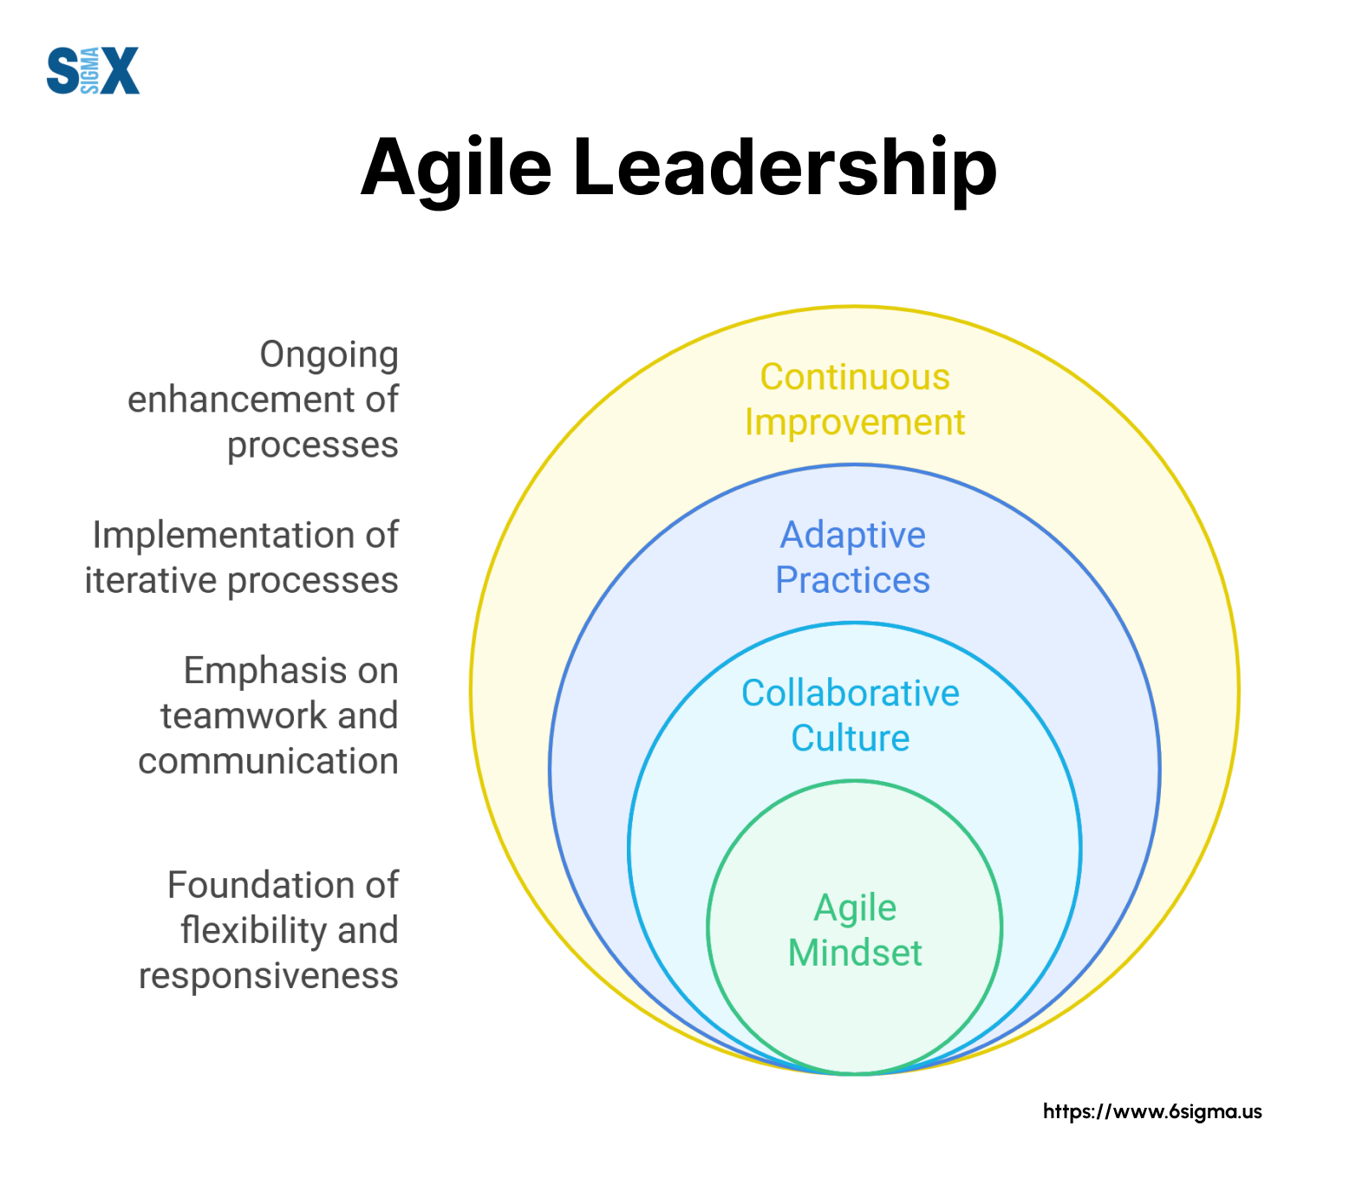
Figure 5.3.1: Agile leadership
(Source: Ratajczak, 2023)
The application of the Resource-Based Theory in the business context of Deliveroo helps in evaluating the need for technological transformation for their business. As per the importance, the human capital is the core requirement for the brand. The agile leaders strictly pass the command to the employees and delivery partners to become capable in handling digital technologies, apps, and software to complete the delivery process. Agile leaders strictly prohibits to practice of traditional operational models to predict needs optimize routes, and manage orders given by customers. The agile leaders involve investors and stakeholders who support innovation and AI implementation within the business to automate the entire food delivery system.

5.3.2 Theme 2: Formation of a link between agile leadership that promotes innovation, teamwork and employee participation
The literature part provides a glimpse of the impact of agile leadership in making an organisation flexible to accept any situation and act accordingly. For a food delivery brand, the customer experience plays an important role in shaping the organisational performance. Customers are the central pillar for the brand like Deliveroo, and currently, customers are preferring quick delivery and a strong online procedure in the ordering process (Mehrotra et al 2025). The agile leadership supports alternative planning and start-up meetings, which pivots the insight into customer experience. The literature study further used the Job Demand Resource model to detect the perspective of customers and candidates about the firm’s business.
From Chapter 4, further findings justify that, the Uber Eats is one of the leading food delivery partners in the UK, and customers prefer this brand due to its punctuality and staffs behaviour. The brand is currently focusing on building a positive image by leveraging innovative strategies for personalisation, convenience, and reliability in the brand (Kachhadiya, 2025). Uber Eats strengthens its website and mobile applications, so that users from the UK can operate this app easily and help in saving time for them. CX strategy for the brand can be improved by understanding the preferences and past order history.
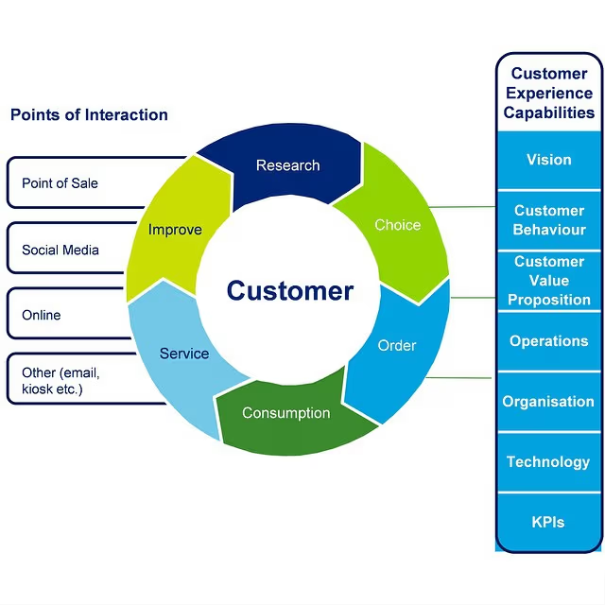
Figure 5.3.2: Customer experiences Design
(Source: Kachhadiya, 2025)
The application of the Technology Acceptance Model for Deliveroo can be used for comparing the brand with others to understand business loopholes. The TAM model is based on two factors such as Perceived usefulness and perceived ease of Use. As per agile leadership planning, the brand Deliveroo can use its own websites to help customers in quick ordering, real-time order tracking, and moreover, provide multiple options for payment. The PEOU is focusing in solving customer queries, dissatisfaction, and re ordering process by integrating search filters and simplifying order history.

5.3.3 Theme 3: The role of agile leaders in prioritising the change management, training, and adoption
Agile leaders play an essential role in training, adoption, and management to embrace sustained value and employee retention on a long-term basis. For the delivery based company, long-term collaboration with delivery partners and employees is essential to run the business seamlessly. The agile leaders act as role models to state the necessity for changes within the firm, while fostering an open communication with stakeholders to dig into the future requirements (Popan, 2024). Agile leaders always prioritize the end on approaches, real-world training, coaching, and mentoring for employees to improve knowledge in the required field.
Grub hub is using strategic leadership practices to provide workplace training to employees to use software and apps seamlessly. Grub hub arranges for digital training for employees on customer support, logistics maintenance, and order handling. In agile leadership, leaders prefer to arrange a virtual workshop in weekly basis to convey ideas of new features and upgradation of the system. Grubhub successfully delivers the onboarding tutorial, webinars, and application guidance to enhance technological competence for the firm.
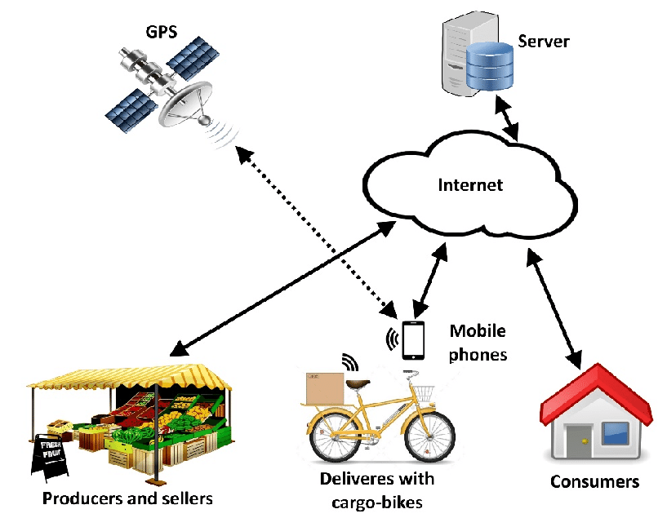
Figure 5.3.3: Food Delivery Diagram
(Source: Popan, 2024)
The application of DTC theory helps in justifying the concept of agile leadership for Deliveroo in a broader sense. The key resources of this theory are sense, size, and design to cope with the demand for regular training for employees in software and application handling (Jia et al. 2022). Deliveroo should create an opportunity for employees to learn through in-app guidance by video tutorials, step by step frameworks, visuals nd interactive pop-ups. On the other hand, the hands-on approaches can help team members in dealing with AI and automation software, such as POS, to compare sales value and resolve errors in revenue generation.

Justification of these themes on case study: building strategies of digital transformation and organisational flexibility at Deliveroo

The literature part shed lights on the impact of data governance and integration in business success of Deliveroo. The platform Deliveroo deals with huge amounts of datasets, such as riders’ data, employees' data, customers' data, and stakeholders’ data; therefore, data governance seems to be crucial for the brand Deliveroo. This data integration can be combined with data governance, with a strict adherence to policies and standards. The company must align with the Data Protection Act 2018 (DPA) and GDPR to safeguard the data ethically and transparently (Lord et al. 2023). It will help the brand to improve its image and safeguard the private data of customers and stakeholders from any kind of data theft.
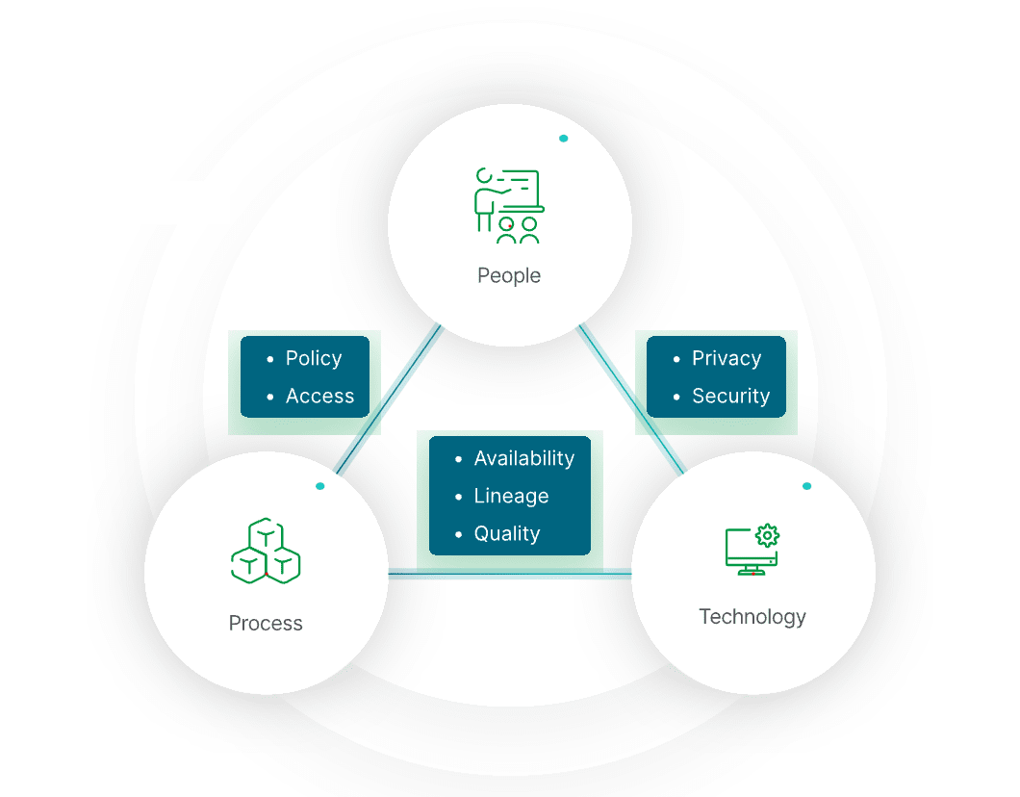
Figure 5.3.4: Importance of Data Integration
(Source:Lord et al. 2023)
The case study analysis of Food hub’s practice of ethical business and social responsibility by managing customers’ data, financial record and inventory levels securely. The agile leadership planning suggests that the competitor brand, Food Hub, implement an ERP system that can provide real-time insight to the Food Hub to understand demand, forecast peak hours, and improve accuracy in the ordering system (Mendonça et al. 2023). The practice of data governance by the leaders of the firm further integrates new policies for data governance. The agile leadership planning structures the policies in the simplest way to get accustomed by employees and delivery partners to these company policies.
The agile leadership planning for Deliveroo highly supports the data-driven decision making through automating the function inside the organisation. The automation within the IT structure can save 100 hours on a weekly basis, which will help the team to focus in campaign related activities to enhance customer engagement. Deliveroo can use cloud-based software such as AWS to ensure consistency and meet the demand of the business.

5.4 Integration into the Conceptual Model for Proposition
Chapter 2 supports Agile leadership as a key driver for the transformation of the firm, Deliveroo. The new conceptual framework for the business of Deliveroo aligns the process improvement and redesign with the application of theories such as TAM, RBV, and Dynamic Capability theory. The framework needs to be empirically supported through a more linear process; therefore, the outcome must state the technology acceptance rate by employees of Deliveroo. The current conceptual framework relies on the improvement of the sales value of the firm after practicing technologies in ordering, online payment acceptance, and building communication with the restaurant chain. Therefore, the revised diagram is well supported by the IBPM framework. After technological enhancement, the company achieved sales of 72.6 million in 2025, and a 7% increase of sales can be noticed. Moreover, the GTV was £1.18 billion in 2025, and order volume reached up to ten million per year.

5.5 Robustness Consideration
In this section, the influence of agile leadership on the firm’s performance might include an alternative explanation, such as market-driven adaptation. Here, the contingency theory can be used as the UK’s food delivery market is volatile. The theory explores the needs in the UK food delivery market, which revolves around a smooth ordering process, online transaction and real-time tracking of orders. All of these are related to customer satisfaction and demand for using the company website without the prolonged wait time for waiting. Another rival theory is the determination of technologies such as APIs to connect more restaurant chains to deliver food at sub urban regions (Pulignano and Grimshaw, 2025). Further application of AI and analytics can help in predicting orders, calculating time, route optimisation, and demand forecasting. The secondary data usage is dominating for interpreting the case analysis of Deliveroo. Henceforth, some reliable data sets are consultancy reports, press releases, industry reports, and annual reports of the company. The over-reliance on secondary data, such as investors report articulate a perspective performance for the company, which seems to be a potential bias for the firm.

5.6 Practical Synthesis
As the practical synthesis from the research, it is aimed to improve sales of Deliveroo, based on an agile leadership strategy. A largely aligned goals of the company results 8.3% rise in GTV and 7% more sales in the first quarter of 2025 (Gossart and Srnec, 2024). The practical insight help in including the strategies taken by Uber Eats to fulfill the demand of customers and minimise the delay in serving orders to the customers’ doorsteps. The process incorporates the implementation of a dark kitchen and the use of online applications for customers to place a smooth order.

5.7 Chapter Summary
From the entire discussion, it can be stated that agile leadership planning is highly appropriate for the brand Deliveroo. The agile leaders are supporting the changes towards digital transformation to give tough competition to the competitors. This part compares and contrasts the case studies of different food delivery companies and detects the importance of technological upgrade for improving CX and customer experiences. Employees of the firm Deliveroo need a supportive environment where they can obtain learning opportunities. Moreover, strategies such as implementing AI-focused automation, analytics, and other software can help the firm in maximising the conversion rate and improving customer retention in the long term.

Chapter 6: Conclusion

6.1 Introduction
This chapter summarizes the findings of the whole study and provides a summary of the main theoretical contributions, outlines managerial implications, limitations of this study, and future research directions. This chapter aims to show how this research has fulfilled the mentioned goals and made contributions to both the theoretical knowledge and practical judgment towards decision-making in the environment, being investigated in the chapter. The study set out to examine the extent to which organisations use digital and analytical capabilities to improve performance and strategic outcomes, based on secondary data from various case studies. Chapter 4 was a multi-case analysis structured in a manner that Chapter 5 was a cross-case analysis in order to establish patterns, divergences, and mechanisms. It is based on these findings that this final chapter provides the overriding answer to the “so what?” scholar-practitioner question.

6.2 Short Summary of the Most Important Findings
The cross-case analysis showed some regular and theoretically supported findings and not isolated case-based results. The following findings can be stated as major findings:
Organisations that oriented digital technologies with strategic goals performed better in an environment of a good governance framework and analytic skills. Normalised digital material made it possible to scale as well as improve operational effectiveness in cases. Digital initiatives had the most positive performance impact when carried out as part of a wider organisational procedure and not as a standalone tool.
Results varied by organisational background, especially the levels of digital maturity, data quality, and managerial dedication. Firms with fairly regulated or resource-restricted operational contexts realized slower facilitative capability formation to enhance the direct positive relationship between digital adoption and performance. All these findings collectively point to the fact that value creation requires less technology and more complementary organisational abilities.

6.3 Theory Implications
The research has a number of significant contributions to theories by improving current frameworks and how digital and analytical capabilities work in organisational settings.
Contribution 1: Explaining the Theoretical Base
The results serve mostly to the Practice-based view (PBV) and the Resource-Based View (RBV) (Rialti and Filieri, 2024). An apt perspective that helps to comprehend how companies change digital resources under the developing conditions is dynamic capabilities, namely sensing, seizing, and reconfiguring. The cross-case evidence can be used to argue that digital assets have an insufficient effect on the creation of sustained advantage; instead, firms need to build the ability to feel the presence of opportunities using data, capture it by making a decision in time, and reorganize resources to support this decision.
Building on RBV, the results reveal that digital technologies as strategic resources can only be realised in situations when they are introduced into organisational routines and facilitated by managerial competence. This is corroborated by previous literature, which opines that IT resources are neither adequate nor sufficient in generating competitive advantage.
Contribution 2: Boundary Conditions and Contingencies
One of the most important theoretical contributions from the VUCA framework is finding the conditions of the boundaries across which the existing relations can be strong or weak (Ncube et al., 2024). Although some studies in the past tend to establish a positive relationship in the direct relationship between digital adoption and performance, this research indicates that the relationship depends on factors like data governance, organisational culture, and leadership commitment. Digital initiatives have not produced the anticipated benefits in instances where data quality was of low or resources in governance structures were not well defined. The results make current assumptions on the body of literature on digital transformation because they prove that moderators contextually play a significant role. The efficacy of digital capabilities is determined by organisational fit and not best practices, as Home Depot predicted, based on the contingency theory.
Contribution 3: Insights on the data and references
In addition to establishing relations, the research illuminates causal processes that support the formation of digital values. Cross-case trends reveal that the standardized digital templates and analytical dashboards lower cognitive workload, reduce learning curves, and enhance the spread of the best practices to organizational units (Alsuhaimi, 2024). This insight into processes provides a deeper understanding of the area of dynamic capabilities that have been criticized as conceptually fruitful, but are empirically imprecise.
In addition, the results emphasize the role of human-technology interaction, in which managerial interpretation and decision-making play a key mediating role between data insights and action strategy. This is in line with socio-technical views and can facilitate technology adoption research because it highlights the importance of collectivism as opposed to individual uptake.
Contribution 4: Integrative Revision of the Conceptual Model
In Chapter 5, a TAM model was developed, which was rationalized on the cross-case evidence. To be more exact, new mediating factors, like the analytical capability and governance clarity, were added, and overly simplistic direct relations between the technology adoption and performance have been eliminated (Burton-Jones and Hubona, 2020). The developed model reflects the non-linear, sophisticated character of the digital transformation.
In locating these contributions in the existing literature, the study supports the existing studies on the significance of complementary capabilities but breaks the deterministic perspectives of the technology-driven performance. The evidence indicates that digital transformation is more of a dynamic organisational process and not a strategic decision.
Generalisability Statement
Although the research is contextual, the findings can be applied to organisations functioning in knowledge-intensive sectors, medium-to-large companies, and conditions of growing digitalisation. The results are especially applicable to those companies that are in the middle of their digital maturity and have a moderate regulation level.

6.4 Managerial Implications
The managerial ground for this research is to suggest that the firm Deliveroo should develop a centralised content platform for better usage. For instance, the firm operates multiple channels such as the rider portal, CMS for marketing, in-app notifications, and dashboards. It creates confusion in order handling and might develop a chance for errors, cancellation, and delay in delivering orders (Igwegbe, 2025). The company should adopt a content management system by integrating policies for reusable content, such as new safety regulations and policy handling. The firm should create a cross-functional team for customer support, marketing, and dispatching products, so that the firm can be aware of customer needs and perceived changes in demand patterns.
The major competitors of Deliveroo are Uber Eats, and the current study suggests the brand use a machine learning model to address operational bottlenecks in the food delivery industry. For instance, investing in an AI algorithm can help in analyzing the previous purchase data of customers, forecasting demands, and weather conditions. This model includes the need for digital training for restaurant staff and delivery partners, so that employees can offer customised assistance for each customer.
The real time Personalisation can be taken as another strategy or recommendation for these food delivery brands, like Just Eat. The brand should help customer to notice the real ratings and feedback of restaurants, so that customers can order food from authentic restaurants. This personalisation can help vegan customers to find out plant-based food and it will improve customer satisfaction.

6.5 Limitations and Suggestions for Future Research
This study, although its contribution can be noticed, also has a number of limitations. To begin with, the use of secondary data implies the risk of bias associated with available data, reporting, and vendor-based stories. The lack of primary data restricts the opportunities to portray subtle managerial perceptions and immediate decision-making procedures. Second, there are limitations to the Generalisability of findings to other sectors with differing technological and regulatory features because of the industry and country concentration of the chosen cases. Third, the measurement limitations, especially of directly linking the performance results to digital initiatives, inhibit causal inference because counterfactual conditions are not seen.
These restrictions present a number of opportunities in the future. The refined propositions can be tested through the longitudinal or panel-based quantitative studies across the industries or over time to enhance the causal assertions. The mixed-method designs that integrate survey and interviews, as well as archival records, would give more depth into the micro-level mechanisms, like the adoption behaviour of employees and the allocation of tasks between humans and AI. At the macro level, research in the future may be on platform governing and regulatory issues in cross-country markets. Also, the triangulation of web analytics, operational metrics, and financial performance data would contribute to the strengthening of the measurement and its validity.

6.6 Closing Statement
Overall, this research makes contributions to the existing knowledge on the generation of organisational value through digital and analytical capabilities, as it explains theoretical processes, boundary circumstances, and dynamics of the process. The study utilizing both the knowledge of dynamic capabilities and the RBV indicates that consistent increases in performance are the result of the congruence achieved between technology, governance, and human capabilities. The most relevant insights would be those related to organisations aiming at strategic digital transformation in multifaceted and changing environments, as they provide a theoretical polishing and practical advice on how they can apply it.

References
Chapter 1:
Asghar, J., Kanbach, D.K. and Kraus, S., 2025. Toward a multidimensional concept of organizational agility: A systematic literature review. Management Review Quarterly, pp.1-27. https://doi.org/10.1007/s11301-025-00497-6
Bekos, G.S., Jaakkola, M. and Chari, S., 2025. Organizational agility and firm performance: The role of architectural marketing capabilities. Industrial Marketing Management, 125, pp.239-253. https://doi.org/10.1016/j.indmarman.2025.01.005
Jing, H., Zhu, P., Zheng, X., Zhang, Z., Wang, D. and Li, Y., 2022. Theory-oriented screening and discovery of advanced energy transformation materials in electrocatalysis. Advanced Powder Materials, 1(1), p.100013. https://doi.org/10.1016/j.apmate.2021.10.004
Blanka, C., Krumay, B. and Rueckel, D., 2022. The interplay of digital transformation and employee competency: A design science approach. Technological Forecasting and Social Change, 178, p.121575. https://doi.org/10.1016/j.techfore.2022.121575
Businessmap (2023). A 6-Step Agile Transformation Roadmap to Success. [online] Kanban Software for Agile Project Management. Available at: https://businessmap.io/agile/transformation/roadmap
Cheng, Z. and Zhu, C., 2025. Academics’ leadership styles and their motivation to participate in a leadership training program in the digital era. Education Sciences, 15(3), p.369. https://doi.org/10.3390/educsci15030369
Esamah, A., Aujirapongpan, S., Rakangthong, N.K. and Imjai, N., 2023. Agile leadership and digital transformation in savings cooperative limited: Impact on sustainable performance amidst COVID-19. Journal of Human, Earth, and Future, 4(1), pp.36-53. https://pdfs.semanticscholar.org/3633/4a84f7e5325f7cdaac5242d5ceb785e7440c.pdf
Dyduch, W., 2024. The pillars of entrepreneurial and managerial success in vibrant environments. Journal of Entrepreneurship, Management and Innovation, 20(2), pp.5-8. https://www.ceeol.com/search/article-detail?id=1231464
Yuet, F.K.C., Noor, N. and Beram, S., 2025. Exploring Trailblazing Agile Leadership Competency: The TALWheel Model for Organizational Adaptability and Performance. International Journal of Organizational Leadership, 14(2). https://www.researchgate.net/profile/Sukor-Beram/publication/392178783_Exploring_Trailblazing_Agile_Leadership_Competency_The_TALWheel_Model_for_Organizational_Adaptability_and_Performance/links/686b14eeb991270ef301ddc9/Exploring-Trailblazing-Agile-Leadership-Competency-The-TALWheel-Model-for-Organizational-Adaptability-and-Performance.pdf
Desalegn, E.G., Guedes, M.J.C., Da Silva Gomes, J.F. and Tebeka, S.M., 2024. Disentangling organizational agility from flexibility, adaptability, and versatility: a systematic review. Future Business Journal, 10(1), p.117. https://doi.org/10.1186/s43093-024-00405-6
Ellström, D., Holtström, J., Berg, E. and Josefsson, C., 2022. Dynamic capabilities for digital transformation. Journal of Strategy and Management, 15(2), pp.272-286. https://doi.org/10.1108/JSMA-04-2021-0089
Omol, E.J., 2024. Organizational digital transformation: from evolution to future trends. Digital Transformation and Society, 3(3), pp.240-256. https://doi.org/10.1108/DTS-08-2023-0061
Ghosh, S., Hughes, M., Hodgkinson, I. and Hughes, P., 2022. Digital transformation of industrial businesses: A dynamic capability approach. Technovation, 113, p.102414. https://doi.org/10.1016/j.technovation.2021.102414
Al-Moaid, N.A.A. and Almarhdi, S.G., 2024. Developing dynamic capabilities for successful digital transformation projects: The mediating role of change management. Journal of Innovation and Entrepreneurship, 13(1), p.85. https://doi.org/10.1186/s13731-024-00446-9
Gonçalves, M.L.A., Penha, R., Silva, L.F., Martens, C.D. and Silva, V.F., 2023. The relationship between project management and digital transformation: Systematic literature review. RAM. Revista de Administração Mackenzie, 24, p. eRAMR230075. https://doi.org/10.1590/1678-6971/eRAMR230075.en
Kovynyov, I., Buerck, A. and Mikut, R., 2021. Design of transformation initiatives implementing organisational agility: an empirical study. SN business & economics, 1(6), p.79. https://doi.org/10.1007/s43546-021-00073-6
Kupiek, M., 2021. Digital Leadership, Agile Change and the Emotional Organization. Springer Fachmedien Wiesbaden. https://doi.org/10.1007/978-3-658-33489-5
Delıoğlu, N. and Uysal, B., 2022. A review on agile leadership and digital transformation. Yildiz Social Science Review, 8(2), pp.121-128. https://dergipark.org.tr/en/pub/yssr/issue/75620/1242807
Tigre, F.B., 2024. Forging Innovative Leadership: The Power of Agility, Diversity, and Risk-Taking Configurations. Merits, 4(3), pp.224-237. https://doi.org/10.3390/merits4030016
Nguyen, Dr.D.S. (2020). Success Factors for Building and Managing High Performance Agile Software Development Teams. [online] ResearchGate. Available at: https://www.researchgate.net/figure/Agile-Leadership-Model_fig2_344729738.
Zhang, Y., Dong, H., Baxter, D. and Dacre, N., 2023. Agile meets digital: A systematic literature review on the interplay between agile project management and digital transformation. https://eprints.soton.ac.uk/476132/
Rialti, R. and Filieri, R., 2024. Leaders, let’s get agile! Observing agile leadership in successful digital transformation projects. Business Horizons, 67(4), pp.439-452. https://doi.org/10.1016/j.bushor.2024.04.003

Chapter 2:
Agile Business (2023) The Nine Principles of Agile Leadership. Available at: https://www.agilebusiness.org/resource/the-nine-principles-of-agile-leadership.html (Accessed: 22 November 2025).
Akkaya, B., Panait, M., Apostu, S.A. and Kaya, Y. (2022) ‘Agile Leadership and Perceived Career Success: The Mediating Role of Job Embeddedness’. International Journal of Environmental Research and Public Health 19(8), p. 4834. doi: https://doi.org/10.3390/ijerph19084834.
AkkayaB. (2020) Agile business leadership methods for Industry 4.0. https://www.emerald.com/books/edited-volume/chapter-pdf/9102112/978-1-80043-380-920201011.pdf. Bingley, U.K.: Emerald Publishing Limited.
Alsuhaimi, M. (2024). International Journal of Economics, Commerce and Management United Kingdom Licensed under Creative Commons AGILE LEADERSHIP IN THE CONTEXT OF DIGITAL TRANSFORMATION: A SYSTEMATIC REVIEW AND FUTURE RESEARCH AGENDA. 12. Available at: https://ijecm.co.uk/wp-content/uploads/2024/10/121012.pdf (Accessed: 22 November 2025).
Anderson, B. (2019). Be A Flexible Leader | SIGMA Assessment Systems. Available at: https://www.sigmaassessmentsystems.com/flexible-leader/ (Accessed: 22 November 2025).
Barrett-Maitland, N., Williams-Shakespeare, E., Allen, D. and Edwards-Braham, S. (2024) ‘From tradition to innovation: Proposing agile leadership as the new paradigm for a higher education institution in a developing country’. Power and Education. Doi: https://doi.org/10.1177/17577438241307310.
Burton-Jones, A. and Hubona, G.S. (2020) 'Individual differences and usage behaviour'. ACM SIGMIS Database 36(2), pp. 58–77. doi: https://doi.org/10.1145/1066149.1066155.
Butt, J. (2020) ‘A Conceptual Framework to Support Digital Transformation in Manufacturing Using an Integrated Business Process Management Approach’. Designs 4(3), p. 17. doi: https://doi.org/10.3390/designs4030017.
Dziak, M. (2024). Technology acceptance model (TAM). Available at: https://www.ebsco.com/research-starters/technology/technology-acceptance-model-tam (Accessed: 22 November 2025).
Evans, Chris (2023). 3 Ways Agile Methodologies Can Help With Digital Transformation. Available at: https://medium.com/agileinsider/3-ways-agile-methodologies-can-help-with-digital-transformation-cd1786e2b9d2 (Accessed: 22 November 2025).
Gouldsberry, M. (2021). What Is Agile Leadership, and Why Does It Matter?. Available at: https://www.betterworks.com/magazine/what-is-agile-leadership-and-why-does-it-matter/ (Accessed: 22 November 2025).
Macintyre, F. (2020). The negative impact of agile on development teams - Pulsion Technology. Available at: https://www.pulsion.co.uk/blog/the-negative-impact-of-agile-on-development-teams/ (Accessed: 22 November 2025).
Madanchian, M. and Taherdoost, H. (2025) ‘Agile Leadership to Foster Innovation and Collaboration’. Tech-Driven Leadership, pp. 65–85. Available at: https://www.emerald.com/books/monograph/17823/chapter/97941836/Agile-Leadership-to-Foster-Innovation-and (Accessed: 22 November 2025).
Ncube, L., Mahlangu, S., Kamango, K., Ncube, N., Moyo, M. and Nemashakwe, P. (2024) ‘The Role of Agile Leadership in the Success of a Contemporary Organisation: A Conceptual Discussion’. International Journal of Management Studies and Social Science Research 6(6). Available at: https://www.researchgate.net/publication/385428677_The_Role_of_Agile_Leadership_in_the_Success_of_a_Contemporary_Organisation_A_Conceptual_Discussion (Accessed: 22 November 2025).
Ogunrinde, V. (2025). Agile Leadership as a Driver of Change Management and Transformation. Available at: https://www.researchgate.net/publication/392870346_Agile_Leadership_as_a_Driver_of_Change_Management_and_Transformation (Accessed: 22 November 2025).
Post, G. (2025). How Agile leadership can help streamline your team’s workflow. Available at: https://nulab.com/learn/project-management/agile-leadership/ (Accessed: 22 November 2025).
Putra, I.K.M. (2022) ‘Digital Transformation and Agile Leadership: Bibliometrics Analysis and Future Avenue’. Journal of International Conference Proceedings 5(4), pp. 96–110. doi: https://doi.org/10.32535/jicp.v5i4.1926.
Rafidah, D., Fuad, S., Ramdan, M., Danial, M., Tazilah, A., Mudin, V. and Khalid, H. (2025) ‘The Impact of Agile Leadership on Burnout: The Mediating Role of Workload in Teacher Education Contexts in Malaysia’. International Journal of Organisational Leadership 14, pp. 591–611. Available at: https://ijol.cikd.ca/article_60866_acc9be680c87b3958a6e35b8fcd7616b.pdf (Accessed: 22 November 2025).
Rialti, R. and Filieri, R. (2024) 'Leaders, let's get agile! Observing agile leadership in successful digital transformation projects. Business Horizons 67(4). Available at: https://www.sciencedirect.com/science/article/pii/S000768132400048X (Accessed: 22 November 2025).
Sarhan, M. (2025) 'Embracing Agility: Examining Agile Leadership in Effective Digital Transformation Initiatives'. Doi: https://doi.org/10.2139/ssrn.5135873.
Snyder, H. (2019) ‘Literature review as a research methodology: An overview and guidelines’. Journal of Business Research 104(1), pp. 333–339. Available at: https://www.sciencedirect.com/science/article/pii/S0148296319304564 (Accessed: 22 November 2025).
Steegh, R., Van De Voorde, K., Paauwe, J. and Peeters, T. (2024) ‘The agile way of working and team adaptive performance: A goal-setting perspective’. Journal of Business Research 189, pp. 115163–115163. doi: https://doi.org/10.1016/j.jbusres.2024.115163.
Stoiko, M.R. (2024) ‘Navigating Digital Transformation: Agile Leadership and Strategic Flexibility in Mid-Sized Manufacturing Firms’. 6, pp. 55–72. Available at: https://jipe.ca/index.php/jipe/article/view/190 (Accessed: 22 November 2025).
Surapto, D. (2024) 'Agile Leadership: Enhancing Trust, Innovation, Ambidexterity, and Job Performance'. Pakistan Journal of Life and Social Sciences (PJLSS) 22(2). Available at: https://www.pjlss.edu.pk/pdf_files/2024_2/9759-9767.pdf (Accessed: 22 November 2025).
Chapter 3:
Agile Business (2023) The Nine Principles of Agile Leadership. Available at: https://www.agilebusiness.org/resource/the-nine-principles-of-agile-leadership.html (Accessed: 22 November 2025).
Akkaya, B., Panait, M., Apostu, S.A. and Kaya, Y. (2022) ‘Agile Leadership and Perceived Career Success: The Mediating Role of Job Embeddedness’. International Journal of Environmental Research and Public Health 19(8), p. 4834. doi: https://doi.org/10.3390/ijerph19084834.
AkkayaB. (2020) Agile business leadership methods for Industry 4.0. https://www.emerald.com/books/edited-volume/chapter-pdf/9102112/978-1-80043-380-920201011.pdf. Bingley, U.K.: Emerald Publishing Limited.
Alsuhaimi, M. (2024). International Journal of Economics, Commerce and Management United Kingdom Licensed under Creative Commons AGILE LEADERSHIP IN THE CONTEXT OF DIGITAL TRANSFORMATION: A SYSTEMATIC REVIEW AND FUTURE RESEARCH AGENDA. 12. Available at: https://ijecm.co.uk/wp-content/uploads/2024/10/121012.pdf (Accessed: 22 November 2025).
Anderson, B. (2019). Be A Flexible Leader | SIGMA Assessment Systems. Available at: https://www.sigmaassessmentsystems.com/flexible-leader/ (Accessed: 22 November 2025).
Asghar, J., Kanbach, D.K. and Kraus, S., 2025. Toward a multidimensional concept of organizational agility: A systematic literature review. Management Review Quarterly, pp.1-27. https://doi.org/10.1007/s11301-025-00497-6
Barrett-Maitland, N., Williams-Shakespeare, E., Allen, D. and Edwards-Braham, S. (2024) ‘From tradition to innovation: Proposing agile leadership as the new paradigm for a higher education institution in a developing country’. Power and Education. Doi: https://doi.org/10.1177/17577438241307310.
Baxter, J. and Nolan, P., 2024. ‘Abductive reasoning in organisational case studies’, Administrative Sciences, 14(3), 112. https://doi.org/10.3390/admsci14030112
Bekos, G.S., Jaakkola, M. and Chari, S., 2025. Organizational agility and firm performance: The role of architectural marketing capabilities. Industrial Marketing Management, 125, pp.239-253. https://doi.org/10.1016/j.indmarman.2025.01.005
Jing, H., Zhu, P., Zheng, X., Zhang, Z., Wang, D. and Li, Y., 2022. Theory-oriented screening and discovery of advanced energy transformation materials in electrocatalysis. Advanced Powder Materials, 1(1), p.100013. https://doi.org/10.1016/j.apmate.2021.10.004
Blanka, C., Krumay, B. and Rueckel, D., 2022. The interplay of digital transformation and employee competency: A design science approach. Technological Forecasting and Social Change, 178, p.121575. https://doi.org/10.1016/j.techfore.2022.121575
Bivona, E., 2023. Determinants of performance drivers in online food delivery platforms: a dynamic performance management perspective. International Journal of Productivity and Performance Management, 72(9), pp.2497-2517.https://www.researchgate.net/profile/Enzo-Bivona/publication/360501392_Determinants_of_performance_drivers_in_online_food_delivery_platforms_a_dynamic_performance_management_perspective/links/631a14000a70852150db7782/Determinants-of-performance-drivers-in-online-food-delivery-platforms-a-dynamic-performance-management-perspective.pdf
Burton-Jones, A. and Hubona, G.S. (2020) 'Individual differences and usage behaviour'. ACM SIGMIS Database 36(2), pp. 58–77. doi: https://doi.org/10.1145/1066149.1066155.
Businessmap (2023). A 6-Step Agile Transformation Roadmap to Success. [online] Kanban Software for Agile Project Management. Available at: https://businessmap.io/agile/transformation/roadmap
Butt, J. (2020) ‘A Conceptual Framework to Support Digital Transformation in Manufacturing Using an Integrated Business Process Management Approach’. Designs 4(3), p. 17. doi: https://doi.org/10.3390/designs4030017.
Cheng, Z. and Zhu, C., 2024. ‘Educational leadership styles and practices perceived by academics’, Educational Management Administration & Leadership. https://doi.org/10.1177/17411432241294171
Cheng, Z. and Zhu, C., 2025. Academics’ leadership styles and their motivation to participate in a leadership training program in the digital era. Education Sciences, 15(3), p.369. https://doi.org/10.3390/educsci15030369
Esamah, A., Aujirapongpan, S., Rakangthong, N.K. and Imjai, N., 2023. Agile leadership and digital transformation in savings cooperative limited: Impact on sustainable performance amidst COVID-19. Journal of Human, Earth, and Future, 4(1), pp.36-53. https://pdfs.semanticscholar.org/3633/4a84f7e5325f7cdaac5242d5ceb785e7440c.pdf
Dyduch, W., 2024. The pillars of entrepreneurial and managerial success in vibrant environments. Journal of Entrepreneurship, Management and Innovation, 20(2), pp.5-8. https://www.ceeol.com/search/article-detail?id=1231464
Yuet, F.K.C., Noor, N. and Beram, S., 2025. Exploring Trailblazing Agile Leadership Competency: The TALWheel Model for Organizational Adaptability and Performance. International Journal of Organizational Leadership, 14(2). https://www.researchgate.net/profile/Sukor-Beram/publication/392178783_Exploring_Trailblazing_Agile_Leadership_Competency_The_TALWheel_Model_for_Organizational_Adaptability_and_Performance/links/686b14eeb991270ef301ddc9/Exploring-Trailblazing-Agile-Leadership-Competency-The-TALWheel-Model-for-Organizational-Adaptability-and-Performance.pdf
Desalegn, E.G., Guedes, M.J.C., Da Silva Gomes, J.F. and Tebeka, S.M., 2024. Disentangling organizational agility from flexibility, adaptability, and versatility: a systematic review. Future Business Journal, 10(1), p.117. https://doi.org/10.1186/s43093-024-00405-6
Dziak, M. (2024). Technology acceptance model (TAM). Available at: https://www.ebsco.com/research-starters/technology/technology-acceptance-model-tam (Accessed: 22 November 2025).
Eisenhardt, K.M. and Ott, T.E., 2022. ‘Rigour in theory building from case research’, Academy of Management Review, 47(2), pp. 201–219. https://doi.org/10.5465/amr.2019.0482
Ellström, D., Holtström, J., Berg, E. and Josefsson, C., 2022. Dynamic capabilities for digital transformation. Journal of Strategy and Management, 15(2), pp.272-286. https://doi.org/10.1108/JSMA-04-2021-0089
Omol, E.J., 2024. Organizational digital transformation: from evolution to future trends. Digital Transformation and Society, 3(3), pp.240-256. https://doi.org/10.1108/DTS-08-2023-0061
Ghosh, S., Hughes, M., Hodgkinson, I. and Hughes, P., 2022. Digital transformation of industrial businesses: A dynamic capability approach. Technovation, 113, p.102414. https://doi.org/10.1016/j.technovation.2021.102414
Al-Moaid, N.A.A. and Almarhdi, S.G., 2024. Developing dynamic capabilities for successful digital transformation projects: The mediating role of change management. Journal of Innovation and Entrepreneurship, 13(1), p.85. https://doi.org/10.1186/s13731-024-00446-9
Erkmen, E. and Turegun, N., 2022. Success model of online food delivery system: The role of brand image in customer responses. Innovative Marketing, 18(2), pp.148-160.https://www.businessperspectives.org/images/pdf/applications/publishing/templates/article/assets/16575/IM_2022_02_Erkmen.pdf
Evans, Chris (2023). 3 Ways Agile Methodologies Can Help With Digital Transformation. Available at: https://medium.com/agileinsider/3-ways-agile-methodologies-can-help-with-digital-transformation-cd1786e2b9d2 (Accessed: 22 November 2025).
Foodhub, About Us, Global Foodhub, viewed 16 January 2026, https://global.foodhub.com/about-us.html
Gonçalves, M.L.A., Penha, R., Silva, L.F., Martens, C.D. and Silva, V.F., 2023. The relationship between project management and digital transformation: Systematic literature review. RAM. Revista de Administração Mackenzie, 24, p.eRAMR230075. https://doi.org/10.1590/1678-6971/eRAMR230075.en
Gouldsberry, M. (2021). What Is Agile Leadership, and Why Does It Matter?. Available at: https://www.betterworks.com/magazine/what-is-agile-leadership-and-why-does-it-matter/ (Accessed: 22 November 2025).
Grubhub, About, Grubhub, viewed 16 January 2026, https://about.grubhub.com/.
Hawkins, P. and Rao, V., 2023. ‘Contemporary applications of thematic analysis in leadership research’, Leadership, 19(4), pp. 566–582. https://doi.org/10.1177/17427150221151152
Igwegbe, E., 2025. The Impact of Digitalized Food Delivery Systems on Urban Space: Exploring Spatial Implications of Platform Economies in Stockholm.https://www.diva-portal.org/smash/get/diva2:1973161/FULLTEXT01.pdf
Iyer, S.S. and Malhotra, S., 2024. Agile Leadership and Strategic Resilience in the Era of Disruptive Innovation: Preparing Organizations for the Future of Work.https://www.academia.edu/download/122541883/12rajar.pdf
Just Eat., 2025. Takeaway.com., 2025. Our company, Just Eat Takeaway Careers. Available at: https://careers.justeattakeaway.com/global/en/our-company (Accessed: 15 January 2026).
Kaya, Y. (2023) ‘Agile Leadership from the Perspective of Dynamic Capabilities and Creating Value’. Sustainability 15(21), pp. 15253–15253. Available at: https://www.mdpi.com/2071-1050/15/21/15253 (Accessed: 22 November 2025).
Keeble, M., Adams, J. and Burgoine, T., 2022. Investigating experiences of frequent online food delivery service use: a qualitative study in UK adults. BMC public health, 22(1), p.1365.https://link.springer.com/content/pdf/10.1186/s12889-022-13721-9.pdf
Khan, M. and Dubois, A., 2025. ‘Generalisation in qualitative research on digital platform organisations’, International Journal of Management Reviews, 27(2), pp. 245–266. https://doi.org/10.1111/ijmr.12345
Kovynyov, I., Buerck, A. and Mikut, R., 2021. Design of transformation initiatives implementing organisational agility: an empirical study. SN business & economics, 1(6), p.79. https://doi.org/10.1007/s43546-021-00073-6
Kupiek, M., 2021. Digital Leadership, Agile Change and the Emotional Organization. Springer Fachmedien Wiesbaden. https://doi.org/10.1007/978-3-658-33489-5
Delıoğlu, N. and Uysal, B., 2022. A review on agile leadership and digital transformation. Yildiz Social Science Review, 8(2), pp.121-128. https://dergipark.org.tr/en/pub/yssr/issue/75620/1242807
Tigre, F.B., 2024. Forging Innovative Leadership: The Power of Agility, Diversity, and Risk-Taking Configurations. Merits, 4(3), pp.224-237. https://doi.org/10.3390/merits4030016
Leung, M. and Patel, S., 2024. ‘Regulatory developments in the gig economy: Implications for platform governance’, Journal of Industrial Relations, 66(2), pp. 245–262. https://doi.org/10.1177/00221856231220411
Macintyre, F. (2020). The negative impact of agile on development teams - Pulsion Technology. Available at: https://www.pulsion.co.uk/blog/the-negative-impact-of-agile-on-development-teams/ (Accessed: 22 November 2025).
Madanchian, M. and Taherdoost, H. (2025) ‘Agile Leadership to Foster Innovation and Collaboration’. Tech-Driven Leadership, pp. 65–85. Available at: https://www.emerald.com/books/monograph/17823/chapter/97941836/Agile-Leadership-to-Foster-Innovation-and (Accessed: 22 November 2025).
Mc Callum, S., 2024. Payout for Uber Eats driver over face scan bias case. [BBC]. Available at: https://www.bbc.com/news/technology-68655429 . (Accessed: 15 January 2026)
Mendonça, P., Kougiannou, N.K. and Clark, I., 2023. Informalization in gig food delivery in the UK: The case of hyper‐flexible and precarious work. Industrial Relations: A Journal of Economy and Society, 62(1), pp.60-77.https://onlinelibrary.wiley.com/doi/pdfdirect/10.1111/irel.12320
Mitchell, T. and Rowe, K., 2023. ‘Integrity and responsible reporting in qualitative studies’, Qualitative Research in Organisations and Management, 18(4), pp. 595–611. https://doi.org/10.1108/QROM-11-2021-2237
Murphy, L. and Kelly, A., 2024. ‘Triangulation and credibility in qualitative organisational studies’, Qualitative Research in Organisations and Management, 19(2), pp. 213–229. https://doi.org/10.1108/QROM-05-2022-1123
Namit (2025). The Impact of Agile Leadership on Organisational Culture and Growth - Amity Institute Of Training & Development. Available at: https://aitd.amity.edu/corporate-training/the-impact-of-agile-leadership-on-organisational-culture/ (Accessed: 22 November 2025).
Ncube, L., Mahlangu, S., Kamango, K., Ncube, N., Moyo, M. and Nemashakwe, P. (2024) ‘The Role of Agile Leadership in the Success of a Contemporary Organisation: A Conceptual Discussion’. International Journal of Management Studies and Social Science Research 6(6). Available at: https://www.researchgate.net/publication/385428677_The_Role_of_Agile_Leadership_in_the_Success_of_a_Contemporary_Organisation_A_Conceptual_Discussion (Accessed: 22 November 2025).
Ncube, L., Mahlangu, S., Kamango, K., Ncube, N.M., Moyo, M., Phiri, T. and Nemashakwe, P., The Role of Agile Leadership in the Success of a Contemporary Organisation: A Conceptual.https://www.researchgate.net/profile/Paul-Nemashakwe/publication/385428677_The_Role_of_Agile_Leadership_in_the_Success_of_a_Contemporary_Organisation_A_Conceptual_Discussion/links/6724d00577f274616d562686/The-Role-of-Agile-Leadership-in-the-Success-of-a-Contemporary-Organisation-A-Conceptual-Discussion.pdf
Ndou, V., Ingrosso, A. and Di Girolamo, A., 2024. ‘Framework for agile transformation: Cultural, structural, and competency shifts’, Administrative Sciences, 14(11), 301. https://doi.org/10.3390/admsci14110301
Nguyen, Dr.D.S. (2020). Success Factors for Building and Managing High Performance Agile Software Development Teams. [online] ResearchGate. Available at: https://www.researchgate.net/figure/Agile-Leadership-Model_fig2_344729738.
Zhang, Y., Dong, H., Baxter, D. and Dacre, N., 2023. Agile meets digital: A systematic literature review on the interplay between agile project management and digital transformation. https://eprints.soton.ac.uk/476132/
Ogunrinde, V. (2025). Agile Leadership as a Driver of Change Management and Transformation. Available at: https://www.researchgate.net/publication/392870346_Agile_Leadership_as_a_Driver_of_Change_Management_and_Transformation (Accessed: 22 November 2025).
Parker, L. and Houghton, A., 2022. ‘Ethical considerations in secondary data research’, Journal of Business Ethics, 179(2), pp. 389–402. https://doi.org/10.1007/s10551-021-05011-4
Post, G. (2025). How Agile leadership can help streamline your team’s workflow. Available at: https://nulab.com/learn/project-management/agile-leadership/ (Accessed: 22 November 2025).
Putra, I.K.M. (2022) ‘Digital Transformation and Agile Leadership: Bibliometrics Analysis and Future Avenue’. Journal of International Conference Proceedings 5(4), pp. 96–110. doi: https://doi.org/10.32535/jicp.v5i4.1926.
Race, M and Conway, Z., 2025. Food delivery apps to tighten checks to stop illegal workers. [BBC]. Available at: https://www.bbc.com/news/articles/c20rrdjvpexo. (Accessed: 15 January 2026)
Rafidah, D., Fuad, S., Ramdan, M., Danial, M., Tazilah, A., Mudin, V. and Khalid, H. (2025) ‘The Impact of Agile Leadership on Burnout: The Mediating Role of Workload in Teacher Education Contexts in Malaysia’. International Journal of Organisational Leadership 14, pp. 591–611. Available at: https://ijol.cikd.ca/article_60866_acc9be680c87b3958a6e35b8fcd7616b.pdf (Accessed: 22 November 2025).
Rao, S. and Ellison, J., 2022. ‘Construct clarity in contemporary leadership studies’, Journal of Leadership & Organizational Studies, 29(4), pp. 424–438. https://doi.org/10.1177/15480518221078852
Renigunta, S., 2024. ‘Exploring the interplay of agile leadership and innovation management competence’, International Journal of Research and Innovation in Social Science. https://doi.org/10.47772/IJRISS.2024.803108S
Rialti, R. and Filieri, R. (2024) 'Leaders, let's get agile! Observing agile leadership in successful digital transformation projects. Business Horizons 67(4). Available at: https://www.sciencedirect.com/science/article/pii/S000768132400048X (Accessed: 22 November 2025).
Ribeiro-Navarrete, S., Saura, J.R. and Palacios-Marqués, D. (2023) ‘Towards a new era of mass data collection: Assessing pandemic-induced organisational transformation’, Journal of Business Research, 158, 113679. https://doi.org/10.1016/j.jbusres.2022.113679
Rogers, J. and Ghaffari, S., 2025. ‘Pattern recognition in digital platform research: Insights from cross-firm thematic analysis’, Journal of Management Studies, 62(1), pp. 45–67. https://doi.org/10.1111/joms.13012
Rybak, T. and Ellis, J., 2025. ‘Triangulation in qualitative case study methodology: Strengthening credibility in digital transformation research’, Information Systems Journal, 35(1), pp. 110–129. https://doi.org/10.1111/isj.12425
Santos, J. and Grundy, K., 2025. ‘Leadership agility in digital platform ecosystems’, Journal of Strategic Management, 12(1), pp. 45–63. https://journals.asmepress.com/jsm/article/view/1234
Sarhan, M. (2025) 'Embracing Agility: Examining Agile Leadership in Effective Digital Transformation Initiatives'. Doi: https://doi.org/10.2139/ssrn.5135873.
Shead., S., 2020. Grubhub defends adding restaurants without telling them. [BBC]. Available at: https://www.bbc.com/news/technology-51279546 . (Accessed: 15 January 2026)
Snyder, H. (2019) ‘Literature review as a research methodology: An overview and guidelines’. Journal of Business Research 104(1), pp. 333–339. Available at: https://www.sciencedirect.com/science/article/pii/S0148296319304564 (Accessed: 22 November 2025).
Steegh, R., Van De Voorde, K., Paauwe, J. and Peeters, T. (2024) ‘The agile way of working and team adaptive performance: A goal-setting perspective’. Journal of Business Research 189, pp. 115163–115163. doi: https://doi.org/10.1016/j.jbusres.2024.115163.
Stoiko, M.R. (2024) ‘Navigating Digital Transformation: Agile Leadership and Strategic Flexibility in Mid-Sized Manufacturing Firms’. 6, pp. 55–72. Available at: https://jipe.ca/index.php/jipe/article/view/190 (Accessed: 22 November 2025).
Surapto, D. (2024) 'Agile Leadership: Enhancing Trust, Innovation, Ambidexterity, and Job Performance'. Pakistan Journal of Life and Social Sciences (PJLSS) 22(2). Available at: https://www.pjlss.edu.pk/pdf_files/2024_2/9759-9767.pdf (Accessed: 22 November 2025).
Tigre, F.B., Henriques, P.L. and Curado, C., 2025. ‘The digital leadership emerging construct: a multi-method approach’, Management Review Quarterly, 75, pp. 789–836. https://doi.org/10.1007/s11301-023-00395-9
Uber., 2026. Earn Money by Driving or Get a Ride Now, Uber India. Available at: https://www.uber.com/in/en/?referrer=singular_click_id%3D000ad548-a3c2-417b-9af3-c9049370f426 (Accessed: 15 January 2026).
Uwasomba, C., Deshpande, A., Sharp, H., Gregory, P., Willis, R., Barroca, L., Uwadi, M. and Taylor, K., 2025. Data-Driven Agility: Assessing Agile Culture transformation in a technology organisation. Information and Software Technology, 183, p.107729.https://www.sciencedirect.com/science/article/pii/S0950584925000680
Willie, M. (2024) ‘Leveraging Digital Resources: A Resource-Based View Perspective’. Golden Ratio of Human Resource Management 5(1), pp. 01-14. Available at: https://www.researchgate.net/publication/385337588_Leveraging_Digital_Resources_A_Resource-Based_View_Perspective (Accessed: 22 November 2025).
Yin, R.K., 2023. Case Study Research and Applications: Design and Methods. 7th edn. Thousand Oaks: Sage. https://us.sagepub.com/en-us/nam/case-study-research-and-applications/book268042

Chapter 4:
Just Eat, 2025. Takeaway.com., 2025. Our company, Just Eat Takeaway Careers. Available at: https://careers.justeattakeaway.com/global/en/our-company (Accessed: 15 January 2026).
Race, M and Conway, Z., 2025. Food delivery apps to tighten checks to stop illegal workers. [BBC]. Available at: https://www.bbc.com/news/articles/c20rrdjvpexo. (Accessed: 15 January 2026)
Iyer, S.S. and Malhotra, S., 2024. Agile Leadership and Strategic Resilience in the Era of Disruptive Innovation: Preparing Organizations for the Future of Work. https://www.academia.edu/download/122541883/12rajar.pdf
Uber., 2026. Earn Money by Driving or Get a Ride Now, Uber India. Available at: https://www.uber.com/in/en/?referrer=singular_click_id%3D000ad548-a3c2-417b-9af3-c9049370f426 (Accessed: 15 January 2026).
Bivona, E., 2023. Determinants of performance drivers in online food delivery platforms: a dynamic performance management perspective. International Journal of Productivity and Performance Management, 72(9), pp.2497-2517.https://www.researchgate.net/profile/Enzo-Bivona/publication/360501392_Determinants_of_performance_drivers_in_online_food_delivery_platforms_a_dynamic_performance_management_perspective/links/631a14000a70852150db7782/Determinants-of-performance-drivers-in-online-food-delivery-platforms-a-dynamic-performance-management-perspective.pdf
Foodhub, About Us, Global Foodhub, viewed 16 January 2026, https://global.foodhub.com/about-us.html
Grubhub, About, Grubhub, viewed 16 January 2026, https://about.grubhub.com/.
Hawkins, P. and Rao, V., 2023. ‘Contemporary applications of thematic analysis in leadership research’, Leadership, 19(4), pp. 566–582. https://doi.org/10.1177/17427150221151152
Keeble, M., Adams, J. and Burgoine, T., 2022. Investigating experiences of frequent online food delivery service use: a qualitative study in UK adults. BMC public health, 22(1), p.1365.https://link.springer.com/content/pdf/10.1186/s12889-022-13721-9.pdf
Mc Callum, S., 2024. Payout for Uber Eats driver over face scan bias case. [BBC]. Available at: https://www.bbc.com/news/technology-68655429 (Accessed: 15 January 2026)
Shead., S., 2020. Grubhub defends adding restaurants without telling them. [BBC]. Available at: https://www.bbc.com/news/technology-51279546 . (Accessed: 15 January 2026)
Shead., S., 2020. Grubhub defends adding restaurants without telling them. [BBC]. Available at: https://www.bbc.com/news/technology-51279546 (Accessed: 15 January 2026)
Uwasomba, C., Deshpande, A., Sharp, H., Gregory, P., Willis, R., Barroca, L., Uwadi, M. and Taylor, K., 2025. Data-Driven Agility: Assessing Agile Culture transformation in a technology organisation. Information and Software Technology, 183, p.107729.https://www.sciencedirect.com/science/article/pii/S0950584925000680
Chapter 5:
Iyer, S.S. and Malhotra, S., 2024. Agile Leadership and Strategic Resilience in the Era of Disruptive Innovation: Preparing Organizations for the Future of Work.https://www.academia.edu/download/122541883/12rajar.pdf
Chukwunweike, J. and Aro, O.E., 2024. Implementing agile management practices in the era of digital transformation. World Journal of Advanced Research and Reviews, 24(1), pp.2223-2242.https://www.researchgate.net/profile/Joseph-Chukwunweike/publication/385291725_Implementing_agile_management_practices_in_the_era_of_digital_transformation/links/671f05c6edbc012ea1427ff1/Implementing-agile-management-practices-in-the-era-of-digital-transformation.pdf
Ratajczak, S., 2023. Agile leadership practices in the digital transformation of Heis. Scientific Papers of Silesian University of Technology. Organization & Management/Zeszyty Naukowe Politechniki Slaskiej. Seria Organizacji i Zarzadzanie, 185, p.409. https://bazawiedzy.wsb.edu.pl/docstore/download/AWSB15bde329bc784f98becc36c0c732d0ce/185-Ratajczak.pdf
Mehrotra, A., Agarwal, R., Awan, U., Walsh, S.T. and Yaqub, M.Z., 2025. Zero waste solutions in hospitality: technology alignment and agile management practices for responsible consumption and production of food. Journal of Sustainable Tourism, 33(12), pp.2715-2748.https://www.tandfonline.com/doi/pdf/10.1080/09669582.2024.2427821
Kachhadiya, A.K., 2025. What are the recent developments in transport and logistics services based on software solutions for smooth delivery in the UK? (Doctoral dissertation, Dublin, National College of Ireland). https://norma.ncirl.ie/7793/1/akshaykumarkachhadiya.pdf
Lord, C., Bates, O., Friday, A., McLeod, F., Cherrett, T., Martinez-Sykora, A. and Oakey, A., 2023. The sustainability of the gig economy food delivery system (Deliveroo, UberEATS and Just-Eat): Histories and futures of rebound, lock-in and path dependency. International Journal of Sustainable Transportation, 17(5), pp.490-502.https://www.tandfonline.com/doi/pdf/10.1080/15568318.2022.2066583
Mendonça, P., Kougiannou, N.K. and Clark, I., 2023. Informalization in gig food delivery in the UK: The case of hyper‐flexible and precarious work. Industrial Relations: A Journal of Economy and Society, 62(1), pp.60-77.https://onlinelibrary.wiley.com/doi/pdfdirect/10.1111/irel.12320
Popan, C., 2024. Embodied precariat and digital control in the “gig economy”: The mobile labor of food delivery workers. Journal of Urban Technology, 31(1), pp.109-128. https://www.tandfonline.com/doi/pdf/10.1080/10630732.2021.2001714
Jia, S.S., Gibson, A.A., Ding, D., Allman-Farinelli, M., Phongsavan, P., Redfern, J. and Partridge, S.R., 2022. Perspective: are online food delivery services emerging as another obstacle to achieving the 2030 United Nations sustainable development goals?. Frontiers in Nutrition, 9, p.858475. https://www.frontiersin.org/journals/nutrition/articles/10.3389/fnut.2022.858475/pdf
Pulignano, V. and Grimshaw, D., 2025. The problem of unpaid labour in food delivery platforms in Europe: understanding the role of socio-technical and employment contract effects. In The Elgar Companion to Regulating Platform Work (pp. 133-150). Edward Elgar Publishing.https://drive.google.com/file/d/18qcDEOjrO81hL2dxWkVjzCnvtqkw9OAR/view
Gossart, C. and Srnec, C., 2024. Responsible innovation and digital platforms: The case of online food delivery. Journal of Innovation Economics & Management, 43(1), pp.215-246.https://www.cairn-int.info/revue-of-innovation-economics-2024-1-page-215.htm
Chapter 6:
Rialti, R. and Filieri, R. (2024) 'Leaders, let's get agile! Observing agile leadership in successful digital transformation projects. Business Horizons 67(4). Available at: https://www.sciencedirect.com/science/article/pii/S000768132400048X (Accessed: 22 November 2025).
Ncube, L., Mahlangu, S., Kamango, K., Ncube, N., Moyo, M. and Nemashakwe, P. (2024) ‘The Role of Agile Leadership in the Success of a Contemporary Organisation: A Conceptual Discussion’. International Journal of Management Studies and Social Science Research 6(6). Available at: https://www.researchgate.net/publication/385428677_The_Role_of_Agile_Leadership_in_the_Success_of_a_Contemporary_Organisation_A_Conceptual_Discussion (Accessed: 22 November 2025).
Alsuhaimi, M. (2024). International Journal of Economics, Commerce and Management United Kingdom Licensed under Creative Commons AGILE LEADERSHIP IN THE CONTEXT OF DIGITAL TRANSFORMATION: A SYSTEMATIC REVIEW AND FUTURE RESEARCH AGENDA. 12. Available at: https://ijecm.co.uk/wp-content/uploads/2024/10/121012.pdf (Accessed: 22 November 2025).
Burton-Jones, A. and Hubona, G.S. (2020) 'Individual differences and usage behaviour'. ACM SIGMIS Database 36(2), pp. 58–77. doi: https://doi.org/10.1145/1066149.1066155.
Igwegbe, E., 2025. The Impact of Digitalized Food Delivery Systems on Urban Space: Exploring Spatial Implications of Platform Economies in Stockholm.https://www.diva-portal.org/smash/get/diva2:1973161/FULLTEXT01.pdf

