Database Design & Implementation
Databases and Application Development
Computing (Software Engineering)
Aled Evans

Table of Contents
1. Introduction 2
2. Database Design 3
2.1 ERD 3
2.2 Entities and Relationships 4
2.2.1 Students 4
2.2.2 Clubs 5
2.2.3 Membership 6
2.2.4 Event 7
2.2.5 EventParticipation 7
2.2.6 Announcement 8
2.2.7 AuditLog 8
2.3 Normalisation to 3NF 9
3. Implementation 10
3.1 Table creation + constraints 10
3.1.1 Students 11
3.1.2 Membership 12
3.1.3 Event 13
3.2 Sample Data 15
3.3 Constraint validation tests 17
3.3.1 Test 1 17
3.3.2 Test 2 17
3.3.3 Test 3 18
4. Stored procedures 19
4.1 Stored procedures (CRUD) 19
4.1.1 Joining a club 20
4.1.2 Leaving a club 20
4.1.3 Registering for an event 21
4.2 Transactions 21
5. Auditing 22
6. Performance Enhancements 23
7. Conclusion 24
8. Bibliography 25

Introduction

The Students’ Union supports a wide range of clubs and societies that provide a vital service to students enabling them to balance student life and academia. In the given scenario, club operations are managed using paper-based records and spreadsheets. This solution makes it difficult to maintain up-to date membership records, organise events, track participation, and keep an auditable history of communications. The result of this is routine tasks (such as confirming membership status or monitoring attendance) become time-consuming and prone to error, whilst reporting is limited by duplicated or inconsistent data.

This project designs and implements a relational database solution for a Campus Club Management System (CCMS) to bring all the Students’ Union’s club related data into a single source of truth. The database is structured around core entities representing students, clubs, memberships, events, event participation and announcements. To support integrity and minimise redundancy, the design applies relational constrains (primary keys, foreign keys, unique constraints, and check constraints) and is normalised to Third Normal Form (3NF). The solution includes realistic sample data to simulate use and validate the database against the initial system requirements as set out in the brief.
In addition to the schema, the solution demonstrates database functionality through stored procedures that support operational tasks, including joining/leaving clubs and registering for events. Transaction control is used to ensure that multi-step operations execute successfully from start to finish and do not leave the database in an inconsistent state if a step fails. Auditing is implemented using triggers the record changes to an audit log for accountability and traceability. Finally, performance is addressed by applying indexes to columns commonly used in joins, filtering and ordering to improve query efficiency.

Database Design

ERD

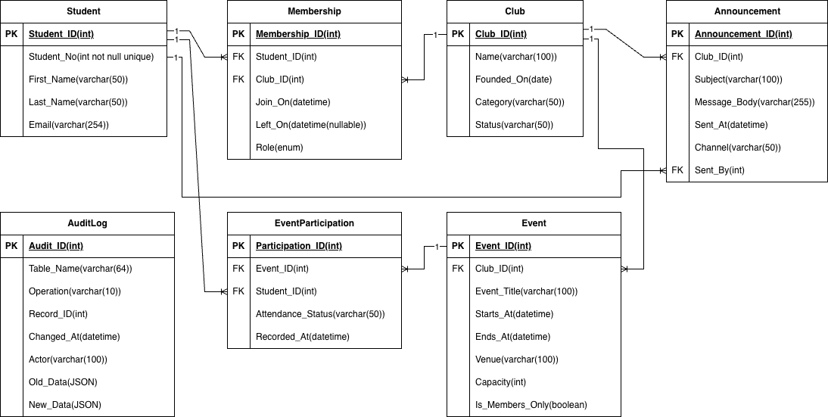
Figure 1: ERD for CCMS

The ERD shows that Students and Clubs have a many-to-many relationship because a student can join multiple clubs and each club has multiple students. This has been created using the associative table Membership, which converts the M:M relationship into two 1:M relationships (Student→Membership and Club→Membership) and stores membership specific data such as join/leave dates and role.

Students and Events are also M:M as students may go to multiple events and events have many attendees, so the implementation is done through EventParticipation, which records attendance status and avoids duplicate registrations. Clubs and Events are 1:M as each event is a property of one club, while clubs can hold several events. Announcements are linked 1:M from Club→Announcement and Student→Announcement (Sent_By) so communications can be attributed to both the club and the sender.

Entities and Relationships

This section identifies the main entities required for the Campus Club Management System and explains how they relate to each other. The design is based directly on the case study requirements: maintaining club records, managing memberships, organising events, tracking participation and recording announcements for audit purposes.

Students

Purpose: Stores details of individual students who can join clubs and attend events.

Key attributes:

- Student_ID (PK): unique internal identifier
- Student_No (UNIQUE): university student number
- First_Name, Last_Name
- Email (Unique, valid by format check)

Relationships

- A Student can join many Clubs (via Membership) M:M Student ↔ Club
- A Student can participate in many Events (via EventParticipation) M:M Student ↔ Event
- A Student can create many Announcements (as sender) 1:M Student → Announcement

Clubs

Purpose: Stores core information about each club/society, including its category and status.

Key attributes:

- Club_ID (PK): unique internal identifier
- Name
- Founded_on
- Category (restricted via CHECK constraint)
- Status (restricted via CHECK constraint)

Relationships

- A Student can join many Clubs (via Membership) M:M Student ↔ Club
- A Student can participate in many Events (via EventParticipation) M:M Student ↔ Event
- A Student can create many Announcements (as sender) 1:M Student → Announcement
I chose to use CHECK constraints for the purpose of this assignment, but in a production environment, I would have stored the available categories and statuses in their own tables.


Membership

Purpose: Resolves the Student–Club many-to-many relationship while storing membership history (join/leave dates) and role.

Key attributes:

- Membership_ID (PK)
- Student_ID (FK)
- Club_ID (FK)
- Join_on, Left_on
- Role
- Active_Student_ID (STORED)
- Active_Club_ID (STORED)

Relationships

- A Student can join many Clubs (via Membership) M:M Student ↔ Club
- A Student can participate in many Events (via EventParticipation) M:M Student ↔ Event
- A Student can create many Announcements (as sender) 1:M Student → Announcement

Constraints

- CHECK ensures Left_On is NULL or ≥ Join_On.
- UNIQUE check on Active_Student_ID and Active_Club_ID

When implementing memberships, a key issue was enforcing the rule that a student must not have two active memberships for the same club, whilst still allowing the database to keep a full history of past memberships. In theory, what I needed was a conditional rule that evaluated if a Student_ID, Club_ID pair already exists and ‘Left_on IS NULL’ (active membership) then block a new membership, but if the existing row has ‘Left_on IS NOT NULL’ (historical) then allow the student to join again.

A simple unique constraint on Student_ID, Club_ID would not work as it would also block legitimate historical re-joins. During research for a solution, I found a practical technique that emulates a partial unique index in MySQL by using generated columns that return NULL for rows that should be ignore by uniqueness enforcement. [1]

I implemented this by creating two STORED generated columns that only contain the real IDs when Left_on IS NULL; once a membership ends, these columns evaluate to NULL.

Event

Purpose: Stores club events (meetings, workshops, activities) with operational constraints.

Key attributes:

- Event_ID (PK)
- Club_ID (FK)
- Event_Title
- Starts_at, Ends_at
- Venue
- Capacity
- Is_Members_Only

Relationships

- A Student can attend many Events (via EventParticipation) M:M Student ↔ Event

Constraints

- CHECK ensures Capacity is more than 0

EventParticipation

Purpose: Resolves Student - Event participation while recording attendance state.

Key attributes:

- Participation_ID (PK)
- Event_ID (FK)
- Student_ID (FK)
- Attendance_Status

Constraints

- CHECK ensures Attendance_Status is one of the approved values (Registered/Attended/No-show/Cancelled)
- UNIQUE prevents duplicate registrations for the same event.

Announcement

Purpose: Stores official communications issued for reference/audit.

Key attributes:

- Announcement_ID (PK)
- Club_ID (FK)
- Subject
- Message_Body
- Sent_At
- Channel
- Sent_By (FK)

Constraints

- CHECK Channel must be one of the following (Email/SMS/Portal)

AuditLog

Purpose: Stores an audit trail of changes for accountability (who, what, when, old/new state).

Key attributes:

- Audit_ID (PK)
- Table_Name
- Operation
- Record_ID
- Changed_At
- Actor
- Old_Data
- New_Data

Constraints

- CHECK Channel must be one of the following (Email/SMS/Portal)

Normalisation to 3NF

Normalisation was used to reduce duplicated data and prevent problems when records are inserted, updated, or deleted. Simply, it means storing each value in the right place and linking tables using the foreign keys. Connolly and Begg describe 1NF as storing a single value in each table cell (no lists in one column). 2NF means that once a table is in 1NF, every column which is not a key must depend on the whole primary key. 3NF means that once a table is in 1NF and 2NF, non-key columns must not depend on other non-key columns. [2]

In the CCMS schema, Student is a table that only stores student attributes, Club is a table that only contains club attributes, Membership is the table through which the Student <> Club M:M relationship is resolved and it also stores the relationship attributes (Join_on, Left_on, Role), Event stores event attributes and it refers to the owning club via Club_ID, EventParticipation stores the Student <> Event M:M relationship and contains participation attributes and Announcement stores communication attributes while referencing the related club and sender via foreign keys. This division keeps each fact stored in only one place and connected via keys, aligning the design and 3NF.

Implementation

This section reports the implementation of the CCMS database in MySQL. Evidence is provided through screenshots showing (3.1) table creation and constrain enforcement, (3.2) insertion of sample data, (3.3) validation tests demonstrating constraint failures, and (3.4) execution of stored procedures, transactions, and auditing triggers. The complete implementation script is available in the .sql submission file, and the report outlines some examples to demonstrate that the system complies with the requirements for integrity, traceability and dependable operation.

Table creation + constraints

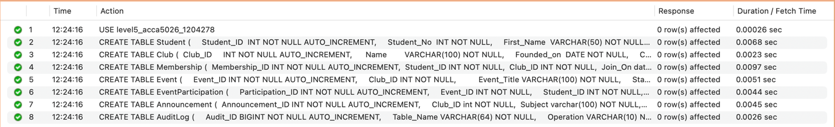
Figure 2: A screenshot confirming that all tables were created successfully.

Students

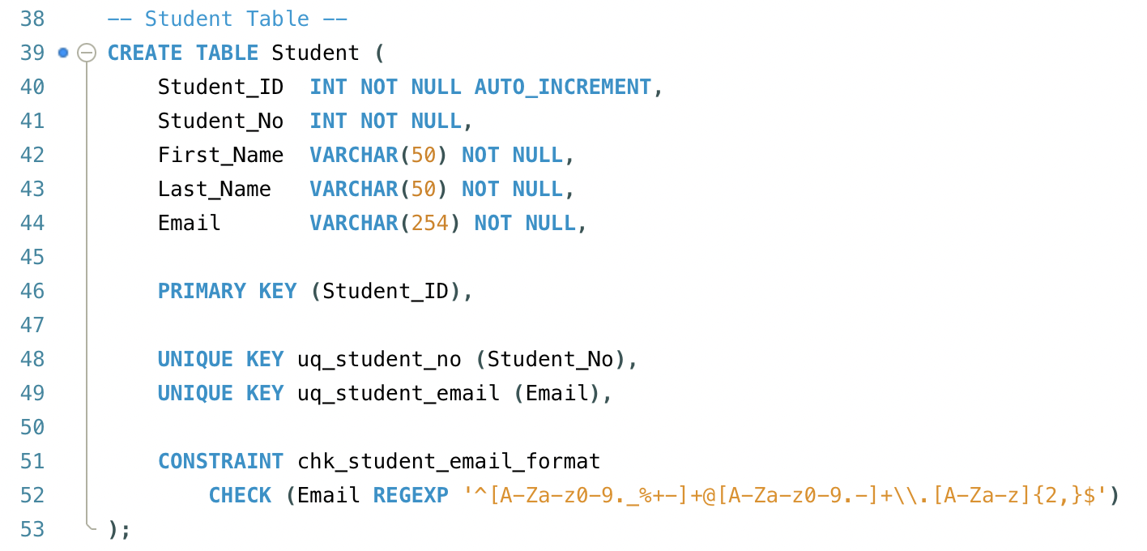
Figure 3: My SQL code for creating the students table with constraints

Figure 3 shows the Student table creation statement together with the defining of its primary key, unique constraints, and email format validation. The primary key (Student_ID) guarantees that every student entry is unique, and Student_No and Email are enforced as unique to prevent duplicates. The CHECK constraining applied on the Email field limits inserts/updates to a valid email format, reducing invalid data entering the system at the database layer.

Membership

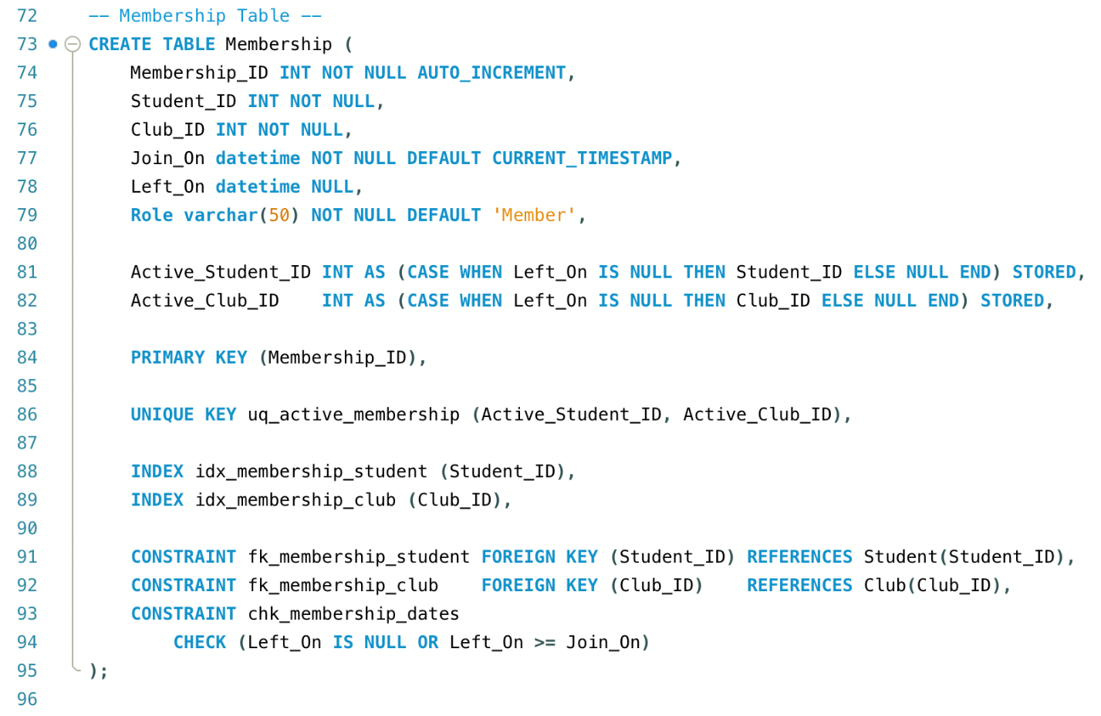
Figure 4: My SQL code for creating the membership table with constraints

Figure 4 displays the Membership table with its constraints. Foreign keys enforce valid connections to existing students and clubs. The date CHECK constraint prevents invalid membership history by ensuring Left_On is either NULL or later than Join_On. Since only one active membership of the same club can be kept by a student, the final rule is a bit more complicated if we consider that at the same time re-joining is allowed. Here, the use of generated STORED columns is used, together with a UNIQUE constraint. This is a way to implement the uniqueness condition only for the active rows. [1]

Event

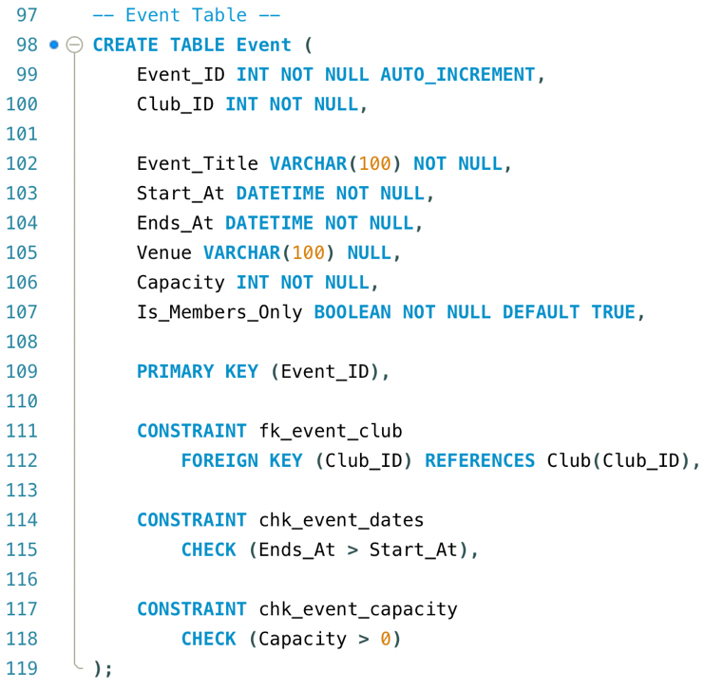
Figure 5: My SQL code for creating the event table with constraints
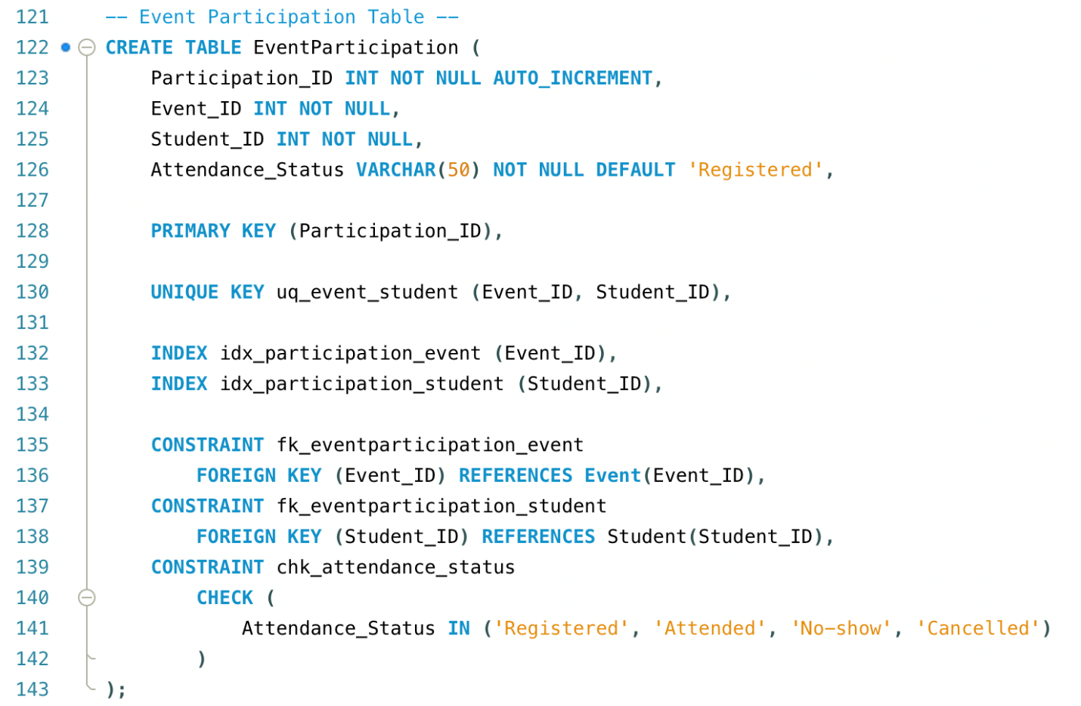
Figure 6: My SQL code for creating the event Participation table with constraints

Figure 5 shows the Event table, including constraints that ensure event times are valid (Ends_At > Start_At) and that capacity is greater than zero. Events link to clubs through a foreign key, ensuring every event is owned by a valid club.

Figure 6 shows the EventParticipation table. A UNIQUE constraint prevents a student from registering for the same event more than once. The Attendance_Status CHECK constraint restricts values to approved states (Registered/Attended/No-show/Cancelled), improving consistency for reporting and capacity logic.

Sample Data

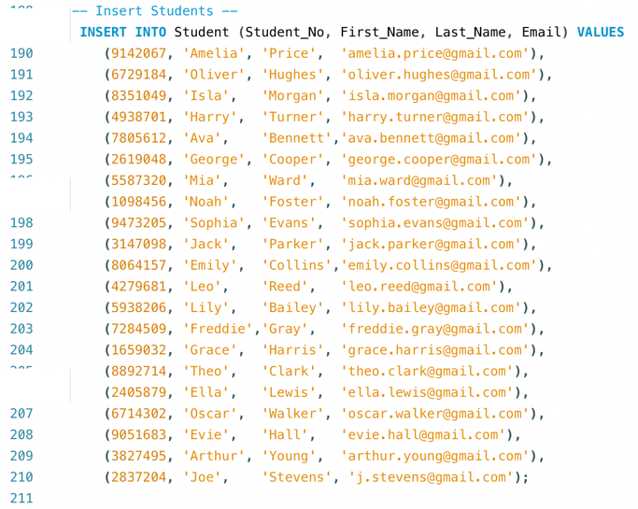  Figure 7: A screenshot of the SQL code used to insert a sample of students | 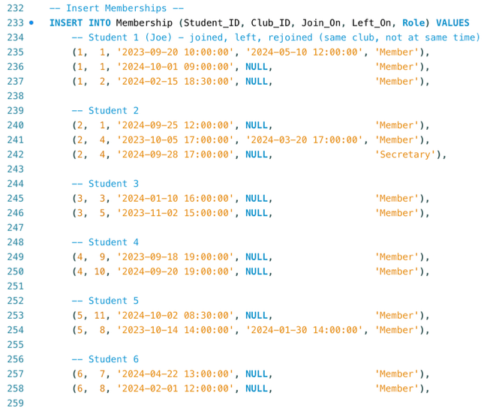  Figure 8: A partial screenshot of the SQL code used to insert a sample of memberships
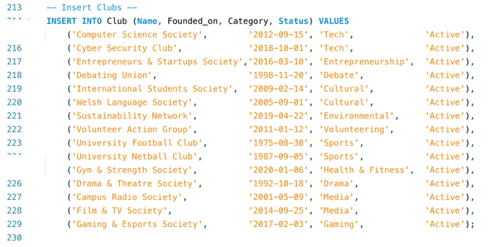  Figure 9: A screenshot of the SQL code used to insert a sample of clubs | 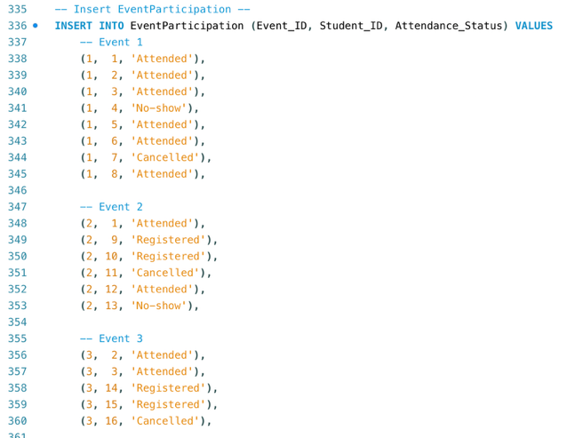  Figure 10: A partial screenshot of the SQL code used to insert a sample of event participation relationships

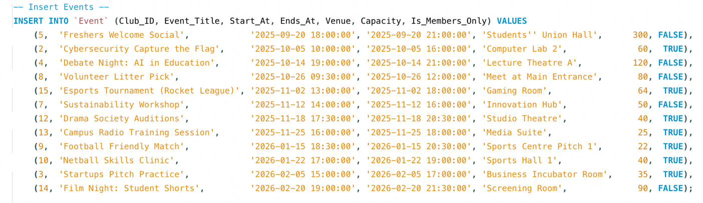
Figure 11: A screenshot of the SQL code used to add a sample of events

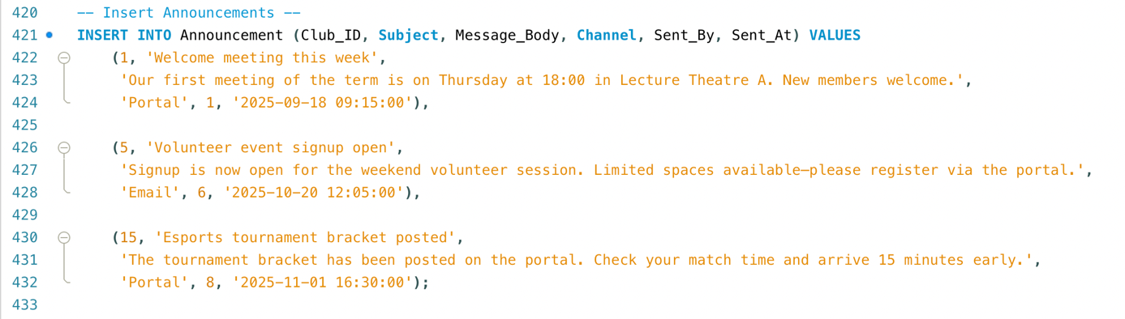
Figure 12: A screenshot of the SQL code used to add a sample of announcements

Figures 7 - 12 demonstrate the insertion of realistic sample data across all tables, including students, clubs, membership records, events, event participation, and announcements. The dataset was designed to reflect real usage scenarios such as students belonging to multiple clubs, memberships ending and later being re-created, events with different capacities and “members-only” restrictions, and varied attendance outcomes. This data is used throughout later sections to validate constraints, stored procedures, and reporting queries.

Constraint validation tests

The accompanying .sql file includes 11 different validation tests, below is a selection of the results documented.

Test 1

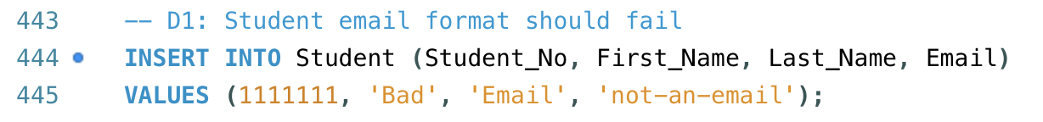
Figure 13: A screenshot showing a SQL insert command designed to fail

Figure 13 shows an attempt to add a new student with an invalid email format.
As expected, this fails with: Error Code: 3819. Check constraint 'chk_student_email_format' is violated.

Test 2

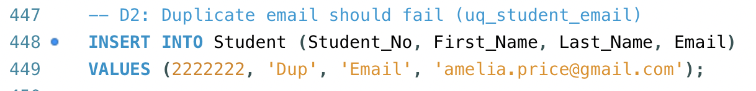
Figure 14: A screenshot showing a duplicated student being added

Figure 14 shows an attempt to add a duplicate student. This attempt failed with:
Error Code: 1062. Duplicate entry 'amelia.price@gmail.com' for key 'student.uq_student_email' as we would expect.

Test 3

Figure 15: A screenshot showing an attempt to add an event that ends before it starts

Figure 15 shows an attempt to add a new event where the end date and time is before the start date and time. As we would expect this failed with: Error Code: 3819. Check constraint 'chk_event_dates' is violated.

Stored procedures

Stored procedures (CRUD)

To demonstrate operational functionality and enforce key business rules consistently, the CCMS implementation includes stored procedures that encapsulate common membership and event actions.

sp_join_club performs an insert type operation to create a new membership after validating that the student and club exist and that the student is not already an active member of the same club.

sp_leave_club performs an update type operation by closing the current active membership row through setting Left_On, and it raises an error if no active membership exists to close.

sp_register_for_event performs an insert type operation to register a student for an event while validating student and event existence, enforcing “members-only” rules, and preventing overbooking through capacity checks; duplicate registrations are prevented through a UNIQUE constraint on (Event_ID, Student_ID).

Within each of these procedures, invalid operations are stopped using SIGNAL with error messages, ensuring that rules are enforced at the database level instead of relying on application logic later. [3] [4]

While each procedure performs a single grouped operation, multi-step workflows that combine these procedures are executed within a transaction (Section 4.2) to ensure the overall process completes and cannot leave partial updates if a step fails.

Joining a club

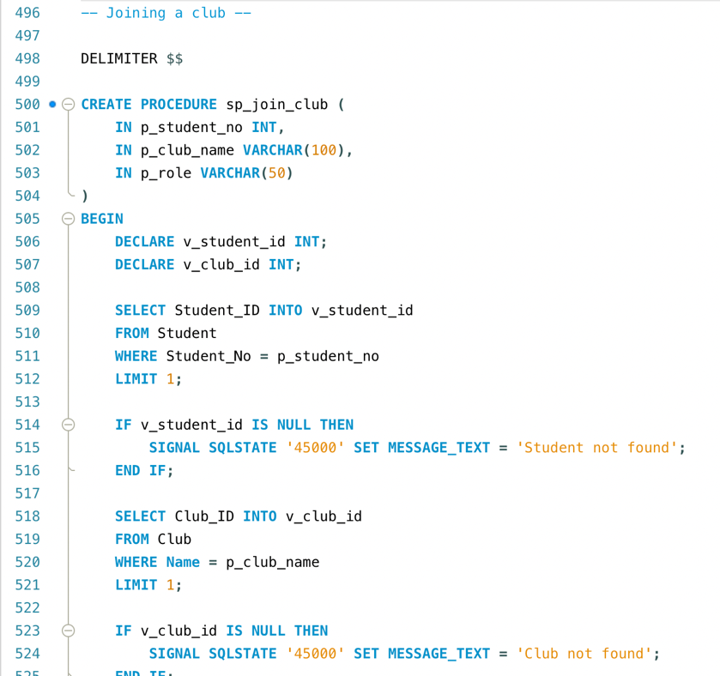
Figure 16: A partial screenshot of my club joining procedure

Leaving a club
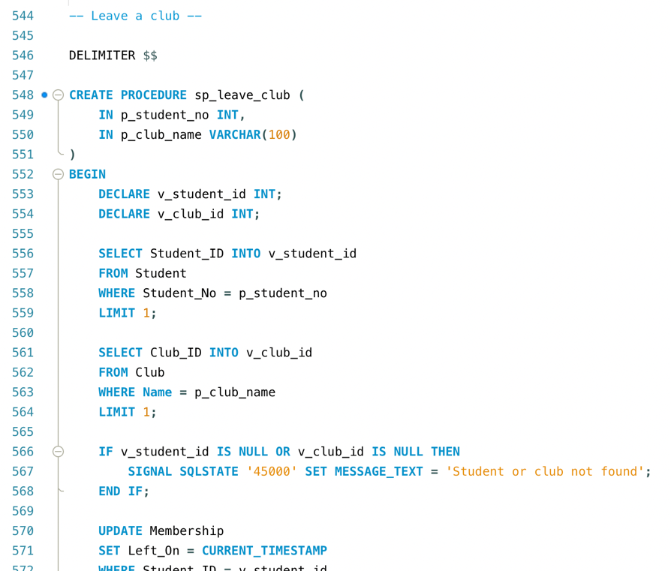
Figure 17: A partial screenshot of my club leaving procedure

Registering for an event

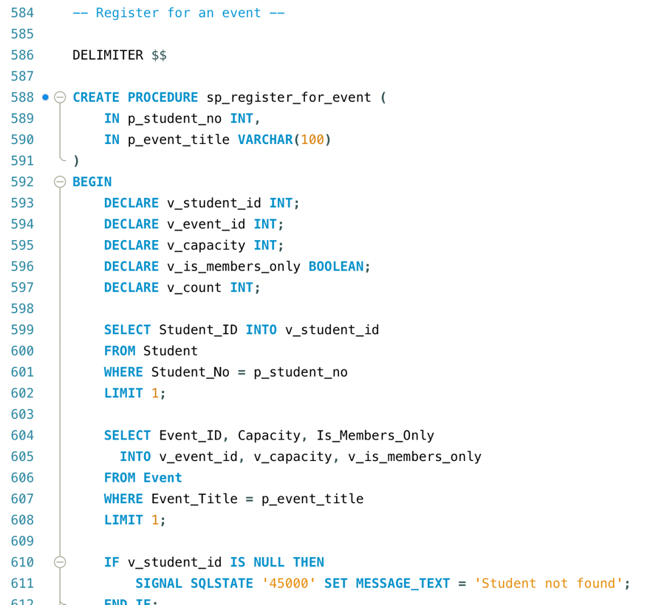
Figure 18: A partial screenshot of my procedure to register for an event

Transactions

To demonstrate transactional integrity, a single onboarding scenario is implemented using START TRANSACTION, COMMIT, and ROLLBACK. A transaction is a block of work where the full sequence must succeed, if any step fails, the database rolls back to undo partial changes. [5]

The procedure sp_onboard_join_and_register groups three dependent actions, creating a student, joining a club, and registering for an event so they either all complete successfully or none are applied. This prevents inconsistent states such as a student record being created without the intended membership/event registration. The rollback decision is justified because partial completion would violate the intended business process and could create misleading records for reporting and auditing.

Auditing

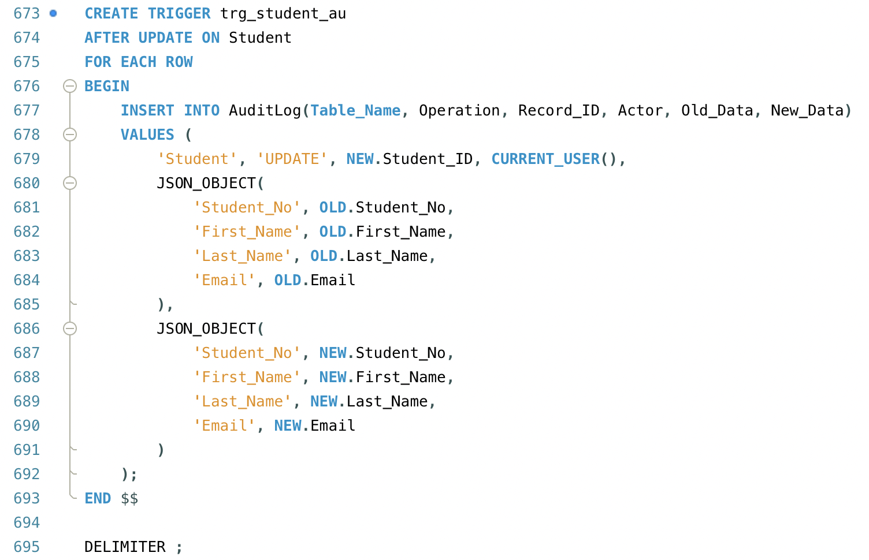
Figure 19: A screenshot of my student table modification trigger

To assist with accountability and traceability, the CCMS includes an auditing system that automatically records changes into an AuditLog table. Triggers run after data is inserted or updated. Figure 19 shows the creation of the trigger on the student table. Once created it monitors the table for new data or updates, once it detects either action it adds a record into the AuditLog table including the table name, operation type, record identifier, timestamp, database user and a before/after snapshot of the affected data as JSON. [6] This provides an evidence trail showing what changed, when it changed and who performed the action. In a production environment more triggers would be created to cover multiple tables.

Performance Enhancements

To improve query performance for day-to-day CCMS operations, secondary indexes were added to columns that could be frequently used in filtering. Membership lookups are performance critical (e.g. checking if a student is currently active in a club and listed club membership), so indexes on Student_ID, Left_On and Club_ID, Left_On support fast retrieval of active memberships.

Event related operations commonly require upcoming events in date order, so an index on Events Start_At improves sorting and range filtering by start time. Announcements are typically retrieved per club and show in reverse order, so Club_ID, Sent_At supports efficient filtering and ordering for communication history.

Overall, these indexes reduce full table scans and enable the system the locate relevant rows more efficiently, improving response time as the database grows.

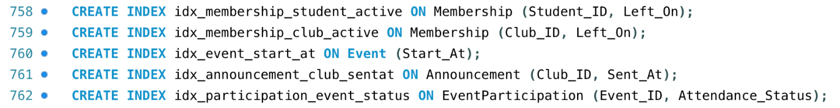
Figure 20: A screenshot of my secondary indexes

Conclusion

This project delivered a relational database solution for a CCMS that centralises Students’ Union club operations into a single, consistent source of data. The final schema supports the brief’s requirements of maintaining club records, managing memberships, organising events, tracking participation and storing announcements with data integrity enforced through primary/foreign keys, unique constrains and check constraints.
The design was normalised to Third Normal Form (3NF) to minimise redundancy and reduce the risk of update errors, whilst still supporting real world scenarios such as students leaving and later rejoining a club.
Functionality was demonstrated though stored procedures that implement key operational tasks and validated business rules using clear error handling. A transactional onboarding scenario was implemented to show how multiple dependant actions can be executed as a single piece of work, ensuring that partial updates are not committed if any step fails. Auditing triggers provide tractability by recording key changes to an audit log, supporting accountability and future review. Finally, performance was addressed by applying further indexes that optimise frequently used query patterns.
The biggest challenge in the implementation was enforcing the one active membership per student per club rule whilst retaining historical membership records. This was solved by using generated columns and a unique constraint to enforce uniqueness without preventing legitimate re-joins.

Bibliography

[1] | T. Petry, “Unique Indexes With Some Rows Excluded,” [Online]. Available: https://sqlfordevs.com/unique-index-ignore-some-rows. [Accessed 08 12 2025].
[2] | T. Connolly and C. Begg, in Database Systems : a practical approach to design, implementation, and management, Boston, Pearson Education, 2015, pp. 466-479.
[3] | Oracle, “SIGNAL Statement,” [Online]. Available: https://dev.mysql.com/doc/refman/9.5/en/signal.html. [Accessed 10 01 2026].
[4] | R. Wang and N. Wang, “Research on SQL Performance Optimization of CRM Stored Procedure,” Applied Mechanics and Materials, Vols. 519-520, 2014.
[5] | P. Wilton and J. W. Colby, Beginning SQL, 1st ed. ed., Indianapolis, IN: Wiley, 2005, pp. 302-313.
[6] | “How to implement audit trail using triggers in SQL,” Sharp Quest, 05 02 2025. [Online]. Available: https://www.sharpquest.com/blog/posts/2025/february/how-to-implement-audit-trail-using-triggers-in-sql/. [Accessed 27 12 2025].

