

Student name: MARCELA HOLUBOVA
Student ID: 2509132
Module name: INTRODUCTION TO HEALTH AND SOCIAL CARE
Module code: LCHS4003
Lecturer name: SHEPHERD ZIKO
Content page

Element 1 - Introduction to Residential Care

Element 2 - Brief History of Residential Care

Element 3 – Current Functioning of the Service

Element 4 – Key Challenges Faced by the Sector

Element 5 – Future Outlook and Key Takeaways
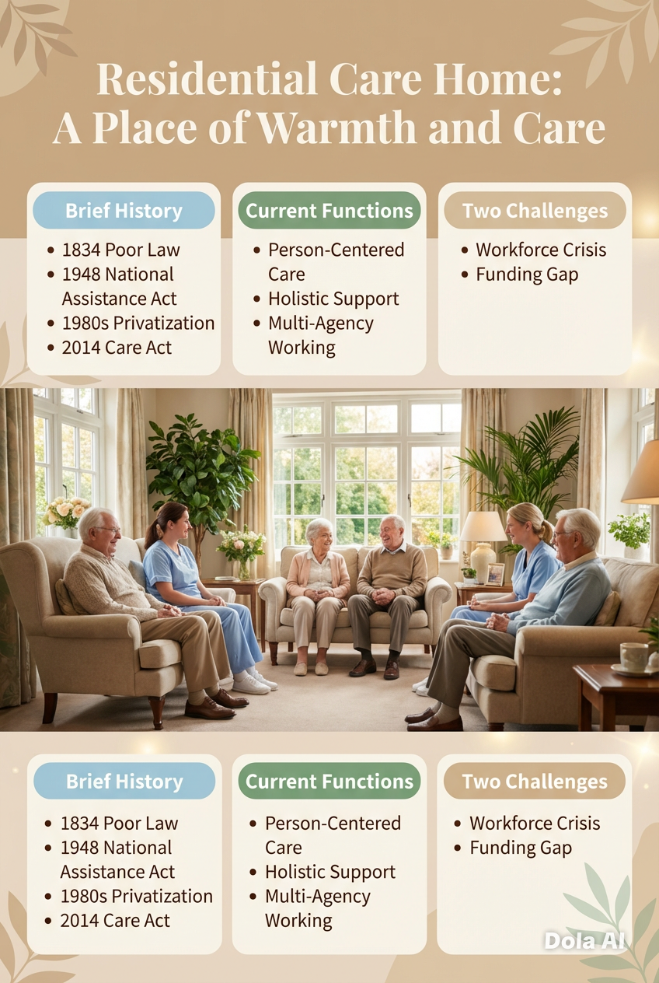
- Residential care homes are fundamental to the social care sector, offering long-term housing, personal assistance, and support for individuals unable to live autonomously. With the ageing global population, these institutions have evolved from rudimentary "almshouses" to advanced, person-centred facilities aimed at improving quality of life (Department of Health and Social Care [DHSC], 2023). This poster examines the historical context, contemporary practices, and systemic obstacles of residential care within the UK framework.
3) Current Functioning of the Service
Presently, residential care homes operate under a strict regulatory framework supervised by the Care Quality Commission (CQC) in England. The current operation is delineated by:
1. Person-Centered Care: Care is no longer "one size fits all." Modern homes use digital care records to track individual preferences, nutrition, and hydration in real-time.
2. Holistic Support: Services include social stimulation (group outings, gardening), mental health support, and family engagement programs.
3. Multi-Agency Working: Care homes collaborate with GPs, social workers, and occupational therapists to ensure a seamless "pathway of care" for the resident (NHS England, 2021).

Residential Care Home
Student Name: Marcela Holubova
Student ID: 2509132

2) Brief History of Residential Care
The 1834 Poor Law Amendment Act was the start of residential care. At that time, "workhouses" were the only places where the elderly and poor could go for safety. These were often harsh and showed no respect.
1. The 1948 National Assistance Act was a turning point because it got rid of the Poor Law and required local governments to give people in need "homely" places to live.

4) Key Challenges Faced by the Sector
1. The Workforce Crisis
The sector suffers from high staff turnover and a chronic shortage of qualified care.
2. Funding and Financial Sustainability
There is a significant "funding gap" between the cost of providing high-quality care and the fees paid by local authorities. Many homes rely on "cross-subsidization," where self-funding residents pay higher fees to offset the lower rates paid by the government for state-funded residents.

5) Residential care homes have transformed from the bleak conditions of workhouses into essential centres of community and assistance. The transition to person-centred care and stringent regulation has enhanced the lives of many, yet the sector continues to be unstable due to ongoing issues such as inadequate staffing levels and fluctuating government support. Confronting the dual challenges of workforce retention and sustainable funding is crucial for maintaining the dignity and safety of residential care for future generations, as these factors directly impact the quality of care and the ability to attract and retain skilled staff.

Section Head Here
Text or images here

The Evolution and Impact of the UK Ambulance Service
The ambulance service is a fundamental component of the UK's National Health Service (NHS), serving as the frontline of emergency medical care. The service has evolved significantly from a basic transport mechanism to a sophisticated mobile healthcare provider, adapting to the changing needs of the British public.
Historical Origins and Context
The inception of the UK ambulance service dates to the late 19th century. Initially, transportation for the ill was disorganised, frequently depending on horse-drawn carriages operated by local authorities or organisations, such as the St. John Ambulance, which was officially founded in 1877 (St. John Ambulance, 2023). Nonetheless, the genuine impetus for professionalisation was World Wars I and II, which illustrated the imperative for swift field triage and mechanised transport, leading to the establishment of more structured and efficient ambulance services in the UK.
The contemporary framework was instituted subsequent to the National Health Service Act of 1946. Upon its inception in 1948, the NHS mandated local authorities to deliver ambulance services (NHS England, 2021). Initially, personnel consisted mainly of drivers possessing fundamental first-aid training. The Millingen Report in 1966 marked a pivotal shift towards "paramedicine", evolving the service from a basic "scoop and run" transport system into a clinical intervention service, initiating treatment upon the crew's arrival at the patient (Geoghegan et al., 2021).
Critical Evaluation of Current Functions
The ambulance service in the UK now operates as a sophisticated clinical system. It is now a "mobile emergency department" rather than merely a transportation service. Advanced life-support equipment, such as defibrillators, ECG monitors, and a variety of emergency drugs, is installed in modern ambulances. However, a critical analysis shows that the service is currently dealing with serious operational issues. The London Ambulance Service and the North West Ambulance Service are two examples of the regional trusts that make up the system. Although advanced paramedic training has improved clinical outcomes for time-critical conditions like cardiac arrests or strokes, the service is under tremendous strain. Response times have increased due to increased demand and "handover delays" at hospitals, where ambulances are kept in bays due to full A&E departments (Association of Ambulance Chief has helped control demand by treating a sizable percentage of callers without a hospital visit, which lessens the strain on secondary care (NHS Digital, 2022).
Significance in Enhancing Quality of Life
The ambulance service plays a crucial role in improving the quality of life for its users. It offers an essential safety net for the individual. In critical emergencies, the swift response of paramedics significantly decreases mortality and long-term disability. The establishment of direct routes to Specialist Stroke Centres guarantees that patients obtain critical care within the "golden hour", significantly enhancing their prospects for complete recovery and autonomy (National Institute for Health and Care Excellence [NICE], 2019) Moreover, the service enhances the quality of life for at-risk populations, including the elderly. Paramedics frequently serve as the principal connection to broader social and community care, recognising safeguarding concerns or directing patients to occupational therapy. This comprehensive strategy mitigates superfluous hospital admissions, enabling individuals to stay in their residences, a crucial element for psychological well-being and dignity (College of Paramedics, 2021).
Conclusion
The UK ambulance service has evolved significantly from horse-drawn carriages to advanced mobile clinics. Despite contending with the challenges of a strained healthcare system, its role remains essential. The service delivers prompt clinical expertise and serves as a conduit to specialised care, thereby preserving lives and enhancing the independence and quality of life for millions of individuals throughout the United Kingdom.

References
Association of Ambulance Chief Executives (AACE) (2023) National Ambulance Handover Delays – Data to October 2023. Available at: https://aace.org.uk/wp-content/uploads/2023/12/National-Ambulance-Handover-Delays-Data-to-October-2023-FINAL.pdf (Accessed: 12 March 2026).

College of Paramedics (2021) The Paramedic Post-Registration Career Framework. 4th edn. Bridgwater: College of Paramedics.

Geoghegan, P., Abel, G. and Tarrant, C. (2021) ‘The history and evolution of the paramedic profession in the UK’, British Paramedic Journal, 6(1), pp. 22–30.

National Institute for Health and Care Excellence (NICE) (2019) Stroke and transient ischaemic attack in over 16s: diagnosis and initial management (NG128). Available at: https://www.nice.org.uk/guidance/ng128 (Accessed: 12 March 2026).

NHS Digital (2022) Ambulance Quality Indicators Data 2021-22. London: Department of Health and Social Care.

NHS England (2021) The NHS Constitution for England. Available at: https://www.gov.uk/government/publications/the-nhs-constitution-for-england (Accessed: 12 March 2026).

St John Ambulance (2023) Our History: From the 11th Century to Today. Available at: https://www.sja.org.uk/who-we-are/our-history/ (Accessed: 12 March 2026).

