BUSINESS PLAN


BUKANI FOOD LTD

Module: | Managing Enterprise in the 21st Century
Module code: | BMSW 4006
Group | 4
Student name and ID number: | - Hristina Bufi - 2121309  - Yordanka Kancheva - 2017633  - Radoslav Nikolov – 2118366
Lecturer: | Rejesh Kumar

Executive Summary



BUKANI Food - Healthy Restaurant.
The mission is to improve people's health with every bite of our products.
After conducting a study by the NHS, the elevated level of obesity and morbidity in the country is evident.
A restaurant that would help people eat healthier.
The team is made up of particularly good specialists, each in their own fields such as Specialists in healthy nutrition, specialists in management and marketing, and specialists in supplies and coordination. The team is a clear example of the benefits and results of healthy eating.
The various analyses are used to determine what the competition is like in the area and how the various aspects will affect business presenting you with a profitable financial plan.

Table of Contents

Businesses Overview 4
Product and Service 5
Market Audit 6
Competitors 6
SWOT Analysis 8
PESTEL Analysis 10
Target Market 11
Marketing and Promotion 12
Menu 13
Management Team 14
Financial Plan 15
Cashflow Forecast 16
Profit and loss 17
Financial indicators 18
Conclusion 19
References 20

Businesses Overview

The name of the company BUKANI Foot is formed from the first two letters of the last name of each of the owners of the company.
The company was established in 2022 in response to our desire to improve nutrition and help people have the opportunity for a healthy lifestyle.
The company is owned by Hristina Bufi, Yordanka Kancheva and Radoslav Nikolov, who participate with equal shares.
Derby Moor ways Sport Village and Water Park has been chosen as the location to develop this business. It was not chosen at random. This is the area with concentrated sports centres and large green areas.
Products will be available in-store as well as online orders with delivery.
There are no competitors to conduct such activity.
Our idea will further help with this by helping to build a healthy eating culture. The menu is offer and the advice to give will create an inseparable link between the way you eat and physical activity.
The menu features fresh foods made from products produced in local farms with guaranteed quality.
The network built with farmers guarantees the daily supply of fresh products.
The diets created will be significant to overweight people who want to change their lifestyle and nutrition and to improve their health.

Product and Service



Production of a healthy and varied menu - breakfast, salads, meat, soups, smoothies, and desserts.
Using pure organic products secured by contracts with nearby farms.
Everyone can order the menu in our self-service restaurant and Delivery to the place specified by the customer is provided.
Also, the Orders are accepted online and by phone.
Utensils and food packaging will be made from recyclable materials, which will help protect nature.

Market Audit

As part of any business plan, the market audit uses various analytical tools to help understand exactly where the proposed business stands and is aware of what is happening in the outside world.

Competitors

For a business plan to be successful, it needs to offer a unique product or service, or at least offer something that differentiates it from its competitors. The creators of this business have identified a gap in demand and supply in the market providing something new and different. The mission of this company is to provide its consumers with a healthy menu prepared from fresh, high-quality products at a price equivalent to the products that its competitors offer of low quality. The table below presents information based on studies of competitors in the immediate vicinity.

Factors | Bukani Food LTD | Mc Donald’s | The Fast-food Co
Manufacturing | Food | Food | Food
Production and Service | Healthy fast-food sells and hot menu delivery to the doorsteps | Fast-food sells | Fast-food sells
Market share | All sport centres around, Rolls-Royce and populated place | global presence | Limited presence in the local area
Strengths and Weaknesses | - no equivalent in the market offering this kind of food  - not imposed on the market | -Big investments; strong brand; image and reputation.  -quality issues; unhealthy image of food | - low production and maintenance costs  -limited and unhealthy menu  -there is no delivery service
Important success factors | Successful Ads; partnership with Rolls-Royce and Moor ways Sport Village and Water Park | Successful Ads (I like this)  Great Partnership (Coca Cola)  clean environment and playground for children | No success factors observed
Threat scope of competitors | - | Threat to hold segment - children | No threat from them is observed
Strategies Used | Offering unique healthy menu; located near to sport centers; Excellent service | Innovation and product development | Тhere are no development plans for the product

SWOT Analysis

S

W

O

T

The SWOT analysis as part of the Market audit helps to build the business strategy and focus over the issues facing it. Тthrough this analysis is easily identified and analyseд the internal and external factors that would have an impact on the chosen business. Four elements are examined:
- STRENGTHS and WEAKNESSES as internal factors intending product and service; the team; all the processes connected with the business.
The following strengths that the company possess over the competitors are identified:
- there is no equivalent in the market in the immediate vicinity offering this kind of product meeting the needs of this part of the population that is oriented and aware of a healthy lifestyle.
- Uniquely created healthy recipes, meeting both taste qualities and dietary nutrition.
- First quality and fresh products will be used daily
- The suppliers that the business will cooperate with are farmers, and producers of clean, organic products.
- Offering fast and quality service including hot menu delivery to the doorsteps.
- Dishes and utensils made of organic materials.
- Close to sports centers and facilities.
- Extremely high hygiene.
- Highly qualified staff.
At the same time, there are weaknesses recognised such as:
- Short shelf life of products
- Impossibility of freezing for future use
- A large part of the population is uninformed about the benefits of healthy eating.
- A new business is started, without much marketing knowledge.
- OPPORTUNITIES as business expansion and attract health-conscious leads in the one hand and the THREATS as high inflation, lack of financial resources and trend of new viruses in the other hand are external factors which can affect some areas such as customers and competitors; various financial problems, technological innovation.
- Dealing weaknesses and threats:
- In-depth preliminary research on the volume of orders
- Forecasting costs covering unused products
- Continuous development of innovative marketing strategies to attract new segments of customers
- Developing innovative ideas to market this product as essential in pandemic conditions fully compliant with government requirements.

PESTEL Analysis

The earliest known author to use ‘Business Environment Scanning ‘‘techniques is Francis J. Aguilar (1967).
Using PESTEL can be done characterize the external factors affecting the business, showing “the big picture.” There are many factors influencing over the business as the following of which may be significant.
The Government can affect this business through indirect way, increasing taxes, changing Industry regulation and if it makes some trade restriction.
An increase in interest rates would lead to a jump in loan returns. Inflation can affect price growth.
The stock that is purchased from our farmer partners may be threatened by weather condition.

Political | Economic | Social | Technology | Environmental | Legal
Tax policy  Trade restriction  Stability of politic  Regulations of Government Industry | Rates of inflation  Interests  Disposable income  Growth of the economy  Wage rates and minimum wage | Population  Health consciousness  Lifestyle attitude  Culture  Consumer taste  Costumer habits  Cost of living | Technology innovations  Automation  Robotics  Social network  Security | Weather  Climate changes and its effect on farming.  Healthy eating benefits the environmental | Health and safety regulations  Costumer protection law

Target Market

The target group on which this business will focus is:
- One of the main target groups that the company is aiming for are people who have realized that healthy eating is the most important thing in their lives and are aiming for people who think they need to lose weight.
- The other no less important group that should be paid attention to is people with health problems. With specially developed diets to help improve their health.
- The main aim is to inform and help all people of all groups to realize the need to change their eating habits towards a sensible and purposeful diet.

Marketing and Promotion

Companies use a variety of methods to communicate with customers or to pique the interest of potential customers. They consist of four components – advertising, public relations, personal selling, and sales promotion.
Advertising can be conducted through the media, the press, the Internet, distribution of various advertising materials (brochures, posters, business cards, calendars, catalogues, etc. Through it, a given product or service is promoted, and users are informed about the creation of new companies, promotions, discounts etc. It is one of the main ways of communication between producers and consumers. Bukani Food is innovative, so it will bet a lot on advertising and popularizing the idea of healthy eating.

Here are the following ways of promotion and advertising that will be used by the company:
• by distributing flyers in key and mass locations in the area
• pasting posters and brochures on mailboxes
• creation of a website and Facebook page - there you will be able to get more information about the products
• possibility to place orders through the website, the application, and by phone

To promote sales, the company will constantly offer new and different promotions, coupons for regular customers, and free home delivery for higher order value. I will have seasonal promotions - discounts on smoothies in the summer and hot foods in the winter, as well as weekly discounts when you order two or more items.
The launch of the company will consist of a free presentation with all products, thus establishing the interest of customers and introducing healthy food.

Menu

The menu will include breakfast, soups, salads, well-cured meats, desserts, and over 20 different types of smoothies. Every day will offer a varied and different menu with fresh products. The prices will be in line with those of competing companies and accessible to everyone, but the quality of the horseradish will be at the highest level.



Management Team

According to the qualifications of the owners of the company, they will occupy the following positions
- Hristina Bufi -Hygiene and production manager -Level 2 Food Hygiene & Safety (Catering)
- Yordanka Kancheva -Economic and sales manager -Diploma for higher Educ.: Economic management Certificate for Sales skills
- Radoslav Nikolov -Transport and Logistics Manager -Driving License CPC card
Based on the book "Growing your business a handbook for ambitious owner managers” by
Burke et al. (2008) to grow the business in the first year the owners will work alone and take temporary positions:
- Hristina Bufi – will prepare the menu and cook the food
- Yordanka Kancheva- will take orders and be a sales consultant
- Radoslav Nikolov- will oversee deliveries and making orders


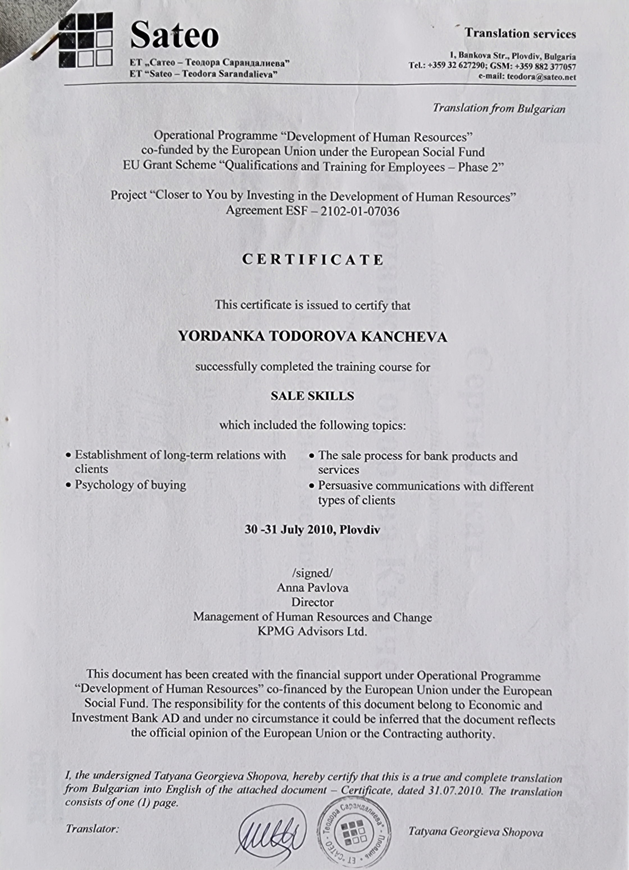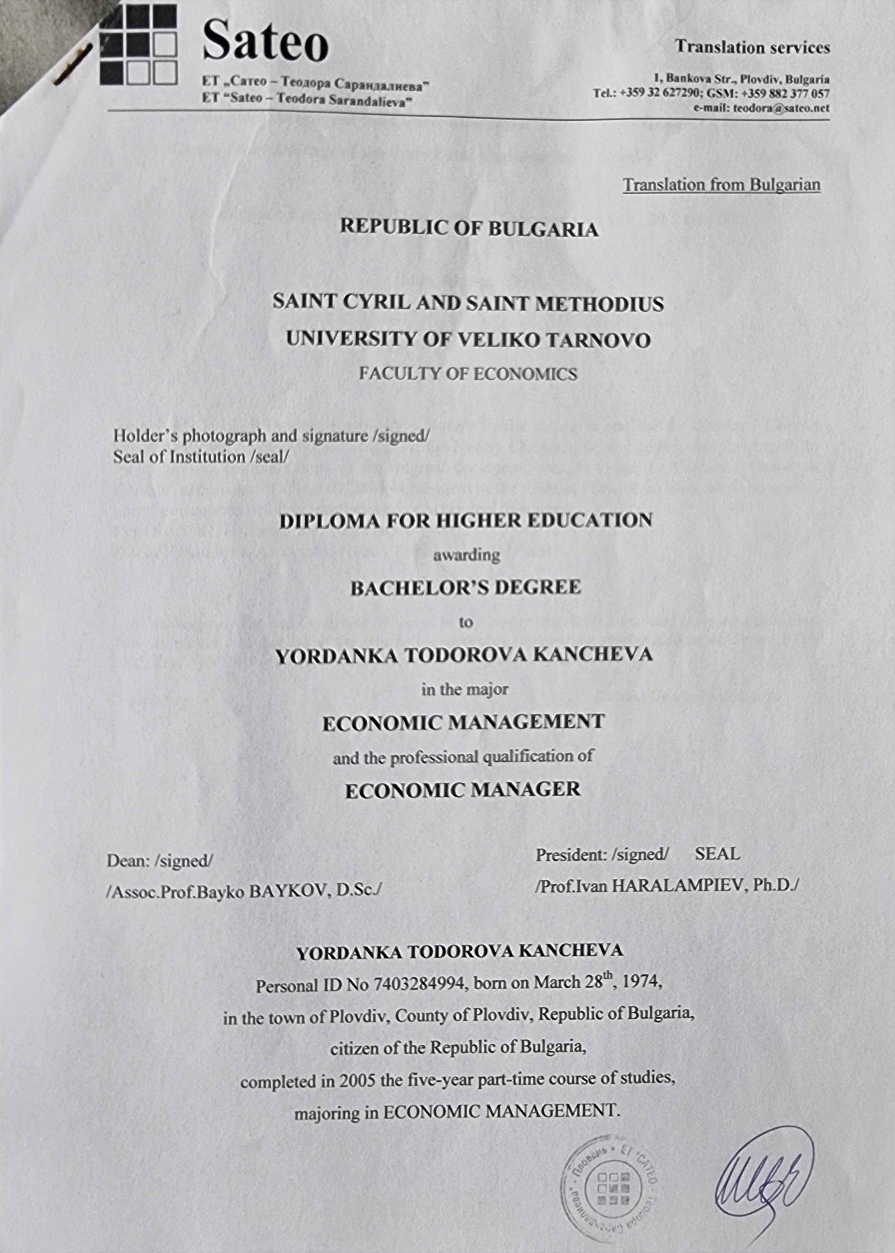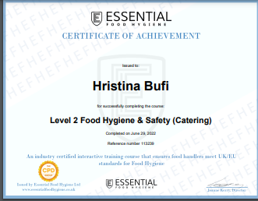
For these positions, after the development of the business, employees will be appointed, and for this purpose a job description is necessary. Which, as a consequence of the work, they will be precisely determined for Bukani food

Financial Plan

The financial plan is based on many types of research; based on this each owner will invest £10,000 making the total investment £30,000.
The financial plan will be presented in two ways:
- The cash flow forecast is presented for 12 months
- of profits and losses for 1 year
All data filled in the table are taken from a survey of the average business and because of the average national sale of fast food.

Cashflow Forecast

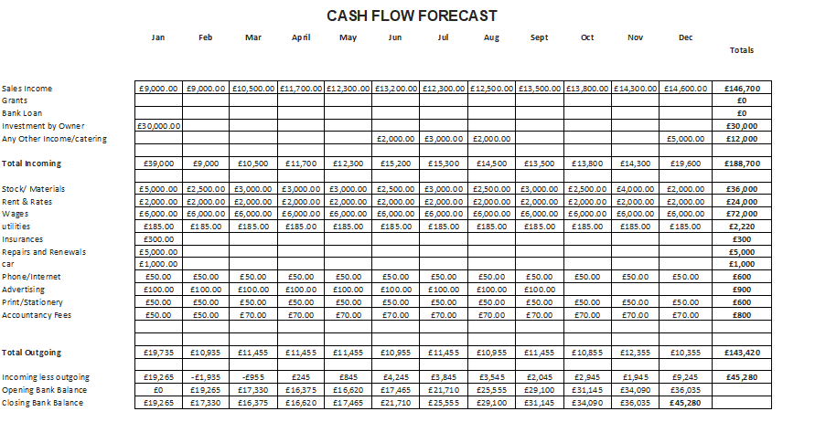

Profit and loss

Business: BUKANI FOOD LTD
Period: Year to 31 December 2023
Sales: | £144,600.00 |  | £156,600.00 | (Units(A)
Any Other Income | £ 12,000.00
Less direct (variable) costs:
Materials | £ 36,000.00
direct wages | £ 72,000.00
transport/travel | £ 1,000.00
Total direct costs |  |  | £109,000.00
Gross profit/contribution: |  |  | £47,600 | (B)
Fixed costs (overheads):
wages/salaries (incl. taxes)
rent | £ 24,000.00
utilities | £ 2,200.00
advertising
insurance | £ 300.00
telephone | £ 600.00
stationery/postage | £ 900.00
repairs/renewals | £ 3,900.00
depreciation | £ -
local taxes | £ 950.00
other Prof. fees | £ -
another Sundry | £ -
Total fixed costs |  |  | £32,850.00 | (C)
Net profit |  |  | £14,750.00
Less drawings or dividends
break-even point = (A*C)/B |  |  | 108,073.74
Profit retained in the business |  |  | 1.10%

Financial indicators

Based on Cashflow Forecast and Profit and loss
- financial result - the developed income and expenditure plan in
the first year of the company's activity shows a positive financial
result - profit of £45,280
- break-even point = 108,073.74 items per year must be sold
- Profit retained in the business -1.10%

Conclusion

This type of activity is unpopular in our country, and it is believed that it will find its own market niche. After reviewing the financial plan, we conclude that it is profitable. Our economy needs innovative ideas.

References

- Bivins, R. (2020). Weighing on us all? Quantification and cultural responses to obesity in NHS Britain. History of Science, 58(2), 216–242. https://doi.org/10.1177/0073275319842965
- Burke, G., Barrow, P. and Clarke, L. (2008) Growing your business a handbook for ambitious owner managers. New York, NY: Routledge.
- Butler. (2006). Enterprise planning and development: small business start-up, survival, and development. Routledge.
- Drummond, Ensor, J., & Ashford, R. (2008). Strategic marketing: planning and control (3rd ed.). Butterworth-Heinemann.
- Evans. (2011). The Financial Times essential guide to writing a business plan: how to win backing to start up or grow your business. Pearson.
- Logue, Jennifer, et al. "Management of obesity: summary of SIGN guideline." Bmj 340 (2010).
- Made craft, Belfiore, J. and Made craft (2021) Conducting a SWOT Analysis. Carpentaria, CA: linkedin.com.
- Mariotti & Glackin (2013). Entrepreneurship: Starting and Operating a Small Business.
- Pictures: from Internet
- Zentner, K. et al. (2020) ‘A Comparative PESTEL Analysis of Canada and China’s Management of Energy Markets’, The journal of applied business and economics, 22(12), pp. 253–273. Available at: https://doi.org/10.33423/jabe.v22i12.3894.

