

Module: Digital Skills and Research Method
Module Code: BMSW4003

Assignment Title: “How I can use the DIKW and CRAAP frameworks to confirm or reject my collected GRIT test result (Primary Data) compared to the UWTSD GRIT Result (Secondary Data) based on the work of Angela Duckworth TED Talk lecture”

Name of Lecturer: Dr Navid Nasirpour

Name of student: Radostina Rusenova
Student ID: 2015829

December 2021

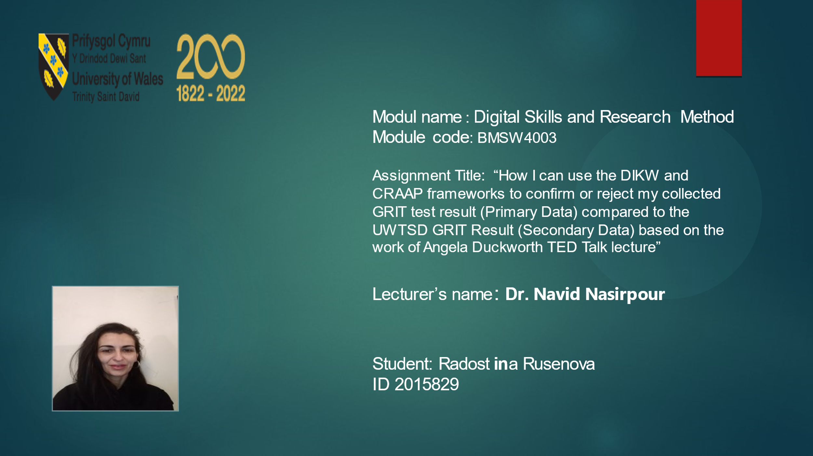

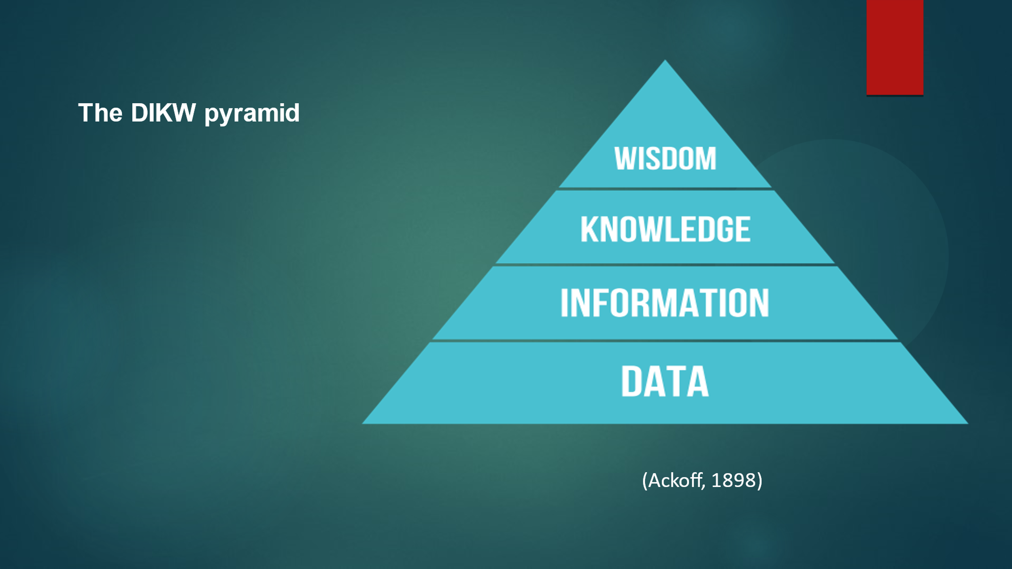
The aim of this assignment to show how can I use the DIKW and CRAAP framework to analyse my collected Academic GRIT test results and be compared to the UWTSD GRIT Result. The analyses will be based on the work of Angela Duckworth’s lecture and her GRIT and growth mindset theory which was developed by Carol Dweck.
The first thing when we need to make analyses and research is to know what steps to follow. In Digital Skills and Research Method module, I learned that it is important to use the DIKW pyramid (Ackoff, 1999) and it is a very useful framework to make the right conclusions. This approach has four stages and the first is to gather data, the second is to transmute data into information, the third step is to comprehend the information and to convert it into knowledge and at the top of this model is wisdom.
It is the transmission and learning of information that occupies most of the school day. Knowledge is transmitted less often and ways to obtain it are less accessible. There is almost no time devoted to transmitting understanding or methods. Additionally, there is rarely a distinction made in the educational process between data, information, etc. up to wisdom. The students are left unmindful of their obliviousness (Ackoff, 1999).
After collected, data itself means almost nothing, but when following the secret statement of DIKW model we realize that data can be used to create information; information can be used to create knowledge, and knowledge can be used to create wisdom. A sign of success is if the connections between knowledge and wisdom and between data and information are valued and improved (Rowley, 2007).


GRIT is described as desire and tenacity towards long-term goals (Duckworth et al., 2007). The concept of grit was established by Angela Duckworth to explain why certain people are determined to achieve their full potential. Less is known about other individual variations that predict success, although the significance of intellectual capacity in all professional disciplines is generally understood. Angela Duckworth investigated the significance of one emotional attribute, GRIT. Duckworth’s conclusions show that achieving tough goals necessitates not only skill but also a consistent and concentrated use of talent over time (Duckworth et al., 2007). Angela Lee Duckworth was concerned about the causes why some individuals prosper, and others fail in life. She learned that success is unrelated to the traditional suspected prophets: chance, IQ results, or physical condition. She found that effort improves skill and makes the skill more valuable (Puiu, 2017)). After investigating the findings of Duckworth, I understood that the higher the GRIT is the well the results are. I will use this finding when analysing my results.

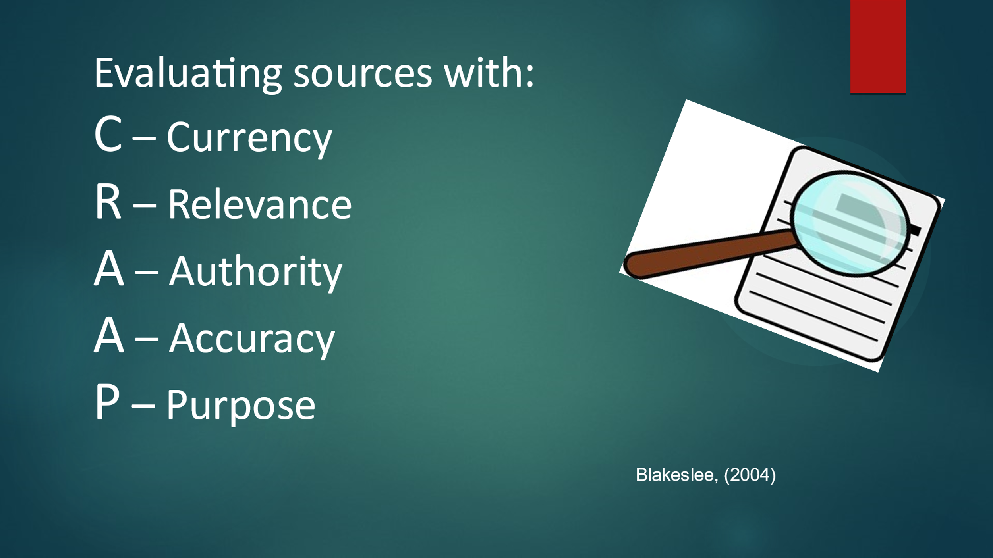

In order to realize if the data is reliable, knowledge of the CRAAP test is necessary.
CRAAP is an abbreviation for Currency, Relevance, Authority, Accuracy, and Purpose. It is made up for the students to be successful and to know how to look and remember these important criteria that will allow them to evaluate information. Given the framework in which it would be used, CRAAP signified something it is not only an abbreviation. Currency refers to when the information is published, has the information has been revised, is it to a proper level. Relevance is about if the information is significant for your needs and refers to your theme. Authority is for the supplier of material, who is the author, is there communication info. Accuracy stands for the proof that supported information and is it referred to. Purpose relates to the reason the information survives (Blakeslee, 2004).
Based on many years of research, on many factual studies in various administrative institutions, the information considered about Angela’s study on academic GRIT, in my opinion, is authoritative and has accepted the Carp test.

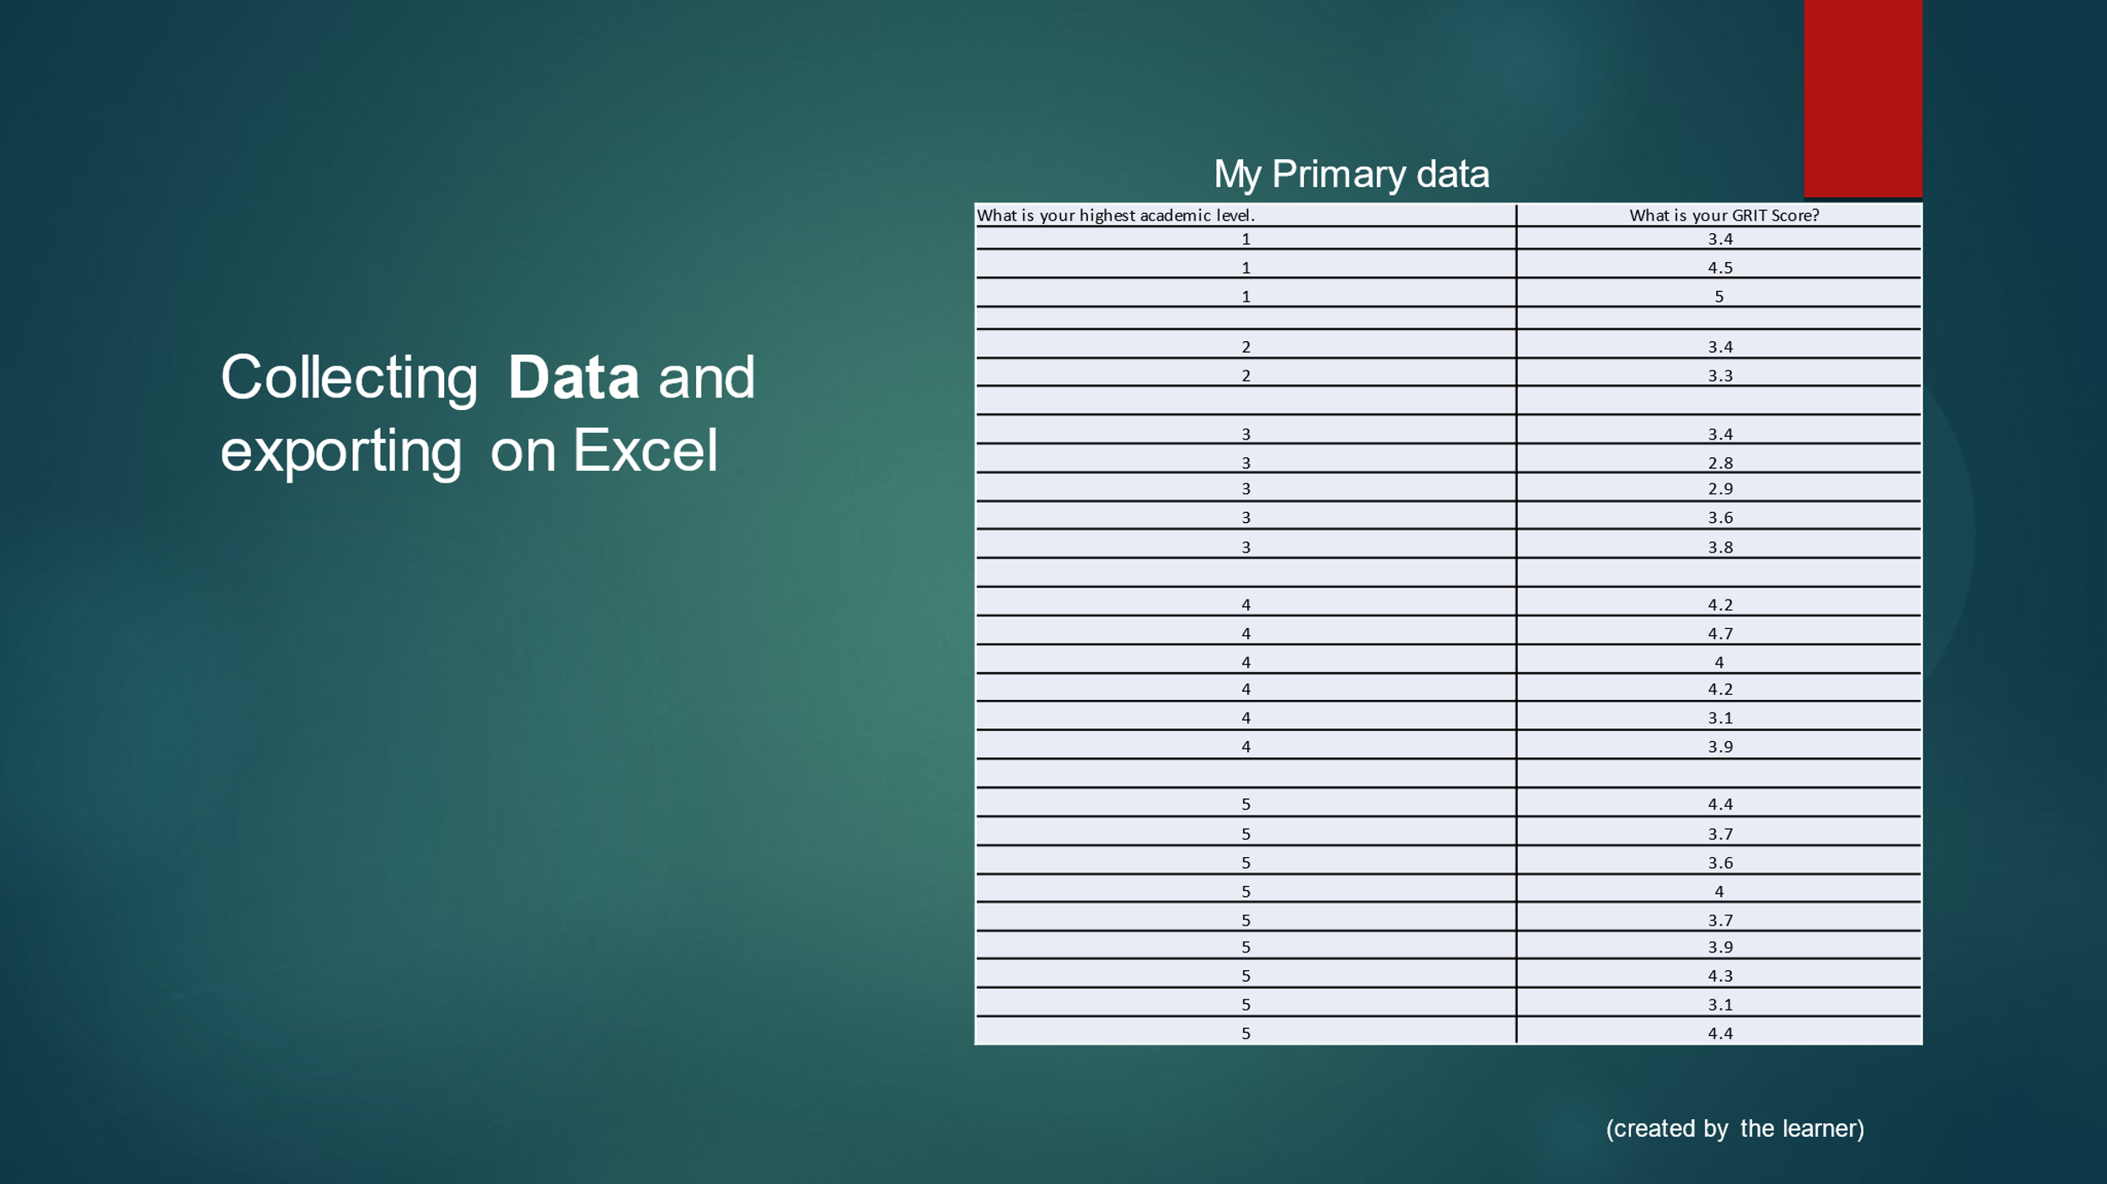
Data are symbols that represent properties of objects, events and their environments. They are products of observation (Ackoff, 1989).
There are quantitative and qualitative data. Data that are considered quantitative can be a result of any study approach. There is various type of quantitative data for example uncomplicated amounts such as frequency of events to more complex data such as test scores, prices or hire expenses. This information needs to be analysed and explained before it can be used and different types of analyses can be done by making tables, diagrams, or other statistics (Saunders, Thornhill, and Lewis, 2015, p. 414).
All non-numeric data is referred to qualitative data. Qualitative data frequently consist of simple list of replies, or questions with open end in a study, and more complicated data like records of detailed discussions. Before they can be used this data must be analysed and the meanings interpreted (Saunders, Thornhill, and Lewis, 2015, p. 480). Secondary data is used to describe type of data that this has been gathered for a different objective. If we collect new data for specific reason that is primary data (Saunders, Thornhill, and Lewis, 2015, p. 256).
After we have learned what is data, we are able to analyze them. The first thing that needs to be done before any analysis can take place is the generation of the data. I used MS Form to prepare a survey with two questions and distributed it online to people to fill it. I asked people “What is the highest academic level?” and “What is tyour GRIT score?”. The answers of the people I sent my survey are quantitative data and signify my primary data. I transferred it to Excel table, part of it is shown on the above slide.

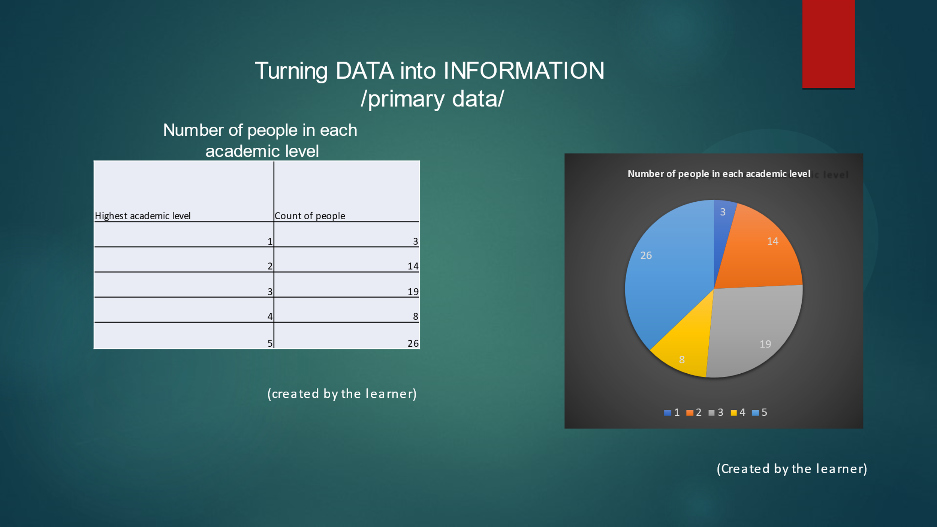
When I follow the steps in the DIKW pyramid I came to the next level of this triangle which is when data is processed and information is produced. To attach meaning to my collected data I process information.
Descriptions provide the information. They contain responses to issues that begin with words like who, what, when, and how many. Data is generated, stored, retrieved, and processed by information techniques. Their administering is frequently numerical or mathematical. Data is used to imply information in both situations (Ackoff, 1989).
Based on the above definition about what information means my understanding is that information can be created by combining data with context and in order to be useful, the data must translate into information. I transferred the results from my inspection to an Excel table. After that, I made another table containing information about the number of people in each academic level for primary data. To see the information clear I made a pie chart using the above table. In the table, I am able to look at just digits. Creating a chart helped me see more clearly the relationship between people at different academic levels. The provided chart indicated that 26 people have academic level 5, 19 people have academic level 3, 14 people have academic level 2, 8 people have academic level 4 and only 3 people have academic level 1. this information on the number of people will be useful to me at the next levels of research.

In summary, a logical collection of data that conveys a message about a certain thing or process is an information.
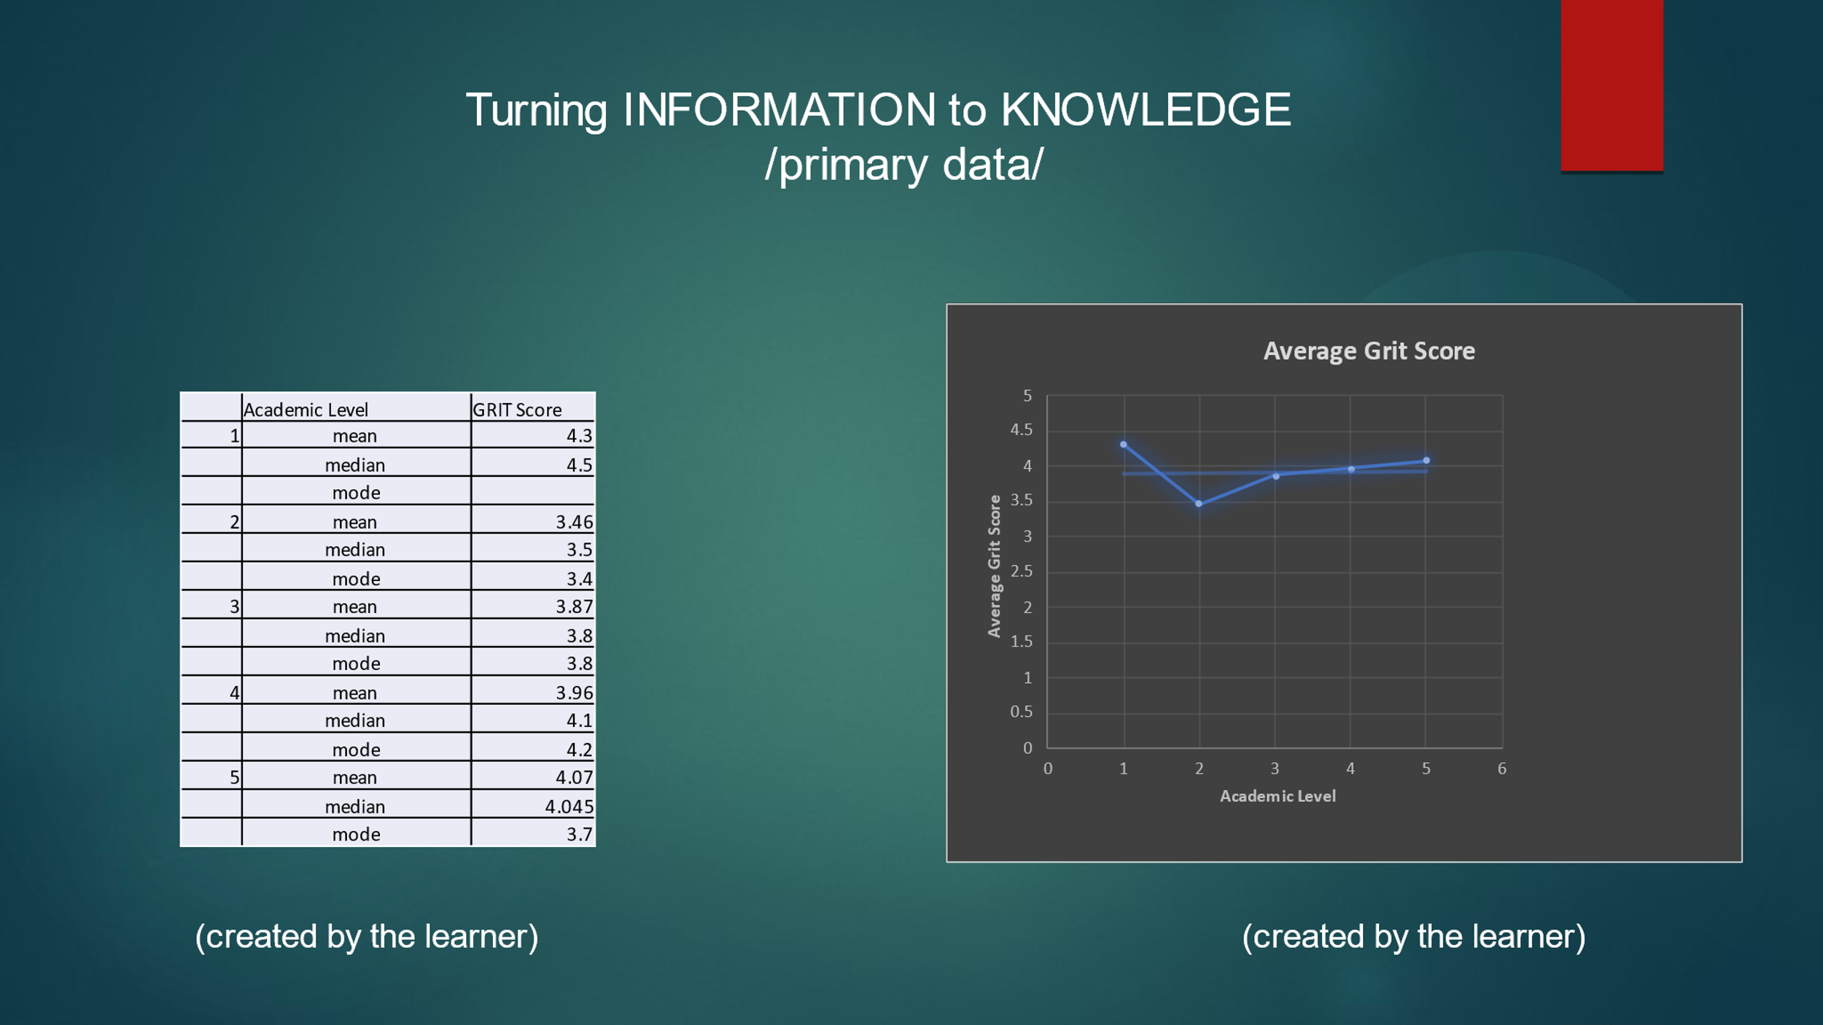
Kowing how a system works is knowledge. The ability to transform into guidelines depends on it (Ackoff, 1989).
I think the contemporary era's heart is knowledge. I believe that whoever holds knowledge has the most power in all fields of life.
After having verified data, the users then need to transform it into usable information. To accomplish this for my assignment, I used Excel to put all my collected primary data into Excel tables and calculated the average GRIT score for each academic level. The next step is to interpret this information, and this will lead us to knowledge. Based on the table I made a scatter chart with information about academic level and average grit score. I put a trend line because it allows me to see that trend is going up. In general, I observe that there is a tendency to increase Grit results with increasing academic level which proves Angela Duckworth’s theory about GRIT.
I see that there is a high grit score for people at level one. To analyze the reason for this I use the previous table with the number of people from each level. It is from there that I can strongly conclude that the number of people interviewed from level one is too low, only 3 people compared to other levels. For some conclusions to be credible, a survey should be conducted among a larger number of people as Angela Duckworth did her research. Another reason that can be pointed out is the possibility that these people did not understand the question correctly.

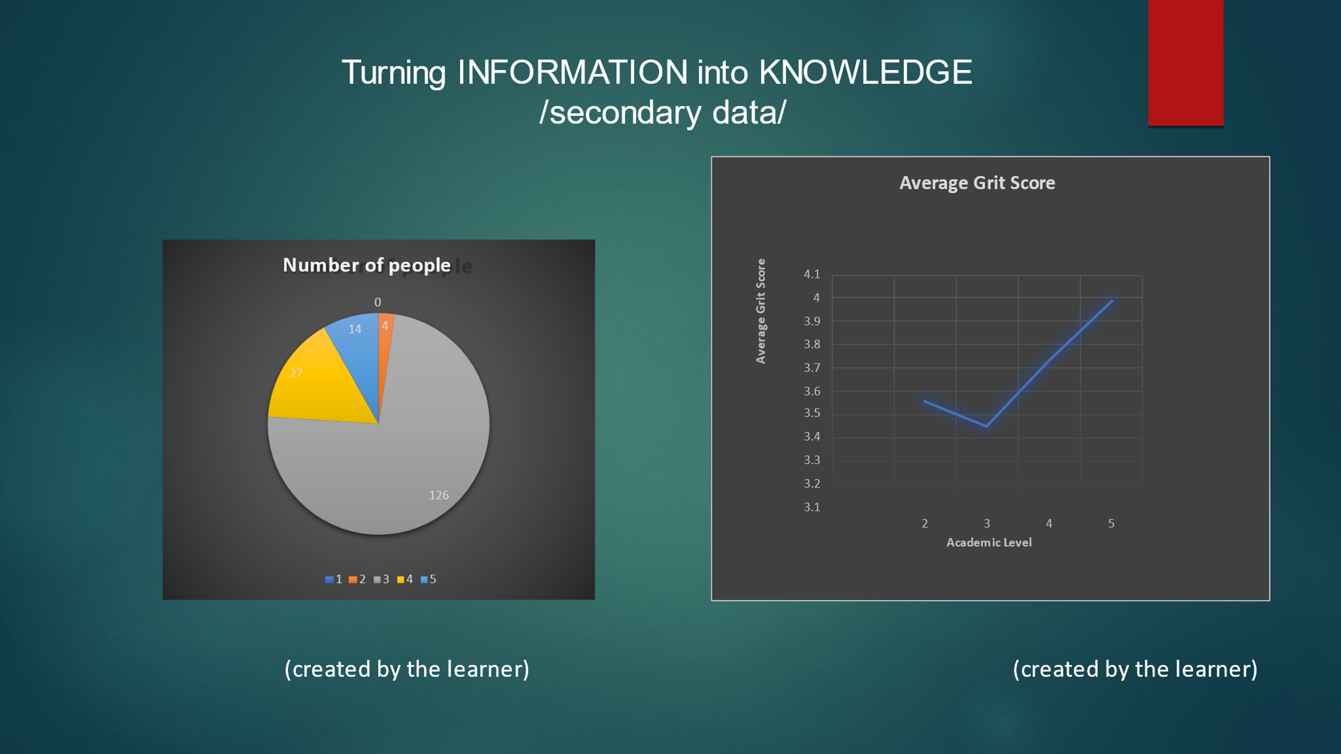
As I mentioned above, we need more data to collect in order to give accurate analysis. That was the reason I need the data collected from the UWTSD as my secondary data. I used Excel to put all my collected secondary data into Excel tables. To see the information clear I made a pie chart about the number of people at each level. I calculated the average GRIT score for each academic level and represented it with a scatter chart. In general, as in the primary data, I observe that there is a tendency to increase Grit results with increasing academic level. This chart also is confirming Angela Duckworth’s talking that if you have a higher level, you will have a higher GRIT score.
I see that there is a high grit score for people at level two. When analyzing the reason for this I use a pie chart with the number of people from each level. The number of people interviewed from level two is too low, only 4 people compared to other levels. I infer that if we gather more data from our participants such as oldness and gender, we will have the right results.
Above all, the relationship between the grits scores and academic level is positive for both types of data and there are other factors affecting the academic level which one can reach.
.


The information I gained from my survey I transformed into knowledge by making charts and tables and that will allow me to make the right interpretations and to lead to the last level of the DWIK pyramid - wisdom.
All of this leads us to believe that wisdom will never be possible to generate as computer systems are constructed to create knowledge information and understanding. Wisdom is the feature that distinguishes humans from robots (Ackoff, 1999). That confirms me that wisdom is purely a human ability and wisdom is the capacity of a person to make significant use of one's information. As a result, knowledge is a portion of wisdom, whereas wisdom is the total. I clearly understood that wisdom demands not just memorizing information but also making sense of them.



By analyzing the results, I achieved the level of wisdom. This allows me to make the right inferences and to increase the effectiveness of my survey. I understand the indication that the increase in grit score increases the academic level one can reach. I added value to my received results by deeply comprehending them.


Ackoff, R. L. (1989) ‘From Data to Wisdom‘, Journal of Applied Systems Analysis, 16, p.3–9
Ackoff, R. L. (1999) Ackoff’s Best. New York: John Wiley & Sons, pp 170 – 172
Blakeslee, Sarah. (2004) ‘The CRAAP Test‘ LOEX Quarterly, 31 (3), p 6-7
Available at: https://commons.emich.edu/loexquarterly/vol31/iss3/40)
Duckworth, A.L. et al. (2007) ‘Grit: Perseverance and Passion for Long-Term Goals’, Journal of personality and social psychology, 92(6), pp. 1087–1101
Kekes, J. (1983). Wisdom, American Philosophical Quarterly, 20(3), 277–286.
Puiu, A. (2017) ‘Grit: The Power of Passion and Perseverance.(Book review)’, International Journal of Applied Behavioral Economics, 6 (3), p. 55-57
Rowley, J. (2007) ‘The wisdom hierarchy: representations of the DIKW hierarchy’, Journal of information science, 33(2), pp. 163–180
Saunders, M., Thornhill, A. and Lewis, P. (2009) Research methods for business students. Fifth edition. New York, New York State: Pearson Education

