Gemma Davies (1707149)
[Email address]
M4X02101

Review of industry skills
Travel and Tourism Industry

Executive summary

This reports will give a brief overview on what skills jobs in the tourism industry require and how important different skills are to the company and the entire industry.

Contents page
Executive Summary
Introduction
Content analysis (skills identified)
Brief summary of findings
Conclusion
References

Introduction
The tourism industry is a fastest and one of the largest industry in the world. According the VisitBritain in 2013 the sector brought in £126.9 billion. It is expected that in 2025 the industry will be worth £257.4 Billions (Visit Britain, 2013). In 2015 the77% of UK visitors were repeat visitors. This goes to show that as a country the UK is doing well to bring in visitors who have already been to the UK. Again, according the VisitBritain repeat visitors are likely to stay longer than what they did the first time which also mean they would be spend more money. In 2013 there were 3.1 million jobs in the tourism sector which comes to a total of 9.6% of jobs in the UK. Since then there are more jobs which have been created in the industry. Included in this report will be key skills which are used in job roles in the industry and how important they are to the job roles.

Content analysis

In the tourism industry there are several different key skills which are needed in all job aspects in the industry. Communication is one of the biggest skills to have when it comes to the tourism industry. When getting a job in the tourism industry exceptional communication skills are vital as most job roles involve talking, helping and working with people of all different kinds of ages, nationalities and temperaments. As a person working and dealing with different people it is important to know how to handle difficult situations and one of the best ways is to have good communication skills, it shows customers that the individual is capable to help to their best ability and the individual will also be able to explain things in a lot of depth. Another one of the biggest stills according to Career Addict is Customer service. Customer service is a skill which takes time to full understand as the individual trying to deliver customer service will need to understand how to meet to needs and expectations of customers. It is all on the individual to ensure everything goes smoothly for customers as they will need to please them. The skill includes empathy and compassion, without these customer service skills will not be performed correctly and it can show customers who have or need a problem dealt with that the individual is unable to help them. Commitment is a big skill to have when joining the tourism industry, when it comes to people joining an airline they will need to understand they then need to be committed and fully flexible. Commitment is also a way to determine if individuals want to succeed. Individuals will need to be on the go all the time and are willing and able to do everything and anything they can to make sure that the job requirements are made and do more than what they need. The tourism industry can be exceptionally demanding which is why it can be very difficult to get a job in the industry. A positive attitude in this industry will help people go a long way. Being positive it can ensure customers that they can trust you and it shows you know what you are doing. A tip to keep the positive attitude is to have your own reward system to help you meet goals and push to succeed.

Brief Summary of findings

The research carried out by the individual shows what requirements and skill are needed for different job roles. Cabin Crew at Virgin Atlantic require a lot of different skills to meet the requirements of the job. Virgin expect their crew to be positive and have excellent communication skills as the individuals are working constantly with passengers who would of paid a lot of money to be on a flight going on holiday. The first people they deal with and are with before their holiday are the cabin crew, as soon as they step on that plane that is when their holiday starts. It is important that the cabin crew are full of enthusiasm and are confidence. Confidence is a huge part when becoming a cabin crew member. When on a long flight the passengers need to feel safe and that they can rely on the staff on board, showing confidence will ensure the passengers that you know what the cabin crew are doing and that they are able to solve issues that arise. Customer service will play a massive part in their job role. It is the cabin crews main priority to ensure that all customer expectations are met and all the passengers are comfortable and are happy on the flight. Virgin Atlantic states that you will need a proven past of delivering irresistible customer service (Virgin Atlantic, 2018). Airport service roles with Virgin Atlantic have a range of different skills needed to meet the requirements to work on a station at the airport. A can do attitude will go a long way with customers and passengers who will be going to your desk to either check in or because they have an issue. All job roles need individuals who have excellent customer service skills as does this job. Airport services include working at a customer service desk. When dealing with passengers who have issues it is important for the individual to ensure that they have empathy and can understand how the passengers are feeling, then it will portray how well the individuals customer service skills are. Another skill set by Virgin Atlantic is a positive attitude. It is the only way issues are going to be solved. With a positive attitude the customer is able to see that the workers know what they are doing, having a positive attitude toward others can ensure that they give you the same attitude back. It is always important to make sure that the customer is always happy and if anything doesn’t go their way the airport service staff are there and able to help to the best of their ability.

Conclusion

Overall key skills in the tourism industry are vital in all jobs that are available. All jobs have specific needs and requirements with skills all included. The biggest and main skill is customer service. It is important that in every job customers are happy with the service. Customer service skills are there to also help the individual in their job role, it can boost confidence as the individual will constantly be learning and adapting how to deal with different people, and can also enhance communication skills as they will constantly be dealing with customers, whether it is selling products, serving passengers on a flight or dealing with issues.

Appendix
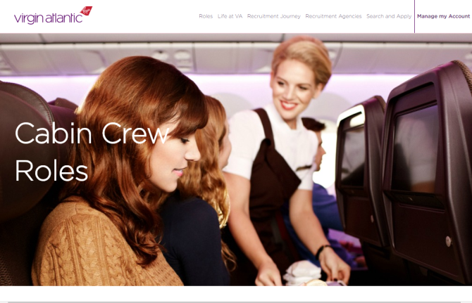

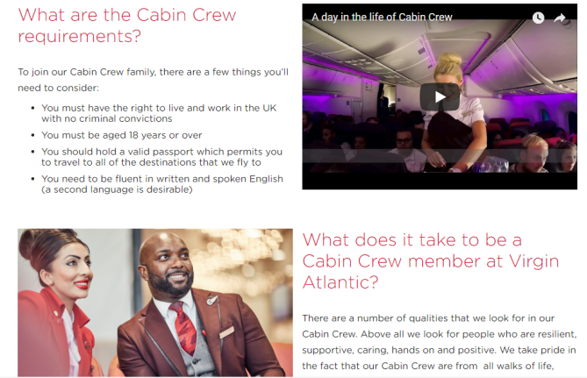

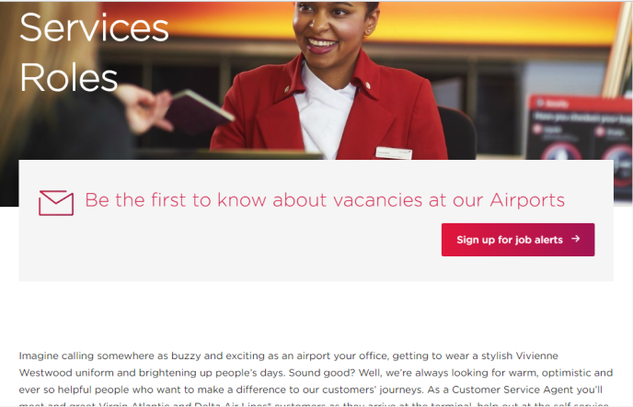

CV
Gemma Davies
10 Dulais Fach Road Tonna, Neath.
SA11 3JW
DOB: 14th October 1997
Telephone: 01639 771099
Mobile Number:07498290010 (preferred to be contacted on)

E-mail: gemma.davies25@hotmail.com
Education:
Primary school: Tonnau Primary School
Secondary School: Cefn Season Comprehensive
Neath Port Talbot College
Personal statement:
I am looking to gain employment in part time work as I am currently studyingInternational Travel and Tourism Management in University. I am a fast learner and an excellent team player. I am always polite and understanding. I'm always willing to help others and have a good sense of communication, being able to speak and work with a variety of people. I also have a strong desire to exceed customer expectations, being able to help willingly any customer to achieve customer satisfaction. I take care of myself to ensure my appearance is up to standard, as I know how important it is for employees to look acceptable on the job. I have had a lot of experience with working with others as I am apart for a Karate club. During the classes I am expected to help children and adults of all ages, I must also communicate with them so that each student understands what I am talking about. I am a very good team player I find it very easy to listen and give feedback to others. One of my strong points is working in a team and working with others. I like working and dealing with others as I feel that it will carry on increasing my confidence. Also working with others gives me a chance to know how to deal and talk to a range of people at any age. As I like to work with others I find that customer service is an essential part to any job as it looks good on the company you work for. As part of my college course I have been taught customer service for two years straight.

Work experience: My placement was in Thomas Cook, Neath. The main skills I learned during my work experience were how to communicate with others and improving on my speaking and listening skills. During the experience I had to work and communicate with the public and deal with different situations.
The things I enjoyed were how I had help off the employees when and if I needed it. They also thoroughly explained what skills I would need if I wanted to go on to become a travel agent.
The thing I least liked about the experience was that I wasn’t able to do as much as I wanted too due the security procedures.
Peacocks- September 2017 – Present
I am currently working in the retail shop Peacocks. I am a sales assistant, I have to deal with customers throughout my shift and to other tasks around the shop which have been set by my manager.
Personal Attributes: I have completed my bronze award Duke of Edinburgh. I attend Karate regularly and I attend competitions all over the over the UK representing the Country.
My key skills
- Reliable
- Excellent at time keeping
- Enthusiastic
- Punctual
- Bubbly personality
- Willing to learn new skills
- Always positive
- Team player

Education: I went to Cefn Saeson Comprehensive School September 2009 – June 2014.
GCSE results.
Subject | Grade
Maths | C
English | C
Science | D
Welsh | C
R.E | B
Child Development | C
Geography | D
Welsh Baccalaureate | Pass

REFERENCES;
Referee 1: Beverley Watkins
Lecturer Travel & Tourism
Neath Port Talbot College SA10 7RF
01639 648000

Referee 2: Tina Williams
Deputy head of Business and Travel & Tourism
Neath Port Talbot College SA10 7RF
01639 648000

References
VisitBritain, (2013),Britains visitor economy facts.’ [Online]. Available: https://www.visitbritain.org/visitor-economy-facts . [2018, April, 28th]
Karrea, M. (2015), ‘Top ten Skills needed for a job in hospitality’ [Online]. Available: https://www.careeraddict.com/top-10-skills-needed-for-a-job-in-hospitality [2018, April, 28th]
Virgin Atlantic (2018), ‘Cabin Crew’ [Online]. Available: https://careersuk.virgin-atlantic.com/customer-services/cabin-crew [2018, April, 28th]
Virgin Atlantic (2018), ‘Job advertisement’ [Online]. Available https://careers.virgin-atlantic.com/fe/tpl_virgin01.asp?newms=jj&id=137826& [2018, April, 28th]
Virgin Atlantic (2018), ‘The World’s your oyster.’ [Online]. Available: https://careersuk.virgin-atlantic.com/ [2018, April, 28th]
Trained for Tourism (2018) ‘which skills do I need for a career in tourism’ [Online]. Available: http://trainedfortourism.org.mt/news.aspx?nid=44 [2018, April, 28th]
Department of environmental affairs and tourism, (2007). ‘Skills in tourism and sport’
Kozak, M. (2016), Tourism and Hospitality Management, Emerald, Bingley

