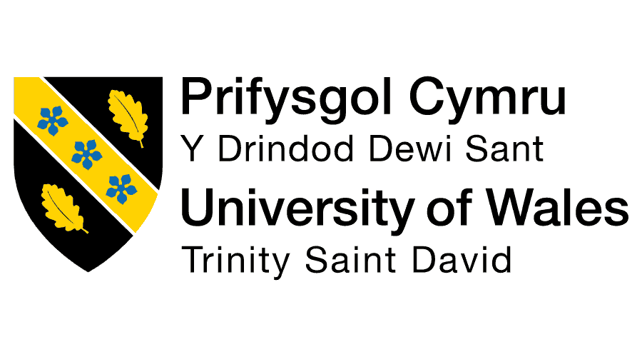
Assessment 1

Name: Anika Ayub
Student ID: 2504343

Module Name: Human Capital Management
Module Code: LCMB7023

Lecturer’s Name: Gladius Kulothungan (London)

Word Count: 2433

Term 1

Table of Contents

1.1 Introduction 03
1.2 How technology is reshaping labour markets .......................................................03
1.3 Example of Marks & Spencer ...............................................................................04
1.4 Implications for HRM and IHRM strategies .........................................................04
1.5 Figure: Share of business tasks performed by machines .......................................05
2.1 Introduction ...........................................................................................................05
2.2 Demographic Factors and Their Influence on Employment Markets ...................05
2.3 Geopolitical Factors and Their Influence on Employment Markets .....................06
2.4 Figure — Workforce Composition by Generation ................................................07
3.1 Introduction ...........................................................................................................07
3.2 The Growing Skills Gap and Its Implications .......................................................08
3.3 Strategic HRM Approaches to Closing Skills Gaps ..............................................08
3.4 Figure — Global Workforce Skills Gap by Sector (2023) ....................................10
4.1 About me ...............................................................................................................10
4.2 Technology ............................................................................................................10
4.3 Communication .....................................................................................................11
4.4 Teamwork ..............................................................................................................11
4.5 Leadership .............................................................................................................12
4.6 Self-Directed Learning ..........................................................................................12
Bibliography ................................................................................................................13

1.1 Introduction
Technology is changing work fast. For HR managers, tools such as artificial intelligence (AI), automation, and digital platforms are no longer optional. (Deloitte, 2023). Today these things are shaping how people are being hired, trained, managed and kept in any organisation. Good use of these technologies helps organisations be quicker, fairer and more data-driven. At the same time, HR teams must manage ethical risks, data privacy and the human side of change. In short, today’s HRM needs tech fluency to stay useful and strategic.
1.2 How technology is reshaping labour markets
AI and automation are changing the kinds of tasks people do. Routine, repetitive tasks in manufacturing, admin and some customer service roles are increasingly automated. That means some jobs shrink or change, while new roles (AI trainers, data specialists, digital service designers) grow (World Economic Forum, 2023). Businesses are also using automation to speed up hiring and on-boarding: CV screening, chatbots for candidate queries, and online assessments make recruitment faster and more scalable (WEF, 2023).
Digital platforms widen the talent pool. Sites like LinkedIn, specialist job boards and gig platforms let employers find talent globally and hire remote or freelance workers. This increases choice but also raises competition and complexity for HR: pay parity, cross-border contracts and compliance become harder to manage. At the same time, remote work technologies (video calls, collaboration suites) have made many roles location-independent, reshaping where talent lives and how organisations plan workforce supply (McKinsey, 2021).
AI augments decision-making, and brings risks. Predictive analytics can help HR forecast turnover, spot skill gaps and target learning. But algorithmic hiring tools can entrench bias if they are trained on flawed data, and they raise questions about transparency and fairness. Regulators and unions are increasingly watching how AI is used in people's decisions (McKinsey, 2021).

1.3 Example of Marks & Spencer (Recruitment & HR during COVID-19)
Marks & Spencer (M&S) shows how tech and HR practices blended during the pandemic. Early in COVID-19 M&S used furlough, redeployed store staff into logistics and online fulfilment, and adjusted rostering to match online demand (M&S annual report 2020). When remote hiring and digital onboarding became necessary, M&S relied on online systems to manage recruitment and training while also offering wage support and redeployment where possible (M&S AR 2020). This approach showed how digital tools help keep hiring and workforce planning flexible in a crisis, but also highlighted the need for human judgement and welfare support alongside tech solutions.
1.4 Implications for HRM and IHRM strategies
- Invest in up-skilling and re-skilling: HR must prioritise continuous learning, focusing on digital and AI skills to move employees into higher-value roles (WEF, 2023).
- Adopt ethical AI governance: set rules for transparency, fairness and human oversight when using AI for hiring or performance management (McKinsey, 2021).
- Build flexible workforce models: combine permanent, remote and gig talent; redesign contracts and HR policies for cross-border work (WEF, 2023).
- Strengthen HR data capabilities: HR teams need analytics skills to interpret workforce data and inform strategic decisions.
- Keep the human touch: use tech to scale the routine, but retain human support for wellbeing, complex decisions and culture-building (M&S example).
Technological change offers big productivity and talent opportunities for organisations, but it also brings ethical, legal and social challenges. Effective HRM and IHRM will combine digital tools with strong governance, continuous learning and a clear focus on people’s welfare to succeed.
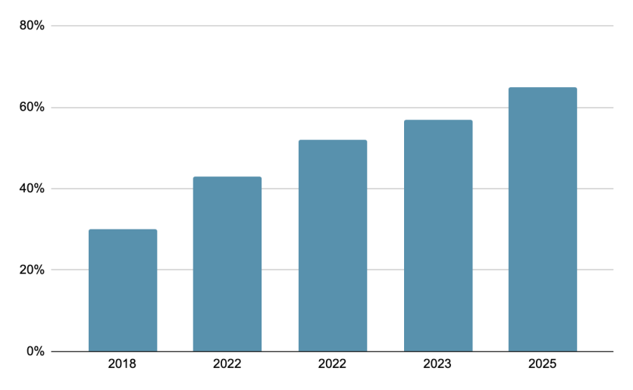
1.5 Figure: “Share of business tasks performed by machines (global average)”
The chart shows the percentage of tasks by machines in different years.
Source: World Economic Forum (2023), The Future of Jobs Report 2023.
2.1 Introduction
In today’s fast-changing world, demographic and geopolitical factors play a vital role in shaping how organisations manage their people. Demographic factors such as age, gender, and cultural background influence workforce composition, while geopolitical events like wars, trade disputes, and global migration impact where and how people work. For Human Resource Management (HRM), understanding these changes is essential to building a stable, inclusive, and adaptable workforce (Dessler, 2020). The mix of different generations—Generation X, Millennials, and Generation Z—in the workplace has also created new challenges for HR teams trying to meet varying expectations and working styles.

2.2 Demographic Factors and Their Influence on Employment Markets
Demographic changes have reshaped modern employment markets in major ways. One of the biggest shifts is the multi-generational workforce. Generation X (born 1965–1980) values job security, structure, and clear leadership. They grew up before the digital revolution and often prefer in-person communication and steady career paths (Armstrong and Taylor, 2020). Millennials (born 1981–1996) tend to seek purpose-driven work, flexibility, and career growth opportunities. They embrace digital tools and value work-life balance over traditional job stability (Deloitte, 2023). Meanwhile, Generation Z (born 1997–2012) is entering the workforce with a strong desire for flexibility, inclusion, and mental health support. They are tech-savvy and prefer hybrid or remote working setups (McKinsey & Company, 2022).
These differences have created both opportunities and tensions in workplaces. HR professionals now face the challenge of designing inclusive policies that appeal to all age groups. For example, offering hybrid work models and diverse learning options can attract younger employees, while stable benefits and structured roles may retain older workers. A “one-size-fits-all” approach to employee engagement no longer works (Beardwell and Thompson, 2017).
Another demographic issue is ageing populations in developed economies like Japan, Germany, and the UK. With more people retiring and fewer young workers entering the job market, organisations face labour shortages and must rethink talent strategies (OECD, 2023). In contrast, emerging economies such as India and Nigeria have young and fast-growing populations, providing both opportunities and pressure for job creation. This imbalance means HR teams must plan for international recruitment, workforce mobility, and global talent management.

2.3 Geopolitical Factors and Their Influence on Employment Markets
Geopolitical issues such as wars, global trade shifts, and political instability also affect labour markets. For example, the Russia–Ukraine conflict disrupted industries and supply chains, forcing companies to relocate staff and rethink hiring strategies in Europe (ILO, 2023). Similarly, trade tensions between the United States and China have influenced where companies manufacture products and hire workers. Many tech firms are now expanding operations in India and Southeast Asia to reduce risk (World Bank, 2024).
For HR professionals, these geopolitical shifts bring complex challenges:
- Managing cross-border teams with different labour laws and cultural expectations.
- Ensuring employee safety and support during crises.
- Dealing with talent migration and remote work compliance across countries.
In addition, HR must navigate cultural diversity while promoting inclusion and ethical leadership. International HRM (IHRM) now requires not just policy management but also political and cultural awareness.
Demographic and geopolitical factors are reshaping how HR professionals manage people around the world. The differences in mindset between Gen X, Millennials, and Gen Z highlight the need for flexible and inclusive HR policies. Meanwhile, global political changes and conflicts demand strategic workforce planning and risk management. For HR to succeed, it must stay adaptable, understand employee diversity, and anticipate global changes that affect work and people.
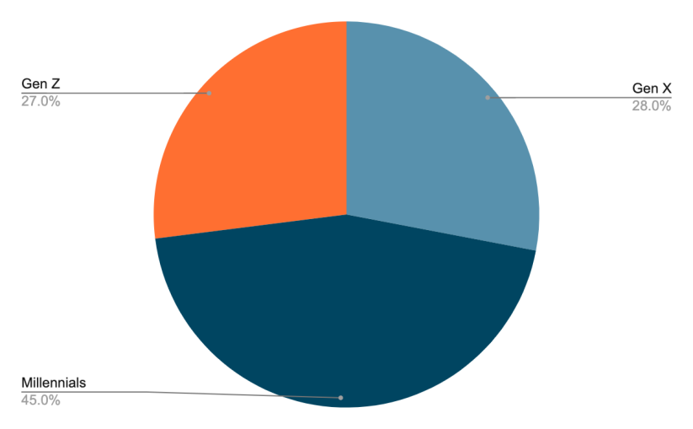

2.4 Figure: Workforce Composition by Generation (Global, 2024)
The pie chart shows the percentage of Global Workforce among different generations.

Source: Deloitte (2023), Global Human Capital Trends 2023: Navigating the Generational Shift. Deloitte Insights.

3.1 Introduction
In today’s competitive job market, having the right mix of hard and soft skills is more important than ever. Hard skills like data analysis, programming, and technical expertise help employees perform specific job tasks, while soft skills such as communication, adaptability, and teamwork make them effective in dynamic workplaces (Armstrong and Taylor, 2020). Many industries — especially technology, hospitality, and healthcare — are facing ongoing skills shortages, creating challenges for HR professionals who must recruit, train, and retain qualified talent. Companies like AVEVA, a global industrial software firm, have started to address these gaps by combining digital upskilling programs with employee development strategies. This approach shows how strategic HRM can bridge the skills gap and support sustainable business growth.

3.2 The Growing Skills Gap and Its Implications
The rapid pace of technological change is one of the main reasons behind skills shortages. As automation, AI, and digital systems reshape industries, new skill requirements emerge faster than workers can adapt (World Economic Forum, 2023). In the technology sector, companies struggle to find talent with advanced digital, cybersecurity, and data analytics skills. In healthcare, ageing populations have increased demand for medical professionals, while hospitality faces shortages in service and management staff due to changing customer expectations post-COVID (OECD, 2023).
These shortages affect not only productivity but also innovation and customer satisfaction. HR managers now face the challenge of identifying future skills, developing internal talent pipelines, and reducing reliance on short-term hiring. Dessler (2020) explains that strategic HRM must integrate workforce planning, learning, and performance management to ensure long-term skills development.

3.3 Strategic HRM Approaches to Closing Skills Gaps
- Upskilling and Reskilling Initiatives
Continuous learning is now essential for all industries. Companies like AVEVA have introduced internal learning platforms and partnerships with universities to help employees upgrade their technical and leadership skills. During the pandemic, AVEVA launched a digital learning hub offering on-demand training in AI, data science, and software engineering (AVEVA, 2023). This helped the company fill internal skill gaps while improving employee engagement.
- Strategic Workforce Planning
HR professionals use data analytics to forecast skill needs and align recruitment strategies accordingly. For example, in healthcare, workforce planning helps identify future shortages in nursing or specialised roles, allowing training programs to start early (McKinsey & Company, 2022).
- Collaborations and Public–Private Partnerships
Organisations can partner with governments, universities, and online education platforms to create talent pipelines. In the tech industry, collaborations with platforms like Coursera and LinkedIn Learning have become common for offering short digital certifications.
- Employer Branding and Employee Value Proposition (EVP)
HR strategies now focus on making organisations attractive to skilled professionals. Flexible work policies, learning opportunities, and inclusive cultures can help retain talent. In hospitality, for instance, companies that offer clear career progression and recognition tend to reduce turnover rates (Deloitte, 2023).
- Fostering Soft Skills and Adaptability
While technical expertise remains important, HRM also focuses on developing adaptability, emotional intelligence, and teamwork. AVEVA’s leadership programs combine technical and behavioural skill development, preparing employees for hybrid and global work environments (AVEVA, 2023).
Addressing the global skills gap requires a proactive and long-term HRM approach. Companies like AVEVA show that combining internal training, technology partnerships, and employee-focused development creates a strong and future-ready workforce. By aligning talent management with strategic business goals, HRM can help organisations remain competitive while ensuring employees have the right balance of technical and human skills.

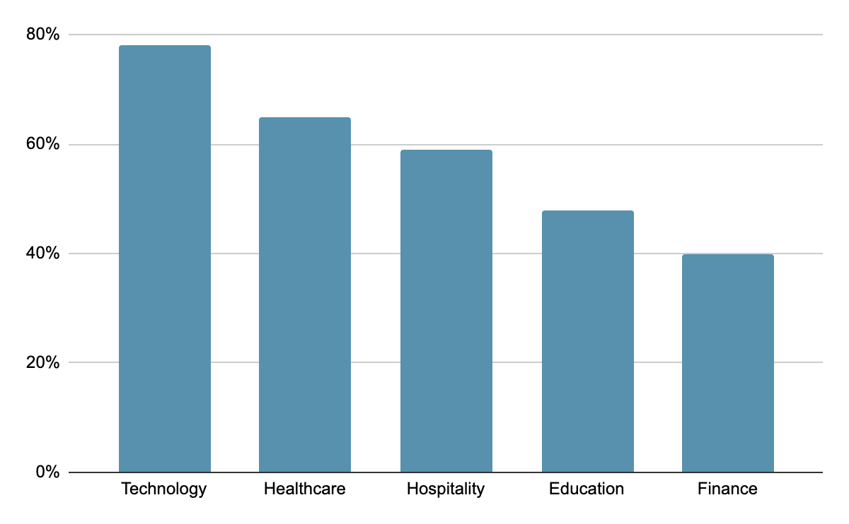

3.4 Figure — Global Workforce Skills Gap by Sector (2023)
The chart shows the percentage of Employers Reporting Skill Gaps among different industries.
Source: World Economic Forum (2023), The Future of Jobs Report 2023. Geneva: WEF.
4.1 About me
My name is Anika Ayub, currently pursuing an MBA in International Business at the University of Wales Trinity Saint David and I have worked as the Deputy Marketing Manager at Interactive Cares. With over three years of experience in marketing and public relations, I have worked in diverse, multicultural settings across Bangladesh and now the UK. These experiences have helped me grow in areas such as technology, communication, teamwork, leadership, and self-directed learning.
These are the skills that are essential for working effectively in an international environment (Armstrong and Taylor, 2020).

4.2 Technology
Technology has been central to my professional growth. I have used digital marketing tools such as Canva, CapCut, MS Office, and Asana for project management and campaign design. During my role at Interactive Cares, I coordinated several digital campaigns using analytics and automation tools to target international audiences. These experiences strengthened my digital adaptability, a key capability in today’s global workforce (Dessler, 2020).
However, one area I need to improve is data analytics for performance measurement. While I am confident in creative tools, I aim to develop deeper analytical skills using tools like Google Analytics and Power BI to make data-driven marketing decisions.

4.3 Communication
Having a background in Public Relations, I developed strong written and verbal communication skills. I managed press releases, digital content, and stakeholder communication for events such as Career Fair 3.0 and the PR Summit. Working with international partners and local clients taught me to adapt my tone and communication style across different cultural contexts (Hofstede, 2011).
My main communication strength is clarity and empathy — I always aim to make others feel heard. However, I still need to work on managing communication across time zones and virtual platforms, which can sometimes cause delays or misunderstandings in international projects.

4.4 Teamwork
Throughout my professional and academic life, I have worked in teams with diverse backgrounds. At Interactive Cares, I collaborated with cross-functional teams — designers, developers, and business strategists — to deliver marketing campaigns. I enjoy teamwork because it encourages creativity and shared responsibility. Research shows that diverse teams often perform better due to varied perspectives (Katzenbach and Smith, 2015).
Still, I sometimes struggle with delegation, preferring to take on multiple roles to ensure project quality. Moving forward, I plan to strengthen my trust and delegation skills by applying project management frameworks such as RACI models for clearer role division.

4.5 Leadership
My leadership journey started as Head of Marketing for Idea Innovation 5.0 and continued through my role as Deputy Marketing Manager. These experiences taught me how to guide teams, manage pressure, and align goals with organisational vision. I practice a transformational leadership style, focusing on motivation and shared learning (Northouse, 2018).
However, I have noticed that in international contexts, leadership requires greater cultural sensitivity. I aim to enhance my cross-cultural leadership competence through global networking, online leadership courses, and continued reflection.

4.6 Self-Directed Learning
I am a proactive learner who enjoys taking responsibility for my growth. Completing training programs in Social Media Marketing, Basic Graphic Design, and Meditation has helped me maintain both technical and mental balance. According to Knowles’ theory of andragogy (1984), adult learners thrive when they direct their own learning — a principle I try to follow.
Nonetheless, I sometimes find it challenging to balance work, study, and personal development. To improve, I plan to set structured learning goals and track my progress through reflection journals and feedback from mentors.

Overall, my international work and study experiences have built a strong foundation in technology, communication, teamwork, and leadership. My main strengths are adaptability, creativity, and collaborative communication. However, I need to improve my analytical, delegation, and cultural leadership skills. By combining ongoing learning with international exposure, I hope to become a well-rounded marketing professional capable of leading diverse teams in a global environment.

Bibliography
Armstrong, M. and Taylor, S. (2020) Armstrong’s Handbook of Human Resource Management Practice. 15th edn. London: Kogan Page.
AVEVA (2023) Sustainability Progress Report 2023: Building Skills for the Digital Future. Available at: https://www.aveva.com (Accessed: 9 November 2025).
Beardwell, J. and Thompson, A. (2017) Human Resource Management: A Contemporary Approach. 8th edn. Harlow: Pearson Education.
Deloitte (2023a) Global Human Capital Trends 2023: Navigating the Generational Shift. London: Deloitte Insights. Available at: https://www2.deloitte.com (Accessed: 9 November 2025).
Deloitte (2023b) 2023 Global Human Capital Trends: New Fundamentals for a Boundaryless World. Available at: https://www2.deloitte.com/global/en/pages/human-capital/articles/global-human-capital-trends.html (Accessed: 11 November 2025).
Dessler, G. (2020) Human Resource Management. 16th edn. Harlow: Pearson Education.
Hofstede, G. (2011) Culture’s Consequences: Comparing Values, Behaviors, Institutions, and Organizations Across Nations. 2nd edn. Thousand Oaks, CA: Sage Publications.
International Labour Organization (ILO) (2023) Global Employment Trends 2023. Geneva: ILO.
Katzenbach, J.R. and Smith, D.K. (2015) The Wisdom of Teams: Creating the High-Performance Organization. Boston: Harvard Business Review Press.
Knowles, M. (1984) The Adult Learner: A Neglected Species. 3rd edn. Houston: Gulf Publishing.
Marks & Spencer (2020) Annual Report and Financial Statements 2020. London: Marks & Spencer Group plc. Available at: https://corporate.marksandspencer.com (Accessed: 3 November 2025).
McKinsey & Company (2021) The Future of Work after COVID-19. McKinsey Global Institute. Available at: https://www.mckinsey.com (Accessed: 3 November 2025).
McKinsey & Company (2022a) The Future of Work and Skills. McKinsey Global Institute. Available at: https://www.mckinsey.com (Accessed: 9 November 2025).
McKinsey & Company (2022b) What Gen Z Wants from Work, Travel, and Life. McKinsey Global Institute. Available at: https://www.mckinsey.com (Accessed: 9 November 2025).
Northouse, P.G. (2018) Leadership: Theory and Practice. 8th edn. Thousand Oaks, CA: Sage Publications.
Organisation for Economic Co-operation and Development (OECD) (2023) The Future of Skills and Work 2023. Paris: OECD Publishing.
Personnel Today (2020) ‘Furlough in action: BDO, Renault, Paddy Power, Hogan …’, Personnel Today, 17 April. Available at: https://www.personneltoday.com (Accessed: 3 November 2025).
World Bank (2024) World Development Report 2024: Labour and Globalization in Transition. Washington, D.C.: World Bank.
World Economic Forum (2023) The Future of Jobs Report 2023. Geneva: World Economic Forum. Available at: https://www.weforum.org (Accessed: 3 November 2025).

