History and Theory Modernism essay Hugo Worthington(2200679)
Villa Savoye

Villa Savoye was built between 1928 and 1931 which was a period influenced by Art Deco. Art Deco was known for its geometric simplistic shapes, use of man-made materials and cubist reference. The Villa was designed in the modernist and international style, a style used exclusively by Le Corbusier in his other designs. The building is situated in Poissy, which is on the outskirts of Paris. The building is sited on an area surrounded by trees. Le Corbusier wanted there to be a contrast between the building and its surroundings, primarily to stand out from the environment and then through integration of nature into the building. It was designed by Le Corbusier in 1927 which incorporates the five points of new architecture into the design, these included pilotis, an open floor plan, a roof garden, large open facades and long windows (Les Coleurs, 2020).
The building was originally designed as a weekend holiday home for the Savoye family and was the last in his series of modernist villas. Le Corbusier in recent years before Villa Savoye designed some other villas in the same modernist style. These villas include the Weissenhof and the villa Stein in 1927, both using very similar elements by Le Corbusier for example the long clear facades, pilotis and the prefabricated reinforced concrete construction.

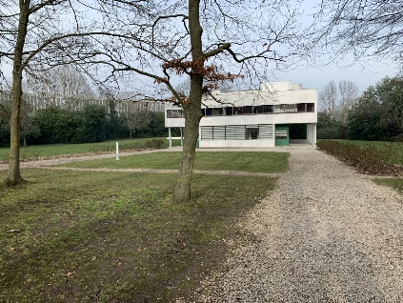
When designing the Villa Savoye plan Corbusier used one of his five points of new architecture, an open floor plan. To save space and have a more open plan he did not use structural walls within the house like most houses built at the time. In order to keep the rooms unconfined by the limitations of structural walls he placed structural columns in a grid to support the structure. This allowed the rooms to be set out more freely and have varying shapes and gives the inside of the Villa the effect Le Corbusier wanted.
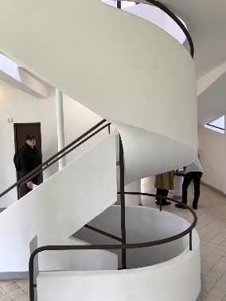
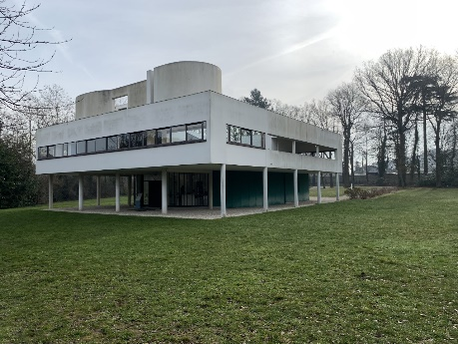
The front of the building as you approach the drive is a clear façade showing the long windows of the ground and first floor, the drive curves underneath the building with pilotis on the outside supporting the above first floor which leads to a garage at the side of the house. The front door is on the other side of the open façade of the house approaching the drive, as you would park in the garage and enter through there. Upon entering the villa the first things you notice are the ramp leading to the first floor and the spiral staircase which leads to first and second floors and in-between them pilotis and a sink placed in an open area underneath the ramp around the rooms for the laundry and maids room. A sink is used in the entrance area of the house in order to wash and cleanse yourself before entering the villa. Up the ramp to the first floor you end up facing the entrance to the living room with the spiral staircase on the right and down the corridor there is the bedrooms.
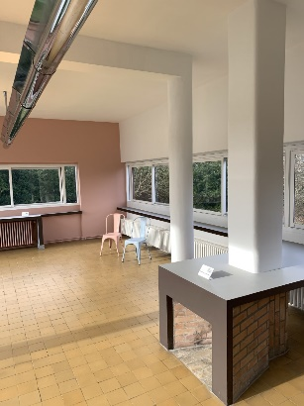
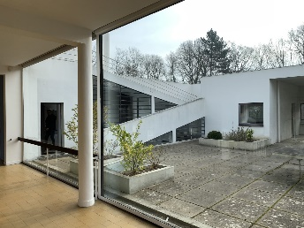
The living room is a very large room with Corbusiers long window running along it in order to view outside and see the surrounding views. The living room also opens into a terrace area which you can access either by opening the large moving windows or enter through the door after the ramp. In the open terrace area above the garage there is a table and a skylight, the ramp for the second floor access is also available on the terrace. Viewed from the terrace you can see how Le Corbusier was inspired by cruise ships as the ramps profile resembles a cruise ships railings and platforms. All of the Living room area and terrace give the first floor of the villa a very open feel as you can see through a lot of the surrounding rooms and have a view of the surrounding area looking out through the long windows stretching the length of the rooms. The main bedrooms and bathrooms on the first floor are accessible when you turn around after exiting the ramp and are in a arranged in a slightly cramped way, the awkward shape of the area to get to these rooms means the column placed makes you feel cramped and uncomfortable. The small bathroom and bath in next room are strangely placed with the master bedroom connected as you have to walk past the bath to access it. This design aspect of the first floor makes it feel disconnected to the rest the first floor as it appeared to be so open previously. The corridor you access immediately after coming up the spiral staircase, however, seems to be spaced out and connected very well as there are two bedrooms with a bathroom which is easily accessible for both of them, and along with the long windows that are in all room it makes the area feel much more open.
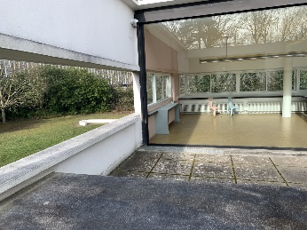
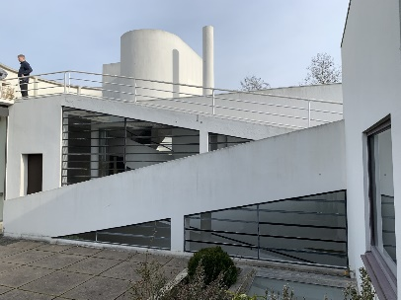
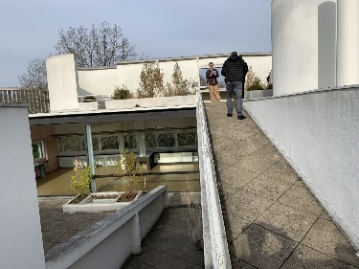
The third floor, an open roof garden and terrace is accessible either by a ramp present on the first floor terrace or the spiral staircase contains the roof garden and a small table where there is a smaller window to view the surroundings from the open garden. The roof garden is surrounded by some concrete walls which don’t encapsulate the entire area but make it seem as if its been shrunk and so the effect of having the open area on the second floor is slightly ruined. Corbusier also includes a number of skylights which are visible on the second floor and feel intrusive to the supposed open floor plan of the villa.

Villa savoye is comprised of reinforced concrete and plastered masonry. The use of reinforced concrete was a very common construction method in the 1930s especially in international style and modernist style (archeyes.com, 2020). The way that the Villa Savoye, though, did cause complications and issues that the Savoye family noticed and complained about directly to Le Corbusier. Madame Savoye wrote a letter to Corbusier stating:

"It's raining in the hall, it's raining in the ramp, and the wall of the garage is absolutely soaked. What's more, it's still raining in my bath- room, which floods every time it rains”
(Madame Savoye in a letter, September 6 1937)

These problems had apparently been happening in the villa even as early as 1930 when the Savoye family first started using it and the problems persisted as The Savoye family did not want to pay the 80,000 euros that would have been necessary to pay to fix these issues. Because of this they never used or visited the Villa again after May of 1940 after they had one final trip before abandoning it entirely.
The materials were chosen by Le Corbusier because they were mostly prefabricated concrete and so easily fit in with his design as he didn’t deal with too many curves in the main structure of the building. The plastered masonry helps the building achieve the right effect that Corbusier wanted to achieve especially in the open facades and long windows allowing for all of the walls of the villa to be a consistent colour and material. Corbusier even uses a combination of rough and smooth surfaces to allow you to feel the building aswell as use it, allowing you to be immersed into the experience of the inside of the villa.

The main ideas that underpinned the design of the building were the five points of new architecture by Le Corbusier which are pilotis, roof garden, long windows, roof garden and open facades. Le Corbusier introduced these in order to be used in modern architecture in the design of his future buildings and were used by architects for buildings until the death of modern architecture in 1972 with the destruction of the Pruitt Igoe buildings stated by Charles Jencks.
The Villa Savoye is an extremely influential statement of modern architecture, as one of Le Corbusiers most famous buildings it influenced the architectural world and future designs of his and others. Le Corbusiers aim for Villa Savoye was to create a machine for living, a building that was not restricted by traditional building techniques and created a building with a completely unique new set of rules and the Villa although it had a lot of problems to do with the construction met all of Corbusiers aims.

Les Coleurs (2020 ) Les Coleurs: le Corbusier. Available at: https://www.lescouleurs.ch/en/the-colours/le-corbusier#:~:text=The%20design%20principles%20include%20the,a%20radical%20change%20in%20architecture. Accessed:

archeyes.com. (2020). The Villa Savoye by Le Corbusier: A Modenist Iconic House ‣ ArchEyes. [online] Available at: https://archeyes.com/the-villa-savoye-le-corbusier/#:~:text=Le%20Corbusier%20used%20reinforced%20concrete.

Murphy, K.D. (2002) ‘The Villa Savoye and the Modernist Historic Monument’, Journal of the Society of Architectural Historians, 61(1), pp. 68–89. Available at: https://doi.org/10.2307/991812.

All Images: Hugo Worthington, 17/2/23

