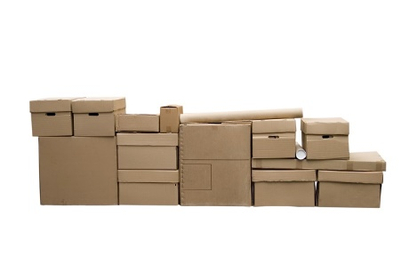
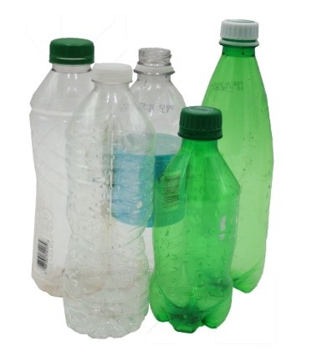
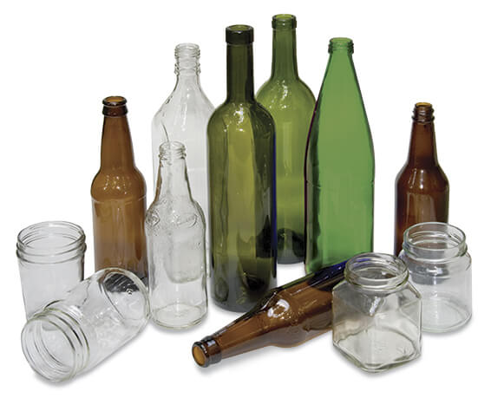
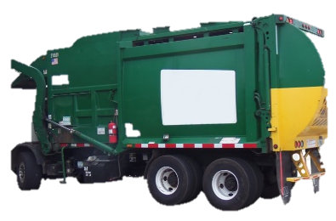
Where does your recycling really go?
A Global Challenge for Business
Nicola Bragg, 1910223, Global Business Challenges, BMSP4001

[4]
[1]
[3]
[2]
For many years we’ve been told to recycle hundreds of different materials, still the main one’s are glass, cardboard, and plastic in domestic waste. We put our recycling into the designated bins for the rubbish men to collect and then it’s gone from our lives forever, but what journey does it take once it leaves our street? Where does it end up? Firstly, we need to find out where do these products come from?
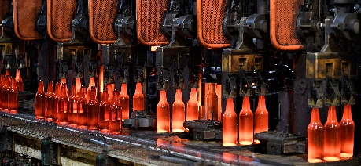
Glass production Owen-Illinois Inc. [5]

I GLASS I
Raw materials are collected by manufacturers examples are cullet, limestone, soda ash, and silica sand these are mixed together and sent to the furnace to be melted. The heater reaches temperatures of around 1565°C turning the concoction into liquid molten, next the product is cooled and snipped into gobs. These gobs enter the forming machinery and are blown into containers, immediately after annealing commences it is the process where containers are re-heated in lehr ovens and slowly cooled. The finish product is inspected, packed and shipped to the needed retailer. [6]

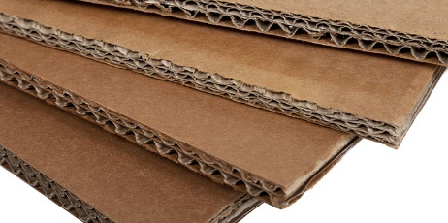
The packing site, cardboard layers. [7]
I CARDBOARD I
A huge roll of partially recycled paper is fed through ridged rollers, where hot steam is blasted to develop the waves needed for the middle layer, the flute. A glue consisting of mainly water and starch is lightly pasted upon one side so the flat sheet of partially recycled paper can be connected, the process repeats for the opposite side. If more strength is needed more layers are added, these sheets are cut into the desired sizes, and made into boxes of all shapes and colours. [8]
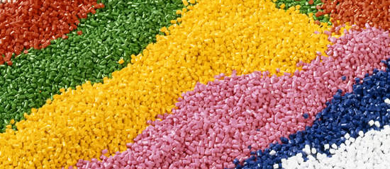
Plastic Pellets. [9]
I PLASTIC I
Plastic is derived from fossil fuels, crude oil and natural gas. The petroleum chemical industry which consists of companies like Dial Chemical, Chevron, and Exxon Mobil, take these basic ingredients and combine them with other chemicals to create a resin. Other companies take the resin and turn them into usable plastic pellets or flakes which can be sold and manipulated into the required shapes. [10]
I RECYCLING I
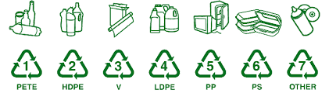
Now we know where these products came from, how did recycling become a permanent part of our daily waste routine?
The big push came from major beverage companies, they reviewed their manufacturing process and wanted to scale up operations where they could mass produce, ship regionally, nationally or even internationally at a cheap rate, by doing so this inspired to further the linear economy by adding, what we know today as ‘single use plastic.’ These beverage companies could still be using glass to contain their products, but plastic is cheaper, more durable, overall the better choice. These organisations aren’t the only ones to blame, laziness from consumers sped up the need of recycling. [10]
Recycling categories. [14]
Did you know? Paper bags were used by consumers enormously, this wasn’t sustainable, this wasn’t fair, the worlds resources were being diminished mainly by de-forestation, that’s what Sten Gustaf Thulin believed. He invented the plastic bag in 1959 to help the environment, consumer ignorance led this design, that was meant to be re-used, into the path of single use. [11]
This alongside many other factors contributed to the major waste pollution we have today.
Recycling Plastic is a massive global business generating 37.6 billion US dollars in 2018. [6]
I UPS & DOWNS I

So, to tackle the growing problem of waste, in 1970 the Container Corporation of America established the three chasing arrows symbol. [12]
Recycling Symbol. [13]
This allowed consumers to follow a system to separate materials into seven categories of recyclability. Unfortuantely unknown to the cosumer only sections one and two had buyers willing to recycle them. [10]
At present only sections one, two and five are widely recycled
The remaining catergories have no market, the plastic production is far too advance for the technology of recycling to keep up. This didn’t stop the large manufacturing companies though, they realised if they could get the public to recycle their products they could keep on selling more of it back to them. They played a massive part in greenwashing the public, taking what was true for sections one and two and applying it across the whole spectrum. This told the consumer everything could be recycled therefore every material was added to thousands of community recycling programmes by 1990, in the US alone. [10]
“9% of plastic ever manufactured has been recycled, the rest has been buried, burned, dumped or found its way to landfill” [10]
Decades of recycling waste started to build up but it could not be recycled, [10] so what could be done?
I CHINA I
Instead of creating a solution it became easier and cheaper for developed countries to sell the waste to China. [10]
Why you ask? China had everything the recycling industry needed. An enormous low wage work structure, and a cheap robust global shipping industry. China new that recycled plastic was dramatically cheaper to purchase than new and was happy to do so, so the rest of the globe dumped waste on them. [10] This didn’t seem to be a problem for China but a positive, thousands of recycling plants grew, creating jobs and processing millions of tones of plastics per year however Steve Wong pointed out with increasing amounts of garbage, most facilities wanted to be as efficent as possible disposing of their excess waste and this wasn’t necessarily eviromentally friendly, it was being burnt causing massive air pollution due to sudden industry growth. Fustrations rose, the impacts of recycling scrap and pollution was becoming more noticeable even with citezens seeing the change in the air, it hit home nationally when the licence to hold the 2008 olympics in Bejing nearly got revoked. Since then China changed their attitude and by July 2017 a ban was implemented of all imports of foreign plastic garrbage. [10, 15]
I CRISIS I
Instantly a global crisis developed, Alexa Bluth outlined the knock on effect by informing the US, that rejected recycling bails from China were building up in the harbours of Hong Kong. [10]
The ban dramatically effected business within South East Asia, Steve Wong owened many recycling factories all over the continent but the ban instantly reduced imports by almost 99% therefore factories, assests and more had to be sold resulting in job loss, and career changes, Mr.Wongs future in China became uncertain. [10]
Mr.Wong still believes there is huge opportunity in recycling.
He has now partnered with other businesses within the mixed recycling realm creating plastic pellets from waste produced within his home country, not from foreign imports. [10]
How did this impact the enviroment? Waste still continuously produced, now it had no where to go thus massive areas within recycling plants and idustrial sites across the globe, became idle with thousands of recycling bails. Companies were trying to export their waste to other countries, India and Asia. [10]
“Pulau Indah” translates to “Beautiful Island”
Chiam Yan Tuan an Maylasian Community Activist began to notice how abandoned areas near the port in the Island of Pulau Indah were becoming a dumping site for recycling waste. The rubbish under the hot sun, created all the elements needed to ignite fires and produce toxic fumes. The community, worried for their health, wondered what they could do. The local authorities wanted the community to prove it was pollution, to which they could not do. Activists in Jenjarom, discovered just 1km away from the town center, a waste land of recycling rubbish. All this excess waste was produced from illegal factories, it was revieled by locals documenting these organisations that also led to the discovery of another tatic used, illegal factories were eradicating excess waste by burning, creating air and water pollution. This as we already know created huge enviromental issues within China. [10]
“Foreign operators don’t care for our enviroment … profits only”
C.K.Lee Community Activist
Tricia Cortez (Executive Director of Rio Grande International Study Center) suggested that “one garbage load is dumped into the ocean every minute.” She represents the Rio Grande river that supplies water to 6 million people. The river miserably finds place within the 10 most endangered rivers of the world, mainly because of insufficent water supply but also pollution. In the early 2000’s many people in the town of Laredo Texas noticed a vast amount of litter from plastic bags surfacing the streets, roads, creeks and rivers of the city, Rio Grande being one of them. [10]
“A global estimate of 5 trillion plastic bags get used every year, 160,000 per second”
In Laredo alone 120 million plastic bags were being bought per year. [10]
I ACTION I
What did communities do to tackle the problem? Unforunately the island of Pulau Indah are still fighting with authorities to prove this waste is a risk to health. The community of Jenjarom started to document the illegal factories and shaming them publically on social media. They conducted a study which indicated, of direct result of plastic waste, that citezens espically the elderly were having repeat problems with ashtma, coughing and that the increased rate of cancer patients quadrupled. This prompted a community campaign to pressure the government to take action. After months of investigative research the government finally clamped down, aiming to close up to 100 plastic waste facilities nation wide. Whilst this is a huge improvement from the government, locals believe monitoring these operations are not the solution, the only solution is “a total ban of foreign plastic imports.” [10] Is this the only solution? On one hand China’s ban effected industry dramatically they had to change and adapt however on the other it helped to clean their enviroment, are the citizens of Jenjoram correct? They could be although at this current time Malaysia is not ready for a ban, industry is still encourgaged so a refusal of recycling garbage just isnt plausiable, yet. The Mayalsian government has developed a roadmap to get rid of all single use plastic by 2030, is this a genuine proposal or a greenwashing façade to distract buyers as the deadline is a decade away, only time will tell. [10] The citezens of Laredo, Texas decided to pull together and insisted the government impose an all-right ban on plastic bags. Other states had already started to implement bans so why couldn’t they? The local community started instigating meetings and hearings finally presenting their findings to the city council. Disastorously the Texas Retailers Assossication opposed, they stated an out-right ban would damage the Laredo’s down town retailers economy. Next the American Chemistry Council, representing the plastic bag manufacturers, resin producers and plastic recyclers, also opposed the ban by declaring “plastic bags are an enviromental choice” June 2014 it was time to vote, the conclusion 6-1 for the ban to go ahead. The ordinance took effect promptly and within the first year the land around became clear of plastic bag waste. [10]
I RESULTS I
It can clearly be seen that with co-ordinance of local authorities, changes and adaptations can result in positive outcomes. These outcomes relate to human health, drinkable water, breathable air. It also shows how these regulations can put a strain on an economies future growth, by forcing industry down a new path. What if the knowledge is still far few and between for consumers or manufacturers to under-go change? All sides of the story have been scrutinised and I believe to solve this problem it lies with manufacturors, consumers and goverment. Manufacturors should not greenwash their shoppers and should really, truly help towards the recycling aspects of their products, they could do this by inundating consumers with information of how to recycle their product? Where to recycle it? What the product is made from? Maybe they should also try and look at alternative materials/chemicals which are not harmful for humans, animals or the enviroment, however I do agree with the plastic industries statement that plastic consumption is a consumers choice. We the buyer can drive massive change, if we just don’t buy it. Consumers should also be more aware of their comsumption, what are they buying? Are there facilities close by to dispose of the product correctly? Is the product recycable at all? Where will the product end up? Can it be made into something else? Are there more sustainable products on the market? Consumers need to shop around more, be savey. Lastly, local authorities they have the power, the power to make change, to implement change, to action new laws and regulations, to make the public aware.
I THE FUTURE I
There are products which have a low enviromental impact, some examples of enviromentally friendly products are, metal or glass water bottles, re-useable bamboo coffee cups, bamboo toothbrushes. These products can either be used again and again, until wear takes it toll, composted within domestic food waste, or recycled within a well established system.
I IDEAS I
What about buying a larger packet of crisps and decanting it into a seable tub rather than purchasing 6 individual single use packets, wrapped within one large layer of plastic. Retailers are now taking these issues on board and developing innovative ideas, one such as creating pump stations where you can re-fill products such as shampoo, conditioner, washing up liquid, laundry liquid. Shoppers are also putting pressure on retailers to remove plastic packaging from supermarket fruit and veg. Fruit and veg never usto be covered in plastic, Why did it start? What do you believe? Do you surmise the blame lies with the manufacturer? The consumer? The athourities? or a mixture of all? If all these issues could be addressed, and tackled, it could push the world into a circular economy. An economy that takes care of what they are bringing into the enviroment, a world that thinks before it acts, a world sacred of their resources, and proves crucial to the security of future generations, quality of life, and living conditions.

References
- Pngfly (2020) Garbage truck [picture] Available at: https://www.pngfly.com/png-4q0n9f/ (Accessed
on: 13 January 2020)
- Hickman, L (2017) A New Path for Glass Recycling [picture] Available at:
https://www.freedoniafocusreports.com/Content/Blog/2017/02/22/A-New-Path-for-Glass-Recycling (Accessed on: 13 January 2020)
- Recycling Works (2020) Plastics [picture] Available at:
https://recyclingworksma.com/how-to/materials- guidance/recycle-plastics/ (Accessed on: 13 January 2020)
- Bennett, S (2015) How to Recycle Large Amounts of Cardboard [picture] Available at:
https://recyclenation.com/2015/06/how-to-recycle-large-amounts-of-cardboard/ (Accessed on: 13 January 2020)
- Owens-Illinois (2020) Glass Production [picture] Available at: https://www.o-i.com/ (Accessed
on: 13 January 2020)
- Glass is Life (2020) How Glass is Made. Available at:
https://recycleglass.co.nz/wp-content/uploads/2015/07/How-glass-is-made.pdf (Accessed on: 10 January 2020)
- The Packing Site (2020) Single Wall Cardboard Layer Pads [picture] Available at:
http://www.thepackagingsite.co.uk/single-wall-cardboard-layer-pads-297-x-420mm-a3-size-100-pack/ (Accessed on: 13 January 2020)
- International Plastics Inc (2013) How Its Made – Cardboard Boxes [video] Available at:
https://www.youtube.com/watch?v=HL2yvqSk8Ww (Accessed on: 11 January 2020)
- Green Biz (2017) Solving the recycled plastics puzzle [picture] Available at:
https://www.greenbiz.com/article/solving-recycled-plastics-puzzle (Accessed on: 13 January 2020)
- Broken (2019) Recycling Sham [documentary] Available at: Netflix (Accessed on: 15 Decemeber
2019)
- BBC News (2019) How Plastic Bags Were Suppose to Help the Planet [video] Available at:
https://www.youtube.com/watch?v=DQW5w9yAWgE (Accessed on: 10 Decemeber 2019)
- Encyclopedia of Consumption and Waste: The Social Science of Garbage (2012) Recycling
Symbol Available at: https://books.google.co.uk/books?id=VifrCgAAQBAJ&pg=PT723&lpg=PT723&dq=american+plastic+consult+created+the+3+chasing+arrows&source=bl&ots=9KKq6gC_F5&sig=ACfU3U0bg3v1tb3j7d1ljPhuMhhbIK-o8w&hl=en&sa=X&ved=2ahUKEwiXj4uFkoPnAhWkuXEKHZ3RDoYQ6AEwAHoECAoQAQ#v=onepage&q=american%20plastic%20consult%20created%20the%203%20chasing%20arrows&f=false (Accessed on: 13 January 2020)
- Recycling (2020) Recycling Symbol [picture] Available at:
https://www.recycling.com/downloads/recycling-symbol/ (Accessed on: 13 January 2020)

- Greensutra (2017) Plastic Recycling Codes [picture] Available at:
https://www.greensutra.in/news/plastic-recycling-codes/ (Accessed on: 11 January 2020)

- Elevate (2018) How has China’s waste import ban changed the recycling scence in Asia?
[article] Available at: https://www.elevatelimited.com/insights/how-has-chinas-waste-import-ban-changed-the-recycling-scene-in-asia/ (Accessed on: 13 January 2020)

