Student Learning Log

Student name: Anamaria Bursuc
Student number: 2122375
Module: BMIH6004
Lecture name: Lisa Bassler

Table of Contents
Introduction: 3
Section 1: Reflection on Experience and Personal Development 3
Section 2: Critical Analysis of Work-Based Skills and Technical Knowledge 4
Section 3: Reflection on Organisational Issues 5
Section 4: Future Action Plan 6
Conclusion: 7
References: 8

Introduction:
Administrative roles are the main pillars of companies (Rhima et al., 2022). They control and regulate the major areas of operations within a firm (Simons, 2019). For students striving in the field of International Hotel Management, it is essential to understand how those administrative roles operate and run a company.
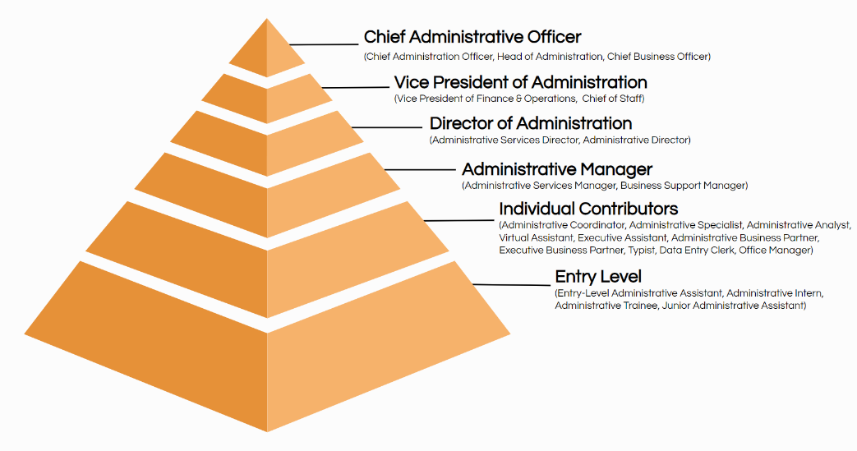
Figure 1. The Top 20 Administrative Job Titles
Source: (Ongig.com, 2024)

Therefore, I am reflecting on my experience gained during my supervisory job role at the Front Desk office. For this purpose, I will use the reflective model of Gibbs's reflective cycle often known as Gibbs' model of reflection. This reflective model is a comprehensive approach, that comprises a few steps such as description, feelings, evaluation, analysis, conclusion and action plan, that one can use to outline his personal experiences gained in a particular context, scenario, or setting (Sharples and Levett, 2020). This model also enables to planning effective approach to enhance the areas where improvement is needed (Tanaka, 2018).
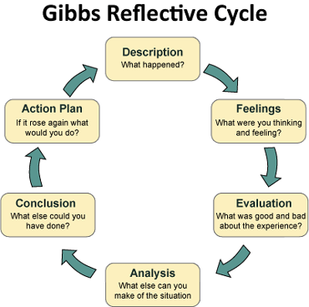
Figure 2. Gibbs' model of reflection
Source: (Main, 2023)

Section 1: Reflection on Experience and Personal Development
- Description:
In my case, I worked closely with the Front Office Supervisor at the Novotel and Ibis Hotel during my work placement. The tasks in this role included the arrangement of check-in and check-out of guests, the handling of reservations and the attending to guests’ concerns and grievances. Assisted in shift meetings and noted the level of interpersonal communication with the employees and guests the supervisor was engaged with.

- Feelings:
At first, I was not prepared for the high speed at which things were being accomplished and the fact that the supervisor had many tasks assigned. However, after having adjusted to the specific expectations of the front office staff, I was able to better understand the central importance of the front office both to guest satisfaction and the functioning of the hotel as a whole.

- Evaluation:
This has made me gain a lot of experience in understanding work-based competencies and technical/trade skills. The positive things that the supervisor demonstrated include the ability to operate the hotel management software, factors that one should consider during stressful situations and guest service. I understood the significance of these skills for the coordination of operative activities and achieving guests' satisfaction.

- Analysis:
About communication and teamwork from the light that I got while shadowing the supervisor, I realised the importance of the two aspects, that is, communication and teamwork. My previous industry experience gave me the basis for what I had to do, but in this position, I realised that I needed to perform more complex tasks in terms of problem-solving and communication. This is due to what I had learnt in my classes regarding customer service as a business concept and the overall functionality of the organisation was made advantageous to me.

- Conclusion:
The shadowing experience was beneficial in getting the theoretical knowledge and experience in practice. This added emphasis on solving problems and maintaining guest satisfaction dictated the need for both personal and vocational training.

- Action Plan:
Looking to the future, I will endeavour to improve by acquiring specific knowledge in the use of hotel management software in addition to asking for feedback on my communication and organisational skills. I will also seek to upgrade my education to enhance my experience and capability of handling guests’ services more efficiently.

Section 2: Critical Analysis of Work-Based Skills and Technical Knowledge
Work-Based Skills and Technical Knowledge:
Work-based skills and technical knowledge are crucial in the management of hotel administration as they facilitate operations and promote guest satisfaction as well as standard service delivery (Abdelhamied, 2019). Communication, problem-solving, coordination, and first-hand knowledge of operating systems used in hotels are crucial skills (Patiar et al., 2021). Technical skills refer to computational skills, booking and reservation systems, customer relations and administrative work, all of which are essential in a hotel business (Dyshkantiuk et al., 2020).

Skills Specific to Administrative Tasks
While shadowing my front desk supervisor I was able to identify several of the work-based key skills and technical knowledge. The essential skill I learned was the operation of the Property Management System (PMS), especially in the area of reservation, checks in, and checks out. The supervisor was very familiar with the PMS and made it easy to book and bill for any availabilities on the calendar. For example, whenever guests asked for their room upgrade during the check-in, the supervisor was able to check the room availability, change the reservation, and update the billing without any hesitation to show proficient knowledge of the system.

Examples:
Another prominent example is that the supervisor demonstrated such important skills in managing the guests’ complaints with understanding as well as professionalism, ensuring that complaints for instance excessive noises from neighbouring guests for change of rooms were promptly addressed. Coordination with the guests and the team members during the meetings and brief sessions, which took place each day, was an important way to make sure everyone was updated and that there was good morale within the workplace.

Section 3: Reflection on Organisational Issues
- Situation Encountered:
While shadowing for a day, one main challenge that I encountered was that the internet connection at the front desk was disturbed and impacted the functioning of PMS as well as additional online services. Consequently, this disruption affected an effective performance in the department as it contributed to the delays in check-ins and check-outs as well as the frustrations of the guests.

- Impact on Department Performance:
The immediate impact was a list of guests waiting for help and the need to check the information regarding the reservations. This impacted negatively on the aspect of guest service and as a result, there were more complaints and less satisfaction.

- Possible Solutions:
To solve such problems, this is where the application of contingency planning is necessary. Measures are to have a local backup of the PMS, make sure that some members of the staff know how manual check-ins work and have IT available.

- Theoretical Framework:
Using Kotter’s Change Management Theory, improvement of the communication about the plan and training can also prevent disruption and guarantee high standards of service. These practical steps can boost resilience, and that can help a company to run more smoothly when technical problems occur (Jain, 2019).
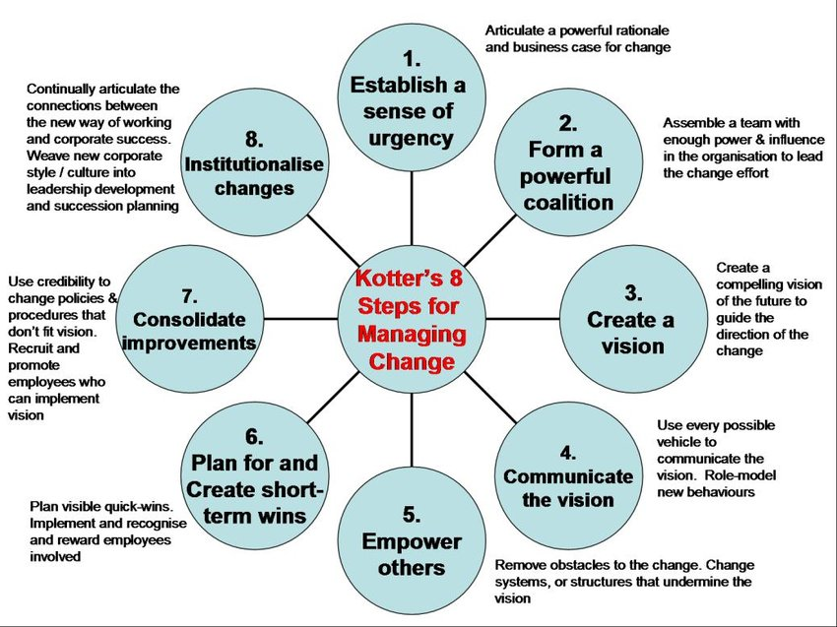
Figure 3. Kotter's change model
Source: (Ebba Ossiannilsson, 2018)

Section 4: Future Action Plan
Area for Improvement | Specific Action | Measurable Outcome | Attainable Steps | Relevant to Goals | Time-Based Target
Communication | Attend a professional communication workshop | Improved guest satisfaction scores | Enroll in a workshop and complete assignments | Enhances guest interaction and service | Within 3 months
Teamwork | Organise regular team-building activities | Better teamwork and collaboration ratings | Plan monthly activities, gather feedback | Strengthens team cohesion | Monthly for the next 6 months
Task Management | Implement a daily task checklist | Increased efficiency and task completion | Create and use a checklist daily | Ensures all tasks are completed on time | Immediately, review after 1 month
Technical Knowledge | Complete an advanced PMS training course | Proficiency in PMS usage | Register for the course, pass the final exam | Improves handling of reservations and check-ins | Within 2 months of course availability
Personal Skills | Practice stress management techniques | Reduced stress levels and improved performance | Attend stress management seminars and practice techniques | Enhances ability to handle high-pressure situations | Within 3 months
Guest Services | Develop a standard procedure for handling complaints | Fewer guest complaints, higher resolution rates | The draft procedure, train staff on its use | i will Improve guest satisfaction and service recovery | Within 2 months

Conclusion:
Shadowing my supervisor at the front desk job was particularly very fruitful in helping me acquire key work competencies and technical information. This was based on areas such as communication, problem-solving and, adequate familiarisation with the hotel management information systems to meet the benchmark on the provision of guest services. The focus on personality and occupation growth with the help of practicum and professional training influenced my further work choice. It is also a highly service-oriented industry and after this all-round learning experience, I am confident to provide high levels of service to the guests.

References:
Abdelhamied, H.H.S., 2019. The impact of training activities on quality of service, customer satisfaction and behavioural intention. Journal of Tourism and Hospitality Management, 7(1), pp.135-148.
Dyshkantiuk, O., Salamatina, S., Polishchuk, L., Komarnytskyi, I., Tserklevych, V. and Nedobiichuk, T., 2020. Modern hotel business management tools. International Journal of Advanced Research in Engineering and Technology, 11(6).
Jain, M. (2019). Kotter’s 8-Step Change Model (+Advantages & Disadvantages). [online] The Whatfix Blog | Drive Digital Adoption. Available at: https://whatfix.com/blog/kotters-8-step-change-model/
Main, P. (2023). Gibbs’ Reflective Cycle. [online] Structural-learning.com. Available at: https://www.structural-learning.com/post/gibbs-reflective-cycle
Ongig.com. (2024). Available at: https://blog.ongig.com/wp-content/uploads/2020/05/administrative-job-titles-hierarchy-Ongig.png
Ossiannilsson, E., 2018. Leadership: In a time when learners take ownership of their learning. In Administrative Leadership in Open and Distance Learning Programs (pp. 1-33). IGI Global.
Patiar, A., Kensbock, S., Benckendorff, P., Robinson, R., Richardson, S., Wang, Y. and Lee, A., 2021. Hospitality students’ acquisition of knowledge and skills through a virtual field trip experience. Journal of Hospitality & Tourism Education, 33(1), pp.14-28.
Rhima, M.H., Muhsen, N.A., Faris, H.M. and Mohammed, R.F., 2022. Study of Pillars and Variables of Business Administration for Successful Organisational Effects. Webology, 19(1), pp.6550-6567.
Sharples, K. and Levett, S., 2020. Reflecting in and on practice. How to Succeed on Nursing Placements, p.175.
Simons, R., 2019. The role of management control systems in creating competitive advantage: new perspectives. In Management Control Theory (pp. 173-194). Routledge.
Tanaka, M., Okamoto, R. and Koide, K., 2018. Relationship between reflective practice skills and volume of writing in a reflective journal. Health, 10(3), pp.283-288.

