Organizational engagement has become a hot topic among practitioners. Based on a survey of 50,000 employees in 27 countries, Lockwood (2007) has reported that engagement is directly linked to business success and employee retention in organizations. Evidences indicate that an engaged and committed workforce can abundantly benefit the organization prominently in terms of lower turnover intentions and reduced absenteeism (Allen et al., 2003; de Lange et al., 2008). Owing to high rivalry in the market, organizations need to align their strategic goals with individual goals to create organizational engagement (Nutov and Hazzan, 2014). Kahn (1990) has predicted that engagement leads to individual and organizational results in terms of the quality of people’s work and productivity of the organization. Engagement is the result of a stronger commitment to the organization, greater job satisfaction and improved work environment (Harter et al., 2002). Employee engagement enhances organizational outcomes, such as productivity, safety, profitability and turnover (Harter et al., 2002), while organizational engagement improves both employee and organizational performance (Richman et al., 2008). Both trust in senior management and procedural justice are significant predictors of organizational engagement (Malinen et al., 2013). Employees who have trust in the senior management show higher levels of engagement and lower intention to quit the organization (Malinen et al., 2013).


Report: Twr y Felin Hotel Consultancy

Student Name: William Thorpe

Student No: 2018536

Module: BMIH6005

We can Solve your issue at the consultancy.

Client: Twr y Felin Hotel St David's

Date: 16/3/2023

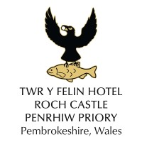

Executive summary

Table of contents

Introduction:
This report aims to discuss Twr y Felin hotel operates on a twenty-four-hour continuous 365 days. Twr y Felin has plenty to offer guests while located in an idyllic location and good transport links centre of Pembrokeshire, surrounded by natural scenic beauty. Popular visitor attractions include the oriel arts gallery, a five-minute walk to the nearest beach, green countryside, rolling hills, and wonderful landscapes. In addition, it is renowned as the smallest City in Britain because St Davids Cathedral makes it the perfect venue to visit historic Pembrokeshire.
The report critically analyses staff retention levels, turnover intention, and recruitment reduced customer numbers during a lunch session, and ROI research on room rate, pricing and evolution. Return on investment property empty rooms need occupying all through, including when Hotel is not seasonal and staff wages are high. Additional overheads constantly turn guests away while recommending the external establishment for lunch and the evening meal because of Labour issues (Twr Y Fellin, 2022). however, researching the problems considering Twr Y Fellin, we understand the organisation's current issues daily; nonetheless, the Hotel always needs human labour. Therefore hospitality and staff shortages have unfortunately become a big issue reason are the Hotel is saturated remotely; however, hospitality is a very diverse industry with people it attracts a multicultural workforce, and the pay is not great employees working unsociable the Hotel is seasonal and they the covid and Brexit and currently the cost of living and energy prices. However, with inflation and the higher price of goods and services, we have been concerned about these issues and decided to analyse the findings by applying SWAT, PESTAL, and TOWs analyses.
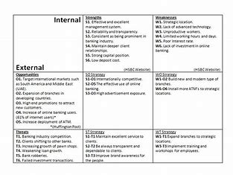
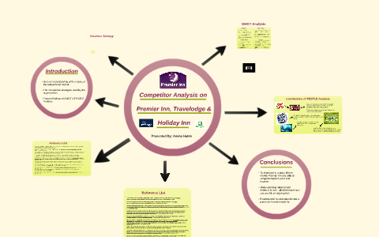
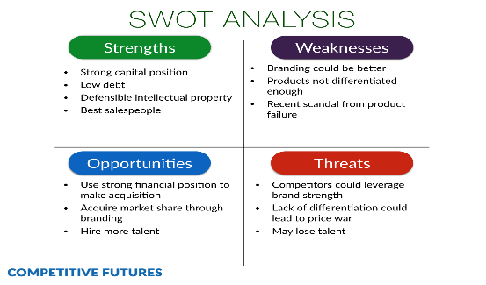

Although Wages have risen to the highest level (Alder 2023) argues that many businesses struggle to pay employees; however, it is a real challenge for the organisation to attract and retain their staff. Moreover, with a very competitive market, many organisations are forced to offer a large pay rise to retain and attract workers.
Intimate brand knowledge reflects an employee's substantial experiential knowledge of delivering brand promise (Xiong and King 2018). however, to encourage employee voice, managers need to facilitate employee brand learning and help employees develop
Scope and analyses:
This report is for Twr y Felin hotel clientele, mostly seasonal guests celebrating birthdays, anniversaries, business clients and guests with disposable income. The Hotel is situated in a scenic and beautiful Welsh City seaside and countryside environment and dates back to 1805; it was as old in the second world war and then transformed from a tower to a hotel until the 20th century; however, after refurbishing the Hotel now has a modern look was first established 2015 and stands Oriel y Parc, which is an impressive art gallery where it is a few minutes walk from the wonderful St Davids Cathedral, where it exhibits a large collection of contemporary art; however, the Hotel is built in an old windmill with high-spec bedrooms. Moreover, the food is exceptionally good, and the chef is truly talented; he is a master in culinary skills; amenities to give the guest the first impression, with a wow factor.
The Hotel comprises 21of minimalist bedrooms, brown leather rugs on boarded floors, grey fabric walls and beige suede armchairs. Bathrooms are slick limestone creations, most with a large walk-in shower separate from a bath. Facilities include a Nespresso machine, fresh milk in the fridge, robes and slippers, and audio systems that link the television to speakers in the bedroom and bathroom ceiling. The cheapest rooms look across the car park. One of the ground-floor Oriel Spacious rooms with a large terrace backing onto an open field and views of St Brides Bay. There is the two-storey Windmill Tower Suite. Twenty more bedrooms in a newly constructed block will open in the summer of 2020.
Blas Restaurant's name means 'taste, and offers some of the best elaborate, upmarket dining in Wales. A dinner-tasting menu highlighted a scallop topped with foam-flavoured apple and elderflower, salmon in a buttermilk and dill sauce, and a deconstructed lemon meringue pie with marzipan ice cream. The emphasis is on Welsh produce, including the potato and laverbread edible seaweed hash with poached eggs at breakfast. The buffet – a colourful fruit salad, fresh pastries and much else– is also very tempting, and the orange juice is freshly squeezed (Mawer, 2022).
However, internal and external organisations face challenges. At the same time, sourcing talent in the labour market is difficult; however, the firm recruits agency staff and accumulates a high expenditure for the Hotel, as off-seasonal employees are given accommodation in unsold rooms for a small fee. Therefore, identifying the problem and carrying out strategic plans and executing any issues that might occur in hotel departments such as housekeeping, food and beverage and kitchen (Gallo, 2016), stating that staff retention levels are of concern, more so for that is the well-being of employees. However, research (National Restaurant Association 2018) adds that young people and students make up a large number of the hospitality workforce, and pay is another factor in employee turnover or staff retention levels (LU and Gursoy, 2016) when off-season and employees are given accommodation in unsold rooms for a small fee.
According to (TripAdvisor.com/hotel) the guest comments about the property state that the internal interior décor is dark looks tired and needs republishing. However, there are positives from reviews; most guests rate the Hotel four stars because the dining experience is excellent, awarded AA Michelin stars, and a talented chef promotes the organisation. However, there are supplier issues, and local produce is hard to source; the war in Ukraine and Brexit, covid 19 disrupted businesses; moreover, inflation crippled the economy by paying higher for energy-imported goods and services (de Haan and Sturm 2017) and (Bernake, 2015) agrees that the next financial crisis the labour markets institutions; however, banks are charging soaring interest on borrowing households, and business nonetheless are struggling will high energy bills and cost of living.
Sadly, a cold and unwelcoming reception team, when they finally got to their desk, coupled with a fussy and choiceless, overpriced restaurant menu with grim and unhappy-looking staff, soured our experience in the otherwise beautiful and generally hospitable county of Pembrokeshire. Suggest anyone wanting to enjoy this area without the expense or non-welcome tries out the much better value Premier Inn just down the road from this place. Barna G (2022) argues that the establishment staff need training when applying the SWAT analysis; we can spot the weakness where unhappy guests can be an issue for an organisation. The General Manager of Twr y Felin, hotel Mrs Ellis Has made inquiries and hired a consultant and paid him a fee of 25 thousand to look into the Hotel's issues and develop improvements.
General Manager Mrs Ellis thanked the guest for an excellent review which praised our warm Welsh welcome. Please also refer to our reviews for Blas which demonstrate how well our dinner offer is considered. As a 3 AA Rosette restaurant, Blas sources the finest products, and we pride ourselves on offering a unique dining experience. Furthermore, we feel that our menu pricing reflects this appropriately. We would be grateful if you could email us more information on your visit so we can understand your comments better Ellis (2022). We are very disappointed about the experience and our usual standards. We suggested that the matter be investigated by an independent body appointed to resolve the organisation's issues. However, the guest would be given a complimentary stay in our prestigious suits. Nonetheless, the general manager will contact the guest privately by telephone and explain the situation the consultant suggests.

We were here out of season, but it was only as much as the cost of a Premier Inn. The standard room is smaller than you would get there, but the quality is different. They were nicely furnished with great attention to detail, especially concerning the lighting: massive, comfortable bed and an enormous TV. The underfloor heating was just right, and the bathroom was high-end stuff. All included are excellent teas, coffees with mineral waters, and fresh milk in the fridge. We were on the ground floor and had a patio area outside, accessible through the patio doors in the room. If the weather had been better, we would have got a cocktail and sat out there taking in the view across the fields to St. Brides Bay and the islands. Everyone working there came across as charming, friendly and very helpful. Suggested that when using the SWAT analyses, the strengths analyses are recognised where there is huge improvement where staff were trained and professional and skilful to carry out their daily duties and guest request and great progress, however, Twr y fellin has had a revamp and upgrade their property to meet the guest standards. I recommend this place to everyone (Jezz G 2023).

Thank you so much for your detailed review. We are pleased you enjoyed your stay in our beautiful Hotel. We hope to see you again (Willcox F 2023) suggests that a property can have success when using the SWAT analysis; however, this clearly shows their strengths where the property has had to revamp, and the organisation recruited skilful professionals to carry out their daily task was staff training was carried out in order to meet guest needs. However, the consultant had advised the general manager on specific issues relating to the property needs, refurbishment staff shortages, supplier issues, and a full restaurant with guests and locals for lunches and evening dining.

The process by which a coach, with the help of a supervisor, can attend to understanding better both the client system and themselves as part of the client-coach system, and by so doing,
transform their work and develop their craft.
There are coaching supervision has three elements:
• Supervising the coach, mentor, or consultant on their work with clients in a way that provides an external perspective to ensure the quality of the practice of the qualitative function.
• Mentoring the practitioner on their professional development of the developmental function.
• Providing a safe and reflective space where the practitioner, with the help of the supervisor, can attend to their support and how they resource themselves in the resourcing function.
Since our first edition (Hawkins 2012) argues that what is required is a subtle yet profound paradigm shift in coaching at all levels, and whether delivered by internal or external coaches, coaches have focused on the person or team they are working with and seen them as clients. In the new coaching paradigm, we need to see this person or team not as a client we face but as a partner with whom we stand side by side, jointly facing the difference that needs to be achieved. Coaching then becomes a joint endeavour in service of a third party, whether that be increased leadership capacity, organisational change, a strategy being implemented or a team better able to serve its many stakeholders.

There is the supervisee, their clients and the organisation (s) they work for in supervision. Supervision needs to be in service of all these parties and of the professions in which it is taking place, not only maintaining standards but also ensuring professions themselves continue to learn.The process by which a coach, with the help of a supervisor, can better understand both the client system and themselves as part of theclient–coach system, and by so doing, transform their work and develop their craft. Explore the reason why this works. We will note that making implicit beliefs and memories explicit 'facilitates neuroplastic changes that trigger unlearning and dissolve specific existing neuronal networks' (Doidge 2010). State that coaching supervision has three elements:
• Supervising the coach, mentor, or consultant on their work with clients in a way that provides an external perspective to ensure the quality of practice (the qualitative function).
• Mentoring the practitioner on their professional development (the developmental function).
• Providing a safe and reflective space where the practitioner, with the help of the supervisor, can attend to their support and how they resource themselves the resourcing.
The following three practices during the coaching facilitate this key outcome of shifting the meaning scheme.
It is working on multiple levels at the same time. In order to enable a shift in the meaning scheme, a coach needs to be able to work on multiple levels simultaneously to attend to the physical, psychological, emotional and purposive elements and how they align in the present situation. For change to be sustained, it must be embodied, i.e. the coachee needs to be able to think differently transformational. In shifting the coachee's stuckness and allowing a new perspective into the equation, the coach needs to focus on creating this integrated perspective transformation at the moment in the room. A method of matching and then mismatching the coachee creates this 'shift in the room'; the clear model encourages this. We will discuss these. Another tool that helps the coach understand how to change assumptions is working with our model of 'the four levels of engagement', which Nick has developed over the last few years (Hawkins and Smith 2010). The importance of this model is to help us track when we are working with assumptions and when we are working with the phenomena generated by assumptions
MentoringCoachingOngoing relationship that can last for a long time. It can be more informal, and meetings can take place as and when the mentee needs some advice, guidance or support. Relationship generally has a set duration. Generally more structured in nature, and meetings are scheduled regularly. More long-term and takes a broader view of the person.Short-term (sometimes time-bounded) and focused on specific development areas/issues. A mentor is usually more experienced and qualified than a mentee. Often a senior person in the organisation can pass on knowledge and experience and open doors to otherwise out-of-reach opportunities. Coaching is generally performed only because the coach needs to have direct experience of their client's formal occupational role unless the coaching is specific and skills-focused. The focus is on career and personal development. The focus is generally on development/issues at work. The mentee sets an agenda, with the mentor providing support and guidance to prepare them for future roles. The agenda is focused on achieving specific, immediate goals.Mentoring revolves more around developing the mentee professionally.Coaching revolves more around specific development areas/issues. The three pillars are only implemented after an organisation establishes coaching activity. Indeed, many organisations studied by Hawkins (2012) only addressed the need for these foundations once they realised they had a lot of coaching activity that needed more effective integration or evaluation.
Increasingly, we are seeing organisations thinking more strategically about how coaching can add real value to their business. often starts with managers and leaders considering the following questions:
• What are our key strategic priorities?
• What development does this require in our organisational culture?
• To achieve that development, what needs to shift in our individual and collective leadership and management style and capability?
• How can coaching help make that difference?
Peterson (2010b) sees a sequential development in the coaching organisation as the coaching approach matures from ad hoc to managed by a coaching champion, to link to business benefits, to strategically aligned. Knights and Poppleton (2008: 10) argue that these stages need not be sequential and that the approach needs to be based on the type of organisation and organisational culture: 'One size only fits some concerning organising coaching services. What is important is having a clear understanding of the organisational context for coaching and then establishing the enabling processes congruent with that understanding and intent.
The systemic shadow consultant may also develop an ongoing relationship with the account team where they act as the team coach, not just on the team functioning but also on developing the relationship with the client system. From this experience of combining the role of account team coach and systemic shadow consultant with many global account teams in major professional services firms, we developed a model of 'account transformation' (BCG 1999 and Hawkins 2011) that suggests account transformation identifies four potential relationship roles with clients.
• Solution supplier is the area when delivering current needs known to the client as the supplier. The work is often won through competitive tender and tightly specified by the purchasing department.
• Strategic adviser is the section where future needs known to the client are anticipated to add value to the client's forward strategy by adding expert knowledge about the sector trends.
• Integrated trust is where current patterns, processes, culture and needs, hidden from the client's view blind spots, are revealed compassionately and appreciatively – so that the client experiences as adding value in areas they could not originally have foreseen.
• Performance partner is the section with joint investment and shared risk between client and consultant, focused on addressing future needs that cannot be predicted with certainty.

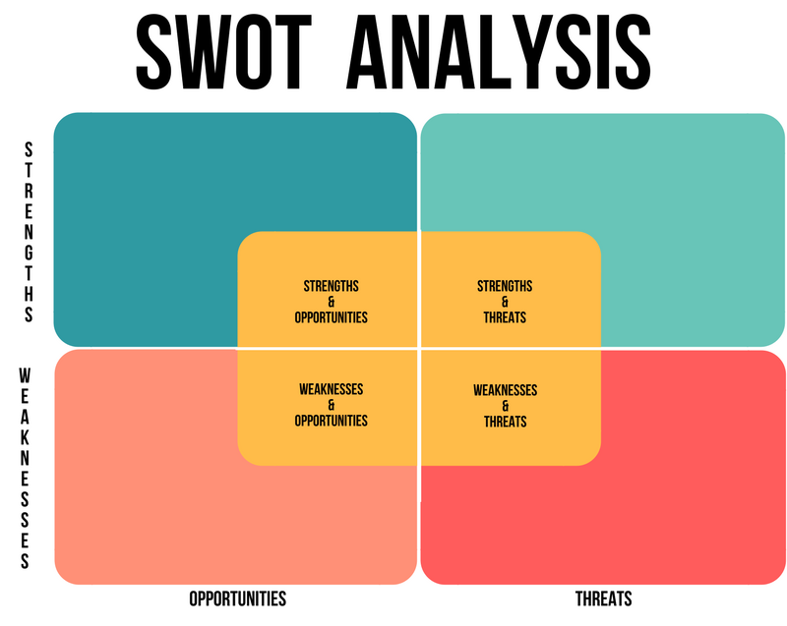

Increase revenue breakfast Beautiful restaurant and location
Promate specials during lunch offseason, not enough people a

Remote location off-season rooms empty
Food and property are excellent ROI is too high

Twr y Fellin SWAT analysis

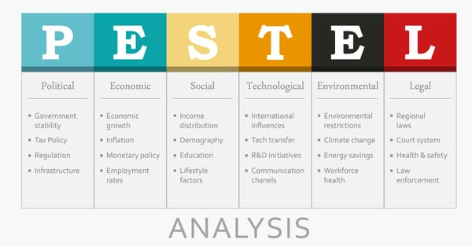
Twr y fallen PESTLE analysis
According to panellists gathered to discuss the topic during the National Restaurant Association Restaurant, Hotel-Motel Show, breakfast may be the most important meal for operators looking to spark sales and improve margins. Consumers are spending an average for breakfast, which is less than what they spend for lunch and dinner, Schmall said. Consumers spend an average for breakfast (Berta, 2009) however, less than they spend for lunch and dinner. Nevertheless, according to panellists gathered to discuss the topic during the National Restaurant Association Restaurant, breakfast may be the most important meal for operators looking to spark sales and improve margins. The panellists said the breakfast daypart attracts consumers with lower prices, convenience, taste and portability of menu items. The morning is also a highly ritualised time for consumers, so operators have an advantage if they can insert themselves into customers' daily routines. The morning daypart is up 1 per cent, and it is the only positive daypart," she said. The panellists said the breakfast daypart attracts consumers with lower prices, convenience, taste and portability of menu items."Perhaps part of the strength of the morning meal is in these tough economic times, and people are trading down to a less expensive daypart," she said. The morning is also a highly ritualised time for consumers, so operators have an advantage if they can insert themselves.
Twr y Fillin can turn breakfast and lunches into a busy profit-making outsource examples from the previous article indicate good practices and methods; however, there is potential to grow revenue, for example, breakfast and lunches high no of customers and improve sales margins. Corporate and Hotel revenues increased (INE, 2018a, INE, 2018b). suggest that post-crisis hotel market trend, a main point beyond boosting profits, labour devaluation is used to improve the distribution of revenues between corporate profits and debt repayments to creditors. Indeed, such labour devaluation processes provoked by difficulties in capital circulation have remained.

The main body:
The factors or issues affecting Twr y Fillen hotel are Main employee turnover and recruitment; however, there are additional issues, such as customer complaints that the Hotel have to deal with on a daily occurrence moreover covid, Brexit, inflation, cost of living, importing goods is at its highest energy and fuel at its highest and organisations hard to recruit workers Employee loyalty refers to the employee's commitment to the company. Loyal employees are willing to assist the company in facing challenges, understanding that they will be duly rewarded for their efforts (Farrukh et al. 2019; Foster et al. 2008).
However, loyalty is not a panacea. Even if the company makes perfect policies or employees have high loyalty, if the rewards are insufficient to meet employees' everyday needs or if employees are unable to help the company achieve its operational goals, employee identification with the company declines and senior management loses faith in the company's employees (Reynolds 2019). Therefore, companies must fulfil their internal CSR and improve their HR management systems (Friedman 2007) to meet the needs of business operations and employees. promotes consensus between companies and employees, resulting in a win–win situation (Marlow 2006). Given the nature of the job at hotels, we believe consensus should be promoted between employees and HR. Accordingly, hypotheses 1 and 2 were proposed: Hotel employees would express consistent perceptions regarding satisfaction with their current job content (H1) and corporate loyalty Even though job satisfaction affects employee loyalty (Amin et al. 2017) the effect of job satisfaction on job performance is the key to retaining highly efficient employees (Friedman 2007).
The factors affecting job satisfaction and loyalty are diverse. Among them, the trust and support of supervisors and fellow employees is the key to establishing loyalty (Bushra et al. 2011) which affects employees' willingness to stay and their feelings toward their job (Yao et al. 2019) Loyalty refers to the employee's commitment to the company. Loyal employees are willing to help the company meet challenges in exchange for due rewards (Liu et al. 2019) Employees with high work efficiency earn the company's trust, which empowers them to actively take on more responsibility. It is tacitly understood that if the company's expectations are met and work efficiency promoted, the employee is rewarded through improved working environment, salary, and workplace relationships. Therefore, we posited that interns' satisfaction with their work environment, compensation, identification with the company, and interpersonal relationships influence their loyal
For years, the pleasant climate in Fujian Province has attracted many international tourists, resulting in growth in the number of Coastal Region Hotels and a boom in tourism development (Matzler and Renzl 2006). However, the development of China's tourism industry is a relatively recent phenomenon, and the speed of personnel training has been unable to cope with the demand; moreover, the turnover rate among hotel personnel is high and willingness to stay is low (Hotel Industry Research Center, Zhongrui Hotel Management College 2019; Noe et al. 2003). indicates flaws in the hotel industry's internal CSR system and implementation effectiveness.

These interns have become one of the main sources of personnel for hotels. This cooperative project is still in its infancy, and more time must pass before its effectiveness can be verified. To understand the degree to which this project has been implemented and uncover the deficiencies, the most realistic method is to examine the perceptions of employees in the field (Ap and Crompton 1998; Widaningsih et al. 2020). Scholars believe that to obtain relevant answers concerning employee loyalty (Yee et al., 2010; Li 2019a; Yukongdi and Shrestha 2020) and job satisfaction (Liu et al. 2019; Seashore and Taber 2001; Cumbey and Alexander 1998; Foo et al. 2020a), the most effective strategy is to ask the employees themselves.
Therefore, in this study, a questionnaire was distributed to participants first through purposive sampling and then through snowball sampling; The participants were hotel trainees in Fujian Province, recovery rate of 93.3%. The data were then coded, and the valid questionnaire data were analysed for demographic variables, job satisfaction, and loyalty of the hotel trainees using statistical validation. was used to analyse the relationship between the variables and validate the research model. Pearson correlation coefficient was used to analyse the relationship between job satisfaction and corporate loyalty. Focused interviews were conducted to obtain the opinions of

