

The use of technology in the modern healthcare workplace

STUDENT NAME: | Cristian Sava
STUDENT NUMBER: | 2125456
MODULE No: | BMSK4003
MODULE TITLE: | Digital Skills and Research Methods
LECTURER NAME: | Koushik Modak
SUBMISSION DATE: | 04-05-2022

ABSTRACT.
Technologies play an important role in the implementation of healthcare services at the hospital. The aim of conducting this research is to find the efficiency as well as effectiveness to implement certain technologies as well as communication systems in the hospitals to improve services and handle the information of patients securely. It has covered the Health Information Technologies (HIT) and Health Information Systems (HIS) which are essential and can help the government in improving the standard quality of healthcare. These technologies and systems involve various advantages when implemented in the hospitals as well as involve certain limitations as well.

Table of Contents
Introduction 4
Rationale……………………………………………………………………………………………………………………………………………4
Research objectives……………………………………………………………………………………………………………………………5
Literature review 5
Research Methodology
Qualitative data methods
Quantitative data methods
Population
Sample………………………………………………………………………………………………………………………………………………
Sample size……………………………………………………………………………………………………………………………………….
Finding, Analysis and Discussion…………………………………………………………………………………………………………
Conclusion……………………………………………………………………………………………………………………………………….
Bibliography…………………………………………………………………………………………………………………………………….11
Appendix………………………………………………………………………………………………………………………………………….12
Appendix………………………………………………………………………………………………………………………………………….13

1.Introduction

Technologies play an important role in the implementation of healthcare services at the hospital. The aim of conducting this research is to find the efficiency as well as effectiveness to implement certain technologies as well as communication systems in the hospitals to improve services and handle the information of patients securely. It has covered the Health Information Technologies (HIT) and Health Information Systems (HIS) which are essential and can help the government in improving the standard quality of healthcare. These technologies and systems involve various advantages when implemented in the hospitals as well as involve certain limitations as well.

2.Rationale
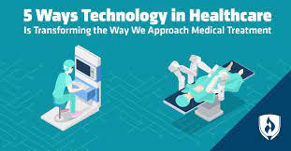
Figure 1 Technologies in Health Care
Source: (Scherman 2019)
Secondary research is being conducted to utilize technology in hospitals. The technologies are identified in these healthcare workplaces by researching them. As the technologies play an essential role in the implementation of operations. The technologies provide various opportunities for transforming as well as improving healthcare services which involve enhancing the outcomes, reducing errors, and tracking the data. The technologies are used for helping the professionals in hospitals in better communication. Technologies can be used for identifying the risks and helps with the compliance of medication. Technologies help in exchanging information in the hospital and also help in tracking as well as monitoring the information (TMF 2020).

3.Research objectives
- To search for the technologies which are used in the healthcare workplace so that operations can be successfully implemented at the hospitals.
- To provide an experience of digital services to the patients as well as the health workers so that they can also avail these services.
- To help the patients and health care providers for using information technology so that they can exchange as well as access the information regarding their health.
- To improve the efficiency of hospitals by planning for resources, registration of information for patients, and planning inventory.
- To enhance the outcomes of patients by identifying the issues and obtaining insights into patients’ health.

4. Literature review.
According to Kruse and Beane 2018, HIT (Health Information Technology) is being introduced to the industry of health care when the mainframes will assist the staff of the hospital in its financial transactions. This technology is used for sharing, analyzing, and storing health information. In this way, the technology can influence the performance of the provider as well as the quality of service. The aim of this paper is to find the effects of this information technology on medical outcomes. The two sources of information from which data is collected in this paper are analysis of medical literature and an online retrieval system. Searches in every database are quite similar. After the accomplishment of the initial search, filtrations and duplicates are removed. For several years, it has been observed that a relationship is present between health information technologies and the outcomes of health, cost, and efficiency of administration. In this article, the author has analyzed the advantages of this information technology from the data which is available.
The author has concluded that health information technology has the capability to enhance safety as well as the quality of services of health care. This will help the service providers in enhancing the medical outcomes and provides sustainability also. The healthcare industry has established various new ways that need to be integrated into the advancement of technologies and also heads toward the interoperability for providing a link between HIT’s applications and their impacts on the output (Kruse and Beane 2018).
According to Hertin and AI-Sanjary 2018, a literature review is being conducted for implementing HIS (Health Information System) in public hospitals. The purpose of this paper is to provide guidelines for information regarding the advantages and significance of a health information system that helps the government in improving the quality of healthcare standards. The implementation of HIS will help in improving the quality of healthcare, and productivity, and allows for obtaining data as well as recording the data. These information systems can also help in reducing errors as compared to the traditional system as well as helps in enhancing communication among members of staff. These systems are considered the electronic frameworks that store, collects, display, and recover the general data and information of patients. In the public hospital, the performance of the health information system is segregated in terms of three groups that involve Basic, Intermediate, and Total HIS. These are also known as BHIS, IHIS, and THIS. These groups are identified on the basis of components in information systems that are being implemented in the hospital.
The framework of HIS is being used for evaluating the implementation of HIS in which the hierarchical and individual level has been examined broadly in terms of appropriation of IT. Among the various models of information systems, McLean and Delone's models are the ones that are broadly implemented in the systems. In this article, the author has used only the McLean and Delone models for analyzing the health information systems rather than depending on their success. TAM is considered as the process for evaluating HIS acceptance level.

Anaysis and discussion-
From the above literature review, it has been observed that health information technology can be used for enhancing security as well as the quality of the services for healthcare. The health care industry has introduced various innovative as well as new ways for integrating upgrades regarding the technology and also provides a better way so that the staff of the hospital can work towards maximum operability. The research is being conducted to define as well as reveal the correlation between medical outcomes and Health Information Technology.
With the help of HIS, access is provided to the information of patients at the hospital, to keep the information of report security, and improving the receipts and requests of lab tests. The health information systems have more viability than the manual paper-based systems. Though, HIS is not easy to be implemented in every hospital which also involves certain difficulties such as complex structures in administration. The hospitals which wanted to enhance their administration, as well as operations, can implement these health information systems. There are various advantages of implementing health information systems and certain drawbacks as well. Advantages involve increased productivity, less cost, enhanced communication, and so on. Whereas, drawbacks involve less satisfaction, limited sources to collect data, technological issues, and so on. Using health information systems is essential in the hospitals which provides various positive impacts to improve the performance of the public hospitals.
This system is helpful in enhancing the systems of recording data in hospitals. It also helps in improving the services as well as the quality of healthcare. Using HIS is necessary as it will enhance the working of hospitals in the future. Though implementation of a health information system is essential, there are some difficulties as well which are faced by the government such as limited sources of finance through which not every hospital is capable of implementing HIS in their system. There are some issues faced by the users as well which involve a low level of acceptance, maintenance of existing system, and deficiency of facilities like laptops as well as computers (Sinhasane 2019).
Health Information Systems play an essential role for the patients as well as the staff of the hospital. The satisfaction of patients is essential as it will lead to quality of healthcare as well as it is required to be improved regularly. The benefits of health information systems are not limited to the security, or medical records only but it has also helped in managing the time in the hospital and serving patients (Brook 2020).

5.Research methodology:

5.1. Research method and methodology
The use of secondary research is done for the information can be gathered from different sources and the management of the data can be done.

5.2 Qualitative, quantitative, and combined approach
Quantitative research is being conducted which involves statistical and mathematical methods. This research can be performed by conducting surveys and observations. Various techniques are available for analyzing quantitative data and it can be in the form of simple graphs for representing data of patients in the hospital (Full Story 2022).
Qualitative research is easy to identify as well as define. It involves languages or words and can also use observations or pictures. This research can be conducted through interviews which can be in the form of unstructured, semi-structured, and structured (Skills You Need 2022).
The combined approach refers to the method for the gathering of the data where the qualitative and quantitative both the approach are required for the analysis of the data. The data can be gathered from journals as well as statistical data of the business.
5.3 Data, primary and secondary data.
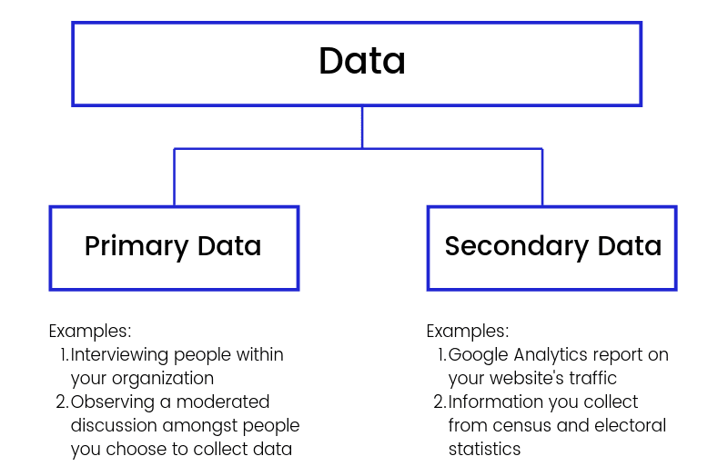
Figure 2 primary and secondary data
Secondary data is generally collected through the other available resources. There are several methods through which data can be collected for the purpose of hospital administration and research. The data is collected manually from the sources based on the ward. The information is gathered through the administrative program of electronic patient management. Observational data is collected manually from the sources based on ward through an assistant. Retrospective data on administration is gathered through an electronic program for managing patients. A retrospective review is performed for scanning the medical records of the patient who is discharged from the hospital (Business Jargons 2022).
Primary data refers to the data being gathered from different resources with the use of interviews, surveys, or other observations. The primary research is the analysis of the data to be done with the business process to be analysed.
5.4 Data collection:
The data collection refers to the method where the data is reviewed from different sources and the management of the different tasks can be formed. The data is gathered easily from the different journals and the technologies that are being used within the business can be identified.

5.5 Population, Sample and sample size:

There are various benefits involved in adopting these health information systems which are improving the value of healthcare, simplification in obtaining data, reducing errors, and improving productivity. Patient administration and information security by using these systems will affect the patient care’s nature, medical services, and understanding of rights. There are certain limitations of implementing a health information system in a hospital involves that its level of acceptance low, less satisfaction among the staff, and technological issues (Hertin and AI-Sanjary 2018).

5.6 Ethics in data collection and presentation:

The data being gathered from different sources are cited properly and the management of the referencing of the each journals being reviewed is also done. The data being gathered is discussed in the scholar.

6. Findings, Analysis and Discussion:
6.1 Secondary data analysis---
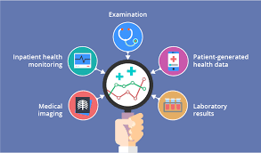
Figure 3 Secondary Data Analysis
Source: (Koktysh 2022)
The analysis of secondary data has helped in providing the data which has a huge impact on the patients in the hospital or implementing complex approaches to achieve the result. It has used the data which is being collected. This analysis provides various benefits as compared to the research of primary data which provides a wide range of information that includes value and costs in care and has reduced financial and logistical challenges.
6.2 Summary of the findings: ---
The types at which secondary data is analyzed involve the following:
- Data of administration involves the discharge reports of the hospital that is presented to an agency of government.
- Data is based on claims which are designed for representing the interaction between the delivery system of health care and insured patients.
- Records of electronic health are obtained at a hospital, medical facility, or clinic.
- Surveys of health are designed for providing an analysis of the population of health.
Though the plan of statistical analysis must involve the aims of secondary data, sources of data, hypotheses, or managing missing data.

7. Conclusion and Recommendation
This report has covered the significance of technologies when implemented in the modern healthcare workplace which is hospitals. Technologies will play an essential role when implemented in the system of hospitals as they will provide digital services to the patients as well as its staff. For this purpose, research is being conducted in hospitals using secondary data. So, a rationale, as well as an objective, is being provided that points toward the need of conducting research in hospitals. A literature review is being covered which involves the importance of technologies in the healthcare sector.
With the use of technologies, hospitals can help in preventing as well as reducing errors, protecting the privacy of patients, and improving the services. Hospitals must provide tools for safeguarding safety as well as the security of patients which can be implemented through technology only. Specifically, alerts will help in adhering to treatment schedules and particular treatments.

References
Brook, C. 2020, What is a Health Information System?, <https://digitalguardian.com/blog/what-health-information-system>.
Business Jargons 2022, Secondary Data Collection Methods, <https://businessjargons.com/secondary-data-collection-methods.html>.
Full Story 2022, What is quantitative data? How to collect, understand, and analyze it, <https://www.fullstory.com/quantitative-data/>.
Hertin, R.D. and Al-Sanjary, O.I., 2018. Performance of hospital information system in Malaysian public hospital: A review. International Journal of Engineering & Technology, 7(4.11), pp.24-28. https://www.researchgate.net/profile/Revita-Hertin/publication/328103150_Performance_of_Hospital_Information_System_in_Malaysian_Public_Hospital_a_Review/links/5bb78143299bf1049b6ff252/Performance-of-Hospital-Information-System-in-Malaysian-Public-Hospital-a-Review.pdf/.
Koktysh, L. 2022, The state of the art in health data analytics, <https://www.scnsoft.com/blog/health-data-analytics-overview>.
Kruse, C.S. and Beane, A., 2018. Health information technology continues to show positive effect on medical outcomes: systematic review. Journal of medical Internet research, 20(2), p.e8793. https://www.jmir.org/2018/2/e41/.
Scherman, J. 2019, 5 Ways Technology in Healthcare Is Transforming the Way We Approach Medical Treatment, <https://www.rasmussen.edu/degrees/health-sciences/blog/technology-in-healthcare-transformation/>.
Sinhasane, S. 2019, What Is Health Information System (HIS) & Its Importance?, <https://mobisoftinfotech.com/resources/blog/importance-of-health-information-system/>.
Skills You Need 2022, Quantitative and Qualitative Research Methods, <https://www.skillsyouneed.com/learn/quantitative-and-qualitative.html>.
TMF 2020, 10 Ways Technology Is Changing Healthcare, <https://medicalfuturist.com/ten-ways-technology-changing-healthcare/#>.

