

Assessment 1
Supporting Paper

Student name: Eleonora Krupic
Student ID: 2008937

Module name: Mental Disorders and Psychopathology
Module code: BMHP6006
Lecturer name: Bianca Sanfilippo
Date: 09/12/2022

Contents

1 Introduction 3
2 What is mental health disorder? 3
3 Anorexia nervosa within the ICD-10 Manual 3
4 Definition – Anorexia nervosa 4
5 Data - Anorexia nervosa in the UK 4
6 Causes 5
7 Symptoms and signs of anorexia nervosa 6
8 Diagnosis 7
9 Historical views for anorexia 8
10 Current treatments (NHS) 8
11 Principles when working with people with Anorexia 9
12 Conclusion 10
13 References 10
14 Appendix 13

1 Introduction
This report shows how mental health refers to a person's overall emotional, psychological, and social well-being. The mental disorder Anorexia is being discussed. Its definition and the description of symptoms tells us how mental health affects how people think, feel and act. Furthermore, it is shown what kind of help and treatment is given in the UK.

2 What is mental health disorder?
Restlessness, anxiety, sadness, discouragement, insomnia, or loss of appetite are natural reactions to difficult life circumstances, conflicts, suffered losses and disappointments. We react with sadness, anxiety, sometimes fear, irritability or anger to failures and disappointments that threaten our good self-image, mental integrity, and sense of security (Mind, 2017). These feelings can lead to disorders if the problems are not solved.
Chronic situational stress, an unresolved situation that causes conflicts or the effects of a traumatic stress can be at the root of the disorder (Mind, 2017). When these disorders caused by stress or neuroses, including disorders of sleep, mood, emotions, and behavior, eating patterns, anxiety, and depression disorders become permanent and begin to disrupt our functioning and affect our relationships with other people, we can talk about mental disorders that require the help of a professional (Manwell et al., 2015). Mental health includes our emotional, psychological, and social well-being (Mental Health Act 1983, 2018)

3 Anorexia nervosa within the ICD-10 Manual
Adjustment disorders are a group of conditions that occur after a stressful life event. What makes these disorders unique is that if a person has them, then they have trouble coping with the event or its consequences. And it has a stronger reaction than expected for the type of event that occurred. The International Classification of Diseases (ICD 10) is a diagnostic tool (manual), that helps doctors and psychologists assess health conditions. ICD 10 describes several criteria that must be present before a diagnosis of adjustment disorder is made 10 (ICD-10 Codes for Eating Disorders, n.d.).
Anorexia nervosa is often simply called anorexia, and in the ICD, -10 (ICD-10 Codes for Eating Disorders, n.d.). The manual is classified in the chapter V under the code F50.0. In chapter V are Mental and behavioural disorders with codes F00-F99 (Iiab.me, 2016). Anorexia is classified as a Behavioural syndrome associated with physiological disturbances and physical factors (F50-F59), where F50.0-F50.9 marks eating disorders (Iiab.me, 2016).
Thanks to the World Health Organization (WHO), today we are witnessing their wide application, as a common health statistical language, in all member countries. The main health classification, the Tenth Revision of the International Statistical Classification of Diseases and Related Health Problems, was published in 1984 and is still in use today (Organization, 2015).

4 Definition – Anorexia nervosa
Anorexia is not "just" a loss of appetite. Anorexia nervosa is an eating disorder and very serious mental health condition. It is classified as a mental health condition because people suffering from this disorder are losing their weight as a coping mechanism for other emotional problems (National Eating Disorder Association, 2018).
Anorexia is characterized by weight loss which leads to extremely low body weight followed by the fear of gaining weight. This disorder is affecting patient’s everyday activities and their health. If not treated properly, health consequences can lead to fatal outcome (National Eating Disorder Association, 2018).

5 Data - Anorexia nervosa in the UK
Even though anorexia can affect all ages and both sexes, it is mostly diagnosed with young women. In the UK between 1.25 and 3.4 million people are suffering from eating disorder. About 25% of those are male, the rest are female. Most of the patients are developing eating disorders during adolescence but it has been recorded eating disorder cases in children and elderly population (Priory, 2019).
10% of all patients suffering from eating disorders in the UK have anorexia nervosa. Anorexia nervosa usually starts to develop in adolescence around 16 years. Positive family history for eating disorders is also significant factor for developing this mental condition. Among all psychiatric disorders, eating disorders have the highest mortality rates. Anorexia nervosa has the highest morality rates among adolescents with psychiatric disorders (Priory, 2019).

6 Causes
The direct cause of anorexia nervosa is, as with most of mental health issues, unknown. It is probably combination of genetics, psychological factors, and the influence of the environment (Mental health UK, 2019). The basis of dissatisfaction with one's own body image is the discrepancy between the perceived and the ideal self, which can come from an internal ideal or imposed by society. The ideal self is often imposed by society and through the media and is often unattainable.
Genetics: There is not yet found a specific gene connected to this disease, but it is believed that some people are genetically more susceptible to developing this mental health disorder. It is noted that those who have positive family history for eating disorders are more likely to develop it themselves than those whose close family members do not have this kind of problems (John Hopkins Medicine, 2019).
Psychological factors: Obsessive-compulsive personality can be associated with anorexia – it makes easer for patients to stick to strict diet even though they are hungry. Also, perfectionism can cause them to never be satisfied with their looks. Some of these patients may have anxiety and, to reduce it, they engage in restrictive eating. Emotional stress of any kind (new school, home or job, breakup, death of loved ones) can lead to developing anorexia (NHS, 2021).
Influence of the environment: Environment may be the most important cause of anorexia. Today it is propagated to look skinny and thin. This is mostly represented to the young girls which is why they are mostly affected by this eating disorder (John Hopkins Medicine, 2019).

7 Symptoms and signs of anorexia nervosa
Anorexia leaves numerous consequences, the most pronounced of which are thinness, changes in all organ systems, abdominal pain, constipation, inability to regulate the body temperature. The fact is that it is the disease from which the highest number of people with a mental disorder die.
We can distinguish two types of symptoms and signs of anorexia – physical and emotional and behavioural.
- Physical symptoms and signs:
These symptoms and signs are related to starvation. Some of these can be seen on external appearance:
- Thin appearance
- Thin hair that breaks and falls out
- Dry, pale skin
- Signs of dehydration – dry lips, sunken eyes (Bhandari, 2006).
And others can be found during physical examination, laboratory tests and anamnestic information that we get from the patient:
- Low blood pressure
- Anemia (low count of red blood cells, hemoglobin, and other parameters)
- Irregular heart rhythm
- Fatigue, dizziness, and fainting (Bhandari, 2006).
- Insomnia
- Constipation and abdominal pain
- Absence of menstrual cycle
- Skin changes (Bhandari, 2006).

- Emotional and behavioral symptoms:
Behavioural symptoms can be related with attempts to lose weight:
- Extremely strict diets even if weight is already very low
- Excessive exercise
- Self-induced vomiting after eating
- Usage of laxatives, diet aids, enemas (Bhandari, 2006).
Emotional signs and symptoms include:
- Eating only privately
- Skipping meals, refusing food
- Finding excuses not to eat
- Preoccupation with food
- Lying about eating and the amount of food that they ate
- Frequently measuring the body and weighing
- Checking in the mirror too often
- Complaining about being fat or having flaws on parts of the body
- Wearing to many layers of clothing to hide their thinness
- Lack of emotions and withdrawal from social activities
- Anxiety (Bhandari, 2006).
If not recognized and treated in time, anorexia can lead to serious health issues and can also have fatal outcome. Due to the lack of nutrition, every organ can be affected – heart, kidneys, brain. It leads to electrolytes imbalance which can be a cause of deadly arrhythmias. Not all these damages can be fixed even if anorexia is under control – there are permanent consequences.
Besides the physical complications, people suffering from anorexia often have additional mental health disorders such as: depression, mood disorders, obsessive-compulsive disorders, alcohol or drug addictions, suicidal thoughts.

8 Diagnosis
It is very important to make a diagnosis as soon as possible to prevent serious complications. Assessment of anorexia includes examination of the patient's psychological and physical condition (Mayo Clinic,2018).
According to Diagnostic and Statistical Manual of Mental Disorders (DSM-5), to diagnose someone with anorexia nervosa, they must meet following criteria:
- Extremely low energy intake that leads to a significantly low body weight for age, sex, developmental trajectory, and physical health.
- Fear of gaining weight despite existing underweight.
- Distorted image of ones looks, influence of body weight or shape on self-evaluation, not recognizing the seriousness of current malnutrition (Anorexia nervosa ,2022).

9 Historical views for anorexia
The word "anorexia" is of Greek origin and refers to a lack of appetite
In 14th century was the case of St. Catherine of Siena's fast was recorded for the first time, concluded that it the first form sign of anorexia was for a religious reason- fasting (Galassi et al., 2018).
Professor Joan Jacob Bromberg’s book "Fasting Girls" shows the starvation (fasting) of girls throughout historical eras.
During the Victorian era, girls who claimed to be able to survive without food had a received gifts by pilgrims, but they were caught in a lie. For fasting in this period, it was considered a transition from spiritual to medical, symptoms such as hysteria and nervousness were revealed.
In 1873, Ernest-Charles Lasègue and Sir William Withey Gull believed that anorexia nervosa stems from emotions, which was already close to today's symptoms of this disease.
1950s in (DSM) it is considered a neurotic disease, and the desire for thinness.
In 2013 according to (DSM-5) anorexia would be in the “Eating Disorder” group (Renzoni,2022).
Nowadays, self-starvation is called "anorexia nervosa" and is considered a mental illness (Pages, 2015).

10 Current treatments (NHS)
People suffering from this disorder need professional help. The treatment of anorexia nervosa belongs to a highly specialized domain and is most often carried out in hospital conditions. Who have lost 25% or more of their body weight or has other serious health problems hospital treatment may be necessary (NHS, 2021).
It includes a combination of therapeutic approaches that include
- individual psychotherapy,
- cognitive-behavioral approach,
- family therapy,
- behavior change and
- medication (most often antidepressants) (NHS inform,2022).
Cognitive-behavioral therapy, developed by Kris Fairburn, uses the traditional foundations of CBT therapy. The goal is to help the individuals to understand, recognize and change their irrational thoughts ("cognitive" part), and to help them to change reality through specific behavioral interventions (such as promoting health, through setting goals, rewards, etc.). This therapy has proven to be effective (NHS inform, 2022).
Another form of psychotherapy that is also effective in the treatment of anorexia is the family therapy. The family can significantly influence the maintenance of the disorder because people with anorexia nervosa use the family's concern about their thinness as a means of manipulation.
Family involvement and support therapy helps sufferers to develop a sense of inner security and self-autonomy. "Maudsley Method" is a specific form of family therapy where parents take responsibility for feeding their anorexic children with the aim of helping them gain weight and improve their eating habits (NHS, 2021).
Depression is a common symptom in people suffering from anorexia. Medical therapy is necessary if in addition to anorexia nervosa, depression, anxiety, and obsessive-compulsive disorder are present (NHS inform,2022).

11 Principles when working with people with Anorexia
In the NICE guideline, we find the basic principles in working with people suffering from anorexia. It refers to a comprehensive collaborative work with all professional experts who are associated with the provision of therapy to anorexia sufferers (NICE, 2017).
Health professionals should offer educational information on how to deal with people suffering from anorexia. It is necessary for everyone to access treatment, which goes without saying for parents and guardians. Not to care about their religion, social status, age, gender. They should be approached with empathy, shown the way to a solution, and not judged (NICE, 2017).
Primary health care takes part in the treatment of users (health and mental health centers), special- licensed health institutions, educational institutions, sports associations, and other social structures.
NICE guideline recommended a process (Appendix 2).

12 Conclusion
From this report we conclude that Anorexia Nervosa should not be accepted lightly. It represents a much more serious public health problem of the psychiatric condition. Despite the relatively simple diagnosis of anorexia, the treatment is complex and long-term, sometimes lifelong.
There is a treatment provided by the NHS and principles from NICE guideline information (NICE, 2017)
We can see that nurses play an important role in this process as well as other members of the team (family) whose goal is to create a stimulating environment.

13 References
Anorexia nervosa symptoms and treatments (2022) symptoms & treatments - Illnesses & conditions | NHS inform. Available at: https://www.nhsinform.scot/illnesses-and-conditions/mental-health/anorexia-nervosa#treating-anorexia (Accessed: November 19, 2022).
Bhandari, S. (2006). Anorexia Nervosa.WebMD. Available at: https://www.webmd.com/mental-health/eating-disorders/anorexia-nervosa/mental-health-anorexia-nervosa (Accessed: November 13, 2022).
Galassi, F.M. et al. (2018) “St. Catherine of Siena (1347–1380 AD): One of the earliest historic cases of altered gustatory perception in anorexia mirabilis,” Neurological Sciences, 39(5), pp. 939–940. Available at: https://doi.org/10.1007/s10072-018-3285-6.
Group, P. (no date) Eating disorder statistics, Priory. Available at: https://www.priorygroup.com/eating-disorders/eating-disorder-statistics (Accessed: November 13, 2022).
Group, P. (no date) How group therapy can help those with eating disorders, Priory. Available at: https://www.priorygroup.com/blog/how-group-therapy-can-help-those-with-eating-disorders (Accessed: November 19, 2022).
ICD-10 Codes for Eating Disorders. (n.d.). Available at: https://www.breathetherapies.co.uk/wp-content/uploads/2019/06/ICD-10.pdf (Accessed 19 Nov. 2022).
Iiab.me. (2016). ICD-10 Chapter V: Mental and behavioural disorders. [online] Available at: http://medbox.iiab.me/kiwix/wikipedia_en_medicine_2019-12/A/ICD-10_Chapter_V:_Mental_and_behavioural_disorders(Accessed 19 Nov. 2022).
John Hopkins Medicine (2019). Anorexia Nervosa. John Hopkins Medicine. Available at: https://www.hopkinsmedicine.org/health/conditions-and-diseases/eating-disorders/anorexia-nervosa (Accessed: November 13, 2022).
Manwell, L.A. et al. (2015) What is mental health? evidence towards a new definition from mixed methods multidisciplinary international survey, BMJ Open. British Medical Journal Publishing Group. Available at: https://bmjopen.bmj.com/content/5/6/e007079 (Accessed: November 13, 2022).
Melinda (2019). HelpGuide.org.HelpGuide.org. Available at: https://www.helpguide.org/articles/eating-disorders/anorexia-nervosa.htm (Accessed 19 Nov. 2022).
Mental Health Act 1983 (2018) NHS choices. NHS. Available https://www.southwestyorkshire.nhs.uk/service-users-and-carers/your-rights/mental-health-act/ (Accessed: November 13, 2022).
Mental health UK (2019). Causes of eating disorders - Mental Health UK. Mental Health UK. Available at: https://mentalhealth-uk.org/help-and-information/conditions/eating-disorders/causes/(Accessed: November 13, 2022).
Mind (2017) Understanding Mental Health Problems - mind. Available at: https://www.mind.org.uk/media-a/2942/mental-health-problems-introduction-2017.pdf (Accessed: November 19, 2022).
National Eating Disorder Association (2018). Anorexia Nervosa. National Eating Disorders Association. Available at: https://www.nationaleatingdisorders.org/learn/by-eating-disorder/anorexia(Accessed: November 13, 2022).
NHS (2019) Adult eating disorders: Community, inpatient and ... - NHS England, Adult Eating Disorders: Community, Inpatient and Intensive Day Patient Care Guidance for commissioners and providers. Available at: https://www.england.nhs.uk/wp-content/uploads/2019/08/aed-guidance.pdf (Accessed: November 19, 2022).
NHS inform (2022) Anorexia nervosa symptoms and treatments, symptoms & treatments - Illnesses & conditions | NHS inform. Available at: https://www.nhsinform.scot/illnesses-and-conditions/mental-health/anorexia-nervosa#treating-anorexia (Accessed: November 19, 2022).
NHS (2021). Overview - Anorexia. [online] nhs.uk. Available at: https://www.nhs.uk/mental-health/conditions/anorexia/overview/(Accessed: November 13, 2022).
NICE (2017) Recommendations: Eating disorders: Recognition and treatment: Guidance, NICE. Available at: https://www.nice.org.uk/guidance/ng69/chapter/recommendations (Accessed: November 20, 2022).
Organization, W.H. (2015). International statistical classification of diseases and related health problems.apps.who.int. World Health Organization. Available at: https://apps.who.int/iris/handle/10665/246208 (Accessed: November 13, 2022).
Pages, T.S. (2015) Anorexia mirabilis: Fasting in Victorian England and modern India - sociological images, Sociological Images Anorexia Mirabilis Fasting in Victorian England, and modern India Comments. Available at: https://thesocietypages.org/socimages/2015/11/13/anorexia-mirabilis-fasting-girls-in-victorian-england-and-fasting-men-in-modern-india/ (Accessed: November 20, 2022).
Priory (2019). Eating Disorder Statistics | Priory Group. [online] Priorygroup.com. Available at: https://www.priorygroup.com/eating-disorders/eating-disorder-statistics(Accessed: November 13, 2022).
Renzoni, C. (2022) The history of anorexia - etymology of the term "anorexia": Learn more, The Recovery Village Drug and Alcohol Rehab. Available at: https://www.therecoveryvillage.com/mental-health/anorexia/history-of-anorexia/ (Accessed: November 20, 2022).

14 Appendix 1 -PowerPoint

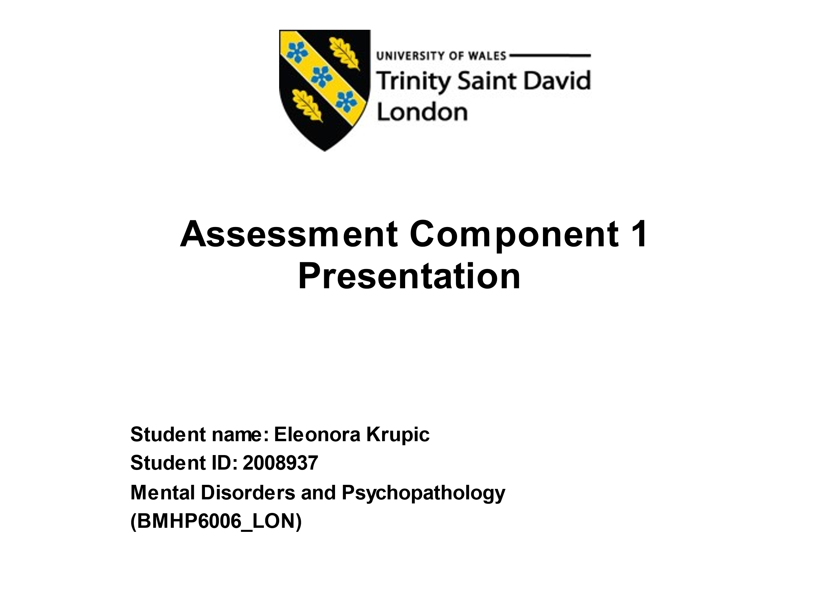

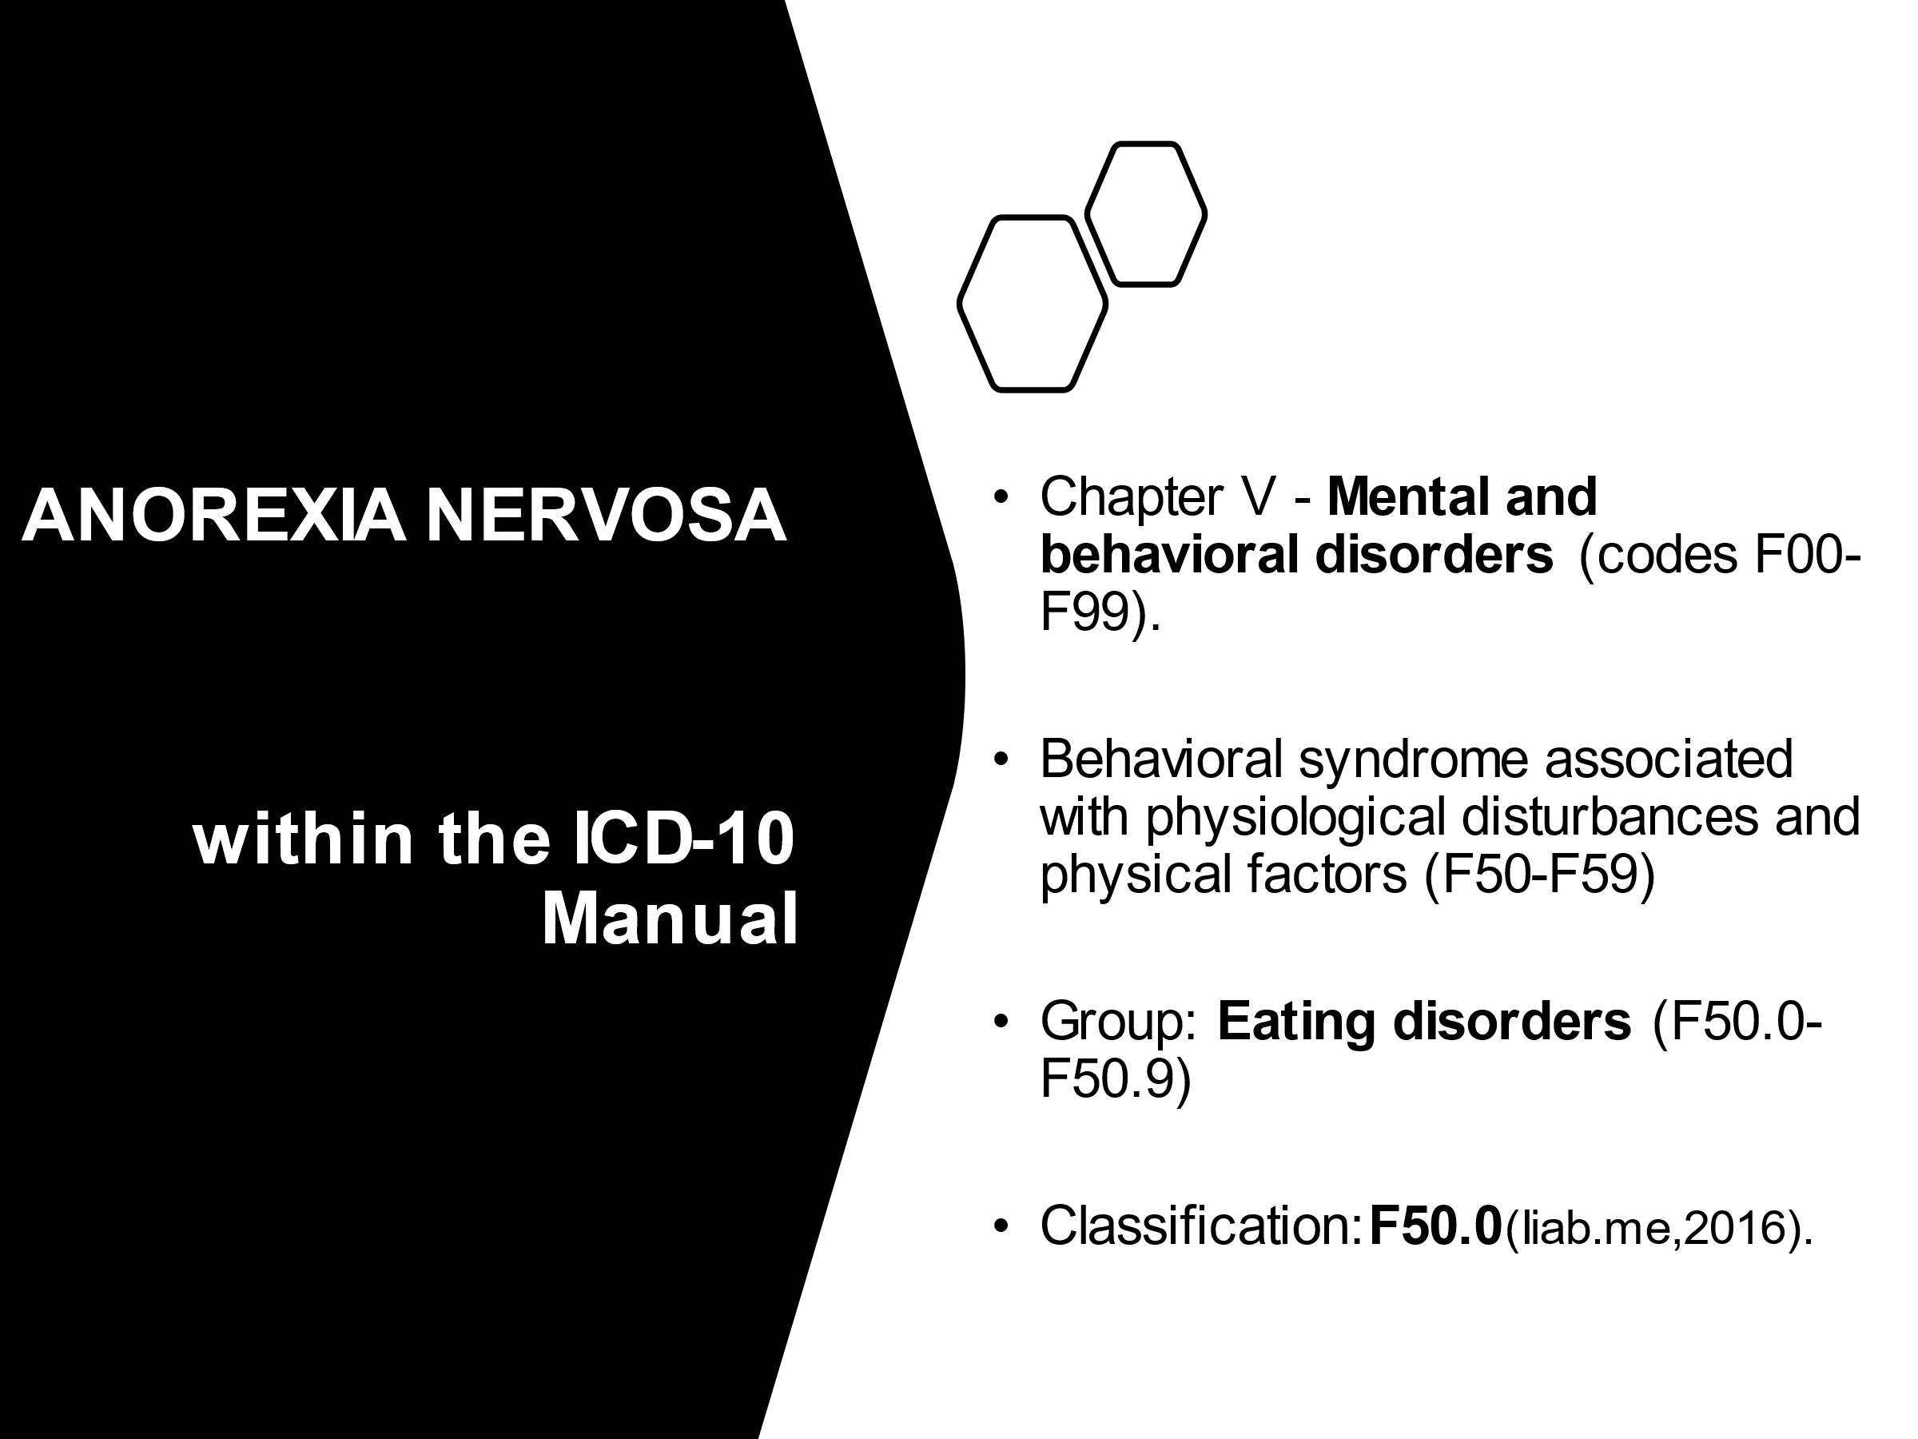

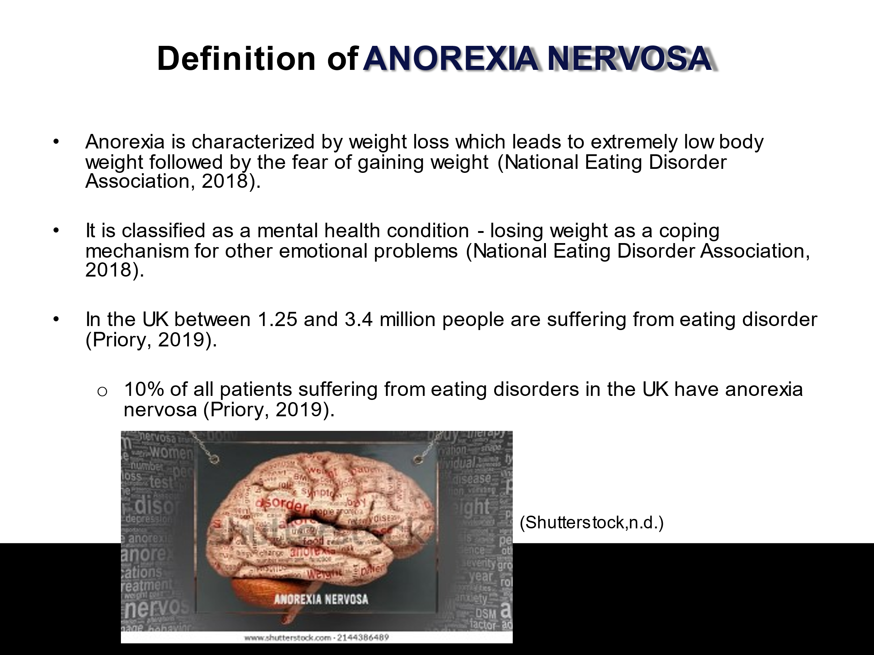
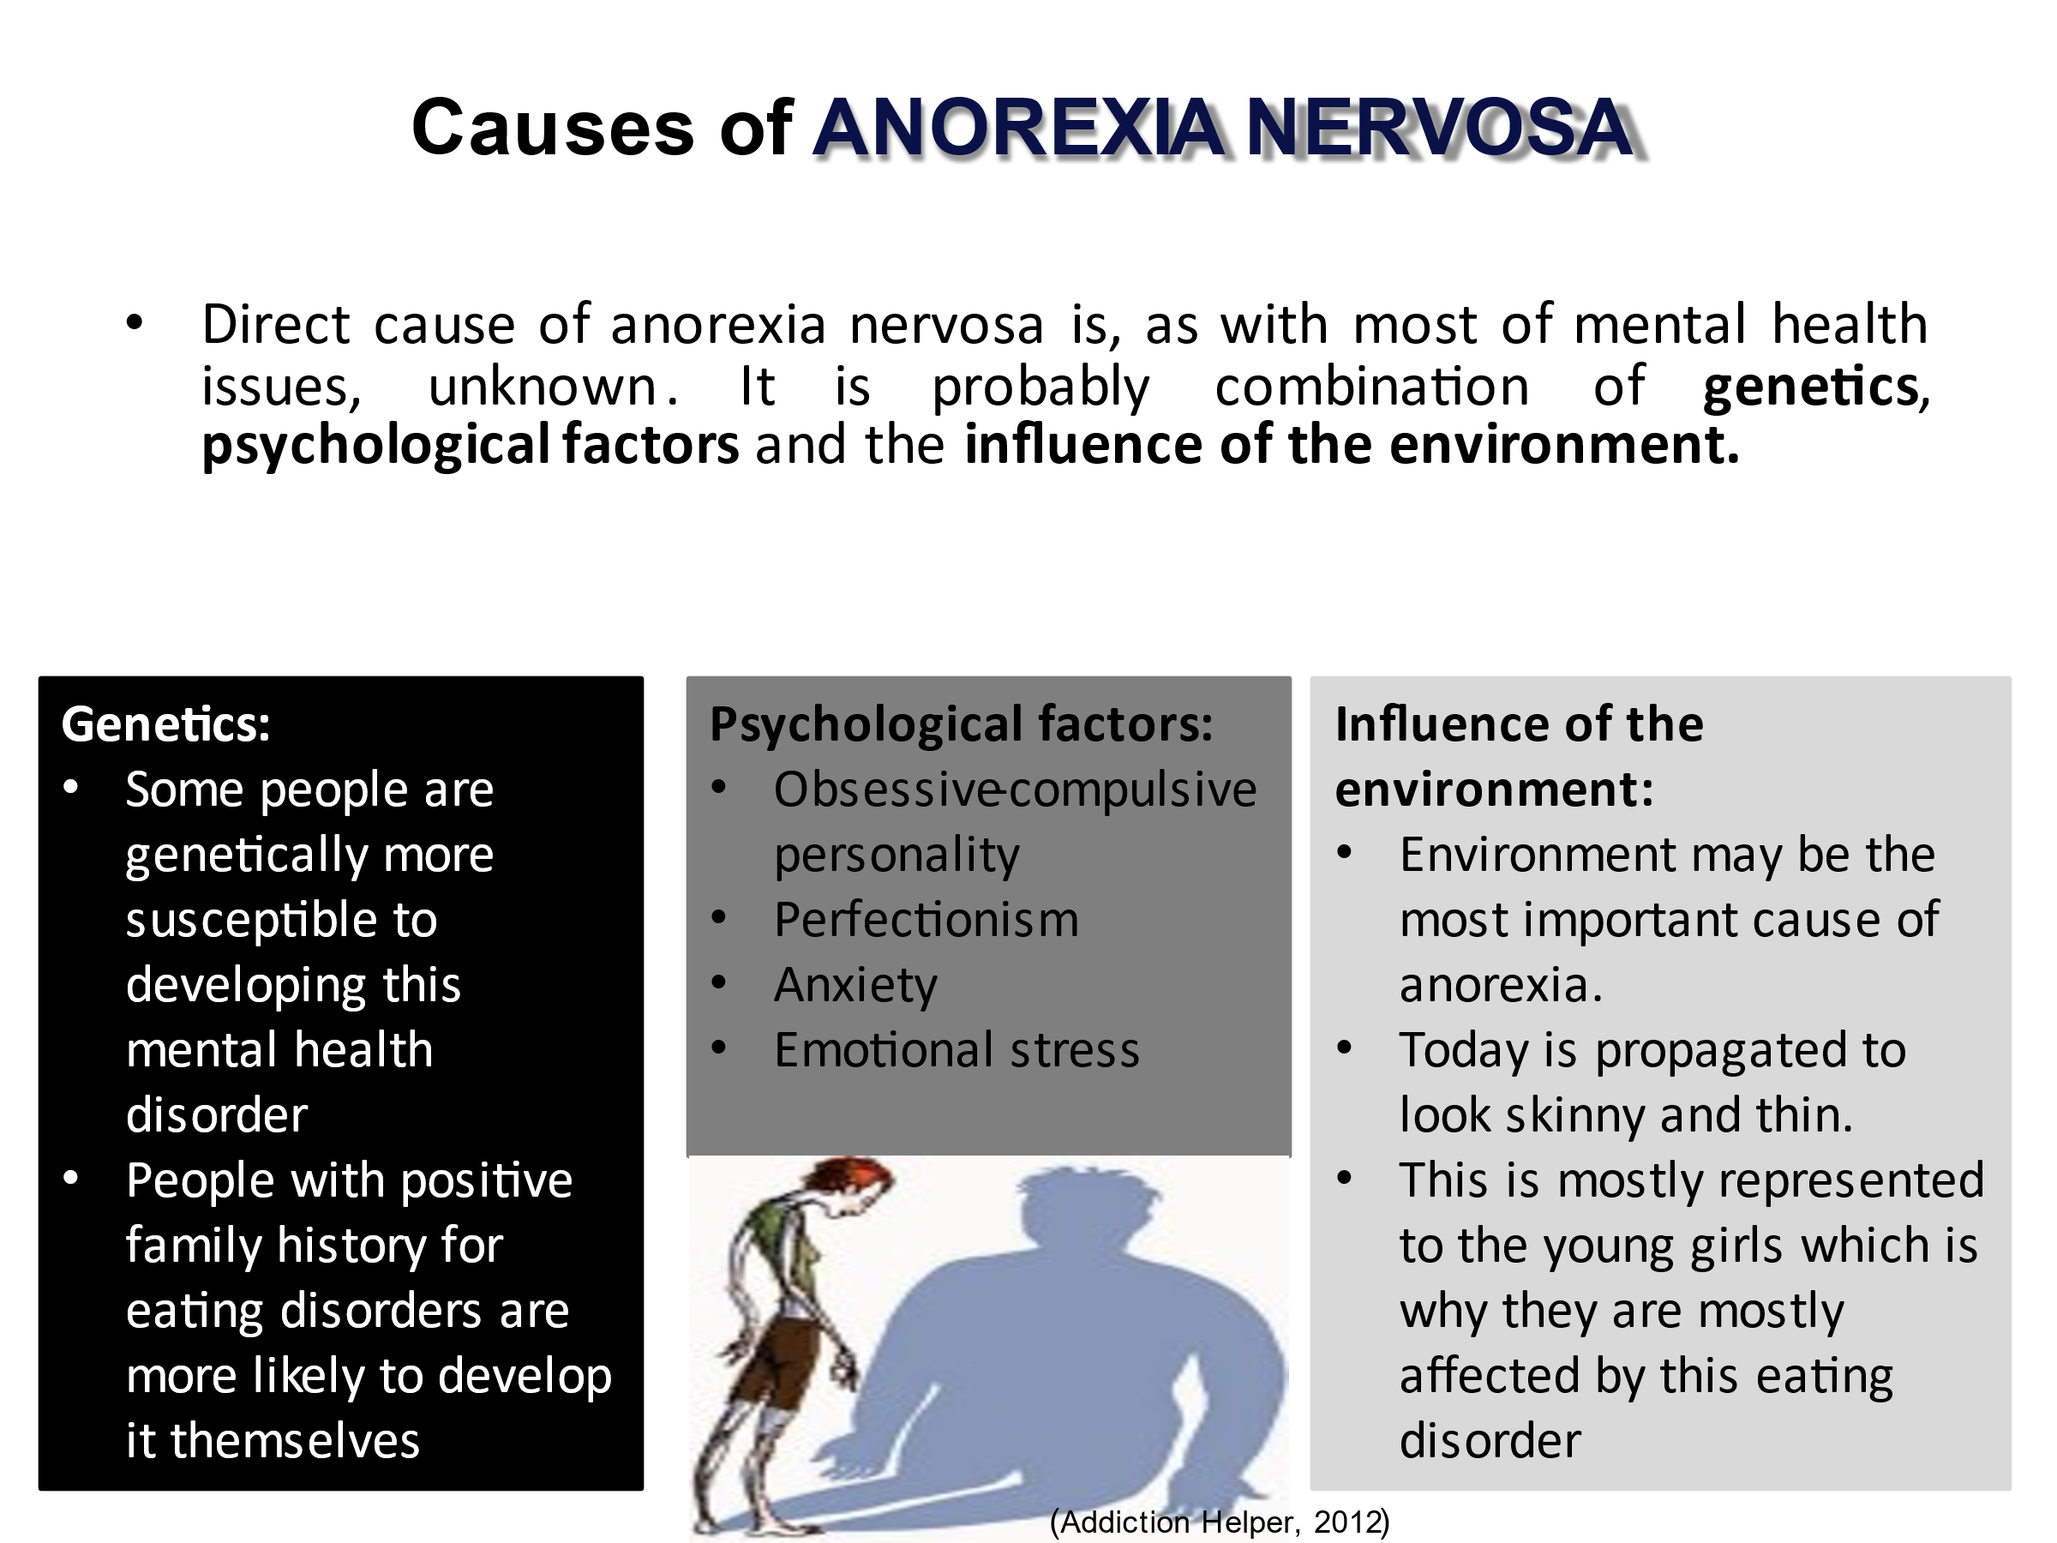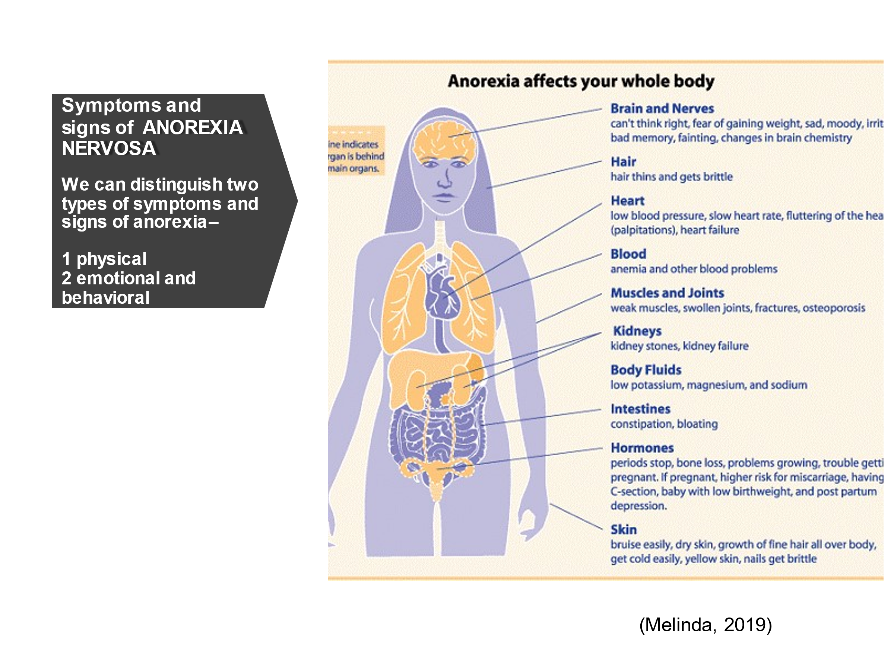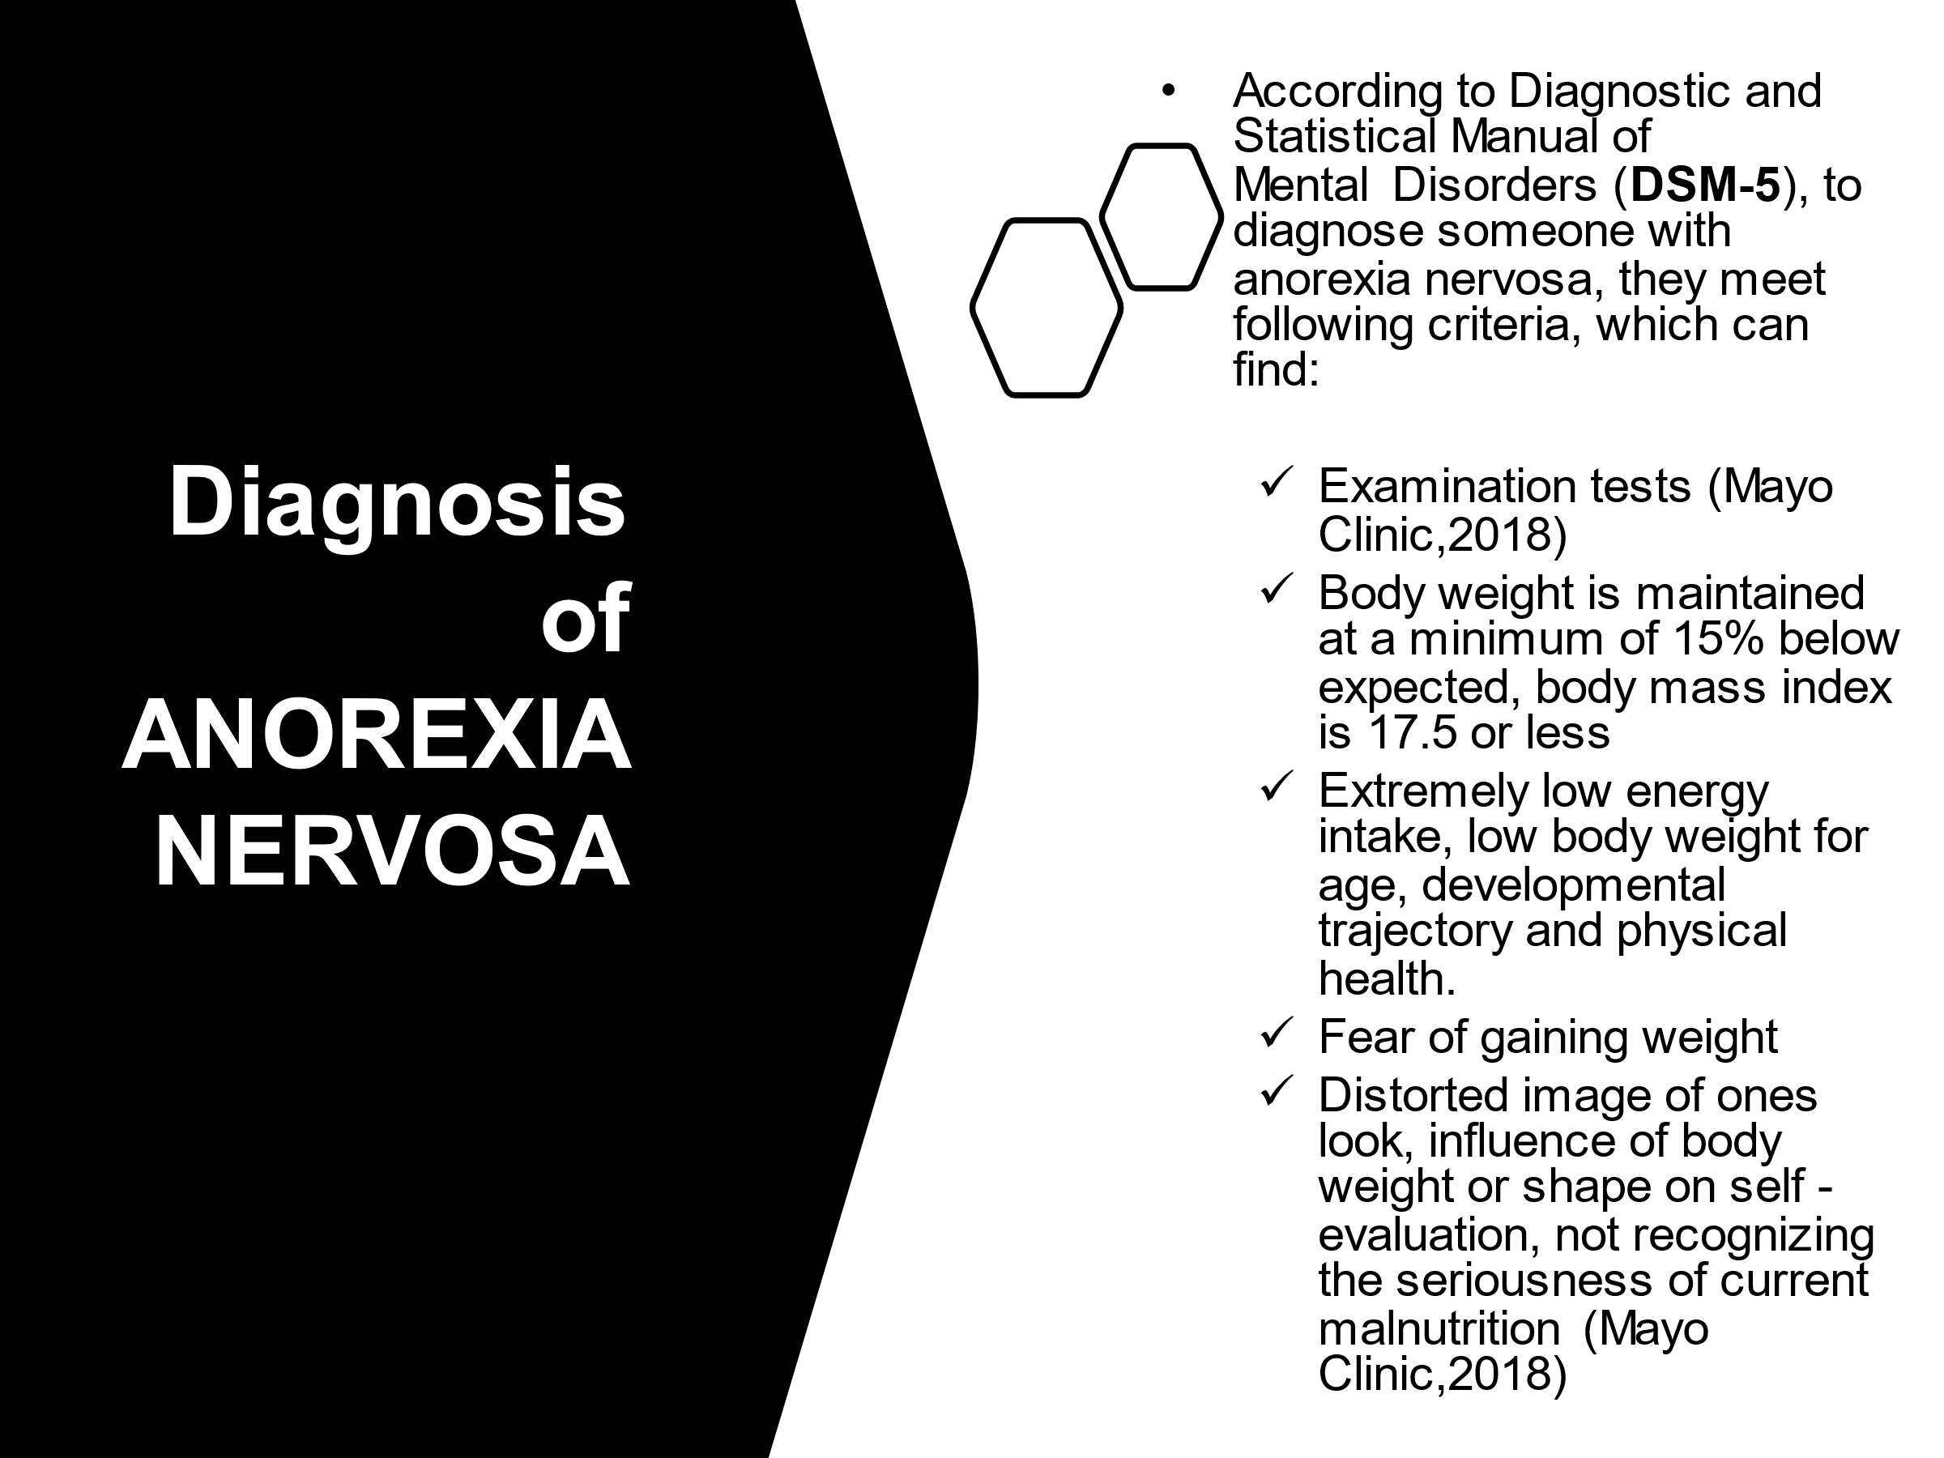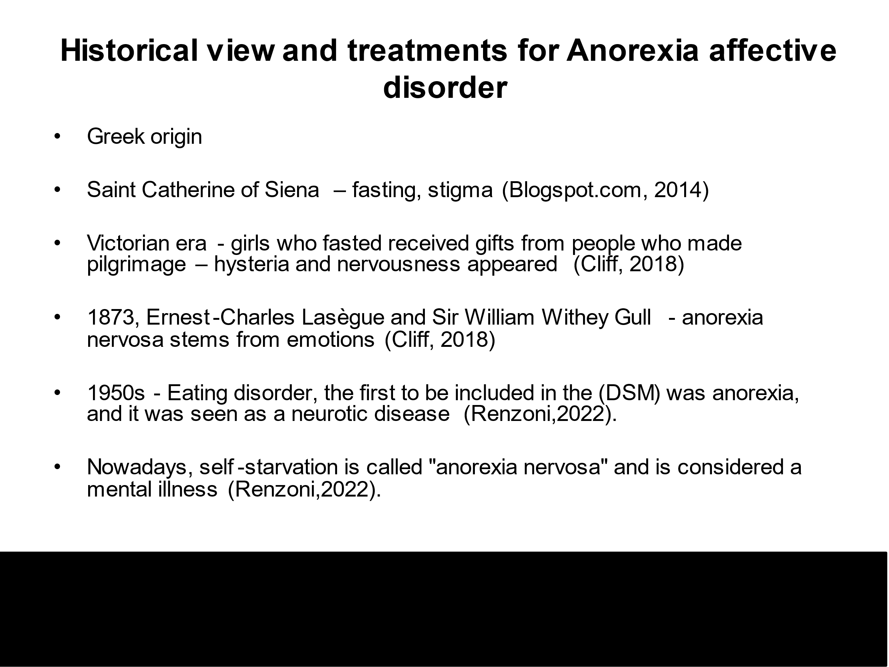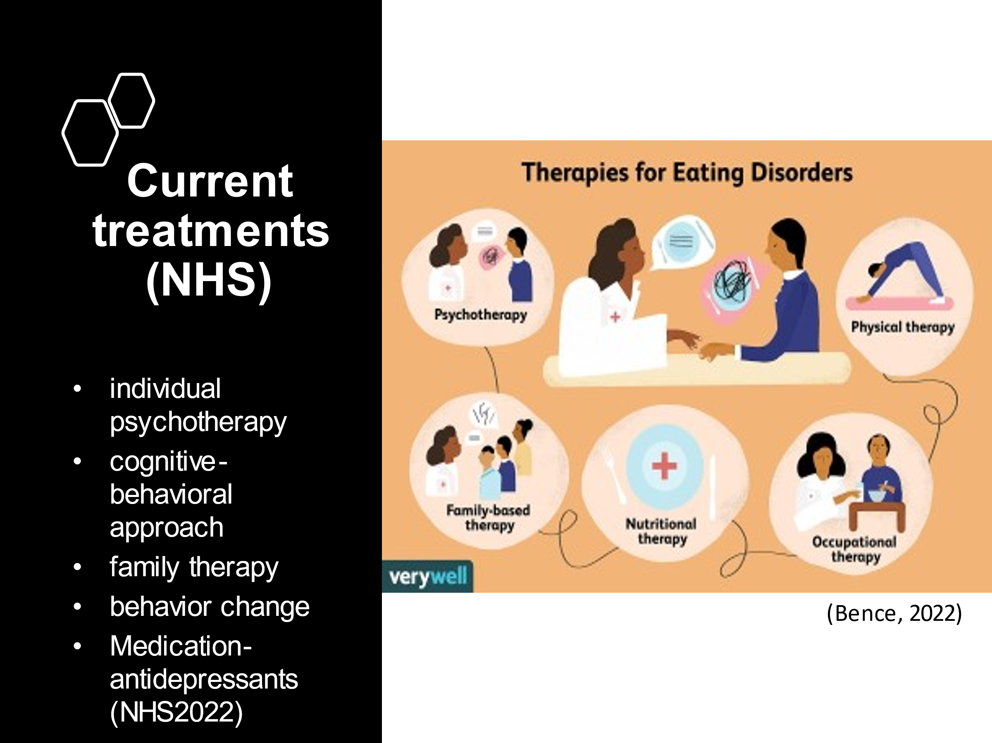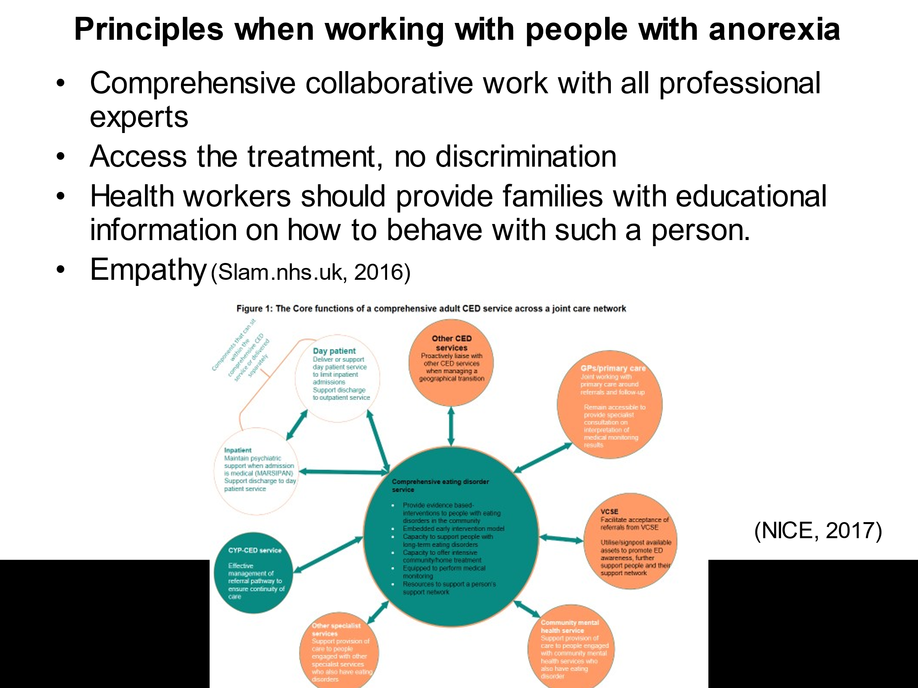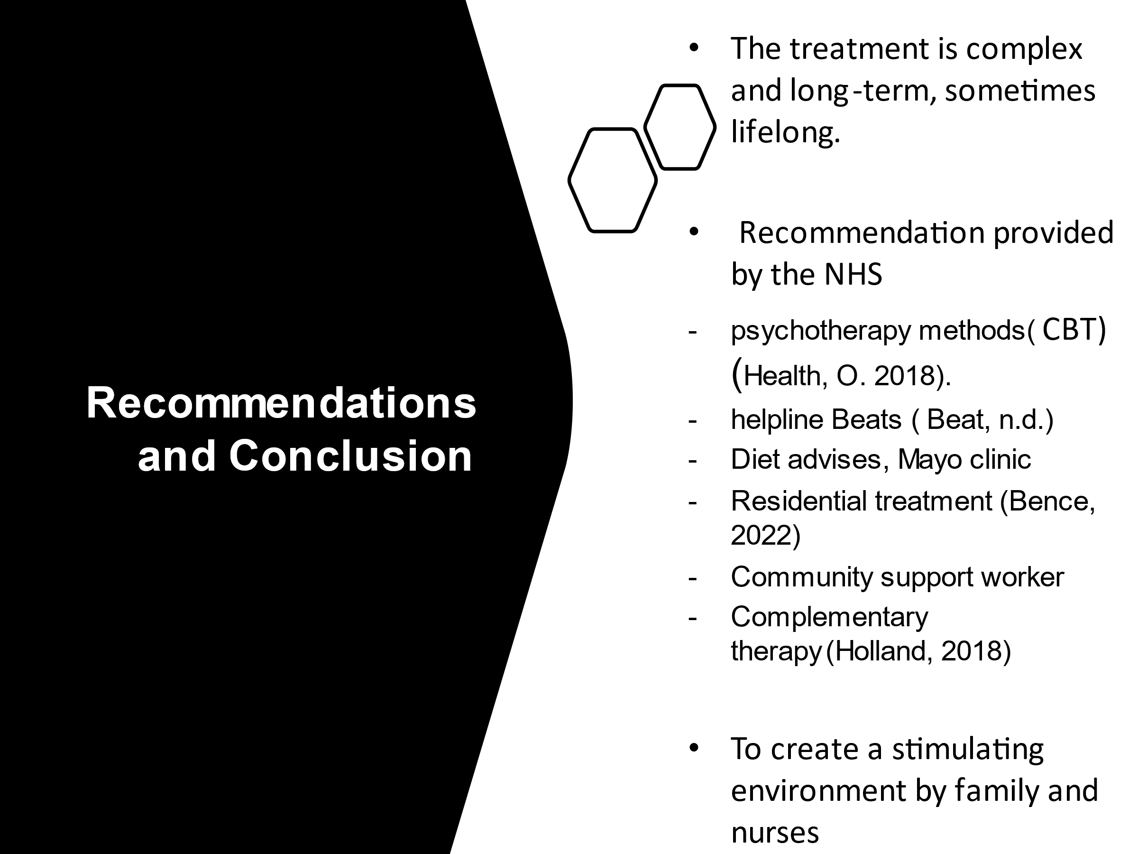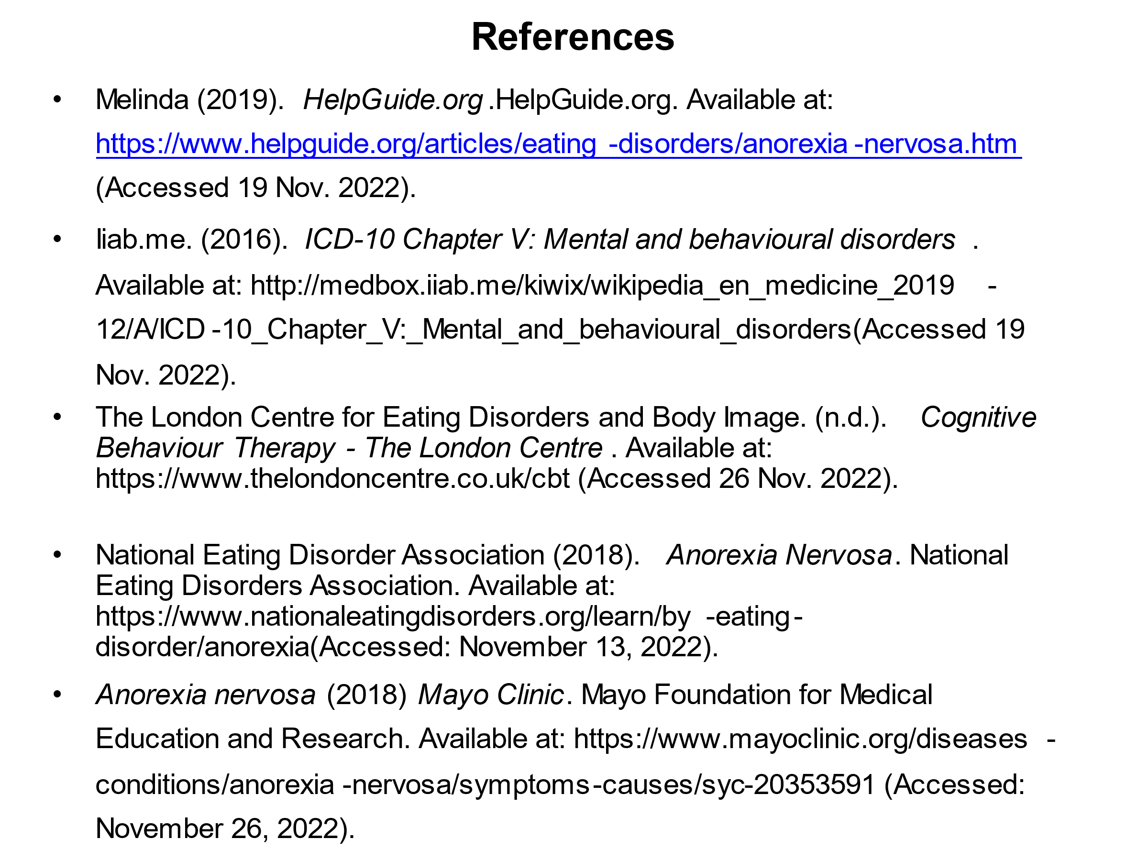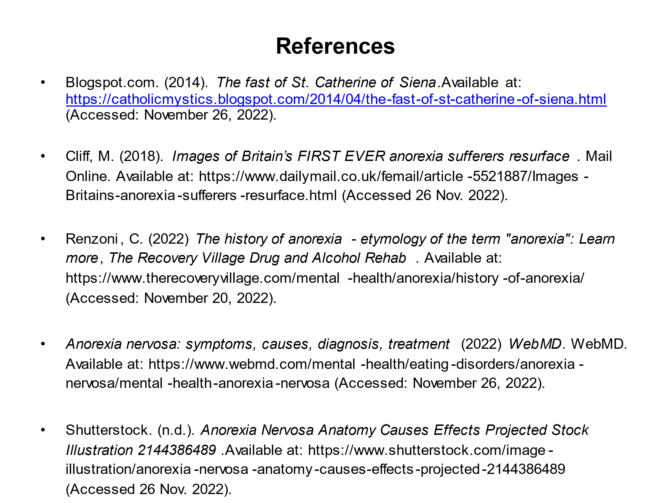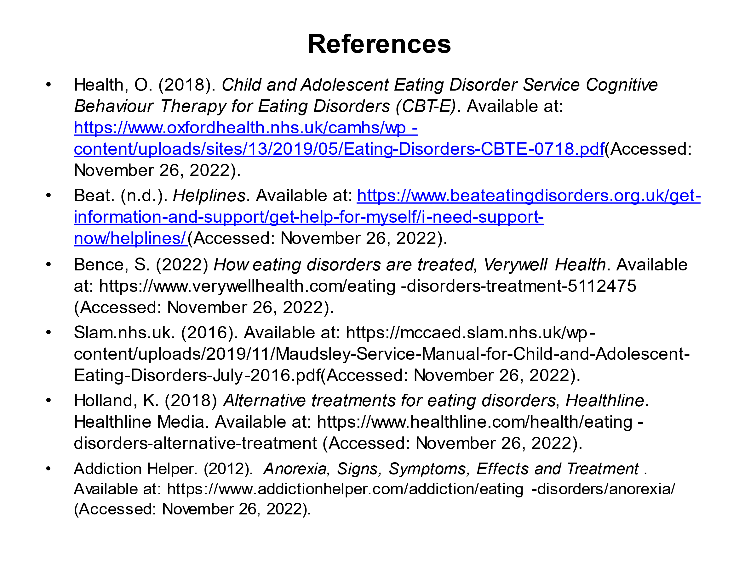Appendix 2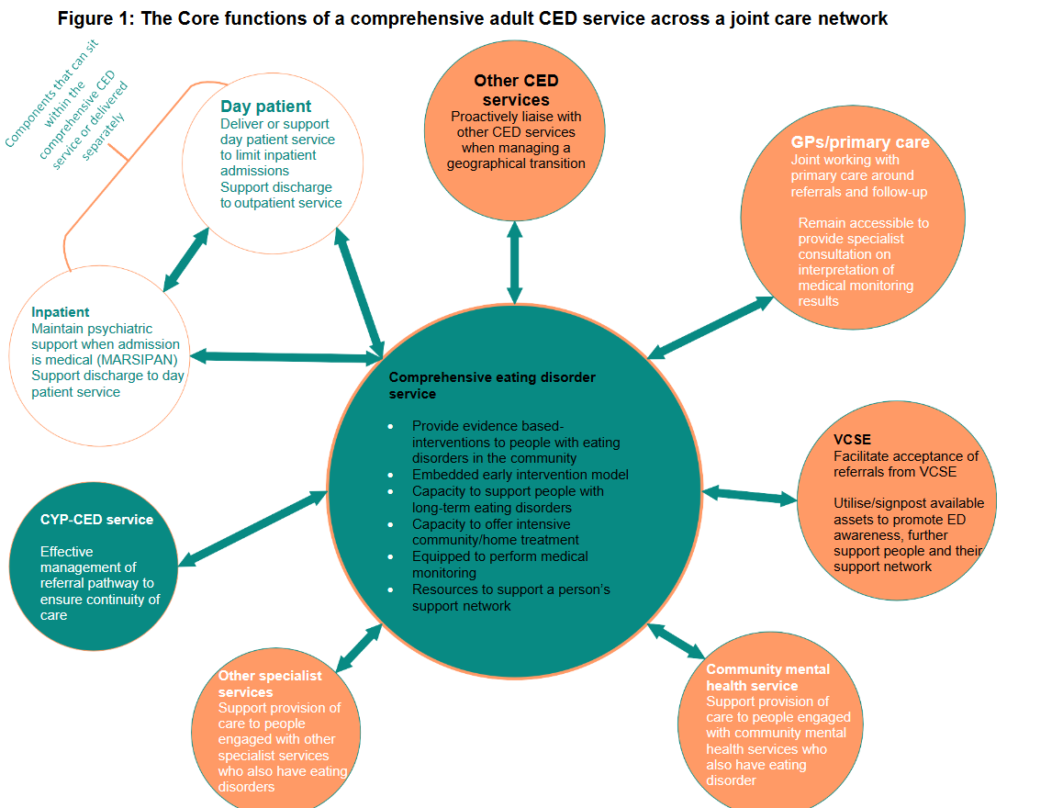

(NHS, 2019)

