

UNIVERSITY OF WALES TRINITY SAINT DAVID

INTRODUCING THE MODERN WORKPLACE - LCBB4003

LECTURER –DR. DUDLEY OFORI

STUDENT NAME – TSONYO TODOROV

STUDENT ID – 2021609

ASSINGMENT 1

REPORT

UNILEVER UK

TABLE OF CONTENTS
Introduction 3
Overview of Unilever UK 3
Organisational Structure of Unilever UK 4
Organisational Culture and Performance 5
Employee Performance 6
Employee Motivation 7
Conclusion 11
Reference 12

INTRODUCTION
An organization’s success depends heavily on its structure, culture, and the enthusiasm of its workers. In this paper, we examine Unilever UK and the ways in which its organizational design, company ethos, and employees’ sense of purpose all work together. This research analyses the effect of these concepts, theories, and frameworks on an organization’s success in reaching its objectives by looking at the connection between structure, culture, and performance as well as theories on employee motivation. The dynamics of Unilever UK’s structure and culture, and how they affect employee motivation, are explored in this research using a mix of actual evidence and theoretical viewpoints. To further boost productivity and encourage an enthusiastic team, suggestions are also provided.

OVERVIEW OF UNILEVER UK
Established in London, England, Unilever is a global leader in consumer goods. In the United Kingdom, the corporation is known as Unilever UK. Dove, Axe, Hellmann’s, Knorr, Lipton, and Axe are just a few of the more than 80 brands that this company sells in the United Kingdom. Almost every home in the United Kingdom has access to Unilever UK’s products. Over 6,000 employees are employed by the firm in the United Kingdom (Unilever UK, 2023). In 2022, Unilever UK earned £10.4 billion (about €12.2 billion) in sales (Unilever UK, 2023). According to GlobalData (2023), the UK grocery market accounts for 40% of the firm’s revenue, followed by personal care (30%) and home care (30%). Sustainable living is a top priority for Unilever UK, and the corporation has set several lofty goals, including reducing its environmental impact by half by 2030.

ORGANIZATIONAL STRUCTURE OF UNILEVER UK
Unilever UK uses a matrix structure for its management that includes functional and divisional features (Robbins and Judge, 2017). The organization is set up in this way so that it can efficiently handle its many different lines of business and the many different regions in which it operates. Marketing, R&D (Research and Development), Finance, Supply Chain, and Human Resources are just few of the departments that make up Unilever UK's matrix structure. By dividing the business into specialized departments, each aspect can be handled with the utmost precision and efficiency. To be sure, the year 2023 is mentioned by GlobalData. For instance, the marketing team works on strategies and campaigns for various product lines, whereas R&D concentrates on new product creation and innovation. Unilever UK uses both functional units and a divisional structure to meet the needs of its many target markets and geographic areas. Separating the company into sections based on product lines or regions enables more targeted approaches and management. For instance, Unilever UK might have several departments for its various product lines, including those related to food, hygiene, and personal care. By structuring the company in this way, Unilever UK can better respond to fluctuations in demand, changes in the law, and variations in consumer taste. Unilever’s matrix organizational structure encourages teams to work together across departments to solve problems and share information (Unilever, 2023). Creativity, adaptability, and good decision-making are all bolstered in a setting like this. Unilever UK is able to effectively manage complex challenges and seize market opportunities by drawing on the knowledge and experience of employees across functional units and divisions. In addition, the matrix design facilitates better collaboration and allocation of resources (Robbins and Judge, 2017). Managers at Unilever UK are tasked with coordinating efforts across departments and business units to achieve organizational objectives. Coordination like this is essential for minimizing waste, maximizing productivity, and maximizing the effectiveness of available resources. Finally, the matrix structure at Unilever UK, which incorporates both functional and divisional parts, allows for a dynamic and cooperative approach to running the business. The organization is now in a better position to take advantage of specialized knowledge, develop market-specific strategies, and improve collaboration between its many units. Incorporating this organizational framework has helped Unilever UK successfully manage its many product lines and regional markets.

ORGANIZATIONAL CULTURE AND PERFORMANCE
Unilever UK’s organizational culture is distinguished by its dedication to ethical business practices, diversity and inclusion, and a focus on the environment. Sustainability training, diversity and inclusion efforts, and ethical compliance programs are only some of the ways in which the corporation encourages these principles among its employees. Unilever UK has been frequently named as one of the finest places to work in the UK, and this is largely due to the company’s impressive culture. The company’s sustainability efforts have earned accolades, and it has aggressive plans to lessen its negative effects on the environment and educate customers on how they may improve their own sustainability footprints as reported by Unilever UK in the year 2023. The company has been named as corporate sustainability leader for the 12th consecutive year in 2022 as selected by more than 700 global experts in a GlobeScan SustainAbility Leaders Survey (Unilever UK, 2023).

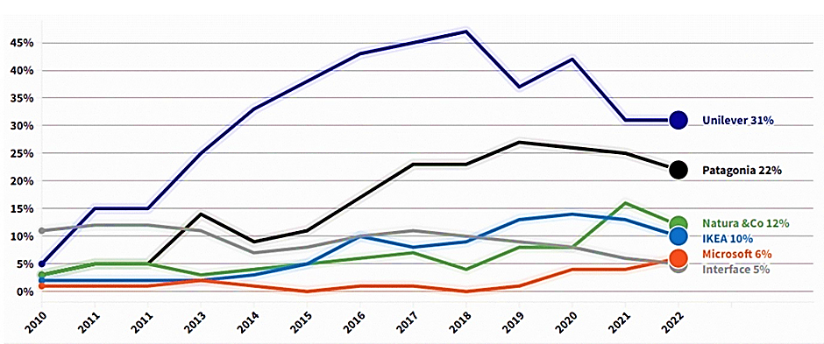

Fig.1 GlobeScan SustainAbility Leaders Survey 2022
Source: www.unilever.com
Unilever UK’s financial results have been improving as the company has increased both revenue and profits over the past few years. The firm earned €6.8 billion in profits off €52.4 billion in sales in 2022 (GlobalData, 2023) and is expected to do the same in 2023. The success of Unilever UK can be attributed to the company’s many distinguishing features, such as its reputable brands, innovative products, and dedication to environmental protection. Among the many reasons for Unilever UK’s success is the company’s culture. The data shows that the company’s dedication to environmental responsibility, diversity and inclusion, and ethical business practices fosters an inspiring and productive workplace. Unilever UK’s sustainability efforts boosted the company’s bottom line. According to them, the company has seen greater profits, decreased expenses, and enhanced risk mitigation as a result of its commitment to sustainability.

EMPLOYEE PERFORMANCE
Unilever UK’s culture plays a vital role in shaping employee behavior and influencing their performance outcomes. A positive and inclusive culture fosters an environment where employees feel a sense of purpose and are motivated to contribute their best efforts (Schein, 2010). This culture promotes collaboration, creativity, and ethical conduct, all of which contribute to improved performance.
- Collaboration: Unilever UK’s culture of collaboration is fostered through a number of initiatives, such as cross-functional teams, open communication, and a focus on teamwork. This culture of collaboration allows employees to share ideas and insights, which can lead to more innovative solutions. For example, in 2019, Unilever UK’s employees came up with over 1,000 ideas for how to reduce the company’s environmental impact. (Unilever UK, 2023). Employees who are part of a company with a positive and welcoming culture have a greater chance of being invested in their work and finding meaning in what they do, according to research conducted at the University of Warwick (Luthans et al., 2007).

- Creativity: Unilever UK’s culture of creativity is fostered through a number of initiatives, such as innovation challenges, hackathons, and a focus on experimentation. This culture of creativity allows employees to take risks and try new things, which can lead to new products and services. For example, Unilever UK’s Dove brand has been at the forefront of innovation in the beauty industry, with products such as Dove Self-Esteem Project and Dove Men+Care. (Unilever, 2023). According to another piece of research published in the Harvard Business Review, innovative company cultures tend to thrive over time (Dyer & Singh, 1998).

- Ethical conduct: Unilever UK’s culture of ethical conduct is fostered through a number of initiatives, such as its Code of Conduct, its Ethics Helpline, and its Whistleblowing Policy. This culture of ethical conduct ensures that employees are aware of their responsibilities and that they feel comfortable reporting any wrongdoing. For example, Unilever UK’s Code of Conduct prohibits discrimination and harassment, and it requires employees to act in a responsible and sustainable manner. (Unilever UK, 2023). Moreover, Customers are more likely to have faith in and support businesses with a strong culture of ethics, according to research (Schwab 2019).
Overall, Unilever UK has a strong organizational culture and a positive performance record. The company is committed to sustainability, diversity, inclusion, and ethical practices, and these values are embedded in its mission and values. As a result, Unilever UK is one of the best places to work in the UK, and it has been consistently growing its revenue and profits in recent years.

EMPLOYEE MOTIVATION
To better understand and meet the motivating requirements of its employees, Unilever UK draws from a number of motivation theories, including Maslow’s Hierarchy of requirements, Herzberg’s Two-Factor Theory, and the Self-Determination Theory.
- Maslow proposed a hierarchy of wants, from the most basic to the most advanced, in which demands were to be met in a specified order (Maslow, 1943). For the sake of their employees’ well-being and motivation, Unilever UK provides them with fundamental necessities such as competitive pay, safe working conditions, and job security (Deci & Ryan, 2000). The corporation provides for its employees’ fundamental requirements, laying the groundwork for high morale and productivity.

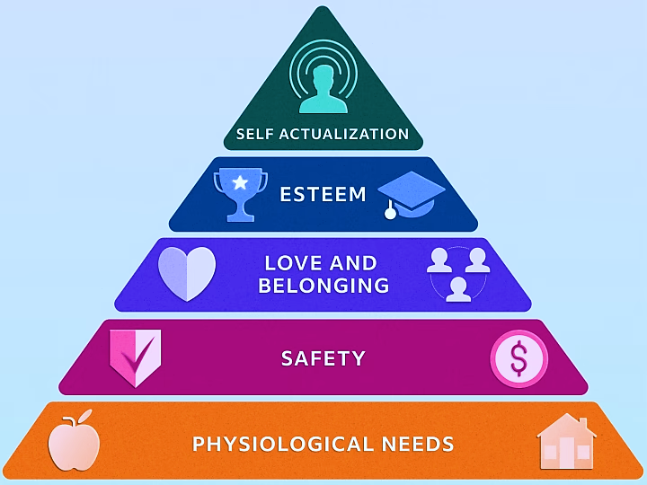

Fig.2 Maslow’s hierarchy of needs
Source: https://www.indeed.com/career-advice/career-development/maslows-hierarchy-of-needs
- According to Herzberg’s Two-Factor Theory (Herzberg et al., 2011), there are a number of elements that contribute to employee satisfaction and performance on the job. To increase employee motivation, Unilever UK prioritizes both intrinsic motivators and basic workplace sanitation. The organization, for instance, creates incentive and recognition programs to show appreciation for workers’ efforts and offers training and promotion prospects to help them grow professionally (Beardwell et al., 2019). To meet the demands of its workforce in terms of personal cleanliness, Unilever UK provides competitive wages, permanent employment, and a risk-free workplace.

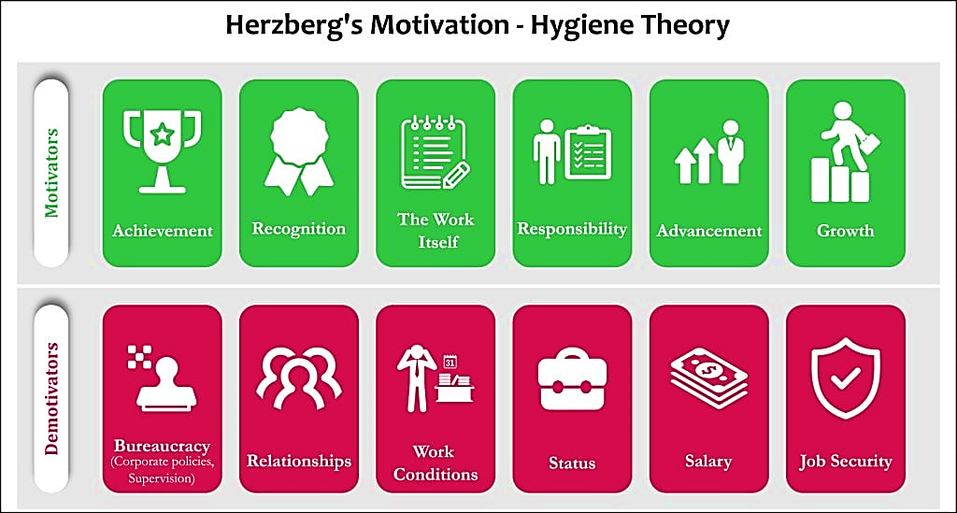

Fig.3 Herzberg’s Two-Factor Theory
Source: https://www.simplypsychology.org/herzbergs-two-factor-theory.html

- According to Self-Determination Theory (Ryan & Deci, 2000), workers are more engaged and productive when they feel a feeling of autonomy at work and are able to pursue goals that matter to them. According to research by Beardwell et al. (2019), at Unilever UK, workers are given the freedom to make their own decisions and are given responsibility for achieving the company’s goals. The corporation recognizes the importance of giving workers a feeling of meaning by emphasizing its commitment to sustainability, social responsibility, and ethical practices (Unilever, 2023).

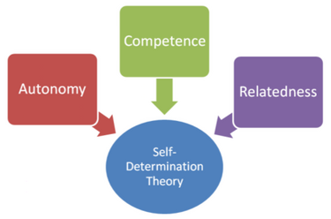

Fig. 4 Self-Determination Theory
Source: https://en.wikipedia.org/wiki/Self-determination_theory

Unilever UK aspires to provide a stimulating workplace by adopting these theories to better understand and meet the requirements of its employees. The necessity of meeting fundamental necessities, offering opportunities for advancement, and encouraging employees’ sense of autonomy and motivation is something the organization takes seriously. The engagement, satisfaction, and productivity of Unilever UK’s workforce have all benefited from this multidimensional approach to motivating.
CONCLUSION
Unilever UK can improve performance and employee motivation by implementing numerous tips. Firstly, encourage ongoing learning. This involves giving employees training and learning resources. Continuous learning boosts professional development and motivates personnel. Secondly, giving employees autonomy and decision-making ability. Employees feel powerful and engaged when they own their job. Unilever UK can delegate decision-making and allow staff to make decisions in their areas of competence. Establishing transparent and equal incentive systems is crucial. Fair wages, recognition programs, and merit-based progression motivate employees. Employees should be informed of performance evaluation standards to provide fair and consistent incentives. Promoting collaboration and teamwork enables people to work together, which boosts innovation and friendship. Unilever UK can establish cross-functional collaboration platforms and regular communication channels for employees to share ideas and provide feedback. Collaboration boosts engagement and encourages employees to work hard. Communicating and reinforcing the company's beliefs and mission is vital. When employees understand and identify with the company's purpose and values, they become more motivated and committed. Through many platforms, Unilever UK may connect employees with organizational goals by communicating the company's values and mission.

REFERENCES

- Beardwell, J., Holden, L., & Claydon, T. (2019) Human resource management: A contemporary approach. Pearson Education Limited.

- Deci, E. L., & Ryan, R. M. (2000) ‘The "what" and "why" of goal pursuits: Human needs and the self-determination of behavior’. Psychological Inquiry, 11(4), pp.227-268.

- Dyer, J.H. and Singh, H. (1998) ‘The relational view: Cooperative strategy and sources of interorganizational competitive advantage’, The Academy of Management Review, 23(4), pp. 660. doi:10.2307/259056.

- GlobalData (2023) Unilever Plc company profile. Available at: https://www.globaldata.com/company-profile/unilever-plc-gd33882/ (Accessed: 05th August 2023).

- Herzberg, F., Mausner, B., & Snyderman, B. B. (2011) The motivation to work. Transaction Publishers.

- Luthans, F., Youssef, C.M. and Avolio, B.J. (2007) ‘Psychological capital: Investing and developing positive organizational behavior’, Positive Organizational Behavior, pp. 9–24. doi:10.4135/9781446212752.n2.

- Maslow, A. H. (1943) ‘A theory of human motivation’, Psychological Review, 50(4), pp.370–396.

- Robbins, S. P., & Judge, T. A., (2017) Essentials of Organizational Behavior (14th ed.). Pearson Education.

- Ryan, R. M., & Deci, E. L. (2000) ‘Self-determination theory and the facilitation of intrinsic motivation, social development, and well-being’, American Psychologist, 55(1), 68-78.

- Schein, E. H. (2010) Organizational culture and leadership (Vol. 2). John Wiley & Sons.

- Schwab, K. (2019) The global competitiveness report 2019. Geneva: World Economic Forum.

- Unilever UK, (2023) About us. Available at: https://www.unilever.co.uk/our-company/ (Accessed: 03rd August 2023).

- Unilever, (2023) Our company. Available at: https://www.unilever.com/our-company/ (Accessed: 03rd August 2023).

- Unilever, (2023) Unilever Annual Report and Accounts 2022. Available at: https://www.unilever.com/investors/annual-report-and-accounts/ (Accessed: 03rd August 2023).

