TOUR OF LONDON
Website Design, Implementation and Evaluation Report
Student Name: Brandon Balanta
Student Number: 2508004
Course: CertHE Computing Skills for Workplace
Module Name: Introduction to Web and Database Concepts
Date: 28 July 2026
Submitted as a specification and evaluation report for the Tour of London website.

Table of Contents
1. Introduction
2. Requirements
3. Implementation
3.1 Design Decisions
3.2 Implementation Process
3.3 Website Page Screenshots
3.4 Validation
4. Evaluation
4.1 Usability
4.2 Accessibility
4.3 Search Engine Optimisation
4.4 Evaluation of the Completed Website
4.5 Comparison with Similar Live Websites
5. Conclusion
6. References

1. Introduction
This report documents the research, design decisions, implementation process and evaluation of the Tour of London website. The website is a small, static tourism website developed using HTML and CSS. It provides a simple introduction to London, presents visual content relating to London attractions and includes a contact page. The report explains the requirements and design rationale, documents the completed pages using screenshots, discusses HTML and CSS validation, and evaluates the site in relation to usability, accessibility and search engine optimisation (SEO). It also compares the project with established tourism and public-information websites to identify strengths and opportunities for future improvement.

2. Requirements
The purpose of the Tour of London website is to provide a straightforward introduction to London for users who are interested in visiting the city or learning about its well-known attractions. The subject matter is London tourism, with visual emphasis on recognisable landmarks and destinations. The intended audience includes tourists, prospective visitors, students researching London and general users looking for a simple visual overview of the city.
The website consists of three main pages: a Home page (index.html), a Gallery page (gallery.html), and a Contact page (contact.html). A consistent navigation bar allows users to move between these pages. The project uses a shared CSS file (style.css) and locally stored image assets. The screenshots supplied for this report show the project structure and the rendered website in a desktop browser.

Functional Requirements
- Provide a clear home page introducing London and the purpose of the website.
- Provide navigation links to Home, Gallery and Contact pages.
- Display London-related images with alternative text where images are embedded in HTML.
- Provide a gallery area for showcasing London attractions.
- Provide a contact form containing name, email and message fields and a Send control.
- Maintain a consistent visual identity across pages using a shared stylesheet.
- Use a responsive viewport declaration so the page can scale to different screen sizes.

3. Implementation

3.1 Design Decisions
The website uses a simple, recognisable visual hierarchy. A blue header provides a strong visual identity and creates separation between the navigation area and the main content. White text is used within the header to create clear contrast. The navigation consists of three short links—Home, Gallery and Contact—which reduces cognitive load and makes the primary destinations immediately visible.
The content area uses a light background and centred content. Images are given a large display area because tourism is strongly visual: photographs of landmarks such as Big Ben, Tower Bridge and Buckingham Palace help users understand the subject immediately. Rounded image corners provide a softer appearance, while the shared footer reinforces consistency between pages.
The implementation follows a simple separation of concerns. HTML files provide structure and content, while style.css controls presentation. The project folder shown in the supplied screenshots contains index.html, gallery.html, contact.html, style.css and an images folder containing multiple JPG and WebP image assets.

3.2 Implementation Process
- The project was organised in Visual Studio Code with separate HTML pages, a shared CSS file and an images directory.
- The HTML structure was created using semantic elements such as header, nav, section and footer.
- A viewport meta element was included to support responsive scaling on mobile devices.
- The shared stylesheet was used to apply the blue header/footer, typography, spacing, image sizing, rounded corners and form styling.
- The Home page was implemented with a welcome heading, introductory paragraphs and a London image.
- The Gallery page was implemented to showcase London attractions through large photographic content.
- The Contact page was implemented with labelled Name, Email and Message fields and a Send button.
- The pages were opened locally in Microsoft Edge to check the rendered appearance and navigation.

3.3 Website Page Screenshots
The following screenshots document the completed website and development environment. They are included as evidence of implementation rather than as code listings. Where a page is visually long, the screenshot represents a reasonable cropped view of the rendered content.
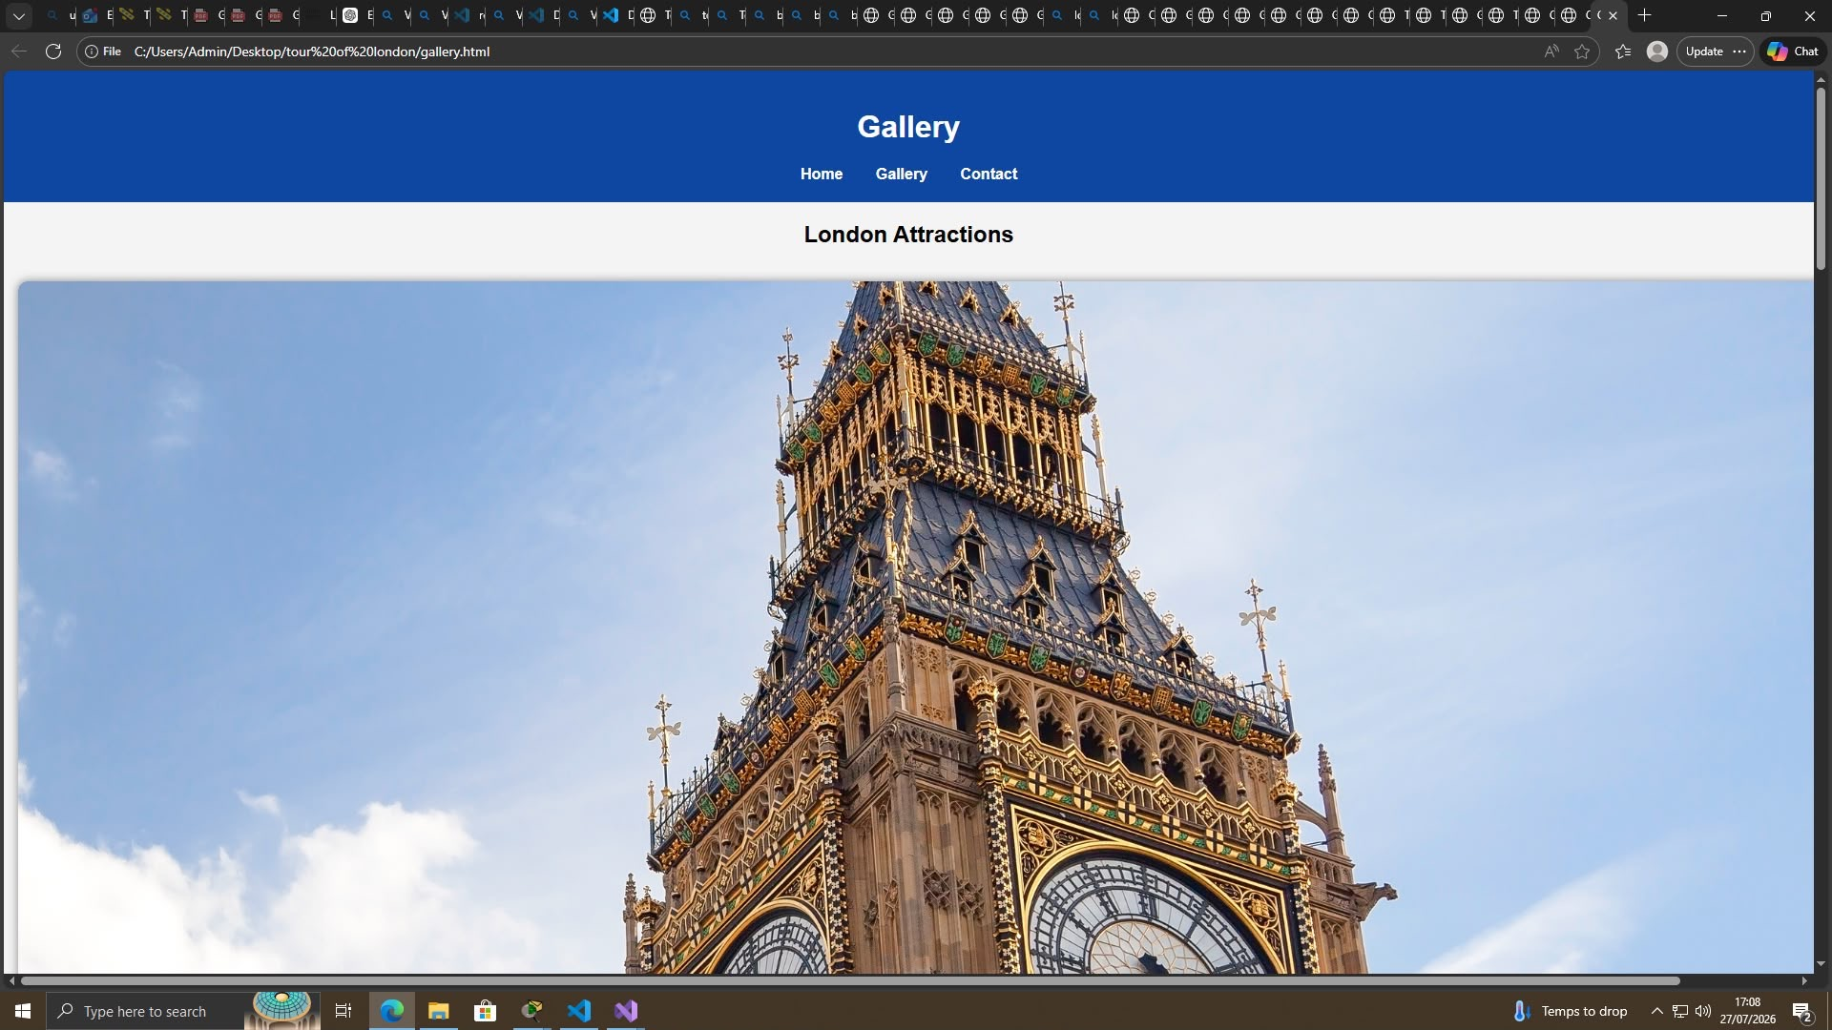
Figure 1. Gallery page showing the Tour of London header, navigation and London attraction imagery.
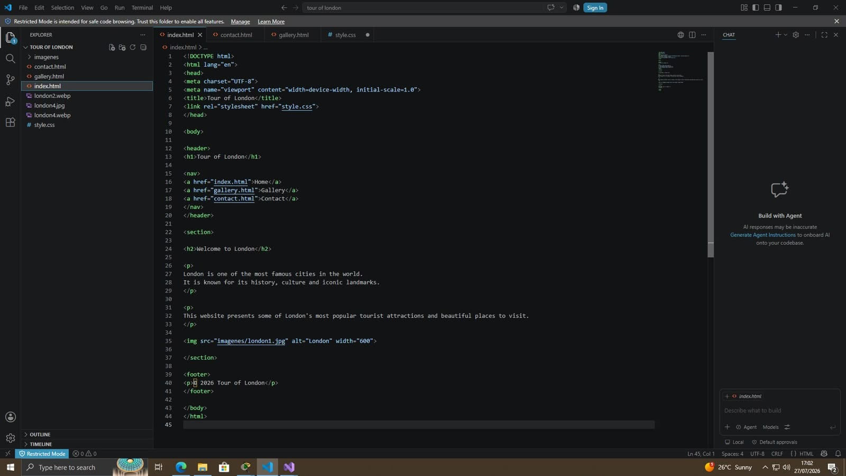
Figure 2. Contact page showing the navigation, Contact Us heading and contact form.
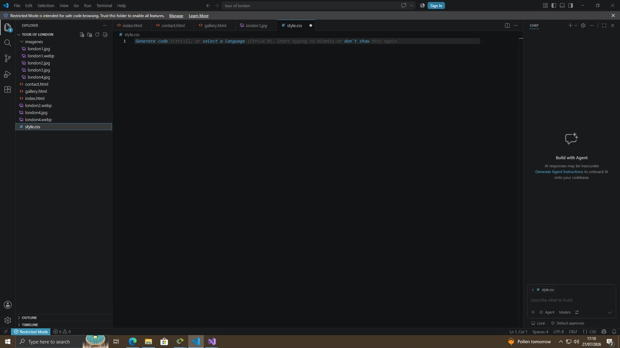
Figure 3. Gallery imagery showing Tower Bridge as a major London attraction.
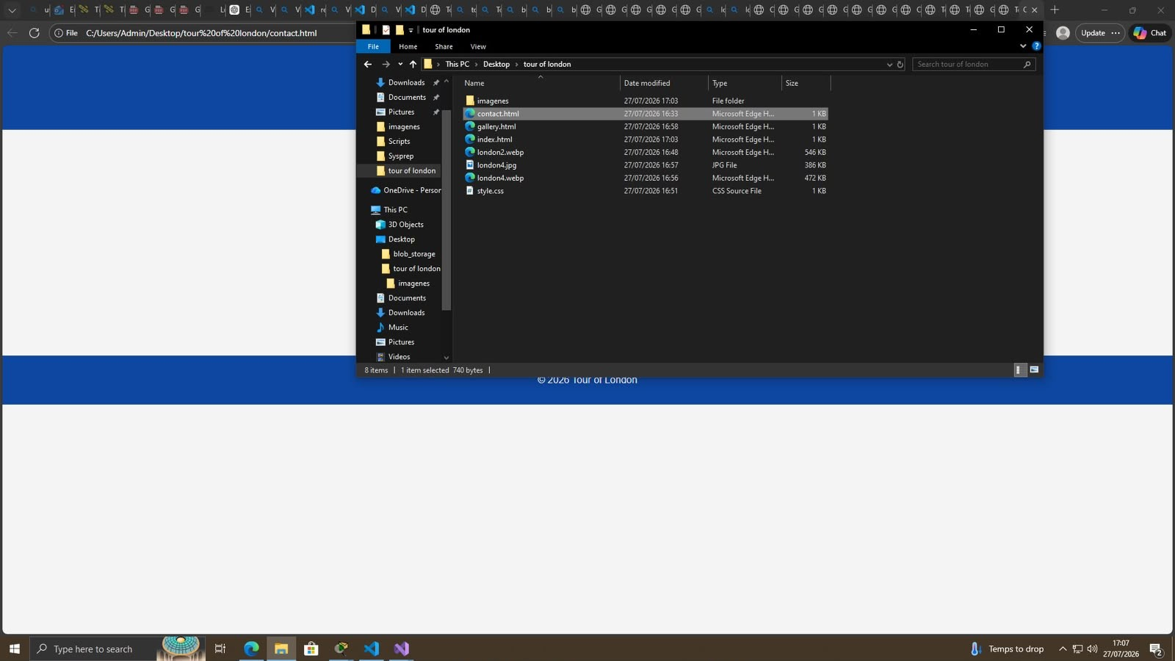
Figure 4. Gallery imagery showing Buckingham Palace and surrounding gardens.
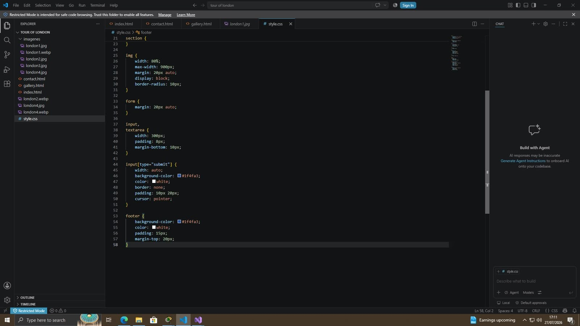
Figure 5. Home page HTML structure in Visual Studio Code.
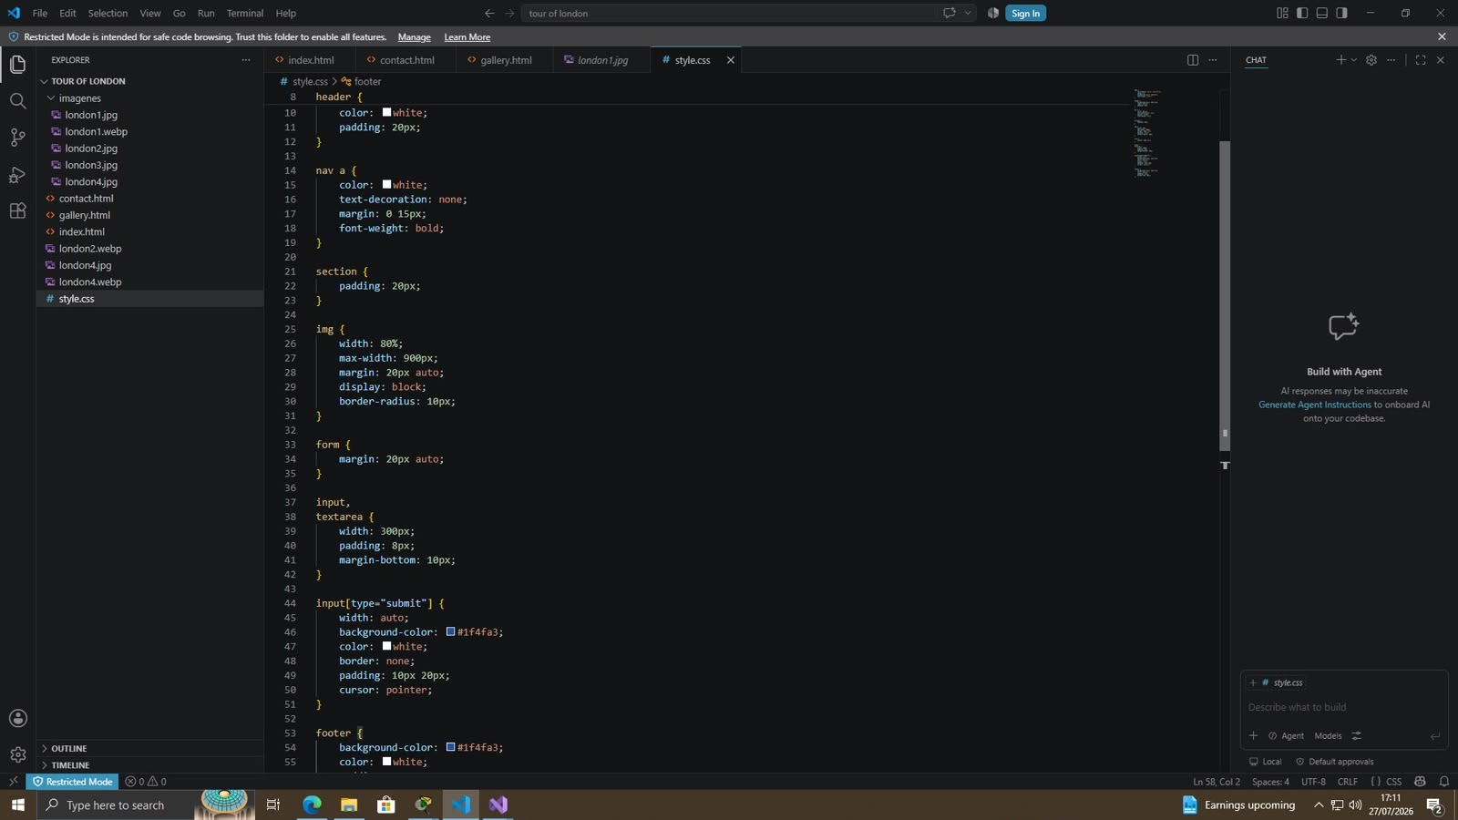
Figure 6. Main CSS rules for layout, images and forms.
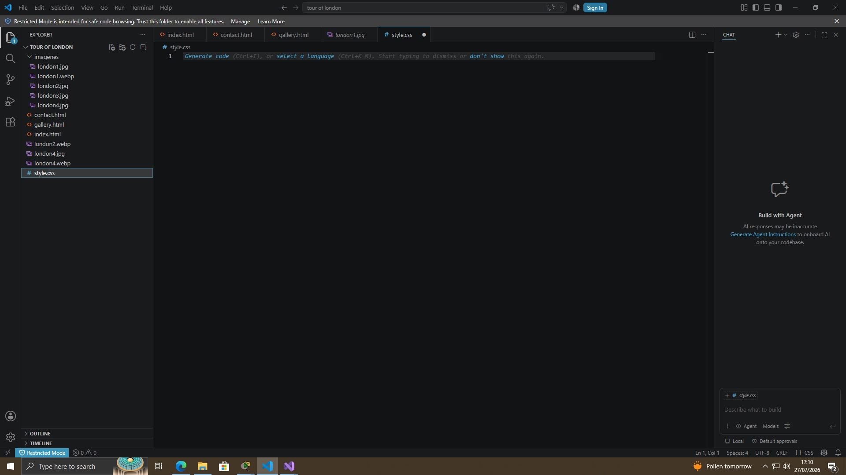
Figure 7. Lower section of the CSS stylesheet showing form and footer styling.
Figure 8. Project folder structure and website assets in Visual Studio Code.

3.4 Validation
The assignment requires validation of the Home page HTML and the main CSS stylesheet. The supplied screenshots show the source files and local rendering, but they do not provide a captured result from the W3C Markup Validation Service or W3C CSS Validation Service. Therefore, this report does not claim a specific validator pass/fail result that cannot be evidenced from the supplied material. The validation section below records the appropriate validation procedure and the issues that should be checked before final submission.

HTML Validation
The Home page (index.html) should be submitted to the W3C Markup Validation Service. The visible source indicates several good practices: a DOCTYPE declaration, lang="en", UTF-8 character encoding, a viewport declaration, a page title, a linked external stylesheet, semantic structural elements and an alt attribute on the main image. The validator output should be attached or pasted here before final submission. If validation identifies errors, they should be corrected by checking element nesting, attribute syntax, required attributes and document structure, then the page should be revalidated.
HTML validation result: To be completed using the W3C validator output for index.html.

CSS Validation
The main stylesheet (style.css) should be submitted to the W3C CSS Validation Service. The supplied stylesheet uses conventional CSS selectors and declarations for the header, navigation, section, images, form controls, submit button and footer. The validator output should be included as evidence. Any syntax errors should be corrected and the stylesheet revalidated.
CSS validation result: To be completed using the W3C CSS validator output for style.css.

4. Evaluation

4.1 Usability
Usability concerns how effectively, efficiently and satisfactorily users can achieve their goals when interacting with a system. In web development, usability affects whether users can understand a site's purpose, find information, navigate between pages and complete tasks without unnecessary effort. Nielsen's usability principles emphasise issues such as visibility of system status, consistency, recognition rather than recall and error prevention.
A relevant peer-reviewed research example is Venkatesh et al. (2003), who developed and validated the Unified Theory of Acceptance and Use of Technology (UTAUT). The study examined factors influencing technology acceptance and found that performance expectancy, effort expectancy and social influence were important determinants of behavioural intention and technology use. Although broader than tourism websites, the findings support the importance of making a website useful and easy to use. For the Tour of London project, the short navigation menu and simple page structure reduce the effort required to reach the Gallery or Contact page.
The site's usability is generally strong for a small introductory website. The navigation is consistent, the number of pages is limited and the visual purpose is immediately clear. However, the site has limited functionality: the gallery could provide captions or attraction descriptions, and the contact form appears primarily presentational unless connected to a server-side processing system. Future development should add clearer attraction information, functional form processing, visible focus states and stronger feedback after form submission.

4.2 Accessibility
Accessibility means designing websites so that people with a wide range of abilities can perceive, understand, navigate and interact with content. Accessible development is important because users may have visual, auditory, motor or cognitive disabilities and may use assistive technologies such as screen readers, keyboard navigation or screen magnification.
A relevant peer-reviewed example is Lazar, Goldstein and Taylor (2015), whose research on web accessibility documented the continuing gap between accessibility requirements and real-world web experiences. Their work highlights that accessibility barriers can arise from design and development practices as well as from technical implementation. The implication for this project is that basic HTML structure and alt text are positive foundations, but accessibility must be evaluated systematically rather than assumed from visual appearance alone.
The Tour of London site demonstrates some accessible practices. The Home page source shown in the supplied screenshots includes a lang="en" attribute, a meaningful title and alt text for the main image. The navigation uses standard anchor links, which are generally keyboard accessible. The contact page presents visible labels for Name, Email and Message.

WCAG 2.1 Four Principles

Perceivable
Content should be available to users in ways they can perceive. The use of text alongside imagery supports this, and the Home page image includes alternative text. Further improvements should include meaningful alt text for every informative image, avoid text embedded in images, and ensure adequate colour contrast.

Operable
Users should be able to operate controls through different input methods. Standard HTML links and form controls support keyboard operation. Future work should verify visible keyboard focus indicators and ensure that all interactive elements can be reached and used without a mouse.

Understandable
Information and operation should be clear and predictable. The consistent navigation and simple page titles support understandability. The contact form would be improved by adding explicit instructions, input types such as email, validation messages and clear feedback when a message is submitted.

Robust
Content should work reliably across user agents and assistive technologies. The use of standard HTML elements is a positive foundation. The site should be tested with automated accessibility tools and assistive technology, and HTML/CSS should be validated to reduce structural and compatibility problems.

4.3 Search Engine Optimisation
Search engine optimisation (SEO) is the practice of improving a website's visibility and relevance in unpaid search engine results. SEO includes technical structure, page content, metadata, internal linking, performance, mobile friendliness and the clarity with which search engines can understand a site's subject.
A peer-reviewed research example is Baeza-Yates and Ribeiro-Neto's work on information retrieval, which explains the importance of matching user information needs with relevant indexed content. In practical SEO terms, this reinforces the need for descriptive page titles, meaningful headings and useful textual content rather than relying solely on images.
The project applies several basic on-page SEO techniques. The Home page has a descriptive title, a clear H1 heading ('Tour of London'), an H2 heading ('Welcome to London'), descriptive paragraphs containing relevant terms such as London, history, culture and landmarks, and an image with alt text. Internal links connect the Home, Gallery and Contact pages. The viewport meta element supports mobile presentation. These measures provide a reasonable foundation, although SEO could be improved through unique and more descriptive titles for every page, meta descriptions, more detailed attraction content, descriptive image filenames, structured data for tourism content, a sitemap and deployment to a crawlable public domain.

4.4 Evaluation of the Completed Website

Usefulness, Usability and Content
The website is useful as a basic visual introduction to London. Its strongest feature is simplicity: users can quickly understand the site's purpose and move between three pages. The blue-and-white colour scheme provides a consistent visual identity, and the large landmark imagery is appropriate for tourism content. The gallery is particularly useful for visual engagement.
The main limitation is depth. The site currently provides little practical travel information such as opening times, transport options, prices, accessibility information or links to official attraction websites. The contact form also requires a back-end service or form-processing mechanism to become fully functional. Future improvements should include richer attraction descriptions, search/filter functionality, responsive image sizing, a working contact workflow and clear confirmation messages.

Layout, Navigation, Readability and User Experience
Area | Evaluation
Layout | The layout is simple and consistent. The header, navigation, content and footer create a predictable structure. Large images support the tourism purpose, although some images appear very large on desktop screens.
Navigation | The three-link navigation is easy to understand and remains consistent across the site. A future active-page indicator would help users know their current location.
Readability | The use of a clean sans-serif presentation, high-contrast white text on blue and clear headings supports readability. More body content and stronger typographic hierarchy could improve information scanning.
User experience | The site provides a low-friction experience for basic browsing. Its main weaknesses are limited interactivity, limited informational depth and the absence of visible validation/feedback on the contact form.

Accessibility Recommendations
- Use more descriptive alt text for each informative attraction image.
- Add explicit label-for/id associations to all form controls.
- Use type="email" for the email field and add required attributes where appropriate.
- Provide visible keyboard focus indicators for links and form controls.
- Check colour contrast with a recognised WCAG contrast checker.
- Test the pages using WAVE or axe and, where possible, a screen reader.
- Add clear error and success messages to the contact form.
- Use responsive CSS media queries so the layout adapts more effectively to small screens.

SEO Recommendations
- Give each page a unique, descriptive title, such as 'Tour of London – Attractions Gallery'.
- Add a concise meta description to each page.
- Use descriptive filenames and alt text for attraction images.
- Expand useful textual content around each attraction to improve relevance and user value.
- Add an XML sitemap and robots.txt when the website is deployed publicly.
- Consider structured data such as Schema.org tourism-related markup where appropriate.
- Optimise image file sizes and use responsive image techniques to improve performance.

4.5 Comparison with Similar Live Websites
For comparison, two recognised websites serving related tourism/public-information functions are Visit London and VisitBritain. These sites operate at a much larger scale than the student project and therefore provide useful benchmarks for content depth, navigation, accessibility and responsive design.
Area | Tour of London | Visit London | VisitBritain
Usability | Very simple navigation and low cognitive load; limited functionality. | Extensive destination categories, search/discovery features and richer trip-planning content. | Strong destination discovery and travel-planning content with a broad information architecture.
Accessibility | Basic semantic HTML, alt text and standard links provide a foundation; requires formal WCAG testing. | Large professional site with accessibility considerations, but complexity means ongoing testing is important. | Established public-facing platform with accessibility information and a broad range of content.
SEO | Basic title, headings, text and internal links; needs metadata and richer content. | Large amount of crawlable, destination-focused content and strong internal linking. | Extensive content targeting travel intent and destination searches.
Mobile responsiveness | Viewport is included, but the supplied CSS does not show comprehensive responsive breakpoints. | Designed for a broad range of devices and modern browsing behaviour. | Designed as a major public travel platform and expected to support mobile users.
Overall comparison | Good as a beginner-level static tourism site; strongest in simplicity. | Much stronger for real-world trip planning and discovery. | Much stronger in scale, content depth, authority and travel-planning usefulness.
The comparison demonstrates that the student project succeeds primarily through simplicity and consistency, whereas large tourism websites succeed through breadth, content depth, search and filtering, technical SEO and mature responsive design. The most realistic improvement path is not to reproduce the complexity of a commercial platform, but to add high-value features incrementally: better attraction information, responsive layouts, accessible forms, clear SEO metadata and useful links to official visitor information.

5. Conclusion
The Tour of London website meets the core requirements of a small static tourism website by providing a clear introduction, a visual gallery and a contact page connected through consistent navigation. The implementation demonstrates fundamental HTML and CSS skills, separation of content from presentation and the use of imagery to support a tourism theme. The evaluation shows that the project has a good foundation in simplicity, visual consistency and basic semantic structure, but further work is required to demonstrate full accessibility compliance, comprehensive responsive behaviour, validated code results and stronger SEO. Future development should focus on formal WCAG testing, W3C validation evidence, richer content, responsive CSS, functional form processing and more detailed on-page SEO.

6. References
- Baeza-Yates, R. and Ribeiro-Neto, B. (2011) Modern Information Retrieval: The Concepts and Technology behind Search. 2nd edn. Addison-Wesley.
- Lazar, J., Goldstein, D.F. and Taylor, A. (2015) Ensuring Digital Accessibility through Process and Policy. Morgan Kaufmann.
- Nielsen, J. (1994) Usability Engineering. Morgan Kaufmann.
- Venkatesh, V., Morris, M.G., Davis, G.B. and Davis, F.D. (2003) 'User acceptance of information technology: Toward a unified view', MIS Quarterly, 27(3), pp. 425–478.
- World Wide Web Consortium (W3C) (2023) Web Content Accessibility Guidelines (WCAG) 2.2. Available from the W3C Web Accessibility Initiative.
- World Wide Web Consortium (W3C) (n.d.) Markup Validation Service. Available from validator.w3.org.
- World Wide Web Consortium (W3C) (n.d.) CSS Validation Service. Available from jigsaw.w3.org/css-validator/.
- Visit London (n.d.) Visit London – Official Visitor Guide. Available at: visitlondon.com.
- VisitBritain (n.d.) Official Tourism Website. Available at: visitbritain.com.

Appendix A – Evidence and Submission Notes
The supplied evidence includes screenshots of the Visual Studio Code project structure, HTML source, CSS source and rendered pages in Microsoft Edge. The screenshots show index.html, gallery.html and contact.html as well as the shared style.css file and local image assets. Before final submission, the student should replace the blank student details on the title page and insert screenshots or exported results from the W3C HTML and CSS validators. If the assignment requires the report to contain screenshots of every page, additional screenshots of the Home, Gallery and Contact pages should be inserted in the Implementation section at the indicated locations.

