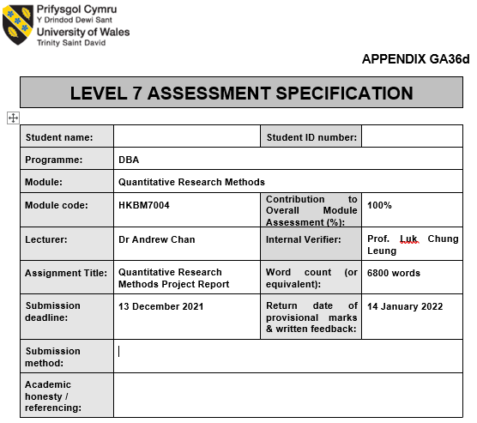


School of Business

Quantitative Research Methods
HKBM7004
By
Dr. Andrew Chan

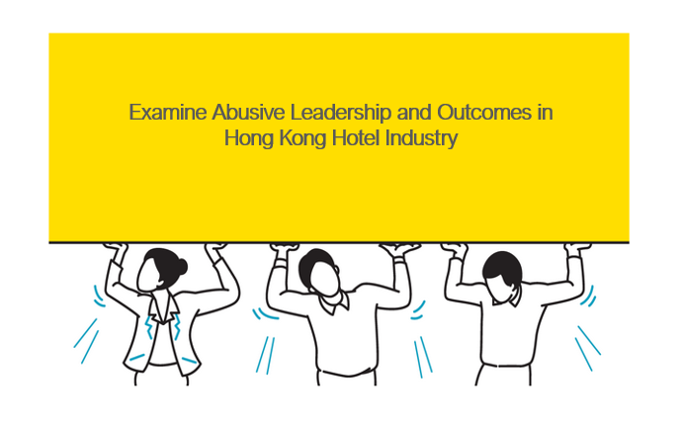

Student Name: Chi Nam Frances WANG
Student Number: 2021190
Word Count: 6,800 words
Date: 12th December, 2021

Table of Contents

Introduction 4
Background and Context 5
Literature review 7
Key Concepts, Theories and Studies 7
Key Debates and Controversies 9
Methodology 10
Research design 10
Methods and Sources 11
Analysis & Report 13
Practical Considerations & Limitations 15
Implications and contributions to knowledge 16
Pilot Test and Results 17
Discussion 20
Conclusion 21
Time Line 22
References 23
Appendix 1 – Hotel Industry Performance Report (Sep) 27
Appendix 2 - Hong Kong Hotel Industry Turnover Repport 28
Appendix 3 – Abusive Leadership Questionnaire 30

Introduction

Do people quit their jobs or their managers? Human resource practitioners are interested in finding answers to this question when talent leaves their company. Throughout the years, experts have examined the reasons for people leaving the company to find out why talent leaves a workplace. A study conducted by Facebook found that employees are dissatisfied with their work, resulting in them leaving the company (Goler et al. 2018). The same study reveals that people who prefer to stay within an organization because they find their job more fulfilling, can utilize their strengths, and obtain additional skills, statistically 31%, 33% and 37% more than others within the organization (Goler et al. 2018). A number of factors may contribute to an employee's dissatisfaction, cause-and-effect, the most common relates to their supervisors and managers. Leaders design jobs, maximize the talents of employees, supervise and support them in their day-to-day operations, without which there may be dissatisfaction in the workplace. Herzberg's two factor theory describes motivating and hygiene factors as impacts on job satisfaction, where motivators are considered factors of satisfaction, and absence of hygiene factors are considered factors of dissatisfaction (Herzberg 2017). Supervision, classified as a hygiene factor by Herzberg, has direct contribution and can negatively influences job satisfaction. Generally, when people encounter undesirable management behaviour at their workplace, they are more likely to terminate their existing employment.
Despite most people believing that people leave their jobs for their bosses, research has shown that job satisfactions (Wang et al.2020; Ulrich et al.2007; Judge and Klinger 2008), job engagements (Wang et al.2020), and leaderships (Goler et al. 2018; Tepper 2000) contribute to people intentions to stay or leave a workplace. The majority of research shows the retention of employees is directly related to employee engagement and satisfaction. On the other hand, where the data is insufficient, the intention to leave a workplace due to bad managers is not explained or commonly reported due to various reasons. Despite some arguing that abusive leadership is agreeable in different cultural settings and industries, abusive leadership is a subjective and unaware leadership practice, possibly related to negative outcomes, and the purpose of this study is to examine the topic using a purposive sample of the Hong Kong hospitality industry.

Background and Context
Hospitality and tourism industries in Hong Kong and around the world are facing the greatest challenge since the 2020 covid pandemic. Hotel occupancy rate in Hong Kong falls from previous 90% annually to current 57.55% year-to-date (refer Appendix 1). While revenue performance in the industry has dropped, the industry is also experiencing high turnover rates. There has been an overall year-to-date turnover of 30.81% and some hotels are experiencing as serious as 100% turnover rate (refer Appendix 2) . Despite the industry's difficulty generating revenue due to macro-environmental factors, operating costs are high, and turnover represents a hidden cost that cannot be ignored. The unemployment rate in Hong Kong declined to 4.3% in November 2021 (Tsang 2021), while the hospitality sector is facing a closed border and restrictions, putting it at risk of losing talent to other industries. There is a shortage of workers in current business conditions, especially in frontline positions. According to industry news, both hotels and restaurants cannot find casual workers on peak festive demand dates even if pay hourly rate is raised to HK$100 per hour, which is almost 40% more than the past (Wong 2021). Over time, the hotel industry loses talent to other industries such as property management, insurance, finance, health care, and other service industries, while talent retention becomes increasingly important.
“The greatest danger in times of turbulence is not the turbulence. It is to act with yesterday's logic.” (Drucker 2012) Studying good leadership, as always in the past, is not a holistic way to study leadership. By finding meaning through reframing experiences can rediscover new knowledges. Therefore, as part of this study, there will be an examination of variables relating to bad leadership practices, and the importance of analysing factors relating to bad leadership practices will also contribute to good leadership practices in a reversed way.

Problem Statement & Research Questions
In a study by Professor Tepper (2000), researchers found that people who quit their jobs had direct links to abusive supervision. Abusive supervision is defined as “subordinates' perceptions of the supervisor engaging in sustained displays of hostile verbal and nonverbal behaviour, excluding physical contact” (Tepper 2000). The term abusive supervision refers to a subjective assessment of leadership coming from a subordinate towards their manager. In the same context, it may be abuse and non-abuse in another. It is believed that this relationship will not end until either side - leader or subordinate - ends their relationship by quitting their jobs (Tepper 2000).
In recent years, researchers have examined the construct of abusive supervision and organizational outcomes variables increasingly. Some of the variables discussed and already identified by current literature including workplace deviance (Mitchell & Ambrose 2007), employee performance (Tepper, Moss, & Duffy, 2011), and organizational citizenship (Rafferty & Restubog 2011). In good leadership, supervisor behaviour will promote favourable outcomes (Tepper 2007). Yet, will the opposite occur in a reversal study of abusive leadership? The purpose of this study is to conduct an extended study on abusive leadership and outcome to address the geographic research gap from the west and test whether results are different in the east. This study also chose a purposive sample of hotel industries wherein multi-layers of management, seniority of service and high turnovers is a common feature of this industry and contributes to abuse of supervision. This research will be measuring variables such as job engagement, job satisfaction, and work ethic based on the following hypothesis:
- H0: Abusive supervision has no relation to job engagement, job satisfaction, or work ethics
- H1: Abusive supervision negatively related to job engagement
- H2: Abusive supervision negatively related to job satisfaction
- H3: Abusive supervision negatively related to work ethics

Relevance and Importance of the Research
Leadership theory is considered highly beneficial from an academic perspective, but most people find it utterly contrary to what they expect. A study published by Hogan Development Survey finds that 65% to 75% of organizations have bad managers (Hogan 2009). The same survey indicates that 27% of high potential staff are at risk of being demoted or terminated for performing below level (Hogan 2009) due to bad leadership. In a more recent research by University of Texas at Dallas, 13 percent of US workers have experienced abusive supervision, resulting in an estimated annual cost of $23.8 billion (ScienceDaily 2018). This research proposal believes it is common to experience bad leadership, but it is rarely examined and explored. Through this study, poor leadership impacts and outcomes are examined to directly improve a phenomenon.
In response to the insights provided by Professor Tepper on abusive leadership since 2000, scholars have conducted intensive research on the subject and produced significant contributions. Over the past two decades, research on abusive leadership has gained significant attention (Martinko 2013). Yet, studies on abusive leadership have been inadequately conducted outside the United States, and cultural differences, such as power distance and masculinity, may affect the way people react to abusive leadership (Tepper 2007). Studies of the topic outside of the United States, so far, using Australian, Canadian, Chinese, Philippines, South Korean, Taiwan (Martinko 2013), and Macau samples (Xu et. al. 2015). The findings and results are not significantly different from findings in western contexts (Martinko 2013).
This research aims to measure the outcomes of abusive leadership, under job engagement, job satisfaction, and work ethics, in a population sample of Hong Kong hotels. In an Asian context, examining correlations between independent and dependent variables will provide insights into current literature. Moreover, this study proposes to use a different scale from Tepper's study (2000) to measure attitude differences on construct items confirmed in the west. The findings of this study are helpful in determining whether Asians perceive abusive leadership differently.
The importance of this study is the fact that it is the first research to examine abusive leadership in the Hong Kong hotel industry. Furthermore, is due to the researcher's experience and passion in the hospitality industry and the desire to provide insight into leadership practices that are inappropriate, in order to reduce risks and the cost of losing talent and maintain healthy working environment. Considering the unique cultural setting in Hong Kong, where east meets west with cultural diversity and globalisation, it is a strong motivation to look into the research questions.

Literature review

Key Concepts, Theories and Studies
What is leadership? Leadership definition from the dictionary refers to the task of leading, a status or a position (www.oxfordlearnersdictionaries.com). Leadership theory is one of Google Scholar's most cited research topics with over 3.69 million citations. Scholars have been unable to agree on a definitive definition of leadership in the current literature, and researchers have spent decades studying the subject (Maslanka 2004). Early leadership theories propose that individuals possess certain characteristics that set them apart from others and allow them to assume leadership roles. Leaders are born according to the Great Man Theory (Carlyle 1874). Yet, the theory ignores and fails to account for situational and environmental factors that affect leadership effectiveness (Horner 2003). Then, scholar examine trait and behaviour leadership theory that provide a new perspective on leadership by identifying behaviours that improve an organization's effectiveness (Nawaz and Khan 2016). The theory is based on the significance of traits, actions, and influence tactics of leaders in influencing followers and their behaviours (Horner 2003). Apart from examining traits, researchers tend to believe skills and styles have an impact on leadership theory. Based on the theory of situational leadership, leadership styles are used according to the existing environment, or depending on the needs of the employer. Over the years, more leadership theories have emerged, research on leadership and management includes studies of transactional leadership, transformational leadership, laissez-faire leadership (Nawaz and Khan 2016), and most recently servant leadership in recent years (Cable 2019). There is substantial empirical evidence that certain models of leadership can contribute to positive organizational change, thus contributing to the growing attention paid to positive and normative aspects of leadership (Leithwood et al. 2008).
Throughout history, many scholars have studied leadership and our current understanding of leadership contrasts sharply with the ancient or early Greek understanding of leadership. Leadership in ancient is studied through examples and leaders were expected to be physically and morally fit (Osgood 2020). The contrast helps to remind us that our modern concepts are culturally determined rather than unchanging facts (Sarachek 1968). Hofstede (2011) presents six dimensions of national culture in his Cultural Dimension Theory. Individuals are shaped by culture in such a way that things may be perceive differently across cultural dimensions, which results in unexpected paradigm shifts. The six dimensions include indulgence vs restraint, long-term orientation vs. short-term orientation, individualism vs. collectivism, uncertainty avoidance, masculinity vs. femininity and power distance index (Hofstede 2011). Scholars have observed culture's influence on leadership from many angles. Researches in China have found that both power distances (Lian et al.2012) and traditional Chinese beliefs (Liu et al.2010) have a direct impact on leadership when compare to western countries.

There has been a growing body of research on abusive leadership since the late 90s (Martinko et al. 2013) and abusive leadership is one of the dark sides of contemporary leadership (Tepper 2000). Professor Tepper examines abusive leadership as an independent variable in a one-dimensional construct. Throughout the years, different scholars have studied the construct in various dimensions from a two-dimensional construct with passive and active (Mitchell and Ambrose 2007); a three-dimensional construct with passive, active and humiliation (Wulani et al. 2014); and, a recent four-dimensional construct four-dimensional construct where yelling, belittling behaviour, scapegoating and credit stealing (Ghayas and Jabeen 2020). Recent literature has given significant attention to the subject.
Abusive leaders are in many forms, for instance Jeff Bezos, the former CEO of Amazon (Schmid et al. 2018), Donald J. Trump (Braun 2018), the former President of the United States of America, or the beloved Steve Jobs, the co-founder of Apple. These leaders are unconventional and different from the studies in current literature. The names mentioned have each been criticized by some of their followers for abusive acts such as yelling, belittling, and shouting. These leaders are, however, also supported by many others. “Bad is stronger than good” (Baumeister 2001), bad things will produce more lasting, stronger, consistent, comprehensive, or extensive effects than good things. On every occasion you flip the coin, there is always a flip side. The light of current leadership theories may not be sufficient to explain the fullness of theories. Exploiting the dark side or shade of grey in leadership is an integrated study of leadership literature that will provide more evidence to support leadership studies.

Key Debates and Controversies
How would you describe Steve Jobs as a leader? Is Jobs visionary, passionate, charismatic, or unconventional (Zhao 2017)? Jobs, the co-founder of Apple, is regarded as one of the greatest leaders, who was innovative and always seeking perfection. In discussing the substantial success of Apple and Jobs, a great deal of literature has been written, but the darkness of Jobs' leadership is rarely examined. To some people, Jobs was not a perfect leader and had some rough edges (Issacson 2012), which fits in with abusive leadership. In other words, leadership is subjective to define abuse by an individual, as Tepper (2000, 2007) raised and some industries embraced abusive approaches to increase performance. Example, in America Football, both coaches and players believe hostility will generate results (Woolston 2018). In another study by Professor Tepper showed that his MBA students viewed hostile leaders as heroes, and this certainly applies to the case of Jobs and Apple, if leaders can oversee business operations successfully without being perceived as abusive (Woolston 2018).
Abusive leadership is controversial due to its negative consequences. Base on casual observations, some industries including the sports and entertainment, as well as the military sector, are known for their hostility in daily operations. According to the majority of practitioners, the more rigorous the supervision, the better the results. The Chinese actor and Hollywood star Jackie Chan owes his fame and hardship to his childhood at the Peking Opera House in learning Kung-Fu (Tateishi 1998). Based on most of Chan's personal interviews, he believes his childhood hardships shaped his success, which means he respects his hardships as essential rather than abusive. As described by Professor Tepper (2000), abuse of leadership is subjective and rarely noticed, and as such it is difficult to quantify in the common field on the cause-and-effect correlation.
In examining shades or dark side leadership, there is always a negative connotation. However, this research suggests that good has bad, and what matters is how people see it differently. Former Prime Minister Lee Kuan Yew was Singapore's first and longest-serving leader and is considered a good man or a good leader by the majority of Singaporeans. Lee took Singapore from a colony of Great Britain to an international power and shaped its foundations in every aspect. Lee is known for his vision, passion, and ability to implement plans for Singapore. Researchers consider this to be the essence of transformational leadership (Adarsh 2018). Leaders who transform and cause a change in an organization or system are said to be transformational. Lee successfully transformed Singapore. What happens if you flip the coin? Lee is also regarded as a representative of autocratic leadership and characterized by leaders making all decisions (Plate 2013). While this study is not meant to debate the leadership style of successful great leaders, it is intended to get rid of the negative connotations associated with bad leadership practices. The importance of investigating a phenomenon that is less likely to be studied is meant to provide an insight into current research.

Gaps in Existing Knowledge
Though some may argue that abusive leadership leads to better performance, a tradition or a culture to obey, a phenomenon that is more prevalent in certain industries or countries with cultural difference with the west. Current literature indicates that abusive approaches, which are seldom noticed by action takers, contribute to destructive performance, staff disengagement, and higher turnover among employees. In spite of the unconventional topic of abusive leadership, different cultures may react, reason, and perceive the issue differently, which Professor Tepper asserts has yet to be explored but is growing in importance due to globalisation and cultural diversity.

Methodology

Research design
Understanding research paradigms is essential to all researchers to better understand research methodologies. A paradigm is a way of interpreting the world and often forms the basis for research (Creswell and Poth 2018, p 58). These assumptions relate to the existence of reality, the creation of knowledge, and what is valuable to learn. To be able to successfully conduct research, researchers should be clear about their own beliefs and assumptions (Bloomfield and Fisher 2019). This research is to examine abusive leadership in Hong Kong's hotel industry by using quantitative methods. The purpose of this study is to investigate abusive leadership in Hong Kong's hospitality industry due to its unique cultural setting and hierarchy structures. Multi-layers of management, seniority of service and high turnovers is common of this business and contributors to abusive supervision in a workplace. From what is learned and discovered by scholars in the west, will that also apply to the east? It is worth noting the importance of Chinese faith in Confucian beliefs and the city's strong power distance index in making this topic interesting. The culture aspect contributes to extending the examination of this research. The theory construct may address different issues from what has been found in the West regarding the attitude of how people’s attitude on abusive leadership behaviour and react to abusive supervision. Study subjects included hotel industry employees ranging in number from 250 to 300 subjects.

Methods and Sources
Participant information includes taking a purposive sample from hotel employees. The characteristics of the industry and the tradition of the practices make it an appropriate choice for this study. The study will utilize descriptive and correlational quantitative research methods. A well-designed questionnaire (refer Appendix 3), with twenty-five items, is the main method of gathering the data. Questionnaires covered four constructs: abusive leadership, job engagement, job satisfaction, and work ethics. The twenty-five items are divided into five items regarding abusive leadership, four items regarding job engagement, five items regarding job satisfaction, and eleven items concerning work ethics. The measurement of the questionnaire will be based on an ordinal scale. Hotel industry practitioners are considered as the unit of analysis.
The sample size for this study is between 250 and 300 subjects. The general rule for determining sample size is 20-30 subjects per independent variable if the fundamental statistical analysis will be multiple regression; a minimum of 5 subjects per item if factor analysis is to be performed (Hoskins and Mariano 2004). The scale of attitude will be changed for each construct of this study. The main construct will base on a 15-point checklist, work of Professor Tepper, as the basis for a confirmatory factor analysis to determine the best fit model for abusive leadership (Tepper 2000). The 15-point checklist is further reduced to a 5-point checklist by other researchers (Mitchell and Ambrose 2007), and it is the main construct in this questionnaire of abusive leadership. The original scale by Professor Tepper was a Likert scale. It was based on an assessment of abusive leadership, ranging from 1 to 5, where a 1 is cannot remember, 2 is very seldom, 3 is occasionally 4 is moderately often, and 5 is very often. The assumption is that people perceive abusive leadership differently from the West, thus the scale is changed to measure attitude instead of frequency. A Likert scale of 5 measuring 1 as individually acceptable, 2 as maybe acceptable, 3 as neutral, 4 as maybe unacceptable, and 5 as individually unacceptable. A multidimensional ethics scale was used in the development of this scale (Cohen et al. 1993).
The main construct of abusive leadership is then tested against three dependent variables, including job engagement, job satisfaction, and work ethics. Engagement refers to the ability to reflect responsibility and dedication to a particular target (Klein et al. 2012), and to measure job engagement, a four-item questionnaire measuring 1 not at all, 2 slightly, 3 moderately, 4 quite a bit, and 5 extremely. This research adopts a five-item version of Judge and Klinger (2008) to measure job satisfaction which is a short Minnesota satisfaction questionnaire version that covers a set of practical questions regarding job satisfaction. When a conflict between values appears, an ethical dilemma will often involve the violation of one in order to obey the other (Langlois et al. 2014). This study examines the relationship between abusive leadership and work ethics at work by using an eleven-item questionnaire developed by Lagnlois (et al. 2014). Instead of a five-point Likert scale, a seven-point Likert scale will be used in this construct. The eleven-item questionnaire measuring 1 never, 2 rarely, 3 sometimes, 4 often, 5 very often, 6 always and 7 opting out to disclose. Multiple rating scales with seven points are more accurate in capturing variability among respondents and in estimating a normal response curve (Cooper and Schindler 2014, p275 & 278).
Due to the sensitivity of the topic, research subject will be recruited from graduates of universities hotel schools and Vocational Training Council. A purpose sampling to reach hotel industry practitioners through education institutes and snowball sampling under voluntary basis through referrals will be the main methods of contacting subjects for this study. Participants are encouraged to invite industry friends and colleagues to take part in the study. Researcher will attempt to use social media platforms to collect data if sample size is inadequate. Data collection will take two months and 10 questionnaires per day are expected for the first month. If the data collection falls short of expectations, researcher will reach out to trade and industry contacts for assistance and use convenience sampling.

Analysis & Report
The items in the questionnaire (refer Appendix 3) were developed and tested by scholars in the field. All data collected from respondents will be analysed using Jamovi 2.2.2. The Jamovi platform provides a comprehensive analysis of statistics data and is free, open, and intuitive. Twenty-five items collected data for four constructs related to abusive leadership, job engagement, job satisfaction, and job ethics. Likert scales under a five- or seven-point scale and ordinal scales are used for measuring data. Each construct will be tested for validity, reliability, and correlations, as well as descriptive statistics on demographics.
For the item analysis, Cronbach Alpha was used to determine the reliability of items measuring each construct and item-rest correlations to identify items with low correlation with the rest of the scale. A coefficient alpha was calculated for each subscale of the questionnaire to assess reliability. An overall scale reliability analysis on the questionnaire indicates an acceptable correlation within the scales for parsimony, with a Cronbach Alpha of 0.71 (refer to figure 1). All constructs and items were reliability assessed by using the coefficient alpha of each subscale on the questionnaire (refer to figure 2). The Cronbach Alpha for the constructs of work satisfaction and work ethics was 0.382 and 0.670 (refer figure 2 highlighted in blue), respectively, at the time of initial testing of scale reliability. Results from reliability analysis by Jamovi showed that several items correlated negatively with the total scale, and items should probably be reversed to improve reliability. The items were reversed as suggested and Cronbach Alpha was improved to 0.804 and 0.764 representing the reliability of job satisfaction and work ethics were dependable. A Cronbach alpha range of 0.764 to 0.879 and work ethics were the lowest amongst the four constructs, whereas job engagement scale was good. This survey attempted to improve reliability by dropping work ethics, but the Cronbach alpha of the scale fell from 0.710 to 0.653 with mean value 3.84 and standard deviation value 0.578. When Cronbach Alpha of the scale is above 0.7 indicating that it has acceptable internal consistency.
During the construction of a test, the item-rest correlation determines whether one item is associated with the overall score (Zijlmans et al. 2018). The item-rest correlation scores of the four constructs are all greater than 0.20 (refer to figure 1), indicating that all items are correlated with the scale. The item-rest correlation scores range from 0.675 to 0.281, with job satisfaction scoring the highest and abusive leadership scoring the lowest. The score of 0.281 is a concern because a small item-correlation indicates that the item does not measure the same construct as the others. Testing was done to determine whether scores could be improved if an item were dropped and all items were retained based on a score greater than 0.20.
Figure 1 – Abusive Leadership Questionnaire- Overall Reliability Test
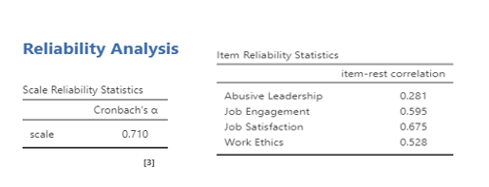

Figure 2 – Abusive Leadership Questionnaire - Constructs and Items
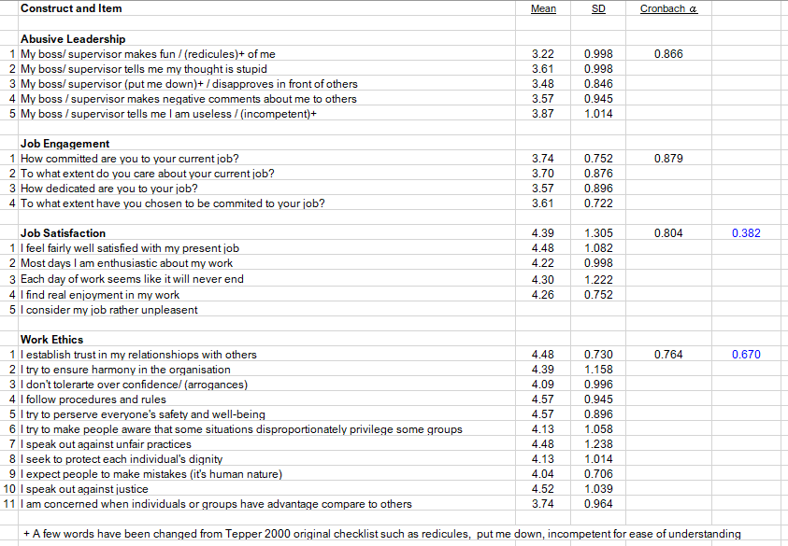

Practical Considerations & Limitations
Research on this topic does not appear to pose an ethical issue, except the topic is sensitive to most management, hotels and hotel groups. Any company with unfounded concerns about abusive leadership may be hesitant to participate or be interested in learning more. It may therefore be difficult to recruit a hotel or hotel group to support or participate in this study. In order to overcome this challenge, no personal information will be recorded, such as names, company names, and direct supervisors' names. All data collected from the questionnaire will remain anonymous. To avoid any potential embarrassment or unnecessary speculation regarding confidential information on management, respondents are suggested to return the questionnaire with their personal contact information rather than their business contact information. By preserving the anonymity of respondents' personal data, participants will feel more confident about participating.
To overcome the difficulty of collecting relevant samples, the researcher would like to collect data from public forums, which are very popular channels for sharing ideas and opinions nowadays. A benefit of collecting data from public forums is that respondents are more willing to share their ideas since their identity is unknown. Yet, the overall impression of public forums is recruiting a lot of hateful participants which in turn may affect the quality of data. Moreover, it is difficult to determine whether or not respondents are giving truthful information, especially in the demographic section. Although there is a question of authenticity of data, the percentage of representation will safeguard the validity and, as part of a quantitative research design employing a scientific method of analyzing data, this should not be an issue.
This study is using a questionnaire as the main instrument to collect data, and the questions were developed by western scholars. A challenge of this study is translating the questions into simple English or a Chinese version. A possible translation bias is to interpret the meaning of words incorrectly in both languages. For example, three out of five items under abusive leadership need to be rephrased to ensure people from different educational levels can understand the questions properly. A word like “ridicule” is altered to “make fun of me”, and to “put me down” is changed to “disapprove of me”. A professional opinion is required in order to minimize possible bias, and the researcher may seek assistance from an academic supervisor and human resource professionals in translating and modifying words. In addition, comments gathered during pilot testing will also assist in controlling the bias.
There is a possibility of interpreting data from a bias perspective (Cooper and Schindler 2014, p.39) which is also the researcher bias. Despite the fact that this is a quantitative study based on scientific evidence, the researcher has an influence on how the data are interpreted. Furthermore, Hong Kong's hotel industries were chosen as a purposive sample, so the results may be overgeneralized to draw a conclusion about a phenomenon. In order to avoid generalization and researcher bias, sufficient samples will be collected in this study to support study conclusions.

Implications and contributions to knowledge

Theoretically, the researcher will examine the extent to which abusive leadership is more acceptable in Hong Kong according to a different scale than western scholars. Further, a purposive sample of hotel industry is examined, which is characterized by hierarchical management and by high power distances. By conducting this study, the practical implication is to understand how hotel practitioners respond to abusive acts confirmed by the west as well as to raise management awareness of the consequences of some unaware leadership behaviours. An effective leadership program and coaching can be implemented, if necessary, from the managerial perspective.
Moreover, it is the aim of this study to shed light on reducing cost implications by understanding the impact of abusive leadership and examining how outcomes are correlated. There are extensive studies in strategic human resources management examining the cost of turnover, replacement, and recruitment are high. By measuring the correlation of abusive leadership to outcomes, the working culture of the hotel industry can be improved by becoming more aware of the subject. This also suggests that costs associated with abusive leadership can be reduced while talents are retained in the industry.
Study results may indicate that abusive leadership and work ethics have a direct relationship. Hospitality is a people business and hotel management is a challenging task. It is possible that the results of this study suggest that policies and feedback are needed to improve work ethics, which facilitates good hotel management practices.

Pilot Test and Results
A pilot test of twenty-four questionnaires was collected, of which one was discarded because all choices were filled in with neutral. Twenty-three questionnaires containing twenty-five items each were analysed. The pilot testing used convenience sampling where participants were chosen based on their availability and willingness to participate and followed by snowball sampling to collect more sample data. A possible selection bias in collecting samples if friends and acquaintances are used as subjects. This will be avoided in the main study. Below record some preliminary findings on descriptive and frequency statistics for demographics of pilot testing (refer to figure 3 and 4).
- There were some missing data in the demographic section. There was one respondent who did not respond to the gender item, two respondents did not respond to the title of the position, and one respondent did not respond to the tenure of service. (Refer to figure 3)
- The number of female (16, 72.7%) respondents was higher than the number of male (6, 27.3%) respondents with one missing data. This distribution is similar to the actual workforce distribution in Hong Kong Hotel industry. (Refer to figure 4a)
- The majority of the participants were under the age group of 31-40 years old (10, 43.5%), and members of generation X born after 1980. The second largest age group was under the age of 21-30 (26.1%), members of generation z, which is born after 1990. Representing a young workforce in the respondent subject. (Refer to figure 4e) A spotted error, a misleading choice between selection of age group 41-50 and over 50, in the survey, which will be corrected before the main test.
- The majority of the participants, over 52.2%, were educated and graduated from universities and one respondent (4.3%) was post-graduated. Studied participants were well educated. (Refer to figure 4d)
- The majority of respondents were supervisors (42.9%), followed by general staff (33.3%), department heads (19.0%) and executives (4.8%). (Refer to figure 4f)
- Most respondents have been serving their companies for more than three years (77.3%) and the majority of respondents have been serving for ten years or more (45.5%). (Refer to figure 4c)
- Front office employees (39.1%) made up the majority of respondents, followed by sales & marketing (30.4%), Food & Beverage (13.0%), Housekeeping (8.7%) and others. (Refer to figure 4b)

Figure 3 – Descriptive Statistics of Respondents

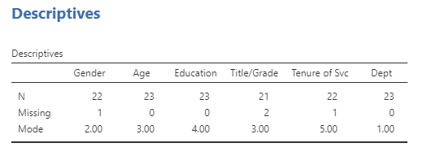

Figure 4 – Frequencies Statistics of Respondents
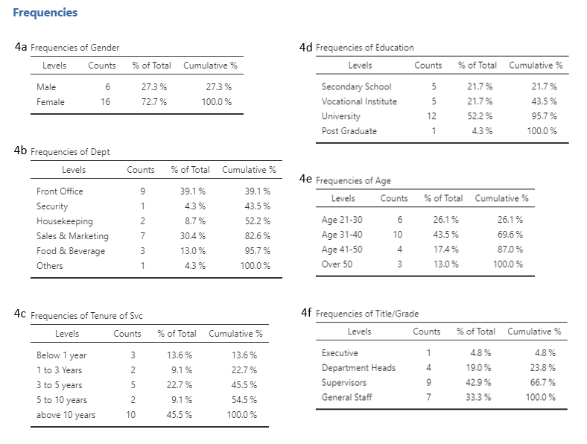
The internal reliability coefficient alphas for each subscale ranged from 0.764 (work ethics) to 0.879 (job engagement), which indicates that the scale range from acceptable to good was positively associated with null hypothesis. The p-values range from 0.184 to 0.078, are greater than 0.05 (p > 0.05), which indicates that the result is not statistically significant and indicates strong support for the null hypothesis (refer to figure 5). “Given a true null hypothesis, p value represents the probability of observing a sample value as extreme as, or more extreme than, the value actually observed” (Cooper, D. and Schindler 2014, p662). The preliminary result of pilot testing the pilot test indicates that variables are not statistically significant, meaning that there is weak or no evidence against the null hypothesis. As the data size is only twenty-three samples, the p value may be affected due to the small number of data representation, which will be improved with larger sample sizes (Sullivan and Feinn 2012).
Pearson's correlation coefficient provides an indication of the strength and direction of a relationship between variables (Lavin and Fox 2003, p321). In light of limited sample sizes, preliminary results indicate that the correlation coefficient is positive and above zero (refer to figure 5). A positive correlation describes a relationship between two variables in which both variables change at the same time. The Pearson’s г reveal the magnitude and positive relationships of the constructs. In this case, the Pearson’s r ranges from 0.1 to 0.3, indicating a small to medium strength of association. As discussed earlier, given a small sample size of twenty-three, result is not statistically significant and null cannot be rejected.
Figure 5 – Abusive Leadership Questionnaire – Correlation Matric
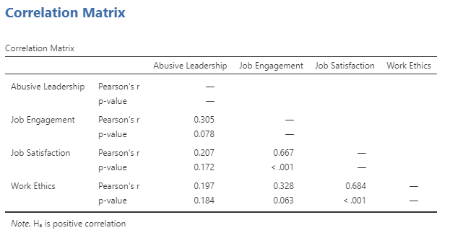

Discussion
A pilot test on this research topic gathered twenty-four samples, one of which cannot be used. A snowball sampling method was used to collect primary data from employees at a hotel in Hong Kong owned by a local hotel group. In descriptive studies of abusive leadership at the beginning of the process, interesting results emerged.
This study adapted five items from Tepper's fifteen-item confirmatory factor analysis checklist to build the construct on abusive leadership. The scale was changed to measure the attitude of respondents instead of the original measure of the frequency of abusive leadership. Most respondents see abusive leadership as neutral, as indicated by the overall selection of (3) (refer to figure 6). Though Jamovi shows that there is more than one mode exists, results suggest that the attitude of Asians or hotel practitioners may be different from western or the current literature. Based on preliminary findings, respondents' attitudes towards abusive leadership differ from studies from the west and current literature. Amongst the five items on abusive leadership, two were seen as neutral (3) by most respondents. "My boss makes fun of me or ridicules me", and "my boss puts me down or disapproves of me in front of others," were neutrally accepted by most respondents. A strong indication of (5) for "my boss tells me I'm useless or incompetent", which is considered individually unacceptable, were chosen by most respondents. The indicator for "My boss told me that my thoughts are stupid" is (4), stands for maybe unacceptable, were chosen by most respondents. The indicator for "My boss makes negative comments about me in front of others" is (3), more than one mode exists, and respondents was neutral on this item. The results of this study support the view that a higher power distance may react to abusive leadership with less intensity. Tepper (2007) suggested that cultural factors may influence how individuals react to abusive leadership. As an extension of current findings, this study will compare the results of the final project to develop a deeper understanding of the construct of abusive leadership.
Figure 6 – Statistical description of abusive leadership
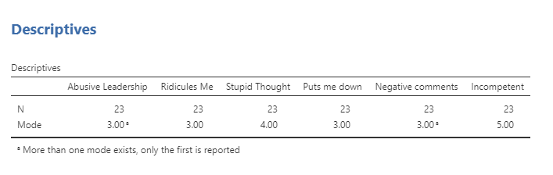

Conclusion

In spite of the small sample size, the initial statistical significance test of this study is not convincing. To improve findings for the final test, the questionnaire will be further reviewed with the academic supervisor to improve the methodical approach of the instrument. On the other hand, the initial findings of descriptive statistics on how hotel industry employees perceive abusive leadership differ from those in the west are interesting and newfound. Grey is the colour when black meets white. If there are grey shades in leadership, by identifying and rectifying the black will improve the shades. Future studies should continue to explore the black or dark colour of leadership and explore relationships. Finding ways to reduce harmful effects generally by understanding cause-and-effect. Understanding the dark side of leadership is just as important as studying the positive aspects of general management. This proposal offers to study abusive leadership what is rarely covered in common literature. Recognizing the attitude of how people see inappropriate act of leadership and the consequences allows an individual and organisation to improve in many ways.

Time Line

It is expected that the research will commence in January 2022 and be completed in December 2023 with a written report on its findings. Research is divided into seven stages: pilot, sampling design and recruitment, data collection, instrument development and testing, data analysis and interpretation, production and final stage. The pilot stage of the research started in November 2021. A pilot test was conducted to identify any weaknesses in instrumentation and design, and to serve as a proxy for selecting a probability sample (Cooper and Schindler 2014, p85). In the early stages of sampling recruitment, the questionnaire will be tested and reviewed together with the program supervisor. After data collection and sampling design are approved, the recruitment process will begin in February 2022 and last for 90 days. Data collection and preparation, data analysis and interpretation will begin in April 2022 and end in August 2022. Starting from September 2022 onwards, the focus of the study will be on developing theories. Report writing will start January 2023 and report presentation is expected to be September 2023 (details please refer figure 5).

Figure 5 – Research Time Line
Research phase | Task | Deadline
Pilot Stage | Research and prepare questionnaire | Nov, 2021
 | Pilot Testing | Dec, 2021
 | Preliminary findings and test | Dec, 2021
Sampling Design & Recruitment Stage | Discuss and examine the questionnaire together with program supervisor | Jan, 2022
 | Recruit respondents by contacting Hong Kong universities' hotel schools and alumni engaged in the hotel industry | Feb – Apr, 2022
 | Register and recruit participants through open social media forums (minimum 10 per day) | Apr, 2022
Data Collection Stage | Collect and input all data from received questionnaire | Apr - May, 2022
Instrument Development & Testing Stage | Use Jamovi to test data and findings | May, 2022
Data Analysis & Interpretation Stage |  | Jun – Aug, 2022
 | Building Theories | Sep - Dec, 2022
Production Stage | Report writing | Jan - May, 2023
 | Report editing | Jun - July, 2023
Final Stage | Report presentation | Sep, 2023

(Cooper and Schindler 2014, page xxvii)

References

Adarsh Sigdyal (2018). A transformational Leader: Lee Kuan Yew. [online] ResearchGate. Available at: https://www.researchgate.net/publication/327790824_A_transformational_Leader_Lee_Kuan_Yew.
Baumeister, R.F., Bratslavsky, E., Finkenauer, C. and Vohs, K.D. (2001). Bad is stronger than good. Review of general psychology, 5(4), pp.323-370.
Bennett, R.J. and Robinson, S.L. (2000). Development of a measure of workplace deviance. Journal of applied psychology, 85(3), p.349.
Bloomfield, J. and Fisher, M. J. (2019) ‘Quantitative research design’, Journal of the Australasian Rehabilitation Nurses Association. Cambridge Publishing, 22(2), pp. 27–30. https://search.informit.org/doi/10.3316/informit.738299924514584.
Braun, S., Kark, R. and Wisse, B., 2018. Fifty Shades of Grey: Exploring the Dark Sides of Leadership and Followership. Frontiers in psychology, 9, p.1877.
Buchholz, R.A. (1978). The work ethic reconsidered. ILR Review, 31(4), pp.450-459.
Carlyle, T., 1874. Great man theory.
Cohen, J., Pant, L. and Sharp, D. (1993). A validation and extension of a multidimensional ethics scale. Journal of Business Ethics, 12(1), pp.13-26.
Cooper, D. R. and Schindler, P. S. (2014). Business research methods, 12th ed, New York: McGraw-Hill Irwin, pp 275, 278-280, 662.
Creswell, J.W. and Poth, C.N. (2018). Qualitative inquiry & research design: Choosing among five approaches (Fourth Ed). London: Sage p. 58.
De Vries, R.E. (2018). Three nightmare traits in leaders. Frontiers in psychology, 9, p.871.
Drucker, P. (2012). Managing in turbulent times. Routledge.
Fischer, T., Tian, A.W., Lee, A. and Hughes, D.J. (2021). Abusive supervision: a systematic review and fundamental rethink. The Leadership Quarterly, p.101540.
Graen, G. B.; Novak, M. A.; Sommerkamp, P. (1982). "The effects of leader-member exchange and job design on productivity and satisfaction: Testing a dual attachment model". Organizational Behavior and Human Performance. 30 (1): 109–131. doi:10.1016/0030-5073(82)90236-7.
Ghayas, M.M. and Jabeen, R. (2020). ABUSIVE SUPERVISION: DIMENSIONS & SCALE. New Horizons (1992-4399), 14(1).
Goler, L., Gale, J., Harrington, B. and Grant, A. (2018). Why people really quit their jobs. Harvard Business Review, 96.
Hannon, P.A., Helfrich, C.D., Chan, K.G., Allen, C.L., Hammerback, K., Kohn, M.J., Parrish, A.T., Weiner, B.J. and Harris, J.R., 2017. Development and pilot test of the workplace readiness questionnaire, a theory-based instrument to measure small workplaces’ readiness to implement wellness programs. American Journal of Health Promotion, 31(1), pp.67-75.
Herzberg, F. (2017). Motivation to work. Routledge pp 59-80.
Hofstede, G. (2011). Dimensionalizing cultures: The Hofstede model in context. Online readings in psychology and culture, 2(1), pp.2307-0919.
Hogan, R. (2009). Hogan development survey manual. Tulsa, OK: Hogan Assessment Systems.
Horner, M. (2003). Leadership theory reviewed. Effective educational leadership, pp.27-43.
Hoskins, C.N. and Mariano, C (2004) Research in nursing and health: Understanding and using quantitative and qualitative methods (Vol. 23). Springer publishing company.
Isaacson, W. (2012). The real leadership lessons of Steve Jobs. Harvard business review, 90(4), pp.92-102.
Judge, T.A. and Klinger, R. (2008). Job satisfaction. The science of subjective well-being, 393.
Kipfelsberger, P. and Kark, R., 2018. ‘Killing me softly with his/her song’: How leaders dismantle followers’ sense of work meaningfulness. Frontiers in psychology, 9, p.654.
Klein, H.J., Cooper, J.T., Molloy, J.C. and Swanson, J.A. (2014). The assessment of commitment: advantages of a unidimensional, target-free approach. Journal of Applied Psychology, 99(2), p.222.
Lakatamitou, I. et al. (2020) The Greek versions of the Team STEPPS teamwork perceptions questionnaire and Minnesota satisfaction questionnaire ‘short form’. BMC health services research. [Online] 20 (1), 587–587.
Lam, L.W. and Xu, A.J. (2019). Power imbalance and employee silence: The role of abusive leadership, power distance orientation, and perceived organisational politics. Applied Psychology, 68(3), pp.513-546.
Langlois, L., Lapointe, C., Valois, P. and de Leeuw, A. (2014). Development and validity of the ethical leadership questionnaire. Journal of Educational Administration.
Leung, A. and Sy, T. (2018). I am as incompetent as the prototypical group member: An investigation of naturally occurring golem effects in work groups. Frontiers in psychology, 9, p.1581.
Levin, J. and James Alan Fox (2003). Elementary statistics in social research. Boston: Allyn And Bacon, p. 321.
Lian, H., Ferris, D.L. and Brown, D.J. (2012). Does power distance exacerbate or mitigate the effects of abusive supervision? It depends on the outcome. Journal of Applied Psychology, 97(1), p.107.
Liu, J., Kwong Kwan, H., Wu, L.Z. and Wu, W. (2010). Abusive supervision and subordinate supervisor‐directed deviance: The moderating role of traditional values and the mediating role of revenge cognitions. Journal of Occupational and Organizational Psychology, 83(4), pp.835-856.
Maslanka, A.M., 2004. Evolution of leadership theories (Doctoral dissertation, Grand Valley State University).
Mansi, A. (2007). Executive coaching and psychometrics: A case study evaluating the use of the Hogan Personality Inventory (HPI) and the Hogan Development Survey (HDS) in senior management coaching. The Coaching Psychologist, 3(2), pp.53-58.
McIver, D. and Lengnick-Hall, C. (2018) ‘The causal ambiguity paradox: Deliberate actions under causal ambiguity’, Strategic Organization, 16(3), pp. 304–322. doi: 10.1177/1476127017740081.
Mitchell, M.S. and Ambrose, M.L. (2007). Abusive supervision and workplace deviance and the moderating effects of negative reciprocity beliefs. Journal of applied psychology, 92(4), p.1159.
Nawaz, Z.A.K.D.A. and Khan_ PhD, I. (2016). Leadership theories and styles: A literature review. Leadership, 16(1), pp.1-7.
Osgood, Josiah (2020). A Leadership Class from the Ancient World. [online] Available at: https://press.princeton.edu/ideas/a-leadership-class-from-the-ancient-world. (Accessed on 09 Dec, 2021)
Plate, T. (2013). Giants of Asia: Conversations with Lee Kuan Yew: Citizen Singapore: How to Build a Nation. Marshall Cavendish International Asia Pte Ltd.
Rafferty, A.E. and Restubog, S.L.D. (2011). The influence of abusive supervisors on followers' organizational citizenship behaviours: The hidden costs of abusive supervision. British Journal of Management, 22(2), pp.270-285.
Rentsch, J. R. and Steel, R. P. (1992) ‘Construct and Concurrent Validation of the Andrews and Withey Job Satisfaction Questionnaire’, Educational and Psychological Measurement, 52(2), pp. 357–367. doi: 10.1177/0013164492052002011.
Rich, B.L., Lepine, J.A. and Crawford, E.R. (2010). Job engagement: Antecedents and effects on job performance. Academy of Management Journal, 53(3), pp.617-635.
Sarachek, B. (1968). Greek Concepts of Leadership. The Academy of Management Journal, 11(1), 39–48. https://doi.org/10.2307/255195
Schmid, E.A., Pircher Verdorfer, A. and Peus, C.V. (2018). Different shades—different effects? Consequences of different types of destructive leadership. Frontiers in psychology, 9, p.1289.
Schyns, B., Felfe, J. and Schilling, J. (2018). Is it me or you? - How reactions to abusive supervision are shaped by leader behavior and follower perceptions. Frontiers in psychology, 9, p.1309.
ScienceDaily. (2018). Research explores workers’ response to abusive supervision: Subordinate deviance differs based on level of cultural power distance. [online] Available at: https://www.sciencedaily.com/releases/2018/02/180208131718.htm. (Accessed on Dec 09, 2021)
Sullivan, G.M. and Feinn, R. (2012). Using effect size—or why the P value is not enough. Journal of graduate medical education, 4(3), pp.279-282.
Tan, J.A., Hall, R.J. and Boyce, C. (2003). The role of employee reactions in predicting training effectiveness. Human resource development quarterly, 14(4), pp.397-411.
Tateishi, R., (1998). Jackie Chan and the Re-invention of Tradition. Asian Cinema, 10(1), pp.78-84.
Tepper, B.J. (2000). Consequences of abusive supervision. Academy of management journal, 43(2), pp.178-190.
Tepper, B.J. (2007). Abusive supervision in work organizations: Review, synthesis, and research agenda. Journal of management, 33(3), pp.261-289.
Tepper, B.J., Moss, S.E., Lockhart, D.E. and Carr, J.C. (2007). Abusive supervision, upward maintenance communication, and subordinates' psychological distress. Academy of Management Journal, 50(5), pp.1169-1180.
Tepper, B.J., Henle, C.A., Lambert, L.S., Giacalone, R.A. and Duffy, M.K. (2008). Abusive supervision and subordinates' organization deviance. Journal of applied psychology, 93(4), p.721.
Tepper, B.J., Moss, S.E. and Duffy, M.K. (2011). Predictors of abusive supervision: Supervisor perceptions of deep-level dissimilarity, relationship conflict, and subordinate performance. Academy of management journal, 54(2), pp.279-294.
Tsang, D. (2021). Hong Kong jobless rate drops to 4.3 per cent as economic recovery rolls on. South China Morning Post. [online] Available at: https://www.scmp.com/news/hong-kong/hong-kong-economy/article/3156218/hong-kong-workers-set-32-cent-pay-rise-inflation. [Accessed 24 Nov. 2021].
Ulrich, C., O’donnell, P., Taylor, C., Farrar, A., Danis, M. and Grady, C. (2007). Ethical climate, ethics stress, and the job satisfaction of nurses and social workers in the United States. Social science & medicine, 65(8), pp.1708-1719.
Wang, C.C., Hsieh, H.H. and Wang, Y.D. (2020). Abusive supervision and employee engagement and satisfaction: the mediating role of employee silence. Personnel Review.
Wong, K. 黃金棋 (2021). The unemployment rate / The banquets are fighting for waiters失業率 /宴會爆棚掀搶人潮 餐飲業雙工請人 黃家和：唔理質素喇. HK01 [online] 香港01. Available at: https://www.hk01.com/article/701508?utm_source=01appshare&utm_medium=referral. [Accessed 24 Nov. 2021].
Wong, S.C.K. (1998). Staff job‐related ethics of hotel employees in Hong Kong. International Journal of Contemporary Hospitality Management.
Woolston, C. (2018). Bad bosses: Dealing with abusive supervisors. Knowable Magazine.
Wulani, F., Purwanto, B.M. and Hani, H. (2014). Abusive supervision scale development in Indonesia. Gadjah Mada International Journal of Business, 16(1), pp.55-68.
Zhao, M (2017). AN INVESTIGATION OF APPLE’S CULTURE IN CREATING COMPETITIVENESS IN XI’AN, CHINA (Doctoral dissertation, BURAPHA UNIVERSITY).
Zijlmans, E., Tijmstra, J., van der Ark, L. A., & Sijtsma, K. (2018). Item-Score Reliability in Empirical-Data Sets and Its Relationship With Other Item Indices. Educational and psychological measurement, 78(6), 998–1020. https://doi.org/10.1177/0013164417728358

Appendix 1 – Hotel Industry Performance Report (Sep)
CONFIDENTIALITY NOTICE
This circular is sent in furtherance of the principal activities of the Hong Kong Hotels Association, namely, to promote and protect its Members' lawful interests. It is intended only for the person or entity to whom it is addressed. Any information it contains may be confidential and privileged under applicable laws and should not be disclosed or copied to anyone. If you are not the intended recipient or you have received it in error, please destroy this message and notify the Association immediately. Thank you.
Hotel Industry Performance in September 2021
Ref.: EXD076/10/21
TO | : | All General Managers of HKHA Member Hotels
FROM | : | Patrick Kwok  Executive Director
DATE | : | 8 October 2021
SUBJECT | : | Hotel Industry Performance in September 2021
Dear Colleagues,
We have attached herewith the Hong Kong hotel industry’s performance summary reports in aggregate numbers for the month of September.
Average industry wide room occupancy rate was 67.51% in September 2021, up 18.72 percentage points from last year and average room rate was $687.87 versus $592.08 last year, up 16.18%, raising average yield from $288.86 last year to $464.39, up 60.77%
For Q1-Q3 2021 average industry wide room occupancy rate was 57.55%, up 17.55 percentage points from last year and average room rate was $661.36, up 6.75% from last year, raising average yield by 53.57% to $380.6.
An updated report on industry performance 1996 to 2021 Q3 is also attached for your kind information.
Thank you for your attention.
PATRICK KWOK
Executive Director
c.c. : | Mr. Michael Li, Executive Director, The Federation of Hong Kong Hotel Owners Ltd.,  Mr. Patric Lee, Chairman, Hotel Controllers and Accountants Association of Hong Kong

HEAD OFFICE - Suite 508 Silvercord Tower Two, 30 Canton Road, Tsimshatsui, Kowloon, Hong Kong Tel: (852) 2375 3838 Fax: (852) 2375 7676
Email: info@hkha.org Website: http://www.hkha.org

Appendix 2 - Hong Kong Hotel Industry Turnover Repport

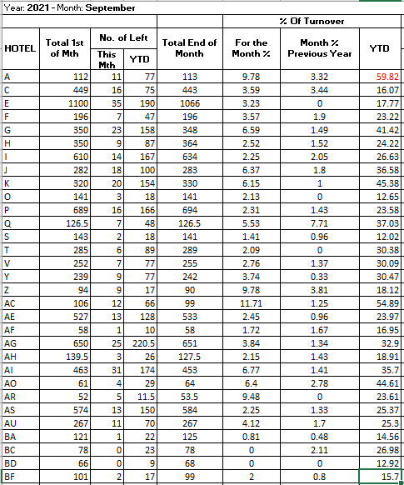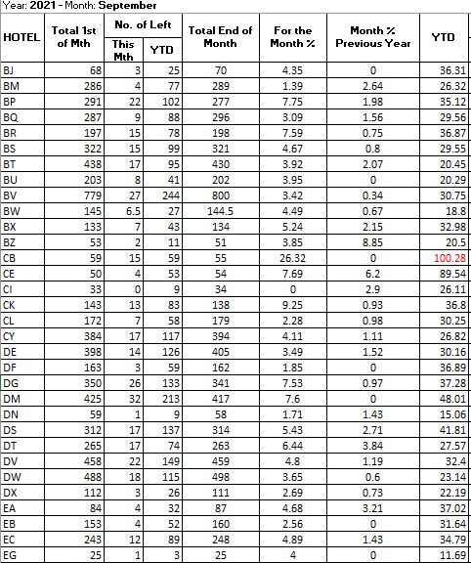

Appendix 2
Hong Kong Hotel Industry Turnover Repport (cont’d)

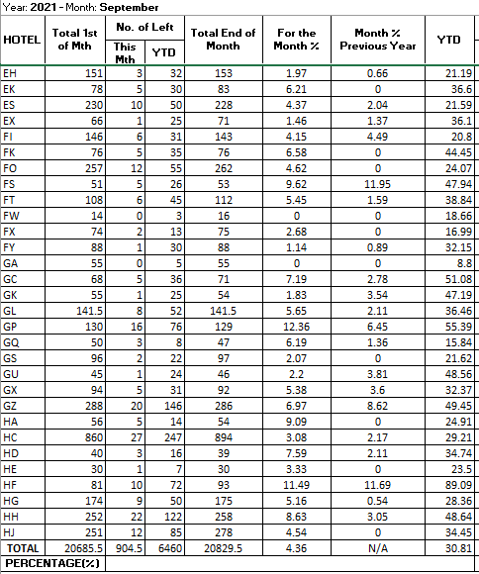

Source: Monthly Turnover Report September 2021, Hong Kong Hotels Association

Appendix 3 – Abusive Leadership Questionnaire

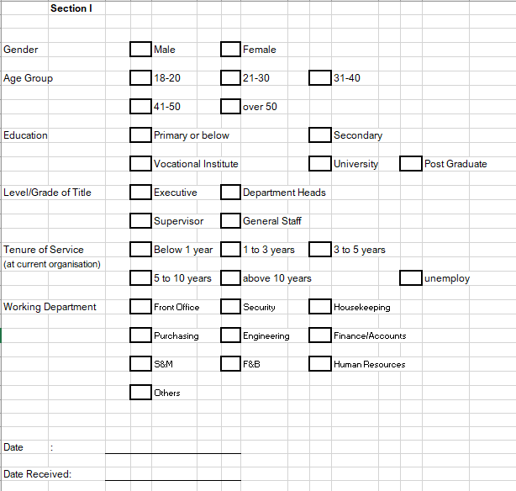
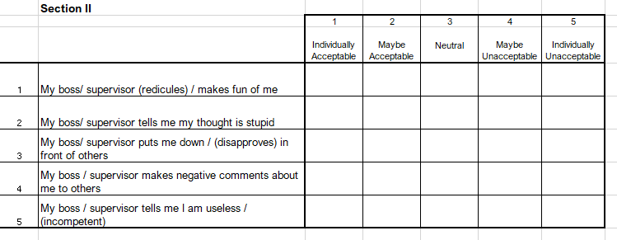

Appendix 3 – Abusive Leadership Questionnaire (cont’d)

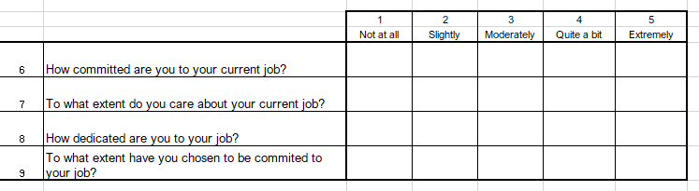
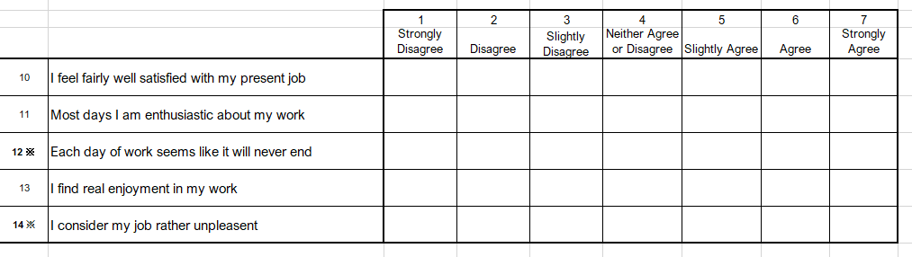
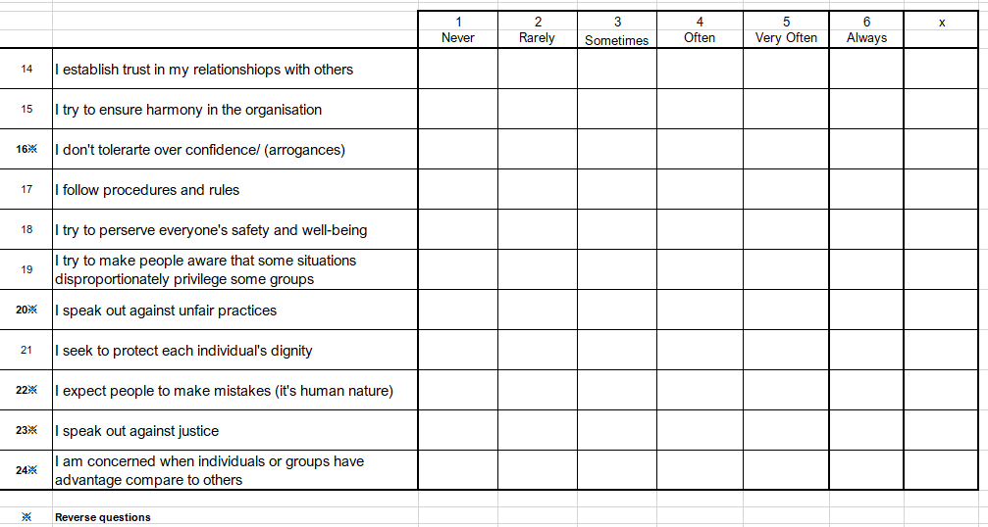

Figures from Hotel Industry Performance in September 2021, Hong Kong Hotels Association.
Figures from Monthly Turnover Report September 2021, Hong Kong Hotels Association
The power distance index of Hong Kong is 68 and higher than US and UK which is 40 and 35 respectively (http://clearlycultural.com/).

