
UNIVERSITY OF WALES:  TRINITY SAINT DAVID |  | PRIFYSGOL CYMRU:  Y DRINDOD DEWI SANT

LOCATION: Coleg Sir Gar (Graig) | LLEOLIAD: Coleg Sir Gar (Graig)
LEVEL 6 | LEFEL 6
EXAMINATION PERIOD | CYFNOD ARHOLIADAU
AUGUST 2020 | AWST 2020

MODULE CODE: SGdm6020
Engineering Management

Examination solutions

Question 1
The discussion should define and describe the six sigma approach and the following diagram would be useful support:
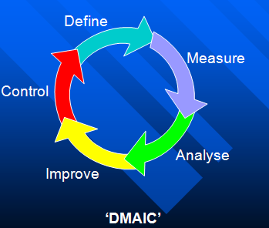
- Define – the scope of the improvement project in terms of customer requirements and the process that delivers these requirements (inputs, outputs, controls and resources).
- Measure – the current process performance & calculate the process capability.
- Analyse – the difference between current & desired performance, prioritise problems & identify root causes.
- Improve – generate improvement solutions to prevent problems recurring.
- Control – implementing the improvement process, for example standards of operation IAW ISO 9000 or techniques such as SPC.
The critical evaluation should cover the following key points:
Advantages:
- Management by fact
- Implementation steps clear
- Logical approach
- Key performance indicators based on data
- Training in statistical techniques develops individuals
- Engenders the team working approach
- Project selection based on highest value
Disadvantages:
- High investment in training required
- Employees sought after by competing organisations
- Focus on data can obscure the bigger picture such as the need for lean and 5s implementation i.e. getting the basics right.
Total marks for 1 = 25

Question 2
Answers expected to list and discuss 10 of the points
Internal
- Scrap
- Rework
- Repair
- Replacement
- Downgrading
- Loss of capacity
- Excess Inventory
External
- Customer complaints
- Warranties
- Returns
- Loss of future sales
- Recalls
- Product liability
(10 marks)
TQM – holistic, company wide, cultural change, RFT, feedback loops, recognises that everyone has an impact on meeting customer requirements.
QA – prevention of quality problems, methods employed to assure quality of process, system, and product. Procedures, defining inspection/sampling levels/rates, customer satisfaction analysis etc.
QC – controlling and monitoring the process to produce quality products, defining types of inspection, measuring quality against targets, the actual process of assuring quality through measuring PPM, AQL etc.
Conformance – defines how well the product achieves the specification both at the point of production and by the end of life.
Inspection – the undertaking of measurements to feed into the quality system. Typical types of inspection such as variables and attributes, types of inspection could also be in the answer.
(15 marks)
Total 25 marks for Question 2

Question 3
- The five quality characteristics:
  - Nominal the best
  - Small the better
  - Larger the better
  - Classified attributes
  - Dynamic response: Output changes with changes in input.
Examples of these would be expected. (5 Marks)

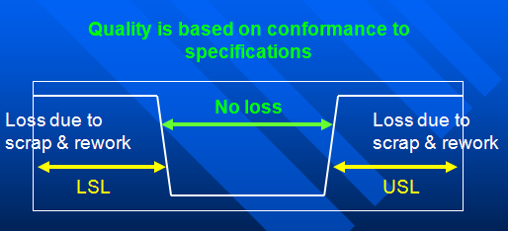
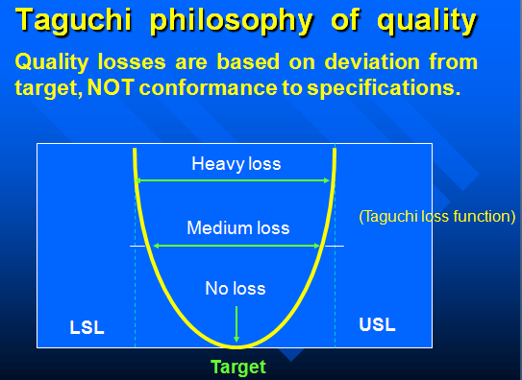
- The discussion should outline the traditional view of loss and contrast this with the Taguchi view with appropriate diagrams for support,

The old, western world production philosophy was “don’t spend extra money striving for accuracy, get inside the specification limits and move on to something else”.
LSL/USL = Lower/upper specification limit
History has taught us that when we adopt this philosophy we can still produce defects (i.e. go/no-go gauges)
(4 marks)
Only by using the new philosophy of hit the target and hit it often can we reduce the variation. When we reduce the variation and are accurate, we can achieve good quality.
E.g. During 1990’s Ford & Mazda produced the same gearbox, working to the same specifications for the Ford Chevrolet.
Fords manufacturing approach was ‘get within the specification limits’, whereas Mazda’s was ‘hit the target, remove variation’.
Consequently, after a period of time the Chevrolets gearboxes started to fail, and over 90% of all gearbox failures were produced by ford. The problem was due to tolerances (variation), even though each component was still within the specifications.
(4 marks)

10.4 | 10.2 | 9.8 | 10.0 | 9.8 | 9.9 | 10.2 | 10.7 | 10.4 | 10.6

Nominal = 10 ± 3
Data set mean = $\overline{y}$ = 102 / 10 = 10.2
Cost (L) = £80
SD ‘S’ (from s.d. function on calc (Xσn), or manual means) = 0.306 (4 marks)
To find K at a point:
Where L = K(y-m)² & L = 80
80 = K(13-10)²
80/9 = K
K = 8.9 (4 marks)
Using the Average Loss Equation: L = K [S² + ($\overline{y}$ - m)²
L = 8.9 x [0.306² + (10.2 – 10)²]
L = 8.9 x 0.1336
L = £1.19 / unit (4 marks)
Total for question 3, 25 marks
Question 4
a) FMEA is a design and pre-production planning technique which structures a teams’ thought processes to consider every conceivable way in which a component or product may fail. It is an analytical technique which:
- Identifies potential failure modes
- Assesses potential effects on a customer
- Identifies potential causes of failure
- Identifies needs for changes, improves design, reliability, maintainability and safety
- Minimises potential causes of failure
- Facilitates inter-departmental dialogue and encourages team working
- Provides a formal record of safety and reliability analysis for use as evidence in reports to customers or in product litigation
- Provide a basis for repair, maintenance and policy manuals

An FMEA enables the team to look at all aspects of design and process in a formalised and structured way. The potential problems are recorded, numerically assessed and ranked in order, for corrective actions to be decided on, and then to be implemented.

An FMEA study can be carried out at any stage during the development of a new product. However, the ideal times to use this technique are:
- At the original concept stage when specifications are being established.
- As soon as the design is finalised but before any manufacturing of tooling etc. is commenced.
- When the processing decisions are being made.
- When major changes are to be carried out, either to the design or process alterations.
- After an FMEA study has been conducted and corrective actions taken; i.e. a re-assessment of an FMEA study.

b)
- define the system being analysed (objectives, level of sub system analysis, components comprising the system, operational/environmental stresses, time requirements, reliability data etc)
- construct functional and reliability block diagrams
- 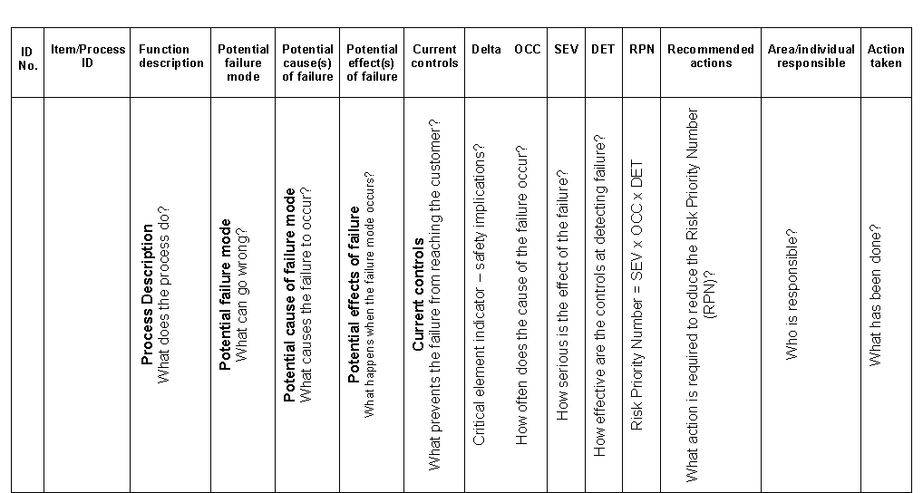complete a FMEA worksheet in order to make conclusions and recommendations

Total for question 4, 25 marks

