12/15/2025
Assessment
Portfolio Report on Contemporary Software Applications for Business


Student Name: ATA POLAT
Student ID: 5212871

Module NaMe: Software solutions for business
Module Code: ACCA 4026
Lecturer: Amitave banik
Trinity saint david University of Wales (London Campus)

Table of Contents
Introduction 2
Task 1 e-Commerce Website builders/software solutions 2
1. Wix: 2
2. Shopify: 3
Task 2. Mind-map of Contemporary Software Applications 3
Picture 1. Mind Map 4
Task 3. Office Applications for creating, storing, presenting, and analysing information/data 5
MS Word 5
Picture 2. MS Word Mail Merge 5
Ms Excel 6
Picture 3. MS Excel Vlookup 6
Ms Access 6
Picture 4. MS Access Query 7
Ms PowerPoint 7
Picture 5. MS PowerPoint 7
IF Function 8
Picture 7. VLOOKUP 9
VLOOKUP 9
Task 4. Communication and Collaboration applications 9
A. 9
Picture 8. Microsoft Outlook 10
Picture 9. Microsoft OneDrive 11
B. 11
Gmail 11
Google Drive 11
References 11
Task 1. 11
Task 3. 11
Task 4. 12

Introduction
Our first task was to research e-commerce website builders/software solutions online, evaluate the results, and write down the most prominent topics under Task 1. Then, we explained two of these, Wix and Shopify, discussing their advantages and disadvantages.
Our second task is to explain what a mind map is and how to use it. In the second part, we explained the mind map we created and included a screenshot.
At the beginning of the task, in the first part, we explained MS Word, MS Excel, MS Access, and MS PowerPoint programs, discussing their advantages and disadvantages and touching on some limitations. In the second part, we explained the IF functions and VLOOKUP used in MS Excel.
Our fourth task is to explain MS Outlook and MS OneDrive applications, discussing their advantages and disadvantages as in the first part. In the second part, we examined the free applications Gmail and Google Drive.

Task 1 e-Commerce Website builders/software solutions

There are many e-commerce website editing and building applications available today. I've listed a few of the most popular below. Here are the top ranked applications in Google search (23.10.2025) results:
1. Wix 2. Shopify 3. Squarespace 4.Bigcommerce 5. Godaddy 6. Hostinger 7. Woocommerce 8. Bluehost 9. Square 10. Weebly.
Today, I will evaluate the two most used applications in the first two places of the list in terms of their pros and cons.
1. Wix: At the base of the pros of making a website using Wix are two of its characteristics: first, its freemium business model, which allows users to see and experiment the platform potential beyond Wix’s website's description of it, and then switch to a paid plan. Second, Wix offers more than a hundred free templates which are mobile optimised and are designed for small businesses, restaurants, artists, musicians and photographers. Wix’s editor, both for editorial websites and e-commerces, allows the merchant to modify the appearance of all the pages with a simple drag and drop system, making Wix one of the platforms that truly earns its spot in the democratisation of the code era. Of course wix comes with some cons as well, otherwise platforms like Salesforce wouldn’t exist at this time, along with e-commerce web agencies. The first main con is one important limit: the navigation structure supports up to only two levels. The second very important limit is the performance of the CMS in correlation of the number of products of which the catalogue is made. The third con regards the customer support, which to many reviews is not delivering on its function. Reaching the support is not as easy as one may expect, since the merchant is able to contact it only after going through the FAQs section and answering a final question asking “did you question get an answer?” with a no. And even having reached that point, the support runs through emails and not live chats, making the responses on both sides slower and the whole process less effective. Among other cons are: the templates are hard to change and not flexible; the site loading speed is one of the lowest among all e-commerce platforms; there is a very limited range of e-commerce apps, making Wix’s e-commerces not flexible and scalable.
As a final consideration, Wix is best for editorial websites and e-commerce run by very small firms [1] [2].
2. Shopify: Unlike Wix or WordPress, Shopify was born as an e-commerce platform and isn't well-suited for hosting a blog-style website. Shopify's robust, scalable plans and options include a user-friendly CMS and an impressive number of apps available through the Shopify app store. Options vary, including staff accounts (accounts that can access the backend and work on content and setup), locations (physical merchant-owned warehouses where stock is distributed and deliveries are dispatched), analytics reports, shipping carriers, transaction fees, and finally, international pricing. Shopify also offers in-platform plugins for Google Analytics and Tag Management [1] [3].

Task 2. Mind-map of Contemporary Software Applications

- Mind mapping can be thought of as a mental exercise. For any job or activity in our lives, we first create a plan in our minds. We first think about it in our minds, then we jot it down on paper or draw small diagrams. While doing all of this isn't a problem for small tasks, it may be necessary to conduct more specific studies or prepare them in a more specific way for complex tasks or processes. This is where programs come in, making our work easier. Using mind maps is crucial in business matters. There's a saying in Turkey: "Getting started is half the battle." This means that once you start a project, you've already taken half the steps necessary to finish it. So, how do you start a project? First, you create a plan in your head, review the steps, consider the pros and cons, and potential problems. You then consider solutions and potential solutions. Ultimately, you'll come up with a plan. This, in essence, becomes your mind map, the embodiment of your ideas. Now, all you need to do is sketch it or put it on paper or use MS Word or other software to transfer it to a physical environment [4].

- Mind Map

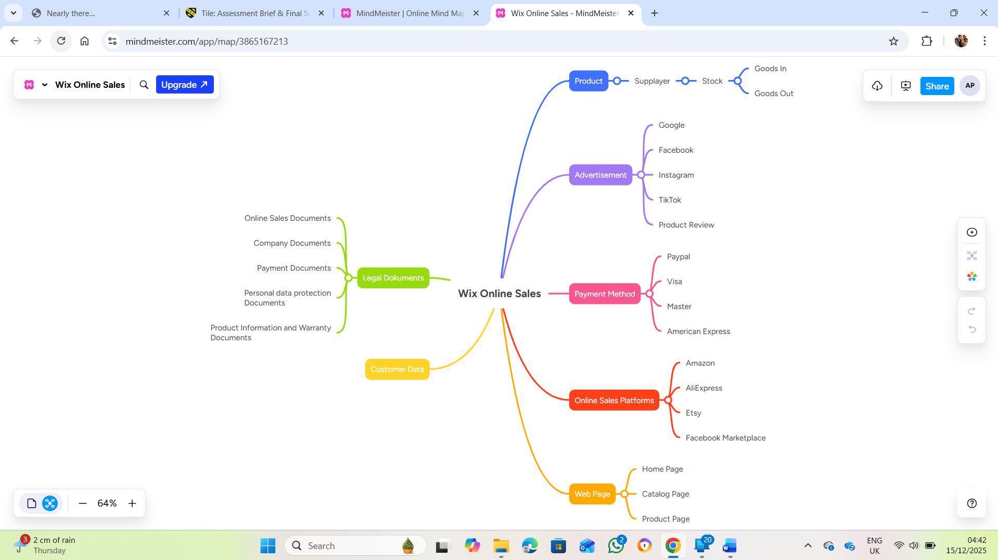

Picture 1. Mind Map

When creating our mind map, I chose the Vix online sales platform creation application, which we explained earlier, as our main topic, and then I branched out the advantages Vix offers to create my mind map. I indicated sub-topics such as website creation, marketing and advertising campaigns, product inventory and product visualization, payment and payment method integration, easy integration of necessary legal regulations, and customer statistics.

Task 3. Office Applications for creating, storing, presenting, and analysing information/data
A
In this section, I will discuss what we can do with MS Word, MS Excel, MS PowerPoint, and MS Access programs, their advantages and disadvantages, and some limitations.
MS Word: While we generally use MS Word for writing text and creating tables, we can create documents in accordance with academic writing rules. For example, with IEEE, the academic language used by our university, we can create easy and understandable academic documents in terms of both writing and references. Furthermore, we can create text by speaking only, without typing, using the dictation command. We can easily save the documents we create as PDFs and use them in this format. All these conveniences constitute some of what we can do with MS Word[1].
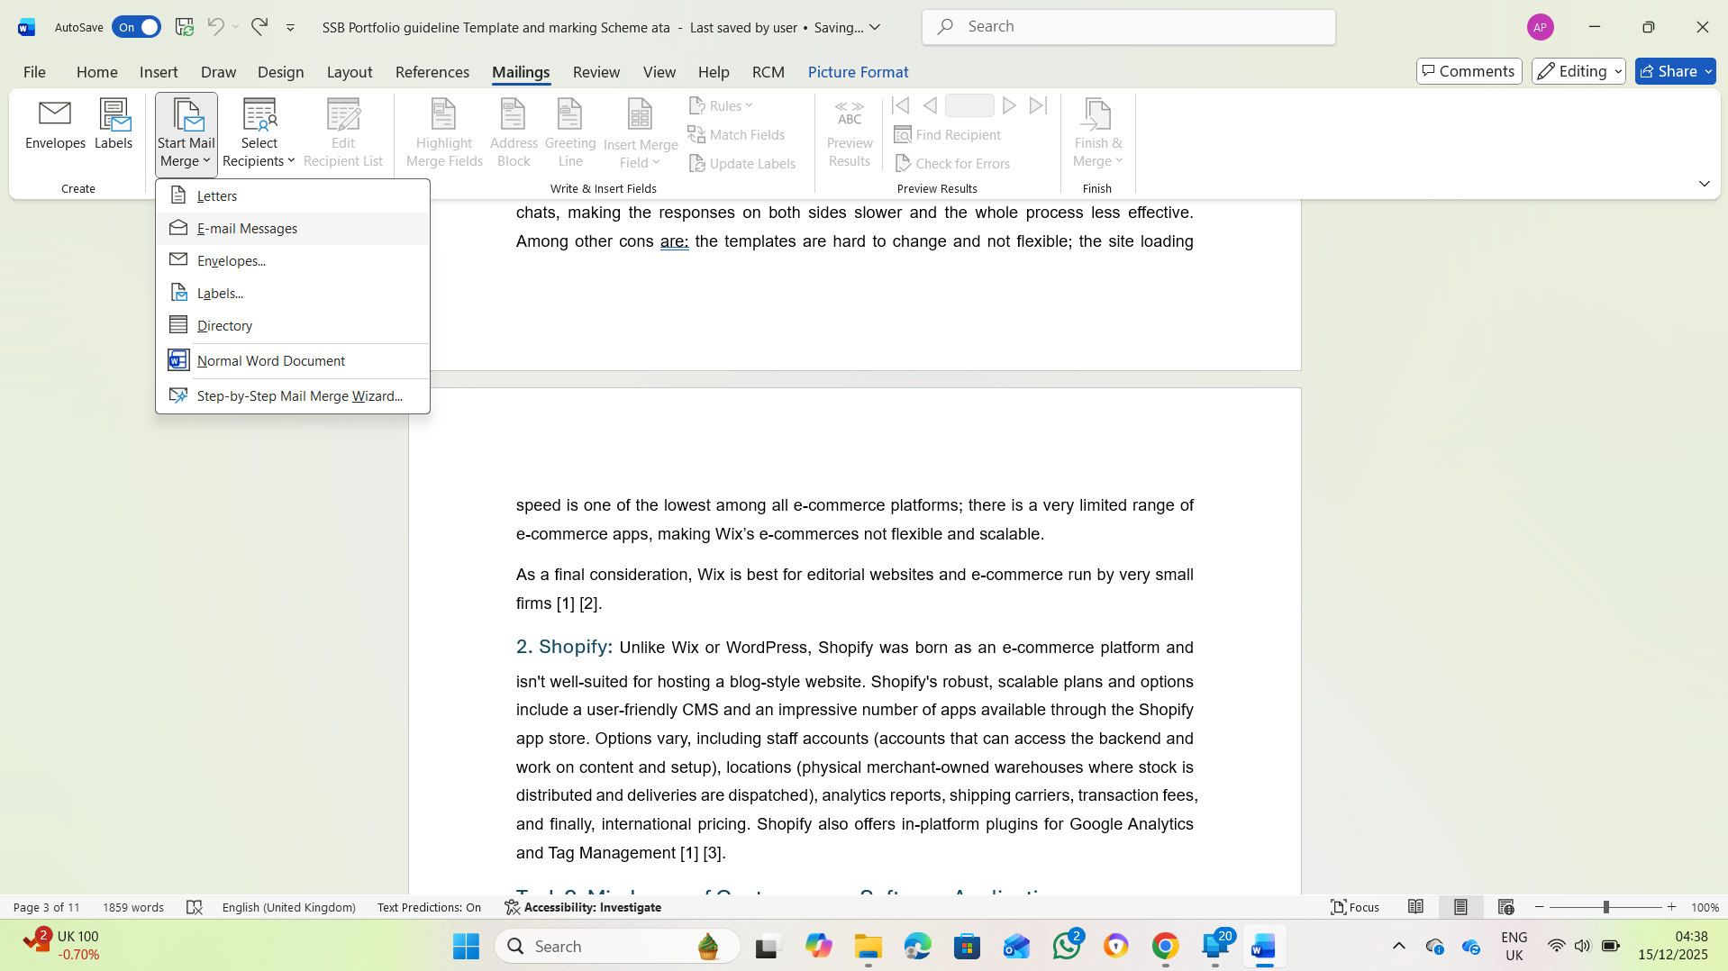

Picture 2. MS Word Mail Merge
Ms Excel: Ms Excel is essentially a data creation and calculation program. It features a very useful cell structure for creating data. Furthermore, it allows us to compare data, filter data, perform mathematical operations such as summing numerical values, and calculate averages. In addition, we can compare data and create tables and graphs accordingly. The disadvantage of Ms Excel is that while it is useful for small datasets, it is insufficient for large data sets, which we call big data[2].
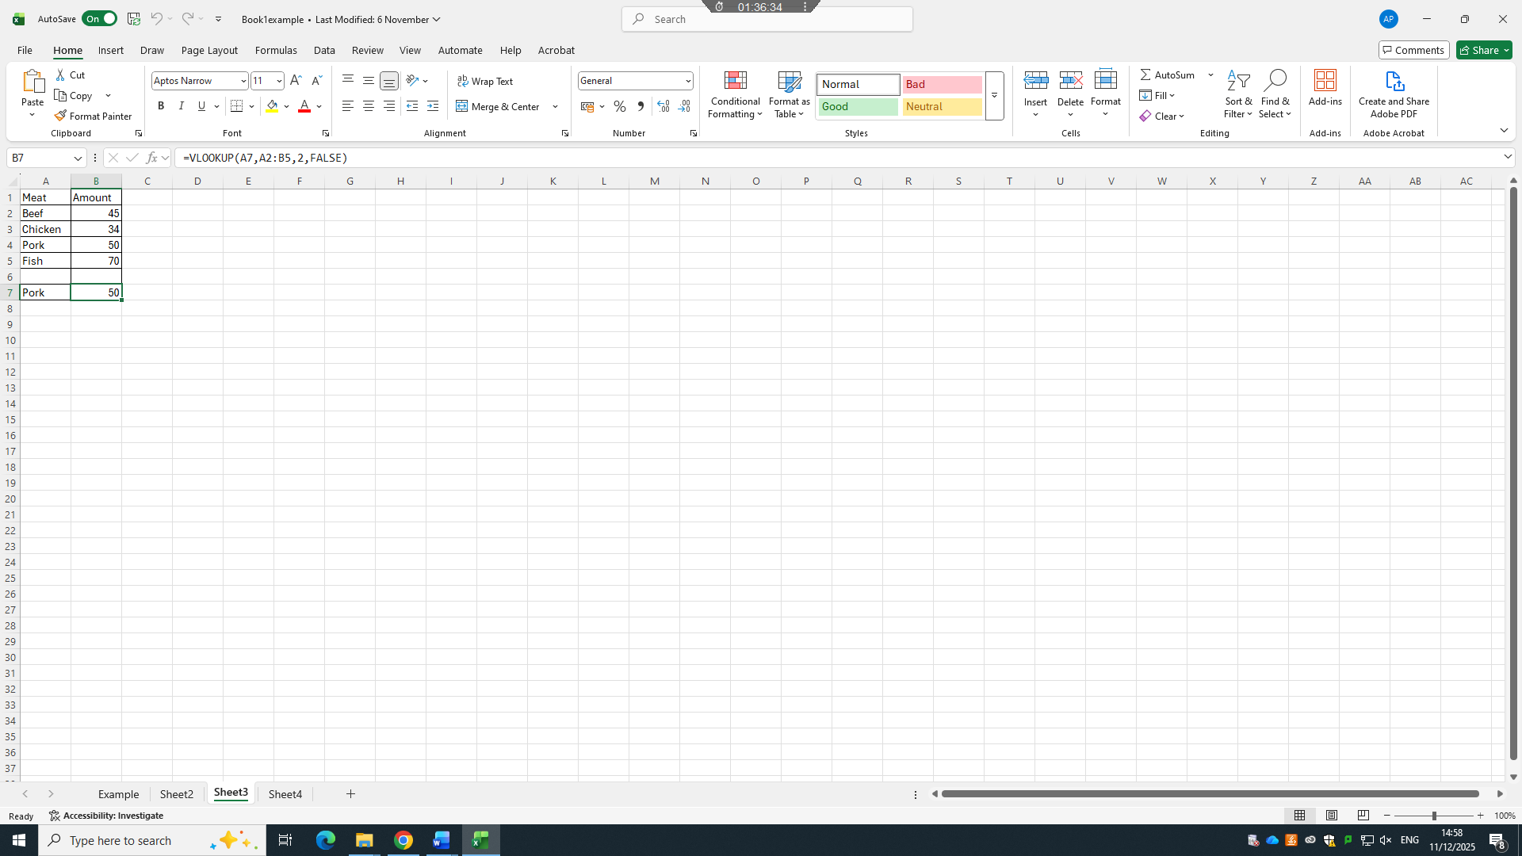

Picture 3. MS Excel Vlookup
Ms Access: As mentioned above, we use Ms Access to analyse, compare, and generate graphical results from large datasets. The biggest advantage of this program is that it allows us to filter large datasets individually, then connect these data points to each other, enabling comparison and data creation accordingly. Ms Excel did not allow us to create such connections. In this respect, Ms Access makes it easier for us to manage large datasets and perform data analysis within them[3].
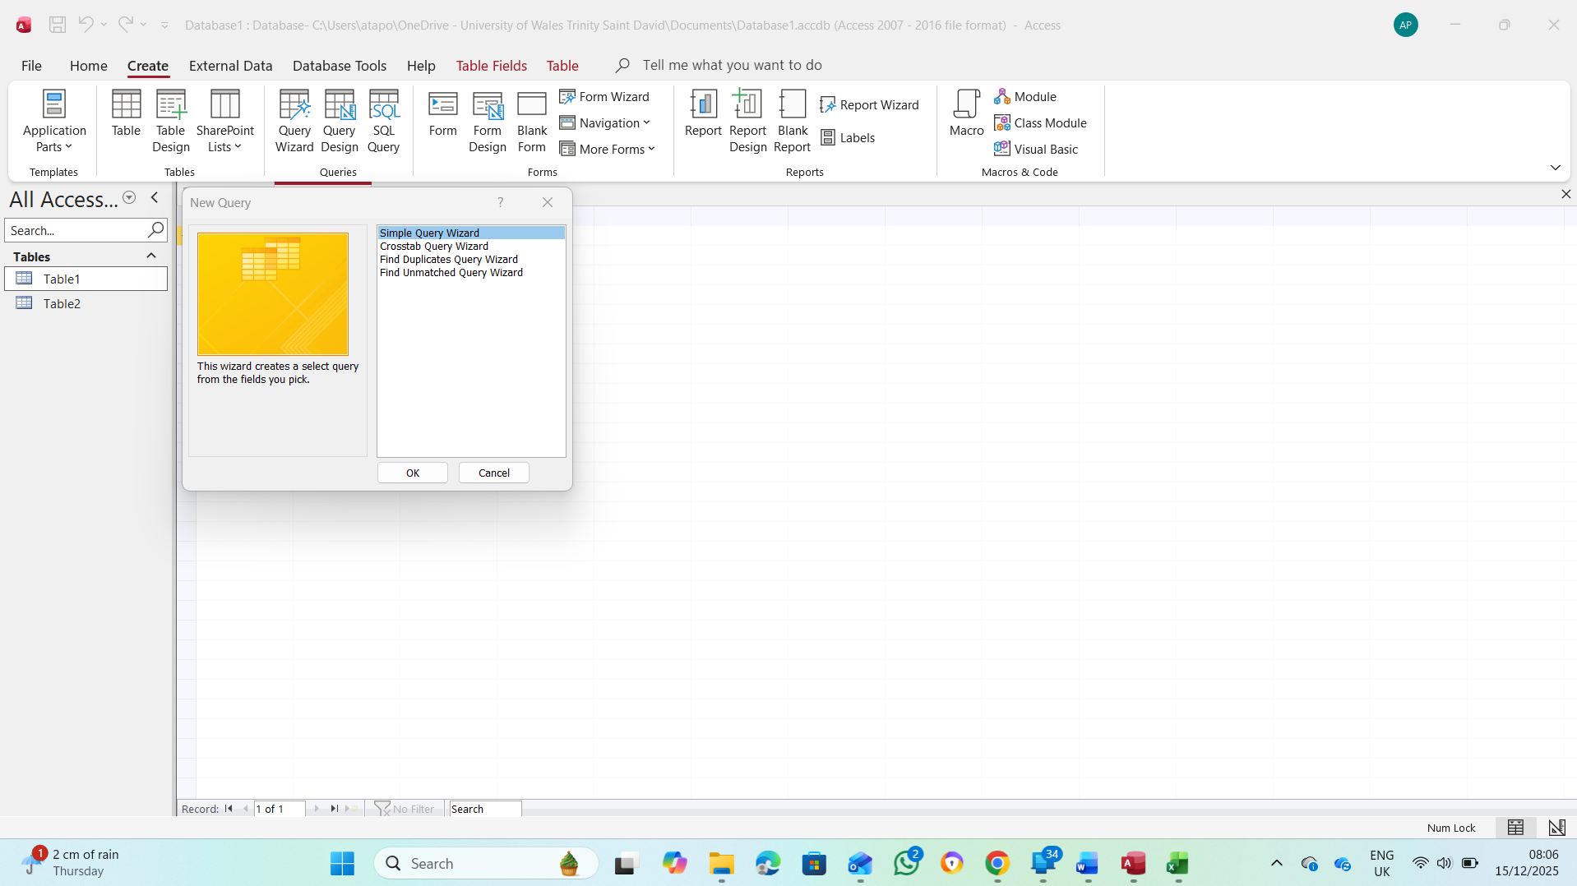
Picture 4. MS Access Query
Ms PowerPoint: We primarily use it for preparing presentations and for combining documents, data, and graphs created in programs like Ms Word, Ms Excel, and Ms Access into a presentation format. We also use it for playing videos, audio files, creating small animations, and adding various visualizations to the slides[4].
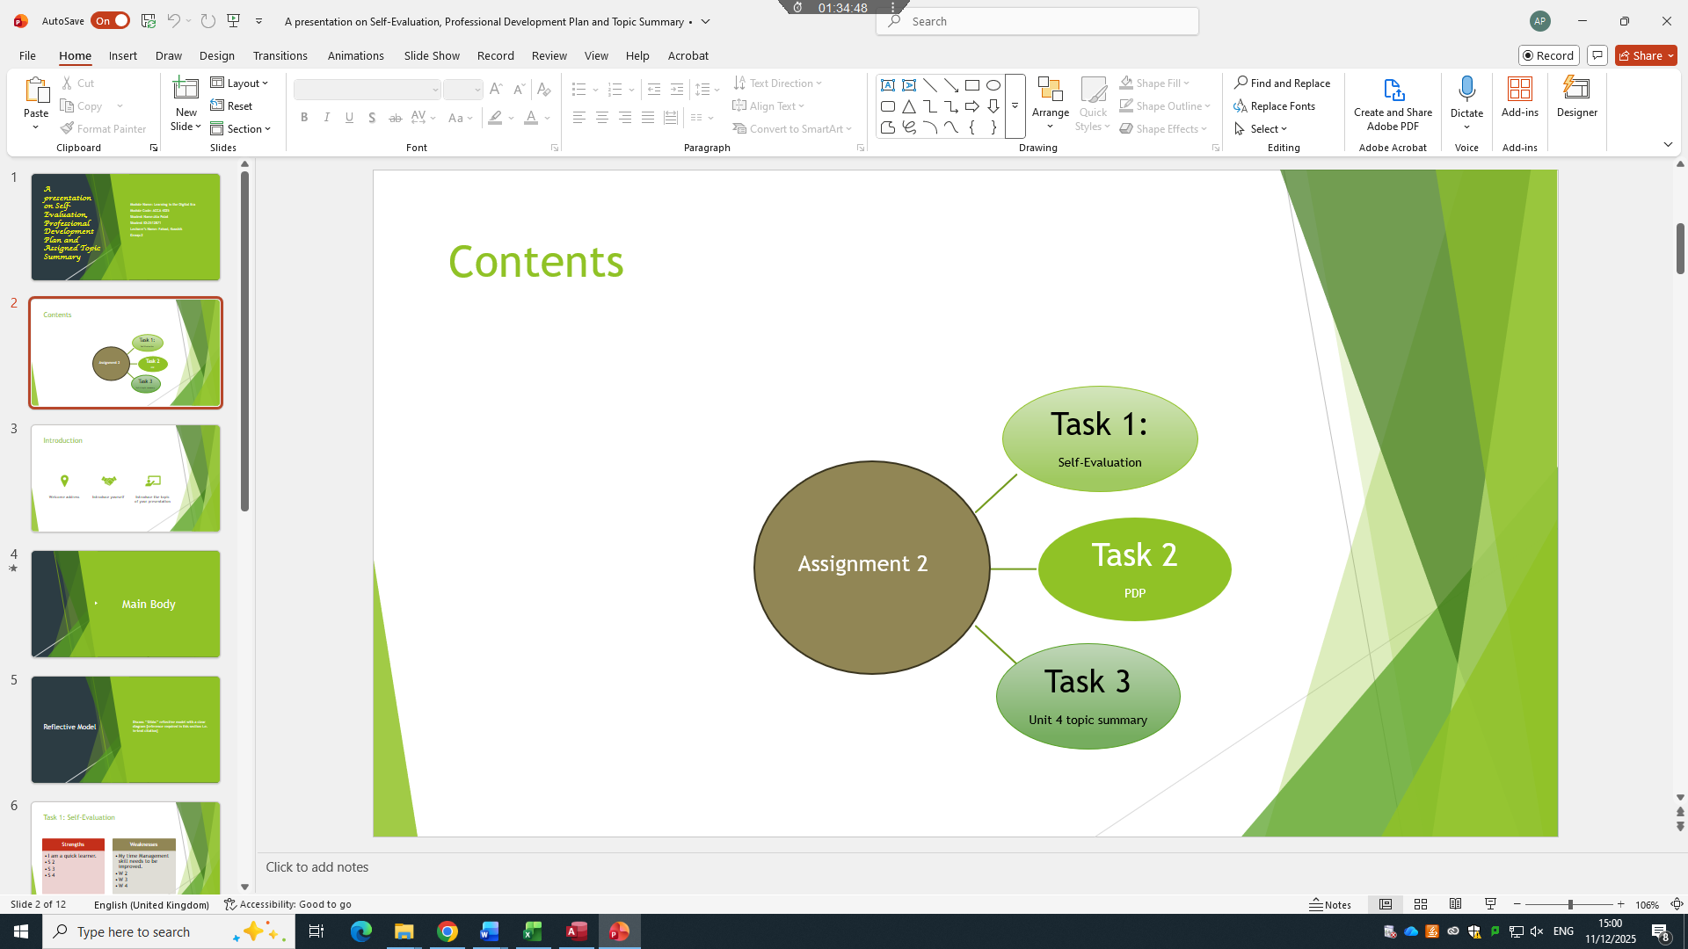

Picture 5. MS PowerPoint
- IF Function and VLOOKUP
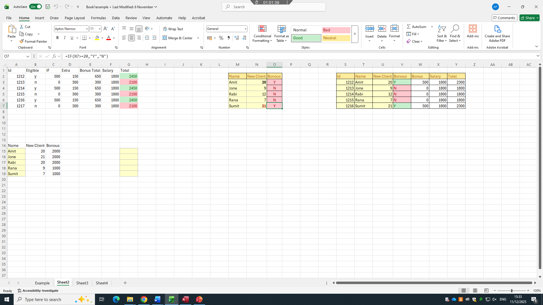Picture 6. IF Function
IF Function: In MS Excel, this function allows you to categorize data as yes/no or positive/negative, and assign a different value based on the resulting outcome. For example, a company plans to give some employees a £1000 salary increase, but you want this increase to only apply to those who have achieved a minimum sales figure of £10,000. In this case, by looking at the sales figures of the employees for that month, you can use the IF function formula to give a £1000 increase to those with sales of £10,000 and above, but no increase to those with sales below £10,000.
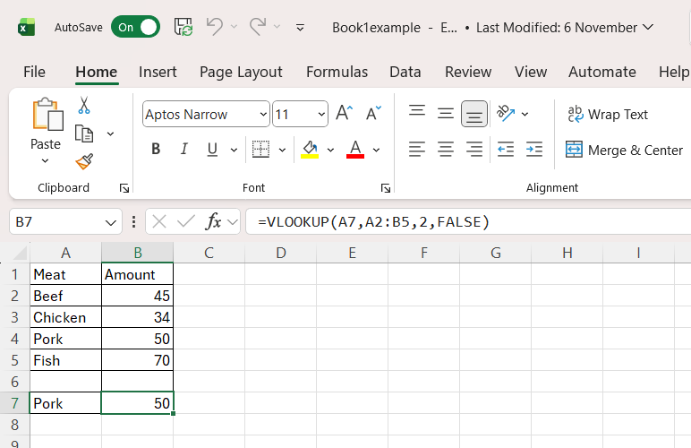

Picture 7. VLOOKUP

VLOOKUP: VLOOKUP allows us to extract information from two different large datasets in Excel. For example, we can use VLOOKUP to match employee ID numbers with payslips in a company and determine salary increase rates accordingly.

Task 4. Communication and Collaboration applications

A.
Microsoft Outlook, along with Google Gmail, is one of the world's most widely used email applications. It includes many features such as sending and receiving emails, a calendar feature, task list creation, and automatic replies. Its integration with other Microsoft applications allows us to manage everything with a single application, which is one of Microsoft Outlook's most important features. However, its complexity of use and slow system performance can be considered its negative aspects[5][6].
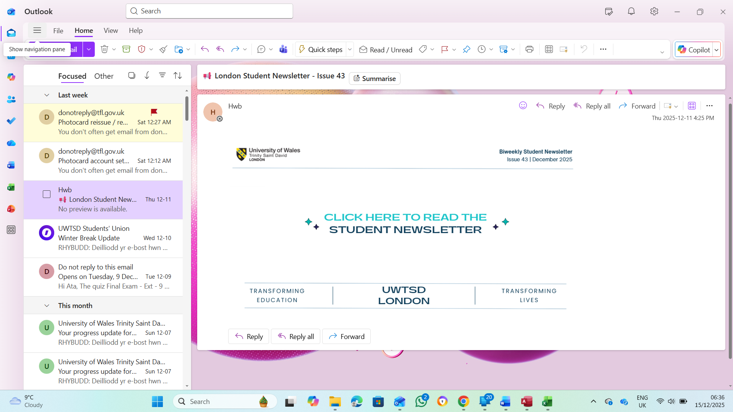

Picture 8. Microsoft Outlook
Microsoft OneDrive: Microsoft OneDrive, while a cloud storage application, primarily functions as a synchronization application. It integrates seamlessly with Microsoft tools, a significant advantage, and provides easy access by synchronizing files across all platforms. Perhaps its biggest disadvantage is that, because it relies on synchronization, when you delete a file, it doesn't keep it in the Recycle Bin for long. In short, if you delete a file, you will eventually lose it completely[7][8].
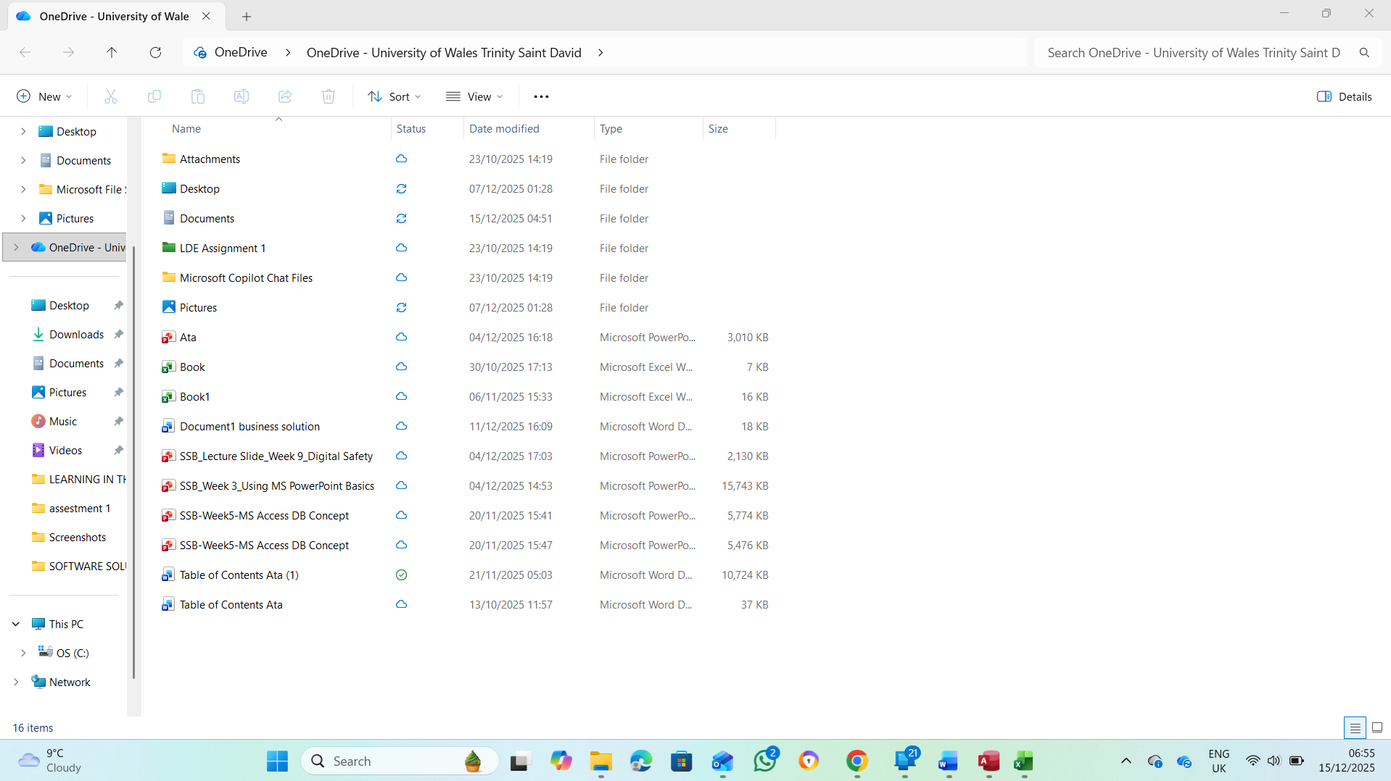

Picture 9. Microsoft OneDrive

B.
Gmail: Gmail is a free email application. Like Microsoft Outlook, it offers features such as sending and receiving emails, calendar organization, and many more. The most important difference between Gmail and Microsoft Outlook is that Gmail is completely free. However, this free application can have insufficient data storage capacity, and therefore offers paid features and more storage under the name of subscription packages. Secondly, because Gmail is free, there can be some issues with data security, especially regarding data sharing with third-party organizations, which is a rather controversial topic.
Google Drive: Google Drive, like Microsoft OneDrive, is a free cloud storage application. Its biggest advantage is that it allows many people to work simultaneously thanks to its ability to synchronize across all devices. A disadvantage is its limited storage space of 15GB. Of course, upgrading to the paid version increases storage space, but this is still considered a drawback for users.

References

Task 1.

[1] | M. Neri, “Master’s Degree in Innovation and Marketing Fashion e-commerce,” Venice, 2020-2021.
[2] | J. Holland, “Learn How to Create a Wix Website: Current Best Practices,” Learn How to Create a Wix Website: Current Best Practices, Emporia, 2023.
[3] | D. Dolifka, “Conducting Experimental Research on Shopify: An Initial Discussion and Guide to Getting Started,” Univercity of California, Los angles, 2023.
[4] | T. Buzan and B. Buzan, The Mind Map Book, London: BBC, 1993.

Task 3.
[1] A. Kohlhase, "MS PowerPoint use from a micro-perspective", EdMedia Innovate Learning, pp. 1279–1286.
[2] K. Reichardt, "Using Microsoft Access® for journal collection management," vol. 37, no. 4, pp.69–78, 2000,
[3] M. S. Excel, "Microsoft Excel," 2007,
[4] O. Kruse and C. Rapp, "Word processing software: The rise of MS Word," in Digital Writing Technologies in Higher Education: Theory, Research, and Practice, Springer, 2023, pp. 15–32.

Task 4.
[1] K. Wilson, "OneDrive," in Everyday Computing with Windows 8.1, Springer, 2014, pp. 71–74.
[2] R. Mercurio and B. Merrill, "Onedrive," in Beginning Microsoft 365 Collaboration Apps: Working in the Microsoft Cloud, Springer, 2021, pp. 81–102.
[3] M. T. Banday and S. A. Sheikh, "Realization of Microsoft Outlook® Add-In for Language Based E-Mail Folder Classification", 2013 International Conference on Machine Intelligence and Research Advancement, pp. 279–284.
[4] B. March, The Microsoft Outlook Ideas Book, Packt Publishing Ltd, 2006.

