University of Wales Trinity Saint David

Wales institute of Science and Arts



2D Diffusion Equation model using the Explicit Finite Difference Method

Computational Methods (ACMA6012)

Jamie Woodberry

2007714

06/05/2024

Table of Contents
Table of Contents
Table of Contents 1
1 Introduction 4
2 Heat Equation 6
3 Explicit Finite difference Equation 7
3.1 Taylor Series 7
3.2 Derivation of Forward, Backward and Central Differences 7
3.2.1 Forward Difference approximation 7
3.2.2 Backwards difference approximation 8
3.2.3 Central Difference approximation 9
3.3 Discretise the Spatial Domain 11
3.4 Discretise the Temporal Domain 12
3.5 Introducing Fourier’s number into Explicit finite difference equation 12
3.6 Explicit Finite Difference Scheme 12
3.7 Defining Stability Criterion 12
4 Boundary Condition 13
4.1 Initial Domain Condition 13
4.2 Constant Boundary Conditions 13
5 Explanation of MATLAB Code 15
6 Validation of the Model 19
7 Sensitivity Analysis of the Model 24
7.1 Grid Spacing 24
7.2 Time Step 26
7.3 Tolerance Value 28
8 Main models limitations 30
9 Suggested improvements and future developments 31
10 Conclusion 32
11 References 33
12 Appendix 35

Table of Figures
Figure 1- Cartesian Notations 11
Figure 2- Commands 15
Figure 3-User Grid Spacing Inputs 15
Figure 4- Time step inputs 15
Figure 5- Zeros Matrix 15
Figure 6- Domain Conditions 16
Figure 7- Title for Command Window 16
Figure 8 16
Figure 9 17
Figure 10- Graph Functions (Same for all three plots) 17
Figure 11- Time to Thermal Equilibrium 18
Figure 12- Analytical equation coding 18
Figure 13- Temperature difference between analytical and numerical matrices 18
Figure 14- A.) Numerical Solution. B.) Analytical Solution (0.5 mesh) 20
Figure 15- Temperature difference for 0.5 mesh 21
Figure 16- A.) Numerical Solution. B.) Analytical Solution (0.25 Mesh) 22
Figure 17- Temperature Difference for 0.25 mesh 23
Figure 18- Graph for Grid Spacing Analysis 25
Figure 19- Graph of Altered time steps. 27
Figure 20- Tolerance Values Sensitivity Analysis 29

Table of Equations
Equation 1- 2D Heat Equation with no heat sources 6
Equation 2- Taylor Series 7
Equation 3- Substituting x=xo+h and h to right of x0 7
Equation 4- Rearranging Equation 4 8
Equation 5- Two-point forward difference Approximation 8
Equation 6- Truncation Error for Forwards Approximation 8
Equation 7- Substituting x=xo-h and h to left of x0 8
Equation 8 - Rearranging Equation 8 8
Equation 9- Two-point backward difference Approximation 8
Equation 10 - Truncation Error for Backwards Approximation 9
Equation 11 - Subtracting Forwards Approximation by Backwards 9
Equation 12 - Constructed equation from subtraction from Equation 11 9
Equation 13- Rearranging Equation 13 9
Equation 14- 1st Derivative Central difference approximation 9
Equation 15- Truncation error for Equation 15 9
Equation 16 - Constructing Central difference Approximation for 2nd Derivative 10
Equation 17- Constructed Equation from Equation 17 10
Equation 18 - Rearranged Equation 18 10
Equation 19- Three-point central difference Approximation 10
Equation 20- Truncation Error Second Derivative Approximation 10
Equation 21 – North and South Grid 11
Equation 22- East and West Grid 11
Equation 23 – Discretisation of the Temporal Domain 12
$F0=α.∆th2$Equation 24- Fourier Number 12
Equation 25- Explicit Finite Difference Equation 12
Equation 26 - Stability Criterion 13
Equation 27 - Initial Domain Condition 13
Equation 28 - Constant Boundary Condition (1) 13
Equation 29$- Constant Boundary Condition (2)$ 14
Equation 30- Analytical Solution 14

Table of Tables

Table 1- Parameter and Results from 0.5 mesh Validation 19
Table 2- Parameter and Results from 0.25 mesh Validation 21
Table 3- Grid Spacing Sensitivity Analysis 24
Table 4- Time Step Sensitivity Analysis 26

Introduction

Heat transfer is pivotal in engineering and other industries to find the material characteristics when under a heated load. This assignment covers heat transfer through 6x6 meter plate with an external heat source being applied onto the plate. The aim of the assignment was to gain an understanding of the governing equation (heat equation), from this being able to derive the equation to approximate heat distribution through the plate. The report will cover what the heat equation is and why it is important to us as engineers.

The discretisation procedure for the explicit finite difference method, starts from the Taylor series approximation to the derivation of the, forward, backward and central difference approximations. This was then possible to generate the explicit finite difference scheme by the discretisation of the spatial and temporal domains of the heat equation. This section also covers the Fourier’s number and stability criterion needed for this study.

Initial and boundary conditions are covered in the report, that are crucial for the heat transfer process of this study. Additionally, the analytical solution is introduced which is pivotal for the validation of the numerical solution. The report will outline the codes’ structure and an explanation on what is being carried out to find the solutions.

Analysis of results obtained from the code will be shown, which carried out a sensitivity analysis study to find the behaviour of the code by varying parameters such as time step, grid spacing and tolerance values. From doing so was possible to find the limitations of the code and suggested improvements that can be applied in the future.

Aims and Objectives:

- Gain an understanding of the heat equation and the numerical solution known as explicit finite difference method.

- To carry out a fully discretisation procedure from the Taylor series to produce the explicit finite difference method.

- State why all conditions are crucial in this method.

- Validation between analytical and numerical solutions.

- Conduct a sensitivity analysis to gain an understanding on varying parameters implements the code behaviour.

- Find the limitations of the model and suggest future improvements for the study.

Heat Equation

Equation 1 shows the heat equation with no heat sources (Widder, 1975). The heat equation is an important equation to calculate the temperature at the next given spatial coordinate with respect to time. The heat equation is important as it allows us to understand how heat propagates through materials, it allows us as engineers to calculate the evolution of temperature over time.

$$\frac{∂^{2}T}{∂x^{2}}+\frac{∂^{2}T}{∂y^{2}}=α. \frac{∂T}{∂t}$$
Equation 1- 2D Heat Equation with no heat sources
Where,
- $α=\frac{ρ.Cp}{k}=$ Thermal Diffusivity
- $ρ=kg/m^{3} =density$
- $Cp=J/kg.C Specific Heat transfer$
- $k=conductivity$
- $t=seconds=time$
- $T=℃=Temperature$
- $x,y=meters=Spatial Coordinates$

Explicit Finite difference Equation
This section covers the full discretisation of the heat equation. From this it was possible to approximate the temperature distribution through the plate depending on different grid spacing and time steps implemented. The full discretisation will start from the Taylor series to approximate for the first and second derivatives. Once derived the forwards, backwards and central differences, it was possible to replace these methods into the heat equation making the explicit finite difference form of the heat equation.

Taylor Series

Equation 2 is the Taylor series where $x_{0}$ represents the derivative of the function at point $x_{0}$. If $x_{0}$ was zero, then the Taylor series is also known as the Maclaurin series (Weisstein, 2004). By truncating such Taylor series, one can derive the difference approximations to the first and second derivatives. These approximations will be used to generate the explicit finite difference form of the heat equation.

$$f\left(x\right)=f\left(x_{0}\right)+f^{'}\left(x_{0}\right).\frac{\left(x-x_{0}\right)}{1!}+f"(x_{0}).\frac{(x-x_{0})^{2}}{2!}+f'''(x_{0}).\frac{(x-x_{0})^{3}}{3!}+f^{4}(x_{0}).\frac{(x-x_{0})^{4}}{4!}+⋯$$
Equation 2- Taylor Series

Derivation of Forward, Backward and Central Differences

Forward Difference approximation

Express the Taylor series with respect to $x_{0}$ where ${x=x}_{0}+h$ with $h$ defining any location to the right of $x_{0}$. The Taylor series can be better expressed where ${x=x}_{0}+h$ and any location to the right of $x_{0}$can be defined as $h$:

$$f\left(x_{0}+h\right)=f\left(x_{0}\right)+h.f^{'}\left(x_{0}\right)+\frac{h^{2}}{2!}f^{''}\left(x_{0}\right)+\frac{h^{3}}{3!}f^{'''}\left(x_{0}\right)+…$$
Equation 3- Substituting x=xo+h and h to right of x0

By rearranging equation 4 we can achieve the following equation:
$$\frac{f\left(x0+h\right)-f\left(x0\right)}{h}=f^{'}\left(x_{0}\right)+\frac{h^{2}}{2!}f^{''}\left(x_{0}\right)+\frac{h^{3}}{3!}f^{'''}\left(x_{0}\right)+…$$
Equation 4- Rearranging Equation 4
Equation 5 is the forward difference approximation from the Taylor series (Svetlana, 2008):
$$f^{'}\left(x0\right)≈ \frac{f\left(x0+h\right)-f\left(x0\right)}{h}+O(h)$$
Equation 5- Two-point forward difference Approximation
Equation 6 shows the forwards truncation error:

$$O(h)≡f^{'}\left(x_{0}\right)-\frac{f\left(x_{0}+h\right)-f\left(x_{0}\right)}{h}$$
$$=-\frac{h}{2!}f^{''}\left(x_{0}\right)-\frac{h^{2}}{3!}f^{\left(3\right)}\left(x_{0}\right)+⋯$$
Equation 6- Truncation Error for Forwards Approximation

Backwards difference approximation
The backwards difference will be defining $h$ to the left of $x_{0}$. and where ${x=x}_{0}-h$ by using the Taylor series.
$$f\left(x_{0}-h\right)=f\left(x_{0}\right)-h.f'\left(x_{0}\right)+\frac{h^{2}}{2!}f''\left(x_{0}\right)+\frac{h^{3}}{3!}f'''\left(x_{0}\right)+…$$
Equation 7- Substituting x=xo-h and h to left of x0
By rearranging the first derivative we can achieve the following equation to find the backwards difference:
$$\frac{f\left(x0-h\right)-f\left(x0\right)}{h}=-f^{'}\left(x_{0}\right)+\frac{h^{2}}{2!}f^{''}\left(x_{0}\right)+\frac{h^{3}}{3!}f^{'''}\left(x_{0}\right)+…$$
Equation 8 - Rearranging Equation 8
Equation 9 shows the backward approximation from the Taylor series (Svetlana, 2008):

$$f^{'}\left(x0\right)≈ \frac{f.\left(x0\right)-f.\left(x_{0}-h\right)}{h}+O(h)$$
Equation 9- Two-point backward difference Approximation
The backwards difference approximation will also have a lower truncation error as the value of $h$ is decreased, this can be expressed as:
$$O(h)≡f^{'}\left(x_{0}\right)-\frac{f\left(x_{0}\right)-f\left(x_{0}-h\right)}{h}$$
$$=\frac{h}{2!}f^{''}\left(x_{0}\right)-\frac{h^{2}}{3!}f^{\left(3\right)}\left(x_{0}\right)+…$$
Equation 10 - Truncation Error for Backwards Approximation

Central Difference approximation

Process to find central difference to the first derivative:
$$f\left(x_{0}+h\right)=f\left(x_{0}\right)+h.f^{'}\left(x_{0}\right)+\frac{h^{2}}{2!}f^{''}\left(x_{0}\right)+\frac{h^{3}}{3!}f^{\left(3\right)}\left(x_{0}\right)+⋯$$
$$-$$
$$f\left(x_{0}-h\right)=f\left(x_{0}\right)-h.f^{'}\left(x_{0}\right)+\frac{h^{2}}{2!}f^{''}\left(x_{0}\right)-\frac{h^{3}}{3!}f^{\left(3\right)}\left(x_{0}\right)+⋯$$
Equation 11 - Subtracting Forwards Approximation by Backwards
From subtracting these two equations we can achieve the following equation:
$$f\left(x_{0}+h\right)-f\left(x_{0}-h\right) =2.\left[h.f^{'}\left(x_{0}\right)+\frac{h^{3}}{3!}f^{\left(3\right)}\left(x_{0}\right)+⋯\right]$$
Equation 12 - Constructed equation from subtraction from Equation 11
Rearranging equation 12 to get:

$$\frac{f\left(x_{0}+h\right)-f\left(x_{0}-h\right)}{2.h} =f^{'}\left(x_{0}\right)+\frac{h^{2}}{3!}f^{\left(3\right)}\left(x_{0}\right)+⋯$$
Equation 13- Rearranging Equation 13
Central difference approximation for the first derivative can be shown in equation 14 (A.Yew, 2011):
$$f^{'}\left(x0\right)≈\frac{f.\left(x0+h\right)-f\left(x0-h\right)}{2h}+O({h)}^{2}$$
Equation 14- 1st Derivative Central difference approximation

For the central difference error shown as:
$$O({h)}^{2}≡f^{'}\left(x_{0}\right)-\frac{f\left(x_{0}+h\right)-f\left(x_{0}-h\right)}{2.h}$$
$$=-\frac{h^{2}}{3!}f^{\left(3\right)}\left(x_{0}\right)+⋯$$
Equation 15- Truncation error for Equation 15

Second Order Derivatives

To find the central difference approximation for the second derivative, can be constructed by adding the two approximations:

$$f\left(x_{0}+h\right)= \left[f\left(x_{0}\right)+h.f^{'}\left(x_{0}\right)+\frac{h^{2}}{2!}f^{''}\left(x_{0}\right)+\frac{h^{3}}{3!}f^{\left(3\right)}\left(x_{0}\right)+⋯\right]$$
$$+$$
$$f\left(x_{0}-h\right)=\left[f\left(x_{0}\right)-h.f^{'}\left(x_{0}\right)+\frac{h^{2}}{2!}f^{''}\left(x_{0}\right)-\frac{h^{3}}{3!}f^{\left(3\right)}\left(x_{0}\right)+⋯ \right]$$
Equation 16 - Constructing Central difference Approximation for 2nd Derivative
By adding the two approximation we can get the following equation for the second derivative:
$$f\left(x_{0}+h\right)+f\left(x_{0}-h\right)=2.\left[f\left(x_{0}\right)+\frac{h^{2}}{2!}f^{''}\left(x_{0}\right)+\frac{h^{4}}{4!}f^{(4)}\left(x_{0}\right)+⋯\right]$$
Equation 17- Constructed Equation from Equation 17

Rearranging the previous equation can produce the following:
$$\frac{f\left(x_{0}+h\right)-2.f\left(x_{0}\right)+f\left(x_{0}-h\right)}{h^{2}}=f^{''}\left(x_{0}\right)+\frac{h^{2}}{12}f^{(4)}\left(x_{0}\right)+⋯$$
Equation 18 - Rearranged Equation 18
Central difference approximation for 2nd derivative can be shown in equation 19 (A.Yew, 2011):
$$f"(x0)≈\frac{f\left(x0+h\right)-2.f\left(x0\right)+f(x0-h)}{h^{2}}+0(h)$$
Equation 19- Three-point central difference Approximation

The error for the three-point central difference approximation can be shown as:
$$0(h)≡f^{''}\left(x_{0}\right)-\frac{f\left(x_{0}+h\right)-2.f\left(x_{0}\right)+f\left(x_{0}-h\right)}{h^{2}}$$
$$=-\frac{h^{2}}{12}f^{(4)}\left(x_{0}\right)+⋯$$
Equation 20- Truncation Error Second Derivative Approximation

Discretise the Spatial Domain

The discretisation of spatial domain is important for calculating the temperature throughout the plate. Cardinal points, East, South, West and North are used to create a uniform structured grid. Such a grid structure is applied on top of the plate. Then, the temperatures will be calculated at each of these nodes at every moment in time. Equation 21 and 22 shows the spatial domain by introducing the central difference approximation.
$$\frac{∂^{2}T_{P}}{∂x^{2}}=\frac{T_{N}-2.T_{P}+T_{S}}{h^{2}}$$
Equation 21 – North and South Grid
$$\frac{∂^{2}T_{P}}{∂x^{2}}=\frac{T_{W}-2.T_{P}+T_{E}}{h^{2}}$$

Equation 22- East and West Grid

Figure 1 shows a representation on how the grid spacing will be applied onto the plate. Where h on the figure represents the grid spacing in all cartesian coordinates, the smaller the grid spacing applied the more points will be calculated through the plate. This figure shows a diagram on how equation 21 and 22 will be applied onto the plate, allowing it possible to approximate at the next point of time.
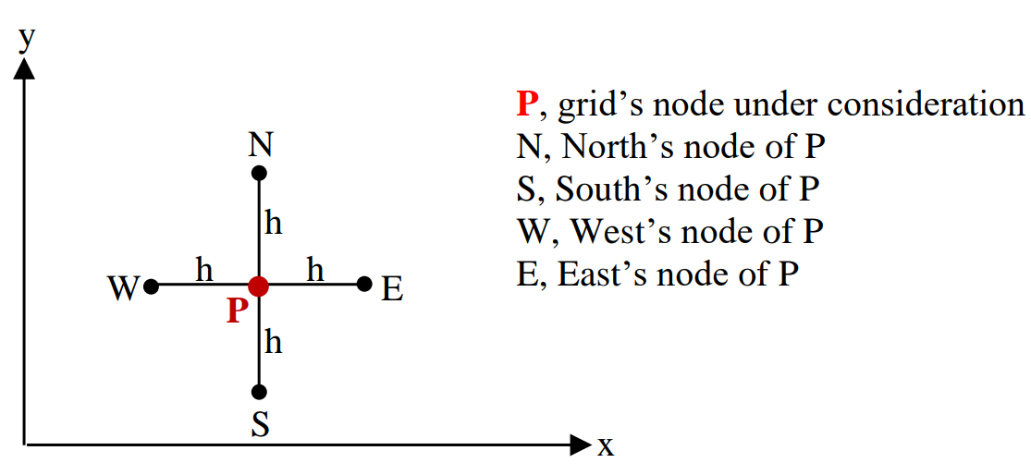
Figure 1- Cartesian Notations

Discretise the Temporal Domain

Time steps must be applied to define the discrete times at which the temperature will be calculated. By creating these time steps, it allows the simulation to approximate the temperature at each point of time.

Discretise the temporal domain of the heat equation by the forward difference approximation:
$$\frac{∂T_{P}^{t}}{∂t} =\frac{T_{P}^{t+∆t}-T_{P}^{t}}{∆t}$$
Equation 23 – Discretisation of the Temporal Domain

Introducing Fourier’s number into Explicit finite difference equation
Introduce Fourier’s number into the explicit finite difference method is crucial for approximating the temperature distribution through the plate. As it involves the factors such as, thermal diffusivity, time step and grid spacing, by having Fourier’s number allows the simulation to iteratively calculate the temperature from on time step to the next throughout the plate, until thermal equilibrium is reached.
.
$F_{0}=\frac{α.∆t}{h^{2}}$Equation 24- Fourier Number

Explicit Finite Difference Scheme
From the procedure from the full discretisation of the Taylor series allowed it possible produce equation 25, which is EFDM :

$$T_{P}^{t+∆t}= F_{0}(T_{E}^{t}+T_{W}^{t}+T_{N}^{t}+T_{S}^{t}-\left(4-\frac{1}{F_{0}}\right).T_{P}^{t}$$
Equation 25- Explicit Finite Difference Equation

Defining Stability Criterion
By incorporating the stability criterion into the model will stabilise the simulation, this is used to improve the accuracy of the equation. If the criterion was to overshoot a quarter the model will become unstable and the results being calculated will not be accurate, if the stability criterion was to overshoot the temperatures within the plate can exceed the heat source being applied onto the plate (Powell, 2002). Thus, shown that the stability criterion is pivotal for approximating accurate temperature being calculated through the plate, the stability criterion can be shown in equation 29.

$0<F_{0}≤\frac{1}{4}$
Equation 26 - Stability Criterion

Boundary Condition

Initial Domain Condition

Equation 19 is the domain size with the x and y direction, which the plate dimension was a 6x6 meter aluminium plate. The left-hand side of the equation states that all the values within the matrix are 0 Degrees.

$$T\left(x,y,0\right)=0 || 0<x<6 || 0<y<6$$
Equation 27 - Initial Domain Condition

Constant Boundary Conditions
These boundary conditions were important for the distribution of the heat to be calculated through the plate, as this condition was the temperature along the top of the plate. From calculating the temperature from the top of the plate using the explicit finite difference equation, allowed possible to calculate the temperature for the next time from the previous temperature.

Equation 28 was used to calculate the temperature at first $\frac{1}{3}$ of the plate.

$$f\left(x\right)=12.5x if 0≤\left(\frac{2}{3} × 6\right)$$
Equation 28 - Constant Boundary Condition (1)

Equation 29 was used to calculate at $\frac{2}{3}$ of the plate:
$$f\left(x\right)=-25x+150 if \left(\frac{2}{3} ×6\right)<x≤6$$
Equation 29$- Constant Boundary Condition (2)$

The justification for using these boundary conditions is because such conditions have the condition that the code will be validated against. There are very little solutions to test against in this subject, this is one that is possible to test against the analytical solution, therefore by testing the numerical solution against the analytical solution give justification that the code is running correctly. From this it would be able to use different condition on the plate as the code was justified and showing correct results against the analytical solution. Equation 33 shows the analytical solution that the code will be tested against (R.C, 2012).

$$T\left(x,y\right)= \frac{450}{π^{2}} . \sum_{n=1}^{∞}{\left(\frac{\sin\left(\frac{2.n.π}{3}\right)}{n^{2}.\sinh\left(n.π\right)}.\sin\left(\frac{n.π.x}{6}\right).sinh⁡\left(\frac{n.π.y}{6}\right)\right) }$$
Equation 30- Analytical Solution

Explanation of MATLAB Code

Command controls that are used in the beginning of the matlab script, ‘clc’ clears the command window, ‘clear’ clears the workspace which were the values that have been calculated are stored and ‘close all’ clears all the figures if graphs are being shows in the script.
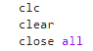
Figure 2- Commands

User inputs for grid spacing, must be within the condition stated.
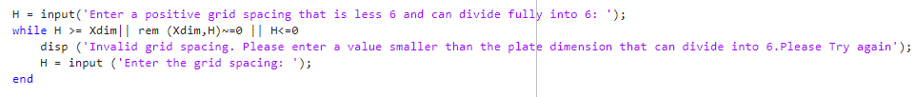
Figure 3-User Grid Spacing Inputs

User inputs for time step, if incorrect time was entered the maximum allowed time will be shown in the error message.
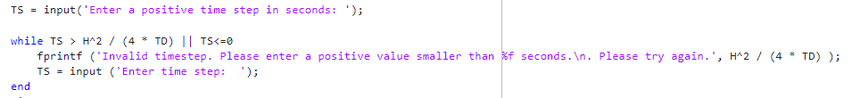
Figure 4- Time step inputs

Creating a matrix full of zeros, replicating the plates temperature. The student applied a function called tic toc, this function will time the code to run after the user inputs the grid spacing and time step.
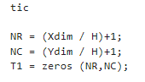
Figure 5- Zeros Matrix

Code for initial domain condition and boundary conditions to apply the temperature along the top on the plate.
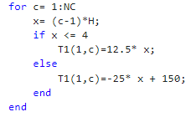
Figure 6- Domain Conditions
This used to apply a title in the command window, which will make the results look clearer once the code has run.

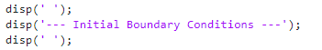
Figure 7- Title for Command Window

Figure 9 shows:
- Calculating Fourier’s number.
- Iterations of the model start at 0.
- TV is the maximum tolerance values
- T2 is a new matrix that is the same as T1, as in the next line of the code it calculates the temperature between the 2 matrices.

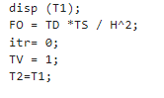
Figure 8

The explicit finite difference equation coded in a for loop. As many calculations are needed to be calculated, by putting the equation in a for loop, the code will loop back at each calculation until the calculation has reached thermal equilibrium. The statements r and c for the spatial discretisation
(P, N, S, W and E nodes), where the coded can calculate the next temperature based on the previous temperature.

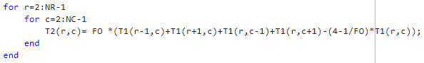
Figure 9

Process to plot the graph for numerical, analytical and temperature difference (figure 11):

- Contourf is a figure to plot a heat map.
- Ylabel and Xlabel for the axis on the figure.
- Colormap for the colour of the figure.
- Colorbar which is the bar to show the maximum and minimum temperatures.
- Clim and lims is a function to set the color bar values.
- G1 Label string to label the colorbar.
- Pausing the figure at each step to show a better visualisation of the heat distribution through the plate.

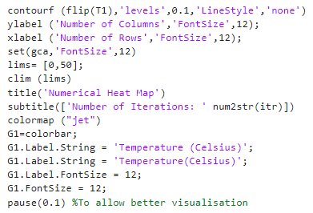
Figure 10- Graph Functions (Same for all three plots)
Figure 11 function were used to showed more appropriate values for thermal equilibrium.

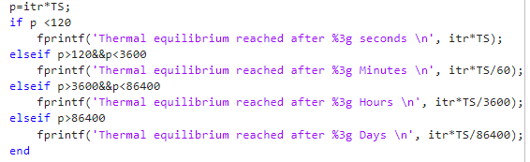
Figure 11- Time to Thermal Equilibrium

Coding procedure for the analytical solution.

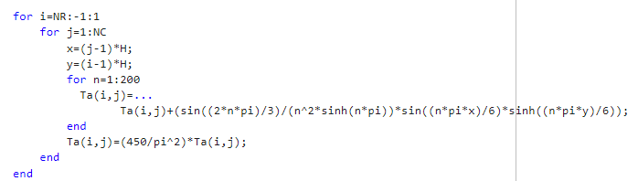
Figure 12- Analytical equation coding

Tdiff shown in figure 13, this was used to calculate the temperature difference between the numerical and analytical matrix.
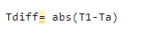
Figure 13- Temperature difference between analytical and numerical matrices

Validation of the Model

A mesh size 0.5 meters was used to capture a better behaviour throughout the plate, rather than a large mesh that would not capture the realistic behaviour in the plate. The time step of 200 was chosen to solve the solution faster, whilst also capturing enough data through each time step. If a smaller time step was applied it could cause computation power problems, by the solution taking too long and round off errors could occur in the solution causing inaccuracy in the model.
Table 1- Parameter and Results from 0.5 mesh Validation
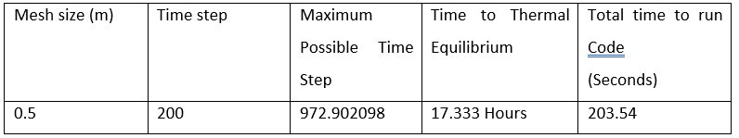
From analysing figure 14, it is clear to see the temperature being distributed through the plate is very similar to the anayltical solution which can be seen in figure 15b. This solution justifies that the numerical solution is working accordingy with heat being distributed in the correct areas as the analytical solution. This has validated that the code has been correctly coded, this can be justrified by the numerical heat map is showing the same distributions through the plate as the analytical solution.

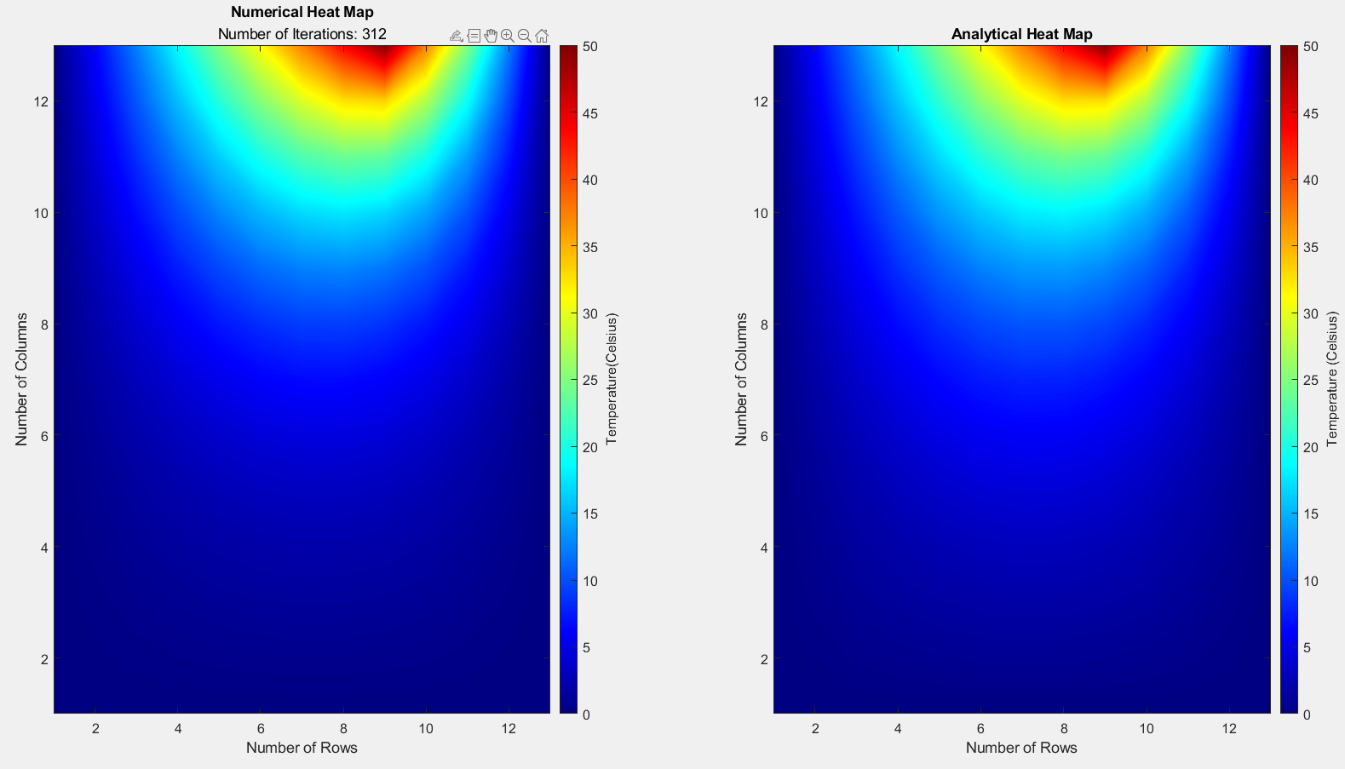
Figure 14- A.) Numerical Solution. B.) Analytical Solution (0.5 mesh)
Figure 15 shows the temperature differences between the two solutions. As shown in the figure there is a temperature difference between the two models. Although the temperatures have a small difference, with the highest temperature difference occurring in the centre of the plate, this would be down to round off errors with the number calculation needed at each iteration. This justifies that the code is working correctly, although there is a small difference which is expected with approximations.

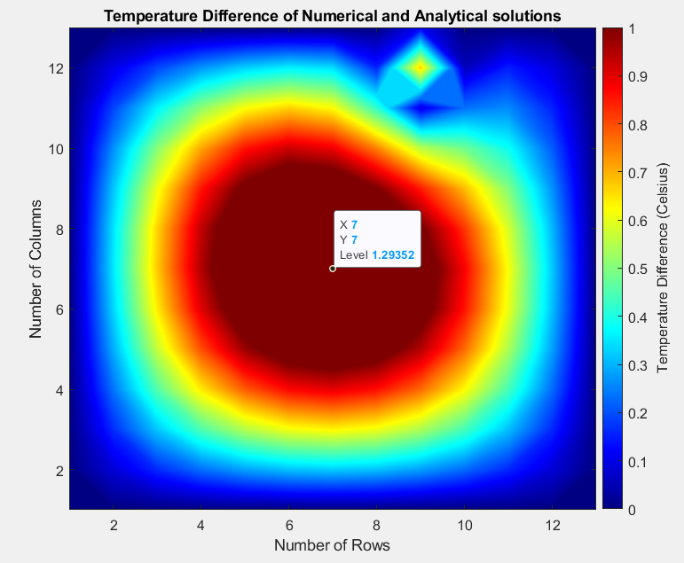
Figure 15- Temperature difference for 0.5 mesh
The student carried out a further validation by creating a finer mesh over the plate. Table 2 shows the results that were obtained from the solution. As the table shows the solving time of the model took longer this was down to a finer mesh and having to take more calculation at each iteration.
Table 2- Parameter and Results from 0.25 mesh Validation
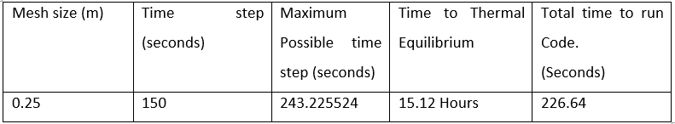
The smaller grid spacing also shows the heat distribution as expected to the analytical solution. This provides more justification on the code working correctly. From the figure it does not show many discrepancies between the two solutions which is a positive. If the numerical solution was different to the analytical solution, it could be down to incorrect coding or deriving the explicit finite method incorrectly. Therefore, by carrying out this validation has justified that the code is working correctly, and the boundary condition can then be changed as the results from the numerical solution have been justified.
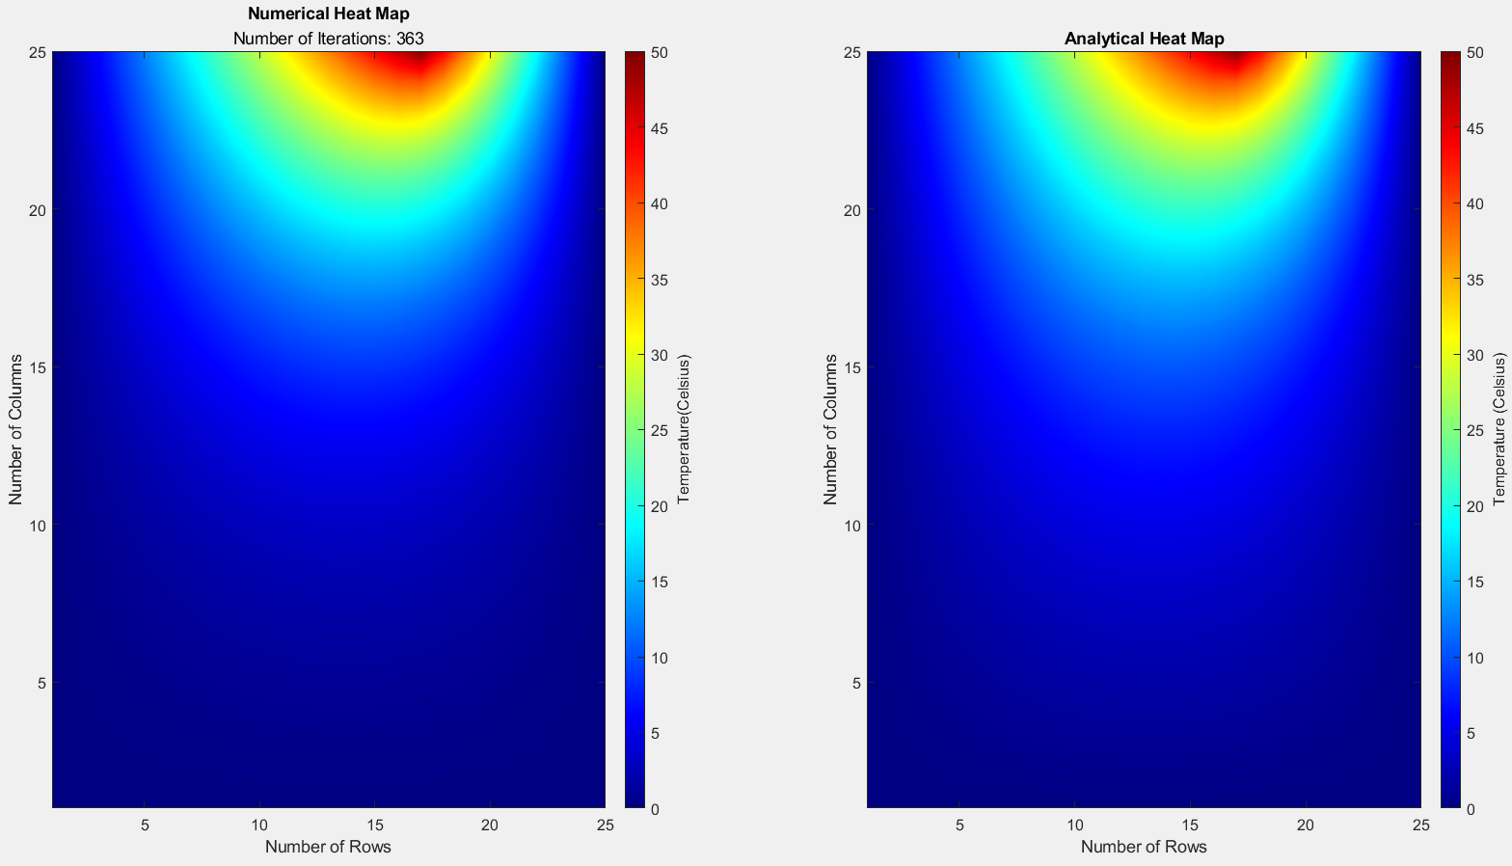
a.)
b.)
Figure 16- A.) Numerical Solution. B.) Analytical Solution (0.25 Mesh)

Figure 17 shows the temperature difference between the two solutions. The difference has increased, which can be down to round off errors, as more calculation were needed for the numerical solution. The results can be negligible as they are minimal, seeing as this is an approximation the results would not be identical. From the values obtained it shows the model can be used to approximate the temperature through the plate, taking into consideration of the limitations of accuracy in the model.
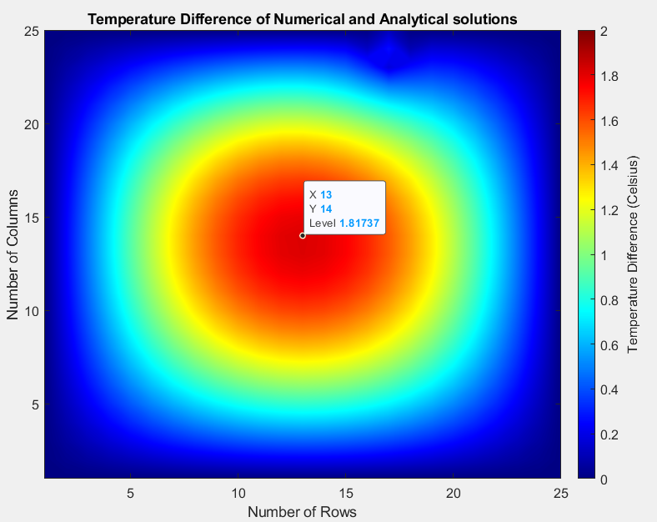
Figure 17- Temperature Difference for 0.25 mesh

Sensitivity Analysis of the Model
This section of the report will be used to find the effects of changing the grid spacing, time step and tolerance value. A study was carried out on these parameters to gain a deeper understanding how modifying these parameters changes the behaviour of the code. When carrying out the sensitivity analysis on these parameters 2 will be fixed, these will be the parameters that are not getting tested. The sensitivity will be carried out to find the effects of truncation error, round off and stopping the code too early or too late.

Grid Spacing

The method behind the grid spacing analysis was carried out to find when the solution will converge when the time step and tolerance values are fixed. This was carried out by initially starting with a large grid spacing and progressively decreasing the grid spacing until the thermal equilibrium time converges. The grid spacing parameters that were changed can be seen in table 3. From the values obtained from this method, it is clear to see that when the mesh is finer the values the values begin to converge.
Table 3- Grid Spacing Sensitivity Analysis
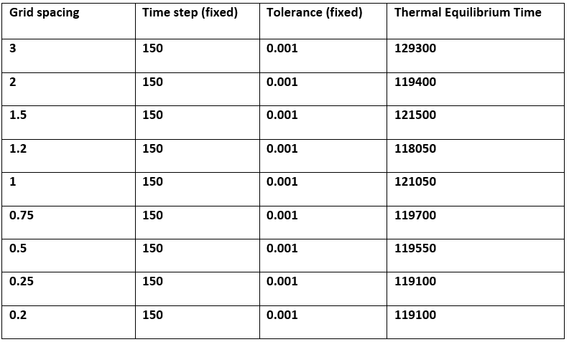

Figure 18 shows a better representation of the grid spacing sensitivity analysis, it shows the discrepancies in the model until the model converges. From analysing the method, it shown that when the grid spacing is decreased the values become closer to converging with a smaller difference between each value.
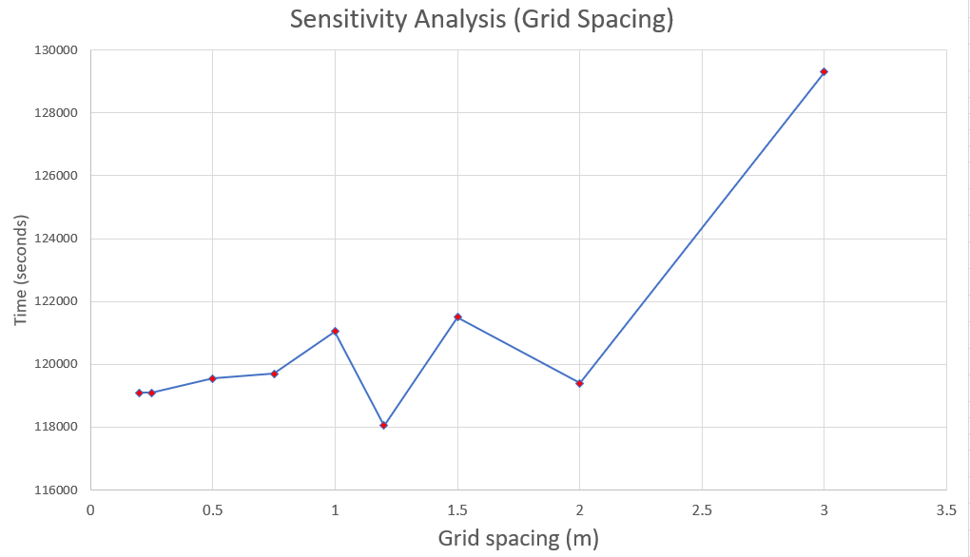
Figure 18- Graph for Grid Spacing Analysis

The results have shown that when the mesh has been refined the model has converged, with less discrepancies in the model. This has been achieved by creating a finer mesh on the model reduces the truncation error (Alexandros Syrakos, 2012). The results have shown that the optimal grid spacing for this model would be 0.25, as the solution has converged which can be seen in figure 18. If the grid spacing was to be decreased anymore it would cause computational power limitations with the model taking too long to solve with very little changes in the solution. It has been stated that the finer mesh applied will reduce the truncation error, although the would be a limitation with this due to round off. This would cause inaccuracy in the code due to the number of calculations needed to be taken at each node. This would then cause a round off error by the computer, and the inaccuracy would progressively get worse throughout the solution (Chen, 2019). The truncation error has arisen from the derivation of the Taylor series, which was previously stated in the equations. This is leads to the condition that the numerical scheme must be at least 1st order. Otherwise, the truncation error cannot be reduced by changing the grid spacing in the model to smaller values (Blazek, 2015). The optimal choice of values is needed between the time step and grid spacing for optimal trade off, by doing so will improve the stability of the code and improve the computational efficiency (Guiting Chen, 2022).

Time Step

Following the same process as the grid spacing sensitivity analysis, this study was carried out by fixing the grid spacing and tolerance value to find the behaviour of the code as the time step values become smaller. The results that have been calculated show that the simulation reaches thermal equilibrium faster with a smaller time step. Table 4 shows the parameters that were fixed in the model for a sensitivity analysis on time steps.

Table 4- Time Step Sensitivity Analysis
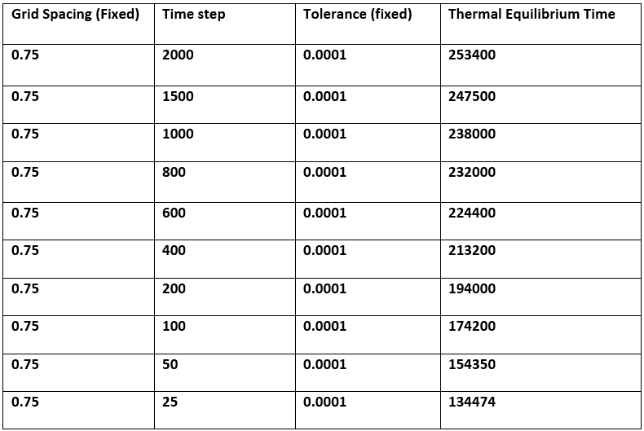
Figure 19 shows a better representation of how decreasing the time step increases the time to thermal equilibrium. Although this seems to have improved the code, the values that can be calculated in this model can be inaccurate due to round off error. As well the smaller the time step being applied the longer the model will take to run. Therefore, the needs to be a trade-off point to where the code is optimal reducing the round off errors and improving the computational efficiency by reducing the time to solve.
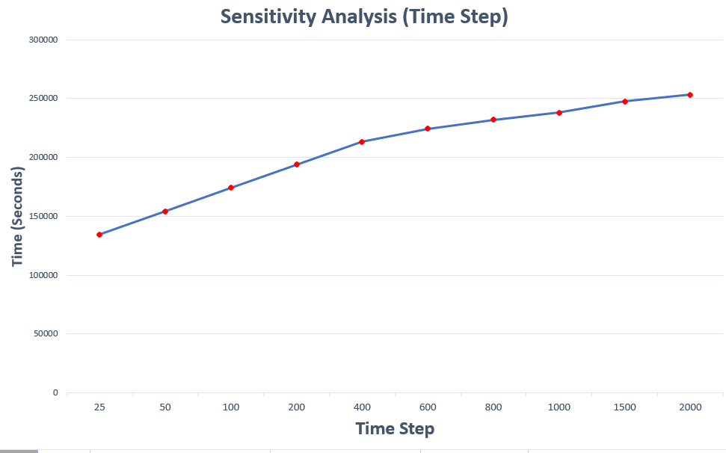
Figure 19- Graph of Altered time steps.

The sensitivity analysis has shown that the smaller time step has made the solution reach thermal equilibrium faster. The larger time steps used are not accurate in a simulation as they do not capture enough data to understand the material characteristics under external load (Guiting Chen, 2022). The smaller time step is typically better as it will capture more data in the material, although this can cause problems for computational resources as it will increase the solving time considerably (Li, 2019).

Tolerance Value

Table 5 shows the tolerance values that had been changed for analysis. The tolerance values play a crucial role to calculate thermal equilibrium in the model. The results obtained can be seen that when a large tolerance value is applied thermal equilibrium is reached faster. This can cause issue when trying to obtain an accurate code as the solution can stop too early before actual thermal equilibrium has been reached. The same can occur when the tolerance value is too small the solution can be solved too late. Smaller tolerance values will cause computational issues due to the solution taking too long solve leading to inaccurate results.

Table 5- Sensitivity Analysis results for Tolerance value
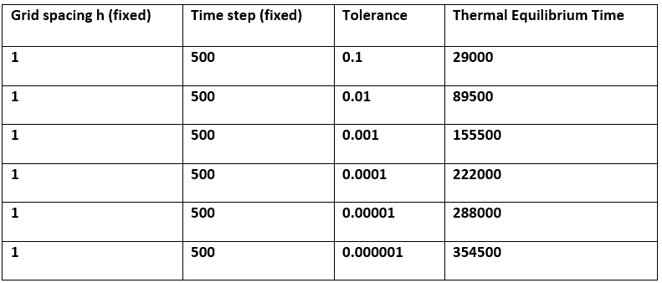
Figure 20 shows a graph of the effects on changing the tolerance values for sensitivity analysis. The figure interprets as previously mentioned, the larger the tolerance value the faster the thermal equilibrium is reached and when a smaller tolerance value is applied thermal equilibrium takes a lot longer to be reached.
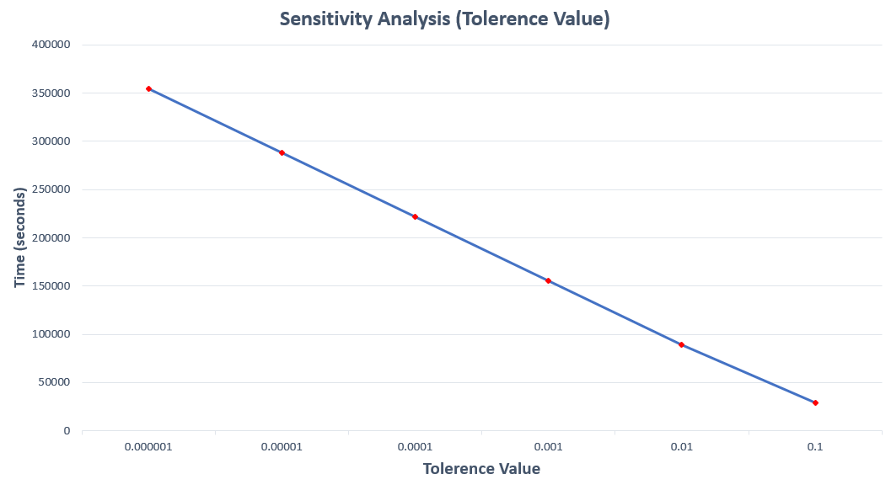
Figure 20- Tolerance Values Sensitivity Analysis

To calculate thermal equilibrium in this model was by calculating the difference between two successive matrices. This has shown that when the tolerance values are large the simulation will stop early as the difference will be achieved faster. The same will happen with a smaller value has the code will need to run for a lot longer for the difference in the two matrices to be achieved and can be too late for thermal equilibrium (Glaeser, 2008). This study has shown that neither a large nor small tolerance values will be suitable to find the realistic thermal equilibrium time.

Main models limitations

As previously mentioned in the systematic analysis, this code can have many limitations with the numerical method. One being choosing the correct grid spacing will need to be applied to the model, otherwise the truncation errors will be high. This can cause a lot of inaccuracy in the solution with not capturing fully how the heat is being distributed through the plate. As shown in the sensitivity analysis it can be seen how the influence of grid spacing affects the codes performance. The limitation with this is by creating the mesh fine too fine will lower the truncation errors, although decrease the codes efficiency by increasing solving time (Blazek, 2015).

Round off errors in the grid spacing and time step can cause limitations with this model by creating the mesh too fine and applying a small-time step to the model. This is because computers will always round off calculations, over time the round off errors will progressively get worse causing inaccuracy in the solution (M Croci, 2022).

The FDM creates uniform grid structures, which is suitable for simple geometries where a uniform grid structure can be applied. Therefore, using this model with complex geometries can cause limitations due to the model being suited for uniform grid structures. This can be resolved although it can cause many complications for computing the complexity grid structures (Orliszo, 1979).

To find the thermal equilibrium of this model, it was calculated by two successive matrices when the values would be zero in the matrix. This was where a tolerance value was applied to allow the matrices to have some deviation when calculating the thermal equilibrium. This was a limitation in the model as the thermal is not a true representation of the accurate time to thermal equilibrium. This can cause problems as the code would terminate when the full heat has fully dissipated, leading to inaccuracies in the model.

Suggested improvements and future developments

The code was able to produce appropriate values, although when a small-time step or grid spacing was entered there would be issues with stability and accuracy. Further improvements for this could be to use alternating direction implicit scheme (ADI), this method is commonly used to avoid numerical instabilities (Xiaoyan Zhang, 2016). Methods like the FDM require high computational efforts, this can be reduced using ADI (W. T. B. de Sousa, 2016). Implicit schemes are considered by the solution of linear system equations, which is unconditionally stable with respect to time (Demirdžić, 2021). By using this method for further studies would increase the accuracy of the code and minimise the numerical instability.

This assignment was to model heat distribution through 6x6m plate which is a simplistic geometry for the FDM to solve, this method would lose accuracy with a more complex geometry. To resolve this problem using implicit vertex centred models, this allows the model to mesh complex geometries by using both quadrilateral and triangular cells (Demirdžić, 2021). To be able to gather more accurate results from complex geometries, using finite element method and finite volume method can be used. These methods both using triangular meshes that are better suited for irregular and complex geometries to model (Nystrom, 2018).

Conclusion
In conclusion, this assignment has provided a comprehensive result for heat transfer through a 6x6 meter plate subjected to an external heat source. Through the process of deriving the heat equation to find the approximations from the explicit finite difference method, allowed it possible to approximate the heat distribution through the plate. This was possible by carrying out a full discretisation procedure starting from the Taylor series and finding the forward, backward and central difference approximations. Following that procedure allowed the development of the explicit finite difference method that was further used in the study.

By addressing the initial and boundary conditions and their pivotal role made it possible to accurately model the heat transfer process. The analytical solution provided justifiable validation for the numerical solution, which ensured reliability of the findings.

The sensitivity analysis showed the behaviour the results by varying the grid spacing, time and tolerance values. This study highlighted the key points in the study and the limitations of the model, which was the further addressed for improvements in the future. To conclude, this assignment has met all the aims and objectives previously established in the beginning of the assignment.

References
A.Yew, 2011. Brown University. [Online]
Available at: https://www.dam.brown.edu/people/alcyew/handouts/numdiff.pdf
[Accessed 2024 May 2024].
Alexandros Syrakos, G. E. J. G. B. a. A. G., 2012. Numerical experiments on the efficiency of local grid refinement based on truncation error estimates. Journal of Computational Physics, 231(20), pp. 6725-6753.
Anon., n.d.
Blazek, J., 2015. Consistency,Accuracy and Stability. In: Computational Fluid Dynamics: Principles and Applications. Sankt Augustin: Butterworth-Heinemann, pp. 331-349.
Chen, Z. L. a. G., 2019. Round off Error. In: G. Chen, ed. Proper Orthogonal Decomposition Methods for Partial Differential Equations. Beijing: Academic Press, pp. 1-56.
Demirdžić, P. C. &. I., 2021. Thirty Years of the Finite Volume Method for Solid Mechanics. Archives of Computational Methods in Engineering , Volume 28, pp. 3721-3780.
Glaeser, H., 2008. GRS Method for Uncertainty and Sensitivity Evaluation of Code Results and Applications. Science and Technology of Nuclear Installations, 26 March, p. 7.
Guiting Chen, Z. P. a. Y. L., 2022. A framework for automatically choosing the optimal parameters of finite-difference scheme in the acoustic wave modeling. Computers & Geosciences, Volume 159.
Kress, R., 2013. The Heat Equation. In: T. Edition, ed. Linear Integral Equation. s.l.:Springer, pp. 171-182.
Li, B. T. &. Y. G., 2019. ime-step optimization method to improve calculation efficiency and feasibility validation reliance. Engineering Optimization, 51(8), pp. 1324-1335.
M Croci, M. B. G., 2022. Effects of round-to-nearest and stochastic rounding in the numerical solution of the heat equation in low precision. IMA Journal of Numerical Analysis, 43(3), pp. 1358-1390.
Nystrom, J. B. a. K., 2018. A unified deep artificial neural network approach to partial differential equations in complex geometries. Neurocomputing, Volume 317, pp. 28-41.
Orliszo, T. a. L. J., 1979. The Finite Difference Method at Arbitrary Irregular Grids and its Application in Applied Mechanics. Computers & Structures, 13 June, pp. 83-93.
Parry Moon, D. E. S., 1953. THE MEANING OF THE VECTOR LAPLACIAN. Franklin Institute, 256(6), pp. 551-558.
Powell, A., 2002. Finite Difference Solution of the Heat Equation, s.l.: Massachusetts Institute of Technology.
R.C, D., 2012. The Two Dimensional Heat Equation, San Antonio, Texas USA: Trinity University .
Svetlana, G., 2008. University of Munster. [Online]
Available at: https://www.uni-muenster.de/Physik.TP/archive/fileadmin/lehre/part2_hypebolic/node6.html
[Accessed 04 May 2024].
W. T. B. de Sousa, A. P. F. N. F. D. a. R. d. A. J., 2016. Application of the FDM-ADI Method for Simulating SFCL Under Inrush Conditions. ADI or Implicit FDM to overcome stability issues, 26(3), pp. 1-5.
Weisstein, E., 2004. Wolfram MathWorld. [Online]
Available at: https://mathworld.wolfram.com/TaylorSeries.html
[Accessed 04 May 2024].
Widder, D., 1975. The Heat Equation. Massachusetts: A Subsidiary of Harcourt Brace Jovanovich .
Xiaoyan Zhang, Z. C. F. a. Y. Y., 2016. An Unconditional Stable Meshless ADI-RPIM for Simulation of Coupled Transient Electrothermal Problems. IEEE JOURNAL ON MULTISCALE AND MULTIPHYSICS COMPUTATIONAL TECHNIQUES, Volume 1, pp. 98-106.

Appendix

SCRIPT
% 2D Diffusion Equation using Explicit Finite Difference Method

clc
clear
close all
Xdim = 6;
Ydim = 6;
k = 143;
D = 2.8e3;
SH = 795;
TD = k / (D * SH);

H = input('Enter a positive grid spacing that is less 6 and can divide fully into 6: ');
while H >= Xdim|| rem (Xdim,H)~=0 || H<=0
disp ('Invalid grid spacing. Please enter a value smaller than the plate dimension that can divide into 6.Please Try again');
H = input ('Enter the grid spacing: ');
end

TS = input('Enter a positive time step in seconds: ');

while TS > H^2 / (4 * TD) || TS<=0
fprintf ('Invalid timestep. Please enter a positive value smaller than %f seconds.\n. Please try again.', H^2 / (4 * TD) );
TS = input ('Enter time step: ');
end

tic

NR = (Xdim / H)+1;
NC = (Ydim / H)+1;
T1 = zeros (NR,NC);

for c= 1:NC
x= (c-1)*H;
if x <= 4
T1(1,c)=12.5* x;
else
T1(1,c)=-25* x + 150;
end
end
disp(' ');
disp('--- Initial Boundary Conditions ---');
disp(' ');
disp (T1);
FO = TD *TS / H^2;
itr= 0;
TV = 1;
T2=T1;

figure (1)

subplot (1 ,2, 1)
while TV >= 0.0001
for r=2:NR-1
for c=2:NC-1
T2(r,c)= FO *(T1(r-1,c)+T1(r+1,c)+T1(r,c-1)+T1(r,c+1)-(4-1/FO)*T1(r,c));
end
end
TV= max(T2-T1,[],'all');
itr = itr+1;
T1=T2;

contourf (flip(T1),'levels',0.1,'LineStyle','none')
ylabel ('Number of Columns','FontSize',12);
xlabel ('Number of Rows','FontSize',12);
set(gca,'FontSize',12)
lims= [0,50];
clim (lims)
title('Numerical Heat Map')
subtitle(['Number of Iterations: ' num2str(itr)])
colormap ("jet")
G1=colorbar;
G1.Label.String = 'Temperature (Celsius)';
G1.Label.String = 'Temperature(Celsius)';
G1.Label.FontSize = 12;
G1.FontSize = 12;
pause(0.1) %To allow better visualisation

end

disp(' ');
disp('--- Temperature Distribution for Numerical Solution ---');
disp(' ');
disp (T1);

disp(' ');
disp('--- Time to Thermal Equilibrium ---');
disp(' ');

p=itr*TS;
if p <=120
fprintf('Thermal equilibrium reached after %0.3f seconds \n', itr*TS);
elseif p>120&&p<=3600
fprintf('Thermal equilibrium reached after %0.3f Minutes \n', itr*TS/60);
elseif p>3600&&p<86400
fprintf('Thermal equilibrium reached after %0.3f Hours \n', itr*TS/3600);
elseif p>=86400
fprintf('Thermal equilibrium reached after %0.3f Days \n', itr*TS/86400);
end

%Analytical coding solution

Ta(NR,NC)=0;

subplot (1 ,2, 2)

for i=NR:-1:1
for j=1:NC
x=(j-1)*H;
y=(i-1)*H;
for n=1:200
Ta(i,j)=...
Ta(i,j)+(sin((2*n*pi)/3)/(n^2*sinh(n*pi))*sin((n*pi*x)/6)*sinh((n*pi*y)/6));
end
Ta(i,j)=(450/pi^2)*Ta(i,j);
end
end

contourf (Ta,'levels',0.1,'LineStyle','none')
title('Analytical Heat Map')
ylabel ('Number of Columns','FontSize',12);
xlabel ('Number of Rows','FontSize',12);
set(gca,'FontSize',12)
lims= [0,50];
clim (lims)
colormap ("jet")
G2=colorbar;
G2.Label.String = 'Temperature (Celsius)';
G2.Label.String = 'Temperature (Celsius)';
G2.Label.FontSize = 12;
G2.FontSize = 12;

Ta= flip(Ta);
disp(' ');
disp('--- Temperature Distribution for Analytical Solution ---');
disp(' ');
disp (Ta);
disp(' ');
disp('--- Temperature Difference of Numerical and Analytical Solution ---');
disp(' ');

Tdiff= abs(T1-Ta)

figure (2)
contourf (flip(Tdiff),'levels',0.001,'LineStyle','none')
title('Temperature Difference of Numerical and Analytical solutions')
ylabel ('Number of Columns','FontSize',12);
xlabel ('Number of Rows','FontSize',12);
set(gca,'FontSize',12)
colormap ("jet")
G3=colorbar;
G3.Label.String = 'Temperature Difference (Celsius)';
G3.Label.FontSize = 12;
G3.FontSize = 12;
lims= [0,round(max(Tdiff,[],'all'))];
clim (lims)

Totat_time = toc;

disp(' ');
disp('--- Total time to Run code after inputs(seconds)---');
disp(' ');
disp(Totat_time)

