Academic and employment skill
LIST OF FIGURES
Figure 1: Interpersonal skills 7
Figure 2: Reliability skills 9
Figure 3: Good vs. Bad Leaders 10
Figure 4: Essential Technical Skills 12
Figure 5: Organisational and management skills 14
Figure 6: Self-management skills 16
Figure 7: Learning skills 17

LIST OF TABLES
Table 1: Self skill evaluation 18

Introduction
Employment is collection of skills, attributes, qualification, and knowledge that makes an individual more eligible to gain job, and become successful in selecting the desired employment option. The employment must benefit the individual, organisation, and the society (Guilbert et al. .2016). The report is divided into nine section. Each section will evaluate the different employment skills that are needed to hunt the best occupation as per requirement and potentials. In the last section, the reporter will provide self Assessment of own employability skill.

Article 1: Target jobs, 2020 (Online) [Accessed through] <https://targetjobs.co.uk/careers-advice/career-planning/273051-the-top-10-skills-thatll-get-you-a-job-when-you-graduate>, [Accessed on 14 August 2020]
Smart leaders of a business aim at employing large workforce for achieving their organisational goals and daily targets (Suleman, 2018). The senior management team wants right candidates for different jobs with high employability skills in different business situations. Such skills may be already present in the candidate or the individual may require to get trained to acquire new skills. Essential employability skills required to attract the desired recruiter are:
Interpersonal skills
The behaviour of individual and manner to interact with others effectively is known as interpersonal skills.
Reliability skills
According to these skills the person must be competent to make the project before the deadlines. The Person should make an effort to meet the challenges and hurdles in the project deadline. The person must be self dependable and accountable at work place.
Leadership skills
The leadership skills are relevant skills which makes the motivational environment in an organisation. The person with good leadership skills can make a competent team. The members of group feels supported and motivated at all stage of work.
Technical skills
Technical skills are some special and effective skills which are inside the person for solving technical problems occurring inside an organisation. The person who has such skills can solve any problem on time and with full efforts which makes improvement in an organisation.
Organisational and management skills
Organisational skills are those which make the person able to create and keep deadlines achievement on time. The goal is set and efficient schedules are made to manage the work internally.
Self-management and learning skills
Self- management and learning skills are those skills which makes the person able to improve the efficiency by being self reliant and self competent. The persons can increase his ability well working in an organisation.

Article2: Skills You Need, 2020 (Online) [Accessed through] <https://www.skillsyouneed.com/general/employability-skills.html>, [Accessed on 14 August 2020]
Interpersonal skills
Everyone uses interpersonal skills in their daily lives. The importance of such skills is critical in business world. Various types of soft skills collectively form interpersonal skills (Pinto and Ramalheira, 2017).
Top interpersonal skills that recruiter search in the applicants is:
Communication skills – Skills one possesses or practice to transfer information appropriately to one or group of members either in writing, oral, or via electronic mediums. In verbal communication, interaction takes place by talking with each other either face to face, virtually, messaging, and on telephone. In non-verbal communication, the interaction takes place by body gestures, voice tone, reactions, emojis etc. Effective listening skill are also part of communication skills. It judges the abilities of an individual to take in, evaluate, and judge the information conveyed by others whether in writing or by other means.
Emotional intelligence – Skills to find, understand, and supervise one’s own emotions in a rightful manner to serve the organisation.
Problem solving–These skills are required in the employees to operate effectively with other team members. It helps in identifying, describing and calculating best solutions to the problematic situations. Such skills encourage employee participation in decision-making process.
Team work – The willingness to work with other team members, share knowledge and skills, develop innovative ideas, and accept each other in formal and informal way.
Conflict management – These skills help in resolving issues and fights between the staff members, team leaders or managers and other stakeholders related to an organisation.
Negotiating skills – Such skills are much useful in searching best and common solutions to various challenges. These attributes also help the professionals to influence others agree at suggested ideas without much disagreements.
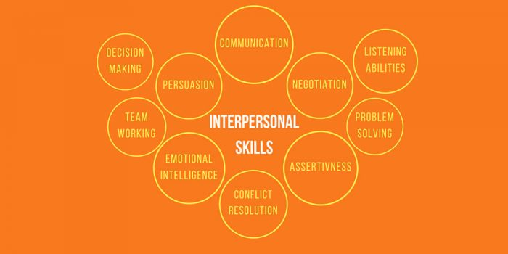
Figure 1: Interpersonal skills
(Source: The Busy Life Style, 2018)
Article3 Indeed, 2019 (Online) [Accessed through] <https://www.indeed.com/career-advice/finding-a-job/employability-skills>, [Accessed on 14 August 2020]
Reliability skills
Being reliable makes an applicant more useful for the organisation as it develops trust between the employer and employee. Reliable employees compete their work on time, make good use of resources and power, and perform least mistakes. Such skill helps in responding to queries and feedbacks immediately and accurately (Ibrahim et al. .2017). One can develop such reliability skills by meeting the performance standards, managing work schedules, accepting misjudgements, and making efforts to rectify the same.
The employee has to be organised, and must possess relevant time management skills. The main activity here is to practice work prioritisation (Wu et al. .2015). Reliable professional takes responsibilities of their work, and also values the organisation’s goals. Employees are free to seek advice of other team members, sub-ordinates and managers in queries or misunderstandings. Self-motivation also drives reliability, creativity, and dependability.
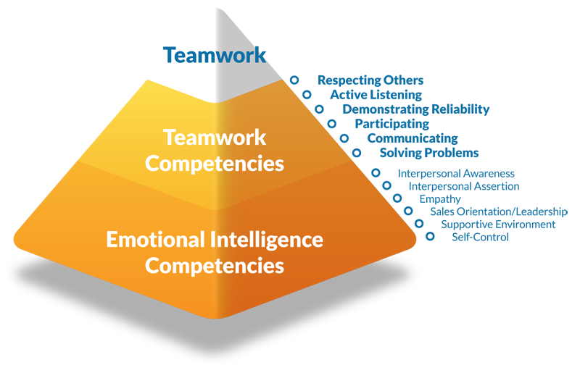
Figure 2: Reliability skills
(Source: Conover, 2020)

Article 4: ‘What are transferable skills?’ https://www.reed.co.uk/career-advice/what-are-transferable-skills/
This article has clarified that transferable skills considered as the core abilities and skills set that is mainly applied for achieving the opportunities of different employment and jobs in the industries. The transferable skill is mainly achieved by the previous position as it provides clarity to the individual about work. The article has also clarified that transferable is needed in the person as it is important to handle the situations softly by dealing with other people. The skill also supports the person to understand the skill expected by the organisation that is needed for the assigned position and role (Nägele and Stalder, 2017). So, if the person lacks in the experience needs to work on the areas related to transferable skills and deal with the assigned work. This skill is mainly related to transferring the qualities and skills to another person with the help of strong communication skills.
Leadership is the main skill that is needed to improve quality of transferable skill because leaders always take the initiative to transfer their knowledge and skills among the team members so that they can deal with the situation as per improved capabilities (Scott et al., 2019). Time management is another transferable skill that is needed to manage the prioritisation of the activities, so that delay while achieving the outcome can be avoided. The Eisenhower Method is the most commonly used method for time management by which urgent, not urgent, including important and not important.

Article5: Alison Doyle, 2019 (Online) [Accessed through] <https://www.thebalancecareers.com/organizational-skills-list-2063762>, [Accessed on 14 August 2020]
Organisational and management skills
Such skills depict one ability to outline the important task first that demands more time and energy. Organisational and planning helps the employees and managers to focus on important areas of improvements and meeting the deadlines (Rosenbaum et al. .2018). Managing activities helps in saving the extra cost too. Individuals can increase their managerial skills by creating a time schedule for everyday business activities, manage the business and personal events, and note down the important task. Maintaining better organisational skills help in reducing poor work performance, bad behaviours, miscommunication, and employee inefficiencies. Leaders hire such candidates that are ready to adapt the changing business environment in every aspect.
Organisational skills are divided into two types: Internal skills that demands employees to be calm and systematic (Grissom et al. .2015). External skills that demands employees must be able to schedule small activities in the team itself, and achieve proper work-life balance.
Examples of outstanding organisational skills includes controlled administration, encourage creative thoughts, give attention to details, regular documentation, identifying problems and solutions, technological efficiencies, situational analysis, task management, planning, forecasting, strategic development and many more.
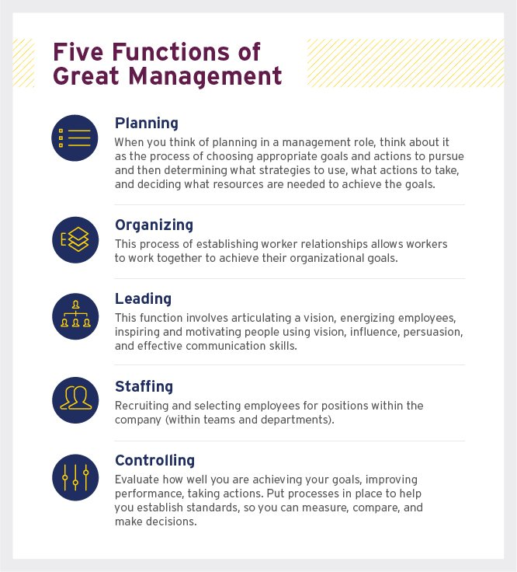
Figure 5: Organisational and management skills
(Source: Ashford university, 2020)

Article 6: Job Wizards, 2020 (Online) [Accessed through] <https://job-wizards.com/en/self-management-how-it-works-with-work-life-integration/?gclid=Cj0KCQjw7Nj5BRCZARIsABwxDKLWNs72QbM4_kszrxwkjkDG2w7QbE8FLFjOv_GFfa2xIe1zB6QMUjYaAkZdEALw_wcB>, [Accessed on 14 August 2020]
Self-management skills
Self-management skills demand candidates to be trustworthy, emotionally intelligent, and conscious. It also describes an individual to be highly self-disciplines in performing the business operations. important self-management skills include:
Stress management–Every job description demands applicants’ abilities to overcome uncertainties, fears, frustrations, emotions at workplace. Being stressed at office makes employees less productive and poor in business performance (Martin et al. .2018). Employers must train the staff members to handle their stress effectively. Peer coaching also helps in minimising stress of employee in high work pressures.
Time management – Employees after being appointed in a big organisation will have to undergo lot of changes and suffer from enormous workloads. Time is a significant factor, and as discussed above prioritising the task is essential for better work performance (Grissom et al. .2015). One must have the skills to differentiate between the important and unnecessary activities, needs, resources, discussions, and trainings to manage the time frame suitably.
Decision making skills–New employees must be patient and confident in giving their opinions, sharing ideas, and making important decisions. One must be fair and practical in making strategical plans (Proctor,2018). Decisions must be made after appropriate evaluation of direct and indirect factors that would impact the future business goals, development, and profits. Confident employees gain trust from leaders, and customers. Such employees are hired for better positions and responsibilities.
Self-protection – Everyone needs to take care of their personal life, feelings, position in an organisation. Mental and physical health are important for every employee, manager, and leader to work with sound mind and energy (Sedikides and Alicke,2019). Negative feeling, and frustrations hunts very easily in tough times. One must develop habits to relax, take breaks, exercise, eat healthy, travel, read, go for entertainment, and have fun in life to wake up next day with full energy and excitement to start working again.
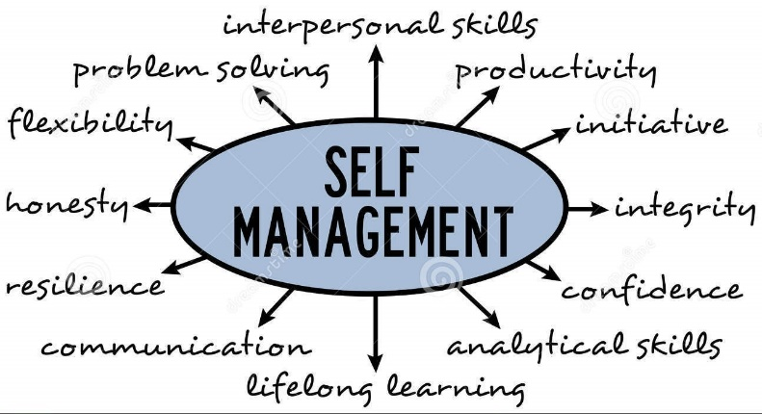
Figure 6: Self-management skills
(Dreamstime, 2020)

Article 7: Kelly Palmer and Aaron Hurst, 2020 (Online) [Accessed through]<https://www.strategy-busines.com/article/How-to-help-employees-learn-new-skills-amid-a-crisis?gko=836fb>, [Accessed on 14 August 2020]
Learning skills
Those candidates that are ready to learn new ideas and experiences always develops better knowledge, skills, and characteristics in personal and professional life. It is closely linked with self-growth (Yoon and Kayes, 2016). Business world is getting competitive day by day and demands employees that focus on continuous learning through formal and informal channels to render best services to the industry and society. Learning helps employees to be adaptive to new and modified transformations, enhance new qualities, develop new products and services, and practice self-management regularly.
The learners evaluate the skills and knowledge through online classes, videos, tutorials, articles, business seminars, workshops, training sessions, and access to peers and experts (Pitan,2017). Afterwards, the learner practices the same skills in their daily professional life, the managers monitors the employee’s performance, provide feedbacks and suggestions for improvement. This cycle goes no continuously till the time the learner has mastered the skill and gained high work experience.
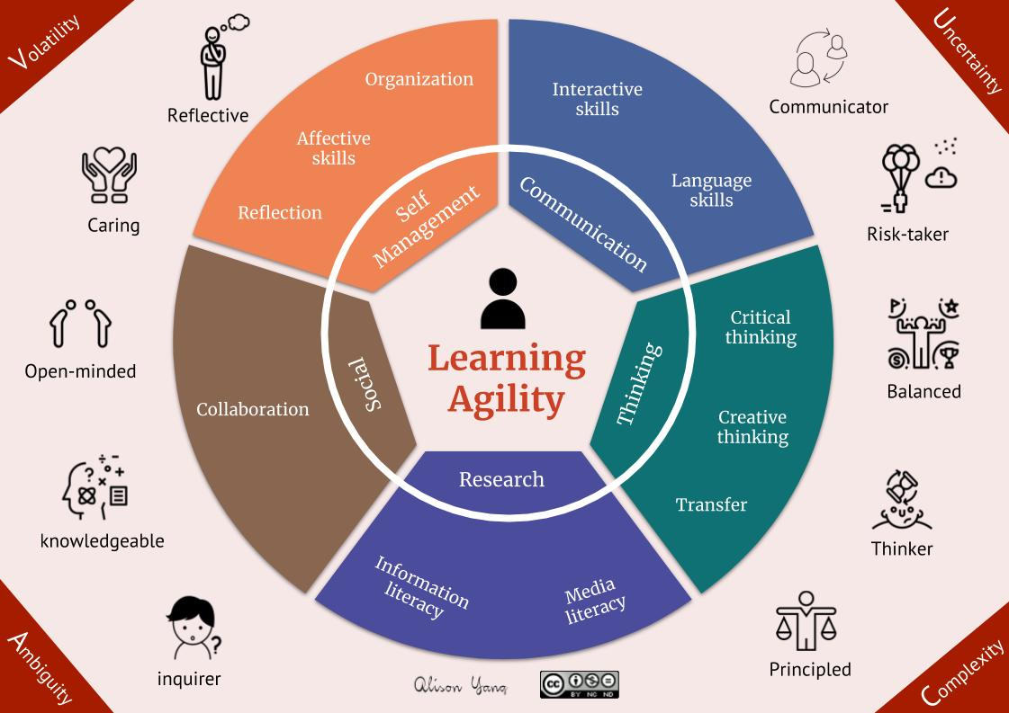
Figure 7: Learning skills
(Source: Alison yang, 2020)

Article 8: Six Ways to Improve Your Employability While Studying’ https://blog.springpod.co.uk/improve-your-employability-while-studying/
The article concluded that self dependable and being self reliable is very relevant in an organisation. The employees must take self steps and self initiatives to solve the internal conflicts in an organisation. The employees must be aware about the organisation objectives and goals to achieve them efficiently. Improvement in the skills can be achieved and self regulation can be maintained among employees. It was also concluded from the article that employees must be very sharp and attentive well thinking strategy for the organisation. The employees after be self reliable can take crucial decisions on time effectively.
Teamwork skills This skills must be possesses in every individual and candidate for improving their efficiency. The efficient working environment can be maintained in an organisation with the coordination of working of every employee initiative in a business. Negotiable skills under this skills employee must possess the quality of negotiability which means person should have quality of settlement of conflicts between two parties. The employee must be good listener and should understand the opinion of another person.
Organization of the activities and projects
It is one of the employability skill through which the employee can select the most important activities that are required to accomplish the business goals and objectives. The productivity and turnover of the organisation can be improved with the proper structure and time scheduled. This are related to time skills management.
Motivational skills
These are skills which are required for motivating other group members for improving the performances in an organisation. The person who is new to organisation and required a friendly environment can be achieved by efficient leader in an organisation. Every employee believes that the person must possess the ability of finishing the work or project on time. The employee must give full efforts during the work pressure and time limit. The employee must also be competent and confidence for his working and can make balance his role as a professional worker with good gestures and without arrogant.

Analyse your own employability skills
Table 1: Self skill evaluation
Skills | Description
Interpersonal skills | Self-awareness,emotionally stable, relationship builder, empathic, effective in verbal and non-verbal communication, practice active listening, disciplined, organised, self-managed.
Reliability skills | Logical thinking, multitasking, self-motivated, responsible, and trustworthy.
Leadership skills | Decisive, integrated, ethical, dependable, able to learn and guide other team members, innovative, positive attitude, creative, and motivating.
Technical skills | Big data analysis, coding skills, digital and social media marketing, technical encryptions, budget planning, task management, MS Office certification, cloud computing, telecommunication, HR software, artificial intelligence, and hardware description language (HDL).
Organisational and management skills | Time management skills, mental and physical organisational skills like assessment, taking notes, conflict management, developing effective strategies, creating useful presentations, reviewing and researching, record keeping, office maintenance, managing stock inventory, and establishing coordination between different departments.
Self-management skills | Problem-solving capabilities, stress management, sharp memory, physically fit and active, answerable in every situation, goal setter, future focused, work on improving weakness and strengthen current abilities.
Learning skills | Analytical skills, abilities to face personal and professional issues, public speaker, ready to accept mistakes and learn from experienced and knowledgeable team members and seniors, have knowledge and experience in sales and marketing, seek opportunity to enrol in coaching and training programs, seminars, webinars.

Conclusion
It is quite clear from the above report that new and experienced employees must posses relevant and latest employability skill to become successful in their career, and performing at best level in an organisation. All the sections have been effective in describing various skills that are essential for the employees to join a new organisation or new job title. The adopting of new skills and knowledge will encourage the employees to learn from present work experiences and become master of all skills. The last section of the report has provided with a self-evaluation table of an employee’s skills that were gained throughout the applicant’s personal and professional life experiences, and studies.

References
Books and Journals
Grissom, J.A., Loeb, S. and Mitani, H., 2015. Principal time management skills. Journal of Educational Administration.
Guilbert, L., Bernaud, J.L., Gouvernet, B. and Rossier, J., 2016. Employability: review and research prospects. International Journal for Educational and Vocational Guidance, 16(1), pp.69-89.
Ibrahim, R., Boerhannoeddin, A. and Bakare, K.K., 2017. The effect of soft skills and training methodology on employee performance. European Journal of Training and Development.
Martin, L., Oepen, R., Bauer, K., Nottensteiner, A., Mergheim, K., Gruber, H. and Koch, S.C., 2018. Creative arts interventions for stress management and prevention—a systematic review. Behavioral Sciences, 8(2), p.28.
Mehrabani, S.E. and Mohamad, N.A., 2015. New approach to leadership skills development (developing a model and measure). Journal of Management Development.
Phillips, A.S. and Phillips, C.R., 2016. Behavioural styles of path-goal theory: An exercise for developing leadership skills. Management Teaching Review, 1(3), pp.148-154.
Pinto, L.H. and Ramalheira, D.C., 2017. Perceived employability of business graduates: The effect of academic performance and extracurricular activities. Journal of Vocational Behavior, 99, pp.165-178.
Pitan, O.S., 2017. Graduate employees’ generic skills and training needs. Higher Education, Skills and Work-Based Learning.
Proctor, T., 2018. Creative problem solving for managers: developing skills for decision making and innovation. Routledge.
Robertson, J., 2016. Coaching leadership: Building educational leadership capacity through partnership. New Zealand Council for Educational Research. PO Box 3237, Wellington 6140 New Zealand.
Rosenbaum, D., More, E. and Steane, P., 2018. Planned organisational change management. Journal of Organizational Change Management.
Sedikides, C. and Alicke, M.D., 2019. The five pillars of self-enhancement and self-protection. The Oxford handbook of human motivation, 2, pp.307-319.
Suleman, F., 2018. The employability skills of higher education graduates: insights into conceptual frameworks and methodological options. Higher Education, 76(2), pp.263-278.
Wu, Y.C., Tsai, C.S., Hsiung, H.W. and Chen, K.Y., 2015. Linkage between frontline employee service competence scale and customer perceptions of service quality. Journal of Services Marketing.
Yoon, J. and Kayes, D.C., 2016. Employees' self‐efficacy and perception of individual learning in teams: The cross‐level moderating role of team‐learning behavior. Journal of organizational behavior, 37(7), pp.1044-1060.

Appendices
Article 1
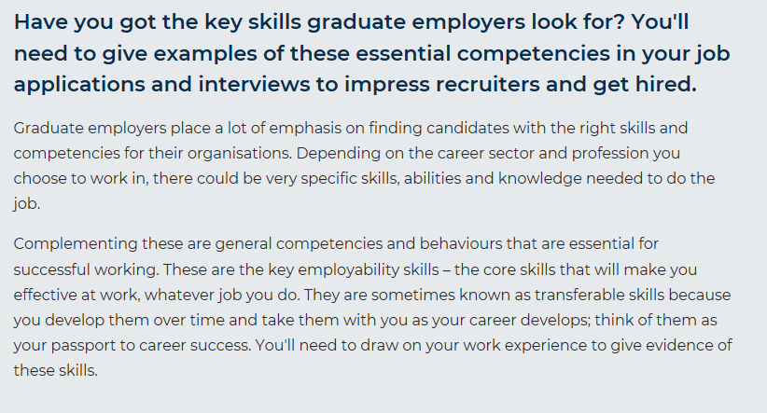
Article 2
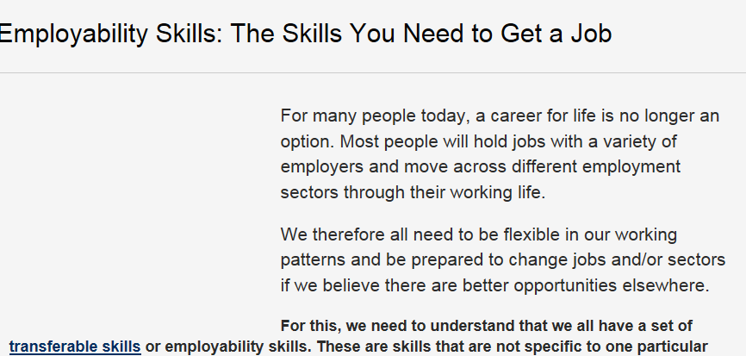
Article 3
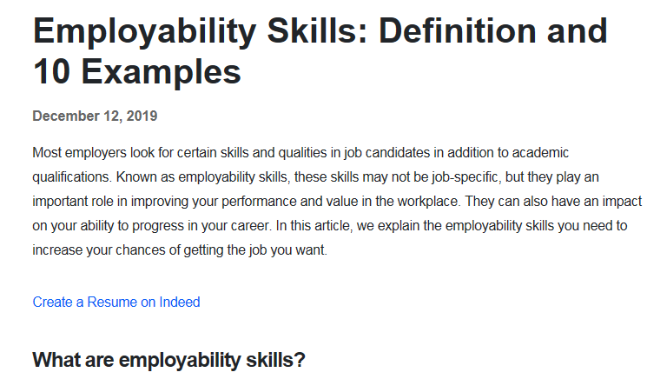
Article 4
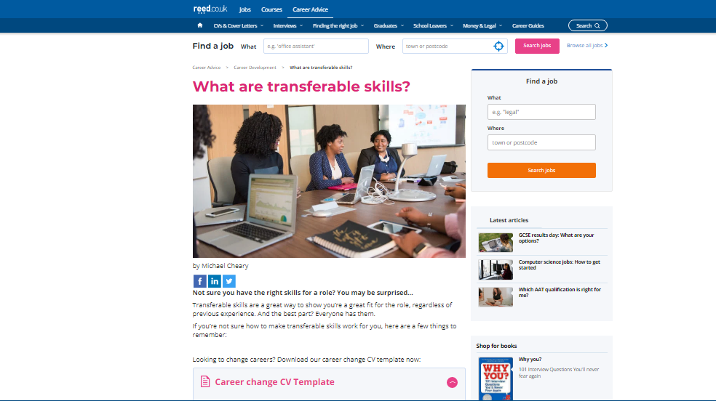

Article 5
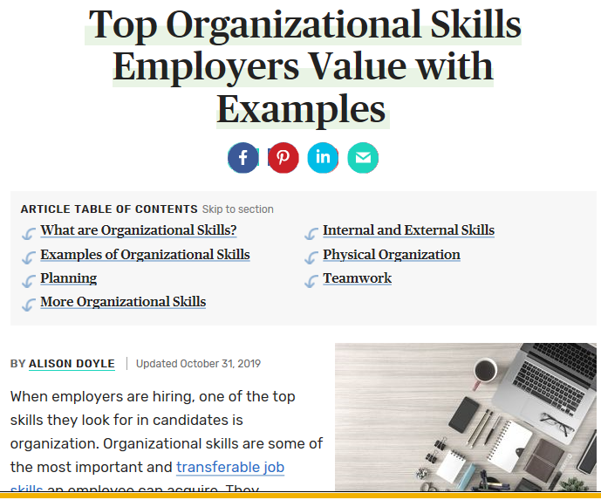
Article 6
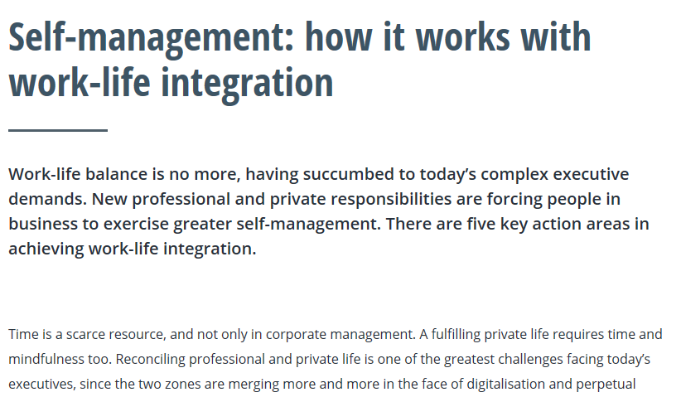
Article 7
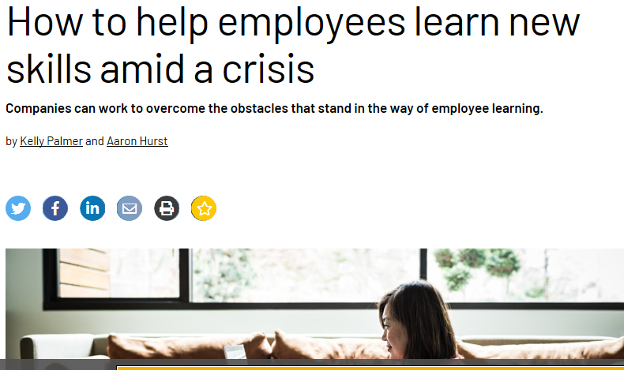
Article 8


