
Name: Antonio De Jesus Soares
Student ID: 2335800
Module Code: BMHP5014
Module Name: Changemakers Creativity and Value Creation
Lecture: Dr Laila Surani
Assignment: 2 CareConnect: A Creative Digital Wellbeing Solution for Unpaid Carers in the UK

Table of Contents
PART 1: Poster 3
PART 2: Report 4
1. Innovation Overview: 4
2. The Problem / Research Gaps in Health and Social Care: 4
3.Target Audience and Impact: 4
4. Establishment and Implementation Timeline: 5
5. Growth and Policies: 6
6. Technology Integration: 6
7. Publicity and Advertising: 6
8. Conclusion: 6
References: 8

PART 1: Poster
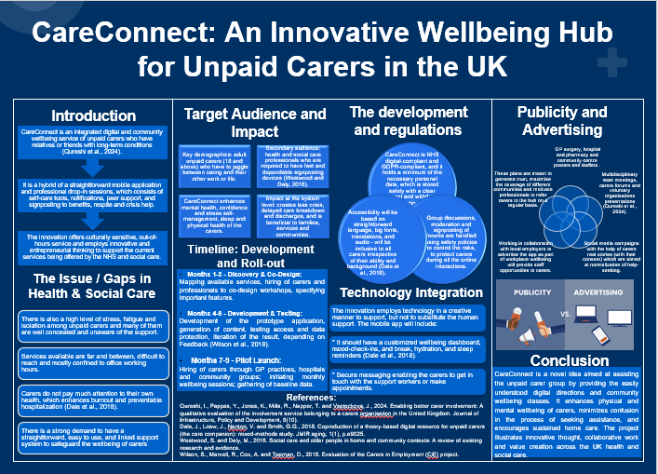

PART 2: Report

1. Innovation Overview:
CareConnect is an example of a wellbeing service comprehensive digital and community-based care designed to help unpaid carers who are helping their relative or friend with long-term conditions (Qureshi et al., 2024). The fragmented nature of services and their unavailability at regular hours is a problem affecting many carers in obtaining timely help. CareConnect is a solution to these issues as it is an integrated model of combining a conveniently developed mobile application with the assistance of a professional local drop-in program. This is a hybrid practice that offers the utilization of self-help tools, bookings of appointments, peer-support groups and signposting to benefits, respite, and crisis support. The innovation supplements, rather than supplants, existing NHS and social services because of its culturally sensitive and adaptable innovation.

2. The Problem / Research Gaps in Health and Social Care:
The pressures incurred by the unpaid carers in the UK end up putting them under a great threat of being affected emotionally and physically. Studies indicate that carers often face stress, fatigue and social separation and that a significant number of carers are often unseen within the community and they do not know of the support services existing. This results in a chain reaction where health of carers is deteriorating but they do not have the resources to seek the help in time (Wilson et al., 2018).
The other chronic problem is that as a career, one is likely to prioritize the needs of other people over their own wellbeing, thus raising the chance of burnout and other stress and avoidable hospitalizations (Dale et al., 2018). In the absence of readily available guidance and built-in signposting, the carers would need to work out how to different agencies and systems interact on their own, potentially overwhelming them. These breaches of the system indicate how crucial it is to have an easy to use, reachable and interconnected platform that would not only protect carer wellbeing but would also help prevent the occurrence of a crisis in the future.

3.Target Audience and Impact:
The main target audience would be the adult unpaid carers aged 18 and above who are involved in caring about the family member or friend and need to combine work, raising children, studying or otherwise. Such carers need access to information and support to be flexible and reliable. One of the secondary audiences is health and social care professionals who require fast-signposting guides to offer the guidance carers require (Westwood and Daly, 2016). CareConnect will enhance mental health, confidence and stress management capability, sleep and physical health through reminders and peer networks. The innovation will save crises, avoidable hospitalisations and discharges that are delayed, which will generate value to families, services and communities at a system-wide level.

4. Establishment and Implementation Timeline:
Months 1-3: Discovery & Co-Design
The first step will be to map out all the current services and define gaps in the local care environment (Dale et al., 2018). The carers and professionals will be hired to attend co-design workshops, this way the innovation will be designed by the people who will be using it. At this stage, major features, accessibility requirements and culture will be identified to make it inclusive and relevant.
Months 4-6: Development & Testing
At this stage, the prototype mobile application will be created along with the required content, navigation design and main functionality. The testing will be based on accessibility, user-friendliness and data security, as they are required to meet the digital and regulatory standards. The early testers will provide feedback, which will be used to make refinements and improvements (Wilson et al., 2018).
Months 7-9: Pilot Launch
The pilot phase will entail direct recruitment of carers by targeting GP practices, hospitals, pharmaceutical stores, local government and the community (Qureshi et al., 2024). This will be the start of monthly wellbeing sessions where carers will get a chance to get face-to-face assistance and peer support. Wellbeing data will be taken to provide a baseline of wellbeing data that will be used in future evaluation.
Month 10-12: Evaluation and Scale-Up Planning
The last step will involve the analysis of usage patterns, satisfaction levels and initial wellbeing results. Such an assessment will contribute to defining the strengths and areas to improve as well as guide the decisions connected with the expansion of the service to other regions or to particular groups of people, including young adult carers (Wilson et al., 2018).

5. Growth and Policies:
CareConnect follows NHS Digital Standards and the UK General Data Protection Regulation (GDPR), and it has a strong safeguard of personal information. The essential data is recorded and kept safely only with the help of the clear consent and the opportunity to withdraw. The idea of accessibility is also at the core of its design, where straightforward wording, font sizes, translation and audio quality can make it inclusive to carers with divergent needs (Dale et al., 2018). Additionally, the discussion of all groups, online forums and peer-support spaces are subject to high-level policies of safety and moderation.

6. Technology Integration:
CareConnect is a creative application of technology to augment human support, rather than oust it. The mobile application will offer a customised wellbeing dashboard with mood-tracking, hydration and break contains and sleep assistants. These resources are designed to promote healthier day to day living of carers. Secure messaging option enables the carers to communicate with the support workers, make appointments and consult quickly (Dale et al., 2018).

7. Publicity and Advertising:
The promotional plan is a mix of the digital and community-based strategy. Carers who will be targeted will be found within their GPs, hospitals, pharmacies, and community centres, and used to place the posters and leaflets. Presentation will be made to multidisciplinary teams, forums and voluntary organisations of carers to create awareness among professionals in charge of signposting (Qureshi et al., 2024). Social media campaigns using real-life stories with permission will be used to normalise help-seeking as well as enhance the public knowledge.

8. Conclusion:
CareConnect is a well-placed model of providing support to unpaid carers focused on digital innovation and community-based wellbeing services. The innovation enhances physical and mental health among the carers by means of offering clarity, prompting them in time, professional advice, and support to their peers. It minimizes confusion, increases service navigation and improves sustainability of home-based care. In general, CareConnect is an indication of innovative thought, joint design and excellent value development in the UK health and social care environment.

References:
Dale, J., Loew, J., Nanton, V. and Smith, G.G., 2018. Coproduction of a theory-based digital resource for unpaid carers (the care companion): mixed-methods study. JMIR aging, 1(1), p.e9025.
Qureshi, I., Pappas, Y., Jones, K., Mills, R., Napper, T. and Vseteckova, J., 2024. Enabling better carer involvement: A qualitative evaluation of the involvement service belonging to a carers organisation in the United Kingdom. Journal of Infrastructure, Policy and Development, 8(10).
Westwood, S. and Daly, M., 2016. Social care and older people in home and community contexts: A review of existing research and evidence.
Wilson, S., Marvell, R., Cox, A. and Teeman, D., 2018. Evaluation of the Carers in Employment (CiE) project.

