LEVEL 6 ASSESSMENT SPECIFICATION

Student name: | Alisha John | Student ID number: | 1901242
Programme: | Physical Education
Module: | Assessment in Physical Education
Module code: | BMPE6001 | Contribution to Overall Module Assessment (%): | 50%
Lecturer: | Dylan Blain | Internal Verifier: | Kate Piper
Assignment Title: | Assessment 1 – Portfolio | Word count (or equivalent): | 3000
Submission deadline: | 15th April 2022 | Return date of provisional marks & written feedback: | 15th May 2022
Submission method: | All written assessments, where practical and possible, must be submitted via Turnitin unless otherwise instructed by the Lecturer. (Please DO NOT put this assessment specification into Turnitin or it will match many similarities with other students’ submissions.)  Alternative submission method (if applicable):  Late submission of the assessment will result in a late penalty mark. Penalties for late submission: Up to one week late, maximum mark of 40%. Over one week late, 0%. Only the Extenuating Circumstances Panel may approve a change to submission dates.
Academic honesty / referencing: | Academic honesty is required. In the main body of your submission you must give credit to authors on whose research and ideas your work is based. Append to your submission a reference list that indicates the books, articles, etc. that you have used, cited or quoted in order to complete this assessment.

Student FEEDBACK FORM

Generic Assessment Criteria | Marks available | Marks  awarded
1. Engagement with Literature Skills  . | 25
2. Knowledge and Understanding Skills | 25
3. Cognitive and Intellectual Skills | 20
4. Practical Application Skills | 20
5. Transferable Skills for Life and Professional Practice | 10

Assessment Mark (Assessment marks are subject to ratification at the Exam Board. These comments and marks are to give feedback on module work and are for guidance only until they are confirmed. ) | Late Submission Penalties (tick if appropriate) |  | %
 | Up to 1 week late (40% Max) |  | %
 | Over 1 week late (0%) |  | %
Assessment Portfolio
This portfolio will discuss the creation of an assessment rubric used to assess a primary school pupil within an athletics lesson. The portfolio will include a detailed rationale for what the assessment rubric aimed to assess, an assessment report based off the observation of the pupil and will conclude with a critical reflection on the process undertaken.

Rationale
Metzler (2011) poses the question “how do you know your students have learned what you intended them to learn?” with research suggesting that assessment is a critical way of answering Metzler. Hay, (2006) deems that assessment is the term for the gathering of information which can then be contextualised by its use. A later definition for assessment more suited to its use within education is “A collection of information in order to establish whether, and to what extent, something has been attained or achieved” (Green, 2008, p.78). The two forms of assessment used within physical education are recognised as formative or assessment for learning (Bennett, 2011) and summative or assessment of learning (Kibble, 2017). The differences between the two forms of assessment lies at its time of implementation and what it can be used to assess. Formative assessment is usually applied throughout the academic year in an effort to provide feedback to both students on their progression and teachers on their effectiveness (Boston, 2002). In contrast, summative assessment is widely used at the end of a term or year in the form of exams to assess the overall learning which has occurred (Boston, 2002). The types of achievement measures include Norm-referenced where an individual is judged and assessed in relation to others performance, Criterion referenced when individuals are judged based on a set criteria and finally Ipsative measure when they are simply measured against their previous work and results (Lockwood and Bowler, 2013). The assessment tool used within this observation was a criterion reference measure created with the aim of assessing the four domains of physical education, with the inclusion of aspects of movement and physical literacy such as foundational movement skills and knowledge and understanding of benefits of being active.

The domains of learning in physical education can be used to form and advance teachers’ competencies throughout the subject (Murray et al., 2018). The four domains of learning within physical education are; Physical, Cognitive, Social and Affective. Dettmer (2005) summaries the main elements of each domain stating how the older versions of the cognitive domain has now been extended to include the concepts and functions of creativity and imagination. Furthermore Dettmer, (2005) goes on to mention how the affective domain includes more than just their feelings and now also risk, wonder and internalisation. Besides the physical aspects of the domain, the physical domain has expanded to include spatial relationships, activity and begins to incorporate the five senses, with the final domain social, introducing sociocultural processes which work alongside the affective processes of feeling and sensing (Dettmer, 2005). Although Dettmer wrote about the expansion and development of the domains over fifteen years ago, their place within physical education has become increasingly evident. Within the older curriculum for learning in Wales from 2008, the domains can be seen within the cross curricular learning through personal and social education as well as aiming to develop thinking and communication in physical education (Welsh Assembly Government, 2008). More recently, within the new curriculum in Wales the domains of learning shine through in not only the new subject title of Health and Well-being but also the what matters statements. Within the what matters statements, both the cognitive and social domain can be seen through the statement of how “our decision-making impacts on the quality of our lives and the lives of others” (Welsh Government, 2021). Furthermore, the physical domain can be seen in a number of statements but combines with the affective domain through the statement of “Developing physical health and well-being has lifelong benefits” (Welsh Government, 2021). As a result of the increasing reference and integration of the four domains within the health and well-being area of learning and experience, the rubric looked to use the domains as areas of assessment.

An increasingly accepted concept within health and wellbeing professions is physical literacy. Physical literacy can be defined as “the motivation, competence, physical confidence, knowledge and understanding to value and take responsibility for engagement in physical activities for life” (International Physical Literacy Association, 2017). Physical literacy is an important aspect of being active as it can lead to a lifetime of being active (Roetert, Kriellaars, Ellenbecker and Richardson, 2017). The definition of physical literacy can be seen to include aspects of the physical, cognitive and affective domains therefore adding importance to their use within health and wellbeing. As a result, physical literacy was a concept used in the creation of the rubric as it can be seen as an underpinning concept for what could be assessed within each domain.

Within each area of assessment, specific aspects linked to the domains were observed. When assessing the pupils’ physical domain, a key aspect which was included within the criteria was foundational movement skills (FMS). Research suggest that foundational movement skills are crucial in young peoples’ activity with evidence supporting a positive relationship between competent foundational movements skills and greater activity levels in children (Hulteen, et al., 2018). Hulteen et al. (2018) displayed the importance of these foundational movement skills through their Development of Foundational Movement Skills: A Conceptual Model for Physical Activity Across the Lifespan. This model shows how crucial foundational movement skills in the development of pupils who are physically active throughout their lifetime, as without the foundational movement skills lifetime activity is unlikely to be achieved (Eather, et al., 2018). A similar model to Hulteen et al. which further displays the importance of foundational movement skills is Clark and Metcalfe (2002) Mountain of Motor Development. This model addresses how foundational movement skills create the base for greater motor development and without them there would be a lack of motor competence which would lead to lower levels of activity (Clark and Metcalfe, 2002). Both these models in addition to extensive research suggest foundational movement skills are critical in the development of active individuals, therefore it is vital that pupils are assessed on their ability to perform foundational movement skills at a young age to improve motor competence and confidence which is why it was included within the rubric.

After looking at Physical Education in the National Curriculum for Wales (Welsh Assembly Government, 2008), the current curriculum for learning in Wales (Welsh Government, 2021) and the Youth Sports Trust (2014) document titled “Assessing Without levels in Physical Education” the cognitive area of the rubric was created. Within the older curriculum of 2008, as previously mentioned one aim of developing skills across the curriculum was to encourage and develop thinking (Welsh Assembly Government, 2008). Within this section, teachers aimed to develop pupils` thinking skills by engaging them in the processes of “Planning, developing and reflecting” (Welsh Assembly Government, 2008, p.8). Examples of how this could be done within physical education included planning how to make progress in performance in addition to identifying areas of improvement (Welsh Assembly Government, 2008). Similarly, within the new curriculum under the health and wellbeing area of learning and experience one of the descriptors of learning is how “our decision-making impacts on the quality of our lives and the lives of others” (Welsh Government, 2021, p.4). This descriptor of learning aims to assess the pupils` ability to make decisions confidently, set goals and plan performances to meet their goals. After viewing the three documents, the rubric comprised what was deemed the best elements of their cognitive assessments to focus on knowledge of tactics, decision making for themselves and their team and finally their ability to identify strengths and weaknesses and plan performances.

The final area of the rubric aimed to assess the pupils social and affective domains of learning. Within the curriculum for Wales (Welsh Government, 2021) one of statements of what matters and principles of progression is titled “How we engage with social influences shapes who we are and affects our health and well-being”. The way which pupils engage with their peers could be a crucial factor in their physical activity and overall health and wellbeing making it an important area of development. The health and well-being area of learning and experience, which has encompassed previous physical education subjects begins to view pupils` as holistic beings and helps create links and highlight the importance of such links between their physical and mental health and wellbeing. Furthermore, research conducted by Salvy et al. (2009) suggests that the presence of friends and interaction with peers can increase the pupils` motivations and desire to be physically active. Linking back to physical literacy once again, having a greater motivation for activity can lead to improved physical activity levels and remaining physically active throughout the lifetime (Roetert, Kriellaars, Ellenbecker and Richardson, 2017). Therefore, the rubric aimed to assess the pupils` ability to work co-operatively within teams and with others in the class. It also looked at the pupils` willingness to engage in the activities and their overall attitude towards being active as all these elements together are important factors in the pupils` social and affective abilities.

Pupil Observation
The pupil was assessed during an athletics session which lasted one hour. The assessment tool used was an assessment rubric which aimed to assess the four domains of Physical Education.
Physical
The pupil demonstrated a range of basic fundamental movement skills exceptionally well and had the ability to group these skills together to perform some specialised skills. In addition, the pupil performed a variety of locomotor skills such as skipping, sidestepping and running, as well as good object control skills which were consistent and required little guidance and input by the teacher. The pupil engaged and participated in a number of activities and tasks set by the teacher throughout the session and demonstrated a good level of fitness by remaining active throughout the majority of the session and for extended periods of time.
Cognitive
This pupil demonstrated a range of cognitive abilities throughout the session. To begin the pupil displayed a great understanding of the task and began to work through personal tactics to evade being caught within their warm-up game. Progressing throughout the session, the pupil demonstrated the ability to apply tactics to a number of activities and began to explain the tactics to other members of their team effectively. This pupil showed great knowledge and understanding of the rules of the tasks asked of them, by not only planning their own performance but beginning to support others with some confidence in planning their performances helping improve individual and team outcomes. Their decision making was mostly accurate and done without the support of the teacher.
Social and Affective
The pupil displayed eagerness in interacting with both the other pupils within the group and the teacher. The pupil displayed confidence whilst speaking to the teacher by asking questions and for clarification when unsure of the task or what they were meant to be doing. In addition, the pupil displayed compassion and concern for others within the group by checking up on them whilst they took breaks or couldn’t complete the tasks. The pupil had the ability to work co-operatively and support others in a range of tasks and had the ability to respect the teacher and other group members and was able to communicate their feelings effectively to the teacher by asking to have a small water break when feeling out of breath.

Critical Reflection

Reflection can be defined as the “key factor in expert learning and refers to the extent which individuals are able to appraise what they have learned and to integrate these experiences into future actions…” (Jonker et al., 2012, p.224). To improve for future assessments, reflection on the process undertaken during this assessment task must be made. Overall, I believe the assessment process went well. The rubric was easy to follow during the observation and the seemed to be at the right level for the pupil as they achieved high level three in all areas and began to meet the criteria for level four suggesting that criteria was not too easy or too challenging for their age. In addition, whilst observing the pupil I was able to position myself somewhere within the area where I was able to see all the activities the pupil took part in as well as hear some of the questioning and instructions being given by the teacher resulting in me being able to assess all areas of the rubric. However, to make the process even more effective and efficient there are a number of key concepts which need to be considered and taken into account.

Firstly, the assessment was conducted during a one-hour athletic session in their penultimate week of sessions with this being a one-off summative assessment and as a result the assessment might not have been as accurate as it could have been. Dixson and Worell, (2016) highlight that the two forms of assessment, formative and summative, are complementary to each other and should be used together to form a true representation of the ability level. Similarly, research into the relationships between formative and summative assessment suggests that there is an overlap between the use of thee assessments (Dolin, Black, Harlen and Tiberghien, 2017). Taking this research into account, the process undertaken during this assessment may have resulted in the overall assessment being an inaccurate representation of the pupil as for example they could have been feeling unwell or having an off day on the day of the assessment and therefore would not have been marked in the correct level. In future assessment processes, the timing of the assessment and whether the one-time observation will be the stand-alone assessment must be considered in order to correctly gain an insight into the pupil’s ability level.

In addition, an issue within this process was the age of the pupils who were observed. Considering the Foundational Movement skills used as a criteria within the physical domain assessment in the rubric, it must be noted that pupils’ develop at different stages. Taking that into account, pupils’ may become proficient in these skills at different ages resulting in them potentially being marked down within an assessment (Hands, 2002). Also, within an activity or task in a session pupils may focus on other elements more than how they are moving so testing foundational movement skills in an isolated test may provide a better representation of their ability. One way of testing foundational movements includes the Functional Movement Screen. The Functional Movement Screen allows practitioners to assess the foundational movements of individuals and can be used to create a baseline of functional movement (Cook, Burton, Hoogenboom and Voight, 2014a). Although the Functional Movement Screen is not intended to be used as an assessment (Cook, Burton, Hoogenboom and Voight, 2014b) it can be used as an assessment tool to assess individuals’ movement patterns and movement competency. Movement competency can be used to identify those at risk of injuries such as falls and movement dysfunction (Cook, burton, Hoognboom and Voight, 2014b.) which could impact their ability to become physically literate individuals who are active throughout their life. Therefore, the accurate assessment of the foundational movement skills is crucial in helping them develop to have a greater chance of leading health, active lifestyles.

Chróinín and Cosgrove (2013) found that teaching and learning within primary physical education had the ability to be enhanced through the integration of assessment in practice. Ways of integrating formative assessment into lessons includes providing feedback for the learners to act upon and through the use of questioning creating effective discussions which evokes and displays learning (William and Leahy, 2016). Due to being an observer rather than the teacher, I had no say in the lesson plan and did not know what the structure of the session would be. This impacted the assessment as especially the cognitive and affective domains of learning required specific questions to be asked to assess their knowledge and understanding. For example, within the affective area of assessment, one criteria aim of level three was the ability to explain the importance of being active which I was unable to assess as the pupils were not questioned on this aspect of their session. In future assessments, to improve the ability to assess these areas of the pupils development collaboration with the teacher to discuss the use of questions and what their plan is would be beneficial in creating a more accurate rubric or one which can be utilised throughout the session.

In conclusion, although the overall assessment process was effective in assessing pupils’ domains of learning within health and wellbeing, for further effectiveness and accurate representation of the pupils’ true ability levels the changes discussed such as different assessment tools, frequency and timing of assessment and integrated assessment should be considered for future assessments.

Word Count= 2821
 | Level 1 | Level 2 | Level 3 | Level 4 | Level 5
Physical (Hands) | Can demonstrate a number of fundamental movement skills to a good level.  Movements have some co-ordination and control. | Can apply and group multiple fundamental movement skills together.  Movements have improving co-ordination and control.  Takes regular breaks in-between activities. | Can demonstrate skills with some consistency and accuracy.  Skills are co-ordinated and controlled.  Skills are performed with some efficiency and some guidance is needed.  Is physically active throughout the majority of the session. | Can demonstrate basic skills with great consistency and accuracy.  Skills are consistently controlled.  Skills are performed efficiently and require little guidance.  Has a good level of fitness and can remain active for extended period of time. | Can demonstrate some specialised skills as well as accurate basic skills in a wide range of activities.  Basic skills are performed exceptionally well.  Skills have a high level of efficiency and require no guidance.  Has an excellent level of fitness and remains active throughout the session for sustained periods of time.
Cognitive  (Head) | Have little knowledge of tactics.  Decision making is slow and infrequent. | Knowledge and understanding of tactics is improving.  Decision making is becoming more accurate and can be done with little support.  Can begin to support others by providing suggestions to improve others’ performances. | Can now explain the tactics to others within their team.  Simple decision making is accurate and done without support.  Can use knowledge of rules to plan a performance.  Can use their knowledge with some confidence to support and improve their own and others performance. | Can confidently explain tactics to others they work with.  Decision making is consistently accurate  Can plan a performance for themselves and others.  Can begin to select appropriate targets for themselves and others to work on. | Can confidently explain and apply tactics of games and activities.  Can make appropriate and accurate decisions in a range of activities.  Can evaluate and plan performances for themselves and others.  Can highlight strengths and weaknesses efficiently and explain how targets set can impact performance.
Affective and Social  (Heart) | Beginning to engage with others, with and without encouragement.  Ready and willing to participate in activities. | Work co-operatively in a range of activities with others.  Communicate feelings within the group and begin to recognise others’ feelings.  Can respect others within the group. | Work co-operatively and support others in a range of activities.  Able to communicate feelings and respond to others.  Can respect and support other group members.  Able to explain why it is important to be active. | Can begin to lead others in a range of activities.  Able to respond to group feelings and help motivate and encourage members.  Can express how being active makes them feel. | Is a confident and capable leader in a range of activities.  Able to uphold the various roles within a team.  Encourages and Motivates all group members.  Have a positive attitude towards being active and engages in a range of activities.

Appendix
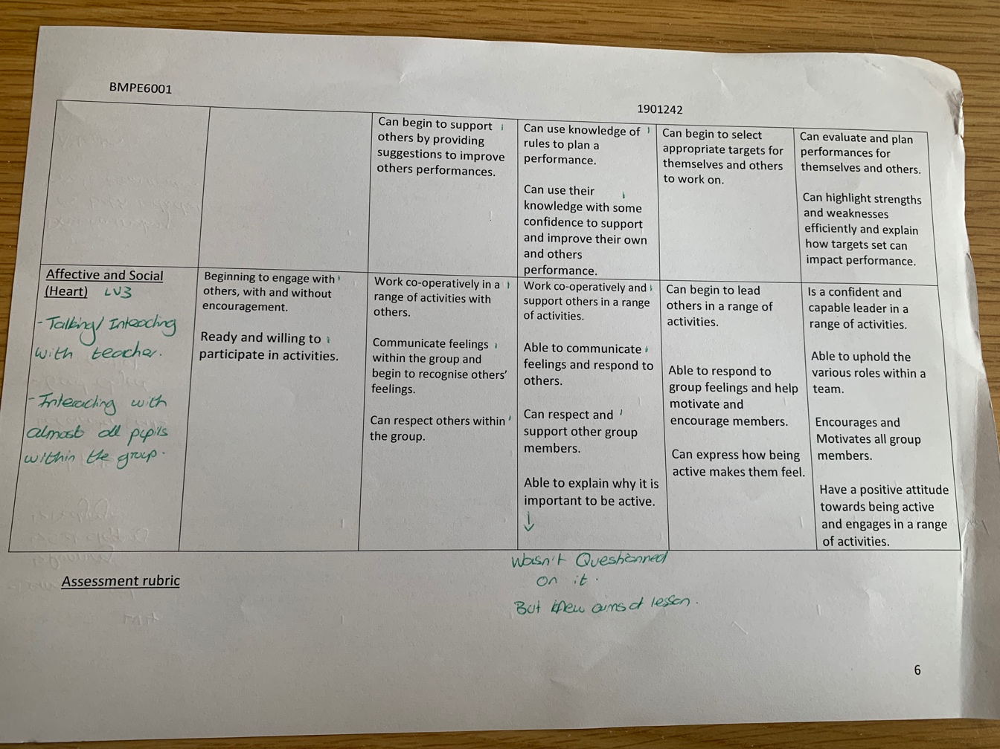
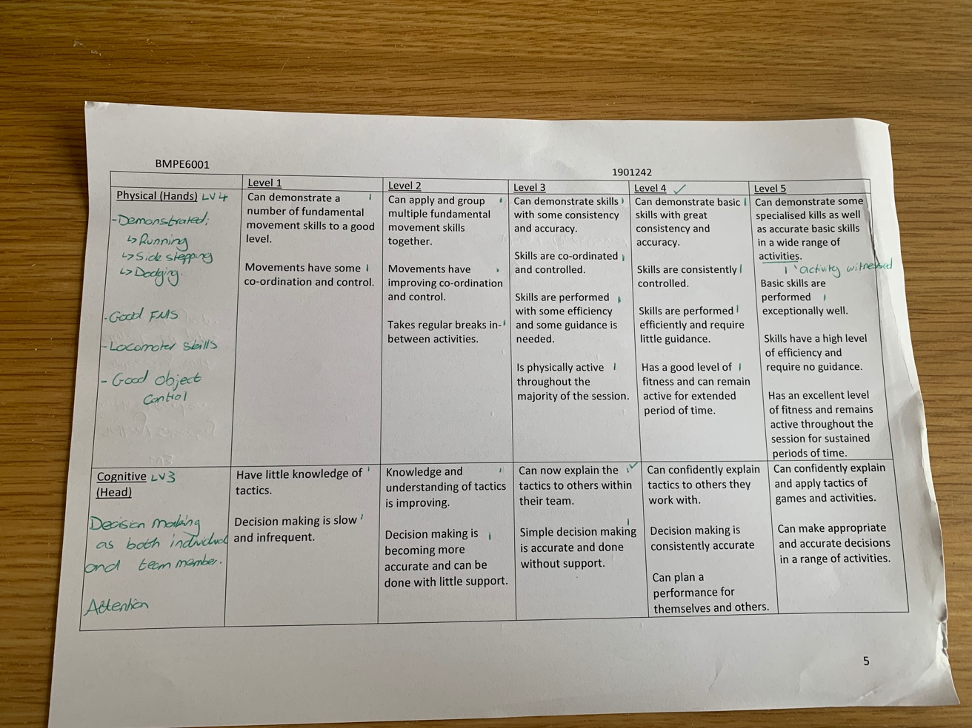
References;
Bennett, R.E. (2011) ‘Formative assessment: a critical review’ Assessment in Education: Principles, Policy and Practice. 18(1), pp.5-25.

Boston, C. (2002) ‘The concept of formative assessment.’ Practical Assessment, Research, and Evaluation. 8(1), p.9.

Chróinín, D.N. and Cosgrave, C. (2013) ‘Implementing formative assessment in primary physical education: teacher perspectives and experiences.’ Physical Education and Sport Pedagogy. 18(2), pp.219-233.

Clarke, J.E. and Metcalfe, J.S. (2002) ‘The mountain of motor development: A metaphor.’ Motor Development: Research and Reviews. 2, pp.183-202.

Cook, G., Burton, L., Hoogenboom, B.J. and Voight, M. (2014) ‘Functional Movement Screening: The use of Fundamental Movements as an assessment of Function- Part 1’ The International Journal of Sports Physical Therapy. 9(3), pp.396-409.

Cook, G., Burton, L., Hoogenboom, B.J. and Voight, M. (2014) ‘Functional Movement Screening: The use of Fundamental Movements as an assessment of function- Part 2’ The International Journal of Sports Physical Therapy. 9(4), pp.549-563.

Dettmer, P. (2005) ‘New blooms in established fields: Four domains of learning and doing.’ Reoper Review. 28(2), pp.70-78.

Dixson, D.D. and Worrell, F.C. (2016) ‘Formative and Summative Assessment in the Classroom’ Theory into Practice. 55(2), pp.153-159.

Dolin, J., Black, P., Harlen, W. and Tiberghien, A. (2017) ‘Exploring Relations Between Formative and Summative Assessment’ Transforming Assessment. Pp.53-80.

Eather, N., et al. (2018) ‘Fundamental movement skills: Where do girls fall short? A novel investigation of object-control skill execution in primary-school aged girls.’ Preventive Medicine Reports. 11, pp. 191-195.

Green, K. (2008) Understanding Physical Education. Thousand Oaks California: Sage.

Hands, B.P. (2002) How Can we best measure Fundamental Movement Skills?.

Hay, P.J. (2006) ‘Assessment for learning in physical education’ in Kirk, D., Macdonald, D. and O’Sullivan, M. (ed.) The Handbook of Physical Education. Thousand Oaks California: Sage.

Hulteen, R.M. et al. (2018) ‘Development of Foundational Movement Skills: A conceptual Model for Physical Activity Across the Lifespan.’ Sports Medicine. 48(7), pp.1533-1540.

International Physical Literacy Association (2017) Physical Literacy.
Available at: https://www.physical-literacy.org.uk/?v=79cba1185463
Accessed on: 13 April 2022.

Jonker, L., Elferink-Gemser, M.T., Roos, I.M, and Visscher, C. (2012) ‘The Role of Reflection in Sport Expertise’ The Sport Psychologist. 26, pp.224-242.

Kibble, J.D. (2017) ‘Best practices in summative assessment.’ Advances in physiology education. 41(1), pp.110-119.

Lockwood, A. and Bowler, M. (2013) ‘Assessment for and of learning’ in Capel, S and Whitehead, M. (eds) Learning to teach physical education in the secondary school. London: Routledge.

Metzler, M.W. (2011) Instructional Models for Physical Education. 3edn. Arizona: Holcomb Hathaway.

Murray, A., et al., (2018) ‘Using learning domains to complement primary physical education teacher education in primary school settings.’ Learning Matters, Physical Education Matters, Official Journal of the Association for Physical Education. 13(2), pp.54-57

Newton, A. and Bowler, M. (2015) ‘Assessment for and of learning in PE’ in Capel, S. and Whitehead, M. (ed.) Learning to teach Physical Education in the Secondary school. 4th edn. London: Routledge.

Roetert, E.P., Kriellaars, D., Ellenbecker, T.S. and Richardson, C. (2017) ‘Preparing students for a Physically Literate Life’ Journal of Physical Education, Recreation and Dance. 88(1), pp.57-62.

Salvy, S.J., et al. (2008) ‘Effect of peers and friends on Youth Physical Activity and Motivation to be Physically Active’ Journal of Paediatric Psychology. 34(2), pp.217-225.

Youth Sport Trust (2014) Assessing Without Levels in Physical Education.
Available at: https://www.youthsporttrust.org/
Accessed on: 18 March 2022.

Welsh Assembly Government (2008) ‘Physical Education in the National curriculum for Wales’ Hwb.
Available at: https://hwb.gov.wales/api/storage/7b01cf26-9974-4c3d-bb1f-ee79e111b448/physical-education-inthe-national-curriculum.pdf
Accessed on: 11 April 2022

Welsh Government (2021) ‘Curriculum for Wales’. Hwb.
Available at: https://hwb.gov.wales/curriculum-for-wales/health-and-well-being/descriptions-of-learning/
Accessed on: 18 March 2022.

William, D. and Leahy, S. (2016) ‘Embedding formative assessment.’ Hawker Brownlow Education.

