Web and Database Concepts
Author: Cameron Brown (2004688)
ACCA4023
School of Applied Computing
Wales Institute of Science and Art

Introduction 3
Data flow Diagram 3
Entity Relationship Diagram 4
Database 4
Forms 5
Queries 7
Reports 8
Suitable tables 9
Suitable Fields 10
Suitable Foreign Keys 11
Relatability between the tables 11
Design Requirements 11
3NF 12
Database User Guide 12

Introduction
This report documents the process of creating a database for Celtic Caterers needs.
The database includes forms that can be filled out to add more entries, queries that display more important information at once rather than having to sift through a lot of IDs and reports that displays all of the information in a neat convenient manner. The process of the creation of the database contains the DFD and the ERD followed by the database creation in Microsoft Access, a preview of the reports featured in the database and then finally a brief user guide on the database.

Data flow Diagram
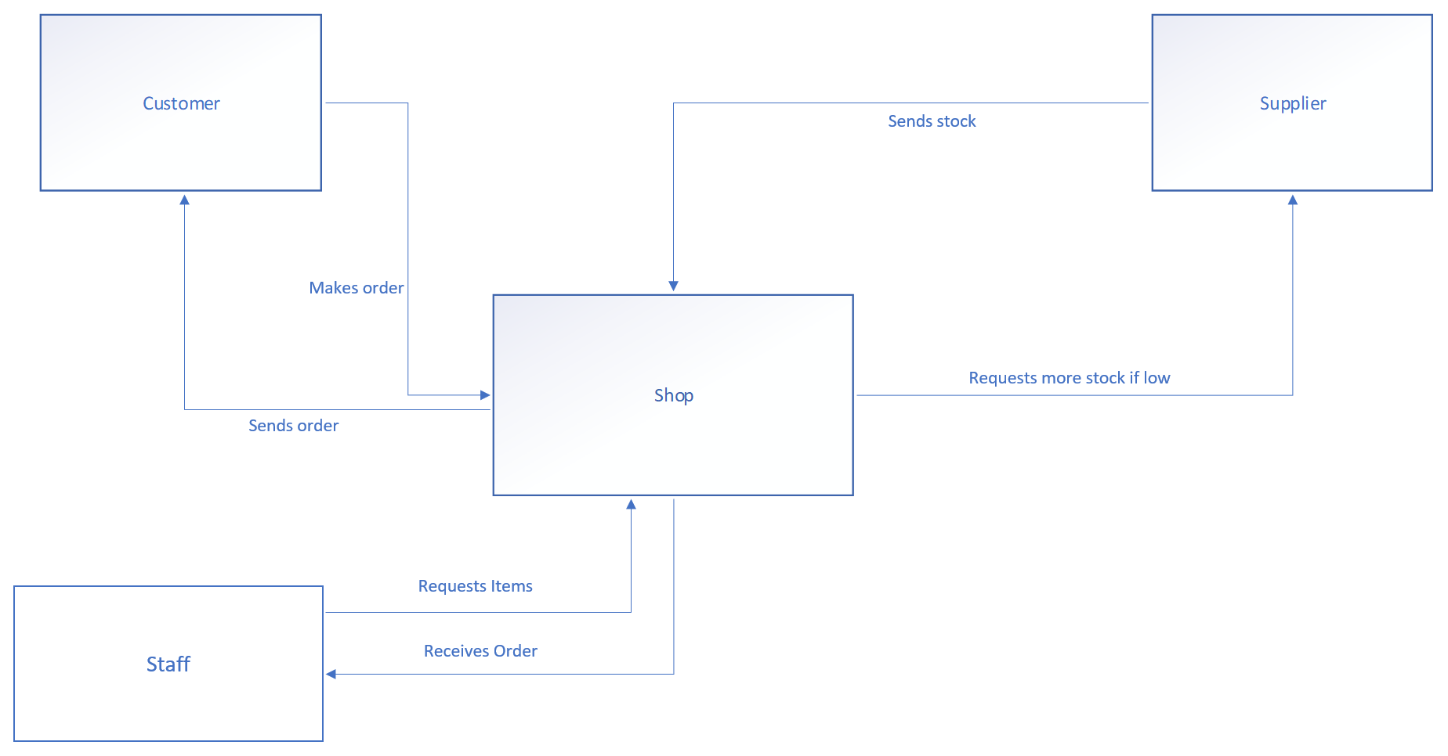

The screenshot above displays the DFD. This was planned to be done in Microsoft Visio but was instead completed in PowerPoint as there were issues with figuring out how to connect multiple arrows to one side of a shape without the arrows overlapping and looking very confusing to look at. Microsoft PowerPoint made this process a lot easier and the outcome would have been more or less the same. The customer makes an order to the shop, the staff receives the order and requests the item from the shop. The shop checks if the stock and requests more stock from the supplier if the stock is low, then the supplier sends the stock to the shop and finally the shop sends the order to the customer. This DFD was used as a basis for the creation of the ERD where all of the above steps are used to create all of the tables and fields in the database.

Entity Relationship Diagram
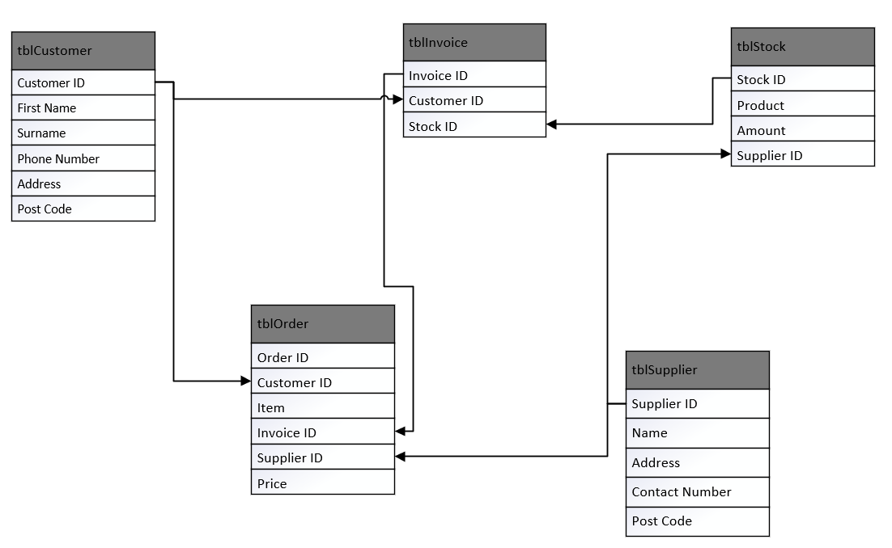
The above screenshot displays the ERD created via Microsoft Visio. There were more issues but this time the relationship connections couldn’t be figured out even after a lot of research about the program was done. Therefore arrows connecting the primary keys to their foreign key equivalents as a replacement. The ERD was used as the layout of the tables and fields to create the database.

Database
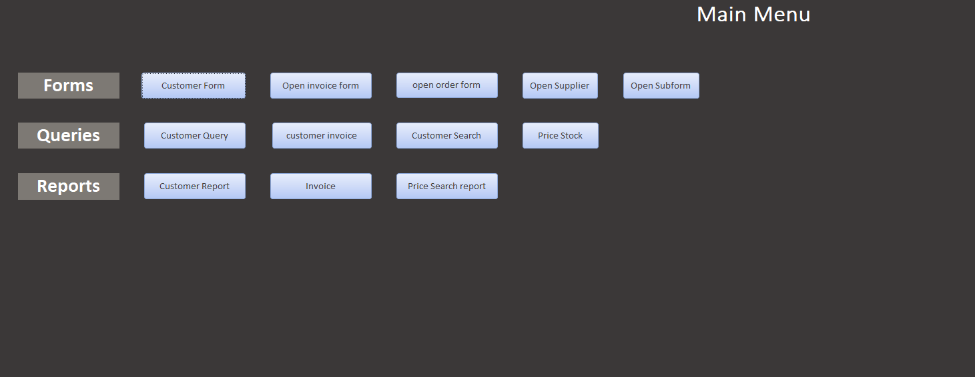
The database opens up with a main menu which allows the user to open any form, query or report that they wish. Everything on this menu is easy to read and easy to access. All of the fields were populated with 6 entries each except for the customer table which has 7 due to testing the options on the forms. These entries were made to make sure that the database was functional and to help with testing in other areas.

Forms
All of the forms were made with the same neat design in mind which made the forms easier to look at compared to if they were made with bright vibrant colours which may have been hard on the eyes. All the forms have the same buttons which can navigate between different records, add records, delete records, save records or return to the main menu.

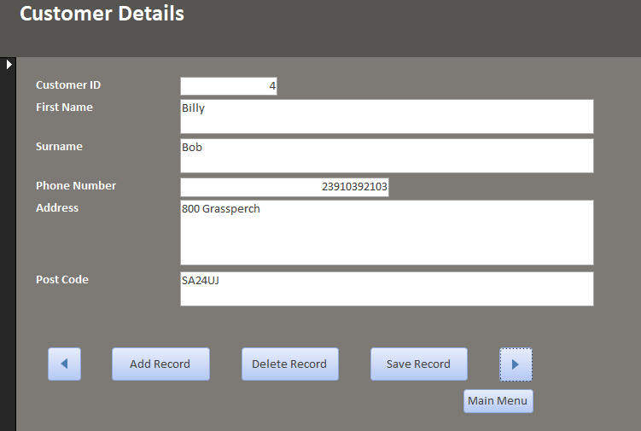
Opening the customer form will give you all the details of any customer on the database with the options to navigate between different records, add records, delete records, save records or return to the main menu.
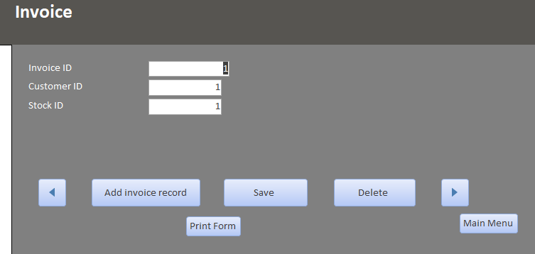
Opening the invoice form displays the invoice ID and the ID of the customer and stock that belongs to it. This form also has the same options and controls as the other forms.

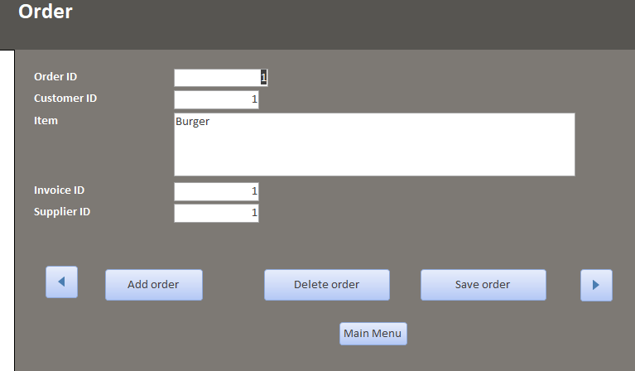The order form displays the IDs of the order, customer invoice and supplier and contains the item that was ordered. This form also has the same options and controls as the other forms.

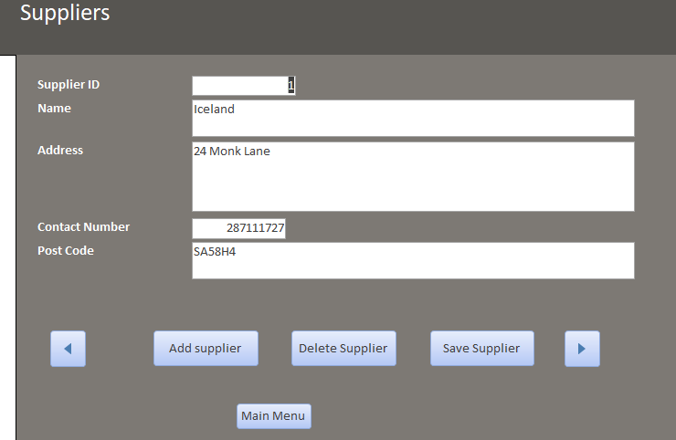
The supplier form displays the supplier ID, name of the supplier, address, contact number and postcode. This form also has the same options and controls as the other forms.

Queries
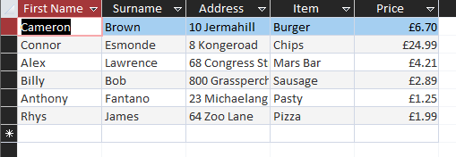
Opening any of the queries will give you the fields of all the information from the query. In this case, it displays the customer's name, address, the item they ordered and the cost of the item.

Reports
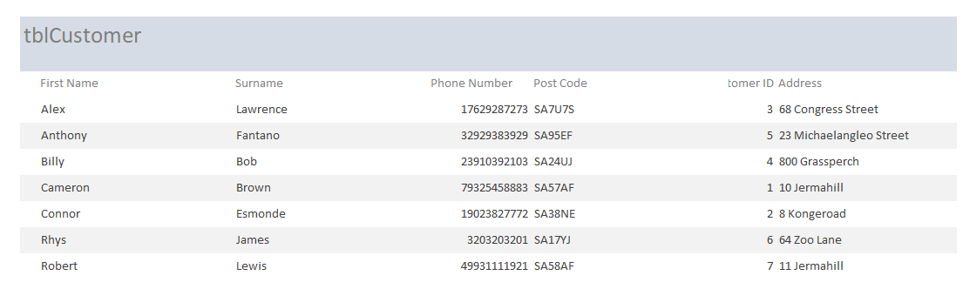
In the database there are 3 reports, one for the customer details, one for the customer invoice and one for a price search for the items. The above report displays the customer details. All of the customer information that is in the database, is displayed here.

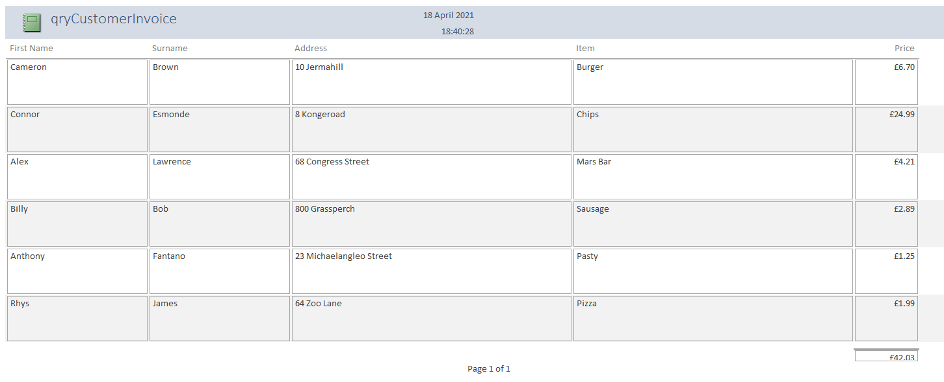
The second report displays the customer invoice which displays the customers name, address, item and cost of the item. The prices of all the items are calculated and the sum of the prices is displayed in the bottom right of the query.
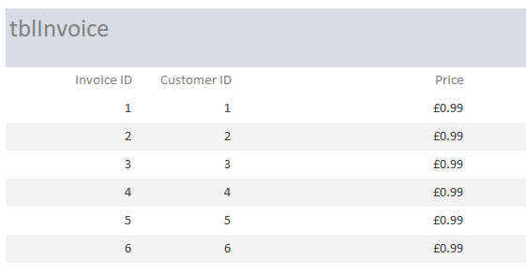
The third report is meant to prompt you to enter a price and then it searches for an item with that price, but as displayed above there were issues with getting it to work which could not be figured out.

Suitable tables
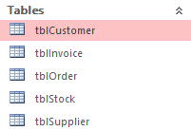
All of the tables are suitable for the database as it covers everything mentioned by Celtic Caterers. These tables are filled with entries that complete the database due to the requirements asked.

Suitable Fields
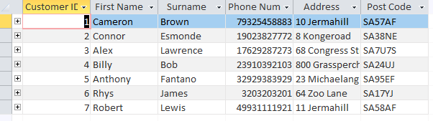
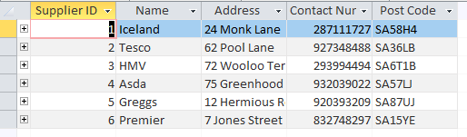
As shown above, all of the fields contain appropriate information and have all the information needed to make suitable connections between the tables. A good amount of entries in the fields were created to help with testing functionality of the database.

Suitable Foreign Keys
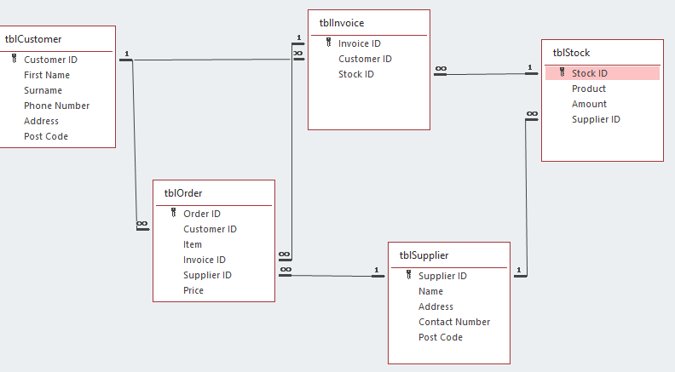
Upon looking at the database relationship diagram provided by Access, we can see all of the primary keys and their equivalent foreign keys. From this we can gather that each table has suitable and appropriate foreign keys that relate to what the tables contain.

We can also see from the screenshot that all of the relationships between the tables are also suitable. Every table has a relationship with at least 1 other table which helps tie everything all together.

Relatability between the tables
All of the tables relate to one another. This is shown as all of the tables have elements of other tables within them. For example, the order table has elements from every other table within it which acts as the final table where all of the most important information combines into one. Which is useful for the customer and staff to know exactly what the customer has ordered and all of the information surrounding it.

Design Requirements
Every aspect of the database is very neat and easily accessible. The main menu and all of the forms are made using colours that are easy on the eyes, which means that prolonged exposure to the database doesn’t strain the eyes in the slightest. All of the buttons are in good places and are labeled correctly which stops anyone from pressing the wrong button accidentally.

3NF
The tables design meet the requirements of 3NF as all of the information has been organised where all the forms layer on top of each other with the foreign keys supporting them. This allows the tables to relate to others as elements of each table are used in other tables.
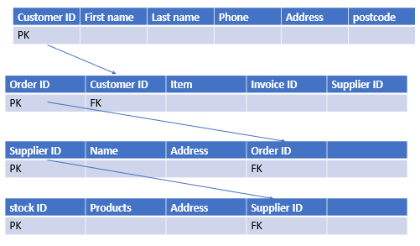
This quickly made image roughly explains how the tables in the database relate to each other and how they also lead into each other with each primary key being a foreign key in another table. As displayed in the image above, the stock table technically holds all of the information of all the tables previous to it, which proves that they all tie in to each other.

Database User Guide
When opening up the database you will be met with the main menu displayed in the screenshot below, which allows you access to every part of the database.
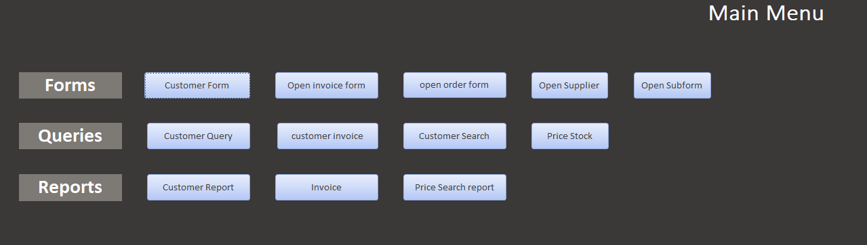
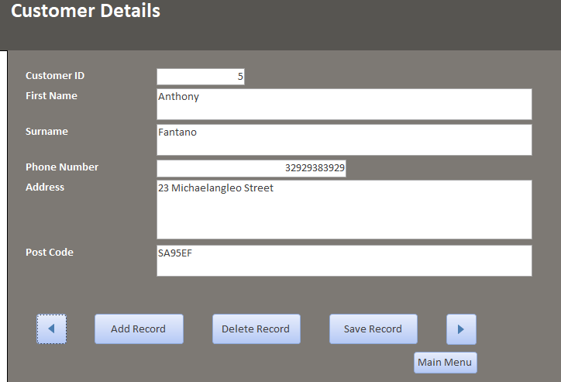
Accessing any of the forms will display you a screen either the same or similar to the one displayed above where you have access to add, delete or save records at will. This is useful for quick additions and deletions of records instead of going into the tables themselves and deleting all of the entries for the customer.

Opening up a query displays important information from numerous tables into one, which saves time from going into numerous different tables and trying to gather the necessary information one at a time as they are all displayed within the queries.
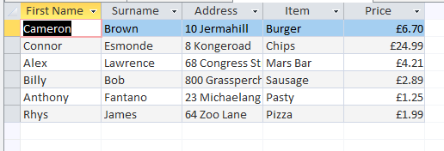

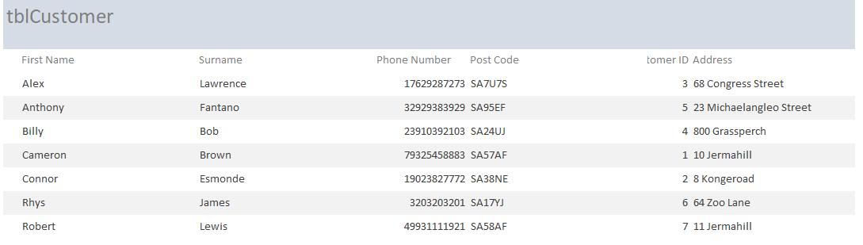
The reports allows you to get a report of the information displayed by the report, in this case it is the customer details. Instead of going into the tables and getting a worse looking table which is made to be edited and changed, you can instead get a better looking display of the information which is made to be looked at and not edited.

