

Cloud Engineering Principles and Practice

Programme Name: MSc Cybersecurity & Digital Forensics
Module Name: Cloud Engineering Principles and Practice
Module code: ACCA7027
Lecturer: Dr Renuga Jayakumar
Student Name: Ansh Italiya
Student ID: 2510659

Abstract
This report discusses the system integration of containerization and current cloud concepts in order to build scalable resilient web services with Docker and cloud load balancer and serverless solutions offered by a major cloud service supplier. It initially informs about the principles of virtualization and encourages the transition between the classical virtual machines to container-based deployment, noting that the technology enables the use of lightweight isolation, portability, and effective usage of the resources as its enablers. It subsequently covers Docker, including image constructions using Dockerfile, registries publishing, enduring storage using volumes, enduring internet networking and describes the core concepts by an entire HTTP web server deployment exposing a custom site on port 8080 and publishing the end resulting image to a public registry. And upon this foundation, the report examines fundamental cloud principles - load balancing, horizontal scalability and application gateway and demonstrates how the health probes, autoscaling rules and Layer-7 routing can be used in conjunction to enhance availability, performance, and security. Lastly, it discusses the key factors behind cloud adoption and provides a critical comparison between serverless Functions-as-a-Service and containerization on the cost and flexibility parameter as well as on operational control and wraps up by reflecting on the real learning experience of implementing and demonstrating the integrated Docker-based solution.
Table of Contents
Abstract 2
1. Introduction 6
1.1 Background on Cloud Computing Development 6
1.2 Significance of Containerization and Docker 6
1.3 Structure and Objectives of the Report 6
2. Virtualization Principles 7
2.1 Defining virtualization 7
2.2 Virtualisation of Shared Hardware 7
2.3 Traditional VMs vs. Modern Approaches 8
3. Containerization with Docker 8
3.1 Principles of Containerization 8
3.2 Benefits of Containerization 9
3.3 Building Docker Images 11
3.4 Docker Images and Publishing 12
4. Container Volumes 12
4.1 Containers Data persistence Issues 12
4.2 Volume Types 13
4.3 Volumes Creation and Management 13
4.4 Use Cases and Best Practices 13
5. Container Networking 14
5.1 Docker networking fundamentals 14
5.2 Network drivers 14
5.3 Creating Custom Networks 14
5.4 Port Mapping and Exposure 15
6. Integrated Docker Demonstration 15
6.1 Complete Web Server Deployment Process 15
6.2 Video Demonstration Overview 16
6.3 Conclusions and Experience 17
7. Cloud Computing Core Concepts 17
7.1 Load Balancing 17
7.2 Scalability 18
7.3 Application Gateways 19
7.4 Complementary Nature of Load Balancing and Scaling 20
7.5 Integration Benefits 20
8. Cloud Computing Expansion and Serverless 21
8.1 Driving Forces for Cloud Adoption 21
8.2 Serverless Computing 22
8.3 Serverless vs. Containerization 23
9. Conclusion 24
10. References 26

List of Tables
Table 1: High-level evolution of cloud computing 6
Table 2: Type 1 vs Type 2 hypervisors 7
Table 3: Containers vs. virtual machines 9
Table 4: Key operational benefits of containers 10
Table 5: Core Dockerfile instructions for image construction 11
Table 6: Key Docker Hub concepts 12
Table 7: Common Docker volume types 13
Table 8: Common Docker network drivers 14
Table 9: End-to-end web server workflow 15
Table 10: Common load-balancing Algorithms 17
Table 11: Horizontal vs vertical scaling 19
Table 12: Key capabilities of Azure Application Gateway 20
Table 13: Key cloud adoption drivers 22
Table 14: Core properties of FaaS platforms (AWS Lambda, Azure Functions) 23
Table 15: Key differences: containers vs. serverless 23

List of Figures
Figure 1: Comparison of containerization vs. virtualization 8
Figure 2: Docker deployment workflow with local environment 16
Figure 3: Dynamic Traffic Distribution Across Backend Servers 18

1. Introduction

1.1 Background on Cloud Computing Development
Cloud computing has developed out of the previous paradigms through utility computing, distributed systems and the grid computing due to development of virtualization, automated management and large scale data centres. With time, the providers evolved on the high level service, where the applications could be put across clusters of commodity hardware on-demand. Most recently, containers as a lightweight virtualization have become an important tool in ensuring secure multitenancy isolation in cloud infrastructure [1], [2], [3], [4].
Table 1: High-level evolution of cloud computing
Era | Key characteristics | Main enablers
Virtualization & grid | VM-based consolidation, batch jobs, shared hardware | Hypervisors, distributed systems research
IaaS / PaaS cloud | On-demand VMs, managed platforms, global data centres, auto-scaling | Elastic resource orchestration, automation
Cloud-native & containers | Microservices, DevOps, container orchestration (e.g., Kubernetes), edge deployments | Container virtualization, orchestration tools

1.2 Significance of Containerization and Docker
Applicational code and dependencies are packed into lightweight, quick to launch, and portable units of isolation that may be moved around across heterogeneous clouds. Docket has come up as the software standard container ecosystem which makes it easy and simplified to create and distribute images and control height of run-time, permits the implementation of contemporary workforce in a scalable and elastic manner. Container-based virtualization currently takes the first place in cloud and edge purposes because it enables dense multitenancy and fine-tuning orchestration of complicated microservice applications [3], [4], [5], [6], [7].

1.3 Structure and Objectives of the Report
In this report, the essential enabling technologies introduced are virtualization, containerization, Docker images, volumes, and networking which are presented through a realistic web-server deployment and publication workflow. It subsequently evaluates important concepts of clouds of load balancing, scalability as well as application gateway services through a service of a significant provider to demonstrate how they integrate to provide resilient applications facing customers. Lastly, the report checks economic and technical drivers of cloud usage and makes a critical comparison between serverless functions and container-based solutions in the area of cost, flexibility, and ability to control how the operation will be run [2], [4].

2. Virtualization Principles

2.1 Defining virtualization
Virtualization is a method that decouples compute resources including CPU, memory, storage and networking devices of the actual body of the physical hardware in such a way that several autonomous virtual machines (VMs) can co-operate together on the same host. The layer, which is a software layer, facilitates to the hardware access, provides virtual devices to each guest operating system, and ensures isolation whereby defects or attacks in one VM fail to impact directly to other VMs. There are usually two typical architectures of the hypervisor, Type 1, which executes directly with the hardware, and Type 2, which executes on top of a traditional operating system [8], [9], [10].
Table 2: Type 1 vs Type 2 hypervisors
Aspect | Type 1 (bare-metal) | Type 2 (hosted)
Deployment layer | Runs directly on physical hardware | Runs as an application on a host OS
Performance | Lower overhead, closer to native performance | Additional overhead via host OS stack
Isolation surface | Smaller attack surface, favoured in data centres | Larger trusted computing base (host OS + hypervisor)
Typical use cases | Cloud platforms, enterprise virtualisation | Desktop/lab virtualisation, testing environments

2.2 Virtualisation of Shared Hardware
The hypervisor allocates physical resources in virtualized host as virtual CPUs, memory pages, virtual NICs and virtual disks and schedules these resources to different VMs based on policies like fair sharing or priority. This provide multi-tenancy capability of having a variety of users or applications co-exist on a common physical server yet be logically isolated in distinct guest operating systems. With consolidation, organizations are able to achieve high average utilization, lower hardware and energy costs, and ease management by centrally providing and moving live between physical machines [8], [9], [10], [11].

2.3 Traditional VMs vs. Modern Approaches
Secondly, the traditional VM-based virtualization offers good isolation since every VM comprise of a complete guest OS and a virtual hardware stack but with too much overhead in memory and storage usage and time-on-BOOT. These costs drove less heavyweight technologies like operating-system-level virtualization containing MacOS containers virtualization, which in theory virtualize at the process level, using a shared host kernel; the containers do not simulate each tenant a full hardware instance. Containers within those VMs, which may be used to deploy coarse-grained application isolation with fine-grained, fast-scale, are thus often used interchangeably with cloud-native platforms, between traditional virtualization and containerization [6], [8], [10], [12].
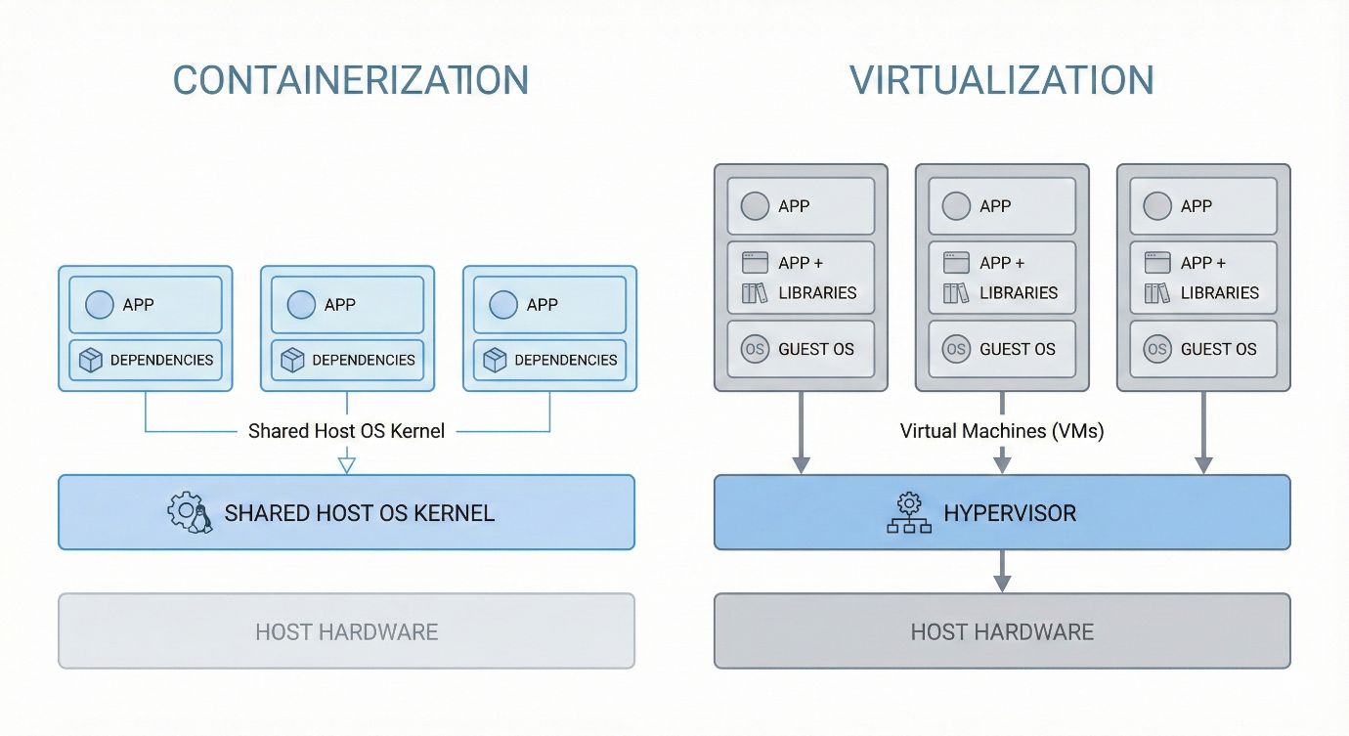
Figure 1: Comparison of containerization vs. virtualization

complete tutorial in Youtube

3. Containerization with Docker

3.1 Principles of Containerization
Containerization is a technique of operating-system level virtualization, where software image programs and their dependencies are executed in separated user-space environments called containers that share the host operating system. Mechanisms like namespaces and control groups function as isolation mechanisms; these isolate views of processes of filesystems, networking and resource usage, permitting high environmental consistency as well as effective resource control with a low overhead [10], [13], [14].

Table 3: Containers vs. virtual machines
Aspect | Containers | Virtual machines
Virtualization layer | OS-level; share host kernel | Hardware-level via hypervisor
Guest OS | No full guest OS per container | Full guest OS in each VM
Startup time | Typically milliseconds to seconds | Typically seconds to minutes
Resource overhead | Lightweight, smaller footprint | Heavier CPU and memory overhead
Density & elasticity | High container density, fine-grained scaling | Lower density, coarser scaling

This Docker set up consists of a permanent daemon (dockerd) handling images, networks and containers, and a client CLI (docker) that no longer than the daemon communicates via a local/remote socket employing API requests. Applications are combined into layered images that are either locally persisted or in registries and this is instantiated in the form of containers that are scheduled as per resource limits and network configurations in accordance to the registered policies [13], [14], [15].
The container lifecycle process involves pulling and building an image, creating the container, and starting and stopping it and lastly removing the container and (when necessary) the image; orchestration layers expound on this with capillation, wellness checks, and spooling rescheduling. The lifecycle allows configuring microservice-based applications on the cloud through repeatable deployments, rollouts and rollbacks, as well as scaling elastically [13], [14], [15], [16].

3.2 Benefits of Containerization
Containers offer lightweight and rapid deployment since they only include the application and its dependencies and thus share a host kernel, which is much faster to start and has a much smaller image than full virtual machines. This allows scaling of services very fast according to demand requirements and with orchestration platforms, it is possible to commence and shut down large volumes of containers within just seconds [14], [17], [18].
Containerization gives high consistency and immutable images guarantee consistency in development, non-testing, and production environments, reducing it accordingly it works on my machine, and increases reproducible scientific and enterprise workloads. Portability comes due to the fact that a conformant container runtime can run the same image on both heterogeneous infrastructural environments on-premises clusters, on a public cloud, and at the edge of the network, and the orchestration systems provide elasticity and automatic placement. Separated scheduling containers at finer granularity makes resource utilization more efficient, by making containers denser and freeing up wasted CPU and memory capacity to serve other services.

Table 4: Key operational benefits of containers
Benefit | Operational impact
Lightweight & fast deployment | Shorter startup times and faster rollouts/rollbacks
Consistency & reproducibility | Same image across dev/test/prod, fewer configuration drifts
Portability & scalability | Run anywhere with a compatible runtime; elastic scaling via orchestration
Resource efficiency | Higher workload density and better datacentre utilization
DevOps & CI/CD integration | Image-based delivery fits automated build, test, and deploy pipelines

Container images are the artefact of DevOps; in CI/CD pipelines they are a product of execution code changes (which trigger automated builds and tests), both versioned images (pass through release bottlenecks), and roll out to staging and production by use of blue-green of canary strategies. This paradigm embraces regular and lightweight solutions and matches infrastructures with unchangeable declarative patterns of deployment.

3.3 Building Docker Images
A Docker image is constructed by using a Docker file, a computer readable recipe that enumerates sequenced instructions on aggregating a filesystem and set up to a reusable artefact. Every Robert (such as FROM, COPY, RUN, CMD) is a new filesystem layer and Docker acts on a build cache such that non-changed layers do not require rebuilding that can considerably decrease the duration of construction. A web-server Dockerfile can be built using the FROM httpd:latest command, which picks a predefined environment based on an HTTP server on top of which application-specific content and its authoring is then added.
Table 5: Core Dockerfile instructions for image construction
Instruction | Primary role | Notes for image quality
FROM | Selects base image and defines parent layer | Choose minimal, well-maintained base images to reduce size and vulnerabilities
COPY | Copies files/directories from build context into the image | Avoid copying unnecessary files to prevent bloat (“Docker smells”)
RUN | Executes commands at build time (e.g., install packages) | Combine related commands and clean caches to reduce layer count and size
CMD | Specifies default container start-up command | Use a single, explicit entrypoint for predictable runtime behaviour

In the given example, the simplest possible Docker file consists of FROM, which is followed by a COPY command, to install a custom index.html in the Apache document root to create a simple web-server image which is serving a regular web-page. Then, a command like docker build -t <username>/docker-demo would be used to create the image itself, and the -t means it is assigned a human name as the repository as well as the tag that will be invoked during the time of running or publishing the image. Semantic versions or Role based tags (such as :1.0.0, :latest, :dev) are used in tagging conventions to make the distinction between builds and allow controlled rollbacks.
The best-practice optimization aims at reducing the size of the base images, not using any unused dependencies, consolidating unnecessary RUN commands, and frequently updating the images of the base so that they reflect known vulnerabilities, all has been demonstrated in practice to decrease the size of the image and the attack surface.

3.4 Docker Images and Publishing
Container registries hold and deliver images through image repositories that can store, store and sense versioned containerized applications. Registries may be either a public or a private registry, and Docker clients use default, or Public registry, which is Docker Hub that serves millions of community and official images that span a vast array of technologies.
Table 6: Key Docker Hub concepts
Concept | Description
Repository | Logical collection of related image versions (tags) for one application
Tag | Label identifying a specific image variant (for example :1.0.0, :latest)
Namespace | Username or organisation scope that owns repositories
Visibility | Public or private access control for repositories

At the time of publishing an image, the user writes his or her name and password to the registry (e.g. docker login), which opens a session with his Docker Hub credentials so that following push and pull actions are authorized. Once a visual representation has been created, a tag is created, consisting of <namespace>/<repository>:<tag> (e.g. user/docker-demo:latest ) and uploaded using docker push, which transmits any layers not already known to the repository on the opposite end.
Tagging is typically used together with moving convenience tags, like latest, with immutable version tags (e.g. semantic versions like 1.0.0, 1.0.1) to ensure that deployments can specify the exact version whilst remaining able to upgrade easily. Image versioning based on registry can enable teams to go back to previous tags in case one deployment turns out to be faulty and in order to redo reproducible experiments referring to the specific image digests.

4. Container Volumes

4.1 Containers Data persistence Issues
Container filesystems are by default not persistent: the data written in the writable layer of on unmounted container is lost, and as such stateful services like databases or content management systems are difficult to run. Persistence should be able to outlive restarts in containers, an upgrade, and host rescheduling in production settings and be able to support backup, migration and requirements, and performance at the same time.

4.2 Volume Types
Docker containers solve the problem of persistence through the use of decoupling of data and container lifetime with the help of volumes.
Table 7: Common Docker volume types
Volume type | Description | Typical use cases
Named volume | Managed by Docker and stored in the Docker data directory | Application data, databases, logs
Bind mount | Maps an explicit host directory or file into the container | Local development, sharing source code, host-tool integration
tmpfs mount | Stores data in memory only, not persisted to disk | Sensitive data, caches requiring high speed and no persistence

4.3 Volumes Creation and Management
Create a named volume by a command like docker volume create httpddata, and then the volume could then be mounted on containers using the options of --mount or -v. To illustrate, it can mount the directory of web data to /usr/local/apache2/htdocs in an HTTP server container to externalise the web root such that the web content may persist in case of rebuilding a container or be externalised between containers. List, inspect, and remove volume commands are also offered by docker and aid in lifecycle judgement and issue shooting of difficult assembly.

4.4 Use Cases and Best Practices
Stateful microservices are based on persistent volumes, which run multi container applications that share configuration or assets or backup strategies that run in the storage layer and not within containers. Isolating the data per service, binding and avoiding critical data to container-specific paths, and monitoring performance and underlying storage capacity can be understood as good practice since filesystem and backend options can have a substantial impact on container I/O behaviour.

5. Container Networking

5.1 Docker networking fundamentals
Container networking also allocates containers a network space that has its own network devices (including virtual ones) and IP addresses, and bridges them together through pluggable network devices. By using this design, the containers can interact with each other and with other external clients and maintain isolation and provide multi-host connectivity where necessary through overlay mechanisms.

5.2 Network drivers
Container platforms often use bridge and overlay drivers, which impose a packet processing overhead over bare-metal networking, and thus optimizing container overlay networks.
Table 8: Common Docker network drivers
Driver | Description | Typical use cases
Bridge | Default local virtual LAN on a single host; containers get private IPs and NAT to host | Single-host apps, development environments
Host | Container shares the host’s network stack; no separate container IP | Performance-sensitive services that do not need isolation
Overlay | Virtual network that spans multiple hosts over an underlay network | Swarm/Kubernetes-style multi-host microservices

5.3 Creating Custom Networks
Bridge networks configured by a user enhance service discovery and isolation through automatic name resolution via DNS and isolation through dedicated application-specific IP subnet. Containers that are configured to be on the same custom network can communicate by using container names and not hard-coded IP address. One of the common ways to do it is to build the network like the one named as httpd_net using docker network create httpd_net and then attach a container using the network flag as --network httpd_net to allow the web server to use other containers belonging to the same logical segment.

5.4 Port Mapping and Exposure
In order to bring the containerised services out into the outside world, Docker uses the -p hostPort:containerPort option on docker run and sets the NAT rules in such a way that the relevant container is contacted by the incoming traffic. In the given example, -p 8080:80 commands host the HTTP server on port 80 in the container to port 8080 on the host allowing users to access the application at port http://localhost:8080 whilst internal container-to-container traffic remains through the custom port-definite network, being the httpd_net.

6. Integrated Docker Demonstration

6.1 Complete Web Server Deployment Process
The demonstration begins by establishing a project directory (such as docker-httpd-demo) and placing two artefacts in it: an index.html file with own custom contents and a Docker file on the basis of FROM httpd: latest which copies this page at the Apache document root. This is followed by an image development using the docker build -t your-dockerhub-username/docker-demo . , which will create an image of a reusable HTTP server that will be using the web server and the static site. In order to continue web content and demonstrate the fact of decoupling data and containers, a named volume, which is also referred to as httpddata, is formed with the help of docker volume create httpddata, and a bridge network, which is also called httpdnet, is created with the help of docker network create httpdnet. A container is started with a docker run -d --name myhttpdcontainer -p 8080:80 --mount source=httpddata, target = /usr/local/apache2/htdocs --network httpdnet your-dockerhub-username/docker-demo with an allowance of data persistence, container to container networked and allow external access at http://localhost:8080. Lastly, the web server is made publicly readable on any compatible host (by docker login, docker tag, and docker push) placing a web server made up of tagged, pushed images in Docker Hub.
Table 9: End-to-end web server workflow
Step | Command / Artefact (summary)
Project setup | Create folder and index.html
Image definition | Dockerfile with FROM httpd:latest and COPY index.html ...
Image build | docker build -t your-dockerhub-username/docker-demo .
Volume & network | docker volume create httpd_data,docker network create httpd_net
Run container | docker run -d -p 8080:80 --mount ... --network httpd_net ...
External access & publishing | Browse http://localhost:8080, docker login,docker push ...:latest

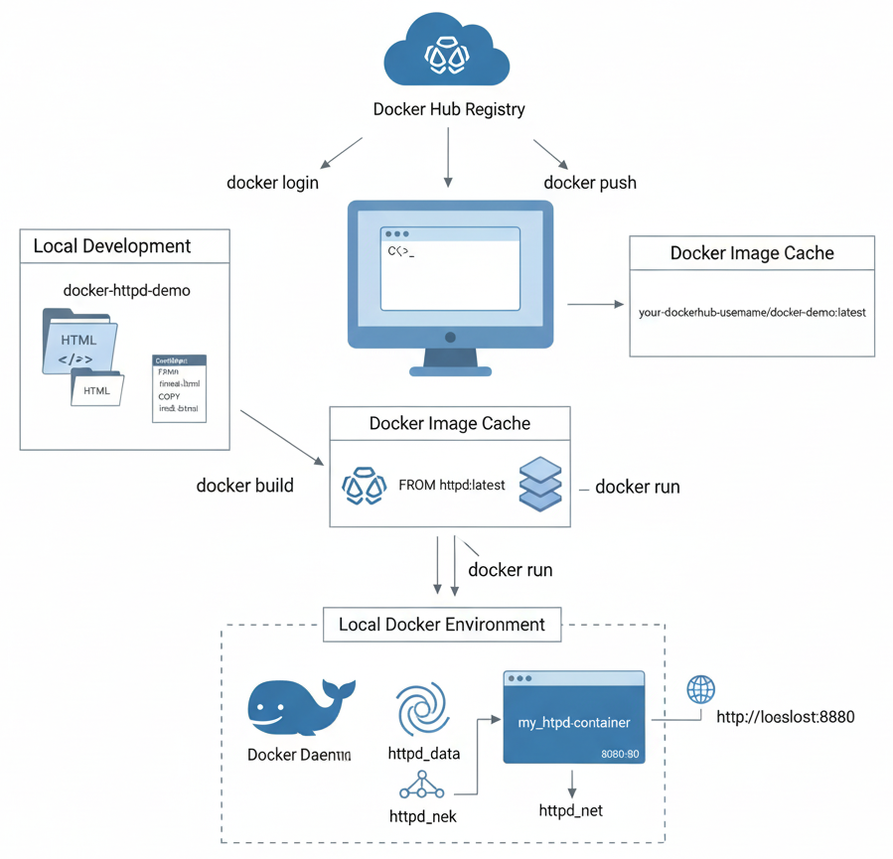
Figure 2: Docker deployment workflow with local environment

6.2 Video Demonstration Overview
This workflow (not listed, no fewer than 15 minutes) ought to be demonstrated live in the video: how the project is built, index.html is edited, why each version of the Dockerfile directive was necessary, and how the docker Iv build command is used, demonstrated on layer generation and caching. It must then show volume and network generation, display the container going up, open the browser with http://localhost:8080, and the final operation is the process of the Docker Hub login, tagging and pushing in which the process takes very little time to demonstrate how it can be further pulled and executed by other hosts.

6.3 Conclusions and Experience
This combined illustration describes how container images, volumes, and networks as well as registries are using blends to create portable, reproducible web application deployment. It also points to more practical issues like the need to separate configuration and content and images, to provide named networks to create a better service boundary, and the formation of tagging and publishing practices that make further scaling, updates, and collaboration in the cloud environment easier.

7. Cloud Computing Core Concepts

7.1 Load Balancing
Load balancing refers to the process of distributing incoming traffic between various backend instances because there should not be a single server as a bottleneck regardless of it enhancing availability, responsiveness, and resource utilization. In the cloud, load balancers are used to provide a single entry point which constantly checks the health of the backends and redirects requests based on the algorithms established to enable the application to scale horizontally, but be resistant to the failure of a single node.
Table 10: Common load-balancing Algorithms
Algorithm | Core idea | Typical effect
Round-robin | Assign requests to servers in a fixed cyclic order | Simple, fair when servers are homogeneous
Least connections | Route new requests to the server with fewest active sessions | Adapts to uneven connection durations, better for dynamic loads
IP hash | Map client IP through a hash to select a server | Provides client “stickiness” without explicit state at the balancer

As an example of using Microsoft Azure, Azure Load Balancer and Azure Application Gateway works at layer 4 and 7 respectively to distribute layer 4 TCP/UDP traffic by using instances of a virtual machine in a backend pool and layer 7 (URL path, host header, and session affinity) traffic respectively. The variant of a common set of deployment is a frontend IP, load balancing rules (with or without a single rule), a backend pool of virtual machines or scale-sets, and the health probes (periodically probing endpoints to automatically eliminate unhealthy systems).​
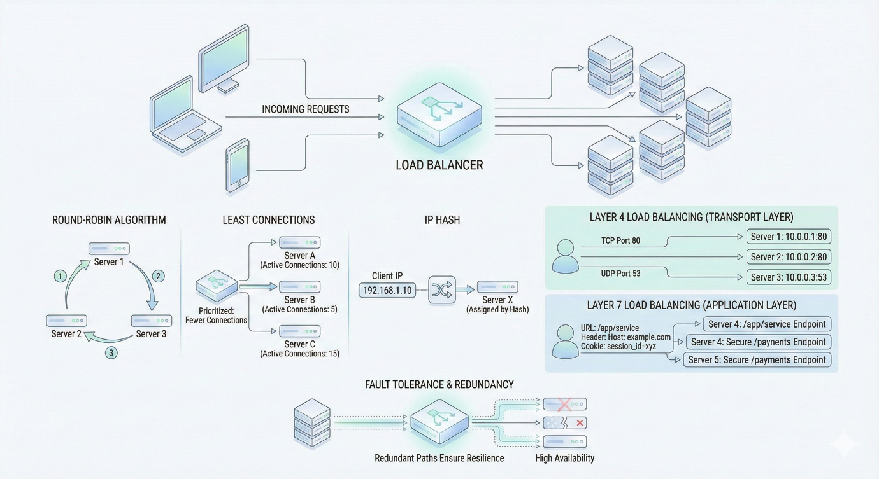
Figure 3: Dynamic Traffic Distribution Across Backend Servers

Health probes enable the platform to identify rear caused failures fast and cease transit of traffic to instances that generate errors or fail to reply in the case of maintenance or failure. Cloud load balancers can also enhance the performance (by directing clients to adjacent or less busy instances) as well as the availability since there is the ability to redirect traffic completely away overloaded or failed nodes, without altering those presented to clients.​

7.2 Scalability
Scalability refers to the capability of a system to add and subtract its capacity of managing the workload by modifying the resources allocated to it without compromising the reasonable performance. Horizontal scaling will be the addition or getting rid of instances (such as more VMs or containers), at the same time, the vertical scaling will increase or reduce the resources (CPU, memory) of an existing instance. The preference is frequently to use horizontal scaling due to the fact that cloud-native stateless services are designed to be distributed with fault isolation whereas vertical scaling is applicable to stateful or monolithic workloads that cannot be replicated easily [19], [20].
Auto-scaling is an automation of such adjustments based on policies known to measure algorithms of average CPU utilization, request rate, or specific application latency. Virtual machine scale sets in Microsoft azure are the pool of identically-defined VMs, which is controlled as one resource; autoscale policies determine metrics (such as CPU percentage) which cause increases and decreases of VM instances on meeting thresholds; cool-down windows prevent oscillation. This allows elasticity such that when demand is high, resources are stretched and when there is turmoil then they are contracted to allow users to have a constant level of performance at a cost that is still consistent with the actual usage [20].

Table 11: Horizontal vs vertical scaling
Aspect | Horizontal scaling | Vertical scaling
Mechanism | Add/remove instances | Add/remove CPU/RAM on existing instance
Fault tolerance | Improved (failover across instances) | Limited to single-node resilience
Architectural fit | Microservices, stateless tiers | Databases, legacy/monolithic apps
Elasticity impact | Fine-grained, high elasticity | Coarser, constrained by maximum machine size

7.3 Application Gateways
Application gateways are Layer-7 load balancers which can optionally interpret HTTP(S) semantics enabling it to make routing decisions based on URLs, headers and cookies instead of merely on IP addresses and ports. They can also include a Web Application Firewall (WAF) which checks application layer attacks like SQL injection attacks or cross-site scripting attacks as well as distributing traffic, and then directing it toward back-end services.
Application gateway In Microsoft azure, outgoing traffic is terminated by the Application gateway, decrypts the traffic using the deployment of SSL/TLS, applied WAF rules in settings, and redirects requests to backend pools of web servers or containers over either HTTP or HTTPs. Listeners associate the frontend IPs and ports (e.g. HTTPS on 443), routing rules are used to route traffic to relevant backend pools through URL-path routing and host-based routing, like /api and /static are served by other microservices behind a single public endpoint [21].
Table 12: Key capabilities of Azure Application Gateway
Capability | Description
Layer-7 load balancing | HTTP(S)-aware routing based on URL, headers, cookies
WAF integration | Centralised protection against common web attacks
SSL/TLS termination | Offloads certificate management and crypto from backends
URL-based routing | Path/host routing to multiple backend pools behind one endpoint

These enhancements outperform security by centrally inspecting and managing certificates and better performance and operability by configuring backends more simply and allowing more fine-tuning of steering traffic in cloud-native designs.

7.4 Complementary Nature of Load Balancing and Scaling
The load balancing and scaling are closely related, since scaling influences how many and how large the instances are, but the load balancer keeps on redistributing the traffic among the existing healthy backends. An autoscaling policy will ensure that it adds new instances to meet the increased load, causing the additional capacity to be incrementally proxied on the new instances to new connections; similarly, the scaling out instances will be drained and deregistered to prevent lost sessions.
These mechanisms can be used together to increase availability through the workload around failed or busy instances, and to heads-up increasing the performance by trading capacity between the aggregate capacity and the workload intensity near real time. A typical real-life example is an e-commerce site whose autoscaling policies add more VMs to the web server when the site is experiencing the most sales, and having the load balancer distribute user demand between all the existing VMs so that they do not overload the server and can still quickly load pages.

7.5 Integration Benefits
Adding load balancing, autoscaling and application gateways, it will result in an end-to-end delivery pipeline whereby user requests come in through an intelligent Layer-7 gateway, are routed safely and efficiently, and allocated to a dynamically sized pool of backends. The application gateway removes the load of the SSL/TLS, enforces WAF policies, and also accomplishes the routing of the URLs, whereas the load balancer and autoscaler collaborate in order to scale both the capacity and maintain the traffic balanced as the demand is varying [22].
To a customer, such integration enhances the customer experience by minimizing latency, preventing timeouts caused by overloads and service continuity even when one or more instances of a service fail or are substituted during deployments. The cost is optimised since autoscaling can avoid overprovisioning over long-term, and intelligent routing result in available capacity utilized efficiently instead of having some instances lying idle at the expense of other instances overloaded. As an example, e-commerce on microservices can only scale the high trafficked checkout service during a flash sale without scaling the entire stack because a toxified gateway and load balancer can direct the checkout traffic to the new instances.

8. Cloud Computing Expansion and Serverless

8.1 Driving Forces for Cloud Adoption
Cost savings are a very high motivation to adopting the cloud, organizations moving to the cash-as-you-go model of operation are inclined to pay off the hardware, data centres, and long-term maintenance agreement, mitigating the initial risk of investing in equipment, and paying costs based on usage, rather than the highest estimate. Elastic resource management also enhances cost-effectiveness by eliminating scenarios whereby resources will be used to capacity during peek loads and it allows the addition and removal of resources based on the demand trend [23], [24], [25].
Cloud platforms are flexible and agile with access to compute, storage and managed services on demand that can be brought online and offline within minutes to expedite experimentation, prototyping and time-to-market of new digital products. Availability zones and distant areas provide global accessibility and allow services to be dispersed nearer to consumers, apply the failover mechanism, and attain uptime goals that might be excessively costly to implement locally.
Providers foster innovation as well by giving access to more sophisticated features like big data analysis, artificial intelligence (AI), machine learning (ML), and serverless computing which may not be economically viable to develop internally and help make data-driven decisions and new business approaches. The area of security and compliance which used to be considered primarily as a barrier has been brought out as a shared responsibility under which major providers make great investments in physical security, encryption, identity and access management and regulatory certifications, when combined with proper governance and controls, are used by adopters to meet industry and government requirements.
Table 13: Key cloud adoption drivers
Driver | Primary benefit
Cost reduction (CapEx→OpEx) | Lower upfront spend, usage-aligned costs
Flexibility and agility | Rapid provisioning and experimentation
Global reach and availability | Multi-region deployment and failover
Innovation enablement | Access to AI, analytics, serverless services
Security and compliance | Provider security investment and certifications

8.2 Serverless Computing
Serverless computing Sometimes implemented as Functions as a Service (FaaS) is a paradigm where a developer packages up individual functions which are run in response to events, and the underlying infrastructure is provisioned, scaled and managed by the cloud provider. Functions are generally short-lived, stateless, units of computation which can be scaled to many parallel instances with on-demand load without a developer having to plan capacity [26], [27], [28], [29].
In AWS Lambda, functions are executed as managed execution environments invoked by events like: API gateway in response to an HTTP request, queue messages, object storage event notifications or an, a timer. The execution model also charges customers bitrate based on invocation and time and memory used to execute each invocation, instead of the potential, named billing granularity that is used to charge at the provisioned server which is not in relation to actual usage. Lambda is automatically scaled out on a smaller number of copies of a function that is run in parallel (more copies as more events volume needs to have taken place) and turned back down as the amount of needed demand decreases, however, cold starts, and limits on concurrency should be considered in latency-sensitive designs [26], [27], [30].
Azure Functions offers an appropriate FaaS environment with a close integration with Azure services, where triggers (such as HTTP, queue messages, timer, and Event Hub) are used to initiate the execution of functions and bindings allow reading and writing data to other services without writing boilerplate client code. The platform is created to cope with the weaving of instances, scaling, and size as well as operate within the consumption based plan where more resources become automatically scaled upon the event traffic or within dedicated plans with more control needs [31], [32].
Table 14: Core properties of FaaS platforms (AWS Lambda, Azure Functions)
Property | Characterisation
Execution model | Event-driven, stateless functions triggered by events
Pricing structure | Pay per invocation plus execution time and memory used
Scaling behaviour | Automatic, fine-grained scaling in and out based on event volume
Operational responsibility | Zero server management; provider handles provisioning and patching

The above features render serverless highly applicable to bursty, function-based workloads, background jobs, and glue logic in between managed services, wherein automatic scaling and per-use billing would drastically decrease the overhead and the cost of operations [29], [33].

8.3 Serverless vs. Containerization
Both Serverless functions and containers have an abstract infrastructure to developers, but it has trade-offs in control, portability, and execution model. Serverless (FaaS) implements short lifecyclical and event-driven events directly controlled by the provider, but long-running service and dependency bundles, which can be transmitted as portable image units and executed using container runtimes or orchestrators, are packageable as containerized services under container servers [28], [34].
Table 15: Key differences: containers vs. serverless
Aspect | Containers | Serverless functions (FaaS)
Control | Fine-grained control over runtime, OS, and dependencies | Limited runtime control; constrained execution environment
Execution model | Long-running services, daemons, microservices | Event-driven, short-lived functions
Scaling | Manual or orchestrator-driven (e.g., Kubernetes) | Automatic, per-invocation scaling
Cost model | Pay for provisioned instances | Pay per invocation and duration
Typical workloads | Stateful services, APIs, batch jobs, custom stacks | Glue code, triggers, bursts, background tasks

Containers are used to suit those applications that have custom run times, long lived connections, stateful services (such as databases) or those applications that need finer control over their networking, security policies, and resource allocation. Serverless suits spiny, lightweight APIs, and integration logic in which small overheads of operation, auto-scaling, and per-use billing are the addressed ethical principles [27], [28], [34], [35].
Combination There has been growing interest in hybrid models, where core micro services or stateful backends are placed in containers, but the edge logic, or scheduling or workflow management is done using serverless functions, which can invoke services behind containerisation to achieve large levels of elasticity with control as it is required. Regarding the motivation behind the adoption of clouds, serverless can easily optimise the cost and the performance of intermittent workloads, and containers can be highly portable and predictable, which can be combined to enable architects to fit each component to the best and most suitable mode of execution.

9. Conclusion
Containerization has evolved to form a cornerstone in cloud engineering by providing lightweight isolation, rapid deployment and consistent runtime environments, which allows achieving dense multi-tenancy and being able to efficiently use resources with a broad variety of infrastructures. Docker realizes these concepts around an image format that is standard and develops around image tools to assemble images and publish images along with the runtime integrating with orchestrators and registries, at the heart of most cloud-native applications and DevOps processes.
Expanding on the cloud notions matters of load-balancing, scalability, and application gateways together with containers to reach resilient high-performing services load balancers distribute traffic over containerised backends, autoscaling systems increase or decrease capacity, and gateways, implement Layer-7 routing, SSL termination and WAF protection at the edge. In the future, we can expect the continued merging of containers and FaaS traditional, where serverless computing, intelligent autoscaling, and edge deployments will suggest more automation, cost sensitivity, and security-by-default features in all its offerings.
In practice, by deploying a roadmap web server, which consists of images, volumes, networks and publication to Docker Hub, one can solidify the theoretical understanding through practice, and exercising how the abstractions get mapped onto the concrete commands, configurations and under analysed behaviour in a implemented workflow in cloud mode.

10. References
[1] S. Ullah and Z. Xuefeng, “Cloud Computing: a Prologue,” Apr. 28, 2013, arXiv: arXiv:1304.2981. doi: 10.48550/arXiv.1304.2981.
[2] B. Varghese et al., “Cloud Futurology,” Feb. 10, 2019, arXiv: arXiv:1902.03656. doi: 10.48550/arXiv.1902.03656.
[3] A. Randal, “The Ideal Versus the Real: Revisiting the History of Virtual Machines and Containers,” ACM Comput. Surv., vol. 53, no. 1, pp. 1–31, Jan. 2021, doi: 10.1145/3365199.
[4] P. Muzumdar, A. Bhosale, G. P. Basyal, and G. Kurian, “Navigating the Docker Ecosystem: A Comprehensive Taxonomy and Survey,” Asian J. Res. Comput. Sci., vol. 17, no. 1, pp. 42–61, Jan. 2024, doi: 10.9734/AJRCOS/2024/v17i1411.
[5] D. Perri, M. Simonetti, S. Tasso, F. Ragni, and O. Gervasi, “Implementing a scalable and elastic computing environment based on Cloud Containers,” vol. 12949, 2021, pp. 676–689. doi: 10.1007/978-3-030-86653-2_49.
[6] R. Vaño, I. Lacalle, P. Sowiński, R. S-Julián, and C. E. Palau, “Cloud-Native Workload Orchestration at the Edge: A Deployment Review and Future Directions,” Sensors, vol. 23, no. 4, p. 2215, Feb. 2023, doi: 10.3390/s23042215.
[7] V. Struhár, S. S. Craciunas, M. Ashjaei, M. Behnam, and A. V. Papadopoulos, “Hierarchical Resource Orchestration Framework for Real-time Containers,” ACM Trans. Embed. Comput. Syst., vol. 23, no. 1, pp. 1–24, Jan. 2024, doi: 10.1145/3592856.
[8] S. G. Langer and T. French, “Virtual Machine Performance Benchmarking,” J. Digit. Imaging, vol. 24, no. 5, pp. 883–889, Oct. 2011, doi: 10.1007/s10278-010-9358-6.
[9] R. Y. Ameen and A. Y. Hamo, “Survey of Server Virtualization,” Apr. 12, 2013, arXiv: arXiv:1304.3557. doi: 10.48550/arXiv.1304.3557.
[10] K. S. Ketha, G. Song, and T. Zhu, “Analysis of Security in OS-Level Virtualization,” Jan. 02, 2025, arXiv: arXiv:2501.01334. doi: 10.48550/arXiv.2501.01334.
[11] F. Ciraolo, M. Nicolella, D. Hoornaert, M. Caccamo, and R. Mancuso, “Light Virtualization: a proof-of-concept for hardware-based virtualization,” Feb. 06, 2025, arXiv: arXiv:2502.15738. doi: 10.48550/arXiv.2502.15738.
[12] H. Aqasizade, E. Ataie, and M. Bastam, “Experimental Assessment of Containers Running on Top of Virtual Machines,” Jan. 15, 2024, arXiv: arXiv:2401.07539. doi: 10.48550/arXiv.2401.07539.
[13] M. Gundall, J. Stegmann, C. Huber, and H. D. Schotten, “Towards Organic 6G Networks: Virtualization and Live Migration of Core Network Functions,” Oct. 25, 2021, arXiv: arXiv:2110.12737. doi: 10.48550/arXiv.2110.12737.
[14] Z. Zhong, M. Xu, M. A. Rodriguez, C. Xu, and R. Buyya, “Machine Learning-based Orchestration of Containers: A Taxonomy and Future Directions,” June 24, 2021, arXiv: arXiv:2106.12739. doi: 10.48550/arXiv.2106.12739.
[15] Z. Li, M. Kihl, Y. Chen, and H. Zhang, “Two-Stage Performance Engineering of Container-based Virtualization,” Adv. Sci. Technol. Eng. Syst. J., vol. 3, no. 1, pp. 521–536, Feb. 2018, doi: 10.25046/aj030163.
[16] J. Choi, M. Cho, and J.-S. Kim, “Employing Vertical Elasticity for Efficient Big Data Processing in Container-Based Cloud Environments,” Appl. Sci., vol. 11, no. 13, p. 6200, July 2021, doi: 10.3390/app11136200.
[17] M. A. Rodriguez and R. Buyya, “Containers Orchestration with Cost-Efficient Autoscaling in Cloud Computing Environments,” Dec. 02, 2018, arXiv: arXiv:1812.00300. doi: 10.48550/arXiv.1812.00300.
[18] M. A. Rodriguez and R. Buyya, “Container-based Cluster Orchestration Systems: A Taxonomy and Future Directions,” Nov. 02, 2018, arXiv: arXiv:1807.06193. doi: 10.48550/arXiv.1807.06193.
[19] F. Rossi, M. Nardelli, and V. Cardellini, “Horizontal and Vertical Scaling of Container-Based Applications Using Reinforcement Learning,” in 2019 IEEE 12th International Conference on Cloud Computing (CLOUD), Milan, Italy: IEEE, July 2019, pp. 329–338. doi: 10.1109/CLOUD.2019.00061.
[20] C. Li, J. Tang, and Y. Luo, “Elastic edge cloud resource management based on horizontal and vertical scaling,” J. Supercomput., vol. 76, no. 10, pp. 7707–7732, Oct. 2020, doi: 10.1007/s11227-020-03192-3.
[21] B. Mukhopadhyay, “A Novel Approach to Load Balancing and Cloud Computing Security using SSL in IaaS Environment,” Int. J. Adv. Trends Comput. Sci. Eng., vol. 9, no. 2, pp. 2362–2370, Apr. 2020, doi: 10.30534/ijatcse/2020/221922020.
[22] Naga Murali Krishna Koneru, “Containerization Best Practices- Using Docker and Kubernetes for Enterprise Applications,” J. Inf. Syst. Eng. Manag., vol. 10, no. 45s, pp. 724–746, Apr. 2025, doi: 10.52783/jisem.v10i45s.8905.
[23] A. Khajeh-Hosseini, D. Greenwood, J. W. Smith, and I. Sommerville, “The Cloud Adoption Toolkit: Supporting Cloud Adoption Decisions in the Enterprise,” Aug. 11, 2010, arXiv: arXiv:1008.1900. doi: 10.48550/arXiv.1008.1900.
[24] I. Fé et al., “Performance-Cost Trade-Off in Auto-Scaling Mechanisms for Cloud Computing,” Sensors, vol. 22, no. 3, p. 1221, Feb. 2022, doi: 10.3390/s22031221.
[25] N. S. Trivedi and S. D. Panchal, “Optimization enabled elastic scaling in cloud based on predicted load for resource management,” Multiagent Grid Syst., vol. 19, no. 4, pp. 289–311, Mar. 2024, doi: 10.3233/MGS-230003.
[26] M. Gabbrielli, S. Giallorenzo, I. Lanese, F. Montesi, M. Peressotti, and S. P. Zingaro, “No more, no less - A formal model for serverless computing,” May 01, 2019, arXiv: arXiv:1903.07962. doi: 10.48550/arXiv.1903.07962.
[27] M. Shahrad et al., “Serverless in the Wild: Characterizing and Optimizing the Serverless Workload at a Large Cloud Provider,” June 06, 2020, arXiv: arXiv:2003.03423. doi: 10.48550/arXiv.2003.03423.
[28] J. Manner, “A Structured Literature Review Approach to Define Serverless Computing and Function as a Service,” in 2023 IEEE 16th International Conference on Cloud Computing (CLOUD), Chicago, IL, USA: IEEE, July 2023, pp. 516–522. doi: 10.1109/CLOUD60044.2023.00068.
[29] M. Chadha, P. Wieland, and M. Gerndt, “gFaaS: Enabling Generic Functions in Serverless Computing,” Jan. 18, 2024, arXiv: arXiv:2401.10367. doi: 10.48550/arXiv.2401.10367.
[30] S. Agarwal, M. A. Rodriguez, and R. Buyya, “On-demand Cold Start Frequency Reduction with Off-Policy Reinforcement Learning in Serverless Computing,” Nov. 13, 2024, arXiv: arXiv:2308.07541. doi: 10.48550/arXiv.2308.07541.
[31] J. Grogan et al., “A Multivocal Literature Review of Function-as-a-Service (FaaS) Infrastructures and Implications for Software Developers,” in Systems, Software and Services Process Improvement, vol. 1251, M. Yilmaz, J. Niemann, P. Clarke, and R. Messnarz, Eds., in Communications in Computer and Information Science, vol. 1251. , Cham: Springer International Publishing, 2020, pp. 58–75. doi: 10.1007/978-3-030-56441-4_5.
[32] M. Caballer, G. Moltó, A. Calatrava, and I. Blanquer, “Infrastructure Manager: A TOSCA-Based Orchestrator for the Computing Continuum,” J. Grid Comput., vol. 21, no. 3, p. 51, Sept. 2023, doi: 10.1007/s10723-023-09686-7.
[33] D. Barcelona-Pons, M. Sánchez-Artigas, G. París, P. Sutra, and P. García-López, “On the FaaS Track: Building Stateful Distributed Applications with Serverless Architectures,” in Proceedings of the 20th International Middleware Conference, Davis CA USA: ACM, Dec. 2019, pp. 41–54. doi: 10.1145/3361525.3361535.
[34] S. Deochake, S. Maheshwari, R. De, and A. Grover, “Comparative Study of Virtual Machines and Containers for DevOps Developers,” Apr. 17, 2023, arXiv: arXiv:1808.08192. doi: 10.48550/arXiv.1808.08192.
[35] S. Risco, G. Moltó, D. M. Naranjo, and I. Blanquer, “Serverless Workflows for Containerised Applications in the Cloud Continuum,” J. Grid Comput., vol. 19, no. 3, p. 30, Sept. 2021, doi: 10.1007/s10723-021-09570-2.

