Student Name: Foqia Farooq
Student number: 2424146
Lecturer Name: Tomy Adattu Chacko
Programme Title: BSc Health & Social Care
Module: Changemakers: Creativity & Value Creation
Module Code: BMHP5014
Assignment Title: Written Assignment (Report)

Table of Contents
CareLink+ Poster 3
C\ARELINK+ Campaign Pitch 4
Introduction 5
Why the Innovation is Needed 5
Target Population and Benefits 5
How CARELINK+ Works 6
Implementation and Professional Collaboration 6
Policy, Legislation and Governance 6
Technology and Innovation 6
Public Engagement and Campaign Strategy 7
Conclusion 7
Reference List 8

CareLink+ Poster

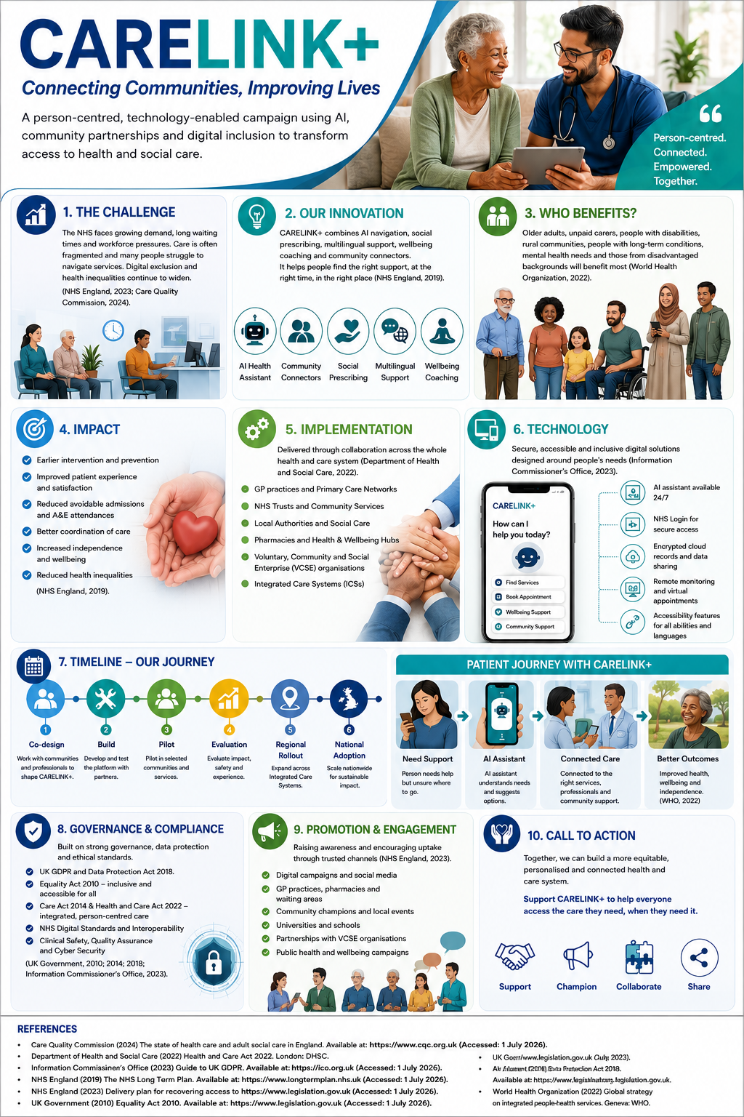
C\ARELINK+ Campaign Pitch

Introduction
The UK health and social care system continues to face significant pressures caused by increasing demand, an ageing population, workforce shortages and persistent health inequalities. Many people experience difficulties accessing the right service at the right time, leading to delays in treatment, avoidable hospital admissions and poorer health outcomes. I have designed CARELINK+ as an innovative, person-centred campaign that combines artificial intelligence (AI), community partnerships and social prescribing to simplify access to care while supporting prevention and wellbeing. Rather than replacing healthcare professionals, the initiative enhances existing services by helping people navigate the health and social care system more effectively. My campaign reflects NHS priorities for integrated, personalised and digitally enabled care while ensuring that compassion, inclusion and professional judgement remain central to every interaction (NHS England, 2019).

Why the Innovation is Needed
Evidence suggests that demand for NHS services continues to increase because more people are living with long-term conditions such as diabetes, cardiovascular disease and dementia (Department of Health and Social Care, 2022). At the same time, health inequalities mean that some communities experience poorer outcomes due to socioeconomic deprivation, language barriers, disability and digital exclusion. Many patients are unsure whether they should contact a GP, pharmacist, NHS 111, social care provider or emergency department. This confusion creates unnecessary pressure across the system. CARELINK+ addresses these issues by providing one accessible platform that directs individuals to the most appropriate support while also connecting them with community organisations that can improve wider determinants of health.

Target Population and Benefits
My campaign focuses on older adults, unpaid carers, people with disabilities, people living with long-term conditions, ethnic minority communities and individuals experiencing loneliness or social isolation. These groups are more likely to experience barriers when accessing health and social care. CARELINK+ improves health literacy by presenting information in plain language, multiple languages and accessible formats. The initiative supports earlier intervention, encourages self-management and empowers people to participate in decisions about their own care. Expected outcomes include improved patient satisfaction, reduced avoidable hospital admissions, increased independence and stronger links between health and community services (World Health Organization, 2022).

How CARELINK+ Works
Users can access CARELINK+ through a secure website, mobile application, GP practice or community hub. An AI-powered navigation assistant asks simple questions before recommending the most appropriate service. Recommendations may include GP appointments, NHS 111, pharmacy advice, mental health support, social prescribing, local voluntary organisations or urgent care where appropriate. Importantly, clinical diagnosis remains the responsibility of qualified healthcare professionals. Individuals who lack digital confidence can receive face-to-face support from trained community navigators, ensuring that technology reduces rather than widens inequalities.

Implementation and Professional Collaboration
Implementation would begin with co-design workshops involving patients, carers, NHS staff, local authorities and voluntary organisations to ensure the service reflects local needs. A pilot would then be introduced within one Integrated Care System before regional and national rollout. Success would be evaluated through patient feedback, service utilisation, waiting times and reductions in avoidable emergency attendance. Delivery depends upon effective multidisciplinary collaboration involving GPs, nurses, pharmacists, occupational therapists, physiotherapists, social workers, mental health practitioners, community link workers, digital specialists and voluntary sector organisations. Working together enables coordinated, person-centred care while reducing duplication of services.

Policy, Legislation and Governance
CARELINK+ supports the ambitions of the NHS Long Term Plan by improving prevention, digital transformation and personalised care (NHS England, 2019). It aligns with the Care Act 2014 by promoting wellbeing, independence and early intervention, while the Health and Care Act 2022 encourages greater integration between health and social care organisations. Personal information would be protected through compliance with the UK General Data Protection Regulation and the Data Protection Act 2018. Equality would remain fundamental through adherence to the Equality Act 2010, ensuring services are accessible regardless of age, disability, ethnicity, religion or language. Clinical governance, cybersecurity and ongoing staff training would ensure safe implementation.

Technology and Innovation
Technology is an enabler rather than the objective of CARELINK+. Artificial intelligence is used to improve navigation, not replace professional judgement. The platform incorporates NHS Login, secure encrypted cloud storage, accessibility tools, multilingual translation, speech-to-text functionality and optional remote monitoring for individuals with long-term conditions. Data analytics would enable healthcare organisations to identify trends, allocate resources more effectively and evaluate service performance while maintaining strict confidentiality. These innovations contribute to safer, faster and more responsive care.

Public Engagement and Campaign Strategy
Public engagement is essential to the success of CARELINK+. The campaign would be promoted through GP surgeries, pharmacies, NHS websites, local authority communications, universities, social media, community centres and voluntary organisations. Community ambassadors and people with lived experience would share personal stories demonstrating the benefits of accessing appropriate support early. Educational workshops would improve digital confidence and health literacy. Members of the public would also be invited to provide ongoing feedback through surveys and focus groups, ensuring the service continues to evolve according to community needs.

Conclusion
CARELINK+ represents a practical and sustainable solution to some of the most significant challenges facing UK health and social care. By combining digital innovation with compassionate, person-centred support, the initiative improves access, reduces inequalities and strengthens integrated care. It empowers individuals to become active partners in managing their health while enabling professionals to deliver more coordinated services. Supporting CARELINK+ is an investment in prevention, inclusion and collaboration that has the potential to improve outcomes for patients, strengthen communities and contribute to a more resilient NHS for future generations.

Reference List
- Care Quality Commission (2024) The state of health care and adult social care in England 2023/24. Newcastle upon Tyne: Care Quality Commission. Available at: https://www.cqc.org.uk/publications/the-state-of-health-care-and-adult-social-care-in-england (Accessed: 2 July 2026).
- Department of Health and Social Care (2022) Health and Care Act 2022. London: Department of Health and Social Care. Available at: https://www.legislation.gov.uk/ukpga/2022/31/contents (Accessed: 2 July 2026).
- Information Commissioner's Office (2023) Guide to the UK General Data Protection Regulation (UK GDPR). Available at: https://ico.org.uk/for-organisations/uk-gdpr-guidance-and-resources/ (Accessed: 2 July 2026).
- NHS England (2019) The NHS Long Term Plan. Available at: https://www.longtermplan.nhs.uk (Accessed: 2 July 2026).
- NHS England (2023) Delivery plan for recovering access to primary care. Available at: https://www.england.nhs.uk/publication/delivery-plan-for-recovering-access-to-primary-care/ (Accessed: 2 July 2026).
- UK Government (2010) Equality Act 2010. Available at: https://www.legislation.gov.uk/ukpga/2010/15/contents (Accessed: 2 July 2026).
- UK Government (2014) Care Act 2014. Available at: https://www.legislation.gov.uk/ukpga/2014/23/contents (Accessed: 2 July 2026).
- UK Government (2018) Data Protection Act 2018. Available at: https://www.legislation.gov.uk/ukpga/2018/12/contents (Accessed: 2 July 2026).
- World Health Organization (2022) Global strategy on integrated people-centred health services. Geneva: World Health Organization. Available at: https://www.who.int/teams/integrated-health-services/people-centred-care (Accessed: 2 July 2026).

