

University of Wales Trinity Saint David
School of Engineering

Manufacturing Processes and Defects
Materials and Introduction to Processing - ACMA4000
Simeon Scoberg-Evans
1252150
04/02/24
Table of Contents
1 Abstract 1
2 Process 1: Open-Die Forging 2
2.1 Process Definition 2
2.2 Process Application 3
2.3 Advantages & Disadvantages of the Process 3
2.3.1 Advantages of Open-die Casting 3
2.3.2 Disadvantages of Open-die Casting 3
2.4 Microstructure of Material 4
2.5 UTS of Material 4
2.6 Common Processing Defects 4
2.7 Remedial Measures to Eliminate Defects 5
3 Process 2: Continuous Casting 6
3.1 Process Definition 6
3.2 Process Application 7
3.3 Advantages & Disadvantages of the Process 7
3.3.1 Advantages of Continuous Casting 7
3.3.2 Disadvantages of Continuous Casting 7
3.4 Microstructure of Material 8
3.5 UTS of Material 8
3.6 Common Processing Defects 8
3.7 Remedial Measures to Eliminate Defects 9
4 Process 3: M.I.G. Welding 10
4.1 Process Definition 10
4.2 Process Application 10
4.3 Advantages & Disadvantages of the Process 11
4.3.1 Advantages of MIG Welding 11
4.3.2 Disadvantages of MIG Welding 11
4.4 Microstructure of Material 11
4.5 UTS of Material 11
4.6 Common Processing Defects 12
4.7 Remedial Measures to Eliminate Defects 12
5 Discussion 13
6 References 14

Abstract
This report will consist of an analysis of three separate metal forming techniques: open die forging, continuous casting, and welding. Each process will be defined, and an example of an application or applications will be given. The advantages and disadvantages of each process will then be discussed as well as the microstructure produced in the processed material and its ultimate tensile strength. Next, common processing defects caused by/during each process will be described, before, finally, offering remedial measures to reduce or nullify those defects. By providing this information, this report will be able to give a comprehensive overview of three manufacturing processes.

Process 1: Open-Die Forging

Process Definition
Open-die forging, also known as free forging or smith forging, is one of the oldest and best-known forging techniques (Dindorf & Wos, 2020). There are two methods of open-die forging; hot and cold forging. When hot forging, a piece of metal is heated above its recrystallisation temperature, so that it can be deformed plastically, (Aksakal, et al., 1997) and then struck with a hammer against a stationary anvil to deform to it. (Canton Drop Forge, no date) Cold forging follows the same method but is done at temperatures closer to room temperature than the extreme heats of hot forging. (General Kinematics, 2020) Open-die forging is a very straightforward forging technique, with the following stages:
(Knap, et al., 2016)
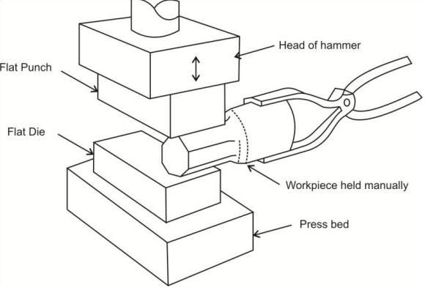
Figure 1 Open-die forging diagram (Upadhyay, no date)

Process Application
Open-die forging produces components that are high in strength and durability but are a simple in form. Products such as flanges, pipe bends, bars, beams, and mandrels, are a few examples of what can be made from this process (Feralloy, Inc., no date).

Advantages & Disadvantages of the Process

Advantages of Open-die Casting
One advantage of this process is that it is a highly versatile in the shapes and sizes of components that it can create. Not only is the material waste incredibly low but the tooling costs are also very low compared to other forging methods, such as extrusion or closed-die forging. The lower press tonnage is also much lower than closed-die forging, which will reduce energy consumption and the price of the equipment required. One of the main advantages of this process is that it refines the grain structure of the material, which is beneficial to both its strength and toughness. (Matlock, et al., 2001)

Disadvantages of Open-die Casting
A disadvantage of open-die casting is the lengthy production times and the need of a high skilled worker, it takes time and experience to learn this process. The main drawback of this process is the limited complexity of the components produced, especially when compared to other processes such as closed-die forging and casting. This process also leaves a poor surface finish compared to closed-die casting, and other processes. There is also less control over the final tolerances of the finished component, making this a less precise process. Although this process refines the grain structure of the material, the difficulty of controlling the material flow can lead to variations of mechanical properties throughout the component and even inequality in the deformation. (Chappell, 2023) This means that certain areas of the workpiece can be weaker or stronger than others.

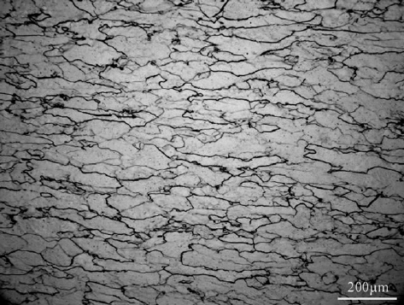
Microstructure of Material
Figure 2 Microstructure of hot forged mild steel (Zhongwu, et al., 2009)
The microstructure of hot forged mild steel, as seen in fig. 2 above, is typically made up of tightly packed and condensed grain boundaries.

UTS of Material
The ultimate tensile strength of mild steel is between 440-520MPa. (Branner, et al., 2009)

Common Processing Defects
One defect caused by the open-die forging process is surface cracking, which happens when the forging is done at too low a temperature. Another common defect is internal porosity, where trapped gases within the material cause minute air pockets when the recrystallisation takes place. Alternatively, it can also be caused by a poorly designed die. The final defect I have selected is incomplete forging penetration, which occurs when the force exerted on the workpiece by the hammer is too low. (CFS Forge, 2018)

Remedial Measures to Eliminate Defects
To avoid surface cracking, the temperature control needs to be improved. The workpiece needs to be heated to the right temperature before any forging takes place. This will also help to avoid internal porosity as well as better die design and sourcing better quality raw materials. Finally, proper, and competent control over the forging press (i.e. using the right amount of force) will avoid incomplete forging penetration. (CFS Forge, 2018) Open-die casting is a highly skilled process, and these defects can be avoided by hiring a competent and experienced forge operator.

Process 2: Continuous Casting

Process Definition
Since the mid-1980’s the continuous casting process has become by far the most common casting method for steel, accounting for 95% of worldwide steel production, exceeding the conventional ingot casting method. (Louhenkilpi, 2014) The process consists of molten metal, or metal alloys, being poured into a mould and rapidly cooled. This ensures that a desired uniform grain structure occurs within the material. (Kairit International Casting, 2019)

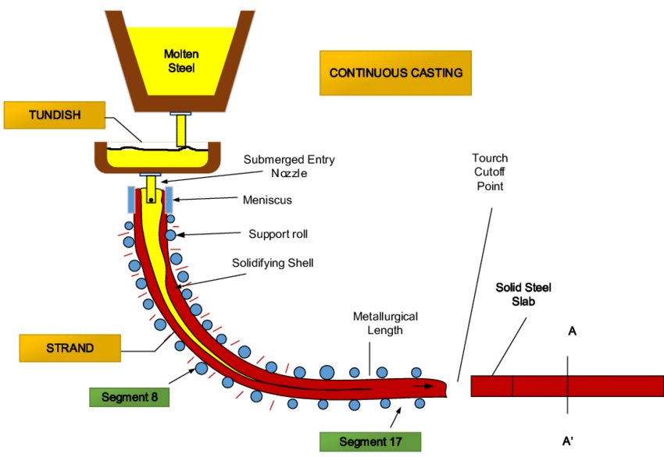
Figure 3 Continuous Casting Process Diagram (Nieto, et al., 2015)

Process Application
One application of continuous casting is in the production of metals. This process is used to make a wide variety of metal products, such as slabs, billets, ingots, bars, beams, and tubes. (Buschow, et al., 2001)

Advantages & Disadvantages of the Process

Advantages of Continuous Casting
The main advantage of continuous casting is that it is a continuous, and efficient process, increasing overall productivity, that ensures consistent quality and material properties throughout the entire length of the cast output. Also, material waste is negligible, and heating and cooling cycles can be employed to reduce the energy per kg of cast, relative to batch processes, which both will reduce overall cost. Another long-term cost saving from continuous casting is how amenable the process is to automation, reducing the output costs per kg of output. This process is perfect for high-volume production of a variety of metals and alloys, albeit not simultaneously but separately or consecutively, providing the tooling and temperatures are changed. (Xometry, 2023)

Disadvantages of Continuous Casting
A major disadvantage of the continuous casting process is the enormous capital investment required to set up the process. Tooling, machinery, expertise, and raw material shipping costs will be monumental at start up and so will the constant maintenance throughout the processes’ lifetime. This process also cannot produce complex shapes or structures. Another major drawback is that any failure within critical parts of the process will result in catastrophic issues. (Chappell, 2023)

Microstructure of Material
Figure 4 Microstructure of A356 aluminium alloy obtained by continuous casting (Robert, et al., 2006)
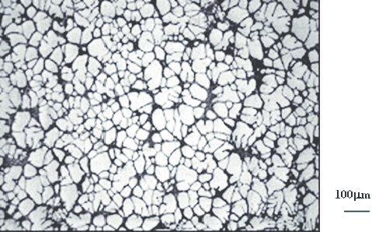
The microstructure of A356 aluminium alloy, as seen in fig. 4 above, consists of composed of relatively tight grain boundaries, although larger and less defined than seen in mild steel, see fig. 2 in 2.2.4 Process 1: Open Die-Casting. This gives the aluminium alloy more ductility but makes it less strong and hard than the mild steel.

UTS of Material
The ultimate tensile strength of A356 aluminium alloy is between 220-310MPa. (Hadliegh Castings, no date)

Common Processing Defects
The most common defects found in this process are transversal and longitudinal cracking, and bleeding. (Camisani-Clazolari, et al., 2003) Transversal cracking takes place due to the steel sticking to the mould, uneven cooling, or because of bending or straightening at low temperatures. (Newton, et al., 1967) Longitudinal cracking occurs also by fast or uneven cooling, but also by an incorrect withdrawal speed, improper mould design and condition, as well as too high a teeming temperature. (Camisani-Clazolari, et al., 2003) Bleeding is the “exudation of molten metal through a rupture in the skin” (Newton, et al., 1967), which is caused by either improper pouring regiment or due to slag or other foreign metals interfering with the solidifying shell. (LMM Group, 2021) Bleeding can also cause oscillation marks, depressions and sticking. There are also internal defects that can be found via NDT testing, such as internal shrinkage and slag entrapment. (Bui & Nguyen, 2020)
Figure 5 Illustration of common defects on a continuously cast billet (Vietch-Michaelis, et al., 2016)

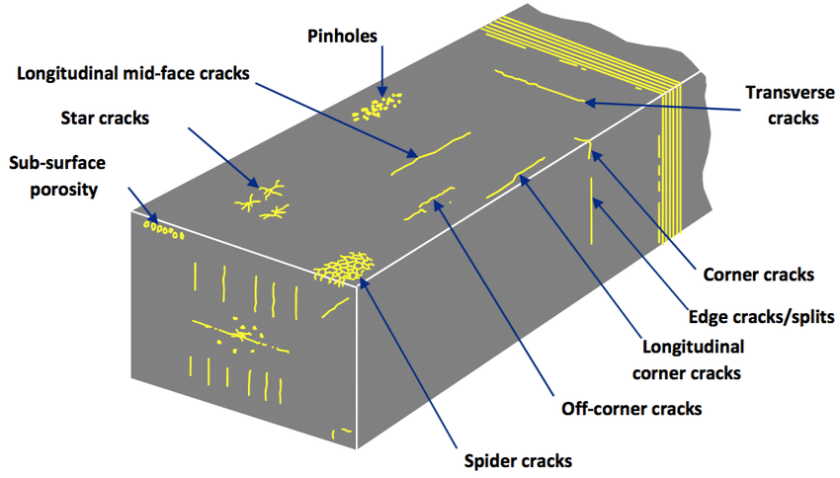

Remedial Measures to Eliminate Defects
Most of the defects are caused by improper temperature control, either during pouring, cooling, or bending/straightening, and by poor mould design or maintenance. By evaluating these methods and by better controlling the temperature and the mould design/condition, these defects can be reduced or removed entirely.

Process 3: M.I.G. Welding

Process Definition
MIG, or metal inert gas, welding is an arc welding process where a continuous solid wire electrode is fed through a welding gun and into the weld pool, which then joins the two pieces of material. A shielding gas, usually a combination or carbon dioxide and argon, is pumped through the gun to protect the weld pool from contamination. (Miller Electric, 2010)
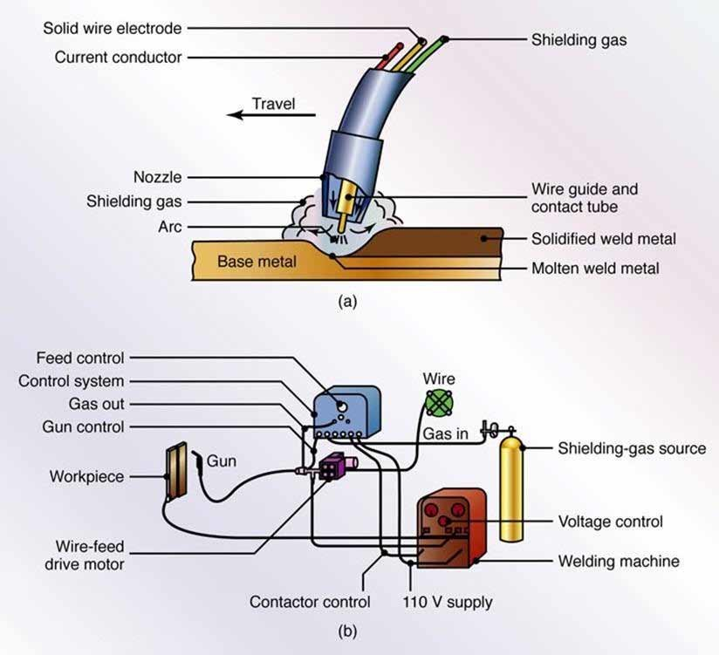
Figure 6 MIG welding process (a) and MIG welding hardware block diagram (b) (Ulutaş, 2021)

Process Application
MIG welding is used to join two pieces of metal together to create one solid piece. It is commonly used in metal and pipework fabrication, as well as in vehicle repairs.

Advantages & Disadvantages of the Process

Advantages of MIG Welding
A major advantage of MIG welding is that it offers higher productivity rates than other welding methods as it is simple to learn and use, and it saves time by no loner needing to change rods or chip away slag. The inert gas protects the weld pool so there is no spatter, which gives a cleaner and better-looking weld. The main advantage it offers is its versatility; it can be used with a wide variety of different metals and as well as in operation, with semi and fully automatic welding capabilities. (Bakers Gas, no date)

Disadvantages of MIG Welding
MIG welding is a far more expensive method of welding, due to the cost of the welding guns, filament, and gas, than rival welding processes. It also has limitations when welding thicker materials and it is also affected by wind, which is a big problem due to a lot of welding taking place outdoors and on-site. (BWS Ltd., 2023)

Microstructure of Material
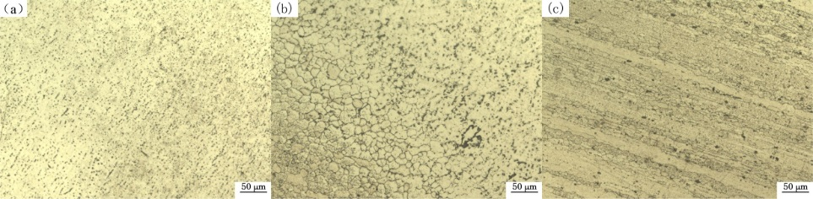
Figure 7 Microstructures of welding metal (a), fusion zone (b) and base metal (c) (Li, et al., 2016)
As seen in image (b) of figure 7, above, the fusion zone has larger grain boundaries than that of the welding metal (a) and the base metal (b). This mean that on the weld boundary is more likely to fail under extreme stress than the material itself.

UTS of Material
The material in figure 7, above, is Aluminium 7005, which has an ultimate tensile strength of 350MPa. (MatWeb, no date)

Common Processing Defects
Common MIG welding defects include pinholes, cracking, and porosity issues appearing in the finished weld. Also, too much weld deposit and improper weld penetration are also issues found in this process. (Bancroft Engineering, no date)

Remedial Measures to Eliminate Defects
All defects in the MIG welding process come down to user error. With the proper training and equipment, all said defects can be avoided. For example, knowing what gas and gas flow rate is best for what material and in what scenario is essential. As well as knowing that your equipment is in good order; tungsten electrodes are in good condition and ground to the correct point, all electrical connections are tight, no gas leakage, and gas nozzles are spatter free. A competent and well-equipped welder should produce a solid weld when called upon. (BOC, no date)

Discussion
Open-die forging is a great method for making gears because it can produce very strong and durable gears at a very low cost. Other methods, such as sand casting, can produce strong and durable gears but they will always be far more costly, which will have a huge effect on final cost when producing in bulk.
Continuous casting is the ideal process for creating steel slabs because it can produce slabs of consistent quality and mechanical properties, in the most efficient way.
MIG welding is the preferred method for fabricating steel pipes in the fabrication shop due to its ease-of-use, weld speed, weld cleanliness, and the versatility of the process in regard to material type and thickness.

References
Aksakal, B., Osman, F. & Bramley, A., 1997. Upper-bound analysis for the automation of open-die forging. Journal of Materials Processing Technology, 71(2), pp. 215-223.
Bakers Gas, no date. The Pros and Cons of MIG Welding. [Online]
Available at: https://bakersgas.com/pages/the-pros-cons-of-mig-welding
[Accessed 3 February 2024].
Bancroft Engineering, no date. GMAW Welding, MIG or Wire Welding Problems. [Online]
Available at: https://bancrofteng.com/gmaw-mig-or-wire-welding-problems/
[Accessed 3 February 2024].
BOC, no date. The Efficiency Series: Reduce costs by reducing your welding defects. [Online]
Available at: https://www.boconline.co.uk/en/blog/reduce-costs-by-reducing-your-welding-defects.html
[Accessed 3 February 2024].
Branner, K., Czujko, J., Paik, J. & Choo, J., 2009. 17th International Ship and Offshore Structures Congress. Seoul, ISSC Committee.
Bui, A.-H. & Nguyen, V.-H., 2020. Defects of the steel billet in continuous casting. Journal of Metals, Materials and Minerals, 30(1), pp. 80-85.
Buschow, K. et al., 2001. Encyclopedia of Materials: Science and Technology. 10th ed. Oxford: Pergamon.
BWS Ltd., 2023. MIG Welding vs. Stick Welding: Pros and Cons - A Comprehensive Guide. [Online]
Available at: https://www.basicwelding.co.uk/blogs/mig-welding-101-from-novice-to-pro/mig-welding-vs-stick-welding-pros-and-cons-a-comprehensive-guide
[Accessed 3 February 2024].
Camisani-Clazolari, R., Craig, I. & Pistorious, P., 2003. A Review on Causes of Surface Defects in Continuous Casting. IFAC Proceedings Volumes, 36(24), pp. 113-121.
Canton Drop Forge, no date. The Die Process: Closed-Die Forging Vs. Open-Die Forging. [Online]
Available at: https://cantondropforge.com/open-vs-closed-die-forging/
[Accessed 01 January 2024].
CFS Forge, 2018. Common Defects of Steel Forgings. [Online]
Available at: https://www.steelforging.org/common-defects-of-steel-forgings/
[Accessed 7 January 2024].
Chappell, R., 2023. Forming lecture 2 complete. Swansea: University of Wales Trinity Saint David.
Dindorf, R. & Wos, P., 2020. Energy-Saving Hot Open Die Forging Process of Heavy Steel Forgings on an Industrial Hydraulic. Energies, 2 April, pp. 13-30.
Feralloy, Inc., no date. Open Die Forging Applications. [Online]
Available at: https://ferralloy.com/post/open-die-forging-applications-2-2
[Accessed 5 January 2024].
General Kinematics, 2020. Pros and Cons of Cold Forging and Hot Forging. [Online]
Available at: https://www.generalkinematics.com/blog/cold-forging-vs-hot-forging/
[Accessed 5 January 2024].
Hadliegh Castings, no date. A356.0 Aluminium Casting Alloy. [Online]
Available at: https://ahead4-hadleigh-castings.s3.eu-west-2.amazonaws.com/content/9be6417437c62c701d950454bd4d7756.pdf
[Accessed 12 January 2024].
Kairit International Casting, 2019. What Is the Continuous Casting Process?. [Online]
Available at: https://kicastings.com/continuous-casting-process/
[Accessed 15 January 2024].
Knap, M., Kugler, G., Palkowski, H. & Turk, R., 2016. Prediction of Material Spreading in Hot Open-Die Forging. Steel Research International, 75(6), pp. 405-410.
Li, Y., Zhang, X. & Ma, X.-J., 2016. Microstructures and Mechanical Properties of MIG Welding Joint of 7005 Aluminium Alloy. Wuhan, Atlantis Press.
LMM Group, 2021. Types, causes and preventive measures of continuous casting breakout accidents. [Online]
Available at: https://www.lmmgroupcn.com/types-causes-and-preventive-measures-of-continuous-casting-breakout-accidents/
[Accessed 25 January 2024].
Louhenkilpi, S., 2014. Chapter 1.8 - Continuous Casting of Steel. Treatise on Process Metallurgy, Volume 3: Industrial Processes, pp. 373-434.
Matlock, D., Krauss, G. & Speer, J., 2001. Microstructures and properties of direct-cooled microalloy forging steels. Journal of Materials Processing Technology, 117(3), pp. 324-328.
MatWeb, no date. Aluminum 7005-T6, 7005-T63, and 7005-T6351. [Online]
Available at: https://www.matweb.com/search/DataSheet.aspx?MatGUID=34c308934f7a4be589a80ecbee94406e&ckck=1
[Accessed 3 February 2024].
Miller Electric, 2010. MIG Welding: The Basics for Mild Steel. [Online]
Available at: https://www.millerwelds.com/resources/article-library/mig-welding-the-basics-for-mild-steel
[Accessed 25 January 2024].
Newton, R. et al., 1967. Definition and Causes of Continuous Casting Defects. 1st ed. London: Percy Lund, Humphreys and Co..
Nieto, P., Anton, J., Gonazalez, V. & Bayon, R., 2015. A New Predictive Model of Centerline Segregation in Continuous Cast Steel Slabs by Using Multivariate Adaptive Regression Splines Approach. Materials, 8(6), pp. 3562-3583.
Robert, M., Zoqui, E., Tanabe, F. & Motegi, T., 2006. Producing thixotropic semi-solid A356 alloy: Microstructure formation 3 forming behaviour. Journal of Achievements of Materials and Manufacturing Engineering, 20(1-2), pp. 19-26.
Ulutaş, A., 2021. Joining Techniques Like Welding in Lightweight Material Structures. In: K. e. a. Kumar, ed. Handbook of Research on Advancements in the Processing, Characterization, and Application of Lightweight Materials. Hershey, Pennsylvania: IGI Global, pp. 121-152.
Upadhyay, A. K., no date. MEM103 - Dayalbagh Educational Institute. [Online]
Available at: http://msvs-dei.vlabs.ac.in/mem103/Unit2lesson2.html
[Accessed 1 January 2024].
Vietch-Michaelis, J., Tao, Y., Walton, D. & Muller, J., 2016. Crack Detection in "As-Cast" Steel Using Laser Triangulation and Machine Learning. Victoria, 13th Conference on Computer and Robot Vision (CRV).
Xometry, 2023. Continuous Casting: Definition, Importance, How It Works, Advantages, and Examples. [Online]
Available at: https://www.xometry.com/resources/casting/continuous-casting/
[Accessed 11 January 2024].
Zhongwu, Z., Guang, C. & Bei, H., 2009. Directional recrystallization and microstructures of an Fe6.5wt%Si alloy. Journal of Materials Research, 24(8), pp. 2654-2660.

