

Impact of Virtual Learning Environment (VLE) Report

Lecture: Koushik Modak

Teodor Krastev
Student’s ID: 2111300

Table of Content
1. Introduction 3
2. Methodology 3
3. Findings and Discussion 3
3.1 Survey (Primary Qualitative Analysis) 3
3.2 Secondary Analysis 8
4. Conclusion 10
References 11
Appendices 13

1. Introduction
Teachers, students, parents, and others in charge of training can access data, tools, and assets through a web-based learning platform, which is also known as a “virtual learning environment. With web-based learning, instructors may better organise their lessons, handle administrative tasks, keep tabs on their students’ progress and level of participation, and even provide extra resources and assistance to those students who need it (Sorensen, 2022). A virtual learning environment (VLE) makes it possible for students to study at their own speed and to pick up new skills without having to travel or worry about childcare while attending sessions (Patra et al., 2022).
In this regard, this particular report will present an analysis among the attendance of the VLE facilities in the Trinity Saint David College Campus to know the importance of VLE and its impact on the educational performances of the associates. Therefore, the main purpose of this report is to analyse the impact of VLE on the learning process of the college.

2. Methodology
The qualitative primary and secondary method has been followed in this research to understand the actual notion of the VLE system (Pandey and Pandey, 2021). Both methods have helped to get the authentic and viable sources that have covered up the main purpose of this particular research. The primary research was conducted through a survey among the 10 participants from the Trinity Saint David college campus. On the other hand, the secondary data has been collected through many published materials based on the related topic. Both the collection procedure has maintained fundamental ethics while gathering the data and information (Nayak and Singh, 2021). The ethical responses from the participants have also got the valid and authentic ramifications from the research that they wish to accomplish to meet the main objective of the report.

3. Findings and Discussion

3.1 Survey (Primary Qualitative Analysis)
The survey was conducted among the 10 participants among individuals from the Trinity Saint David college campus that has helped to get the accuracy of the results as per their realisation and reflection of their thoughts.

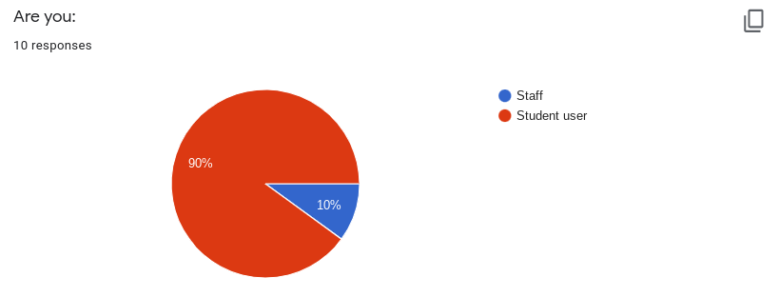
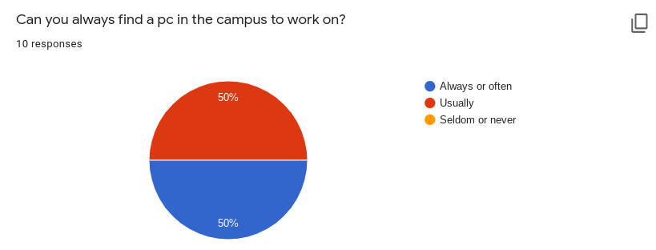
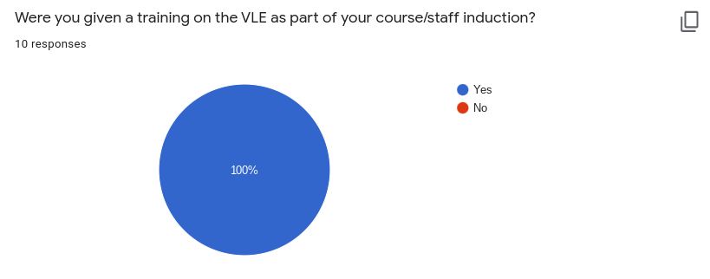
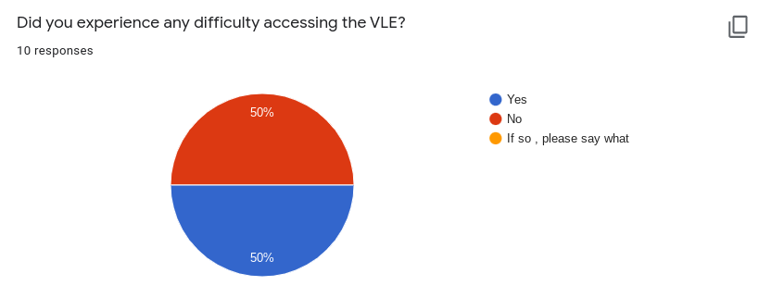
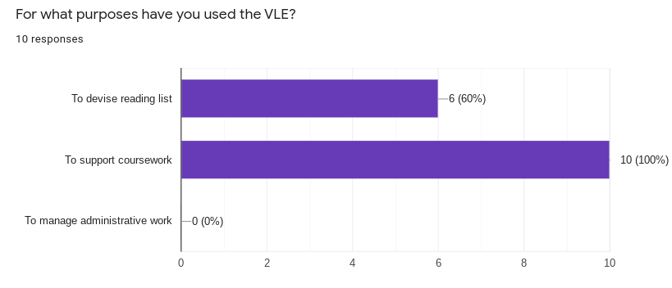
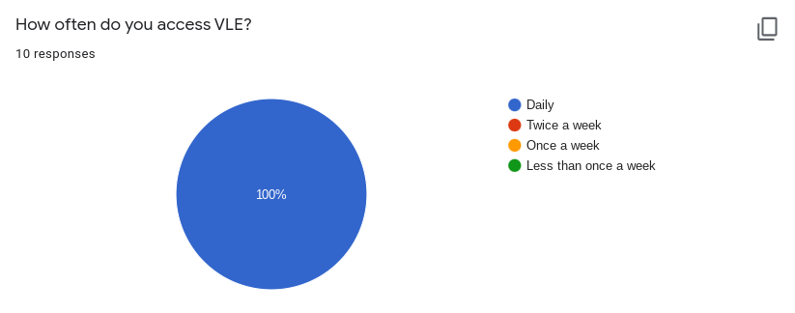

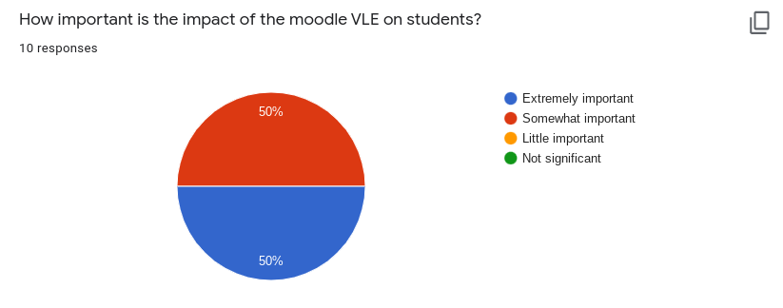
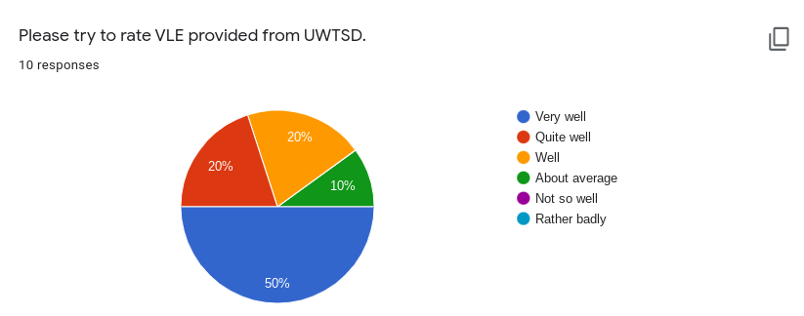

From the 10 participants, it has been seen that the research is mainly focused on the students and as well as most of the respondents are from the students of the Trinity Saint David College where 90% are students. From the above analysis, it has been seen that almost all the students are using the VLE learning method that has helped them to generate a better understanding of their studies. In that case, it has been seen that they are most of the time available to work on PCs on their campus to work on the VLE applications for educational purposes.
That means, the college administration also associates the students with the VLE approach for educational purposes. Even, from the analysis from the interview session, it has been seen that most of the students (70%) are said that, they have practised such kind of courses of some notions that has helped them to adapt the system of VLE to get the better result from it, and in that case only near about 30% students have not any advanced concepts about the practice before coming the Trinity Saint David College campus as a learner.
The analysis through the interview session has shown that among the 10 respondents most everyone has got training for the VLE for their particular educational purpose. The training session has helped them to extend their studies. During the session in the VLE, there might be some difficulties as faced by the students which are clearly obtained from the interview, where 50% of the students have said that they have faced difficulties when they have got the session in the VLE. On the other hand, another 50% have not faced any difficulties. Therefore, it can be said that most of them are very satisfied while they use the VLE in their education session.
Individuals have a different purpose while they use the VLE session for their educational purposes. In that case, the interview session has given them some options and from where it has been seen that, most of them are using the VLE for access and support for their coursework and to devise the reading list. That means the approach of the virtual learning process has enabled the individuals to get better results regarding the working or learning session that make the result in a better way.
Regarding this matter, the analysis based on the interview has shown that the participants regularly used the virtual learning process in their educational way that has helped them to progress their learning way to better perceptions. Of the 10 participants, 10 of them said that they have regularly used the VLE applications to access their working and learning processes in a better way. The importance of the VLE has also been given through this analysis when from all participants most of them (50%) said that it is very for the students and another 50% has said that, the VLE learning process is somewhat important for the students to drive the educational way in a fluent path.
In that way, the expectations of the students and staff are definitely in the path of increment and this is proved from their response in the interview session. The majority (60%) has said that they want to see more additional features in the VLE system, whereas 40% have no interest in the additional features and that means they are satisfied with what they have been given from the VLE.
The last question is based on the ratings from the individual participants that have presented that most of the students preferred the VLE and they are satisfied with the provided VLE from the UWTSD. In that case, Majority (50%), has said “Very Well” 205 of them have expressed that it is quite good and 20% has said well and 10% are about the average. Therefore, from the overall analysis through this interview session, it can be said that the provided VLE from the Trinity Saint David College has been accepted by most of them and some of them are willing to get some additional features.

3.2 Secondary Analysis
The secondary analysis is trying to get authentic and relevant information as per the wish of the main purpose of this report. In this section, the three individuals publish research material on the topic and have provided the information and data about the selected topic.
Material 1: The use of virtual learning environments and their impact on academic performance by Peter Damian
Recent years have seen a flurry of interest in VLEs in educational theory and practice. In theory, a well-designed VLE should allow students of all learning styles to get the most out of their learning, in a way they would not be able to in a lecture-based setting that caters only to listening and speaking, i.e. those who learn best by listening (Demian and Morrice, 2012). If someone is teaching co-located students rather than distance learners, you should offer just enough content so that students may enhance their course work and obtain a more complete comprehension of the subject (Rodríguez-Ardura and Meseguer-Artola, 2021).
The class or lecture venue experience of a student is contingent upon how well the teaching method suits their positive impact on student learning. The same challenges occur with virtualization, and a diverse set of resources is required to accommodate different learning styles appropriately (Tus, 2021). Numerous institutions of higher learning are becoming increasingly varied and lacking in cohesiveness or unity, and view VLEs as a means of addressing the issues created by the national spike in the number of students who attend college and the increased workload associated with this development.
A VLE, no matter how expensive, will always have a wide range of students using it in different ways (Karagiannis and Magkos, 2021). Most students at Coventry University were found to have read educational content and downloaded educational content. Only 14 per cent of students browsed external websites in a study of 209 undergraduates at the university. As a result, students regard VLE resources as online duplicates of course content, instead of as a source of growth information to help in their learning.
Material 2: The Influence of Virtual Learning Environments in Students’Performance by Paulo Alves , Luísa Miranda, Carlos Morais
Learning systems that use websites and innovative sources are intermediaries in the learning process because of the behaviours they facilitate (Alves, Miranda and Morais, 2017). The reason for this is that they promote interaction and interconnections within a continual process of information, making it easier for learners to create and rebuild their information and concepts, as well as their behaviour and patterns, within a shared framework (Grønlienet al., 2021).
Utilising VLEs in any setting requires an understanding of their primary characteristics and capabilities (Rashid et al., 2021). Learning settings and settings are dynamic and complex notions that arise as a result of the digital society’s new educational concepts and activities. According to Qureshi et al., (2021), the primary promise of VLEs is the availability of a suite of tools aimed at facilitating content creation and distribution, interaction, and evaluation of the teaching - learning activities.
Material 3: Effectiveness of Second Life Virtual Learning Environment for Language Training in Hospitality and Tourism by Nguyen Ngoc Vu , Vo Thuy Linh , Nguyen Thi Thu Van , Nguyen Thi Hong Lien
A simulator can be used as a teaching or evaluation tool anytime the teaching method involves extensive and visually spectacular engagement. Preparation using a simulator entails the teacher participating on an as-needed basis in a well-structured study schedule. Students are actively immersed in schoolwork in a virtual learning environment, just as they are in the actual world, as they solve issues and make decisions ‌(Vu et al., 2021) Additionally, a classroom simulation entails time analysis and digesting, which enables students to discuss their experiences. Additionally, their capacity for learning is assessed, and an evaluation is conducted at the conclusion of the exercise. ‌Vu et al., (2021), assert that the best simulations employ a genuine system with a high degree of simulator knowledge.
VLEs, on the other hand, may play a critical role in constructing knowledge in non-formal and casual settings when seen through the lens of change and innovation. The term “innovation,” as it is used in contemporary culture, suggests a desire for independence or restoration, or a desire to try something new.
Learning analysis is the method of analysing classification models in order to aid instructors, training developers, and virtual learning environment (VLE) administrators in detecting trends and information on active learning (Lan, Hsiao and Shih, 2018). The fundamental purpose of studying statistics is to improve the results and the creation of knowledge in the classroom. Despite the fact that interaction is the essential unit of learning in online classes, there is currently no consensus on the behaviours that are required for effective learning to take place.

4. Conclusion
From the adobe primary and secondary analysis it has been seen that the impact of VLE is acceptable in the modern educational learning system. The primary analysis based on the interview session has proved that the participants are satisfied with the provided VLE from the Trinity Saint David College and it has helped them to get better and authentic access to the study materials. On the other hand, from the secondary analysis based on the three different sources of published research in that topics are also shown that how the VLE has an effective impact on the educational system and how it has positively engrossed the study limits of the students and also the staff in their academic educational procedures.
Therefore, from this extensive analysis, it has been shown that the VLE has changed the way of the educational method a little. Students are reliable on this method and they are also eagerly waiting for the additional services through the VLE application that will help them get more work in an accurate path.

References
Alves, P., Miranda, L. and Morais, C. 2017. The Influence of Virtual Learning Environments in Students’ Performance. Universal Journal of Educational Research, 5(3), pp.517–527.
Demian, P. and Morrice, J. 2012. The use of virtual learning environments and their impact on academic performance. Engineering Education, 7(1), pp.11–19.
Grønlien, H.K., Christoffersen, T.E., Ringstad, Ø., Andreassen, M. and Lugo, R.G., 2021. A blended learning teaching strategy strengthens the nursing students’ performance and self-reported learning outcome achievement in an anatomy, physiology and biochemistry course–A quasi-experimental study. Nurse Education in Practice, 52, p.103046.
Karagiannis, S. and Magkos, E., 2021. Engaging Students in Basic Cybersecurity Concepts Using Digital Game-Based Learning: Computer Games as Virtual Learning Environments. In Advances in Core Computer Science-Based Technologies (pp. 55-81). Springer, Cham.
Lan, Y.J., Hsiao, I.Y. and Shih, M.F., 2018. Effective learning design of game-based 3D virtual language learning environments for special education students. Journal of Educational Technology & Society, 21(3), pp.213-227.
Nayak, J.K. and Singh, P., 2021. Fundamentals of Research Methodology Problems and Prospects. SSDN Publishers & Distributors.
Pandey, P. and Pandey, M.M., 2021. Research Methodology Tools and Techniques.
Patra, A., Asghar, A., Chaudhary, P. and Ravi, K.S., 2022. Integration of innovative educational technologies in anatomy teaching: new normal in anatomy education. Surgical and Radiologic Anatomy, pp.1-8.
Qureshi, M.A., Khaskheli, A., Qureshi, J.A., Raza, S.A. and Yousufi, S.Q., 2021. Factors affecting students’ learning performance through collaborative learning and engagement. Interactive Learning Environments, pp.1-21.
Rajasekaran, V.A., Kumar, K.R., Susi, S., Mohan, Y.C., Raju, M. and Hssain, M.W., 2022. An Evaluation of E-Learning and User Satisfaction. International Journal of Web-Based Learning and Teaching Technologies (IJWLTT), 17(2), pp.1-11.
Rashid, A.H.A., Shukor, N.A., Tasir, Z. and Na, K.S., 2021. Teachers’ Perceptions and Readiness toward the Implementation of Virtual Learning Environment. International journal of evaluation and research in education, 10(1), pp.209-214.
Rodríguez-Ardura, I. and Meseguer-Artola, A., 2021. Flow experiences in personalised e-learning environments and the role of gender and academic performance. Interactive Learning Environments, 29(1), pp.59-82.
Sorensen, L.S., 2022. Technology’s Impact on Students in a Virtual Environment.
Tus, J., 2021. Amidst the Online Learning in the Philippines: The Parental Involvement and Its Relationship to the Student’s Academic Performance. International Engineering Journal for Research & Development.
‌Vu, N.N., Linh, V.T., Van, N.T.T. and Lien, N.T.H., 2021, March. Effectiveness of Second Life Virtual Learning Environment for Language Training in Hospitality and Tourism. In 17th International Conference of the Asia Association of Computer-Assisted Language Learning (AsiaCALL 2021) (pp. 19-28). Atlantis Press.

Appendices
Are you:
Staff
Student user
Can you always find a pc in the campus to work on?
Always or often
Usually
Seldom or never
Before you came to UWTSD had you been on a course that involved learning by means of a VLE?
Yes
No
Were you given a training on the VLE as part of your course/staff induction?
Yes
No
Did you experience any difficulty accessing the VLE?
Yes
No
If so, please say what
For what purposes have you used the VLE? E.g. to devise reading list , to support coursework……..
How often do you access VLE?
Daily
Twice a week
Once a week
Less than once a week
How important is the impact of the moodle VLE on students?
Extremely important
Somewhat important
Little important
Not significant
Would you like to see any additional services provided via VLA?
Yes
No
If so, please say what
Please try to rate VLE provided from UWTSD.
Very well
Well
Quite well
About average
Not so well
Rather badly

