Assignment

Critical Literature Review for Doctoral Research (LCDB7009)

How Young People use Tiktok to Make Money: A Case of Entrepreneurs Development

Student’s Name： Xuefeng Qin Student’s No：2109185

Contents

1. Part 1: The Purposes of a Literature Review 3
2. Part 2: Annotated Bibliography 7
3. Part 3: Preliminary Literature Review 16
3.1. Introduction 16
3.2. Social Media and its Entrepreneurship Analysis 17
3.3. The Rise of TikTok 22
3.4. How Young People are using TikTok to make Money 24
3.5. Research Gap 27
5.6. Proposed Research Questions 27
4. References 28

1. Part 1: The Purposes of a Literature Review
A literature review is a logical analysis of scholarly articles on a chosen topic (Efron and Ravid, 2019). The central aim is to critically examine, evaluate, and synthesize study theories, findings, and practices by researchers and scholars related to an exploration area (Efron and Ravid, 2019. Therefore, the writer’s main role in reviewing the literature is to understand and critically analyze distinct research findings and theories; reveal current research gaps; and indicate what needs to be advanced on the already known concepts about the topic (Efron and Ravid, 2019). In order to write an exemplary literature review, it is important to understand its purposes. This section critically explores the many purposes, content, and format of a critical literature review, which would remain outstanding in doctorate research.
A literature review sets the context of the study (Efron and Ravid, 2019). When writing a literature review, the writer gets the chance to define and clarify key concepts and terms based on the context of the study (Efron and Ravid, 2019). The idea is to help the reader grasp the studied topic’s exhaustive meaning and implications. It is hard to start investigating a topic without having a grasp of what previous scholars and researchers have examined on the same related matter (Efron and Ravid, 2019). Thus, a literature review offers such information, which acts as a starting point and a guide for the new research (Efron and Ravid, 2019). Equally, a literature review is used to situate the topic within the historical background of the study area (Efron and Ravid, 2019). All studies are set based on a specific topic of exploration; these topics help the writer understands the background context of the investigated issue or subject (Efron and Ravid, 2019). It is this study background that gives shape to the entire study.
Additionally, a literature review helps set up a theoretical framework for the research, creating a guide to contrast ideas, perspectives, and approaches (Efron and Ravid, 2019). A theoretical framework guides in choosing a relevant theory that helps select the best research method. Importantly, the framework helps the writer to create connections with existing knowledge (Efron and Ravid, 2019). In other words, it supports the understanding of variables and concepts based on their meaning, providing a platform for knowledge building (Efron and Ravid, 2019). Therefore, a literature review is a fundamental element in research as it guides the researcher in choosing the most feasible frameworks and approaches that would help answer the investigated problem or issue.
Further, a literature review creates an investigative platform for the writer to recognize influential scholars, researchers, and seminal studies that shape the research context (Efron and Ravid, 2019). In other words, a literature review gives an opportunity to note different researchers that have made contributions to the topic, their views, and how their findings impact the writer’s field of study (Efron and Ravid, 2019). Thus, a literature review acts as a resourceful source of information that enriches the writer with vast knowledge about the topic. As a result, it becomes easy for the researcher to even frame research questions in the new study in a manner that answers the investigated questions and bridges identified gaps in previous studies.
A literature review also guides the writer in placing the topic within a present framework and reveals knowledge of the state-of-the-art development (Efron and Ravid, 2019). More so, it sets a context for exploring current and trending news, debates, questions, and conversations around the investigated topic. Equally, a literature review provides the platform to determine connections between theories and ideas and their practical inferences (Efron and Ravid, 2019). These connections create a platform for a deeper understanding of the explored topic.
Importantly, a literature review plays a purpose in informing about the research design and methodology (Efron and Ravid, 2019). Firstly, it sets the context to narrow the investigated research problem, making it feasible and investigative within the study setting and constraints (Efron and Ravid, 2019). Every topic can be examined from different angles; however, every angle must be addressed at a time. As a result, a literature review helps in narrowing the topic into a context that would be easily investigated (Efron and Ravid, 2019). A topic can be examined from different perspectives, and it will be challenging to investigate different areas at a go; therefore, a literature review narrows the area into a single topic, which is easily explored (Efron and Ravid, 2019). Narrowing the topic helps in choosing the research design and methodology that will shape the entire study.
In that case, it helps the writer to refine and modify the focus of the research, making it easy to note and critique research techniques and methodological assumptions used in the studied literature (Efron and Ravid, 2019). At the same time, a literature review helps uncover research instrumentations and methodologies that may assist in designing the study and developing data collection and analysis strategies (Efron and Ravid, 2019). Based on the context of the literature review, it becomes easy to choose the research approach to employ (Efron and Ravid, 2019). In other words, the literature review helps the researcher determine either to use a quantitative or qualitative methodological approach. In this case, a literature review that revolves around the quantification of a studied subject will most probably follow a quantitative approach (Efron and Ravid, 2019). On the other hand, a literature review that involves investigating behaviors in a population will most probably follow a qualitative approach (Efron and Ravid, 2019). Ideally, the context of a literature review helps in determining the methodological approach and techniques to employ in a study.
Additionally, a literature review helps the writer identify deficiencies and gaps in previous studies, making it easy to avoid such flaws in the research (Efron and Ravid, 2019). In other words, every research provides a list of limitations a researcher encountered in their study and highlights reasons for such confinements. Every study has limitations, sometimes errors that seek further development of the same study. Equally, other studies leave some gaps unaddressed (Efron and Ravid, 2019). As a result, a literature review acts as a guide to the writer, directing on how to avoid similar flaws in the current research (Efron and Ravid, 2019). At the same time, a literature review helps note such gaps, and future researchers work on bridging them (Efron and Ravid, 2019). The idea is to ensure every gap or question left unanswered in the previous studies is addressed in the current research.
Noted flaws and unaddressed gaps and questions help the researcher think about the topic critically and develop a new investigative approach to help answer the queries and bridge the gap (Efron and Ravid, 2019). Further, a literature review helps in confirming the researchability of the research questions (Efron and Ravid, 2019). Writing a literature review involves surveying and critically exploring scholarly articles and other relevant sources on a particular topic (Efron and Ravid, 2019). The review process provides a descriptive summary and critical analysis of such sources in relation to the investigated research questions or problems (Efron and Ravid, 2019). This process translates to confirming the researchability of the research questions. As a result, it provides a guideline before conducting a new investigation by letting the writer understand what is already known and what needs to be investigated about the studied topic.
Additionally, a literature review helps overcome room for trivial or insignificant research (Efron and Ravid, 2019). As noted earlier, a literature review provides a platform for the researcher to grasp a detailed understanding of the studied topic based on what is already known. On the other end, the researcher notes available gaps that seek further research to promote the validity and reliability of the study (Efron and Ravid, 2019). Bridging these gaps equates to avoiding trivial research. It is important to note that research involves answering unaddressed questions and problems in previous studies (Efron and Ravid, 2019); thus, new research provides significance since all gaps are addressed and questions answered (Efron and Ravid, 2019). Therefore, exploring different literatures helps the writer to develop reliable research that houses helpful information.
Lastly, a literature review helps note areas that need further advancement in the scholarly field (Efron and Ravid, 2019). It offers a platform for the writer to summarize existing research to support the development and emergence of new interpretations and perspectives (Efron and Ravid, 2019). Also, it helps justify the significance of the investigated topic by establishing the value of the issue explored in the research (Efron and Ravid, 2019). As explained, a literature review helps note gaps in present research and showcase areas of omissions and concerns, requiring further exploration to bridge those gaps and promote the significance of such literature (Efron and Ravid, 2019). More so, a literature review demonstrates how the study is related to the reviewed research findings (Efron and Ravid, 2019). Above all, a literature review helps the reader or the researcher to refine their knowledge of the investigated topic.

Part 2: Annotated Bibliography
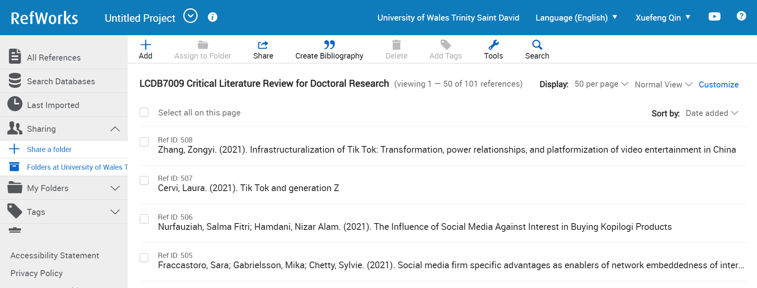
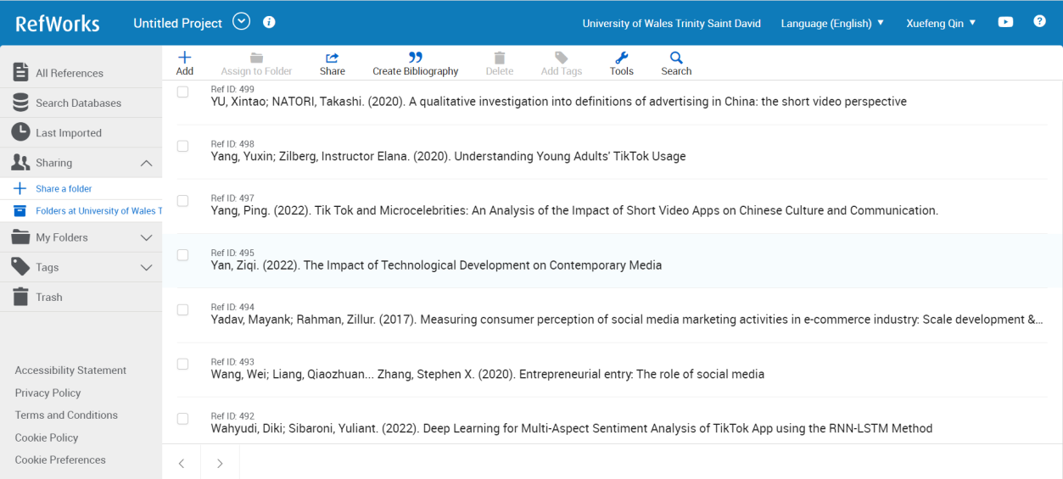
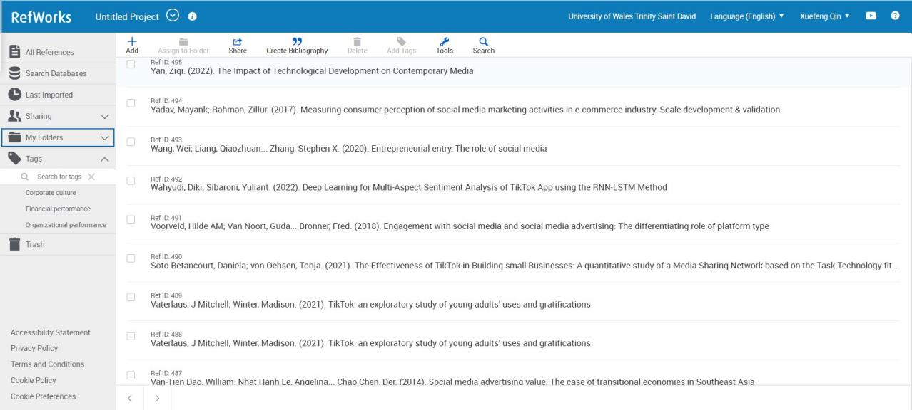
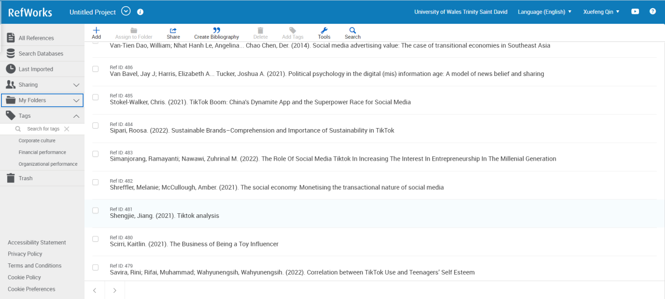
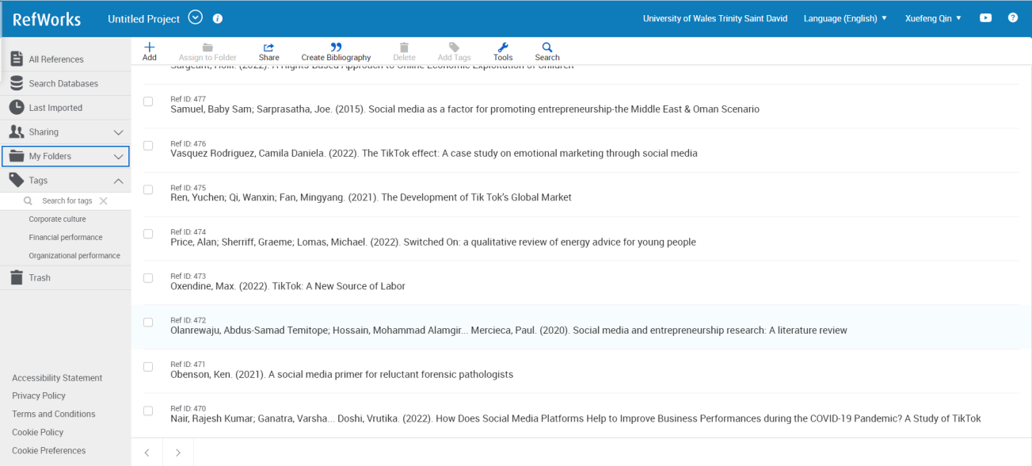

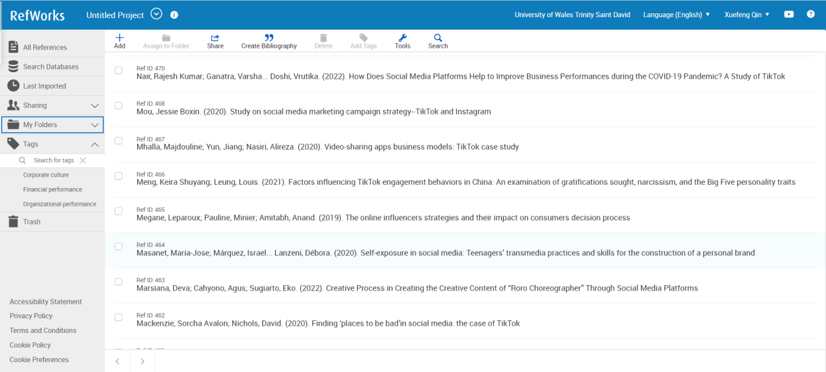
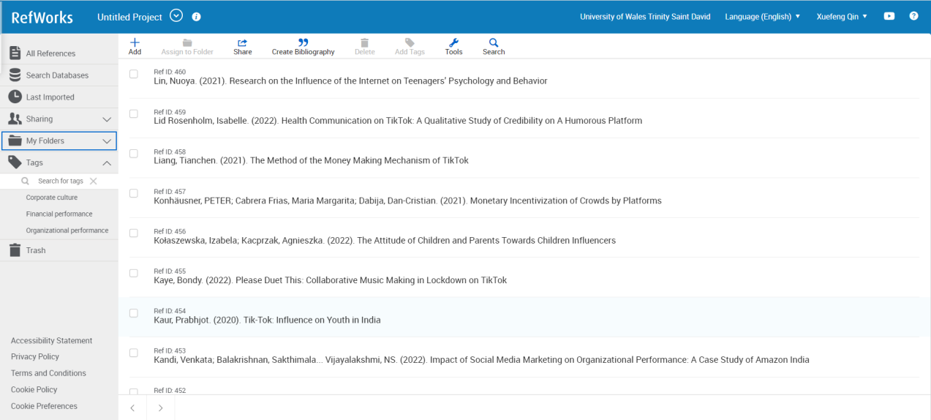
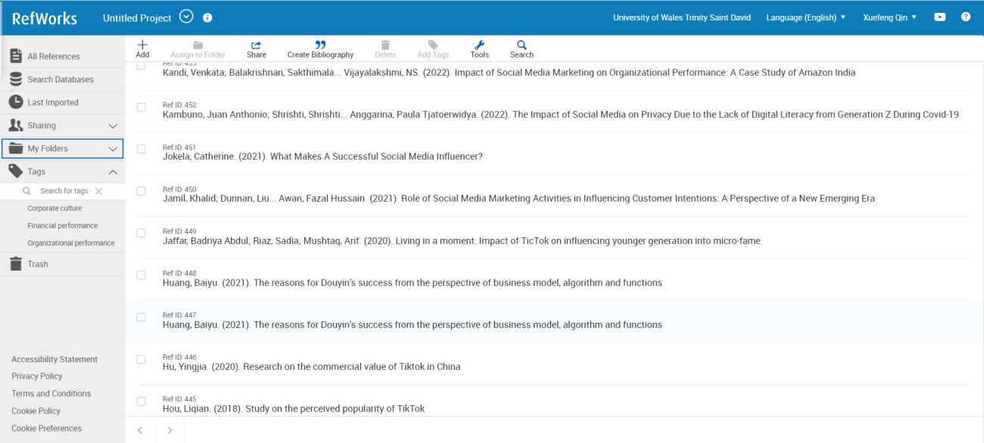
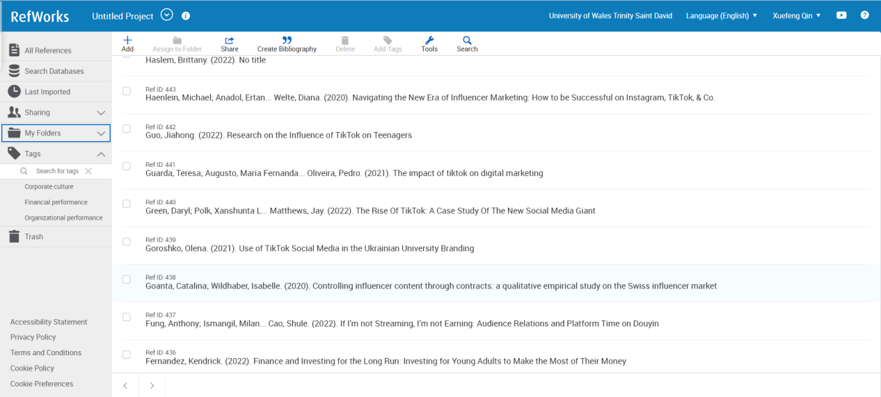
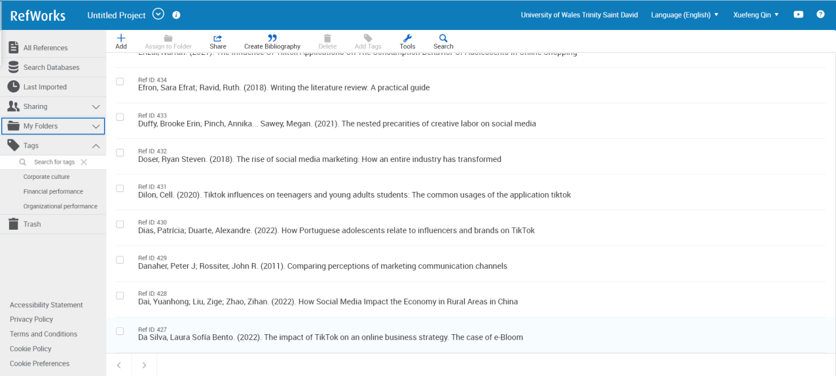
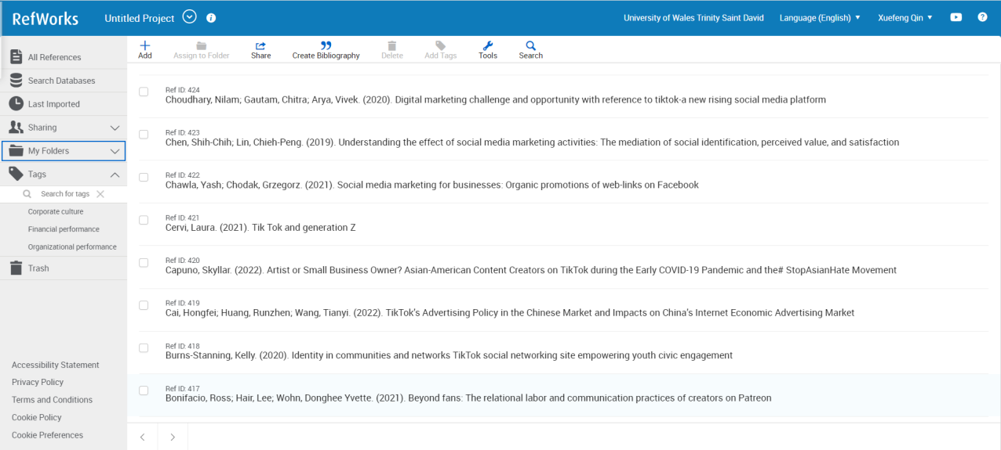
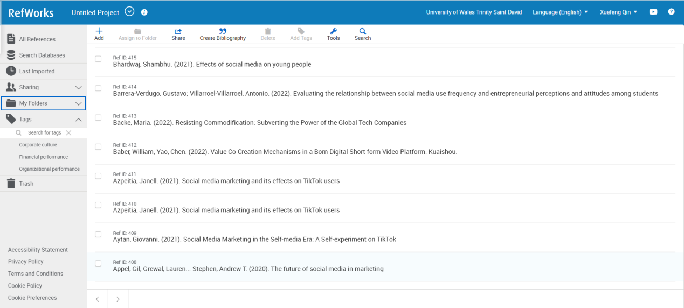
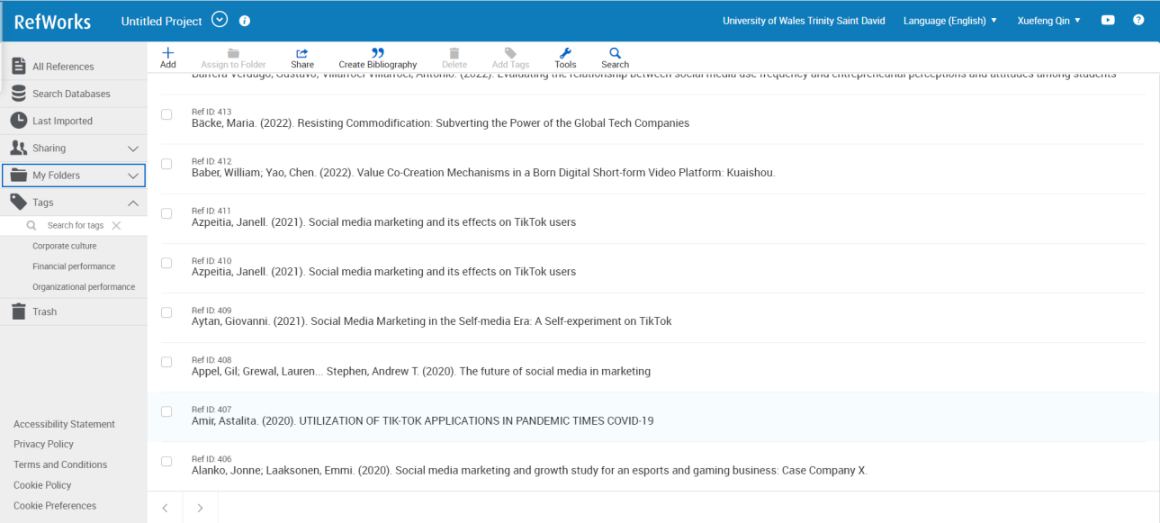
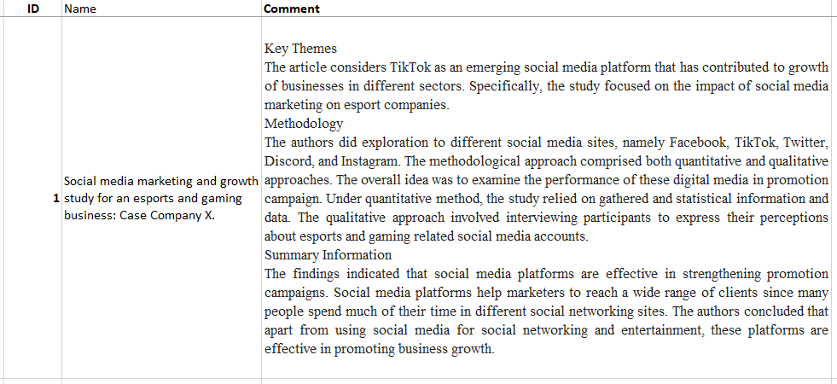
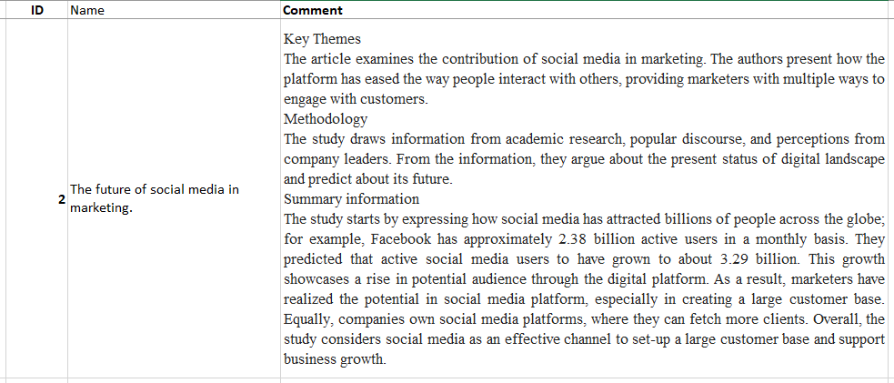
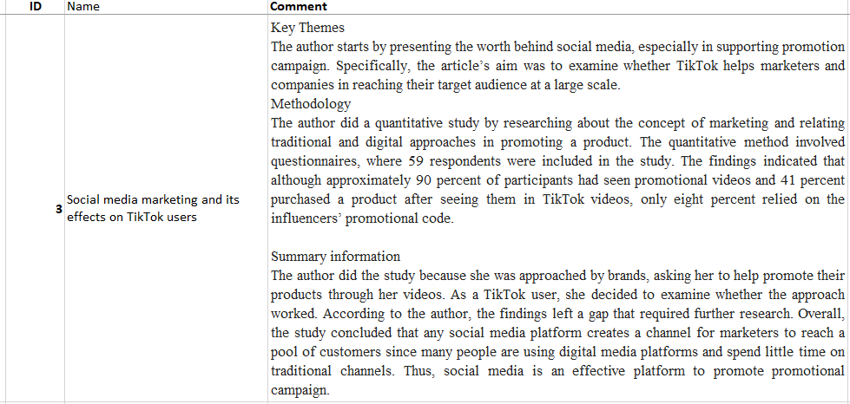
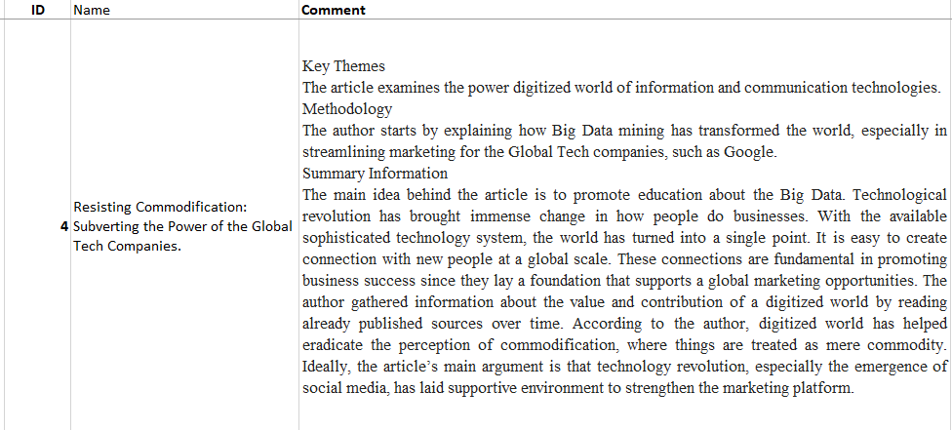
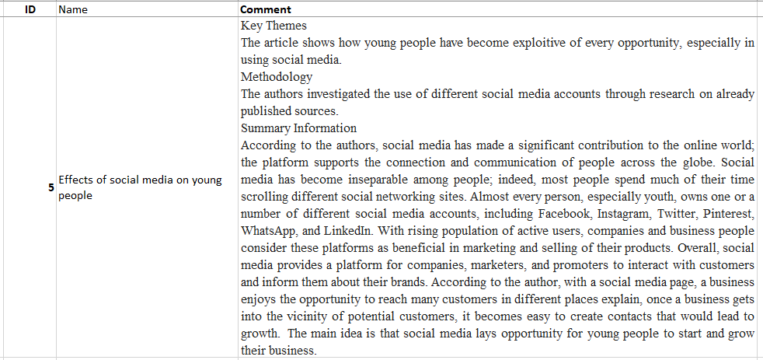
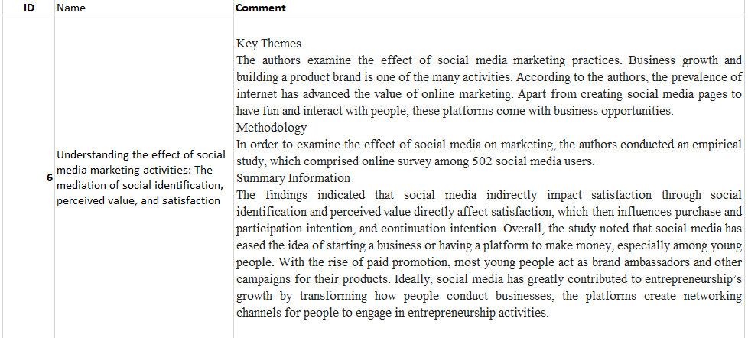
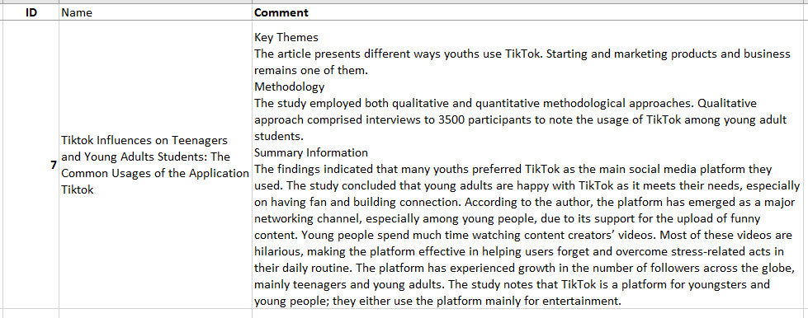
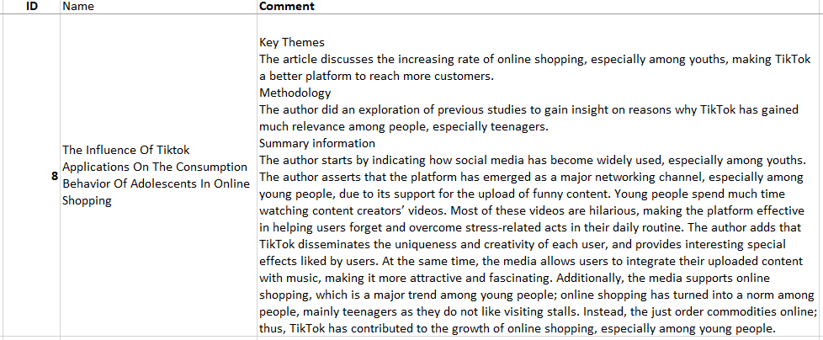
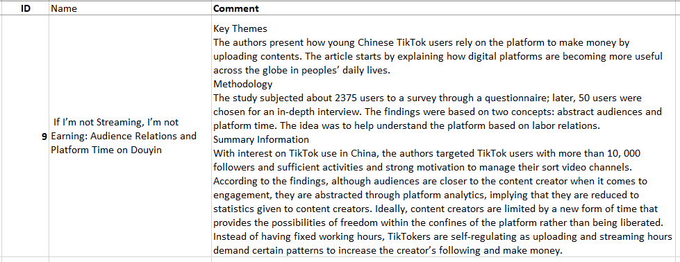

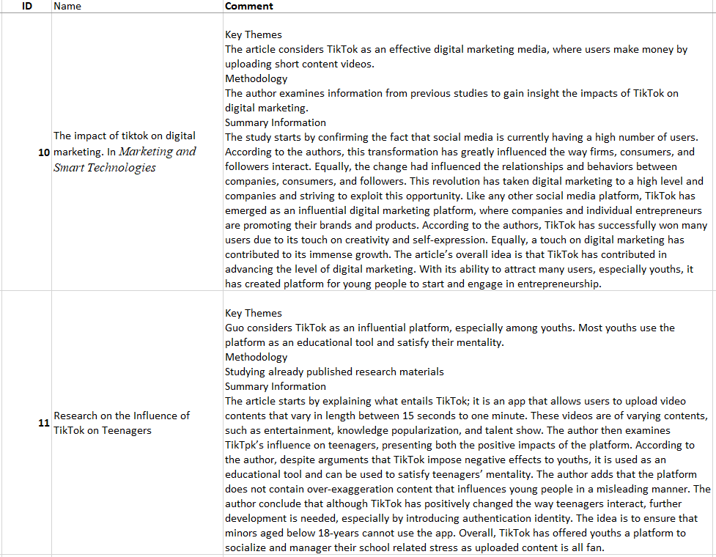

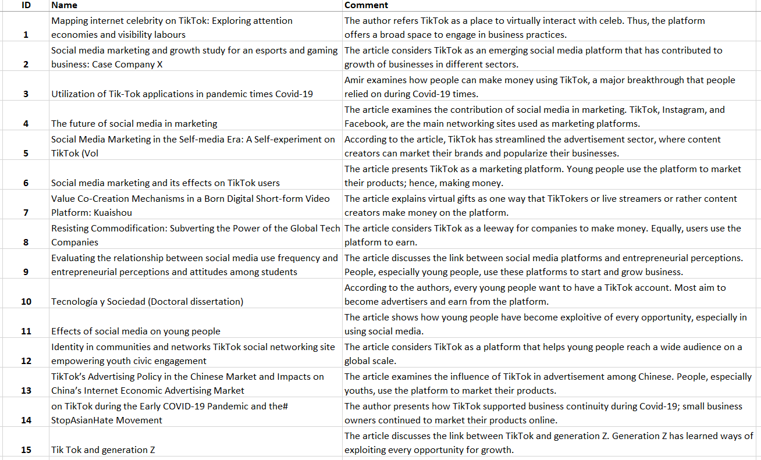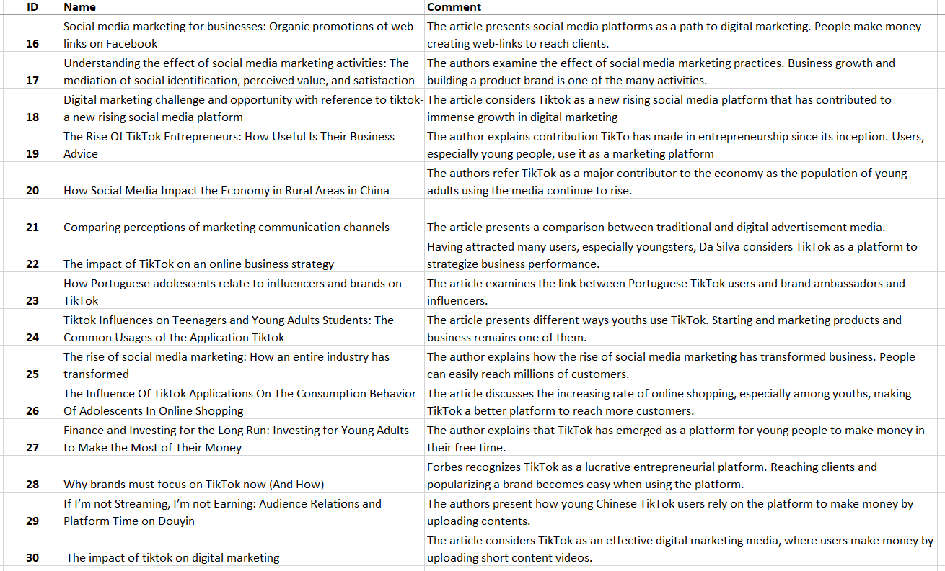
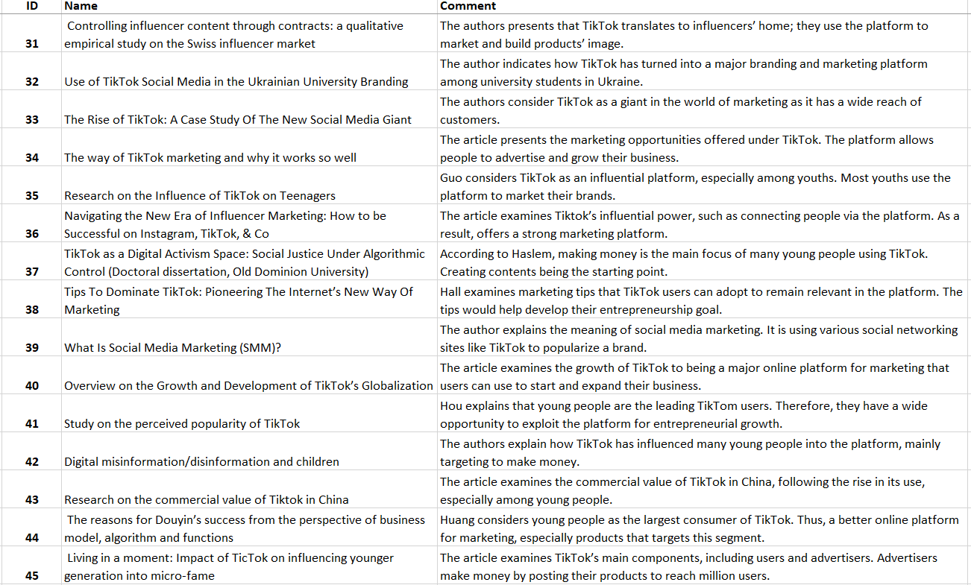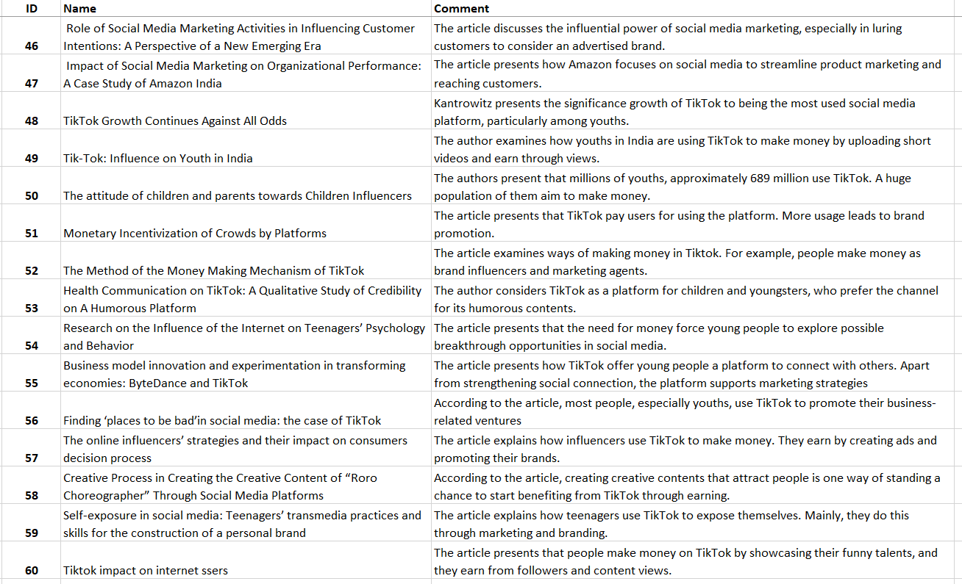
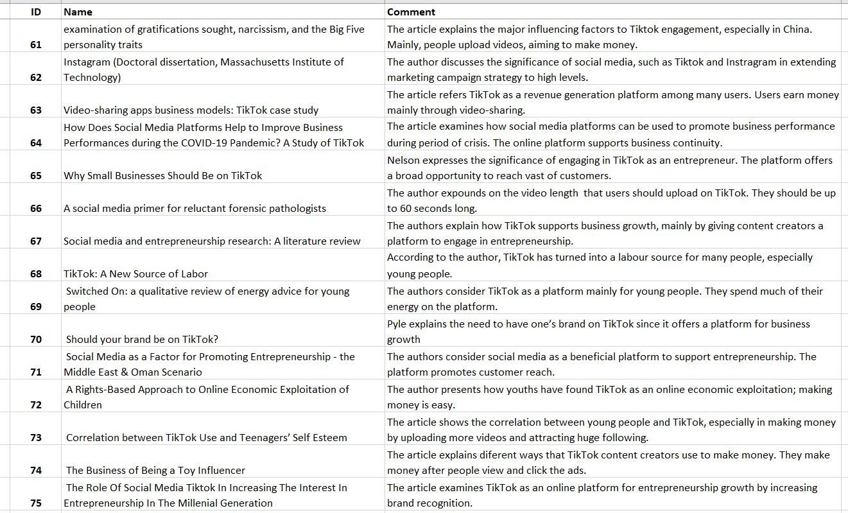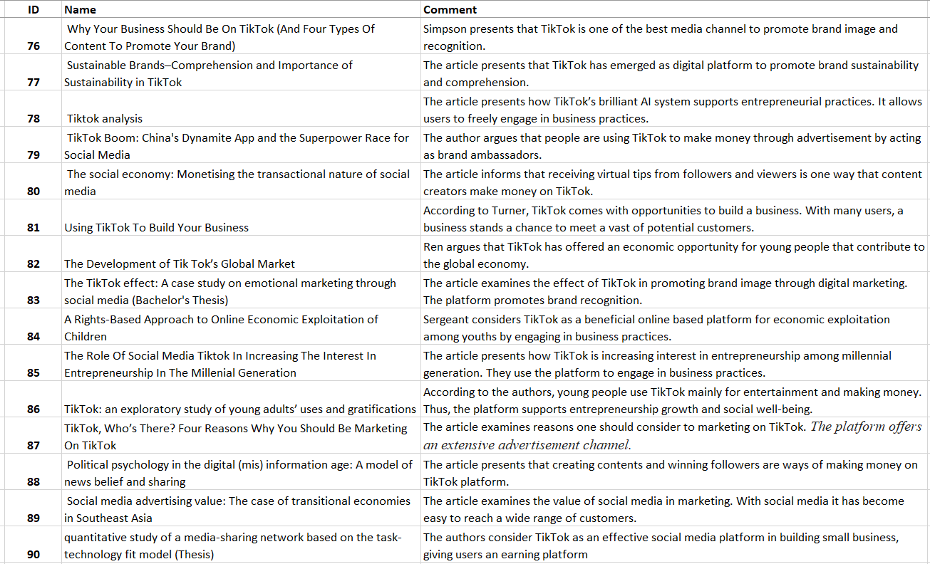
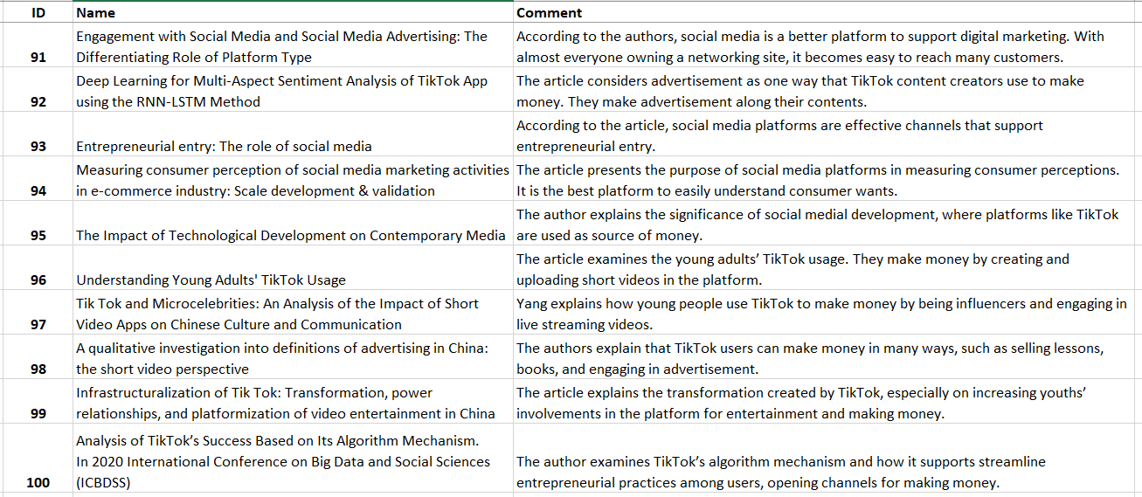

3. Part 3: Preliminary Literature Review

3.1. Introduction
In today’s world, it is unimaginable for most people to pass the day without engaging in either of the many social media platforms (Appel et al., 2019; Vaterlaus and Winter, 2021). According to Aytan (2021), social media has become inseparable among people; indeed, most people spend much of their time scrolling different social networking sites. Almost every person, especially youth, owns one or a number of different social media accounts, including Facebook, Telegram, Twitter, YouTube, Instagram, WhatsApp, WeChat, and TikTok (Guarda et al., 2021; Goroshko, 2021; Grome, 2022). These platforms are fascinating as they support messaging and video sharing. Mainly, they support socialization across the globe (Vaterlaus and Winter, 2021; Van Bavel et al., 2021). Although many people use these platforms for entertainment, creating social networks, and staying updated with trending news, others consider social networking sites as channels for business growth (Barrera-Verdugo and Villarroel-Villarroel, 2022). Following the increasing rise in social media usage, businesses have found a place to market and popularize their products (Van Bavel et al., 2021). According to Jamil et al. (2022), social networking sites offer a platform for businesses to expand their customer reach. Therefore, it is without a doubt that social media channels play a fundamental role in shaping many aspects of life, ranging from socialization, entertainment, and entrepreneurship (Van-Tien Dao et al., 2014; Voorveld et al., 2018). TikTok is one of the major platforms that have gained fame over the last few years; it has become a major channel for young people to interact and engage in entrepreneurial practices (Azpeitia, 2021). According to Fung et al. (2022), Guarda et al. (2021), Goroshko (2021), and Grome (2022), the majority of young people use TikTok to make money in different means.

3.2. Social Media and its Entrepreneurship Analysis
Social media has attracted billions of people across the globe. For example, Facebook attracts over two billion active users on a monthly basis (Chawla and Chodak, 2021; Wang et al., 2020). According to Barrera-Verdugo and Villarroel-Villarroel (2022), the number of active users continues to grow, promising a massive potential, particularly in entrepreneurship. This growth has become an opportunity for marketers, striving to create virtual contact with all daily users on different social media accounts (Wang et al., 2020; Yadav and Rahman, 2017). Social media provides a platform for companies, marketers, and promoters to interact with customers and inform them about their brands (Goanta and Wildhaber, 2020). Indeed, social media platforms have significantly helped small businesses to strategize in advancing their practices beyond the local limit (Bhardwaj, 2021; Capuno, 2022; Nelson, 2022). With a social media page, a business enjoys the opportunity to reach many customers in different places (Kandi et al., 2022; Yadav and Rahman, 2017). As Chawla and Chodak (2021) and Wang et al. (2020) explain, once a business gets into the vicinity of potential customers, it becomes easy to create contacts that would lead to growth.
Popularizing a business after start-up is a crucial factor that every entrepreneur must consider (Wang et al., 2020; Yadav and Rahman, 2017). The idea is to make the business known among the target customers. Although traditional advertisement channels, such as magazines, newspaper, TVs, and Radios, remain relevant in marketing, digital commercial enjoys a large perimeter in meeting many clients (Danaher and Rossiter, 2011; Choudhary, Gautam and Arya, 2020). Equally, with the emergency of digital social platforms, only a few people, mainly the aged, still seek information from the known traditional media channels (Lin, 2021; Choudhary, Gautam, and Arya, 2020). The current generation spends their time on social media; the platform has become the major source of information among youths, young adults, and middle-aged people (Obenson, 2021; Olanrewaju et al., 2022). Therefore, social networking sites have become the most viable platform to market a business and reach many people (Choudhary, Gautam, and Arya, 2020). Indeed, almost every business owns a social media page (Marsiana, Cahyono, and Sugiarto, 2022); the website allows people to learn about the company, increasing the chances of growth.
Additionally, social media offers the opportunity for paid ads, where organizations pay a specific media platform for their advertisements to reach the target audience (Marsiana, Cahyono, and Sugiarto, 2022). In other words, social media acts as an intermediary between the business and customers. The business pays the media for the advertisement it wants to be conveyed to the public (Chawla and Chodak, 2021). The idea is to ensure the business or the product is popularized among specific social media followers and users (Wang et al., 2020; Yadav and Rahman, 2017). Although the approach seems to benefit media platforms directly, the business indirectly enjoys from the plan (Price, Sherriff, and Lomas, 2022). Once the business is known, the chances of winning loyal customers widen. Ideally, digital advertisement is less costly compared to marketing via traditional means (Marsiana, Cahyono, and Sugiarto, 2022; Chen and Lin, 2019). Although companies pay dearly for digital ads, they benefit greatly since the platforms widen customer reach within a short time.
According to Choudhary, Gautam, and Arya (2020), social media allow users, especially entrepreneurs, to negotiate about starting and operating a business. In other words, sellers and buyers can virtually interact, where the buyer makes the payment, and the seller delivers the product (Wang et al., 2020; Yadav and Rahman, 2017). In most cases, all these happen without the involvement of an intermediary (Chawla and Chodak, 2021; Sugiarto, 2022). Normally referred to as online commerce, people make online purchases and get their ordered products delivered within the shortest time (Price, Sherriff, and Lomas, 2022). Such benefits increase efficiency since there is no time wastage. For example, a person can order a product through Amazon’s social media page; make a payment, and the product gets delivered within the expected timeline (Kandi et al., 2019; Dai, Liu, and Zhao, 2022). With such development, social media platforms emerged as a turning point toward streamlining entrepreneurship (Marsiana, Cahyono, and Sugiarto, 2022). A business needs a social website Wang et al., 2020; Choudhary, Gautam, and Arya, 2020; Chawla and Chodak, 2021; Sugiarto, 2022), where it can post its products and strategizes on attracting customers.
Further, developers of these social media platforms have set up algorithms that learn users’ behaviors (Price, Sherriff, and Lomas, 2022). For example, once a media platform realizes that a specific user likes to search for information about a particular product, the person will most likely start to receive related pop-up notifications on their social media accounts (Chen and Lin, 2019; Sugiarto, 2022). The strategy is to provide users with a range of products that suits their online searches (Kandi et al., 2019; Wang et al., 2020; Yadav and Rahman, 2017). Therefore, social media platforms have successfully taken entrepreneurship to a high level, increasing business interaction between vendors and customers (Sugiarto, 2022; Chen and Lin, 2019). According to Barrera-Verdugo and Villarroel-Villarroel (2022), social media has significantly reduced trading barriers, especially in accessing a product. Without social networking sites, it would be challenging to note the presence of a new product in the market or what different vendors are selling (Sargeant, 2022; Scirri, 2021; Van-Tien Dao et al., 2014). Overall, as Doser (2018) and Chawla and Chodak, 2021 assert, social media has somehow turned trading into a single point as it only takes a person a little time to find a preferred via social media platforms.
Ideally, social media has greatly contributed to entrepreneurship’s growth by transforming how people conduct businesses (Marsiana, Cahyono, and Sugiarto, 2022; Masanet et al., 2022). Creating networking among business people is a crucial factor in entrepreneurship. Social networking allows people to interact and share ideas, regardless of one’s geographical location. Such connection allows entrepreneurs to share ways of promoting their business and addressing issues that impact businesses (Doser, 2018; Chen and Lin, 2019). Mainly, business networking is fundamental as it creates a platform for the generation of ideas that would support further growth (Sargeant, 2022; Scirri, 2021; Van-Tien Dao et al., 2014). Specifically, different social media platforms have made it possible for people, especially young folks, to engage in business (Samuel and Sarprasatha, 2015; Price, Sherriff, and Lomas, 2022). One does not have to own or rent a physical stall to conduct a business (Chawla and Chodak, 2021; Masanet et al., 2022; Sargeant, 2022). With online means, one can have the products in their respective homes and deliver them to customers (Dai, Liu, and Zhao, 2022; Dai, Liu, and Zhao, 2022). One only needs to market the goods via the preferred media platforms.
Social media has eased the idea of starting a business or having a platform to make money, especially among young people (Masanet et al., 2022; Sargeant, 2022). With the rise of paid promotion, most young people act as brand ambassadors and other campaigns for their products (Sargeant, 2022). Also, the emergency of content creators has supported many youngsters, making a living by uploading funny content and getting paid based on the number of views (Dai, Liu and Zhao, 2022; Samuel and Sarprasatha, 2015). Specifically, content creators get paid since their tasks translate to popularizing a particular social media platform (Sargeant, 2022; Scirri, 2021). For example, content creators continue to make money on YouTube by uploading funny videos, educative lessons, or any other content that earn the platform more airtime from followers (Samuel and Sarprasatha, 2015; Mou, 2020). Thus, as Fung et al. (2022) and Guarda et al. (2021) explain, social media has taken entrepreneurship to a high level as any person can make money by just uploading videos or engaging in advertisements and promotion practices.
Overall, digital social media platforms have changed how people do business in their daily routine (Choudhary, Gautam, and Arya, 2020). Almost every person, especially youths, owns at least one of the many social media channels (Sargeant, 2022; Scirri, 2021; Van-Tien Dao et al., 2014; Voorveld et al., 2018). Many join these platforms to follow trending news, get entertained, make new friends, and socialize with others (Nelson, 2022; (Van-Tien Dao et al., 2014; Voorveld et al., 2018). Apart from this reason, many people, including organizations, have realized the potential of social media platforms in entrepreneurship (Dai Liu and Zhao, 2022; Yadav and Rahman, 2017). Companies use different media platforms for marketing their brand and reaching a large population of clients on a global scale (Rodríguez, 2021; Simanjorang and Nawawi, 2022). Such benefits extend to individuals, mainly young people; they are engaging and starting business opportunities like selling products online through their media social networking sites (Mou, 2020; Scirri, 2021; Wang et al., 2020; Choudhary, Gautam and Arya, 2020). The strategy allows them to meet a wide range of online customers. Others engage in paying activities like content creation, as witnessed among YouTubers and TikTokers (Van-Tien Dao et al., 2014; Voorveld et al., 2018). Although TikTok emerged a few years ago, the platform has grown immensely and has attracted many active users, mainly young people (Simanjorang and Nawawi, 2022; Fung et al., 2022; Nair et al., 2022). Users, especially content creators (Masanet et al., 2022; Sargeant, 2022; Van-Tien Dao et al., 2014; Voorveld et al., 2018), have transformed the platform into a source of labor and make money in various ways.

3.3. The Rise of TikTok
TikTok emerged in 2016 as a social networking platform that allowed people to socialize and share short video clips, ranging from 15 seconds to three minutes (Cook, 2021; Kantrowitz, 2022). Video content can range from any subject as long as it does not violate the platform’s policies (Cervi, 2021; Kantrowitz, 2022; Lid Rosenholm, 2022). For example, a person can upload clips on dancing, education, songs, and humorous content (Dilon, 2020; Jaffar, Riaz, and Mushtaq, 2020). The platform has emerged as a major networking channel, especially among young people, due to its support for the upload of funny content (Kantrowitz, 2022; Hou, 2018). Young people spend much time watching content creators’ videos (Cervi, 2021). Most of these videos are hilarious, making the platform effective in helping users forget and overcome stress-related acts in their daily routine (Kantrowitz, 2022; Lid Rosenholm, 2022). Overall, TikTok offers its users hours to experience amusing video clips.
The fact that almost every person owns a smartphone, it is accessible to most individuals (Hou, 2018; Kantrowitz, 2022; Lid Rosenholm, 2022). Equally, being supported by all types of smartphones is a factor that has contributed to growth in its usage (Baber and Yao, 2022; Jaffar, Riaz, and Mushtaq, 2020)). All Android and iPhones support this app; therefore, as long one has a smartphone, enjoying amusing videos becomes a norm (Guo, 2021; Yan, 2022). The platform has experienced growth in the number of followers across the globe, mainly teenagers and young adults (Howard et al., 2021; Price, Sherriff, and Lomas, 2022). According to Kołaszewska and Kacprzak (2022), TikTok attracts hundreds of millions of youths on a global scale; for example, over 80 percent of youths that use TikTok in China are aged 35 years and below (Kaur, 2020; Jaffar, Riaz, and Mushtaq, 2020)). Therefore, it is a platform for youngsters and young people (Erizal, 2021). They either use the platform to pass the time watching videos (Howard et al., 2021; Price, Sherriff, and Lomas, 2022), while others create short clips.
Amazingly, TikTok has turned into a revenue generation platform, particularly among young people, including businesses (Wahyudiand Sibaroni, 2022; Yan, 2022). Like in any other social media platform, companies are taking TikTok’s opportunities to reach a large vast of customers (Samuel and Sarprasatha, 2015; Pyle, 2022; Price, Sherriff, and Lomas, 2022). Having attracted millions of users, it has become a marketing opportunity to popularize and promote the brand image (Von Oehsen and Betancourt, 2021; Wahyudiand Sibaroni, 2022; Yan, 2022). The young generation is not left behind, and they strive for the opportunity to start and engage in entrepreneurship practices (Simanjorang and Nawawi, 2022). With the immense rise in active users, young people have realized the opportunity in the platform, especially in entrepreneurship, when it comes to broadening the customer base (Savira, Rifai, and Wahyunengsih, 2022). As Von Oehsen and Betancourt (2021), Dilon (2020), and Jaffar, Riaz, and Mushtaq (2020) assert, apart from using the platform to enjoy uploaded videos, most young people are uploading videos and engaging in money-making activities through the channel.

3.4. How Young People are using TikTok to make Money
Engaging in paid advertisements by being a brand ambassador is one way young people make money from TikTok (Zhao, 2020). As a content creator, who has gained influence and a huge following, companies collaborate with such content creators to market their product (Villa, 2022; Simanjorang and Nawawi, 2022)). In this case, a TikTok content creator integrates a brand into the content. Once people view these videos, TikTokers are paid based on the number of views. If a specific video earns many views, the deal becomes sweet, and the content creator makes huge money (Yu and Natori, 2020). According to, the better the content performs based on the number of views and likes, the deal between the company and the TikToker becomes sweet (Simanjorang and Nawawi, 2022). Therefore, young people who seek to earn through TikTok as brand ambassadors are looking for companies to market their products (Rodríguez, 2021; Ren, Qi, and Fan, 2021); they make money and get the opportunity to address their financial needs.
Equally, engaging in sponsored content is another way TikTokers make money through the platform (Margarita, 2022; Collie and Wilson-Barnao, 2020). TikTok Creator Marketplace allows content creators who have reached 100,000 followers and 100,000 video likes in about one month (Collie and Wilson-Barnao, 2020; Duffy et al., 2021). After reaching the limit, a person can apply with TikTok to join the marketplace platform, which connects influential content creators with paying brands. Many young people apply for the platform once they have gained 100,000 followers and 100,000 video likes (Duffy et al., 2021; Collie and Wilson-Barnao, 2020). Indeed, it is a paying platform. Also, TikTokers make money by receiving gifts from viewers (Baber and Yao, 2022; Collie and Wilson-Barnao, 2020). There is a tab for gifts that range in price. If the viewer finds a specific video interesting or prefers a certain content creator and would like to support them financially, they send the gifts (Baber and Yao, 2022; Collie and Wilson-Barnao, 2020). Once received, content creators can redeem the gifts for money.
Selling products through the TikTok platform is another way young people make money on the platform (Rodríguez, 2021). If a person thinks of starting a business, like selling some preferred products, TikTok provides a platform to venture into commerce (Ren, Qi, and Fan, 2021; Zhang, 2021). One has to sign up for a TikTok account and start uploading products (Kambuno et al., 2022). For example, if a person wants to engage in the sale of apparel, one has to upload videos showing the kind of attires along with respective prices and their contact information on their TikTok account (Rodríguez, 2021). Viewers will watch the content, and if interested, they will contact the seller (Kambuno et al., 2022; Abidin, 2020). Therefore, one does not have to own a stall or a shop to keep the stock (Simanjorang and Nawawi, 2022); most young people are just keeping these products in their houses and delivering them once interested customers place orders.
On the same line, in 2021, TikTok introduced TikTok Shopping, aiming to empower businesses to trade products on the platform (Kambuno et al., 2022). A shopping tab on users’ profiles allows users to see products from the seller’s shopping catalog (Kambuno et al., 2022; Ren, Qi, and Fan, 2021). The introduction of a catalog is an opportunity for young people to engage in business (Abidin, 2020; Ren, Qi, and Fan, 2021). The shopping catalog allows them to indicate the products they are selling (Kambuno et al., 2022; Abidin, 2020); as people view and get interested, they make money from the sales. At the same time, driving sales with TikTok ads is another way young people make money through the platform (Turner, 2020). Users earn by running in-feed image ads, which are meant to promote their content and enjoy more views (Shreffler and McCullough, 2021); the only strategy is to remain active on the platform.
Additionally, TikTokers are paid to add songs on their platform. Almost every uploaded video on TikTok is accompanied by a background song (Tomyuk and Avdeeva, 2022). Content creators collaborate with singers, mainly upcoming artists, to popularize their songs. Once a TikToker earns a huge following, musicians pay for their song to gain popularity (Boffone, 2021; Tomyuk and Avdeeva, 2022). When people watch the uploaded content, they listen to the song, and it becomes known, benefiting the artist (Tomyuk and Avdeeva, 2022); the content creator is paid in return. For example, once content goes viral, the background music tags along (Boffone, 2021; Tomyuk and Avdeeva, 2022), allowing the artist to be known and the song becomes popular.
Further, young people on TikTok join TikTok Creator Fund, a program that pays content creators for creating engaging and fascinating videos (Kaye, 2022). According to Duffy et al. (2021), the more engaging the content is, the more one earns from TikTok. However, a content creator must have reached 100,000 views in the last one month to join this platform (Duffy et al., 2021). Also, young people make money through TikTok by starting a Patreon platform (Jokela, 2021). They offer free content on TikTok but entice their followers to support them on Patreon. The only strategy is to make their content engaging, worthwhile, and valuable (Bonifacio, Hair, and Wohn, 2021). According to Bonifacio Hair and Wohn (2021), Patreon is a major membership platform that helps content creators get paid. The platform mainly targets young people as they are the largest social media users (Bonifacio, Hair, and Wohn, 2021). Fortunately, they have learned routes of making money.
Overall, there are many ways young people use TikTok to make money (Kambuno et al., 2022; Abidin, 2020). As a rising social media platform and having attracted millions of active users across the globe, people consider it a platform to reach potential clients by advertisement (Collie and Wilson-Barnao, 2020). Content creators have engaged in sponsored content, and others act as brand ambassadors, promote their products, promote artists’ songs, and receive donations through gifts (Boffone, 2021; Tomyuk and Avdeeva, 2022). These strategies support the idea of making money. Above all, TikTok has established other paying platforms like TikTok Creator Marketplace, TikTok Creator Fund, and Shopping Catalogue, which allow TikTokers to make money (Kaye, 2022; Duffy et al., 2021). Overall, when used appropriately, TikTok is well paying social media platform (Kambuno et al., 2022); young people have realized this opportunity and are making money.

3.5. Research Gap
The existing research indicates how social media platforms can support business growth. Although these studies are instrumental in showcasing the potential behind digital platforms for entrepreneurship development, none adequately addresses how young people use TikTok to make money. Therefore, the projected research seeks to bridge this gap.

5.6. Proposed Research Questions
RQ1: Why is the rate of young people using TikTok increased highly over the last few years?
RQ2: Is TikTok paying? How do young people use the platform to make money?
RQ3: How do platforms like TikTok Creator Fund, Shopping Catalogue, and TikTok Creator Marketplace support money-making among content creators?

4. References
Abidin, C., 2020. Mapping internet celebrity on TikTok: Exploring attention economies and visibility labours. Cultural Science Journal, 12(1), pp.77-103.
Alanko, J. and Laaksonen, E., 2020. Social media marketing and growth study for an esports and gaming business: Case Company X.
Amir, A., 2020. Utilization of Tik-Tok applications in pandemic times Covid-19. Fox Justi: Jurnal Ilmu Hukum, 10(02), pp.55-59.
Appel, G., Grewal, L., Hadi, R., & Stephen, A., 2019. The future of social media in marketing. Journal of the Academy Of Marketing Science, 48(1), 79-95. https://doi.org/10.1007/s11747-019-00695-1
Aytan, G. (2021). Social Media Marketing in the Self-media Era: A Self-experiment on TikTok (Vol. 12). LIT Verlag Münster.
Azpeitia, J., 2021. Social media marketing and its effects on TikTok users. https://www.theseus.fi/handle/10024/494757
Baber, W. and Yao, C., 2022, January. Value Co-Creation Mechanisms in a Born Digital Short-form Video Platform: Kuaishou. In HICSS (pp. 1-10).
Bäcke, M., 2022. Resisting Commodification: Subverting the Power of the Global Tech Companies. Bandung, 9(1-2), pp.49-79.
Barrera-Verdugo, G., & Villarroel-Villarroel, A., 2022. Evaluating the relationship between social media use frequency and entrepreneurial perceptions and attitudes among students. Heliyon, 8(4). https://doi.org/10.1016/j.heliyon.2022.e09214
Bermeo, C., Jhady, J., Martin, J.C. and López, E., 2022. Tecnología y Sociedad (Doctoral dissertation).
Bhardwaj, S., 2021. Effects of social media on young people. Asian Journal of Multidimensional Research, 10(11), pp.28-34.
Boffone, T., 2021. Renegades: Digital dance cultures from Dubsmash to TikTok. Oxford University Press.
Bonifacio, R., Hair, L. and Wohn, D.Y., 2021. Beyond fans: The relational labor and communication practices of creators on Patreon. New Media & Society, p.14614448211027961.
Burns-Stanning, K., 2020. Identity in communities and networks TikTok social networking site empowering youth civic engagement. In The 11th Debating Communities and Networks Conference (Vol. 27, pp. 1-11).
Cai, H., Huang, R. and Wang, T., 2022, March. TikTok’s Advertising Policy in the Chinese Market and Impacts on China’s Internet Economic Advertising Market. In 2022 7th International Conference on Financial Innovation and Economic Development (ICFIED 2022) (pp. 1884-1893). Atlantis Press.
Capuno, S., 2022. Artist or Small Business Owner? Asian-American Content Creators on TikTok during the Early COVID-19 Pandemic and the# StopAsianHate Movement.
Cervi, L., 2021. Tik Tok and generation Z. Theatre, dance and performance training, 12(2), pp.198-204.
Chawla, Y., & Chodak, G., 2021. Social media marketing for businesses: Organic promotions of web-links on Facebook. Journal of Business Research, 135, 49-65. https://doi.org/10.1016/j.jbusres.2021.06.020
Chen, S., & Lin, C. (2019). Understanding the effect of social media marketing activities: The mediation of social identification, perceived value, and satisfaction. Technological Forecasting and Social Change, 140, 22-32.
Choudhary, N., Gautam, C. and Arya, V., 2020. Digital marketing challenge and opportunity with reference to tiktok-a new rising social media platform. Editorial Board, 9(10).
Collie, N. and Wilson-Barnao, C., 2020. Playing with TikTok: algorithmic culture and the future of creative work. In The Future of Creative Work (pp. 172-188). Edward Elgar Publishing.
Cook, S., 2021. The Rise Of TikTok Entrepreneurs: How Useful Is Their Business Advice. Business Because. https://www.businessbecause.com/news/insights/7658/tiktok-entrepreneurs-business-advice
Da Silva, L.S.B., 2022. The impact of TikTok on an online business strategy. The case of e-Bloom.
Dai, Y., Liu, Z. and Zhao, Z., 2022, June. How Social Media Impact the Economy in Rural Areas in China. In 2022 8th International Conference on Humanities and Social Science Research (ICHSSR 2022) (pp. 2711-2715). Atlantis Press.
Danaher, P.J. and Rossiter, J.R., 2011. Comparing perceptions of marketing communication channels. European Journal of Marketing.
Dias, P. and Duarte, A., 2022. How Portuguese adolescents relate to influencers and brands on TikTok. Journal of Digital & Social Media Marketing, 10(1), pp.82-95.
Dilon, C., 2020. Tiktok Influences on Teenagers and Young Adults Students: The Common Usages of the Application Tiktok. American Scientific Research Journal For Engineering, Technology, And Sciences (, 68(1), 132-142.
Doser, R., 2018. The rise of social media marketing: How an entire industry has transformed. Honors.
Duffy, B.E., Pinch, A., Sannon, S. and Sawey, M., 2021. The nested precarities of creative labor on social media. Social Media+ Society, 7(2), p.20563051211021368.
Efron, S. E., & Ravid, R., 2018. Writing the literature review: A practical guide. Guiltford Publications, ProQuest Ebook Central.
Erizal, N., 2021. The Influence Of Tiktok Applications On The Consumption Behavior Of Adolescents In Online Shopping. International Journal of Cultural and Social Science, 2(1), pp.39-43.
Fernandez, K., 2022. Finance and Investing for the Long Run: Investing for Young Adults to Make the Most of Their Money. Abiprod Pty Ltd.
Forest, A., 2021. Why brands must focus on TikTok now (And How). Forbes. https://www.forbes.com/sites/forbesagencycouncil/2021/10/11/why-brands-must-focus-on-tiktok-now-and-how/?sh=37651e454953.
Fung, A., Ismangil, M., He, W. and Cao, S., 2022. If I’m not Streaming, I’m not Earning: Audience Relations and Platform Time on Douyin. Online Media and Global Communication.
Goanta, C. and Wildhaber, I., 2020. Controlling influencer content through contracts: a qualitative empirical study on the Swiss influencer market. In The Regulation of Social Media Influencers (pp. 210-231). Edward Elgar Publishing.
Goroshko, O., 2021. Use of TikTok Social Media in the Ukrainian University Branding. Соціальні комунікації: теорія і практика, 13(2), pp.171-183.
Green, D., Polk, X., Arnold, J., Chester, C., & Matthews, J., 2022. The Rise of TikTok: A Case Study Of The New Social Media Giant. Management And Economics Research Journal, 8(1), 1-6. https://merj.scholasticahq.com/article/33261.pdf.
Grome, J., 2022. The way of TikTok marketing and why it works so well. Forbes. https://www.forbes.com/sites/forbesbusinesscouncil/2022/04/13/the-way-of-tiktok-marketing-and-why-it-works-so-well/?sh=4b8b681a498e
Guarda, T., Augusto, M.F., Victor, J.A., Mazón, L.M., Lopes, I. and Oliveira, P., 2021. The impact of tiktok on digital marketing. In Marketing and Smart Technologies (pp. 35-44). Springer, Singapore.
Guo, J., 2021. Research on the Influence of TikTok on Teenagers. Atlantis-press.com. https://www.atlantis-press.com/article/125968665.pdf.
Haenlein, M., Anadol, E., Farnsworth, T., Hugo, H., Hunichen, J. and Welte, D., 2020. Navigating the New Era of Influencer Marketing: How to be Successful on Instagram, TikTok, & Co. California management review, 63(1), pp.5-25.
Hall, J. (2022). Tips To Dominate TikTok: Pioneering The Internet’s New Way Of Marketing. Forbes. https://www.forbes.com/sites/johnhall/2022/04/17/tips-to-dominate-tiktok-pioneering-the-internets-new-way-of-marketing/?sh=7aee28951bdd
Haslem, B., 2022. TikTok as a Digital Activism Space: Social Justice Under Algorithmic Control (Doctoral dissertation, Old Dominion University).
Hayes, A., 2022. What Is Social Media Marketing (SMM)?. Investopedia. https://www.investopedia.com/terms/s/social-media-marketing-smm.asp.
He, X., Hua, K., Ji, C., Lin, H., Ren, Z., & Zhang, W. (2021). Overview on the Growth and Development of TikTok’s Globalization. Atlantis-Press. https://www.atlantis-press.com/article/125965906.pdf.
Hou, L., 2018. Study on the perceived popularity of TikTok.
Howard, P.N., Neudert, L., Prakash, N. and Vosloo, S., 2021. Digital misinformation/disinformation and children. University of Oxford. UNICEF. New York. Preuzeto, 14, p.2022.
Hu, Y., 2020. Research on the commercial value of Tiktok in China. Academic Journal of Business & Management, 2(7).
Huang, B., 2021, March. The reasons for Douyin’s success from the perspective of business model, algorithm and functions. In 6th International Conference on Financial Innovation and Economic Development (ICFIED 2021) (pp. 320-325). Atlantis Press.
Jaffar, B.A., Riaz, S. and Mushtaq, A., 2020. Living in a moment: Impact of TicTok on influencing younger generation into micro-fame. Journal of Content, Community & Communication, 10, pp.187-194.
Jamil, K., Dunnan, L., Gul, R., Shehzad, M., Gillani, S., & Awan, F. (2022). Role of Social Media Marketing Activities in Influencing Customer Intentions: A Perspective of a New Emerging Era. Frontiers In Psychology, 12. https://doi.org/10.3389/fpsyg.2021.808525
Jokela, C., 2021. What Makes A Successful Social Media Influencer?.
Kambuno, J.A., Shrishti, S., Jasmine, A.S. and Anggarina, P.T., 2022, April. The Impact of Social Media on Privacy Due to the Lack of Digital Literacy from Generation Z During Covid-19. In 3rd Tarumanagara International Conference on the Applications of Social Sciences and Humanities (TICASH 2021) (pp. 1837-1843). Atlantis Press.
Kandi, V., Balakrishnan, S., Sivakumar, G. and Vijayalakshmi, N.S., 2022. Impact of Social Media Marketing on Organizational Performance: A Case Study of Amazon India. ECS Transactions, 107(1), p.12749.
Kantrowitz, A. (2022). TikTok Growth Continues Against All Odds. CMS Wire. https://www.cmswire.com/digital-experience/inside-tiktoks-explosive-growth/.
Kaur, P., 2020. Tik-Tok: Influence on Youth in India. PalArch's Journal of Archaeology of Egypt/Egyptology, 17(6), pp.4194-4207.
Kaye, B., 2022. Please Duet This: Collaborative Music Making in Lockdown on TikTok. Networking Knowledge: Journal of the MeCCSA Postgraduate Network, 15(1), pp.59-77.
Kołaszewska, I. and Kacprzak, A., 2022. The attitude of children and parents towards Children Influencers.
Konhäusner, P.E.T.E.R., Cabrera Frias, M.M. and Dabija, D.C., 2021. Monetary Incentivization of Crowds by Platforms. Információs Társadalom, 21(2), pp.97-118.
Liang, T., 2021, December. The Method of the Money Making Mechanism of TikTok. In 2021 3rd International Conference on Economic Management and Cultural Industry (ICEMCI 2021) (pp. 3102-3105). Atlantis Press. https://www.researchgate.net/publication/357617684
Lid Rosenholm, I., 2022. Health Communication on TikTok: A Qualitative Study of Credibility on A Humorous Platform.
Lin, N., 2021, May. Research on the Influence of the Internet on Teenagers’ Psychology and Behavior. In 7th International Conference on Humanities and Social Science Research (ICHSSR 2021) (pp. 996-1000). Atlantis Press.
Ma, Y. and Hu, Y., 2021. Business model innovation and experimentation in transforming economies: ByteDance and TikTok. Management and Organization Review, 17(2), pp.382-388.
Mackenzie, S.A. and Nichols, D., 2020. Finding ‘places to be bad’in social media: the case of TikTok. In Urban Australia and post-punk (pp. 285-298). Palgrave Macmillan, Singapore.
Margarita, I.Å., 2022. Tiktok impact on internet ssers. Ecoforum Journal, 11(1).
Marsiana, D., Cahyono, A. and Sugiarto, E., 2022. Creative Process in Creating the Creative Content of “Roro Choreographer” Through Social Media Platforms. Catharsis, pp.1-13.
Masanet, M.J., Márquez, I., Pires, F. and Lanzeni, D., 2020. Self-exposure in social media: Teenagers’ transmedia practices and skills for the construction of a personal brand. In Innovation in Advertising and Branding Communication (pp. 136-153). Routledge.
Megane, L., Pauline, M. and Amitabh, A., 2019. The online influencers’ strategies and their impact on consumers decision process. Вестник Санкт-Петербургского университета. Менеджмент, 18(3), pp.419-447.
Meng, K.S. and Leung, L., 2021. Factors influencing TikTok engagement behaviors in China: An examination of gratifications sought, narcissism, and the Big Five personality traits. Telecommunications Policy, 45(7), p.102172.
Mhalla, M., Yun, J. and Nasiri, A., 2020. Video-sharing apps business models: TikTok case study. International Journal of Innovation and Technology Management, 17(07), p.2050050.
Mou, J.B., 2020. Study on social media marketing campaign strategy--TikTok and Instagram (Doctoral dissertation, Massachusetts Institute of Technology).
Nair, R., Ganatra, V., Sugumaran, H., Kee, D., Heng, S., & Mei, H. et al., 2022. How Does Social Media Platforms Help to Improve Business Performances during the COVID-19 Pandemic? A Study of TikTok. Journal of the Community Development in Asia, 5(1), 41-53. https://doi.org/10.32535/jcda.v5i1.1384
Nelson, C., 2022. Why Small Businesses Should Be on TikTok. WSJ. https://www.wsj.com/articles/why-small-businesses-should-be-on-tiktok-11651247260.
Obenson, K., 2021. A social media primer for reluctant forensic pathologists. Journal of Forensic and Legal Medicine, 82, p.102206.
Olanrewaju, A., Hossain, M., Whiteside, N., & Mercieca, P., 2020. Social media and entrepreneurship research: A literature review. International Journal of Information Management, 50, 90-110. https://fardapaper.ir/mohavaha/uploads/2019/11/Fardapaper-Social-media-and-entrepreneurship-research-A-literature-review.pdf.
Oxendine, M., 2022. TikTok: A New Source of Labor. Comm-entary, 18(1), p.11.
Price, A., Sherriff, G. and Lomas, M., 2022. Switched On: a qualitative review of energy advice for young people. Switched On: A qualitative review of energy advice for young people.
Pyle, S., 2022. Should your brand be on TikTok?. Bizjournals. https://www.bizjournals.com/bizjournals/how-to/marketing/2022/04/should-your-brand-be-on-tiktok.html.
Ren, Y., Qi, W. and Fan, M., 2021, December. The Development of Tik Tok’s Global Market. In 2021 3rd International Conference on Economic Management and Cultural Industry (ICEMCI 2021) (pp. 2779-2784). Atlantis Press.
Rodríguez, C., 2021. The TikTok effect: A case study on emotional marketing through social media (Bachelor's Thesis). Linnaeus University.
Samuel, B., & Sarprasatha, J., 2015. Social Media as a Factor for Promoting Entrepreneurship - the Middle East & Oman Scenario. International Journal of Economics, Finance and Management Sciences, 3(5), 483-493.
Sargeant, H., 2022, March. A Rights-Based Approach to Online Economic Exploitation of Children. In Technologies of Deception Conference, Yale Law School.
Savira, R., Rifai, M. and Wahyunengsih, W., 2022. Correlation between TikTok Use and Teenagers’ Self Esteem. Indonesian Journal of Learning Studies, 2(1), pp.19-24.
Scirri, K., 2021. The Business of Being a Toy Influencer. Capstone Press.
Shengjie, J., 2021. Tiktok analysis. Journal of Frontiers of Society, Science and Technology, 1(1), pp.8-12.
Shreffler, M. and McCullough, A., 2021. The social economy: Monetising the transactional nature of social media. Journal of Digital & Social Media Marketing, 9(3), pp.243-251.
Simanjorang, R. and Nawawi, Z.M., 2022. The Role Of Social Media Tiktok In Increasing The Interest In Entrepreneurship In The Millenial Generation. Journal Of Business, Social And Technologi, 3(1), pp.10-13.
Simpson, J., 2020. Why Your Business Should Be On TikTok (And Four Types Of Content To Promote Your Brand). Forbes. https://www.forbes.com/sites/forbesagencycouncil/2020/07/23/why-your-business-should-be-on-tiktok-and-four-types-of-content-to-promote-your-brand/?sh=5004d80172b9
Sipari, R., 2022. Sustainable Brands–Comprehension and Importance of Sustainability in TikTok.
Stokel-Walker, C., 2021. TikTok Boom: China's Dynamite App and the Superpower Race for Social Media. Canbury Press.
Tomyuk, O.N. and Avdeeva, O.А., 2022. Digital transformation of the global media market: in search for new media formats. Economic consultant, 37(1).
Turner, M., 2020. Using TikTok To Build Your Business. Forbes. https://www.forbes.com/sites/marciaturner/2020/03/31/using-tiktok-to-build-your-business/?sh=4762647c5846.
Van Bavel, J.J., Harris, E.A., Pärnamets, P., Rathje, S., Doell, K.C. and Tucker, J.A., 2021. Political psychology in the digital (mis) information age: A model of news belief and sharing. Social Issues and Policy Review, 15(1), pp.84-113.
Van-Tien Dao, W., Nhat Hanh Le, A., Ming-Sung Cheng, J. and Chao Chen, D., 2014. Social media advertising value: The case of transitional economies in Southeast Asia. International journal of Advertising, 33(2), pp.271-294.
Vaterlaus, J.M. and Winter, M., 2021. TikTok: an exploratory study of young adults’ uses and gratifications. The Social Science Journal, pp.1-20.
Villa, D., 2022. TikTok, Who’s There? Four Reasons Why You Should Be Marketing On TikTok. Forbes. https://www.forbes.com/sites/forbesagencycouncil/2022/02/25/tiktok-whos-there-four-reasons-why-you-should-be-marketing-on-tiktok/?sh=18a241c4cef0
Von Oehsen, T., & Betancourt, B., 2021. The effectiveness of TikTok in Building Small Businesses: A quantitative study of a media-sharing network based on the task-technology fit model (Thesis). Jönköping University.
Voorveld, H., van Noort, G., Muntinga, D., & Bronner, F., 2018. Engagement with Social Media and Social Media Advertising: The Differentiating Role of Platform Type. Journal Of Advertising, 47(1), 38-54. https://doi.org/10.1080/00913367.2017.1405754
Wahyudi, D. and Sibaroni, Y., 2022. Deep Learning for Multi-Aspect Sentiment Analysis of TikTok App using the RNN-LSTM Method. Building of Informatics, Technology and Science (BITS), 4(1), pp.169-177.
Wang, W., Liang, Q., Mahto, R., Deng, W., & Zhang, S., 2020. Entrepreneurial entry: The role of social media. Technological Forecasting and Social Change, 161, 120337. https://doi.org/10.1016/j.techfore.2020.120337
Yadav, M. and Rahman, Z., 2017. Measuring consumer perception of social media marketing activities in e-commerce industry: Scale development & validation. Telematics and Informatics, 34(7), 1294-1307.
Yan, Z., 2022, January. The Impact of Technological Development on Contemporary Media. In 2021 International Conference on Social Development and Media Communication (SDMC 2021) (pp. 845-848). Atlantis Press.
Yang, P., 2022. Tik Tok and Microcelebrities: An Analysis of the Impact of Short Video Apps on Chinese Culture and Communication. China Media Research, 18(1).
Yang, Y. and Zilberg, I.E., 2020. Understanding Young Adults' TikTok Usage. Dostupno na.
YU, X. and NATORI, T., 2020. A qualitative investigation into definitions of advertising in China: the short video perspective. International Journal of Japan Association for Management Systems, 12(1), pp.93-102.
Zhang, Z., 2021. Infrastructuralization of Tik Tok: Transformation, power relationships, and platformization of video entertainment in China. Media, Culture & Society, 43(2), pp.219-236.
Zhao, Y., 2020, August. Analysis of TikTok’s Success Based on Its Algorithm Mechanism. In 2020 International Conference on Big Data and Social Sciences (ICBDSS) (pp. 19-23). IEEE.

