Dealing with Pain
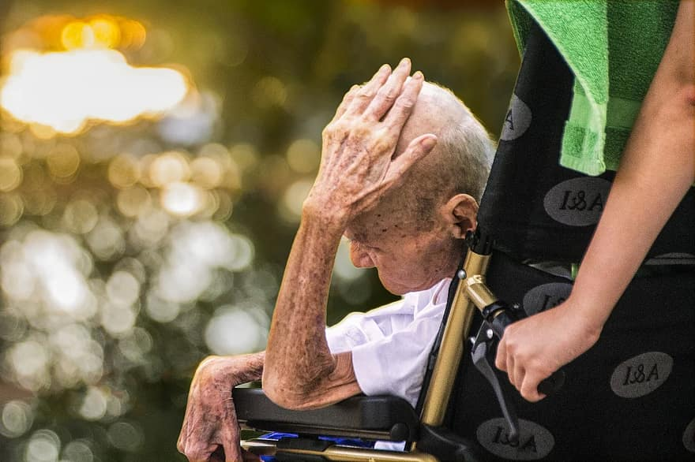
Harry is elderly and though he copes on his own in sheltered accommodation he has lived for a long time with a painful condition that affects his mobility. The most recent diagnosis was an infection in his replacement hip. However, this has unfortunately not responded to a range of antibiotics and he is waiting to see another specialist. Recently, he has become increasingly depressed and you have been asked to talk to him as a client.
Discuss the way that you will deal with this example or similar scenarios related to chronic pain.
What are some of the questions you might ask?

Support suggestions
Research suggests that it is harder to manage pain if someone does not feel they have been ‘listened to’. Some surgery patients report greater recovery effects when they feel they have been ‘heard’ by a doctor, than those who feel their problems have not been sufficiently acknowledged.
In a situation like this…. positive caring, a sense of nurturing and sensitive questioning techniques are key tools for you. Avoid anecdotal references of your own. People can sometimes release their stress through speaking:
“I’m here for you, this is your time, the world is outside but this is your quiet time with me.”
“We have an hour together to talk about you.”

Reflecting back a client’s body language to them can help someone to feel heard:
“I can see that you are looking more relaxed.”
“ Your expression has changed.”
“I can see that you look angry and tense.”
“You have relaxed your shoulders, are you feeling more comfortable?”

Regarding severe pain:
“Tell me about your pain.”
“How would you describe it?”
“How long have you had the pain?”
“What’s your level of pain.”

