
component 2 report
CERT HE- Learning in digital era – learning to learn- personal development plan

July 1, 2026
student: beata Orlowska- 2520903
Lecturer :Malik Mohmood

Table of Contents
Task 1- self Evaluation 3

Task 1- self Evaluation

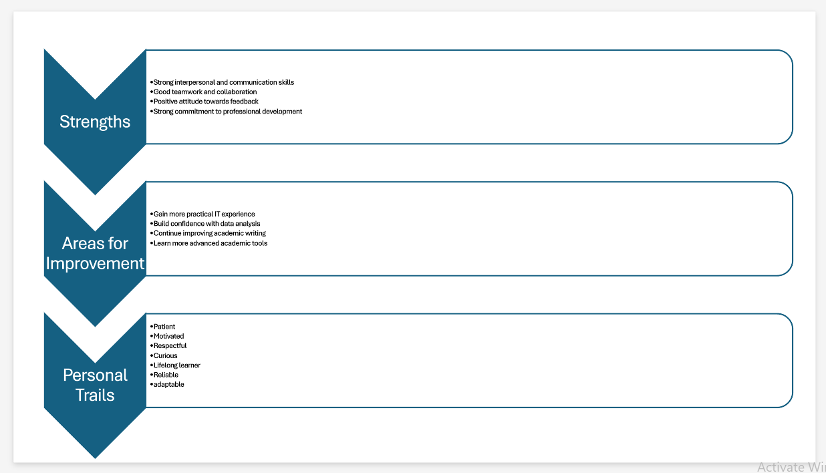

Task 2 – PDP Plan and Goals

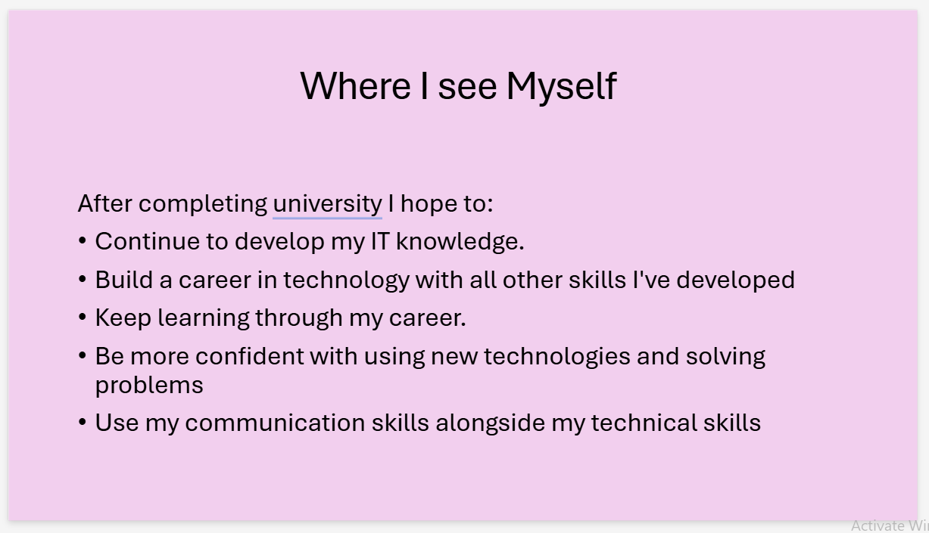
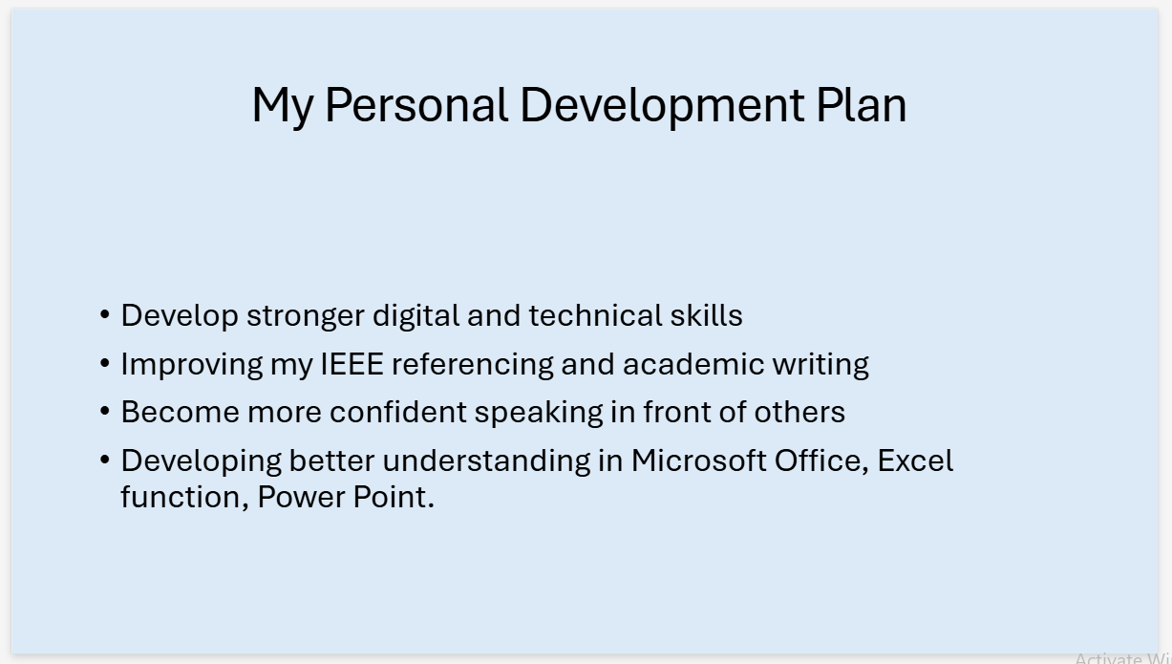

Task 3- Topic Summary

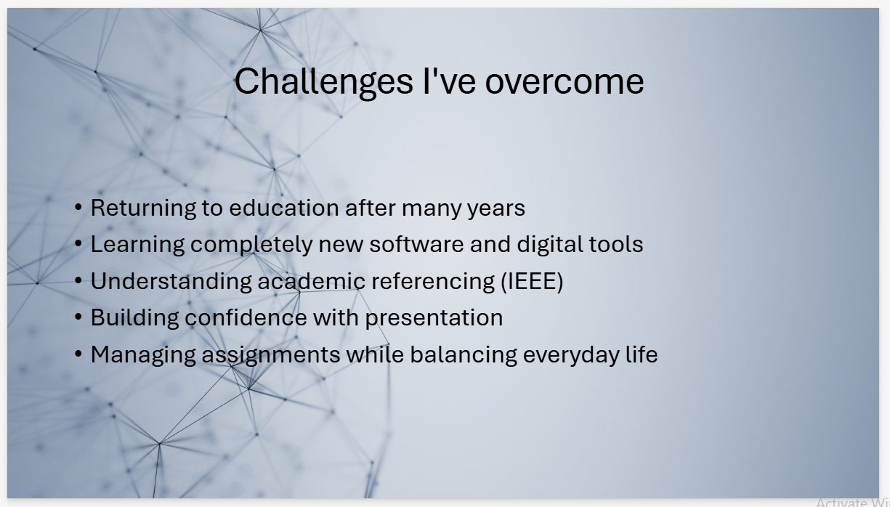

Task 4 – Video Link

Becoming a long life learner.pptx

https://uwtsd.hosted.panopto.com/Panopto/Pages/Viewer.aspx?id=ff46f78a-6a73-451c-bba1-b48d0094c84d

