Individual Report on
Knowledge & Information Management of Amazon.com
Student Name: Oana Cristina Ilau
Student ID: 1817441

Executive Summary
The individual assessment is focused on the knowledge and information management of Amazon.com. The report will begin with an elaborate description of Amazon.com. after the introduction, key management theories related to the operations of Amazon will be discussed. The theory-related discussion will be accompanied by the importance of information systems in knowledge development management practices. After the discussion of theoretical aspects, the discussed theories will be implemented in the context of Amazon.com, especially in terms of creating knowledge assets and customer relationship management. The report will be concluded with a discussion of challenges in the knowledge management process and how they can be mitigated.

Contents
Executive Summary 1
Introduction 3
Brief Introduction to Amazon.com 4
Key Knowledge Management Theories Relevant to Amazon's Operations 5
Choo Sense-Making Model 6
Zack Knowledge Management Model 7
Demonstration of the Importance of Different Information Systems for Good Knowledge Development Practices 9
The Effectiveness of Information and Knowledge Management Culture in Amazon.com in Terms of Customer Relationship Management & Knowledge Asset Creation 13
Information Management 13
Knowledge Management 15
Potential Challenges of Knowledge Management in Amazon.com and Recommendations to Strengthen the Knowledge Management Practices 17
Conclusion 19
References 20

Introduction
Businesses did not think about multiple aspects or complicated strategies in the past to stay afloat in the sea of intense competition. However, companies in the current climate do not have the luxury to playthings casually. A business or organisation needs to take care of marketing, strategic decisions, HRM, information systems management, financing strategies, etc., to stay ahead of the competition or just to survive. With the passage of time, knowledge management has gained wide acceptability and importance in organisations (Nonaka, 2013). Organisations use knowledge management to turn the information into something useful that can be used for harnessing better results. This report will focus on how Amazon.com manages its information and turns them into knowledge.

Figure 1: Amazon.com Logo (Amazon.com, 2021)

Brief Introduction to Amazon.com
Even three decades ago, whenever a person heard the word 'Amazon,' they would think about the massive rainforest situated in the South American region. The notion has slowly changed over the past three decades as most young people refer to the biggest E-commerce organisation in the world when they hear the word Amazon. Amazon was formed in 1994 and was initially known as Cadabra. The site was found by Jeff Bezos, one of the richest people in the world. Bezos started the venture as a book-selling platform. However, he soon shifted to selling other products such as electronics, games, apparel, furniture, etc. Before long, Bezos was looking at a gigantic E-commerce organisation that was going to be one of the most successful organisations in the world. While Amazon owns over 40 other subsidiaries such as AWS, Zappos, IMDB, Amazon, books, etc., the focal point of the business is the e-commerce platform (Denning, 2021). Amazon is the world's largest e-commerce platform and ships to almost all the countries in the world. It has the richest collection of items, and there are very few well-known wholesalers or retailers who do not sell their products via Amazon.com. Amazon.com caused a disruption in the technology industry. It can be considered as the pioneer in the field of E-commerce as it gives inspiration to many other e-commerce sites all over the world. Even when many businesses were perishing amid the pandemic, Amazon.com was soaring higher than ever (Tsidulko, 2021).

Figure 2: Amazon CEO and Founder Jeff Bezos (Amazon.com, 2021)

Key Knowledge Management Theories Relevant to Amazon's Operations
Having a concrete idea about knowledge management is essential to understand the models and theories relevant to it. Knowledge management is a process that includes the creation, storing, sharing, using, and managing of knowledge & information. Knowledge & information management is done for ensuring the achievement of strategic objectives of an organisation through the use of knowledge and information (Sam, 2021). Most bookish theories give a basis of understanding so that people can have a starting point of understanding complex things. The reality is very different from bookish knowledge as organisations use a mixture of strategies and customize them according to their needs. Two knowledge management theories that go well with Amazon.com are the ZACK knowledge management model and the Choo Sense-making model. Amzon.com might not use the direct versions suggested by the model and theories, but parts of the models are used and in altered form in certain cases.

Choo Sense-Making Model
According to Choo's sense-making model, there are three areas where organisations need to focus on using information strategically and managing knowledge.

Figure 3: Three Arenas of Focus of the Choo's Model (Knowledge Management Models, 2021)
Sense-making: Sense-making dictates that an organisation will use different information related to competition, environment, opportunities, clients, suppliers, etc., to adapt to the changing situation. Sense-making focuses on keeping the organisation relevant to current trends by strong analysis of data and use of knowledge management (Nonaka, 2013).
Knowledge Creation: Knowledge creation enables an organisation to use new information for crafting new knowledge so that it can be used for the betterment of the organisation. For example, After the pandemic wanes and life goes back to normal, most businesses will use the information gathered throughout the pandemic and create relevant knowledge regarding how to brace to guard the organisation against impact during a recession or stressful period.
Decision-Making: the decision-making step of the model is concerned with using information and gathered knowledge for making decisions among multiple alternatives that will best serve the organisation (Christiansen, 2021). For example, both John Lewis and Rowlinson were presented with the choice to retain employees or let them go amid the pandemic. John Lewis decided to close down a few stores and lay off some employees for the overall betterment of the organisation, while Rowlinson kept the employees and gave them a bonus. Based on available information and the knowledge gathered through organisational learning, organisations make decisions that meet their strategic goals.

Zack Knowledge Management Model
Zack and Meyers came up with a model of knowledge management that worked with processing data from the beginning and refining it to the point that It contributed greatly towards knowledge creation.
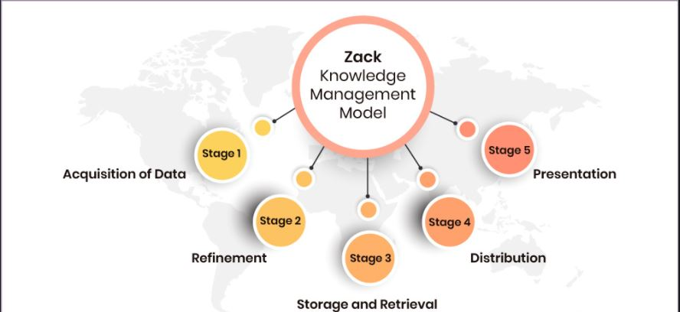
Figure 4: Zack Knowledge Management Model (Knowledge Management Models, 2021)
Stage 1: The first step is to collect data from relevant sources. For most businesses nowadays, Facebook, Google, and other social media collect user data based on their activities, and then the data is sold to the businesses. Some businesses collect data from their own websites (Denzel, 2021).
Step 2: All of the data collected might not be relevant. In this step, the essential data is separated from the non-essential ones, and then essential data is collected (Knowledge Management Models, 2021).
Step 3: After the refined data has been collected, the data has to be stored. In most cases, data is stored in clouds/ some businesses still prefer preserving data in hard disks. However, it can be costly and hard to manage.
Step 4 & 5: After storing the data successfully, the information has to be distributed to the relevant parties through proper media so that they perceive the data, and the data is turned into knowledge that can be used by them for making stronger decisions.

Demonstration of the Importance of Different Information Systems for Good Knowledge Development Practices
Before delving into further theories and types of information systems, it is essential to distinguish between information and knowledge. In many instances, both terms are used interchangeably, which is a wrong practice. Information refers to the refined state of raw data that has a context. On the other hand, knowledge is the awareness or learning that is earned from the derived information and which can be used for bringing certain results. A simple example will make it easier to perceive. Let it be assumed that data related to the sales of Books in a specific bookstore was collected over a period of 3 years. This is raw data. When the raw data is brought together and the sales figure of all the years are compared to find the year having better or worse information, it can be termed as information. When this information is perceived by the audience, and the implications of the incident come to their understanding which helps them to make a decision, it is considered as knowledge. A strong prerequisite to good knowledge management is good information management. To ensure proper information management, there are information systems of different sorts that are used by organisations. The effective collecting, storing, sharing, application, and integration of information is the task of information systems (Nonaka, 2013).
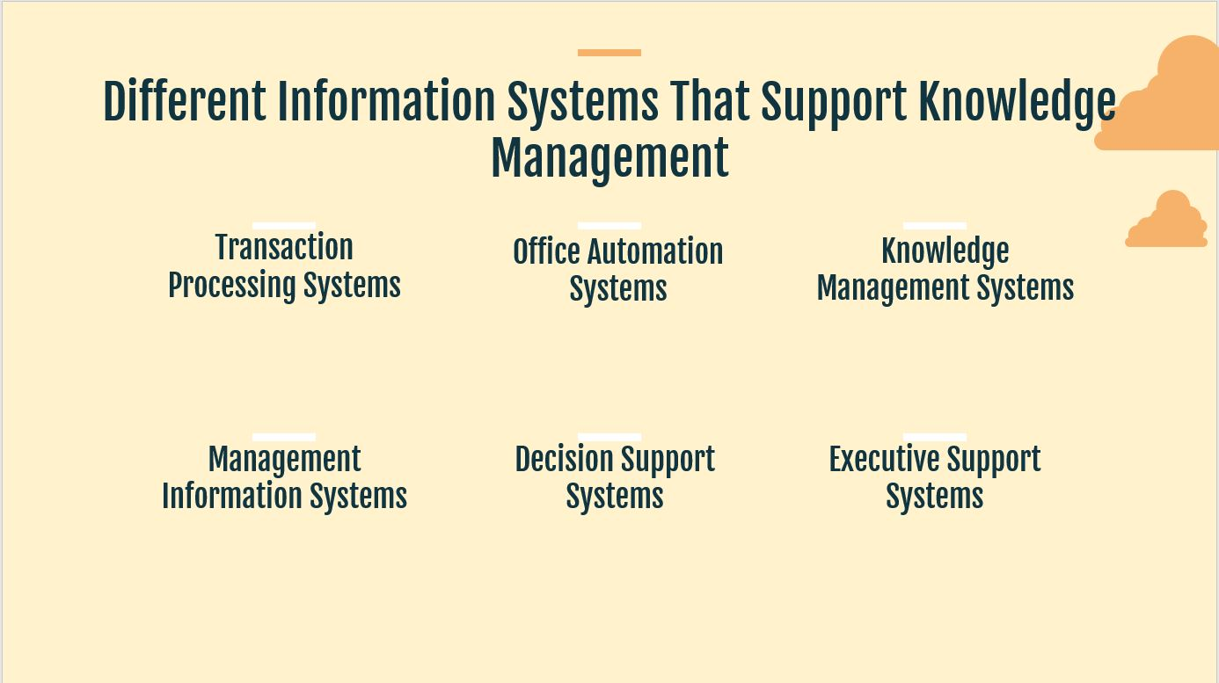
Figure 5: Different Information Systems (Davis, 2015)
Transaction Processing Systems: As the name suggests, transaction processing systems are concerned with digital processing transactions that occur online through different methods or the recording of cash transactions. Through TPS, different important information such as the number of daily transactions, frequent transactors, nature of transactions, size of transactions, etc., is recorded and analysed by the system. As software, the TPS is only capable of extracting the data and turning it into information. Based on the information, knowledge is derived, which can be of use to the organisation. The frequency of transactions, size of transactions, etc., tell a lot about the financial performance of the organisation. With the data being recorded properly, knowledge regarding why such a phenomenon is occurring can be derived, and then steps can be taken to either correct the situation or come up with better solutions.
Office Automation Systems: the office automation system takes care of multiple simple clerical jobs such as automated sending of documents, producing reports, mailing paperwork, etc. When digital technology was not as advanced, most of the work mentioned above had to be completed manually. With office automation systems, employees do not have to worry about simple yet tedious work. With more time to themselves, employees and managers can take more time in interpreting the information provided to them and derive knowledge that is useful to them. In simpler terms, the impact of OAS on knowledge management is indirect yet significant.
Knowledge Management Systems: The knowledge management system is strictly related to the knowledge management of an organisation. The knowledge management systems are dedicated to helping users enhance their knowledge to optimise their performance through the systematic storing and extraction of information. The KMS assists greatly in developing knowledge management practices. Employees, customers, management, and many other parties are the users of a KMS. KMS usually holds a library of solutions to different problems based on past experiences of the organisation or external sources (Maier, 2017). When an employee, manager, or any stakeholder needs assistance with a specific matter, KMS comes up with a solution. For example, when fresh graduates enter a firm as sales employees, they do not have much idea of how sales work. In that case, KMS provides them with the expert insight of experienced employees or industry experts, which gives them a better understanding of they are supposed to work.
Management Information Systems: unlike many other information systems, the MIS is dedicated to the managers and management of an organisation. The MIS itself relies on multiple other information systems to process data and provide useful information that can be used by the managers. As the managers use MIS and receive useful information, they come up with solutions to different problems, which can later be used by newer employees or even other employees as a lesson on how to tackle certain situations. So, MIS supports knowledge management practices (Davis, 2015).
Decision Support Systems: Much like the management information systems, decision support systems or DSS are dedicated to assisting the management. However, DSS has a stronger focus on the decision-making process. While MIS arranges data in a convenient manner and lets the manager decide what to do, DSS comes up with alternatives as well and suggests the better alternative based on available data. As the decision support system collects data and offers alternatives, it can act as a learning session for employees in the future or even existing employees (Christiansen, 2021).
Executive Support Systems: The ESS is equipped with more telecommunication functionality and computing functionality when compared to the DSS. It is mostly used by owners and executive leaders to optimise the decision-making process. The ESS compiles data and gives different pointers on how to improve performance by making minor tweaks. The target audience might be the leaders, but the information collected through this system assists knowledge management as well. With small optimization decisions, junior managers and employees get to understand how small decisions can make a big impact on an organisation. The important decisions can be preserved in KMS so that employees of the future can learn something from work.
All the discussed forms of information systems collect, process, share, present, etc., data in multiple ways and for multiple purposes. The ultimate goal of each system is the same; to ensure continuous development and sustainability of the organisation. These pieces of information can later be used by employees and managers to learn new things and optimise their way of thinking. Thus, these information systems assist the knowledge management development practices.

The Effectiveness of Information and Knowledge Management Culture in Amazon.com in Terms of Customer Relationship Management & Knowledge Asset Creation
Amazon is an outlier in the business world, with an owner being the world's first trillionaire and a company that has a strong grip in most markets in the world. Undoubtedly, the information and knowledge management culture of Amazon played a great role in bringing the organisation to where it is today. As the scenario suggests, Amazon has been a customer's choice for low prices, timely shipping, and ease of shopping. While many organisations faced losses in the pandemic, Amazon saw a rise in its profits as well as employees (Tsidulko, 2021). The project 'Ultraviolet' was Amazon's way of supporting its workers with essential protective gear during the pandemic. While the very nature of the organisation explains the growth in financial performance, knowledge and information management had a significant role in ensuring success.

Information Management
It isn't possible to pinpoint exactly the information systems used by an organisation as most of them prefer to keep it confidential. However, based on many reports and operations of Amazon, It is evident that Amazon.com uses inventory control systems, HRM systems, Expert systems, and knowledge management systems. Each of these systems either builds knowledge assets or helps with customer relationship management. Amazon.com depends on the Linux 2 platform to execute its information systems. Amazon Prime, on the other hand, depends on the AWS system.
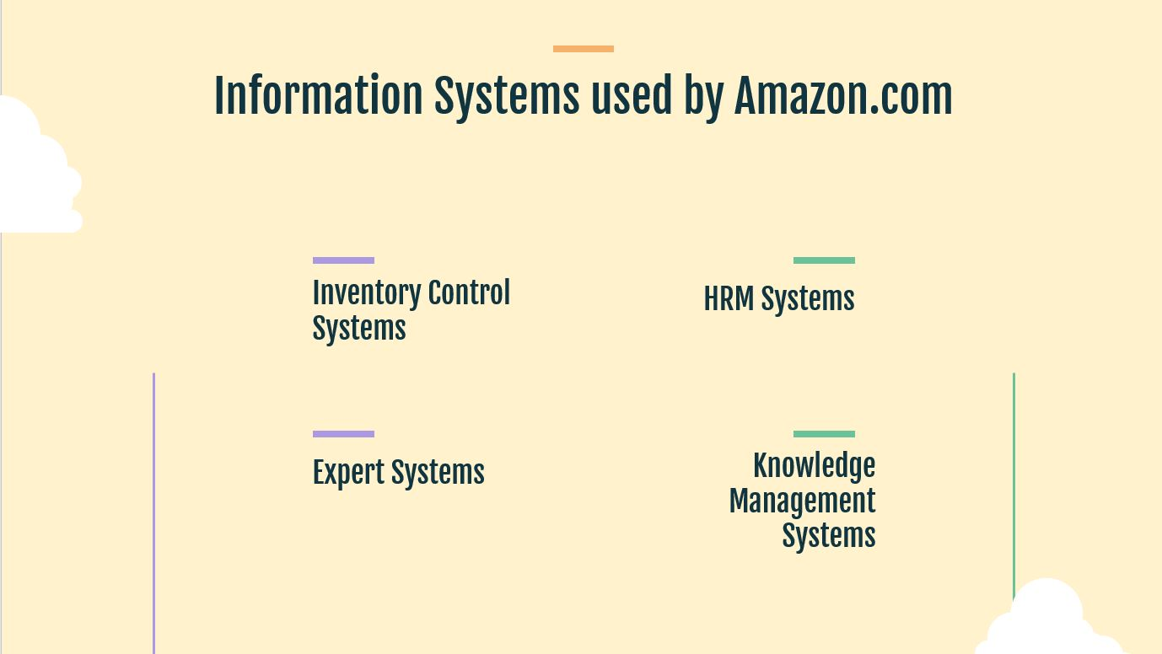
Figure 6: Information Systems used by Amazon.com (Denning, 2021)
Inventory Control Systems: Amazon has to rely on the powerful Linux 2 platform to operate its inventory control systems. On average, Amazon ships 1.6 million packages worldwide daily. With such a tremendous amount of load, inventory control systems assist Amazon.com in managing the inventory automatically based on the order placed by the customers and then update lists accordingly. As the website gets updated automatically based on orders placed and inventory replenished, there is almost no chance of miscommunication between Amazon.com and the customers. This boosts the CRM. Even amid the pandemic, Amazon was able to supply the customers with their desired product as the inventory system was automated and efficient.
HRM Systems: The HRM systems of Amazon is rather sophisticated as it manages the pays, holidays, appraisal, etc. of the employees. The system gives a holistic view of the condition of each employee under a manager. As the manager gets a holistic view with just a click, it becomes much easier to assess the employees and work on them. Amazon.com uses this system to increase the knowledge asset of the organisation (Tony, 2021). The HRM systems came up with a suggestion for investing in employee benefit during the pandemic, which gave rise to the project ultraviolet.
Expert Systems: Expert systems is special systems used by Amazon.com. Much like the knowledge management systems, ES stores the experience and the activities of a human expert. Amazon is the home to many great managers, Jeff Bezos being one of the greatest. There are many tips and procedures explained by organisation experts that are stored in the ES. When required, the employees and managers are graced with expert experience and opinion, which gives them extra insight. The whole process itself is dedicated to developing knowledge assets so that future employees and managers can serve the customers well (Maier, 2017).
Knowledge Management Systems: The knowledge management systems take care of all kinds of past experiences and knowledge gained by the organisation during its operations. KMS helps the employees with not only expert opinion or advice but with different solutions to similar problems faced in the past. As the employees seek the support of the KMS, they form their own opinions and then customize the solution according to the situation. As a result, knowledge asset is developed. The increased knowledge assists the employees in serving the customers better. If the world is hit by another anomaly in the future, the KMS of Amazo.com is ready with sufficient resources to guide the employees (The Knowledge Management Genius of Amazon.com, 2021).

Knowledge Management
Amazon.com uses diverse knowledge management models and techniques. However, the use of the Zack model and the Choo model is more dominant. A mixed illustration of how Amazon.com uses both will be provided.
Data Collection: Amazon's biggest data collection point is the website itself. Amazon has multiple pages of websites dedicated to different regions. Based on the region, the websites are linked with information systems of respective regions. Apart from the website, Amazon gets additional information related to a consumer preference based on their social media activities and google searches. Amazon's automated system collects the data and then processes it (Amazon's CRM Success Story, 2021).
Data Refinement: Not every data collected through external sources is useful for Amazon. For example, if a person searches a specific item for once and then never looks for it again, it can be assumed that the person searched for it just out of curiosity. Pushing advertisements related to that product will not be fruitful for Amazon as the person will not buy the products, and it might also be the reason behind irritation. So, the system detects the frequency of search and other relevant statistics, eliminating unnecessary information.
Date Preservation and Retrieval: After the separation of unnecessary data from the necessary ones, the system then stores the data in the cloud, where there is a database. The information collected can be viewed by actual managers, or it can be used by sophisticated systems to push advertisements accordingly. The sense-making strategy of Choo's model of knowledge management comes in handy here as well (Denning, 2021).
Data Distribution and Presentation: This the step where Amazon turns the collected information into knowledge. Based on types of information recovered and refined, Amazon.com sends the information to relevant parties. For example, increasing or decreasing demands of products is communicated with the supply chain and inventory manager. By looking at the statistics, the managers can then assess why there is a shift in demand by merging the real-life variables. For example, if there is a sudden decrease in demand for premium umbrellas from Harrod's just before the winter, the managers do not need to worry about it as it is only rational that the demand for umbrellas will be lower in the winter. The personalisation process of the Amazon.com website is also an excellent example of how knowledge management is used for better CRM. As users use the site more frequently, the site tends to pick up the pattern and make suggestions accordingly. The Artificial intelligence software is smart enough to turn the information into knowledge and use it for serving the customers (Amazon's CRM Success Story, 2021).
The whole combination of both models adds to knowledge assets as well as CRM practices. When Amazon.com is using different information systems and adding to the knowledge base of the organisation, it is acting as a reference point for the existing as well as incoming employees. The advice, decisions, experiences, etc., are recorded in the knowledge management systems. As future employees face problems with a situation, especially in the customer management arena, the knowledge management system will come up with a solution. As a result, Amazon.com will be able to serve the customers without any lag or problem.

Potential Challenges of Knowledge Management in Amazon.com and Recommendations to Strengthen the Knowledge Management Practices
Knowledge management is undoubtedly an invaluable asset for Amazon.com. However, it is not free from problems. There might be a few challenges in front of Amazon.com when they try to strengthen their knowledge management practices. The challenges along with recommendations have been provided below:
- The success of knowledge management hugely depends on how well the employees perceive the knowledge. There is usually a huge age gap between experts and young employees. So, the message delivered might not seem as interesting to the new generation. Without proper motivation, the KMS will not be of no use as employees will be reluctant to perceive the knowledge. Retaining the knowledge will become difficult. To keep the employees motivated, Amazon.com can connect incentives for those going through knowledge management sessions. Also, the portrayal of the knowledge can be made interesting with infographics.
- Knowledge is a subjective matter. The same knowledge might not be valuable to all parties. For example, the marketing-related tips and tricks will not interest the supply chain or HR manager (Casey, 2018). Rather than looking at the effort behind imparting knowledge, the shared purpose should be focused upon. Only relevant knowledge should be shared with different parties.
- Amazon is a big organisation and has strong control over its staff. However, to expand beyond the horizon and to stay ahead, Amazon has to rely on external knowledge as well. However, acquiring relevant knowledge from external sources can be problematic as many experts might not be interested in sharing their experiences (Alkhanbashi, 2015). To mitigate this problem, Amazon can come up with lucrative incentives for such experts so that they cannot turn down the offer of imparting their knowledge.
- It is not an uncommon culture in the corporate world to lay off employees when more efficient employees come in their place. The younger employees have a certain skill set that is absent in older employees. The experience is what makes the difference between them. However, as the experts or experienced employees of the organisation are requested to impart their knowledge, they might fear for their job security. Although it is not possible to gather years of knowledge with just a simple knowledge-imparting session, the fear is not irrational. For this problem as well, Amazon.com can tie lucrative incentives as well as ensuring that the employee will not be replaced or laid off by younger employees. The security will act as a great relief for the experienced managers, and they will not have problems with transferring their knowledge to other employees and managers.
- As Amazon.com is heavily dependent on tech, it is not unusual for experts to assume that the employees will understand all technical terms. However, the audience of the same knowledge can be different based on the situation. The use of technical terms might deprive many of the imparted knowledge. Amazon.com can easily mitigate this problem by creating a written and easier format of the same shared knowledge. This will not deprive the managers and employees of retaining the knowledge.
- The frequency of knowledge-sharing has to be regulated. If the employees are too dependent on shared knowledge for each situation they face, they might start losing their decision-making skills (Casey, 2018). Not only that, but the absence of relevant knowledge might demotivate the employees and influence them in making weak excuses for not being able to do work.

Conclusion
Amazon.com is the world's fastest-growing e-commerce business, which has shown the path to countless other e-commerce sites. Even amid the pandemic, Amazon did not slow down for a day and continued serving its customers throughout the ordeal. Not only did they serve the customers, but they also provided benefits for the employees and managers. Much of its success can be accredited to information and knowledge management. Because of the well-defined knowledge and information management techniques, Amazon.com has been able to steer ahead among hundreds of adversities. The meticulous use of Zack's and Choo's model, along with multiple information systems, has kept Amazon ahead of its competitors.

References
ALKhanbashi, M., 2015. Knowledge Management Challenges in the Public Sector. Knowledge Management: An International Journal, 15(4), pp.23-42.
Amazon.com. 2021. Amazon.com: Online Shopping for Electronics, Apparel, Computers, Books, DVDs & more. [online] Available at: <https://www.amazon.com/> [Accessed 9 May 2021].
Casey, M., 2018. 11 Knowledge Management Challenges Managers Face - DZone Agile. [online] dzone.com. Available at: <https://dzone.com/articles/11-knowledge-management-challenges-managers-face> [Accessed 9 May 2021].
Christiansen, L., 2021. [online] Altametrics.com. Available at: <https://altametrics.com/information-systems/information-system-types.html> [Accessed 9 May 2021].
Davis, G., 2015. Management information systems. 9th ed. Malden, Mass.: Blackwell.
Denning, S., 2021. How Amazon Became Agile. [online] Forbes. Available at: <https://www.forbes.com/sites/stevedenning/2019/06/02/how-amazon-became-agile/> [Accessed 9 May 2021].
Denzel, W., 2021. [online] Scribd.com. Available at: <https://www.scribd.com/presentation/374802861/Meyer-and-Zack-KM-Cycle-pptx> [Accessed 9 May 2021].
Expert Market. 2021. How Do They Do It? Amazon's CRM Success Story. [online] Available at: <https://www.expertmarket.co.uk/crm-systems/amazon-crm-case-study> [Accessed 9 May 2021].
Learning Solutions Magazine. 2021. The Knowledge Management Genius of Amazon.com. [online] Available at: <https://learningsolutionsmag.com/articles/1480/the-knowledge-management-genius-of-amazoncom> [Accessed 9 May 2021].
Maier, R., 2017. Knowledge management systems. 7th ed. Berlin: Springer.
Nonaka, I., 2013. Knowledge management. London: Routledge.
Sam, S., 2021. Difference Between Information and Knowledge (with Comparison Chart) - Key Differences. [online] Key Differences. Available at: <https://keydifferences.com/difference-between-information-and-knowledge.html> [Accessed 9 May 2021].
The CloudTutorial. 2021. Models of Knowledge Management (KM Models) Explained. [online] Available at: <https://www.thecloudtutorial.com/knowledge-management-models/> [Accessed 9 May 2021].
Tony, D., 2021. Knowledge Assets. [online] Baldrige21.com. Available at: <http://baldrige21.com/BALDRIGE_GLOSSARY/BN/Knowledge_Assets.html> [Accessed 9 May 2021].
Tsidulko, J., 2021. Amazon Earnings Soar Amid COVID-19 Pandemic. [online] CRN. Available at: <https://www.crn.com/news/cloud/amazon-earnings-soar-amid-covid-19-pandemic> [Accessed 9 May 2021].

