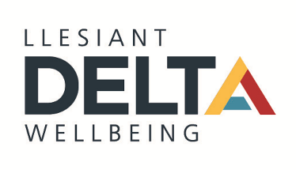

Llesiant Delta Wellbeing and an Analysis of its Entrepreneurial Ecosystem

2023

Master of Business Administration- General Management

Author: Cathie Davies Supervisor: Dr Louise Emanuel
Student Number: 1705973

DECLARATION
This work has not previously been accepted in substance for any degree and is not being.
concurrently submitted in candidature for any degree.
Signed ..Cathie Davies.......................................................... (candidate)
Date .........06/09/2023.........................................................
STATEMENT 1
This work is the result of my own investigations, except where otherwise stated.
Other sources are acknowledged by footnotes giving explicit references. A bibliography
is appended.
Signed ........... Cathie Davies.................................................. (candidate)
Date ................ 06/09/2023........................................................
STATEMENT 2
I hereby give consent for my work, if accepted, to be available for photocopying and for
inter-library loan, and for the title and summary to be made available to outside.
organisations.
Signed .......... Cathie Davies.................................................. (candidate)
Date ................ 06/09/2023........................................................
NB: Candidates on whose behalf a bar on access has been approved by the University (see
Note 1), should use the following version of Statement 2:
I hereby give consent for my work, if accepted, to be available for photocopying and for
inter-library loans after expiry of a bar on access approved by the University.
Signed ............. Cathie Davies............................................. (candidate)
Date .................. 06/09/2023......................................................

Candidate's signature ......... Cathie Davies..........................................................
Date .. 06/09/2023......................................

Acknowledgment

I firstly would like to take this opportunity to thank Neil, my children, and my family for the unwavering support during my MBA journey, especially in the last 6 months as I complete this dissertation.

I would like to give special thanks to my dissertation supervisor Dr Louise Emanuel, whose patience is truly amazing, and advice and guidance have been invaluable.

And finally, thank you to the team at Llesiant Delta Wellbeing, especially Samantha Watkins, who have been so supportive and inspirational. They all have given their time so freely and have been an incredible source of knowledge, I would have not completed this dissertation without them.

Abstract

In recent history, there has been an almost continuous stream of what would once be considered once in a lifetime events: the 2019 Covid Pandemic, Cost-of-Living Crisis, the Ukraine war to name but a few. The effects of such events and a VUCA environment have been felt globally, with the conditions set to intensively with the effect of climate change. Governing bodies across the world, including the WG and CCC have searched for ways to elevate people from poverty and meet social and health needs in a sustainable way. The WG has created projects which look to facilitate innovation, not just in the private sector but through the public sector to, with the creation of the RPB creation.

How to foster entrepreneurship and innovation is a question though which has troubled policy makers, such as the WG. To start, there is a concern over who and what clarifies as example of beneficial entrepreneurism and how to identify them? Once identified, there is concerned how to support viable entrepreneurships, while promoting the sustainable, self-sufficient creation of others in a region? Theories of Entrepreneurial Ecosystems look to identify, the best way of doing this have emerged in recent years, though there is a long history of research into the concepts involved. The literature chapter discusses entrepreneurial Ecosystem Theory, with focus on the different factors and actors interact, and then is applied to a longitude case study of Llesiant Delta Wellbeing.

Llesiant Delta Wellbeing is a unique creation. An example of organisational entrepreneurism, born from CCC services which were in danger of being shut or outsourced due to lack of income, and outdated working models. LDW has become an example of high-growth entrepreneurism, with its employee numbers tripling since its creation in 2018. As a local Authority Trading Company, it has the luxury of freedom that a private company has, with the supports of a local Authority. This does come with red tape though, adding to its operational complexity. This report finds that Llesiant Delta Wellbeing has been influenced by the Entrepreneurial Ecosystem at every point of its entrepreneurial activity, from nascent entrepreneurship, to established innovative organisation. Its culture of openness to risk and its capacity to learn and be agile, is largely down from the Senior management staff who developed their skills through past learning in employment roles within the Entrepreneurial Ecosystems.

Entrepreneurial Ecosystems provide continuous learning opportunities for organisations, though not just through educational institutions but also, through networks and feedback loops. This report concludes with recommendations of strengthening the Ecosystem through policies which encourage knowledge and resource sharing. How this is achieved, is still unclear as this study is limited to the one case study. If the complex nature of the Entrepreneurial Ecosystem which Llesiant Delta Wellbeing inhabits, further examinations of the actors is needed to understand the connections fully.

Contents

Abstract 3
Figures 7
Tables 8
Abbreviations 9
1. Introduction 10
1.1. Aims and Objectives 11
1.2. Llesiant Delta Wellbeing – As an example of Entrepreneurship 12
2. Dissertation Literature Overview 15
2.1. Introduction 15
2.2. Entrepreneurship Definition 15
2.2. Entrepreneurship Ecosystems 17
2.3. Factors of an EE using Isenberg, (2011), Figure 2.3 as a guide. 23
2.3.1. Culture 23
2.3.2. Support 24
2.3.3. Human Capital 25
2.3.4. Markets 26
2.3.5. Policy 26
2.3.6. Finance 27
2.3.7. Actors 28
2.4. Criticism of the EE theory 29
2.5. Conclusion 29
3. Research Methodology 31
3.1. Introduction 31
3.2. Research Rational 31
3.3. Research Philosophy 32
3.4. Research Strategy 33
3.4.1. Case studies 33
3.4.2. Time Horizons – Cross-Sectional 34
3.4.3. Research Choices- Mixed Method 35
3.5. Research Methods 35
3.5.1. Interviews 35
3.5.2. Questionnaires 36
3.5.3. Secondary Data Research 37
3.6. Data Analysis 38
3.7. Ethical Consideration 39
3.8. Limitations 40
3.9. Conclusion 40
4. Analysis of Results 41
4.1. Introduction 41
4.1.1. Aim 1 41
4.1.2. Aim 2 41
4.1.3. Aim 3 41
4.2. Presentation of Results 43
4.3. Summary of Thematic Analysis of Interviews with Senior Management of LDW 44
4.4. Factor: Supports/ Sub-Factor: Infrastructure 48
4.4.1. Questionnaire 1 48
4.5. Factor: Policy/ Sub-Factor: Government 48
4.5.1. Questionnaire 2 48
4.6. Factor: Policy/ Sub-Factor: Leadership 50
4.6.1. Questionnaire 2 50
4.7. Factor: Markets/ Sub-Factor: Networks 57
4.7.1. Questionnaire 2 57
4.8. Factor: Human Capital/ Sub-Factor: Educational Institutions 61
4.8.1. Questionnaire 1 61
4.9. Factor: Policy/ Sub-Factor: Labour 64
4.9.1. Questionnaire 1 64
4.10. Factor: Culture/ Sub-Factor: Success Creation 67
4.10.1. Questionnaire 1 67
4.11. Actors 69
4.11.1. Identified Actors from interviews. 69
4.11.2. Identified Actors from LDW website. 71
5. Discussion of Findings 73
5.1. Introduction 73
5.2. LDW as an Entrepreneurial Organisation 73
5.3. LDW’s Entrepreneurial Ecosystem 75
5.3.1. Culture 76
5.3.2. Support 78
5.3.3. Human Capital 79
5.3.4. Markets 81
5.3.5. Policy 81
5.3.6. Finance 82
6. Conclusion 84
7. Recommendations 86
Recommendation 1: 86
Recommendation 2: 86
Recommendation 3: 86
Recommendation 4: 86
Bibliography 87
Appendices 103
Appendix A- Background – PESTLE analysis of Wales 2018 to 2023 and future 103
Appendix B- Thematic Analysis of Interviews 109
Appendix C 125
Identified Actors from LDW website- https://deltawellbeing.org.uk/ 125
Appendix D- Questionnaire 1 (Q1) Carmarthenshire’s Entrepreneurial Ecosystems 127
Appendix E- Questionnaire 2- Entrepreneurial Ecosystems- Llesiant Delta Wellbeing Case Study 131

Figures

Figure 2.1 (McKenzie et al, 2007) 16
Figure 2.2 (World Economic Forum, 2013) 21
Figure 2.3 Domains of the entrepreneurship ecosystem (Isenberg, 2011) 22
Figure 4.1. Q1.6 48
Figure 4.2. Q1.8 49
Figure 4.3 Q2.1 51
Figure 4.4 Q2.2 51
Figure 4.5 Q2.3 52
Figure 4.6 Q2.5 54
Figure 4.7 Q2.6 55
Figure 4.8 Q2.10 57
Figure 4.9 Q2.11 58
Figure 4.10 Q2.12 59
Figure 4.11 Q1.1 61
Figure 4.12 Q1.2 62
Figure 4.13 Q1.3 62
Figure 4.14 Q.4 63
Figure 4.15 Q1.4 64
Figure 5.16 Q1.10 65
Figure 5.17 Q1.11 65
Figure 4.18 Q1.7 66
Figure 5.19 Q1.8 67
Figure 4.20 Q1.9 68
Figure A.1 ONS UK population growth chart 102
Figure A.2 NHS general and acute care age-cost curve, 2013 to 2014, England 103

Tables

Table 4.1 Summary of Thematic Analysis of Interviews with Senior Management of LDW 47
Table 4.2 Q1.9 50
Table 4.3 Q2.4 54
Table 4.4 Q2.7 57
Table 4.5 Q2.13 59
Table 4.6 Q2.14 60
Table 4.7 Identified Actors from Interviews 71
Table B.1 Thematic Analysis - Entrepreneurial Activity 107
Table B.2 Thematic Analysis- Factor: Supports/ Sub-Factor: Infrastructure 107
Table B.3 Thematic Analysis- Factor: Supports/ Sub-Factor: Non-government institutions 108
Table B.4 Thematic Analysis- Factor: Supports/ Sub-Factor: Support Professions 109
Table B.5 Thematic Analysis- Factor: Policy / Sub-Factor: Government 111
Table B.6 Thematic Analysis- Factor: Policy / Sub-Factor: Leadership 112
Table B.7 Thematic Analysis- Factor: Markets/ Sub-Factor: Early Customers 115
Table B.8 Thematic Analysis- Factor: Markets/ Sub-Factor: Networks 116
Table B.9 Thematic Analysis- Factor: Human Capital/ Sub-Factor: Educational Institutions 117
Table B.10 Thematic Analysis- Factor: Human Capital/ Sub-Factor: Labour 119
Table B.11 Thematic Analysis- Factor: Financial 119
Table B.12 Thematic Analysis- Factor: Culture/ Sub-Factor: Social Norms 121
Table B.13 Thematic Analysis- Factor: Culture/ Sub-Factor: Success Creation 121
Table C.1 Identified Actors from LDW website. 123

Abbreviations

LDW | Llesiant Delta Wellbeing
CCC | Carmarthenshire County Council
EE | Entrepreneurial Ecosystems
RPB | Regional Partnership Board
GDPR | General Data Protection Regulation
VUCA | Volatile Uncertainty Complexity Ambiguity
WG | Welsh Government

Introduction

Since the turn of this century, Academics and commentators have surmised that we are living in a “volatile, uncertain, complex and ambiguous” times, also known by the acronym VUCA (Bennett & Lemoine, 2014), The VUCA environment has been exasperated even further by recent events such as the 2019 Covid pandemic, the Cost-of-Living Crisis, Climate Change and increased global tensions, which includes the Russian invasion of Ukraine, (please see Appendix A) which has now shifted exponentially the business landscape and altered the rules of competition (Doheny, Nagali, & Weig, 2012). Global governments and NGOs have been looking on how counter the damaging effect that these events have caused, both economically, on the health and wellbeing of their citizens.

In 2017 WG published a plan, titled National Strategy: Prosperity for All (Welsh Government, 2017), in which it looked to identify ways of closing the “productivity gap” by investments in human resource development, infrastructure, “innovation and science and enterprise”. The report highlights the wish by the WG to cultivate entrepreneurship by supporting SME and micro-businesses, while encouraging innovation and new product ideas through the development of Business Wales Services and Development Bank of Wales (Welsh Government, 2017). As a way of increasing entrepreneurship and innovation, Government interventions such as these are good for encouraging these activities, for example Wickham (2006, p.163-164) how inward investment stimulated the growth of entrepreneurship in China which has led to high growth in the last 20 years.

For a high public sector economy such as Wales, innovation and entrepreneurship require further stimulus (Wickham, 2006). It is this combination of stimulus from such sources in addition to government, as: Academic institutions: NGOs, Businesses, & service providers, who provided “levers” such as education, networks, regulations, capital, infrastructure, and culture (Batten Institute, 2019) that the nascent entrepreneur can be actualised and grow. This combination of factors is what researchers have coined as the “entrepreneurial ecosystem” (Batten Institute, 2019).
Entrepreneurship, “as a process is influenced by opportunities in the environment as well as by the intentions and capacity of the individuals or groups seeking to exploit opportunity” (McKenzie et al, 2007) and innovation have been key to an economy's growth (Galindo & Mendez, 2013) and “at the heart of national advantage” (Porter, 1990 p.125). As will be discussed in this report, while there is recognition for the importance of Entrepreneurism for the regions, not just financially but also societal, there has been no concreate agreement on the best way to encourage it.

This research seeks to better understand how entrepreneurship can develop in times of uncertainty and the extent which an Entrepreneurial Ecosystem (EE) develops to support the entrepreneurs aims of innovation and the growth of a businesses, which will then benefiting the economic and social development of the EE. This report will do so by the studying a high-growth enterprise in the Carmarthenshire region- Llesiant Delta Wellbeing (LDW), from its establishment in 2018 to the present day.

Aims and Objectives

How has the EE which LDW exists in developed to support innovation and growth of the business to benefit economic and social change? This report looks to address the following aims:

- To examination of the creation of the enterprise which provides services to the corporate and individual customers across Wales. This will be achieved through a range of qualitative and quantitative, analysing the organisation through the lens of Entrepreneurial theory.

- The second objective will be to look at the ecosystem and the actors which have formed around and alongside LDW, and examining the effects on them by policy, human capital, finance, culture, and support.

- The third objective will be to look how factors between actors can be strengthened so to benefit Social and economic outlook for the region.

Llesiant Delta Wellbeing – As an example of Entrepreneurship

Delta Wellbeing Ltd, later renamed LDW LTD from March 2019, was set up in 2018 as a Local Authority Trading Company (LATC) and is owed wholly by CCC. Set in the backdrop of year after year budget cuts, with “£11.1 millions of managerial proposals” in 2018 (Carmarthenshire County Council, 2018b), faced with an aging demographic, the local Authority looked to find a sustainable model for social care, which was often first cut and difficult to predict budgets for (Carmarthenshire County Council, 2018b,). The rational of the new service model as a commercial enterprise, moving away from the Careline council service, allowed the local authority to sell its services to external companies and reach a wider audience, so generating extra revenue which can be reinvested into the company and spill overs, into the council (Carmarthenshire County Council, 2018a).

From its incorporation in June 2018, its work force has grown to 139 in 2022, up from 117 in 2021. The LDW brand offers a range of services and products for customers, which currently includes:

- Telecare, which is a Pendant alarm service, which is linked to a telephone line and is then monitored in by the staff in their two locations: Eastgate Llanelli and Spillman Street, Carmarthen, both are staffed 24 hours a day, 365 days a year. LDW also offer “Assistive Technology” which includes smoke, flood, gas, carbon monoxide and temperature sensors, as well as pressure mats, fall detectors, domestic abuse alarms, bogus callers, call blockers, and medicine carousels.

- LDW as monitor the Pendant Alarm Systems for several partnering organisation, for example, Pembrokeshire Lifelines, Flintshire Alarms, Neath Port Talbot telecare.

- LDW offer a Carer emergency card service, where carer’s details are stored by LDW, and an ID card carried by the carer so if a carer is involved in an accident or fall seriously ill, it will alert emergency services or those present that they care for someone.

- The also offer Out of Hours and emergency support for Local Authorities and Housing Associations, such as, Flintshire County Council, Wrexham County Council, CCC, Powys County Council, Bron Afon Housing Association, Trivallis Housing Association, Tai Calon Housing association and 6 other Housing association, and in addition Emergency Duty Team call monitoring for Pembrokeshire and Ceredigion County Councils.

- Within the LDW brand, sits another brand, The CONNECT project. The project provides the telecare service across three counties: Carmarthenshire, Pembrokeshire, and Ceredigion, as well as a “Specialist Response Service and via community-based support”. Within the CONNECT package, Wellbeing calls are offered on a weekly or monthly bases, where trained staff call the supported individual or their family member to discuss how they are and what other support they may require, either from LDW or from the wider social prescriber network.

- In partnership with Hywel Dda Health Board, LDW offer a range of Telehealth products and monitoring services, such as blood pressure monitors and tablets to record the readings.

- LDW also acts as the single point of access to all Adult Social Care in Carmarthenshire. Calls answered by call handlers in the Monitoring centres, before being passed through to LDW’s Information, Advice and Assistance Team for triaging and referring to as appropriate, be this to Adult Social Service, Occupation Therapist etc. or advising on where the caller may find support such as signposting to Council approved organisations.
(Deltawellbeing.org, 2023)

Dissertation Literature Overview

Introduction

This chapter evaluates appropriate research from Academic journals, research papers and reports from relevant organisations such as NGO discuss entrepreneurship and the development of EE theory. The chapter begins with the examination of the definition of the term entrepreneur, and their correlation with innovation creation. It then continues by discussing EE theory and their common characteristics, concluding with the criticism of research on EE so far.

Entrepreneurship Definition

The debate over who is an entrepreneur has lost importance with researchers which new focus on the “economic and social structure surrounding the entrepreneurial process” (Dodd & Anderson, 2007: Spigel & Harrison, 2017). These entrepreneurial factors of the structure effecting entrepreneurship in McKenzie et al (2007) framework is the “entrepreneurial capacity” which they link to scope of skill, knowledge, and resource available for entrepreneurship; “opportunity” in the environment which could in effect manifest itself through a Kirszner’s unbalanced equilibrium or a Schumpeter creative destruction; the “intention” which motivated all actors in the entrepreneurial process; and the “form of exploitation”. This framework is useful as a guide to explain what is now coined as the ‘entrepreneurial ecosystem’ which is the bases of this investigation.

In their paper McKenzie et al, (2007) propose a theoretical framework which denotes the influences and drivers of entrepreneurism, maintaining that it is not who is the entrepreneur but the environmental factors which are key. The paper observes that entrepreneurship is not limited to economic activity. Drucker (1985) view of the entrepreneurship is that the entrepreneur must bring something new, which could be innovation to management, production, marketing etc. GEM research has shown that less than 30% of start-ups have products unseen to the markets (Autio, et al., 2014). Indeed, entrepreneurship too lends to social, political and sustainability aims not just economical (McKenzie et al,2007).

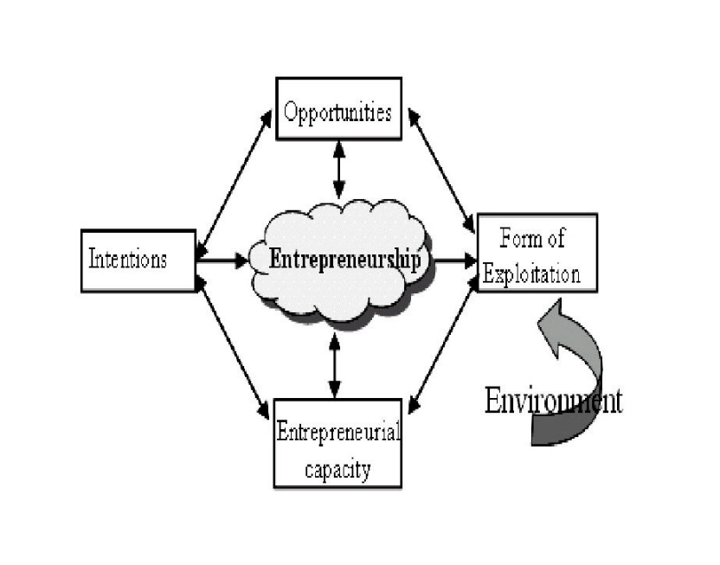

Figure 2.1 (McKenzie et al, 2007)

There are three main traditional thoughts to who an entrepreneur is (Binks & Vales, 1990). The first main E theory of note is the Austrian school of Economics’ theory where a notable theorist such as Kirzner, who understood entrepreneurs to be those who are merely “alert to the opportunity” (Kirzner, 1975) and the value is merely captured by the “reactive entrepreneur” (Binks & Vale,1990). With the Austrian school of thought, it is the market economy which dictates the potential of an opportunity, where there is a disequilibrium there is unexploited opportunity. It is only when this opportunity or need is fulfilled that the economic equilibrium is restored.

The second theory of note which Binks & Vale (1990) summarised is that of German school of thought and which the economist Joseph A. Schumpeter was part of. Schumpeter believed that it was the innovative entrepreneur who was the key to economic growth. The entrepreneur’s role is to look to exploit innovation for short term monopolies, which will encourage further entrepreneurs to disrupt those monopolies (Wickham, 2006). This Schumpeter (1943) called “Creative Destruction”. This is at odds with Austrian’s viewpoint of the entrepreneur, with this disruption “destroying the pre-existing state of equilibrium” (Kirzner, 1999). This destruction would ultimately lead to new markets and opportunities, and in existing markets would free the resources through the reinvention of old processes and methods that are uncompetitive and outdated. This is reinforced by Peter Drucker (1985) who saw no reason for the entrepreneur but to “do something new”. Like Kirzner though Schumpeter did agree that it is the environment which ultimately enables the entrepreneur to fulfil their potential in be it the capture or the execution in Schumpeter’s view where the entrepreneurs’ gift is the “capacity” to envision, with an ability to read societal needs but also the resources to enact (Schumpeter, 1943).

The third theory discussed in Binks and Vale (1990) is that of H. Leibenstein, which summarises that though there are the basic differences between entrepreneurs either economically continuous or disruptive, it is the actions of management of the enterprise by the entrepreneurs that ultimately defines the significance of the entrepreneurship (Leibenstein, 1968). This view is close to Kirzner (1999) further consideration of Schumpeter’s and his view where Kirzner discusses that the main difference between the two theories is how innovation exists and that ultimately it is how the capacity of the entrepreneur to act on that innovation which is key. Profit was not necessarily the primary goal for the Schumpeterian entrepreneur, rather that pursuit of something new was the desire, where the entrepreneur is “the agent of change” (Rae, 2007).

Entrepreneurship Ecosystems

EE theory is thought to provide rational how certain global regions have certain types of entrepreneurships be highly successful while in other regions they fail (Spigel, 2017). There is an area of EE research that looks to understand the underlying reasons why countries with high entrepreneurial rates still tend to be less innovative than those of more affluent economies which have low entrepreneurial levels (Autio, et al., 2014). In the natural world, “an ecosystem is a group of inter-connected organisms (animals, plants and microbes) and their physical environment found in a particular area” (Natural Resources Wales, 2023). Audretsch et al (2018), outline an ecosystem as being “self-defined by its boundaries”, which can be physical and linked to “exit and entry barriers”.

The metaphor of a “Business ecosystems” was introduced by Moore (1993: Audretsch et al, 2018) to describe how different stakeholders “co-exist in a common setting and evolve together like creatures in their ecosystem do” (Audretsch et al, 2018). EE are comprised of a complex network of relationships between firms and the factors echoing equally complex biological ecosystems where living and abiotic components interact for mutual benefit (Kshetri, 2014). In nature, a resilient ecosystem deals with “pressures and demands”, with signs of its resilience being its diversity, extent, condition, and connectivity (Natural Resources Wales, 2023).

Ecosystems have long been discussed as potentially being an important factor for economic change for a region. Historically, this is evident in examples such as the British industrial revolution of the 17th century where the combination of invention supported by educational institutions, entrepreneurship, political reform, skilled workers who learnt on the job and banking developments, coupled with leadership of those implementing the new technologies lead Britain to have competitive advantage over the rest of the world. Competitive advantage is not achieved by a firm on its own, it is achieved by the shared resources but are based on shared resources, networks, shared, knowledge sharing and the many stakeholders along its value chain as discussed by Porter (1990).

Entrepreneurial Ecosystem first became prominent in the early 21st century by researchers such as Cohen (2006a) but the concept has been discussed prior to this, including prior a paper where Cohen et al (2006b) discusses both entrepreneurial systems and 20th century research into the factors which encourage the creation of spin off enterprises. Cohen (2006) expands on the initial 2006 paper by theorising that regions can control and develop EEs to benefit living standards of region by actively controlling the type and quality of spin offs through the factors that influence entrepreneurship.

The boundaries of the ecosystem are not explicit but can be correlated with the barriers to entry and exit (Audretsch et al, 2018). Almost all EEs though have been noted to share the same characteristics of “a supportive culture, (venture) capital, active networks of entrepreneurs, local government officials, and investors, the presence of universities and support services” (Neumeyer & Santos, 2018). EE differentiates themselves from innovative systems is that it is interested in ‘value creation’ and not just innovation formation (Ratten, 2020).

Mason and Brown (2014) in their paper notably describe EE (EE) as:

“a set of interconnected entrepreneurial actors (both potential and existing), entrepreneurial organizations (e.g. firms, venture capitalists, business angels, banks), institutions (universities, public sector agencies, financial bodies) and entrepreneurial processes (e.g. the business birth rate, numbers of high growth firms, levels of ‘blockbuster entrepreneurship’, number of serial entrepreneurs, degree of sell out mentality within firms and levels of entrepreneurial ambition) which formally and informally coalesce to connect, mediate and govern the performance within the local entrepreneurial environment. (p. 5)” (Mason and Brown, 2014: Alvedalen, and Boschma, 2017).

The EE acts as the environment per McKenzie et al (2007)’s framework. EE are a complex multi-faceted entity which is difficult to unpick and although EEs have shared characteristic, each EE is unique with its own different factors. The metaphor of EE has been compared to other complex adaptive ecosystems (Kuckertz, 2019), such as the Amazon, where the unique natural environmental factors, and diverse fauna, create new species through Darwinism (Holland, 2014). This is perfectly demonstrated in Nyland and Cohen’s 2017 paper where their research support’s their hypothesis that the larger the number different actors interact in an EE, known as “collision density”, an increase in number and diversity of start-up occurs.

Research into Entrepreneurial environments has sort to identify factors which affect “supply of entrepreneurs” and is the bases of current EE research (Spigel, 2020). Potential and existing entrepreneurship affects and is affected by factors in the environment which can be understood by a combination of theories such as Stakeholder theory, interplayed with Resource based and knowledge-based theories (Wickham, 2006), “competition dynamics” (Moore, 1993), and even social network theory (Neumeyer & Santo (2018). Individually, researchers and policy makers have struggled to translate such associated theories into workable models. Though a relatively new term, the several have been thought to be important to entrepreneurial research into the development of entrepreneurial action in regions for some time (Neck, et al., 2004), there has though been no real development in the EE theory. For example, Isenberg (2011) argues for governments and policy makers to concentrate resources into attracting one big high growth enterprise per 50000 to 15000 citizens which will spawn additional spin off entrepreneurship, but the “Genealogical Tree” as discussed by Neck Et al (2004) with the case of IBM and Boulder County, has not translated in copies of Silicon Valley for countries that have tried to imitate the region. This was argued at the time by Neck et al (2004) be due to the emphasis on result of the spin off and not on the moment the spawned the new enterprise. These moments would be created through the correct conditions and support, such as that of adequate finance, so prompting the question of what comes first “the chicken or the egg” (Cohen, 2006).

In addition, each function in the EE plays a different role in the ecosystem, depending on additional factors such as the type of entrepreneurship such as age of the venture; high growth and scalability; and the level of the ecosystem: how well lower-level firms can access higher tire EE resources (Neumeyer & Poncela-Casanovas, 2016). EE not only support the formation of the entrepreneurial action, but they too can also facilitate and guide innovation so to ensure that the entrepreneurship achieves the greatest value possible, while identifying the least valuable (Autio, et al., 2014). A 2013 report by the World Economic Forum where it surveyed 1000 people with substantial “early-stage company experience, found that their differences between EE where great but proposed that there is common eight factors or “pillars” on which EE were built. The WEF attributed Accessible Markets, Human Capital Workforce, Funding and Finance, Mentors Support and Infrastructure, Education and Training, Major Universities as Catalysts and Cultural support as the main factors which make the EE.

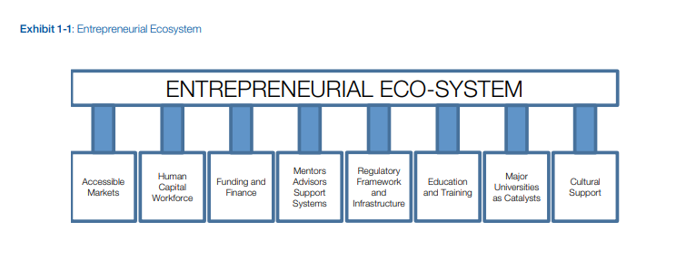

Figure 2.2 (World Economic Forum, 2013)

Similarly, in his paper Domains of the entrepreneurship ecosystem, Isenberg, 2011, discusses EEs as being made up from 6 main factors: Policy, Finance, Culture, Supports, Human Capital and Markets (figure 2.3). Where these ideas converge is that Isenberg sub divides the categories further, which is where we find that Isenberg has recognized the same concepts as the WEF, such as in Figure 2.2 Market Advisors and Support Systems is a main factor, for Isenberg (2011) we can see in Figure 2.3 the same concept is included in the main Factor Markets, sub-factor Networks.
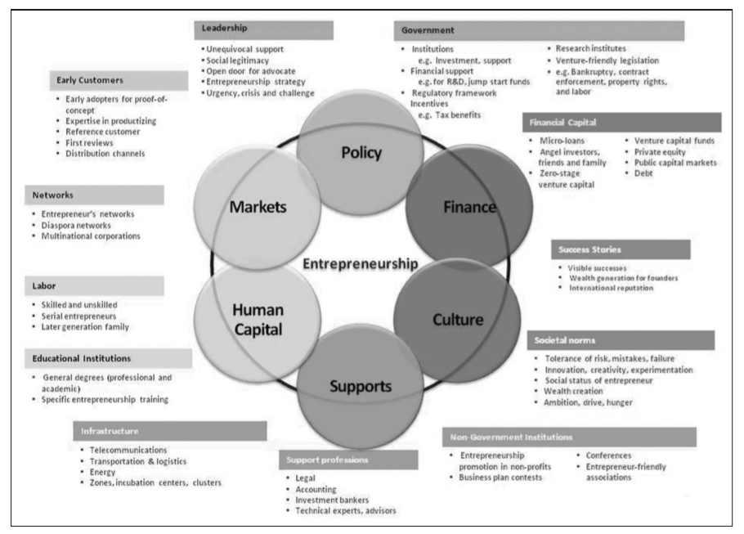

Figure 2.3 Domains of the entrepreneurship ecosystem (Isenberg, 2011)

Factors of an EE using Isenberg, (2011), Figure 2.3 as a guide.

Culture

The entrepreneur can be argued as being the most important component of the EE as the entrepreneur “creates new value” (Wickham 2006). How and why people become entrepreneurs is still a debatable topic, with researchers attributing personality traits such as ability and type such as temperament i.e., high need to achieve McClelland 1961: Rae 2007 pg. 27); learning and experience; and social i.e., social economical, family history of entrepreneurship, all playing a part in developing the entrepreneur (Wickham 2007).

The way economies develop and operate in a particular environment are impacted by its cultural environment which has developed through “social and industrial legacies, and demographic trends” (Massey 1995: Spigel 2020 pg35), and where both national and sub-national culture play an active role in shaping an area’s economic behaviours (Spigel, 2020). Culture influences both the individual’s choices but also, the “the value system of the wider community” (Wickham 2006). Researcher Hofstede singled out four factor which cultures (national) differ: Power distance which is denoted the attitudes to authority; Individual-Collectivism which would influence to go alone or work as a team; Long-term orientation so looking to the future; and Uncertainty avoidance, i.e., how well the entrepreneur is willing to tolerate risk (Johnson et al, 2017). A criticism of Hofstede though is that regional culture identification is too “heterogeneous” to be beneficial to economic analysis (Daniels et al 2007). A national and regional culture which encourages entrepreneurial risk taking in the face of ambiguity, with a willingness to innovate where the entrepreneur sees how the world could be is desirable, but so is the control of cultures which decide which enterprises are legitimate and desirable (James 2007: Spigel 2020). High-growth entrepreneurships are often found in clusters in a region (Spigel, 2020). Feld (2020) attributes the culture of the EE to “leadership” provided by the entrepreneurs providing “cues on behaviour, activities, and attitudes” (Feld, 2020). The culture of acceptance of risk and acceptance of ambiguity by the available work force is also important, with start-ups more likely to have non-traditional working or even to collapse. The work force requires resilience and flexibility to learn new skills quickly something which they are more likely to have gathered in previous employment in the region (Spigel, 2020).

Support

Research has found the more social connections an entrepreneur has in their Network the more successful they are (Stam et al 2014: Spigel 2020). A Network are all the social ties which the entrepreneur has which enables them to bring together the resources and knowledge for the identification, and pursuit of the opportunity, (Spigel 2020). These networks can be formal such as larger corporations, or professional services, or informal such as colleagues and similar businesses (Neck et al., 2004).

Entrepreneurial Support Organisations is the umbrella term for “incubators, accelerators and support programs” which can be provided publicly, privately or “quasi-public” (Spigel 2020).
Incubators and other ESOs can help entrepreneurs and start-ups access the support such as training, mentoring, and cheap sources of finances but also, often also provide physical support with workspaces (Kshetri, 2014). Incubators are frequently linked with local universities and aimed to start-ups which require high levels of Research and Development (Spigel 2020). Constraints such as time are not necessarily placed on the firm by an Incubator, but it does run the risk of creating “Zombie firms” which cannot continue without the incubator whereas Accelerators are time-limited and often run as for-profit (Spigel 2020).

Support professionals such as solicitors, consultants, and accountants, not only provide skilled practical support but also, through their networks provide further opportunities and contacts for the entrepreneur (Spigel 2020). Networks are particularity important, being shaped by experienced and connected entrepreneurs acting as “bridge-builders” to provide access to resources, and connections to the right people (Feld, 2020).

In addition to resources for firm, infrastructure, and natural geographical conditions such as terrain and climate mixed with access to customers, affect the firm’s ability to do business effectively (Kshetri, 2014). Favourable amenities and infrastructure such as transport links, leisure facilities, service industries and green spaces in a region encourages the influx of people to an area and so increases the available work force for the start-up while decreasing the costs to the business (Audretsch & Belitski 2016).

Human Capital

In his later paper, Isenberg (2014) questions whether formal entrepreneurial training is essential in the development of a successful EE, citing the success of early EEs such as Israel and Silicon Valley before university courses in Entrepreneurship where the EEs grew organically. Isenberg (2014) uses his own experience in teaching the first Technological Entrepreneurship master’s at Technion University, Israel in the 1980s, long after the EE was developed as evidence of the lack of need, but this is a very restricted view, as though entrepreneurial studies was not itself a course, it did play an increasingly larger role in Management education in the 20th century. Israel had several notable business schools, for example Tel Aviv university’s Coller School of Management which was established in 1966 and Technion’s William Davidson Faculty of Industrial Engineering & Management was established in 1958. Silicon Valley has many such established business schools predating its EE i.e., Stanton University, and Haas School of Business Berkeley. Though not directly in the EE but in the peripheral area in the same state of California 365 miles away is Claremont University, home to influential entrepreneurial and innovation scholar Peter F. Drucker from 1971. Universities give opportunity for nascent entrepreneurial students to realise potential in their research and designs, providing a platform and network needed (Spigel 2020)

The skills of the Entrepreneur are not enough to grow the firm on its own. Skilled workers are fundamentally important to High-growth companies and the availability of such potential employees are vital to a start-up as training is costly both financially and with time (Spigel 2020). Universities and established organisations give access to employed with skills required and knowledge transfers. Universities also are research hubs where new knowledge creation and transfer, takes place not just with the students but private sponsors and guest speakers/lectures. Lectures too often act as consultants, providing a multi way knowledge share between industry, the university and those who are linked to it.

Markets

It is entrepreneurs themselves who best to identify gaps in the market and barriers to them (Feld, 2012), barriers to access “early adopters, distribution channels, diaspora networks etc..” in the EE which act as scaled tests to market through feedback loops, and identifies problems which would greatly hinders the valuation of the idea (Liguori et al 2018) so in turn will reduce the chances of investment, growth of the start-up. Auerswald & Dani, (2017), theorises that the barriers to markets for innovations are lowered due to collaboration across the actors of an EE.

Policy

Local and national governmental policy not only directly shapes market conditions, infrastructure, and a firm’s ability to access human and financial resources, its policies dictate if the entrepreneurial firm can do business and with whom (Kshetri, 2014). Bureaucracy, local regulations, and large governments hinder the creation and management of start-up while well planned out support services and resource allocation create conducive environments for start-ups to thrive (Audretsch & Beliski 2017). Kung et al, 2017, examined the effect of strong government intervention in South Korea’s EE. It also found that although there possibly is previous arguments that too much intervention by state deters creativity and innovation, it is too much bureaucracy which hinders any positive interventions, such as the promotion of initiatives such as incubators and support services (Kung, et al, 2017).

Finance

Investors are the second most mentioned actor in EE research (Spigel, 2020). The availability of capital to firms can determined a firm’s capability into overcoming barriers of entry to a market, and to compete. In a badly performing EE, costs of finance can increase as lenders believe that conditions are unfavourable (Kshetri, 2014). Finance in developing countries is often far more expensive of SMEs than those in developed countries, often due to lack of competition operation in the regions, and lack of credit rating agencies (Kshetri, 2014). Although there are “global mobile capital” opportunities, investment appears to be centred by investors to regions near the investor (Mason and Harrison, 2003: Spigel 2020). This is due to the reliance of networks built on regular social interactions, to judge the worth of the investment, entrepreneur, and idea (Spigel, 2020). 70% of finance to start-ups are Angel investors, while current or past entrepreneurs account for 75-85% of Angel investors who invest in their own EE lending both finance but their own experience (Morrissette 2007; Nyland & Cohen 2021). Venture Capital is privately funds lent to companies considered to have high growth potential. Start-ups in developing countries find it difficult to get access to this kind of finals due to the lack of available investors within the region and unfavourable political conditions for international investors (Kshetri, 2014). Often venture capitalists have shown to have an “one hour rule” where they are more likely to invest in companies which are just hours’ drive from the office (Griffin et al, 2007: Spigel, 2020).

The lack of finance options is often critical to an EE. Not only does the skills and knowledge transfer of the investor to the Entrepreneurial endeavour does not take place, the signal of potential to other stakeholders when an investor invests does not happen. Governments national or local often intervene, who are often less qualified to judge the validity of the idea so putting public money at risk (Spigel 2020). Public funds provided by government agencies in the form of grants etc are crucial form of finance for firms that are locked out of traditional means of finance (Kshetri, 2014).

Actors

Although not a factor, to recognise the importance of the various actors who enact the entrepreneurial action be it the individual or a group such as an organisation, for example the entrepreneurs as an individual or the University as an organisation have different efficacy of the EE. Each actor has a level of control over the influence of the factor on the EE but with each actor having its own ultimate agender they may not agree over desired outcome (Spigel, 2020).

According to Spigel (2020), five of the most important individual actors noted by EE research are:

- Entrepreneurs who can recognize the challenges which their enterprise and the wider entrepreneurial environment face.
- Investors who provide sources of capital and can take many forms.
- Skilled workers available to the enterprise
- Role models as a source of advice and support
- Support professions and dealmakers which provide supporting functions such as solicitors and accountants.

Criticism of the EE theory

There is doubt if EE research can advance economic and business understanding as many of its critics’ view EE as “old wine in a new bottle” (Scaringella & Radziwon, 2017), with the term “ecosystem” being just a fuzzy concept that encapsules old economic theories such as the “triple-helix initiative” of university, governmental and the firm and Porter’s (1990) Competitive Advantage of a Nation (Scaringella & Radziwon, 2017).

A key theoretical concern that researchers such as Mack and Mayer (2016); Roudy, et al (2018), Alveden and Boschma (2017), is the notable lack of research on the “interdependencies” of the factors and actors, with EE research thus far mainly focuses on examining “successful ecosystems to identify best practice” (#03).

It is thought that for an entrepreneurial ecosystem to be successful and sustainable then all actors must benefit (Isenberg, 2014). There is no clear understanding in the literature on the relationships between the many parts of the ecosystem can benefit the many different objectives while simultaneously providing enough scope for unrestrained growth and scalability. Alvedalen & Boschma, (2017) critiques of EE literature to date, questioning the lack knowledge of the cause and effect between factors, the lack of an agreed systems model, lack of understanding of how size, shape, contactivity and density effect the clusters. The paper also criticises the lack of use of chronological data examined, with researchers looking at fixed points and not the development of EEs, so not fully understanding the cause and affect nature of events, factors or actors.

Conclusion

In summary, it has long been understood that the entrepreneurial process does not happen in a vacuum, it takes a great many factors to initiate and continue the process. With entrepreneurs being considered a key to a healthy economy, now more than ever the need for support entrepreneurs, and in entrepreneurial activity, in its many forms, from start-ups to intrapreneurs. Even when looking at EE outside the lens of theory, it makes sense for policy makers to support entrepreneurs so to create the best environment for it to flourish. EE creates a starting point for policy makers, researchers, support providers and entrepreneurs themselves to understand and facilitate the entrepreneurial process. By understanding the many factors and actors which make up an EE resources and effort can be syphoned into the best possible direction, minimising waste, and maximising limited resources but how is the complex, multifaceted nature of the EEs understood?

Research Methodology

Introduction

This chapter will outline the research methodology which has been chosen and detail how it will be carried out. The chapter will begin discussing the Research Rational behind the report and the specific aims it looks to address. The chapter then continues identify the research paradigm and them goes on to describe why a case study has been chosen and the specific research techniques which will be used to carry out the primary and secondary research.

Research Rational

This report seeks to continue from previous research and explore how actors of an entrepreneurial ecosystem interact in view of strengthening factors to improve an economic and social sustainability for a region, both micro and macro perspectives. The previous Literature Review chapter looked the definition of entrepreneurialism, concluding that no matter the type of entrepreneurial action, it does not exist in a vacuum and that emergent research on EE looks to understand what creates the phenomenon.

This research will specifically look at the area of Carmarthenshire using mixed research techniques and will begin by examining the case study of LDW Ltd, examining how has affected and been affected by other actors as the key large enterprise in the local entrepreneurial ecosystem since it was established as a trading company in 2018. This research will look to answering the question of how has the EE which LDW exists in developed to support innovation and growth of the business to benefit economic and social change? This report looks to address the following aims:

- The first objective for this will be the examination of the creation of the enterprise which provides services to the Corporate and individuals across Wales. This will be achieved through a range of qualitative and quantitative, analysing the organisation through the lens of Entrepreneurial theory.

- The second objective will be to look at the ecosystem and the actors which have formed around and alongside LDW, and examining the effects on them by policy, human capital, finance, culture and support.

- The third objective will be to look how factors between actors can be strengthened so to benefit Social and economic outlook for the region.

Research Philosophy

This researcher will take a Realist paradigm to this work as it seeks to discover the “mechanisms which link events”, in the case of this research the parts of an ecosystem, while being aware of the subjectiveness of what is being studied (Fisher, 2004). Due to ethos of this report, where the aim to ultimately find solutions to strengthen other facets of the ecosystem, results will look to be generalisable, the paradigm of Critical Realism offers the hope of practical solutions (Brymasn & Bell, 2003).

Research Strategy

Case studies

To test assumptions made in the Literature Research part of this report, the next step of this research was to take an inductive view and use the testing of an existence of a Gazelle in the active or emergent Entrepreneurial Ecosystem in a specific geographical region by using a case study to explore this phenomenon, so to test existing theories and build upon them (Tellis, 1997). As EE is a relatively new area of research with a lack of workable models, the use of a case study as a starting point for exploration will unearth novel new areas of research, which might diverge from the existing studies in the domain.

“Case studies can be used for different types of research purposes such as exploration, theory building, theory testing and theory extension/ refinement” (Voss et al, 2002).
A case study is chosen as a method as it offers a means to study root in a “holistic, in-depth” which is not constrained by limitations of models and traditional research methods (Tellis, 1997; Voss et al, 2002). Case studies are useful as a tool to not only for researching and developing new theories but for testing and developing pre-existing theories in practice while giving the researcher an opportunity to fully assess all facets of a complex reality of the phenomena, some of which are not visible prior to the exploration (Voss et al, 2002: Bebensat et al, 1987).

Validity of the research in a single-case study is achieved using multiple sources of evidence. Within case study protocol for business research, documentation, archival records and interviews are all considered as sources of evidence (Tellis, 1997).

A drawback to case studies is the large time investment required so to conduct thoroughly, rigorous research (Voss et al, 2002). There is risk that the case is not able to be expressed as a construct with a beginning and an end but instead, if there are no defined boundaries than research may be too broad to address the issues being investigated (Yin, 2009).

Another potential issue with carrying out Case research, is skill set required to carry out such a large undertaking, may not be possessed by the researcher, with each type of data collection requiring a skill set (Tellis, 1997). Bias on the part of the research and the participants risk distortion of the problem, which is exasperated by the lack of viable ways of cross-checking data (Bell & Waters, 2018). The analysis of case studies can produce fuzzy generalisations, where statistical generalisations cannot take place, so to leaves the conclusions to be that it is “possible, or likely or unlikely” (Bassey, 1999).

Time Horizons – Cross-Sectional

Evaluation of archival documentation and information will allow this report to take a retrospective longitudinal view of the problem, which for this research will be from 2018 to present. The choice of single in-depth case study over a period for this research project offers a way of studying the possible causal effect of the Gazelle on an Entrepreneurial Ecosystem (Voss et al, 2002). Longitude analysis measured the same variables over an extended period, multiple times (Oppenhiem,2004. A criticism of longitude studies where additional variables might have affected what is being studied (Oppenhiem, 2004).

Research Choices- Mixed Method

This inductive view of research seeks to take a pragmatic approach and combine both qualitative and quantitative data collection, which is known as mixed methods research (MMR). MMR combines the positives of both the analytical testing of qualitative research with the cultural and behavioural in-depth research of qualitative (Bell Waters, 2018). Questionnaire will look to gather both types of data for comparison with Interviews.

Tourmen (2009) concludes that MMR is a pragmatic concept which incorporates both epistemological and ontological paradigms. This fits well with existing knowledge of EE, as discussed in the Literature Review chapter, there is still argument to what is the Entrepreneurial ecosystem and how to quantify (epistemology) or if it is a reality outside the entrepreneurs and enterprises (Ontology).

Research Methods

Interviews

Tellis (1997) states that some of the positive advantages of carrying out interviews are that they are “targeted” and “insightful- provides perceived casual inferences”, and he considers them to one of the most valuable sources of information for the researcher using the Case Studies. Drawbacks to interviews though can be researcher bias, poor question choices, incomplete answers, and “reflexivity” where the views expressed are those which fit the narrative and not true views of the interviewee.

interviews will be carried out with key figures at LDW. The Interview’s will be carried out to gather primary data, with the aim to introduce “reference points” that can other data collections can be compared to (Bryman & Bell, 2003). These interviews are exploratory and will be carried in a semi-structured style, so to guide the interview but as interviews progress and new information comes to light, the semi-structured nature will help leave the opportunity to be explorative into the topic.

The initial interview will be with the Chief Director of organisation, who is seen for the purposes of this report as a rich source of data, having been in the position from the inception of LDW and so can give a phenomenological view. Further interviews will be carried out with those who are judged to be key players, in the same way that the Chief Director is, but who can offer further insight (Groenwald, 2004). Additional interviews will be carried out with those who support entrepreneurs in the industry such as Planed, which supports Micro Entrepreneurs in the Care industry. Other organisations will be identified during the field research part of the enquiry, and interviews with them these should primarily focus finding blocks in the EE.

Questionnaires

The first survey looks to mix both the qualitive and quantitative and will take the form of a questionnaire via Microsoft Forms. The survey will differ from a traditional questionnaire as the questions look to exact qualitative data sets via a more narrative approach, by use of a questionnaire with a mixture of open and closed questions which will be sent out to Senior management of LDW which will include the Chief Director, Operations Manager and Chief Strategic Officer. The survey looks to investigate how much entrepreneurship affects their business choices and to map internal and external factors and actors which knowingly or unknowingly, have affected their performance as Senior managers, thus shaping the organisation. These surveys will be used as a method of cross-referencing data provided from the interviews and data collections. Microsoft Forms offers an analytic tool and exports data to Microsoft Excel. Completion can be tract.

The second survey, will be a self-completed questionnaires created on online survey tools such as Survey Monkey, will be emailed to all staff of LDW to complete with management’s consent. These questionnaires will focus on past employment and education history. The benefit of this technique is that they provide the opportunity to standardise questions, reducing bias and greater anonymity. The questionnaire will look to gather mostly qualitive data sets.
Sampling logic will not be used for this research as it is the use of case study method means that the subject will be examined as a “whole” (Tellis, 1997). As of April 2022, there were 147 employees of LDW. As an employee of LDW, I have sought provisory agreement from Senior Management that an email can be sent out to all staff via the company wide email address with link to the online questionnaire. Due to my position in LDW and my close working capacity with many my fellow employees, a slightly larger than average response is hoped. Holtom et al (2022) found that in recent years average survey response rate for business research had increase to 56% in 2015. The rate increase in 2020 to 68%, but I believe that this figure cannot be benchmarked due to the significance of this year, i.e., the global pandemic.

Secondary Data Research

To understand the interdependencies, and to investigate what these actors and factors look like in County of Carmarthenshire, secondary research will be carried out to ascertain types and breath of support. Desk research will be carried out, accessing information from internet searches, publicly available records such as Companies House and data sets produced by The Office of National Statistics, as well as collection of appropriate documentation and archival record. This enables longitude analysis to be carried out, tracking changes and trends in the Entrepreneurial Ecosystem over time (Bryman, & Bell, 2003). Due to the differing intension of the author of secondary data’s research, it is difficult to conduct multivariable analysis as key variable which are being studied in this report are omitted. Secondly, while the validity of all such data though, should be scrutinised and corroborated, to guard against inaccuracy and so not to distort analysis (Tellis, 1997). The advantages of carrying out analysis of secondary data, such as this is the access to “high-quality” data sets carried out by experience and reputable sources whose sample can be assumed to be representative, due to their rigorous procedures. This would be costly and time consuming to carry out for the purpose of this report (Bryman & Bell, 2003).

Data Analysis

Grounded theory is an approach to analysing qualitive data in a “iterative process” (Hayes, 2000). Data is collected initially, linked to the research questions, and then analysed prior to further data being collected. From there the researcher collects further data and so on, until all research avenues have been depleted or the constraints, such as time, has been depleted. Thematic analysis is similar, in the sense that it too can an inductive tool to identify further detailed research, where identified themes are identified and examined (Bell & Water, 2008). Tellis (1997) argues that “experience and literature” are required to interpret findings and that statistical analysis is not always the most beneficial means. Analysis through Triangulation includes the examination of multiple data sources, through a variety of methods, so that the validity of analysis and conclusions drawn can be seen as more complete (Voss et al,2002; Bell & Waters, 2018).

With both Quantitative and Qualitative data collection, it is required that to organise and analyse data collections a standardised platform is used where other researchers would be able to access code the research is desired (Tellis, 1997). The platform NVivo is particularly useful for this approach as it offers an opportunity for the analysis of unstructured data sets.

Ethical Consideration

This research project with be conducted responsibility and integrity, for example all legal requirements regarding data protection for the countries being investigated will be adhered to by the researcher. This researcher will demonstrate honesty and ensure that all participants understand the matter and intended purpose of the research so to give their ‘informed consent’. It is recognised that there is potential business risk in participants revealing sensitive business information. This risk will be minimised as no information gathered will be shared other than to though who have been granted consent and the University of Wales Trinity Saint Davids. Confidentially will be practiced as well as anonymity where required by the participants. All personal information will be made anonymous for the use in the report.

Questionnaire sent will not be unsolicited via individual email addresses email, but to the shared staff group email address and consent sort first from Senior management. All participants will receive a second email thanking for the completion of questionnaire and asking though who have not to complete if possible. Again, no direct email will be sent to individual email addresses but to the staff group email address.

Research will be recorded and analysed with scientific objectivity, impartiality, accuracy and with fairness to all. There is potential business risk in participants revealing sensitive business information. This risk will be minimised as no information gathered will be shared other than to Supervising Lecture This research will be carried out in the matter set by the University of Wales Trinity Saint David’s Research Ethics and Integrity Code of Practice.

No financial disclosure will be sort from the participants and only public record would be used if required.

Limitations

On consideration, there are several limitations to the work. The first the desire to study LWD using a longitude time horizon, there is a concern that there is a lack of available data from multiple points in LDW’s history.

The second consideration is the lack of available time for the research. This research is carried out in my own spare time, which has been limited since the global pandemic and greatly challenging. This will be negated by strong time planning skill and an ability to prioritise workload.

Another challenge of this report is navigating data consent and GDPR in relation to the subject and confidential business information. To counter any issues that may arise, an adapted Personal Information sheet was prepared and sent to LDW director.

Conclusion

The methodology chosen for this research, was chosen as best fit to the problem at hand. The limitation of information for this longitude study means that a cross-sectional analysis may have been easier to achieve, but in doing so it would not have fully answered the questions that this report is designed to do. To fully understand the EE, further research would be needed to be gathered in the form of multiple organisations studies. Due to the limited size of this report, and time frame, only the one case study is being examined.

Analysis of Results

Introduction

This research looked to answering how has the EE which LDW exists in developed to support innovation and growth of a businesses in the region to benefit economic and social change. The specific aims are the following:

Aim 1

The examination of the creation of the enterprise which provides services to the Corporate and individuals across Wales. This will be achieved through a range of qualitative and quantitative, analysing the organisation through the lens of Entrepreneurial theory.

Aim 2

To look at the ecosystem and the actors which have formed around and alongside LDW, and examining the effects on them by policy, human capital, finance, culture, and support.

Aim 3

To look how factors between actors can be strengthened so to benefit Social and economic outlook for the region.

The research comprised of two questionnaire and a set of four interview. Questionnaire 1 (Q1) was sent to all 175 staff at LDW, via a link to a Microsoft Forms survey named Carmarthenshire’s EE. There was a 24% response rate with 42 respondents, all of whom are anonymous.

Questionnaire 2 (Q2) was aimed at just management at LDW. The survey was again created with Microsoft Forms and the link was emailed to the management team, which consists of Company Director, two Strategic Innovation Leads, TEC manager, Head Operations Manager, Response Lead, Operations Manager, 5 Operation Team Leader, TEC Team Leader, Infrastructure Officer, Finance officer, Marketing Manager, 2 Response Team Leaders and 2 IAA Team Leaders. Out of the 20 surveyed, there was a response of 12, which represents a response rate of 60%.

Due to the limit in time and the scope of the project, interviews were carried out with just four of the Senior Management team. The first interviewee is the Managing director of LDW, the next three interviewees were chosen as they all are directly responsible for innovation in the organisation. These include shared Strategic Innovation Leads, with one focusing on innovations in Service and the other innovations through TEC, and the third interviewee is the Head of Technologies. Each interview was semi-structured, with a set of questions which were slightly altered for each interview, depending on their role. The question set can be seen in appendix C, D, E, and F. All interviews were recorded via Microsoft Teams.

Once the set of interviews were concluded, the interviews were transcribed, and the produced documents imported to qualitive analysis program NVivo, where the researcher coded the data. Parent codes and child codes were devised using Isenberg (2011)’s models of EE’s factors (Figure 2.3 Domains of the entrepreneurship ecosystem (Isenberg, 2011):

- Policy
  - Government
  - Leadership
- Culture
  - Social Norms
  - Success Stories
- Finance
  - Financial Capital
- Human Capital
  - Educational Institutions
  - Labour
- Markets
  - Early Customers
  - Networks
- Supports
  - Infrastructure
  - Non-government Institutions
  - Support Professions

A further code was added to the parent code which was used to identify specify entrepreneurial activity which does not fit necessarily into the previous six categories:
- Entrepreneurial Activity

Once coded, results were transferred to Microsoft Excel, where there was further analysis of the coded transcripts. A copy of the Thematic Analysis can be found in Appendix B.
Thematic analysis was caried out and meaning derived, which are presented in the table which are clearly labelled for the reader.

Presentation of Results

The discussion will start by discussing LDW entrepreneurial activity, the for the purposes of continuity, the discussion of the result which follows, will be sorted into Isenberg’s (2011) EE factors and concluding with the linking Actors of the EE and LDW.

Summary of Thematic Analysis of Interviews with Senior Management of LDW

Factor | Subfactor | Thematic Analysis Findings Summary | Link to position in Appendix B
Entrepreneurial Activity |  | LDW have a business model which is agile, and so has been able to be accepting and alert to opportunities over the last 5 years.  Their entrepreneurship model is based on service innovation using widely available technology, where experience and unique organisational knowledge is key for their competitive advantage. Reputation for expertise has been advantageous, especially when persuading stake holders and other actors in the EE to increase their rate of change, so LDW can further innovate. | Table B.1 Thematic Analysis - Entrepreneurial Activity
Supports | Infrastructure | Technological advancement and digital infrastructure are proving a struggle for many governmental, NGOs and private organisations in Wales, where they are unable to keep up with the rate of change. This leads to a compatibility issue between actors, but if utilised they can provide further opportunities for the EE, with access to new customers and new business models. | Table B.2 Thematic Analysis- Factor: Supports/ Sub-Factor: Infrastructure
Supports | Non-Governmental Institutions | Value can be created for organisations by working with other companies who cultivate their corporate reputation can. Knowledge spill overs can work either direction and sharing data, is beneficial in lowering costs, improving quality, and creating innovation. LDW has done this by working with MNCs with similar values and non-governmental industry regulators. Awards and Conferences have been useful as a marketing tool. | Table B.3 Thematic Analysis- Factor: Supports/ Sub-Factor: Non-government institutions.
Supports | Support Professions | LDW have benefited from specialist support from CCC, which is LDW pays a fee. The benefits are economies of scale, strategic fit, and value of service. Contact via Service Level Agreement is guarantee of quality expected. Working with CCC and companies such as, boosts LDW’s value proposition CGI.  LDW works as a support provider to other governmental and NGOs, which boosts brand recognition, trust and Corporate Reputation, word of mouth is invaluable. | Table B.4 Thematic Analysis- Factor: Supports/ Sub-Factor: Support Professions
Policy | Government | LDW is subject not only government policy as a Limited Trading Company, but also as one which is owned by a Local Authority. The difference between the two, help LDW recruit quicker to fill gaps in the work force, but LDW still must follow CCC HR process such as remissions. The difference between the two can cause strategic mismatch as both have different agendas and as such there are different regulations for each, and red tape can be a hinderance.  The WG have been a catalyst for LDW and other projects to combat economic stresses, though there is often lack of carry through from the initial testing phase. | Table B.5 Thematic Analysis- Factor: Policy / Sub-Factor: Government
Policy | Leadership | Leadership of LDW has been chosen based on experience of management, and corporate entrepreneurship. LDW Leadership in CCC looked to create LDW due to economic factors which were having a detrimental effect to services. CCC governing board had final sign off on whether to progress as a company, so strong leadership and a clear plan was needed to win over the board. Strong leadership is needed in stakeholders and other actors of the EE, as clear objectives are required and strong change management skills. This includes stakeholders as far up as the WG. | Table B.6 Thematic Analysis- Factor: Policy / Sub-Factor: Leadership
Markets | Early Customers | Pre LDW, the services which CCC provided were not financially viable, and the service was poor. LDW was able to gain these customers and so already had a customer base on launch but was able to do so in a more viable way. This was an early proof of concept. Outside factors such has the Covid 19 pandemic has opened doors for LDW. During this period LDW was agile enough to be open to opportunity, and supported, even when not financially viable, other organisations. This has led to a larger customer base after the pandemic. | Table B.7 Thematic Analysis- Factor: Markets/ Sub-Factor: Early Customers
Markets | Networks | Opportunities have come from taking contracts in times of emergencies which has snowballed into other opportunities and created a network of contacts. LDW has taken the opportunity to be seen as an innovator or early adopter whi8ch has boosted their standing in the network and positioned themselves as experts in the field. | Table B.8 Thematic Analysis- Factor: Markets/ Sub-Factor: Networks
Human Capital | Education Institutions | Partnerships have led to staff training opportunities, and additional skills which can be used to secure additional business. Educational Institutions are direct, and non-directly linked to LDW, with them important to research in the EE. An example is Cardiff Universities Life Science Hub. | Table B.9 Thematic Analysis- Factor: Human Capital/ Sub-Factor: Educational Institutions
Human Capital | Labour | There is a focus on skills such as leadership opposed to educational achievement. Entrepreneurial traits are evident in management and have demonstrated these skills in prior roles. Staff are trained to be multiskilled so to the organisation can be agile and move to fit demand. | Table B.10 Thematic Analysis- Factor: Human Capital/ Sub-Factor: Labour
Financial |  | Financial sustainability is a primary goal of the service and what is needed to transform Health and Social Care. Reliance in financial Grants post Brexit is an unsustainable model. | Table B.11 Thematic Analysis- Factor: Financial
Culture | Social Norms | CCC has an ambitious culture, which helped create LDW’s ethos of entrepreneurship. Risk is accepted but it must be a calculated risk and always supported by knowledge. The ability to absorb change is an indicator to attitudes to risk. Stakeholders and other EEs not necessarily happy to let go of Traditional business and innovation models but has helped LDW become market leaders. | Table B.12 Thematic Analysis- Factor: Culture/ Sub-Factor: Social Norms
Culture | Success Creation | LDW looked internationally to research service models and solutions. Success helps organisations to become more comfortable with risk. | Table B.13 Thematic Analysis- Factor: Culture/ Sub-Factor: Success Creation

Table 4.1 Summary of Thematic Analysis of Interviews with Senior Management of LDW

The discussion will continue by discussing LDW entrepreneurial activity, the for the purposes of continuity, the discussion of the result which follows, will be sorted into Isenberg’s (2011) EE factors and concluding with the linking Actors of the EE and LDW.

Factor: Supports/ Sub-Factor: Infrastructure

Questionnaire 1

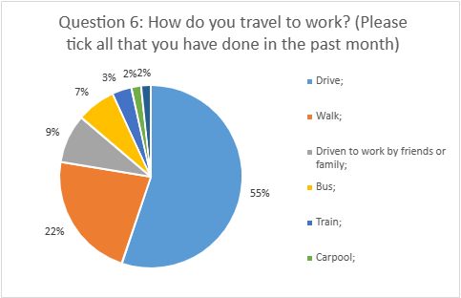

Figure 4.1. Q1.6

Only 6 which equals 12% of the respondents indicated that they used public transport to travel to and from work. Whereas 55 % of the respondents drive to work. And an additional 2% carpool and 9% have been driven to work by family and friends.

Factor: Policy/ Sub-Factor: Government

Questionnaire 2

These sets of questionnaires are concerned with the relationship with policy making stakeholders of LDW.
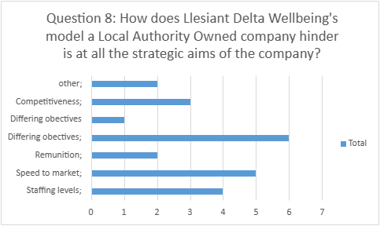

Figure 4.2. Q1.8

This question looks whether the Strategic goals of LDW are in line with the Strategic Aims of the local Authority owners CCC? Differing objectives appear to be the biggest hindrance with 7 out of 12 respondents, answering this option. The second biggest hindrance in the eyes of the responders is the speed to markets with 5 responses answering this, followed by staffing levels, competitiveness, and the remunerations which only had 2 agreeing that this was an issue.

Question 9: If possible, can you elaborate on Question 8's answer?

 | Key words
Remuneration - Delta is tied to CCCs pay grades and job evaluations and may struggle to recruit very senior staff against employers in the NHS and private sector.  There is potential for competing priorities between Delta's growth as a company and CCC's priorities | - Remunerations- pay grades.  - Remunerations- job evaluations which determine pay grades for roles.  - Inability to employ high quality staff with knowledge.  - Strategic aims
As a trading company, we have more flexibility and less red tape when it comes to launching new services. | - Less issues due to business model
Local Authority attitudes and approaches to work still exist especially in long serving staff, and I have seen this cause resistance to change and a belief that staff jobs are for life and taken for granted. | - Culture  - Models  - Resistance to change.
There are legal obligations that we must abide by as a LATC that restrict certain business opportunities as well as ensuring that the Company Board supports any decisions. | - Governance  - Business ownership model
Funding - Adult Services. Higher funding would enable our SPOA model to deliver the service far more effectively for the public. | - Funding – high reliance on public sector as customers

Table 4.2 Q1.9

Factor: Policy/ Sub-Factor: Leadership

Questionnaire 2

The following questions are concerned how entrepreneurial the management team of LDW, and its management team are and how these feeds into the organisation.
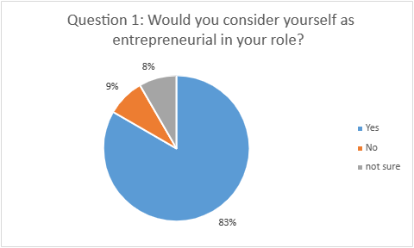

Figure 4.3 Q2.1

10 respondents consider themselves as entrepreneurial in their role., with only one believing that they are not.

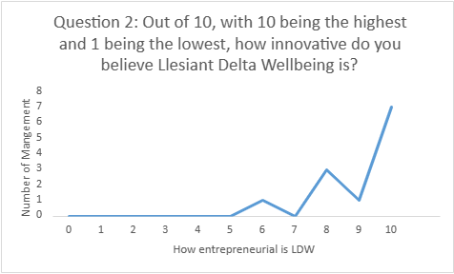

Figure 4.4 Q2.2

Respondents also believe strongly that LDW is an innovative company, with all respondents answering that LDW is at least 60% innovative. The average response was 9.08, which is equivalent to being 90.80% innovative.

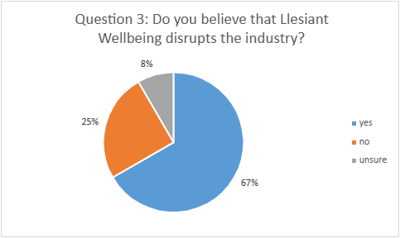

Figure 4.5 Q2.3

Following on from the previous question, 67% of the respondents believe that the innovation by LDW disrupts the industry. Respondents was requested to elaborate in the following question.

Question 4: If you answered yes to the previous question, how has LDW disrupted the industry?

 | Key points
CONNECT – is unique in what it offers, goes above and beyond other service providers in delivering a full wrap around approach to TEC care. The service diversified during COVID to include hospital-based staff, again a first. The company continues to look at new and innovative ways to deliver health and social care solutions to provide better outcomes for the patient and cost savings for the public sector. | - Connect Service  - Uniqueness  - Service excellence  - TEC  - Diversification  - Response during times of acute stress  - Partnerships with NHS  - Continuous opportunity search  - Social entrepreneurship  - Agile  - Public sector  - Health and Social care outcomes  - Cost efficiency
By introducing new services (response, proactive calling, telehealth), by working closely with partners in health – this was not generally done by others in the industry previously and by creating a new software platform to suit our business, rather than just accepting the existing available offering | - Partnerships with stakeholders  - Relationship marketing  - New services/ products  - Entrepreneurship though product/service innovation  - Entrepreneurship through service delivery, and new agile ways of working
Entering the market with a product or service that performs better or for a cheaper cost than current products or services, in turn this displaces the market leaders and transforms the industry. | - Disruption of industry through service/product pricing / quality differentiation
Absorbs other local lifeline monitoring services. Models best practice across Wales and sets examples | - Cannibalisation of competitors  - Differentiation from Service excellence  - Best practice
Being open to innovation and change that can allow more opportunities for the company | - Alertness to opportunity  - agile
Absorbs other businesses in the industry. | - Cannibalisation of competitors
by utilising Tec in a way no other health agencies or providers do | - Entrepreneurship through technology utilisation
Taking the lead in transforming the way health and social care deliver services. | - Social entrepreneurship  - Industry leaders  - New way of service delivery

Table 4.3 Q2.4

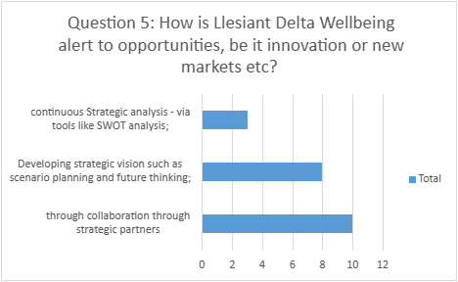

Figure 4.6 Q2.5

What we can see from these results is that the partnership with key stakeholders is the most important tool in the identification of opportunity available to LDW, with 10 responders answering this option. The next popular answer is Developing strategic vision, such as scenario planning, with 8 responding that this is an important tool for LDW. The least popular option are strategic analysis tools such as SWOT analysis, with only 3 responders choosing this option.

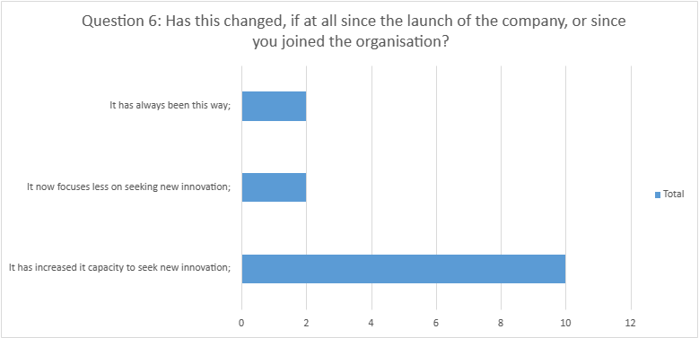

Figure 4.7 Q2.6

10 of the respondents indicate that this has not always been the way, and this would then suggest that is a skill developed by learned experience of management and LDW.

Question 7: How has LDW changed or adapted to meet demands posed inside the organisation (e.g., staffing, recruitment, structure)? Can you give an example?

 | Key words
Workforce has more than trebled in 4 years since company inception, roles have diversified, and structure is continually reviewed | - Growth of employee numbers  - Increase of roles  - Business structure  - Diversification of roles and thus skill sets
By developing existing staff and creating new roles more suited to the direction of the business since it was formed and as it has grown | - Training  - Increase of roles  - Diversification of roles and thus skill sets  - Strategic fit of roles
Delta Wellbeing has taken stock of what matters the most to its customers and adapted to change the strategic planning of new services and products to meet customer needs. For example: To facilitate more flow at acute hospital sites, Delta Wellbeing developed the 'Blue Army' to support patient discharge and provided a response service that supported patients to return home earlier than planned. | - Strategic analysis  - Market research  - Service/ product use analysis  - Innovative ways to deliver services to clients
Staffing levels have dramatically increased, and the company structure has evolved. | - Increase of employees  - Business structure
Higher focus on recruitment and staff workload. New OOH department to help spread this workload and adapt to new contracts | - Increase of employee numbers  - Prioritising recruitment  - Creation of new silos  - Agile
increased staffing | - Increase of employee numbers
Recruits staff from outside the organisation to bring in new ideas (which is rare in a Local authority linked organisation), constantly evaluating methods of delivery. | - Increase of employee numbers  - Human resource knowledge  - Strategic analysis  - Product/ service analysis
The business continues to grow, which brings staffing opportunities. | - Increase of employee numbers  - Capacity to accept new opportunities
Through transformation funded projects Delta Wellbeing has created and developed new service areas to meet the demands of our partners such as the Response Team. | - Funding via WG and other regeneration funding  - Partnerships with stakeholders  - Innovative delivery to meet demand
From prior to me starting employment with the organisation, the strategic implementation of roles/structure to enable various development of staff and services to drive growth has always been at the forefront of Delta Wellbeing's vision. Through implementation of the Connect project and how that has grown/developed over the past three years is testament to the vision of the leadership team. | - Development of business structure  - Increase of employee numbers  - Increase of roles  - Development of staff  - Organisational knowledge  - Innovative services/ products  - Leadership

Table 4.4 Q2.7

Factor: Markets/ Sub-Factor: Networks

Questionnaire 2

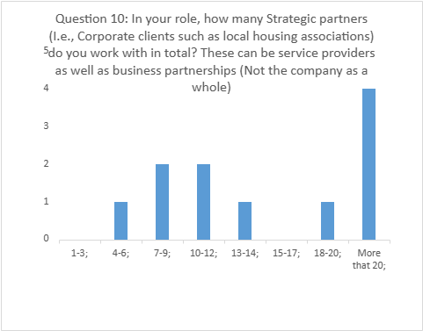

Figure 4.8 Q2.10

From these results, it can be concluding that management must consider a high number of stakeholders, with 4 respondents having 20 or more strategic partners, 1 respondent has 18-20 strategic partners, and a total of 6 with between 4 and 14 strategic partners.

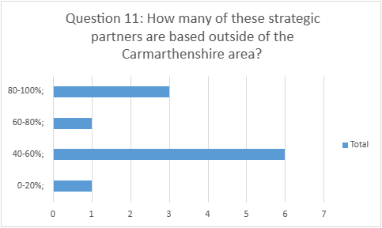

Figure 4.9 Q2.11

From the results, the over 50% of stakeholders which management interact with are based outside of Carmarthenshire.
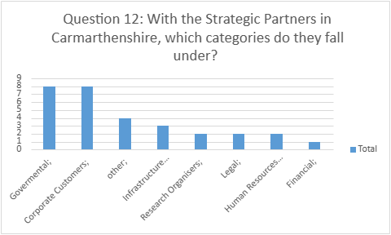

Figure 4.10 Q2.12

8 of the respondents answered governmental agencies in Carmarthenshire, 8 respondents answered that they deal with corporate customers which are situated in Carmarthenshire.

Question 13- If other was chosen in Question 13, can you clarify?
Governmental and infrastructure
Housing Associations
Health professionals, Care providers, Social Workers.
TEC providers
Uniform provider

Table 4.5 Q2.13

From the answer clarifying question 13, the majority of other Strategic Partners situated in Carmarthen are Governmental or Public services providers. The names of the companies have been changed as agreed with Senior Management of LDW.

Question 14: If you can, can you list the Carmarthenshire companies that you interact with in your workday? This can include companies such as those used for catering meetings, to uniform suppliers. This is to tally the characteristics of organisations used i.e., age of firm. names would not be included in the final report.

Marketing company 2  Marketing Company 1 | - Service provider- website design  - Service provider- website design
Marketing Company 1  Property management 1  My interactions with companies based in Carmarthenshire are limited, most interactions are with health, social care and universities within Wales and companies based nationally and globally | - Service provider- website design  - Service provider- property management  - Health and Social Care providers  - Health Board  - University
Supplier 1 | - Service provider- uniform manufacture
Business support 1  Uniform supplier 1 | - Supports- business support.  - Service provider- uniform manufacture
Uniform supplier 1  Training provider 1for NVQ delivery. | - Service provider- uniform manufacture  - Specialist training providers
Social services. Hywel Dda.  Uniform Supplier 1 | - Local Government agency  - Health Board
Uniform Supplier 1 | - Service provider- uniform manufacture

Table 4.6 Q2.14

Factor: Human Capital/ Sub-Factor: Educational Institutions

Questionnaire 1

The first four questions of Questionnaire 1 focus on the educational experience which has shaped the Human Resources of LDW.
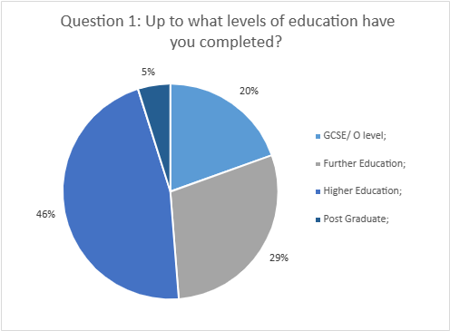

Figure 4.11 Q1.1

Of the respondents, 19 were educated to at least Higher Education Level, which is equates to 46%, This percentage is higher than the percentage total adults in Carmarthenshire educated up to Higher Education Level, which at was calculated by ONS (2021) as being 31.3% of the population. An addition 5% who have achieved post-Graduate level bringing the total number educated to at least Higher Education Level to 51%.
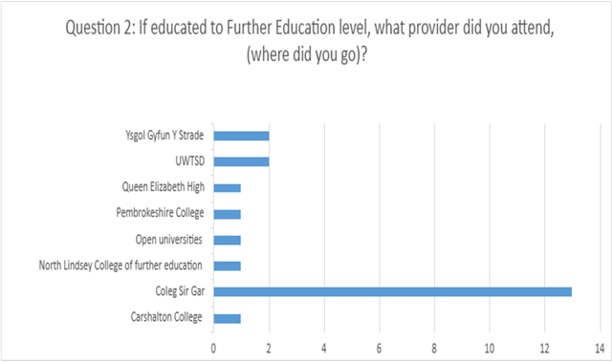

Figure 4.12 Q1.2

Of the 22 who responded to the question 59.09% (13) of the respondents indicated that they attended Coleg Sir Gar.

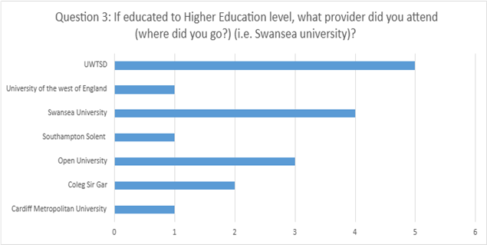

Figure 4.13 Q1.3

Carrying on the theme from the FE results, we can see that 64.7% obtained their Higher Education through educational providers which are situated in the Carmarthenshire / Swansea Area. Cardiff Metropolitan University, which is situated down the M4 corridor, 54 miles from LDW Eastgate Office in Llanelli, Carmarthenshire. An additional 17.65% taking Distance Learning course with the Open University.

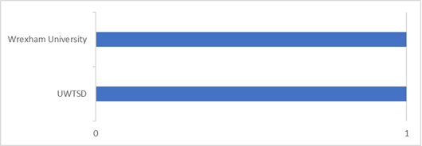

Figure 4.14 Q.4

Only 2 providers were mentioned regarding post graduate education (Figure 5.1.4). Both are Welsh Universities, though it is no indication in the question to differentiate whether the courses were studied in person or distance learning, nor the course studied.

Question 5 was designed to gather information regarding the inputted knowledge resources available to LDW.

Factor: Policy/ Sub-Factor: Labour

Questionnaire 1

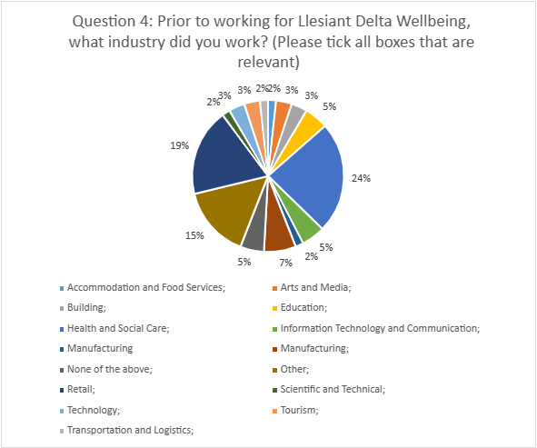

Figure 4.15 Q1.4

24% of employees have a background in Health and Social care.
Questions 6 to 11 were designed to assess the informal connections to the local business area.

The last set of questions are designed to assess the entrepreneurial experience and knowledge available to LDW.

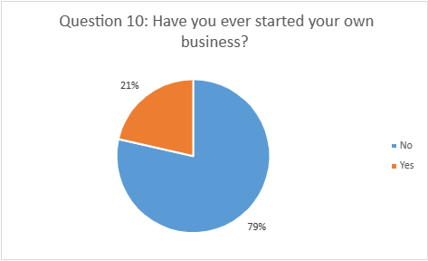

Figure 5.16 Q1.10

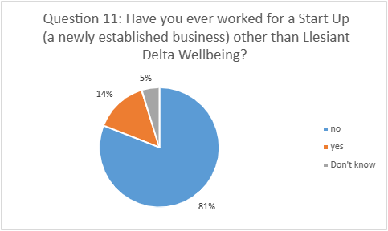

Figure 5.17 Q1.11

Responses to Question 11 shows that just over a fifth of employees, 21% of the respondents have started their own business, the limitation of this question is that there are no follow up questions about type of business which was established. Question 11 responses show though that in comparison that only 14% have worked for a start-up, not including LDW.

Factor: Culture/ Sub-Factor: Success Creation

Questionnaire 1

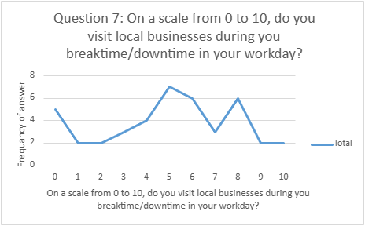

Figure 4.18 Q1.7

The results of frequency of visiting local businesses on break is mixed, with 5 respondents not visiting any while they are on their break. 7 respondents though indicated that the visited local businesses 50% of the time and 6 visited 80% of the time, only 2 respondents stated that the visited local businesses every breaktime.

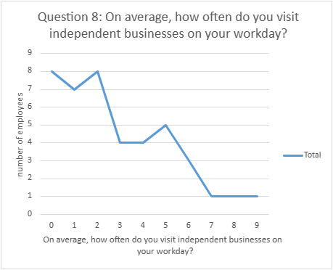

Figure 5.19 Q1.8

No respondent visited a local business on their break in their workday, while only 1 respondent visits a local business 90% of their breaks, 5 visit one 50% of their break 8 20% of the time. 8 respondents stated that they visited local businesses at no point during their breaks.
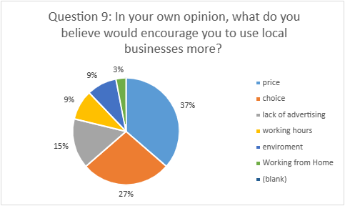

Figure 4.20 Q1.9

Price appears to be the biggest issues stopping employees from using local independent business of their break, with the next largest deterrent being the lack of choice available. Awareness off local independent businesses appear and the local environment is also an issue a large issue. Only 12% of responders are inhibited by issues resulting by working routine.

Actors

Identified Actors from interviews.

In the graph below, the Actors or Group of actors listed on the left is marked on the chart next to the Factors and Subfactors that they were discussed with during the interviews.
 | Finance | Human Capital- Educational Institutions | Human Capital- Labour | Markets= Early Customers | Markets- Networks | Policy- Government | Policy- Leadership | Supports- Infrastructure | Supports- Non-government institutions | Support Professions | Culture-Social Norms | Culture - Success Creation
Award providers
Cardiff university;
Care Inspectorate
CCC
CGI
Consultancy firm
Customers- B2B
Customers- Potential
Customers
Customers in the EE
EE organisations
EU
External business consultants;
Health & Social care Organisations
Health Board
infrastructure providers
customers- initial
Other Local Authorities
Local work force pool
Lunn Poly
Management
Networks
Public Sector
Research organisations
Silicon Cwm
Social media
Spanish and EU Health and Social Care
workforce
Strategic partners
TEC industry
Telecom Infrastructure i.e., Open Reach
Third Sector
Trade Unions- including Unison
TriTech
TSA
UK Government
University institutes
WG
RPB
wider economic environment

Table 4.7 Identified Actors from Interviews

From this chart, it is evident that CCC is the one organisation which LDW is biggest influence in the factors which surround LDW’s ecosystem. The only two factors that it does not feature in our Culture: Success stories and Labour: Educational Institutions. The second biggest influence of factors is the WG and then the Health Board and Health and Social Care organisations.

Identified Actors from LDW website.

The following is a summary of findings from the LDW website,
https://deltawellbeing.org.uk/. Analysis of LDW website can be found which can be found in Appendix D.

From the data from LDW’s website, we can see that there is just one organisation which is Carmarthenshire based only which is CCC. Appendix shows that 11 out of the 41 partners are the West Wales Region not including the Wale and UK wide categories, which would take the total to 14. If you expand the region which is in the EE to be the whole of the area of West and mid Wales RPB, the total number of this set of Actors in this EE is 17 out of the possible 41.

Discussion of Findings

Introduction

This chapter will discuss the analysed data collected in the view to answering how has the EE which LDW exists in developed to support innovation and growth of a businesses in the region to benefit economic and social change, with consideration to the original three aims of the report.

LDW as an Entrepreneurial Organisation

To begin the discussion into if and how LDW fits into an EE, first whether LDW is an example of Entrepreneurialism and what type must be debated. From the interviews carried out for this report, we can see evidence of Drucker’s (1985) view of what makes an entrepreneur, where “whatever changes the wealth-producing potential of already existing resources constitutes innovation” (Drucker, 1985):

“So, we might look to do something that. improve the way things work within Delta, or we may look at things that we could do externally. So, if you look at say, Response, good example where we have grown that into various pilots within say Neath Port Talbot and things like that. So, I suppose that's quite entrepreneurial. In a way it's not massively entrepreneurial because it's not a new idea, it's not, it's just an expansion of an existing idea.” (Extract from Interview 3).

This was a theme that is evident in all four interviews as categorised in Table 5.1, innovation started out relatively small, where there had been a gap in the market which then in turn LDW has been able exploit further. An example of this, is in the quite above, where they have taken their entrepreneurial service, Connect (Response), and expanded into new territories such as NPT, where there were no similar services. From this example alone, LDW can be considered a Kirzner (1975) entrepreneur, who was “alert to opportunity” and captured value from the “disequilibrium” of the unexploited opportunity which was the original gap. But we can also see that LDW also takes a Schumpeter (1985) entrepreneurial philosophy.

“Because what that's done is that has taken a problem and applied some, some you know technology effectively in a service to try and change the way things work. Nobody else has done it quite like that before as far as we're aware.” (Extract from Interview 3).

Thematic analysis of the interviews as see in Table 5.1.2 shows how LDW brought “disruption” to the industry, stakeholders were required to disrupt themselves to adjust to the new offering which are seen to be beneficial to their own social and financial goals. An example being LDW’s digital adoption, which although is not wholly new for the industry globally, it meets the criteria of “entrepreneurial venture” being “based on a significantly new way of doing things” (Wickham, 2006) and can be objectively seen as to be hastening the rate of change through the Health and Social Care industry, i.e. LDW and Hywel Dda’s TEC Health program, which through the use of TEC monitor a patient’s health post discharge, in hope of better outcomes for the patient. The analysis of Interviews in Table 5.1 also highlights how LDW have had opposition to its disruption by industries which are not ready to adopt the change or need to have results thoroughly scrutinised by stakeholders before wider adopters. Again, this corresponds with Drucker’s (1985) theory of innovation and entrepreneurship, for knowledge-based innovation to be adopted fully, a “convergence of several different kinds of knowledge is, not all of them scientific or technological” is needed. It is through this lens that LDW start to be seen as part of a wider EE. An entrepreneurial entity but one that’s entrepreneurial reach is dependent on other stakeholders.

From the data collected and initially discussed in 6.2, it is evident that LDW is part of a much larger Ecosystem than just the local region. What differentiates LDW as being part of an EE and not a Cluster or viewed through the lens of RIS, is LDW as a key actor, who is encouraging change in an industry, with support from public organisations such as Universities and Health Boards, whereas Cluster and RIS theories look at how these Public organisations look to facilitate and the exploration of innovation for their own aims, and of their larger resources to achieve them (Spigel, 2020). There is some overlap in the theories though as can be seen in the Extract 6.3, below. LDW is a LATC which was, as discussed in the interviews, born from internal and external pressures faced by not just CCC but other Local Authorities. CCC and its “Transformation Team’s” decision to create the LATC aligns closely with the corporate venturing school of thought, under Corporate Entrepreneurship Theory, where creation and management of new smaller enterprises are created separate, with a strategic aim to manage entrepreneurial activity without risk to the parent organisation (Burns, 2008).
“There was a consolidation in the market, and you know, Carmarthenshire really had to decide. You know, go large or go home sort of thing and you know they decided to go large or go big. So, we thought what our point of difference to what everyone else is doing?” (Extract 6.3 from Interview 1)

LDW’s Entrepreneurial Ecosystem

The boundaries of the LDW’s EE are fuzzy, and not explicit (Audretsch et al, 2018). The data collected presented in figure 20 can be seen as demonstrating that stakeholders LDW’s EE is not confined to Carmarthenshire, for example from a much farther area South and West Wales area in terms of institutes such as University and Research supports, and Public Sector agencies which feed into the EE (Mason and Brown, 2014: Alvedalen and Boschma, 2017). It is for this reason further discussion, when referencing LDW’s EE it will take the view of the EE encompassing South and West Wales and not just Carmarthenshire when discussing the factors of the EE unless stated that it relates substantially to Carmarthenshire alone.

Culture

As previously discussed, LDW emerged from need to create a new way of looking at CCC’s Social Care provision, but what can be asked is why did CCC take this approach when other LAs chose the more traditional path of inhouse or outsourcing the functions? The interviews carried out for this research, suggest that CCC’s culture is what differentiates itself from similar LAs. As Wickham (2006) suggests, the Culture of the environment is what heavily influences the proclivity to entrepreneurialism by its unique values systems and “social and industrial legacies” (Massey, 1995: Spigel, 2020 pg35).

There is evidence in the interviews though of organisational culture changing the culture and values of other actors in the EE. If we examine LDW in the eye of Hofstede’s dimensions and compare against Burn’s (2008, pg. 120, 121) description of “entrepreneurial culture summarized by Hofstede’s dimensions”, there is a clear match. Analysing the interviews, we can see a theme emerge where although there are several key entrepreneurial figures in LDW, there is a move from high Individualism to one that has a clear identity in the team, but which differs from the “out group” of competitors (Burns, 2008). LDW’s structure has developed from a small management team and initial staff to a larger more traditional hierarchical organisational structure. Still, there is evidence of Information flows through the organisation from director to lower levels through which was key to the buy in of existing staff at the creation of the organisation. Management structure also is relatively flat in retrospect, were ideas and information flow freely with the encouragement of the director, which is evident of a Low Power Distance:
“I'm kind of a figurehead cause I'm the MD of the company, but nothing works without the frontline staff at all. They are the ones that know when things are not working, and you know I often get some of the managers come to me and say oh so said this and you know they're not very happy with this. …………………...OK, so if we want to keep moving forward as an organisation, we've got to be brave. And I think culturally that's got a trickle down.” (Extract from interview 1).

The third dimension is Uncertainty Avoidance where entrepreneurs are thought to have low avoidance and high acceptance of risk (Burns, 2008). From the thematic analysis there is a high acceptance of calculated risk if the risk is in line with the wider business plan of creation of jobs and a Social Care DNA. Most interviewees saw themselves as having “what is the worst that can happen” mindset.

“We're quite lucky that we have actually got an MD who is willing to allow us to try and actually that's part and parcel of being able to be entrepreneurial because if you're being restricted, you, you, you're never going to change” (Extract from Interview 2).

LDWs culture of risk acceptance and tolerance of uncertainty, may have been amplified by the wider VUCA environment, and the significant stress the local EE of Carmarthenshire faced during the COVID-19 pandemic. As a new company, where its structures and culture were still forming, LDW was able to be agile to meet demand and took a continuous learning approach which helped to transfer this expertise into other business opportunities and areas. This then led to competitive advantage, when most organisations where closed or working on a skeleton staff.
The last of Hofstede’s dimensions is Masculinity which depicts the perceived the strictness in following social norms of a culture (Burns, 2008). LDW’s model was again a reaction to the pressures that the services faced prior to its creation. The need to break away from the strict governance of CCC so to be able to evolve so to save services, the time frames for change was shorter than would be the norm. This tolerance of risk is often a buy product of the wider cultural norms in a region and experience from past employment (Spiegel, 2020).

The findings from Questionnaire 1, question the wider entrepreneurial culture in Carmarthenshire, in other industries, and its casual links with LDW. As shown in Figure 5.18, only 5 employees stated 50% likely to visit at least one independent business in their workday. When asked the reason why, 37% answered that price was a big factor, and 27% answering choice. This shows the challenges faced by the economic outlook and the pressures of the Cost-of-Living Crisis, as discussed in the PESTLE analysis of Wales (Appendix A) shape EE’s local culture (Spigel, 2020).

Support

The support professions which play a large part in an EE, such as solicitors, and HR support, and which provide a secondary source of contacts in the network (Spigel, 2020), has been largely taken up by CCC for LDW. When setting up the organisation, a Service Level Agreement was put in place which they gave LDW access to CCC’s services for a fee, which does let LDW benefit from CCC’s economies of “scales and scope”, and strategic fit, while financially benefitting CCC by monetarising their services. CCC can been seen as having a monopoly on services which increases LDW outside factors which affect CCC’s quality and abundance of services (Hallikas, et al, 2004). These potentially as discussed in the PESTLE analysis (Appendix 5) include, struggling to recruit staff, lower revenues, and the ongoing potential for budget cuts. The Interviews do suggest though that the quality assurance provided by CCC’s support functions provide, makes up from the benefits further outsourcing would gain:

“Aligned to the county councils, which provides our trust for service users, for clients and their families. You know, ultimately our people are going to company, but we're about the County Council, we have the council logos and things, So there's a definite element of trust there.” (Extract from Interview 3).

LDW has been able to utilise development in infrastructure to its own advantage. A telecom switch from traditional analogue systems to digital one has been mandated by government and will be completed by 2023. This has left organisations, such as LDW who use analogue telephone lines to provide their core TEC business. LDW has need to manage the change, and in doing so has expanded their network of support further, to include global companies such as CGI. The Interviewees all strongly believe that LDW has been able to navigate the speed of change due to it being agile, but other organisations in the EE are not so equipped to manage the change.

From the results of Questionnaire 1, Question 6, geographical infrastructure inhibits staffs’ ability to access either of the two LDW offices. Public transport equates for just 18% of the journeys made by those questioned, of which 12% stated that they used public transport at all. 55% of all journeys were staff driving in and 22% of journeys made on foot. Effective transport links are thought to encourage people into areas which in turn would provide LDW access to a greater human resource pool (Audretsch & Belitski, 2016). The restriction of transport links, maybe countered though with the flexible working opportunities that the digital infrastructure upgrade will bring.

Human Capital

From the result data, there is a limited amount evident specific formal entrepreneurial training through Educational Institutions prior to the creation of LDW. This as Issenberg (2014) points out is not considered essential as entrepreneurship can often grow their skills organically. There though, is a large amount of entrepreneurial experience in the Senior Management Team. When asked if they could identify entrepreneurial traits in themselves, all considered themselves to have ability traits, such as problem solving and temperamental traits such as confident, open to risk (Wickam, 2006). All four interviewees linked their confidence with their past roles and industry knowledge.
All four interviewees have managerial training provided in their past employment. Interview 1 did not go the traditional educational route to begin with but had vocational training on the job, moving from sales to management in a small space of time in an industry, before moving to management in the CCC. The other interviewees are similar, with Interviewee 2 moving form management of another LA careline department to LDW, Interviewee 3 moving from a management role for an innovations company in the Health and Social care industry which was situated in the Welsh Innovation Cluster Region “Cwm Silicon” of in the South Wales Valleys. Interviewee 4 also came from a Senior management role in the Careline department of CCC. Entrepreneurial skills of the Senior Management team are supported by entrepreneurial staff with 21% having experience of starting their own business and 14% answering that they have worked for a startup.

As discussed, prior in the Literature Review chapter, sourcing and training skilled employees takes time and finances which are not readily available to start-ups. High-growth companies rely highly skilled available workforce (Spigel, 2020). Analysis of the Questionnaire 1 shows that there is a significant number of staff who have achieved higher education awards. This percentage is higher than the percentage total adults in Carmarthenshire educated up to Higher Education Level, which at was calculated by ONS (2021) as being 31.3% of the population. An addition 5% who have achieved post-Graduate level bringing the total number educated to at least Higher Education Level to 51%. As analysis of figure 5.1 Welsh Educational Institutes make up most institutes attended, with 64.7% obtaining the HE from Carmarthenshire or Swansea HE institutions. Additionally, thematic analysis of the interviews shows that educational institutes are key to ongoing training of staff and management in the organisation. The EE has helped shape tacit knowledge resources in LDW, with just under a quarter of staff at 24% report passed employment in the Health and Social Care sector. Other employment and education have also provided transferable skills, for example 9% of staff have a background in retail which provides customer service and sales skills. Technology employment experience has been found to be very low at just 3%. This view is supported by Senior Staff, with the Thematic Analysis finding that they strongly believe that previous employment brings skills, both tacit and soft, which formal education cannot alone.

Markets

Early customers which transferred from CCC provided not only early customers but market research for LDW via feedback loops (Liguori et al, 2012. LDW did have to persuade stakeholders of its aims and reassure those financial goals where not the primary aim. It is this push in relationship marketing that helped reputation when outside factors in the wider environment, its position in the market and contacts helped it to leverage its value proposition and it was able to innovate to meet demand. There is strong evidence with in all the results that LDW has indeed lowered barriers to market through its collaboration in the EE (Auerswald & Dani, 2017), and lead to identification of opportunities and possible innovative answers to problems which would not have been identified by just one point of view (Feld, 2012).

LDW has used different marketing strategies for different types of business customers. Social Media and website marketing plays a big role in the awareness of B2C, whereas B2B has been achieved by being an active player in its network, where opportunities have grown through relationships. Conferences and Awards have also helped LDW be seen by a wider audience.

Policy

As a LATC LDW can be seen as more vulnerable to governmental policy change that those of the private sector. When asked in Questionnaire 2, managerial staff believed that the differing objectives were a potential to hinder strategic business aims. Management also believes that remuneration in the public sector and not just LDW, were cause for concern when recruiting knowledgeable and experienced managers. LDW though, as a LATC does not have the same restrictions when hiring as public organisations such as CCC does. Recruitment can be flexible, without the limit of governance approval and red tape.

CCC and the WG have been a catalyst for encouraging leadership in LDW. LDW in turn have encouraged leadership and innovation in CCC, the Health Board and other partners it works with. It is these partnerships which management (Questionnaire 2, Question 5) helps LDW be innovative.

As an organisation which has come from CCC, unions play a large part in the policy making for LDW. Plans had to be agreed by Unions prior to the creation of LDW. There was considerable onboarding that needed to be done with existing staff and that included having the Unions in agreement also increasing the amount of red tape and barriers that LDW has had to overcome.

Finance

On analysis, financial factors of the EE worked solely as pressure on LDW. Increased cost due to macroeconomic and microeconomic factors. Financially sustainable Health and Social care services, and LDW have been an issue in recent years. Modernisation of services, including the change to digital infrastructure systems, have increased the costs in the short term, prior to the industry seeing any benefit from the change. Due the economic obstacles, not all businesses and organisations in the EE are necessarily able to cope with the added cost. LDW is more susceptible to such pressures as due to being a LATC, it does not have the flexibility to seek traditional private forms of investments.

LDW has initially been dependant on grant funding from the WG in the initial creation of the Connect project. As discussed in the PESTLE analysis (Appendix A), funding of this sort is dependent on external factors, in this case EU regeneration funds provided to the WG after Brexit. Questionnaire Question 9 supports that relying on public finances in exchange for services which LDW supply, limits the funds available to expand and develop the services further.

Conclusion

The aim of this study was to answer how EE in which LDW exists has developed to support innovation and growth of a businesses in the Carmarthenshire Region to benefit economic and social change. It became clear early in the research that LDW’s EE is larger than Carmarthenshire itself and encompassed a large section of both West and South Wales. This has caused the conclusions to be more generalised than for a specific region.

There is a history of entrepreneurial action by individuals and organisations, long prior to LDW’s creation. The initiation of the RTB by the WG provided a catalyst for new ideas when regions had to compete for much needed funding for their areas, in a backdrop of service cuts and austerity. CCC’s RTB and LDW can be both seen as entrepreneurial organisations, taking existing services and transforming them into new business models and growing to meet new opportunities, fitting Drucker’s entrepreneur definition of “whatever changes the wealth-producing potential of already existing resources constitutes innovation” (Drucker, 1985).

LDW’s unique ability appears to be in part their skill of opportunity spotting. Early customers in the EE, both Carmarthenshire and West and South Wales, have created feedback loops, identifying opportunities but also weaknesses. LDW’s alertness, and unique problem-solving skills have led to growth from their modest beginnings in a service where many peers were failing. Through partnerships, such as the local health board, it is challenging the way others are working, helping the industry adapt and the EE to strengthen.

Data gathered, both primary and secondary, support current EE theories as outlined in the Literature Review chapter of this report. It is argued in the discussion that the EE has shaped LDW’s innovative approach, through the role based entrepreneurial training that the Senior managers have experienced in their previous roles, as well as a culture which has nurtured entrepreneurism as a norm in their current roles. The research has also found that a good available supply of work force who are adaptable and can deal with ambiguity, with experience in the field has helped LDW to become agile to meet demand. At present, this works in LDW’s advantage, but as LDW grows it is to be seen if the current supply of available workforce will match demand. It will be seen if LDW and the EE can grow and evolve together in a sustainable way, where goals are broad but the environment unpredictable.

Recommendations

Recommendation 1: Further expansion of this study is recommended to fully understand the EE. It may be beneficial to carry out the same analysis of the private sector and the public sector and compare to LDW so to fully understand how the EE can be supported to increase positive outcomes in the Health and Social care industry. This would be done ideally in partnership with or by the WG or another governing body who have the capacity to put in place policy changes and supports to encourage its growth.

Recommendation 2: It is this researcher's recommendation that there should be a uptick in universal entrepreneurial training, through on the job or training courses or giving employees freedom to become more intrapreneur in their roles, can nurture a culture where entrepreneurialism and calculated risk is a norm, as well as identify potential leaders in an organisation.

Recommendation 3: Networks between LDW, Health Boards and other partners could look to invite further research organisations, start-ups, educational providers, and others in the EE not already included, to foster further collaborations in the EE and support greater innovation. Greater communication and knowledge sharing should be encouraged by CCC and governing partners.

Recommendation 4: LDW as a case of a LATC has shown how it can successfully be achieved, and that LDW has benefited by cheap but high-quality support services. There could be opportunities for other spill overs, even support services themselves, which can be utilised to support start-ups in the EE. Keeping them LACT and not fully private will help CCC keep an eye on the quality provided but also help make services agile and future proof.

Bibliography

Alvedalen, J. and Boschma, R., (2017). A critical review of entrepreneurial ecosystems research: Towards a future research agenda. European planning studies, 25(6), pp.887-903.

Amaral, M., (2019). ‘‘Entrepreneurial Ecosystems and the Diffusion of Startups” by (Eds.) Alvarez, S., Carayannis, EG, Dagnino, GB, & Faraci, R. (Edward Elgar Publishing, 2018).

Ardichvili, A., Cardozo, R. and Ray, S., (2003). A theory of entrepreneurial opportunity identification and development. Journal of Business venturing, 18(1), pp.105-123.

Audretsch, D. B., & Belitski, M. (2017). Entrepreneurial ecosystems in cities: establishing the framework conditions. The Journal of Technology Transfer, 42, 1030-1051.

Audretsch, D.B., Cunningham, J.A., Kuratko, D.F., Lehmann, E.E. and Menter, M., (2019). Entrepreneurial ecosystems: economic, technological, and societal impacts. The Journal of technology transfer, 44, pp.313-325.

Audretsch, D., Mason, C., Miles, M. P., & O’Connor, A. (2018). The dynamics of entrepreneurial ecosystems.

Audretsch, D. B., Obschonka, M., Gosling, S. D., & Potter, J. (2017). A new perspective on entrepreneurial regions: linking cultural identity with latent and manifest entrepreneurship. Small Business Economics, 48, 681-697.
Auerswald, P. E., & Dani, L. (2017). The adaptive life cycle of entrepreneurial ecosystems: the biotechnology cluster. Small Business Economics, 49, 97-117.

Autio, E., Kenney, M., Mustar, P., Siegel, D. and Wright, M., (2014). Entrepreneurial innovation: The importance of context. Research policy, 43(7), pp.1097-1108.

Babbie, E. R., (2010) The Practice of Social Research. 12th ed. Belmont, CA: Wadsworth Cengage.

Baron, R.A., (2004). The cognitive perspective: a valuable tool for answering entrepreneurship's basic “why” questions. Journal of business venturing, 19(2), pp.221-239.

Bassey, M. (1999). Case study research in educational settings. McGraw-Hill Education (UK).

Battram, A. (1999). Navigating complexity: The essential guide to complexity theory in business and management. Spiro Press.

Belitski, M., Martin, J., Stettler, T., & Wales, W. (2023). Organizational scaling: the role of knowledge spillovers in driving multinational enterprise persistent rapid growth. Journal of World Business, 58(5), 101461.

Binks, M., Starkey, K., & Mahon, C. L. (2006). Entrepreneurship education and the business school. Technology Analysis & Strategic Management, 18(1), 1-18.

Bolton, B. & Thompson, John. (2000). Entrepreneurs: Talent, Temperament, Technique: First Edition.

Bonner, K., Prashar, N., Ri, A., & Hart, M. (2017). GEM UK: Wales Report 2021.

Brown, R., & Mason, C. (2017). Looking inside the spiky bits: a critical review and conceptualisation of entrepreneurial ecosystems. Small business economics, 49, 11-30.

Burns. (2007). Entrepreneurship and small business (2nd ed.). Palgrave Macmillan.

Burns. (2008). Corporate Entrepreneurship: Building the Entrepreneurial Organization (2nd ed.). Palgrave Macmillan.

Bryman, & Bell, E. (2003). Business research methods. Oxford University Press.

Campbell, C. A. (1992). A decision theory model for entrepreneurial acts. Entrepreneurship theory and practice, 17(1), 21-27.

Cantner U., Cunningham, J. A., Lehmann, E. E., & Menter, M. (2021). Entrepreneurial ecosystems: a dynamic lifecycle model. Small Business Economics, 57(1), 407–423.

Carayannis, E. G., Grigoroudis, E., Campbell, D. F., Meissner, D., & Stamati, D. (2018). The ecosystem as helix: an exploratory theory‐building study of regional co‐opetitive entrepreneurial ecosystems as quadruple/quintuple helix innovation models. R&d Management, 48(1), 148-162.

Carland, J. W., Hoy, F., Boulton, W. R., & Carland, J. A. C. (1984). Differentiating entrepreneurs from small business owners: A conceptualization. Academy of management review, 9(2), 354-359.

Carter, S., Jones-Evans D., (2006), Enterprise and Small Business; Principal, Practice and Policy, 2nd Edition, Essex: Pearson Education Limited.

Carvalho, L.C. ed., 2017. Handbook of research on entrepreneurial ecosystems and social dynamics in a globalized world. IGI Global.

Ceresia, F., & Mendola, C. (2019). The effects of corruption in entrepreneurial ecosystems on entrepreneurial intentions. Administrative Sciences, 9(4), 88.

Cohen B, (2006). Sustainable Valley Entrepreneurial Ecosystems. Business Strategy & The Environment, 15(1),

Collinson S., Narula, R., & Rugman, A. M. (2012). International Business (Sixth Edition.). Pearson.

Cooke, P. (2001). Regional innovation systems, clusters, and the knowledge economy. Industrial and corporate change, 10(4), 945-974.

Deamer, I., & Earle, L. (2004). Searching for entrepreneurship. Industrial and commercial training, 36(3), 99-103.

Department For Environment Food & Rural Affairs, (2021). United Kingdom Food Security Report 2021: Theme 2: Uk Food Supply Sources, retrieved from United Kingdom Food Security Report 2021: Theme 2: Uk Food Supply Sources - Gov.Uk (Www.Gov.Uk)

Department For Environment Food & Rural Affairs, 2023, Food Statistics in Your Pocket. UK Government. Retrieved from https://www.gov.uk/government/statistics/food-statistics-pocketbook/food-statistics-in-your-pocket

Drucker P. F., (1985), Innovation and Entrepreneurship, New York: Butterworth-Heinemann.

Galindo, M. Á., & Méndez, M. T. (2014). Entrepreneurship, economic growth, and innovation: Are feedback effects at work? Journal of business research, 67(5), 825-829.

Gedeon, S. (2010). What is entrepreneurship. Entrepreneurial practice review, 1(3), 16-35.

Gov.Uk, (2023), Schedule of Retained Eu Law, Department for Business and Trade.

Gray, C., (1998), Enterprise and Culture, London: Routledge: Rae, D., (2007) Entrepreneurship from Opportunity to Action, 1st Edition, London: Palgrave Macmillan.

Green, L., Ashton, K., Azam, S., Clemens, T., & Bellis, M. (2023). Brexit, COVID-19, and climate change: mapping the impact of the ‘triple challenge’on health and well-being in Wales. Impact Assessment and Project Appraisal, 41(2), 126-138.

Hallikas, J., Karvonen, I., Pulkkinen, U., Virolainen, V. M., & Tuominen, M. (2004). Risk management processes in supplier networks. International journal of production economics, 90(1), 47-58.

Hanlon, G. (2014). The entrepreneurial function and the capture of value: Using Kirzner to understand contemporary capitalism. ephemera: theory & politics in organization, 14(2), 177-195.

Hayes, N. (2000). Doing psychological research: Gathering and analysing data. Open University Press.

HM Government, (2022). The Benefits Of Brexit: How The UK Is Taking Advantage Of Leaving The EU, retrieved from https://Assets.Publishing.Service.Gov.Uk/Government/Uploads/System/Uploads/Attachment_Data/File/1054643/Benefits-Of-Brexit.Pdf

Holland, J. H. (1992). Complex adaptive systems. Daedalus, 121(1), 17-30.
Houchin, K., & Maclean, D. (2005). Complexity Theory and Strategic Change: An Empirically Informed Critique. British Journal of Management, 16(2)

Howorth, C., Tempest, S. And Coupland, C., 2005. Rethinking Entrepreneurship Methodology and Definitions of The Entrepreneur. Journal Of Small Business and Enterprise Development, 12(1), Pp. 24-40.

IMF. (2022). World Economic Outlook, October 2022: Countering the Cost-Of-Living Crisis, IMF

IPCC, (2023) Ar6 Synthesis Report: Climate Change 2023, IPCC.

Isenberg D (2011) The Entrepreneurship Ecosystem Strategy as A New Paradigm for Economic Policy: Principles for Cultivating Entrepreneurship. Dublin: Institute of International European Affairs.

Isenberg, D. (2014). What An Entrepreneurship Ecosystem Actually Is. Harvard Business Review Digital Articles, 2-6.
Isenberg, D. J. (2016). Applying the ecosystem metaphor to entrepreneurship: Uses and abuses. The Antitrust Bulletin, 61(4), 564-573.

Isenberg, D., & Onyemah, V. (2016). Fostering scale up ecosystems for regional economic growth. In Global Entrepreneurship Congress (pp. 71-97).

Jack, K. (2020), What The UK Global Tariffs Mean For Dairy, Agriculture And Horticulture Development Board, retrieved from At Https://Ahdb.Org.Uk/News/What-The-Uk-Global-Tariffs-Mean-For-Dairy.

Jack, S., Anderson, A., (1999), Entrepreneur Education Within Enterprise Culture. International Journal of Entrepreneurial Behaviour and Research, 5(3), P.110-25.

Johnson, G., Whittington, R., Scholes, K., Angwin, D., & Regnér, P. (2017). Exploring Strategy: Text and Cases, Eleventh Ed., Harlow: Pearson Education Limited.

JRF. (2023). Going Under And Without: Jrf’s Cost Of Living Tracker, Winter 2022/23 retrieved from Https://Www.Jrf.Org.Uk/Report/Going-Under-And-Without-Jrfs-Cost-Living-Tracker-Winter-202223.

Jung, K., Eun, J. H., & Lee, S. H. (2017). Exploring competing perspectives on government-driven entrepreneurial ecosystems: lessons from Centres for Creative Economy and Innovation (CCEI) of South Korea. European Planning Studies, 25(5), 827-847.

Kirzner I. M., (1973), Competition and Entrepreneurship, Chicago: Chicago University Press.

Kirzner I. M., (1997), Entrepreneurial Discovery and The Competitive Market Process: An Austrian Approach, Journal of Economic Literature, 35, P.- 60-85.

Kirzner I. M., (1999), Creative And/or Alertness: A Reconsideration of The Schumpeterian Entrepreneur, Review of Austrian Economics, 11 P.-5-17.

Kshetri, N. (2014). Global Entrepreneurship: Environment and Strategy. Routledge.

Kuckertz, A. (2019). Let's take the entrepreneurial ecosystem metaphor seriously! Journal of Business Venturing Insights, 11, e00124.

Leibenstein, H. (1968). Entrepreneurship And Development. American Economic Review, 58(2), 72

Liguori, E., Bendickson, J., Solomon, S., & McDowell, W. C. (2019). Development of a multi-dimensional measure for assessing entrepreneurial ecosystems. Entrepreneurship & Regional Development, 31(1-2), 7-21.

Lopes, J., Farinha, L., & Ferreira, J. J. (2019). Exploring entrepreneurial ecosystems: a bibliometric review. Smart specialization strategies and the role of entrepreneurial universities, 1-30.

Lowe, L, Marriott, S., (2006), Enterprise: Entrepreneurship and Innovation Concepts, Contexts and Commercialization, 1st Edition, Oxford: Butterworth-Heinemann. P.13.

Mack, E., & Mayer, H. (2016). The Evolutionary Dynamics of Entrepreneurial Ecosystems. Urban Studies, 53(10), 2118-2133.

Marr, B. (2022). The Top 10 Tech Trends In 2023 Everyone Must Be Ready For, retrieved from https://Www.Forbes.Com/Sites/Bernardmarr/2022/11/21/The-Top-10-Tech-Trends-In-2023-Everyone-Must-Be-Ready-For/?Sh=3aabc7ae7df0

Mason, C., & Brown, R. (2014). Entrepreneurial ecosystems and growth-oriented entrepreneurship. Final report to OECD, Paris, 30(1), 77-102.

Mason, C., & Brown, R. (2014). Entrepreneurial ecosystems and growth-oriented enterprises: background paper prepared for the workshop organised by the OECD LEED Programme and the Dutch Ministry of Economic Affairs.

Maylor, & Blackmon, K. L. (2005). Researching business and management. Palgrave Macmillan.

Mckenzie B., Ugbah S. D., Smother N., (2007), “Who Is an entrepreneur?” Is It Still the Wrong Question? Academy Of Entrepreneurship, 13(1). P.-23-43.

Miller, V. (2016). Brexit: Impact Across Policy Areas, House Of Commons Library, retrieved from Https://Researchbriefings.Files.Parliament.Uk/Documents/Cbp-7213/Cbp-7213.Pdf

Morrissette, S. G. (2007). A profile of angel investors. The Journal of Private Equity, 52-66.

Muijs, D., (2010), Doing Quantitative Research in Education with SPSS. 2nd Edition. London: Sage Publications.

Natural Resource Wales (2023) Ecosystem Resilience Field Guide, retrieved from https://naturalresources.wales/guidance-and-advice/environmental-topics/land-management/ecosystem-resilience-field-guide/?lang=en, (last accessed on 01/09/2023)

Natural Resource Wales (2023b), Our Work On Climate Change, retrieved from Https://Naturalresources.Wales/About-Us/What-We-Do/Our-Roles-And-Responsibilities/Climate-Change/Our-Work-On-Climate-Change/?Lang=En#:~:Text=Risks%20in%20wales,-Our%20work%20on&Text=Increases%20in%20deaths%20and%20illness,Supplies%20and%20the%20natural%20environment (last accessed on 01/09/2023)

Neck, H. M; Meyer, G. D; Cohen, B; Corbett, C; (2004). An Entrepreneurial System View of New Venture Creation. Journal Of Small Business Management, 42(2), 190-209.

Neumeyer, X., & Poncela-Casasnovas, J. (2016). Detecting social boundaries in entrepreneurial ecosystems. In Academy of Management Proceedings (Vol. 2016, No. 1, p. 14065). Briarcliff Manor, NY 10510: Academy of Management.

Neumeyer, X., & Santos, S. C. (2018). Sustainable business models, venture typologies, and entrepreneurial ecosystems: A social network perspective. Journal of cleaner production, 172, 4565-4579.

Nylund, P. A., & Cohen, B. (2017). Collision density: driving growth in urban entrepreneurial ecosystems. International entrepreneurship and management Journal, 13, 757-776.

NHS Wales. (2019). The Public Health Impact of Brexit in Wales: A Health Impact Assessment Approach. Main Findings. Cardiff, Public Health Wales NHS Trust.

Nylund, P. A., & Cohen, B. (2017). Collision density: driving growth in urban entrepreneurial ecosystems. International entrepreneurship and management Journal, 13, 757-776.

ONS, (2018). Living Longer: How Our Population Is Changing And Why It Matters, retrieved from https://www.ons.gov.uk/peoplepopulationandcommunity/birthsdeathsandmarriages/ageing/articles/livinglongerhowourpopulationischangingandwhyitmatters/2018-08-13

ONS, (2019), Living Longer and Old-Age Dependency – What Does the Future Hold? Retrieved from Https://Www.Ons.Gov.Uk/Peoplepopulationandcommunity/Birthsdeathsandmarriages/Ageing/Articles/Livinglongerandoldagedependencywhatdoesthefuturehold/2019-06-24

ONS, (2021). Overview Of The UK Population: January 2021, retrieved from Https://Www.Ons.Gov.Uk/Peoplepopulationandcommunity/Populationandmigration/Populationestimates/Articles/Overviewoftheukpopulation/January2021#Impact-Of-The-Coronavirus-Covid-19-On-Population-And-Migration-Statistics

Oppenheim, & Oppenheim, A. N. (Abraham N. (2008). Questionnaire design, interviewing and attitude measurement. Continuum.

PCW. (2023). Why Resilience Matters to The UK Public, PCW. Retrieved from Https://Www.Pwc.Co.Uk/Services/Risk/Rethink-Risk/Insights/How-The-Cost-Of-Living-Crisis-Is-Changing-People-S-Behaviours-An.Html

Petrakis, P. E. (1997). Entrepreneurship and growth: creative and equilibrating events. Small Business Economics, 9, 383-402.

Petrakis, P. E. (2004). Entrepreneurship and risk premium. Small Business Economics, 23, 85-98.

Porter. (1990). The competitive advantage of nations. Macmillan.

Public Health Wales, (2021). More at risk of health outcomes from Brexit after pandemic increases vulnerability, retrieved from https://phw.nhs.wales/news/more-at-risk-of-poor-health-outcomes-from-brexit-after-pandemic-increases-vulnerability/

Rae D., (2007), Entrepreneurship from Opportunity to Action, 1st Edition, London: Palgrave Macmillan,

Ratten, V. (2020). Entrepreneurial ecosystems. Thunderbird International Business Review, 62(5), 447-455.

Roberts, E. B., (1991), Entrepreneurs in High Technology: Lessons from MIT And Beyond, Oxford: Oxford University Press,

Roger E., (1962), Diffusion of Innovations, Accessed At Http://Moodle.Uwtsd.Ac.Uk/Course/View.Php?Id=4451#Section-3

Roundy, P. T. (2017). Hybrid organizations and the logics of entrepreneurial ecosystems. International Entrepreneurship and Management Journal, 13, 1221-1237.

Roundy, P., Bradshaw, M., & Brockman, B. (2018). The Emergence of Entrepreneurial Ecosystems: A Complex Adaptive Systems Approach. Journal Of Business Research, 86, 1-10.

Roundy, P. T., & Fayard, D. (2019). Dynamic capabilities and entrepreneurial ecosystems: The micro-foundations of regional entrepreneurship. The Journal of Entrepreneurship, 28(1), 94-120.

Salgado-Banda, H., 2007. Entrepreneurship And Economic Growth: An Empirical Analysis. Journal Of Developmental Entrepreneurship, 12(1), Pp. 3-29.

Samila, S., & Sorenson, O. (2011). Venture Capital, Entrepreneurship, And Economic Growth. The Review of Economics and Statistics, 93(1), 338-349.

Scaringella, L., & Radziwon, A. (2018). Innovation, entrepreneurial, knowledge, and business ecosystems: old wine in new bottles? Technological Forecasting and Social Change, 136, 59-87.

Schumpeter, J., A., (1947), The Creative Response in Economic History, The Journal of Economic History, 7(2) P.- 149-159.

Schumpeter, J.A., (1934), The Theory of Economic Development: An Enquiry into Profits, Capital, Credit, Interest, And the Business Cycle, Cambridge: Harvard University Press.

Senedd Cymru, (2018). What Impact Will Brexit Have On The Welsh Economy? retrieved from https://research.senedd.wales/research-articles/what-impact-will-brexit-have-on-the-welsh-economy/#:~:text=The%20scenario%20simulations%20reveal%20that%20Brexit%20will%20lead,GDP%2C%20GDP%20per%20capita%2C%20trade%2C%20investment%20and%20employment.

Spigel, B. (2017). The Relational Organization of Entrepreneurial Ecosystems. Entrepreneurship: Theory & Practice, 41(1), 49-73.

Spigel, B. & Harrison, R (2018). Toward A Process Theory of Entrepreneurial Ecosystems. Strategic Entrepreneurship Journal, 12(1), 151-169.

Spigel. (2020). Entrepreneurial ecosystems: theory, practice, and futures. Edward Elgar Publishing.

Stam, E., & Van de Ven, A. (2021). Entrepreneurial ecosystem elements. Small business economics, 56, 809-832.

Tellis, W. (1997). Application of a case study methodology. The qualitative report, 3(3), 1-19.

Tourmen, C. (2009). Evaluators' decision making: The relationship between theory, practice, and experience. American Journal of Evaluation, 30(1), 7-30.

Vale, P. A. And Addison, M. (2001) ‘Promoting Entrepreneurship and Innovation in A Large Company: Creating A Virtual Portfolio’, Journal of Change Management, 2(4), P. 334.

Van Praag, C. M., & Versloot, P. H. (2007). The economic benefits and costs of entrepreneurship: A review of the research. Foundations and Trends® in Entrepreneurship, 4(2), 65-154.

Voss, C. (2010). Case research in operations management. In Researching operations management (pp. 176-209). Routledge.

Welsh Government, (2022), Welsh Government’s Net Zero Strategic Plan, September 2022, Welsh Government.

Welsh Government, (2023). Eu Exit and Eu Funded Projects, Gov.Wales, retrieved from EU exit and EU funded projects | GOV.WALES

Welsh Government, (2023b). Law Wales: UK Parliament And Government In Wales, retrieved from Https://Law.Gov.Wales/Constitution-And-Government/Law-Making-Wales/Uk-Parliament-And-Government-Wales

Wennekers, S. & Thurik, (1999), Linking Entrepreneurship and Economic Growth, Small Business Economics, 13 (1) Pp 27–56

Westhead P., Ucbasaran D., Wright M., Binks M., (2005), Novice, Serial and Portfolio Entrepreneur Behaviour and Contributions, Small Business Economics, Vol. 25(2), P.109–132.

Wickham, P. A., (2006), Strategic Entrepreneurship, 4th Edition, Essex: Pearson Education Limited.

World Economic Forum. (2013). Entrepreneurial ecosystems around the globe and company growth dynamics. Retrieved from http://www3. weforum. org/docs/WEF_EntrepreneurialEcosystems_Report_2013. pdf (25.06. 2020).

Wright, M. & Vanaelst, I. (2006) Entrepreneurial Teams. Cheltenham: Edward Elgar, Accessed From: Wright, M., (2012) Entrepreneurship and Growth, International Small Business Journal 31(1) 3 –22.

Yin, R. K. (2009). Case study research: Design and methods (Vol. 5). sage.

Appendices

Appendix A- Background – PESTLE analysis of Wales 2018 to 2023 and future

According to CIPD (2023), PESTLE analysis is an important tool for understanding broad trends which could potentially affect business, so to allow for strategic planning. In the purpose for this report, PESTLE analysis is a useful the report so to look at background factors which have the potential to affect businesses in Wales, now and in the future. It takes a holistic approach, where the main body of this report will investigate the factors which affect the EE individually.

Political

As of 31/01/2020, Wales was, along with the rest of the UK, left the European Union, pending the 2016 referendum. A referendum where 52.5% of Welsh voters voted to leave the EU (Miller, 2016), slightly higher that the UK wide result of 51.9%.
Europe was the UK’s largest trading partner is 2016, accounting for 44% of imported goods and 53% of exports (Miller, 2016). though, Welsh Government's preferred resolution to Brexit is at odd with Westminster’s, the Senedd would ideally like “continued and unfettered access to Europe's Single Market and remaining in the EU Customs Union” (Senedd Cymru,2018) it looking to future. Historically, Wales benefited from EU funding, with an estimated £2.7bn contributed by the EU to Wales between 2014 and 2020 (Miller, 2016). Projects funded in Wales by the European Union, have been set the deadline of 2023 to end the funding and to find alternative support, though reassurance was given that funding would continue for existing projects to this date (Welsh Government, 2023). ramifications from Brexit, and the imposition of tariffs on good from the EU which one would have been tariff free. The British Government have adopted chosen to create a “UK Global Tariff” system, which looks to converge existing global Tariff regulations and new European tariffs, which they hope will reduce cost for business (HM Government, 2022). Governments impose often tariffs to protect local industries (Collinson & Rugman, 2012). A joint study by Cardiff University and the Welsh Government found that although, tariffs have a low to medium risk on export trade of Medical/Health products and services, but it found that tariff will have effects on outputs, with a Medium to High-risk effect on Medical/Health products and services (Senedd Cymru, 2018).

Economical

Cost of Living Crisis

Findings from PCW’s Annual survey carried out in August 2022, found that 54% of adults were worried about, an increase of 14% of the previous year, which the sample surveyed said they were going to cut back on non-essential expenditure (PCW, 2023). There are several reasons why the cost of Living has increased so rapidly in the past 18 months, these include the increase of electricity and gas prices, though capped by the UK government, still doubled from 2021 to 2022 and the surge in the price cost of goods such as milk and pasta having increased by 30% partly due to agricultural issues caused by the Ukrainian war (Institute for Government, 2023), and Brexit as previously discussed. Research carried out by the Joseph Rowntree Foundation has found that 7.2 million are going without basics, with the lowest 20% of incomes going without food or other essentials (JRF, 2023). The “Cost of Living Crisis” has a knock-on effect for the economy, with IMF predicting that the UK economy will grow just 0.3% in 2023, lower growth than all but two other advanced economies, and weakest growth since the 2020 when the county was in the grips of the COVID-19 pandemic (IMF, 2022).

Social

According to the Office of National Statistic’s finding from the 2021 Census, the UK’s population has grown to 66.8 million in mid-2019, with Wales’s population at 3.2 million. Population growth has slowed down to 0.5% for the UK in 2019, with Wales’s population growth slightly lower at 0.45%. 2019 saw 29,704 births and 33,183 deaths. The ONS, have not looked at 2020 in this analysis due to the disruption caused by the COVID-19 pandemic, and skewed net migration figures (ONS, 2021).
The ONS (2021) also found that there was an increase of one person households, with numbers on single occupant households increasing by 95 in the last decade to 8.2 million, which they found was largely made up by older adults aged 65 and over, 49.1 % over 65 years old or older and of which 29% were 75 years old or over (ONS, 2021).

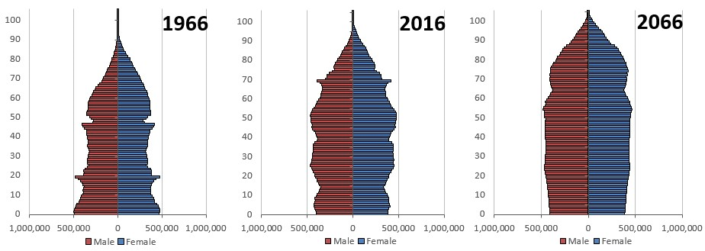
Figure A.1 ONS UK population growth chart (ONS, 2018)

The Census 2021 also showed that the UK’s population is aging, Figure 1.1 is an infographic showing population age range in the last 50 years up to 2016 and predictive growth for the following 50 years. The 2021 Census follows similar pattern (ONS 2021). The older population of 65 years and older are continuing to grow, with those reaching retirement in the next decade and a half coming from the Baby Boomer generation. It is predicted that by the year 1939, one in four will be over the age of 65 years old (ONS, 2021). This has significant issues for health services as cost per person increases as they get older.

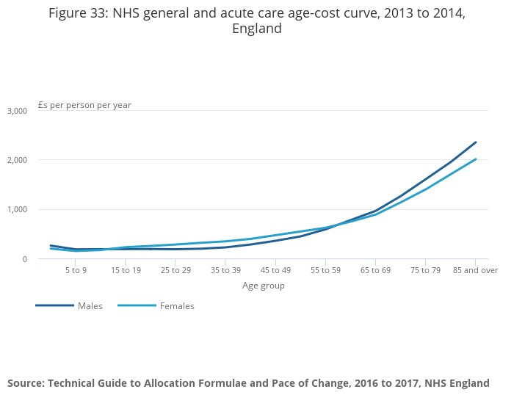
Figure A.2 NHS general and acute care age-cost curve, 2013 to 2014, England (ONS, 2019)

Technology

In his 2022 article for Forbes, Futurist Bernard Marr predicts that the most important Technology trends are the increasing use of AI - Artificial Intelligence, the Metaverse – the immersive internet which includes Augmented Reality and Virtual Reality, Web3 – decentralized internet which is driven by Blockchain technology and AI, use of Digital Twins and 3D printing for design, Nanotechnology, Quantum Computing, Green Technology, more human like robotic, Autonomous systems- such as self-driving vehicles, and sustainable technology (Marr, 2022). Deloitte Insights report (2023) “Tech Trends 2023” discusses these ten trends but through the lens of what it means for business, as it will afford businesses with “immersive environments” so to “streamline operations” or “collaborate and learn”, AI will assist decision making, while blockchain systems help by removing complexity of Cloud systems so streamlining, while increasing security (Deloitte, 2023).

Legal

Wales is a devolved nation of the UK, and while laws can be specifically for Wales by the Senedd Cymru since 2006, UK wide law must be made by the UK Parliament, which also has the power to legislate for Wales in matters which include, “policing, justice, social security, and most commercial/business law” (Welsh Government, 2023 b). In the aftermath of Brexit, Retained EU law (REUL) was created so to conserve all EU law as it stood at the time of the UK’s departure of the EU for continuity, but this bill is due to be revoked from December 2023 when the UK government hopes to revoke or reform all outstanding EU laws (Gov.UK, 2023).

Environmental

A United Nations body: The Intergovernmental Panel on Climate Change (IPCC) has made six reports on the impacts of climate change, through the lens of sociological, technical, and scientific data, since 1988, the newest one in 2023. It found that while it was likely that increased “agriculture and ecological drought”, and an increased “compound flooding” was with “medium confidence” a result of man-made, Global Sea level change was very likely to be manmade as was the increasing of global temperatures (IPCC, 2023). These changes in the environment have an adverse effect on Wales with increased heat leading to risk of added pressure on the health service, with increased illnesses and death; agricultural difficulties due to the poor soil conditions and reduced biodiversity; and reduced natural resources such as water. As Wales has a large coastal area, rising sea levels risks coastal erosion and flooding (Natural Resources Wales, 2023).
The Welsh Government hopes to reach net zero emissions by 2050, both with in government and by influencing partnering organisations to do the same, by assessing tender, procurements, and contracts for their net zero, eco-friendly credentials, investing in renewable energy and help create a national forest and will (Welsh Government, 2022).

Appendix B- Thematic Analysis of Interviews

The themes also are codes, and the key is as follows:

Key
Influence from LDW on other actors
Influence on LDW from other actors
Influence both from and on LDW by other actors

A key will also be place in the Appendix chapter, for easier referencing.

Entrepreneurial Activity

- Constant analysis and agile business models help to make LDW alert to opportunities
- Entrepreneurship on how the Technology is used and innovative new ways of using the technology to deliver the services. Early customers were required to change to accommodate the new offering.
- Consideration of delivery to market is as important as the innovation itself; Invention needs to be adapted by the entrepreneur for innovation
- Innovation through service, using often traditional products. Innovation also can be relatively simple but requires knowledge to expand to a large audience.
- There are KPI which need to be achieved before being moved from testing phase to roll out phase. If innovation fail these, e.g., for Health Board or Government customers, then what happens to the innovation when it still beneficial?
- Buy-in is need by professionals who are reluctant of change.
- By carrying out a value chain analysis of the many touch points and all training method need in the business that the new product travels through from procurement by the organisation to the final user, so to be as efficient as possible.
- To enable entrepreneurial action, then encouraging change in the ecosystem is required

Table B.1 Thematic Analysis - Entrepreneurial Activity

Factor: Supports

Sub-Factor: Infrastructure

- A lack of common objectives is stopping coherence in the ecosystem. As LDW is involved with several stakeholders, this causes stress to its own strategic focus
- Infrastructure developments can be utilised and provides opportunity
- IT infrastructure and speed of change has been barrier to further improvement in the public sector
- Policy of changing infrastructure to digital systems have increased possibilities for organisations, and can lead to a step strategy if positioned right
- Digital Infrastructure and other actors' failure to adopt new technology is a barrier to market and a restriction to faster adoption of technology

Table B.2 Thematic Analysis- Factor: Supports/ Sub-Factor: Infrastructure

Sub-Factor: Non-government institutions

- Entrepreneurial actions are not always welcomed if they seem go against stakeholder interests
- Networking via Awards and Conferences have boosted the reputation and builds relationships as well as promoting brand awareness
- Network effect of working with MNC can be extended to others in the EE providing the organisations are willing
- Utilising the knowledge spill overs from non-profits and other non-government universities and combining with other organisations help general innovation.
- Sharing data and carrying out product analysis with suppliers and researchers and looking to help develop equipment, can lower costs, improve quality, and develop better suited TEC for the client

Table B.3 Thematic Analysis- Factor: Supports/ Sub-Factor: Non-government institutions.

Sub-Factor: Support Professions
- LDW purchase business function supports such as Human Resource and IT through Carmarthenshire CC Service Level Agreements. Carmarthenshire CC departments had to change view of their service to accommodate
- Strategic fit is important is all functions including procurement
- Partnering and procuring of services from MNC with shared corporate values and are experts in their field, will help boost recognition of its value proposition.
- Supplier based in Swansea who produce innovative technology which although good, there are similar products on the market. LDW in capacity as experts in the field have advised there is potential for the technology to be developed further to add further functionality which would service LDW clients, which LDW have the data and the market breath to deliver to.
- Positive of being LA owned is purchasing regulations. LAs are a large customer base, which has barriers of entry for private organisations who are required to go through procurement.
- Customer data can be mined to target services and customers, not just for LDW but also other stakeholders
- Being a LATC restricts the amount that can be paid in wages and so limits the available employee pool as lack of competitiveness.
- Further support and strategic focus are required so to reduce barriers
- Support providers are chosen due to values and strategic fit. LDW are chosen due to the same attributes.
- Change management is a vital part of the adoption of innovation in organisations and throughout the ecosystem. Differing objectives are a barrier to the acceptance of change for stakeholders.
- Partnering with others who experience the same problems help research and innovation
- Word of mouth, reputation and is brand recognition has been important when attracting experienced organisations when putting out tender
- Knowledge resources acquired from expert organisations outside the company
- Provide consultancy to other organisations in a way to grow trust and to make sure that there are no compatibility issues

Table B.4 Thematic Analysis- Factor: Supports/ Sub-Factor: Support Professions

Factor: Policy
Sub-Factor: Government

- Although there are some restrictions from being owned by Carmarthenshire CC, there is freedom with some business functions, such as recruitment. LDW can choose skills it requires to fill gaps in service and organisational knowledge
- Multiple stakeholders. Legal binding to Local Authority governance and, Trade Union Recognition agreements
- Legal binding agreement to the governance by Carmarthenshire CC
- Public sector and Private sectors have differing agendas. Neither were a business fit for what LDW
- There was a governmental need for health and social care solutions. A Governmental Organisation was set up, which commissioned projects, and research innovative solutions to solve these regional challenges.
- Policy as a lever for development of innovation but unless developed further there are barriers to fully access the market after initial period.
- Welsh economic and social problems have prompted the Welsh Government to widen their scope for help for solutions
- LACT offers both private and public organisational advantages and disadvantages but also, affects perception
- Governance from Council does provide some restrictions but divergence on some issues is mitigated and LDW are able to continue with objectives.
- Local Government departments are restricted as they have a stricter governance and regulation
- Policies and other red tape can slow progress
- Government funding opportunity was the catalyst for Connect Innovation and entrepreneurship by LDW
- Adoption of similar services are easier in international regions due to differing laws, regulations, culture, and social norms.
- In the UK the service is no statutory, which diverges from the Spanish model.
- appetite for risk is watered down by regulation and governance attached to the ownership model.
- utilising the LATC position through partnership marketing and reputation marketing between the Local Authority and the company, boosts trust
- Life cycle of product/service is limited and limited market development due to barriers such as economies of scale, capital requirements and legal agreements
- Cardiff Science Hub which is linked with Cardiff University, has helped develop the Health and Social Sciences industry in Wales, which has been encouraged by the Welsh Government through policy and funding
- Funding by grants is always going to be finite and more sustainable models are needed, especially if widespread adoption is sort
- Government policy is limited in what it can achieve
- Positive of being LA owned is purchasing regulations. LAs are a large customer base, which has barriers of entry for private organisations who are required to go through procurement.
- There is a need for a link between the innovation and knowledge from the Universities and research structures in Wales and industry.
- Ownership and business type determines the rate and breath of growth.

Table B.5 Thematic Analysis- Factor: Policy / Sub-Factor: Government

Sub-Factor: Leadership
- Experienced leaders were picked to develop a Corporate Entrepreneurial project as response to outside factors which were having a detrimental effect of Carmarthenshire CC services
- Problems in the economic landscape required public organisations to find cuts which then diminished services
- Plans needed to be signed off by Carmarthenshire CC governing board who are publicly elected officials
- Plans had to be also agreed by Unions who are elected and represent their members
- By choosing becoming registered with the Care Inspectorate, LDW became viewed as a responsible business and provides trust
- Entrepreneurial attitude was needed by not just by the Management but also Council Governance
- Others in the ecosystem may not have ability or capacity to absorb change and so maybe more risk adverse
- Opportunity has come to LDW via relationships and industry placement when other organisations have seen a business need.
- Leadership is needed help the to push further integration of the innovation
- Trading on the trust which is provided by having to follow Carmarthenshire CC policies
- Understanding the customer is important in knowing how innovation can benefit them and the customer, which is not something the manufacturer or supplier may have thought about themselves.
- Reason for change- short term and long-term threats to services require more resilient services. The new business model supports this.
- Slower adoption because services aren't mandated by Government, even though they are considered of benefit
- Policy of changing infrastructure to digital systems have increased possibilities for organisations, and can lead to a step strategy if positioned right

Table B.6 Thematic Analysis- Factor: Policy / Sub-Factor: Leadership

Factor: Markets
Sub-Factor: Early Customers

- By being agile and available knowledge resources positioned LDW to take on contracts in time of urgency, which in turn opened the door to other opportunities
- pre LATC LDW was able to leverage its value proposition and had customers, but it was not financially viable.
- Entrepreneurial activity by CCC led opportunity as there was gaps in the market which was not being filled by other CC
- Outsourcing functions reduces control of quality. Experienced consultants used to assess best possible outcome
- Existing customers from acquired Careline Carmarthenshire CC department with what was taken over in the creation of LDW are not only proof of concept but are valuable sources of market research. There is a Relationship Marketing problem as the service was a Loss Leader.
- LDW has integrated itself centrally in the ecosystem
- Concerns from existing customers that the new model would prioritise profit and have differing objectives but instead LDW chose a value proposition.
- LDW took part in strategic analysis and scenario analysis to build their business plan. This was achieved by experienced CC management who know the industry.
- Existing service has opened channels which innovation and entrepreneurship developed by a business can be funded and delivered
- The innovation comes from how it uses the technology available
- Strong early relationships have helped place the foundations to build upon. Network built because of strong positive reputation and being able to respond in time of crisis, as well as awareness through events.
- Entrepreneurship on how the Technology is used and innovative new ways of using the technology to deliver the services. Early customers were required to change to accommodate the new offering.
- Stakeholders required to be comfortable with risk, but trust is important
- There were divergence and convergence between Spain and the UK's social care and health, but the model was still applicable and could be modelled to fit the service requirements.
- Innovation through service, using often traditional products. Innovation also can be relatively simple but requires knowledge to expand to a large audience.
- Different marketing channels and different strategies are used for different customer bases. Social media such a s Facebook is utilised for the public, but others such as LinkedIn and conferences are used for more B2B marketing
- Disruptive Innovation is forcing change throughout the ecosystem, reducing the barriers to entry, and expanding the available markets
- Same products can be matched, and service provided to other customer groups, by understanding the full possibilities of the tech
- Improved infrastructure help create new avenues for businesses. Businesses have no choice but to adapt to the change.
- Due to the type and age of the TEC industry, to grow and stay relevant, risk is required
- Word of mouth, reputation and is brand recognition has been important when attracting experienced organisations when putting out tender
- LDW is in a good position with the experience they have in the industry to date.
- Market research into customer base and their values. Wealth creation is not a goal.
- Awards from working with initial customers has marketed the company by raising awareness.
- Being the early adopters requires selling concepts to partnering organisation and others in the EE. Others in the EE may require assistance with change management
- Availability of early customers to test ideas. This then can be expanded to further adoption when proved.

Table B.7 Thematic Analysis- Factor: Markets/ Sub-Factor: Early Customers

Sub-Factor: Networks

- By being agile and available knowledge resources positioned LDW to take on contracts in time of urgency, which in turn opened the door to other opportunities
- Not limited to partners due to business ownership model
- To differentiate from competitors, LDW chooses a path to be innovators or early adopters. To develop the customer base for the innovation, LDW knowledge shares.
- Network built because of strong positive reputation and being able to respond in time of crisis, as well as awareness through events.
- Stakeholders and others in the Ecosystem are needed to adopt change and keep up with technological advances.
- Relationship marketing through utilisation of brand reputation and word of mouth has been affective of generating client interest and partnering organisations.
- Opportunities from social need due to economic and social factors and crisis such as the pandemic. Opportunities have come from Local Health Board and Local Authority Social and the Welsh Government. LDW structure and knowledge have helped it absorb these new remits.
- Opportunities have come from a snowball effect and utilising the different services in new ways to meet demand from existing and new stakeholders in the Health and Social care ecosystem
- Some missing units from the traditional business models, but this is mitigated by the close relationship with others in the ecosystem
- Networks can open avenues to new innovations
- The change of infrastructure in the UK to digital telecommunication system, will open possibilities for new ways to support individuals and government services, which then provides opportunities for businesses.
- Largest partners- LA Social Care and Local Health board
- Continuously evaluating and improving
- Positioning and reputation in the Ecosystem are an important marketing tool

Table B.8 Thematic Analysis- Factor: Markets/ Sub-Factor: Networks

Factor: Human Capital
Sub-Factor: Educational Institutions

- Partnerships with external organisations has resulted in training opportunities for staff which will translate into both tactic and explicit knowledge for the organisation
- Formal education is not as important as skill set and fit of the individual
- There is personal development of staff and management which adds explicit knowledge to the organisation and role-based learning which does the same but there is no strategic role of learning through the organisation and no audit. Shared knowledge is important but not strategically examined
- New business analysis tools via explicit knowledge gained from post graduate training by leaders
- Data collection by LDW has the possibility to be leveraged to help other organisations. One way is to partner with research organisations so to test their research in real world situations
- Siloed innovation areas- service and technology and managers who have entrepreneurial and leadership experience in their domain
- There is evidence of continuous learning by staff and management

Table B.9 Thematic Analysis- Factor: Human Capital/ Sub-Factor: Educational Institutions

Sub-Factor: Labour

- Autonomy not to follow LA procedures and so quicker staff recruitment time.
- Blockages in the road to becoming a company in its own right- planning to political approval required leadership
- Experienced staff move through the local business ecosystem, with skilled staff entering and progressing out of the organisation. Higher staff retention rate than region
- Passed sales positions have provided entrepreneurial training. Entrepreneurial traits have been born and developed over time
- Buy in from staff was an issue in the transfer from Carmarthenshire CC to LATC.
- encouragement of entrepreneurial traits
- Experienced staff move through the local business ecosystem, with skilled staff entering and progressing out of the organisation. Higher staff retention rate than region due to Organisational Culture
- With expansion, further job roles and skills are required
- High growth means high recruitment numbers which in turn leads to fit of potential candidates in the talent pool in the local ecosystem as well as training existing staff to meet new opportunities
- Staff are multiskilled and flexible. Low uncertainty avoidance.
- Entrepreneurial personality traits are evident in the LDW management team, but confidence and tolerance of risk is also increased by the confidence the team have in each other and the support. Having a resilient, agile business provides support for calculated risk
- Entrepreneurial experience in past roles and network effect from managements contacts in past roles have created value for LDW
- Calculated risk, which is supported by organisational knowledge
- Experience in leadership and innovation
- Tacit and soft skills are prioritised in recruitment, including management, other than formal education. Employee engagement is utilised by shared values, and this has been reflected in higher retention rates. New partnerships will also widen the potential recruitment pool.
- Agile due to the speed in recruitment, and the available pool.
- LDW look to experiment with new entrepreneurial ways such as expansion of existing innovation by delivery in existing customers who do not already have the aspect of the service. LDW also look to be Innovators by being more risk accepting than competitors
- Entrepreneurial personality traits are common in senior management of the organisation, but confidence is situational
- There are different kinds of entrepreneurial experience
- Areas of expertise has helped Managerial staff advance
- Constant learning and evaluating, especially in times of crisis has helped develop the service
- Knowledge management who has an interest in learning about technology
- Management and technological management experience
- continuous refreshing procedures and staff training
- Multi skilling employees can help the organisation become more agile and help navigate times when service is stretched
- Previous employment brings skills and contacts
- Management can see specific entrepreneurial traits in themselves, but personality is mouldable due to the context of the situation. Interviewee is feeling less risk aversion due to context
- Essential Organisation during time of crisis who benefited from lower competition; Dynamic Conditions
- Buy in from existing staff proved to be difficult

Table B.10 Thematic Analysis- Factor: Human Capital/ Sub-Factor: Labour

Factor: Financial

- Objective to be financially sustainable service
- Financial incentives for regions to find solutions but also will bring cash flow into areas.
- Finance is a big strategic hinderance
- Limited funding to translate the innovation to applicable services.
- Funding by grants is always going to be finite and more sustainable models are needed, especially if widespread adoption is sort
- as a LATC Can not seek private investment
- Finance goals of others in the ecosystem determined the organisational own
- Analogue is changing to digital, which is going to increase costs
- Reason for change- short term and long-term threats to services require more resilient services. The new business model supports this.

Table B.11 Thematic Analysis- Factor: Financial

Factor: Culture
Sub-Factor: Social Norms

- CCC has an ambition culture
- Acceptance of risk must match business values
- Global crisis and VUCA environment forced change and disruption in the industry and helped develop relationships and so forced LDW to find innovative approaches to problems
- LDW is looking to create a culture of entrepreneurship
- There has been a positive reputational effect of being able to cope well in times of great stress
- The ability to be agile and continuous learning has helped to transfer this expertise into other business opportunities and areas. Understanding the customer is important but the is a certain homogeneous of to clients, where they diverge organisations can focus on adapting.
- Openness to calculated risk should be is supported by organisational knowledge
- There is a need for a link between the innovation and the user that is often missing and stops wider adoption.
- Data collection by LDW has the possibility to be leveraged to help other organisations. One way is to partner with research organisations so to test their research in real world situations
- Product portfolio and market analysis help to decide what risks to take and so, help balance higher and low risk activities and the level of creativity which is achievable.
- Others in the ecosystem may not have ability or capacity to absorb change and so maybe more risk adverse
- Organisational culture has been one of firefighting opposed to strategic learning, so no widespread culture of learning.
- Initial business structure was limited; innovation from standard Council Structure;
- Leadership and change management of Director helped the onboarding of existing staff
- Though a traditional Hierarchical organisational structure where Director is a figure head and management has a locus of control and more autonomy to be entrepreneurial that traditional model
- Sustainable growth is a priority as well as strategic fit when choosing opportunity
- Innovation in a way of being a market leader
- Network effect can alert interested parties to you and how you can help and vis versus
- Entrepreneurial traits and leadership come from top down in LDW- Leading from example
- Business objectives are not about profit but instead service. There is a higher acceptance of risk as profit is not prioritised
- Potentially higher risk tolerance that other CCs
- To save services, the time frame for changing the business model and becoming a company was shorter than would be the norm. The tolerance of risk was increased due to the urgency of the situation.
- It worthwhile pursuing a loss-lead as it will boost reputation and build customer base

Table B.12 Thematic Analysis- Factor: Culture/ Sub-Factor: Social Norms

Sub-Factor: Success Creation

- Alertness to opportunity through experimentation and comfortableness of finding creative solutions to problems. Stakeholders are also comfortable in taking calculated risks due to the LDW's reputation
- The successful utilisation of the service in Spain was examined by the board which was setup to innovate new solution.

Table B.13 Thematic Analysis- Factor: Culture/ Sub-Factor: Success Creation

Appendix C

Identified Actors from LDW website- https://deltawellbeing.org.uk/

Strategic Partner | Area | Association
Welsh Government | All Wales | Funding
Cardiff Chartered Housing Associations | Cardiff Area, Wales | Customer
Temp 2 Perm | Cardiff Area, Wales | Customer
Carmarthenshire County Council | Carmarthenshire, West Wales | Owner
Ceredigion County Council | Ceredigion, West Wales | customers
Canary | Global | provider
CGI | Global | provider
Tunstall | Global | provider
Tyne Tec | Mainly Mid England & North Wales | provider
Merthyr Tydfil County Council | Merthyr Tydfil, South Wales | customers
Newydd | Mid and South Wales | Customer
Caredig | Mid and South Wales area, Swansea Based | Customer
Barcud | Mid Wales | Customer
Neath Port Talbot County Council | Neath Port Talbot, South Wales | customers
NHS Hywel Dda Health Board | Pembrokeshire, Carmarthenshire and Ceredigion, West Wales | Customers
West Wales Regional Partnership Board | Pembrokeshire, Carmarthenshire and Ceredigion, West Wales | governance; research
Pembrokeshire Coast National Park | Pembrokeshire, West Wales | customers
Pembrokeshire County Council | Pembrokeshire, West Wales | customers
Powys County Council | Powys, Mid Wales | customers
Pobl | South and West Wales | Customer
Bron Afon | South Wales | Customer
Hafod | South Wales | Customer
Linc | South Wales | Customer
Tai Calon | South Wales | Customer
Trivallis | South Wales | Customer
Valleys to Coast | South Wales | Customer
Cartrefi Cymru | South, Mid, West and Northwest Wales | Customer
Swansea County Council | Swansea, South Wales | customers
Swansea University | Swansea, South Wales | research
Community Lives Consortium | Swansea, Neath Port Talbot; South Wales | Customer
Abbeyfield | UK wide | Customer
BT | UK wide | provider
Enovation | UK wide | provider
Just Checking | UK wide | provider
Telecare 24 | UK wide | provider
TSA | UK wide | regulation
Dementia Friends | UK wide & USA | provider
Dewis Cymru | Wales | provider
Birt and Co | West Wales | Customer
Bro Myrddin | West Wales | Customer
Wrexham County Council | Wrexham. North Wales | customers

Table C.1 Identified Actors from LDW website.

Appendix D- Questionnaire 1 (Q1) Carmarthenshire’s Entrepreneurial Ecosystems

Carmarthenshire’s Entrepreneurial Ecosystem
This research project focuses on using present theories to identifying Entrepreneurial Ecosystems so facilitate innovation in the Health Care Sector. A definition of an Entrepreneurial Ecosystem is:
“a set of interconnected entrepreneurial actors (both potential and existing), entrepreneurial organizations (e.g. firms, venture capitalists, business angels, banks), institutions (universities, public sector agencies, financial bodies) and entrepreneurial processes (e.g. the business birth rate, numbers of high growth firms, levels of ‘blockbuster entrepreneurship’), ” (Mason and Brown, 2014: Alvedalen, and Boschma, 2017, pg.5), which then in turn facilitates and guides innovation (Autio, et al., 2014).
An argument in the creation of an Entrepreneurial Ecosystem is that a high growth organisation establishing themselves in an area is one of the main drivers to the creation of an Entrepreneurial Ecosystem (Issenberg, 2011). Llesiant Delta Wellbeing as an accurate representation of a novel, high growth entrepreneurship is being used as an example in this research understanding the current stage of Entrepreneurial Ecosystem in Carmarthenshire. If there is even one as all?
Though your participation in the questionnaire / interviews, I hope to ascertain information on the hidden connections that Llesiant Delta Wellbeing with other organizations in Carmarthenshire.
All questionnaires will be kept strictly confidential to the researchers involved and at NO time will individual completed questionnaires be released to the public or other members of Llesiant Delta Wellbeing. This gives you a chance to express your views on your programme in a confidential and anonymous forum and still be able to make a difference. Your participation in this study is completely voluntary so you can withdraw from the questionnaire at any stage.
Our questionnaire should take no more than 10 minutes to complete, but there is no time constraint. There are also no right or wrong answers and feel free to leave any questions you deem irrelevant.
Thank you in advance for your time and participation. If any questions do arise, feel free to contact me at your convenience. I can be reached via my student email address: 1705973@student.uwtsd.ac.uk or alternatively by telephone on 07969268729.
1.Prior to completing the questionnaire, please read the following and mark as appropriate: Multiple choice.
I understand that my participation is voluntary and that I am free to withdraw at any time, without giving any reason.
I understand that any information given by me may be used in future reports, articles or presentations by the research team.
I understand that my name will not appear in any reports, articles or presentations.
I agree to take part in the above study.
2.Up to what levels of education have you completed? Multiple choice.
GCSE/ O level
Further Education
Higher Education
Postgraduate
Doctorate
3.If educated to Further Education level, what provider did you attend, (where did you go)? (i.e., Coleg Sir Gar) Single line text.
Enter your answer.

4.If educated to Higher Education level, what provider did you attend (where did you go?) (i.e., Swansea university)? Single line text.
Enter your answer.
5.If educated to post-Graduate level, what provider did you attend (where did you go?) (I.e., Swansea University)? Single line text.
Enter your answer.
6.Prior to working for Llesiant Delta Wellbeing, what industry did you work? (Please tick all boxes that are relevant) Multiple choice.
Banking & Financial Services
Agriculture
Building
Manufacturing
Tourism
Health and Social Care
Retail
Transportation and Logistics
Energy Supply
Arts and Media
Information Technology and Communication
Accommodation and Food Services
Scientific and Technical
Technology
Education
Other
None of the above
7.How do you travel to work? (Please tick all that you have done in the past month) Multiple choice.
Walk
Drive
Bus
Train
Taxi
Carpool
Driven to work by friends or family.
8.On a scale from 0 to 10, do you visit local businesses during you breaktime/downtime in your workday? Net Promoter Score.
Not at all
Always
9.On average, how often do you visit independent businesses on your workday? Net Promoter Score.
Not at all
Every workday
10.In your own opinion, what do you believe would encourage you to use local businesses more? Multi Line Text.
Enter your answer.
11.Have you ever started your own business? Single choice.
Yes
No
I do not wish to disclose.
12.Have you ever worked for a Start Up (a newly established business) other than Llesiant Delta Wellbeing? Single choice.
yes
no
Don't know.

Appendix E- Questionnaire 2- Entrepreneurial Ecosystems- Llesiant Delta Wellbeing Case Study

Entrepreneurial Ecosystems – Llesiant Delta Wellbeing case study
Hello,
This research project focuses on using present theories to identifying Entrepreneurial Ecosystems so facilitate innovation in the Health Care Sector.
A definition of an Entrepreneurial Ecosystem is:
“a set of interconnected entrepreneurial actors (both potential and existing), entrepreneurial organizations (e.g. firms, venture capitalists, business angels, banks), institutions (universities, public sector agencies, financial bodies) and entrepreneurial processes (e.g. the business birth rate, numbers of high growth firms, levels of ‘blockbuster entrepreneurship’), ” (Mason and Brown, 2014: Alvedalen, and Boschma, 2017, pg.5), which then in turn facilitates and guides innovation (Autio, et al., 2014).
An argument in the creation of an Entrepreneurial Ecosystem is that a high growth organisation establishing themselves in an area is one of the main drivers to the creation of an Entrepreneurial Ecosystem (Issenberg, 2011). Llesiant Delta Wellbeing as an accurate representation of a novel, high growth entrepreneurship is being used as an example in this research understanding the current stage of Entrepreneurial Ecosystem in Carmarthenshire. If there is even one as all?
Though your participation in the questionnaire / interviews, I hope to gather information for my research project.
All questionnaires will be kept strictly confidential to the researchers involved and at NO time will individual completed questionnaires be released to the public or other members of Llesiant Delta Wellbeing. This gives you a chance to express your views on your programme in a confidential and anonymous forum and still be able to make a difference. Your participation in this study is completely voluntary so you can withdraw from the questionnaire at any stage.
Our questionnaire should take no more than 20 minutes to complete, but there is no time constraint. There are also no right or wrong answers and feel free to leave any questions you consider irrelevant.
Thank you in advance for your time and participation. If any questions do arise, feel free to contact me at your convenience. I can be reached via my student email address: 1705973@student.uwtsd.ac.uk or alternatively by telephone on 07969268729.
The University of Wales Trinity Saint Davids' Research & Integrity Code of Practice can be found here: https://www.uwtsd.ac.uk/media/uwtsd-website/content-assets/documents/research/REICoP-July-2022.pdf.
1.Prior to completing the questionnaire, please read the following and mark as appropriate: Multiple choice.
I understand that my participation is voluntary and that I am free to withdraw at any time, without giving any reason.
I understand that any information given by me may be used in future reports, articles or presentations by the research team.
I understand that my name will not appear in any reports, articles or presentations.
I agree to take part in the above study.
2.Corporate entrepreneurship is the existence of entrepreneurial behaviour in an established firm so to create competitive advantage. This is achieved using innovation throughout the various levels of the company. Would you consider yourself as entrepreneurial in your role? Multiple choice.
Yes
No
not sure
3.Out of 10, with 10 being the highest and 1 being the lowest, how innovative do you believe Llesiant Delta Wellbeing is? Rating.
4.Do you believe that Llesiant Wellbeing disrupts the industry? Multiple choice.
yes
no
unsure
5.If you answered yes to the previous question, how has Llesiant Delta Wellbeing disrupted the industry?
Multi Line Text.
Enter your answer.
6.How is Llesiant Delta Wellbeing alert to opportunities, be it innovation or new markets etc?
(Check all relevant boxes)
Multiple choice.
continuous Strategic analysis - via tools like SWOT analysis
Developing strategic vision such as scenario planning and future thinking
through collaboration through strategic partners
7.Has this changed, if at all since the launch of the company, or since you joined the organisation? Multiple choice.
It has always been this way.
It has increased its capacity to seek innovation.
It now focuses less on seeking innovation.
It never has looked for innovation.
8.How has Llesiant Delta Wellbeing changed or adapted to meet demands posed inside the organisation (e.g., staffing, recruitment, structure)? Can you give an example? Multi Line Text.
Enter your answer.
9.How does Llesiant Delta Wellbeing's model a Local Authority Owned company hinder is at all the strategic aims of the company? Please mark all that are relevant. Multiple choice.
Staffing levels
Remuneration
Differing objectives
Competitiveness
Speed to market
other
10.If possible, can you elaborate on Question 9's answer? Multi Line Text.
Enter your answer.
11.In your role, how many Strategic partners (I.e., Corporate clients such as local housing associations) do you work with in total? These can be service providers as well as business partnerships (Not the company as a whole) Multiple choice.
1-3
4-6
7-9
10-12
11-14
15-17
18-20
More than 20
12.How many of these strategic partners are based outside of Carmarthenshire Multiple choice.
0-20%
20-40%
40-60%
60-80%
80-100%
13.With the Strategic Partners in Carmarthenshire, which categories do they fall under? Multiple choice.
Governmental
Financial
Corporate Customers
Human Resources providers
Research Organisers
Infrastructure providers (e.g., telecom providers)
Legal
other
14.If other was chosen in Question 13, can you clarify? Single line text.
Enter your answer.
15.If you can, can you list the Carmarthenshire companies that you interact with in your workday? This can include companies such as those used for catering meetings, to uniform suppliers. This is to tally the characteristics of organisations used i.e., age of firm. names would not be included in the final report. Multi Line Text.
Enter your answer.

