Construction Technology 2

Reeve Thomas

2419449

Assignment 2

Contents
- Introduction
  - Introduction
    - Foundations Chosen
- Environmental Influence
  - Orientation
    - Natural Light
    - Ventilation
    - Additional Advantages
  - Life Cycle
  - Aesthetic
- Facades Greening & SUDS
  - Assessing the Potential for Green Facades
  - SUDS Implementation
- Buildability
  - Evaluation of Construction Practicality and Methods
  - Site Logistics & Material Availability
  - Technical Feasibility Analysis: Sequencing and Structure
  - Integrating Efficiency, Safety and Sustainability Project Design
  - Construction Storyboard

1.0 Introduction

1.1 Introduction

When considering a medium to high rise building that is located on the edge of Swansea city, that is known for its coastal area and high-speed winds, this means that the building design requires careful deliberation of both environmental forces and subsurface ground conditions, particularly where sand and clay soils are present (Information taken from Construction Tech assignment 1). Coastal locations are inherently dynamic, influenced by wave action, tides, storm surges and erosion which can significantly affect the stability and durability of the buildings structure (Prasad, 2023). Due to these site-specific investigations, are very important to be conducted as a part to understand the various soil compositions, ground water levels and long-term coastal processes before the construction phase begins (Mercatus edits, 2025).

1.1.1 Foundations Chosen

The foundation for the build will consist of Pile foundations as they have a excellent background for high rise buildings. They can safely transfer various loads including vertical and lateral loads through the soil types underneath the chosen site location. The pile foundation can also minimise the dependency on the sandy clay and gravel and offer a larger structural stability for the hotel. As the location is near a beach you can expect a lot of wind and be more prone to storms, the pile foundation can include a superior resistance against these forces. This foundation will also perform better if under high ground water conditions. (Information Taken from Construction Tech 2 Assignment 1).

1.1.2 Site Location
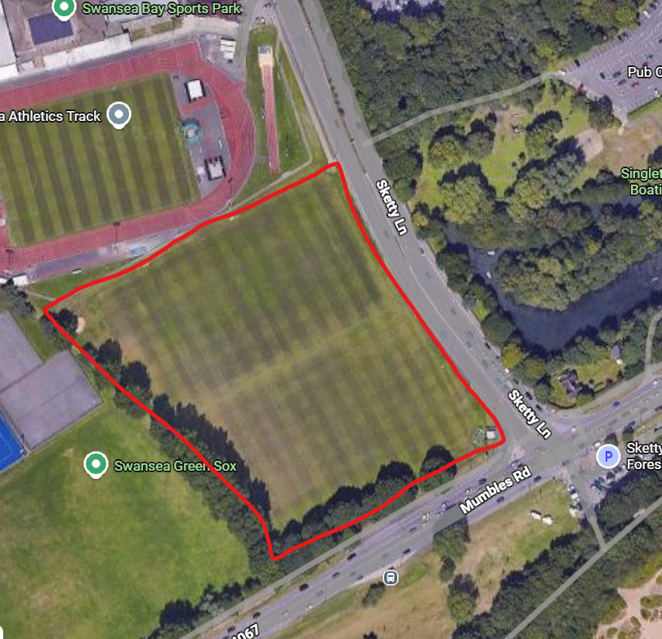

(Image taken from Google, Produced by Google Maps)

As you can see from the image above the site is easy to access if any supplies need to be transported to site, for example prefabricated construction methods.

2.0 Environmental Influence

2.1 Orientation

2.1.1 Natural Light

Firstly, when looking at the building orientation, it is a critical factor of achieving high environmental performance, particularly for a medium to high rise building that is close to a bay, where climatic conditions. By carefully positioning the building in relation to the suns path, designers can then find the best way to maximise as much natural daylight into the building as possible. If they can make it possible the building can warm up, reducing the amount of energy consumption going into the building. they can then at the same time install shading systems such as blinds and overhangs when the season hits summer as the sun is higher. This then will prevent any overheating (UKGBC, 2023).

2.1.2 Ventilation

Secondly, the orientation of the building also plays a major role in harnessing natural ventilation, due to the building being located near the coast. As the building is going to be built near the coast, the bay will provide and consistent sea breeze due to the temperature differences between the land and water, known as the sea breeze effect. This means by orientating the building to take advantage of prevailing winds, it generally requires the building to incorporate openings on each side so that the cross ventilation can be created. That then can enhance the indoor air quality while reducing the need for mechanical systems (Walker, 2016).

2.1.3 Additional Advantages

The orient of the building can also have many other advantages of:

- It can reduce exposure to harsh coastal conditions such as strong winds, salt spray and high humidity
- Helps and extend the lifespan of the materials chosen for the building
- Building orientation enables better integration of renewable energy sources
- Position of roofs for optimal solar angles for the best sun exposure
- It can also reduce the reliance on fossil fuels for energy

Information taken from (IEA, 2019).

2.2 Life Cycle

Furthermore, when evaluating the life cycle of a building located near the Swansea coastline it requires a strong focus on how the different marine conditions accelerate material deterioration over time. The various coastal environments as stated above, such as exposure to the salt air, high humidity and strong winds, all which can help each other to reduce the lifespan of the materials chosen for the building. it can lead to carrion of the steel reinforcements, reduced strength and increased porosity in the concrete. In recent studies it has been said that chemical interactions from sea water are among the primary causes of structural damage (Fulin Qu, 2021). Likewise, long term exposure to seawater can break down cementitious materials by increasing porosity and weakening binding properties, particularly under repeated wetting and drying cycles (Ting, 2023).

To help improve life cycle performance, the material selection and long-term maintenance plans are very essential. Materials that can be durable in these environments can include low-permeability concrete, fiber-reinforced polymers and corrosion-resistant metals can substantially extend the service life in coastal conditions, reducing the need for frequent repairs. For instance, fiber-reinforced polymer composites are increasingly used in marine construction due to their resistance to corrosion and long-term durability (Kappenthuler, 2021). Moreover, life cycle thinking should include environmental impacts from production, transportation, and eventual degradation or disposal of materials, as these stages contribute to the overall carbon footprint of the coastal structures (Sakr, 2025).

2.3 Aesthetic

Additionally, the aesthetic value of the hotel should reflect and complement the surrounding landscape, while preserving the areas strong sense of place. Swansea bay is described by its sweeping coastline and natural scenery. Therefore, the hotel should use forms and materials that coordinate with the bay rather than dominate it. When producing the hotel near Swansea bay it is very important to maintain the character and scenic quality of the coastline in future developments (Swansea County Council, 2017).

Natural materials such as stone, timber, textured concrete and glazed facades can benefit from the reflection with the surrounding environments, whilst adding large windows and open public spaces to maximise views across the water and strengthen the visual connection between the building and the coastline. An example of this can be seen in the proposed Swansea bay tidal lagoon visitor center. This is where the design of the building was inspired by oyster shells and local fishing heritage to create a structure that felt integrated with the marine setting (Stevens, 2014).

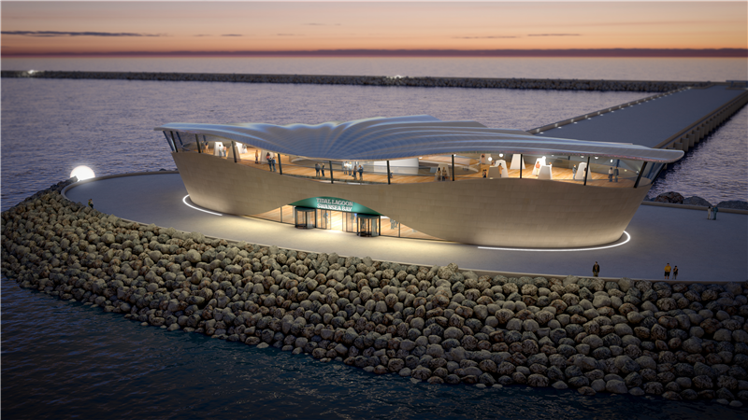

Image Taken from (OffshoreWIND.Biz, 2014)

Successful coastal architecture near the Swansea coastline should balance a modern design with environmental sensitivity and community identity. Developments such as the Copr Bay regeneration project demonstrates how the contemporary buildings, landscaped public spaces, and coastal parks can enhance the waterfront while celebrating Swansea’s industrial and maritime history through design details and public realm improvements (Anon, n.d). Not just Swansea bay has chosen this outcome but preservation areas like Langland bay shows buildings that remain visually secondary to the landscape, that can protect the natural beauty of the Wales coastline (Swansea County Council, 2025).

3.0 Facades Greening & SUDS

3.1 Assessing the Potential for Green Facades

Green Facades are very helpful when it comes to improving both the environment and the visual quality of buildings, particularly in dense urban, or coastal areas. The Green Façade includes a vegetation system attached to an exterior wall, creating a natural layer that helps regulate building temperature and improve insulation levels. They can also reduce energy demand, minimise environmental impacts, and help mitigate the urban eat island effect by lowering surrounding temperatures and reducing solar heat gain (Radic, 2019). In addition, vegetation acts as a natural air filter by trapping dust, absorbing pollutants and improving air quality around the building. studies also show that green facades can reduce the heat absorption during summer while limiting heat loss in winter, this then decreases the need for artificial heating systems (Aung, 2023). Further studies show that green facades can also benefit the notice reduction, improved wellbeing and increased visual connection to the surrounding environment (Manso, 2021).

3.2 SUDS Implementation

When implementing SUDS into a building there is a strong potential for managing surface water runoff, particularly for coastline developments where the different weather conditions like the amount of rainfall is increase and the flood risk can place a lot of pressure on conventional drainage infostructure. SUDS are designed to copy natural drainage processes by slowing, storing, filtering and infiltrating rainwater close to where it falls rather than rapidly directing it into sewers. The runoff according to the UK Government National Standards for SUDS should first be managed through infiltration or above-ground systems wherever practical to reduce flood risk and improve the overall water quality as shown in the sketch below (Department for Environment, Food & Rural Affairs, 2025).

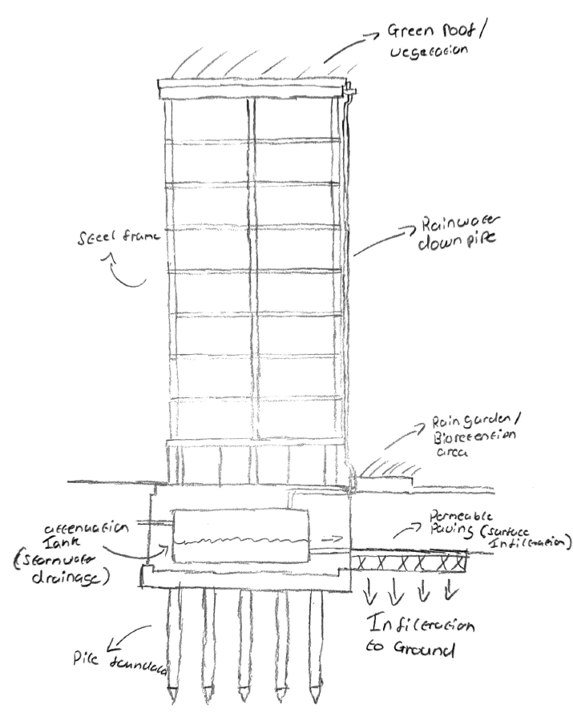

With the positioning of SUDS components across the project it must be very effective, in instance permeable paving is typically located in car parks and pedestrian routes to allow for rainfall to infiltrate directly into the ground, while swales are positioned along roadsides and site boundaries to convey and temporarily store runoff, NBS recommends that integrating SUDS, where runoff moves through multiple treatment stages such as green roofs, filter drains, swales and much more (NBS, 2026). The sizing of SUDS components depends on the site area, rainfall intensity, infiltration rates and much more. Design standards suggest that individual soak ways should generally serve a maximum impermeable area of 1000m2, while swales should typically have base widths between 0.5m and 2m with maximum depths of around 600mm to safely manage water flow (Buckinghamshire Council, 2022).

3.3 Wind Load Calculation

Average wind speed – 6.25m/s

Average density – 1.25 Kg/m3

Wind Pressure – 0.5

= 0.5 x 125 x 26 = 3.90 kN/m2

4.0 Buildability

4.1 Evaluation of Construction Practicality and Methods

From the last assignment I have chosen pile foundations as this building is going to be a high-rise build, a steel frame structure is highly recommended as a practical solution for a building located near the Swansea coastline, due to its rapid construction speed, high strength to weight ratio, and ability to accommodate large spans with flexible internal layouts. As the hotel is located by the side of the coastline, there can be many different conditions that could cause delays, this method will reduce the delay as the steel frame is produced offsite then transported to site for its assembly. Composite steel and concrete floor systems would be the preferred construction method because they improve the structural integrity/stiffness, fire resistancy and acoustic performance while maintaining efficient buildability. According to Eurocode 3 steel structures provide efficient structural performance and are widely used in modern commercial and residential developments due to their adaptability and ease of fabrication (BSI, 2023).

The use of SUDS measures will also be incorporated into the development to manage surface water runoff effectively, as stated above is particularly important in coastal environments. SUDS measures could also include permeable paving, attenuation tanks, swales, rain gardens and green roof systems to slow runoff rates, this will then reduce the pressure on the local drainage (Susdrain, 2019). Overall steel frame construction lightweight because of the it reduces the foundation loads, which can then lower the excavation requirements and embodied carbon associated with the substructure works. This is highlighted in coastal areas as the ground is full of weaker materials like sand and clay (Materials from borehole survey in Construction Tech 2 assignment 1) (SteelConstruction, 2016).

4.2 Site Logistics & Material Availability

For the steel frame construction there must be a logistical management put in place to limit on site storage that can dictate the need for delivery date of the steel components, that is requiring robust logistical planning to mange the crane operations, especially for a high-rise hotel (Turner International Turkiye, 2022). In the Uk there are many suppliers that will supply you with a high-grade steel frame, but you will need to engage with the suppliers early as it is critical for managing lead times and ensuring availability (NSC, 2024).

Skilled operatives are required to install steel frames, particularly for complex lifting and connecting structural elements (BuildSteel, 2016). When working near the coast it also involves specific challenges requiring specialised training for working at heights and in high wind environments, along with specific maritime health and safety regulations (Cruickshank, 2005). Efficiency and sequencing can also have a massive play on labour, due to the repetitive nature of hotel floor plans. Employing labour proficient in lean construction methods can maximise the speed if steel erection (BuildSteel, 2016).

4.3 Technical Feasibility Analysis: Sequencing and Structure

The hotel is near the coast and can face many different challenges consisting of corrosion. Coastal environments require high grade steel as stated above or advanced steel protection, such as high-performance coatings or specialised stainless-steel alloys, to resist salt spray (Capacite, 2025). High-rise structures like this hotel must withstand intense wind and seismic activity using systems like braced bays, outrigger systems or specific complex shapes/orientation to minimise wind-induced vibration (Engenuiti, 2016).

Generally, the build sequence can involve laying down the pile foundations, followed by erecting the structural steel frame alongside the concrete cores for stability (Engenuiti, 2016). The steel must be treated or coated with precise care taken at joints and bolts to ensure continuous protection against the various conditions (Friesen, 2024).

4.4 Integrating Efficiency, Safety and Sustainability in Project Design

Utilising prefabricated steel modules and components significantly accelerates the assembly process, reducing onsite construction time and minimising weather-related delays, which is critical in coastal locations (Evans, 2024). There is also implementation of a structured assembly sequence optimizes the use of onsite cranes and reduces material handling, streamlining the construction schedule (Ibeehive, 2026).

When it comes to safety it always assures that the high strength of the chosen construction methods provides superior resistance to the lateral loads, such as the high-velocity winds (Ibeehive, 2026). The construction methods stated also can minimise onsite waste and allows for cleaner, safer working conditions compared to traditional, heavy wet trade construction such as timber frames (MR industrial Services, n.d).

The steel structure also is 100% recyclable, bolted connections allows for components to be dissembled and reused in the future (Turner, 2022). As stated above it also minimises onsite waste, dust pollution and noise levels (MR Industrial Services, n.d). Integrating steel frames with advanced insulation and airtight glazing systems enhances energy efficiency, lowering operational costs and contributing to lower carbon emissions (Rodriguez, 2025).

4.5 Construction Storyboard

Stage | Key Activity | Critical Milestone
1. Pile Foundations | Install piles and pile caps | Foundations complete
2. SuDS & Drainage | Install drainage and attenuation | Drainage tested
3. Steel Frame | Erect steel columns and beams | Frame structurally stable
4. Floors & Roof | Install decking and roof | Building watertight
5. Brick & Blockwork | Construct external/internal walls | Envelope complete
6. Fit-Out & Handover | Services, finishes, testing | Building handed over

As you can see above is a construction story board illustrating the critical milestones in bold and filled in orange.

References

Anon (n.d) ‘The Vison’ (Online)
Available at: https://coprbayswansea.com/the-vision/
Accessed on: 23/04/2026

Aung, T (2023) ‘Implementing green facades: A step towards sustainable smart buildings’ (Online)
Available at: https://journals.sagepub.com/doi/10.3233/SCS-230014
Accessed on: 24/04/2026

Buckinghamshire Council (2022) ‘Sustainable Drainage Systems (SuDS): guidance for developers’ (Online)
Available at: https://www.buckinghamshire.gov.uk/environment/flooding-and-flood-risk-management/submitting-a-surface-water-drainage-strategy-guidance/flooding-guidance-for-developers/design-standards-for-suds-components/
Accessed on: 25/04/2026

BuildSteel (2016) ‘Steel Framing: The Future of Hotel Construction’ (Online)
Available at: https://buildsteel.org/projects/non-residential/steel-framing-the-future-of-hotel-construction/
Accessed on: 10/05/2026

British Standards Institution (2022) ‘Eurocode 3: Design of steel Structures – General rules and rules for buildings’ (Online)
Available at: https://landingpage.bsigroup.com/LandingPage/Standard?UPI=000000000030414382
Accessed on: 03/05/2026

Capacite (2025) ‘5 Common Challenges in High-Rise Construction and How to Overcome Them’ (Online)
Available at: https://capacite.in/5-common-challenges-in-high-rise-construction-and-how-to-overcome-them/
Accessed on: 10/05/2026

Cruickshank, I (2005) ‘Construction health and safety in coastal and maritime engineering’ (Online)
Available at: https://assets.publishing.service.gov.uk/media/602bd61d8fa8f503896d6c5f/Construction_health_and_safety_in_coastal_and_maritime_engineering_technical_report.pdf
Accessed on: 10/05/2026

Department for Environment, Food & Rural Affairs (30th July 2025) ‘National standards for sustainable drainage systems (SuDS)’ (Online)
Available at: https://www.gov.uk/government/publications/national-standards-for-sustainable-drainage-systems/national-standards-for-sustainable-drainage-systems-suds
Accessed on: 25/04/2026

Evans, A (2024) ‘What Are Sustainable Construction Practices and How Can You Implement Them into Your Project?’ (Online)
Available at: https://www.carnegiesteelbuildings.co.uk/blog/what-are-sustainable-construction-practices/
Accessed on: 10/05/2026

Engenuiti (17th June 2016) ‘STRUCTURAL & CIVIL ENGINEERING RIBA STAGE 2 REPORT’ (Online)
Available at: https://moderngov.dover.gov.uk/documents/s19007/Annex%201D%20-%20Redacted%20Feasibility%20Study.pdf
Accessed on: 10/05/2026

Fulin Qu (2021) ‘Durability deterioration of concrete under marine environment from material to structure: A critical review’ (Online)
Available at: https://www.sciencedirect.com/science/article/abs/pii/S2352710220337062
Accessed on: 16/04/2026

Friesen, M (11th October 2024) ‘Common Challenges in Steel Building Construction’ (Online)
Available at: https://wiebessteelstructures.com/common-challenges-in-steel-building-construction/
Accessed on: 10/05/2026

Google Maps (2026) ‘Google Maps’ (Online)
Available at: https://www.google.com/maps/@51.6062718,-3.986101,448m/data=!3m1!1e3?entry=ttu&g_ep=EgoyMDI1MTIwOS4wIKXMDSoASAFQAw%3D%3D
Accessed on: 15/04/2025

IEA (2019) ‘Solar Energy: Mapping the Road Ahead’ (Online)
Available at: https://www.iea.org/reports/solar-energy-mapping-the-road-ahead
Accessed on: 15/04/2026

Ibeehive (2026) ‘Steel Structure Hotel Building for Modern Hospitality Projects’ (Online)
Available at: https://www.ibeehivesteelstructures.com/blog/steel-structure-hotel-building/
Accessed on: 10/05/2026

Kappenthuler, S (2021) ‘Assessing the long-term potential of fiber reinforced polymer composites for sustainable marine construction’ (Online)
Available at: https://link.springer.com/article/10.1007/s40722-021-00187-x
Accessed on: 16/04/2026

Mercatus edits (8th August 2025) ‘Coastal Weather Considerations for Construction: Key Factors and Best Practices’ (Online)
Available at: https://mercatusbuilders.com/coastal-weather-considerations-for-construction/
Accessed on: 10/04/2026

Manso, M (2021) ‘Green roof and green wall benefits and costs: A review of the quantitative evidence’ (Online)
Available at: https://www.sciencedirect.com/science/article/abs/pii/S1364032120304020
Accessed on: 24/04/2026

MR Industrial Services (n.d) ‘Sustainable construction benefits and steel sustainability’ (Online)
Available at: https://mrindustrialservices.co.uk/sustainable-construction-benefits-and-steel-sustainability/
Accessed on: 10/05/2026

NBS (2026) ‘Publication C753 SuDS manual’ (Online)
Available at: https://www.thenbs.com/PublicationIndex/documents/details?DocId=314088&Pub=CIRIA
Accessed on: 25/04/2026

NSC (2024) (Online)
Available at: https://www.newsteelconstruction.com/wp/wp-content/uploads/2024/02/NSCFeb2024-digimag.pdf
Accessed on: 25/04/2026

OffshoreWIND.Biz (2nd June 2014) ‘Tidal Lagoon Power Joins Ocean Energy Europe’ (Online)
Available at: https://www.offshorewind.biz/2014/06/02/tidal-lagoon-power-joins-ocean-energy-europe/
Accessed on: 10/04/2026

Prasad (2023) ‘Design Considerations for Coastal Structures’ (Online)
Available at: https://www.structuralguide.com/design-considerations-for-coastal-structures/
Accessed on: 10/04/2026

Redic, M (23rd August 2019) ‘Green Facades and Living Walls—A Review Establishing the Classification of Construction Types and Mapping the Benefits’ (Online)
Available at: https://www.mdpi.com/2071-1050/11/17/4579
Accessed on: 24/04/2026

Rodriguez, A.C. (2025) ‘Sustainable Building Construction: Principles, Practice & Future Pathways’ (Online)
Available at: https://www.hpw.co.uk/post/sustainable-building-construction
Accessed on: 10/05/2026

Stevens, P (2014) ‘juice architects spirals tidal lagoon at swansea bay’ (Online)
Available at: https://www.designboom.com/architecture/juice-architects-spirals-tidal-lagoon-at-swansea-bay-02-07-2014/
Accessed on: 22/04/2026

Sakr, A (2025) ‘Living in a material world: Support for the use of natural and alternative materials in coastal restoration and living shorelines’ (Online)
Available at: https://www.sciencedirect.com/science/article/pii/S0925857424002878
Accessed on: 16/04/2026

SteelConstruction (2016) ‘Sustainability’ (Online)
Available at: https://www.steelconstruction.info/Sustainability
Accessed on: 03/05/2026

Susdrain (2019) ‘Sustainable drainage’ (Online)
Available at: https://www.susdrain.org/delivering-suds/using-suds/background/sustainable-drainage.html
Accessed on: 03/05/2026

Swansea County Council (November 2017) ‘Local Seascape Character Assessment’ (Online)
Available at: file:///C:/Users/ReeveThomas/Downloads/Carmarthen_Bay__Gower_and_Swansea_Bay_Local_Seascape_Character_Assessment_Final_Report_8_November_20.pdf
Accessed on: 22/04/2026

Swansea County Council (2025) ‘Conservation area - Langland Bay’ (Online)
Available at: https://swansea.gov.uk/conservationarea8?lang=en
Accessed on: 24/04/2026

Turner, M (2022) ‘Steel Building Sustainability: The Future of Eco-Friendly Construction’ (Online)
Available at: https://www.springfieldsteelbuildings.com/blog/sustainable-steel-construction-uk/?srsltid=AfmBOoqtT7S-u2_KeGZaNTuIfiQVz9nYxwmCTWkamqPWWFo9wo66rFoc
Accessed on: 10/05/2026

Turner International Turkiye (14th December 2022) ‘A Program Management Approach : Site Logistics’ (Online)
Available at: https://www.linkedin.com/pulse/program-management-approach-site-logistics-turner-turkey
Accessed on: 03/05/2026

Ting (2023) ‘Durability of cementitious materials in seawater environment: A review on chemical interactions, hardened-state properties and environmental factors’ (Online)
Available at: https://www.sciencedirect.com/science/article/abs/pii/S0950061822038806
Accessed on: 16/04/2026

UKGBC (2023) ‘Climate Change Mitigation’ (Online)
Available at: https://ukgbc.org/our-work/climate-change-mitigation/
Accessed on: 15/04/2026

Walker, A. (2016) ‘Natural Ventilation’ (Online)
Available at: https://www.wbdg.org/resources/natural-ventilation
Accessed on: 15/04/2026

