

Report

Student name: Adriana Dulceneya Ribeiro Silva
Student ID: 2008480
Programme: BSc (Hons) Health and Social Care
Module: Community Care and Development
Module Code: BMHP6022
Lecturer: Dr Laila Surani
Assignment Title: Assessment Component 2 (Written Assignment)
Submission deadline: 18th August 2023

Table of Contents
1. Introduction 2
2. Demographic of Peterborough 3
3. Health and Social Care needs within the Peterborough community 5
4. Prevalence of suicide 6
5. Approaches and initiatives within the Peterborough community 8
6. Campaigns and initiatives 10
7. Method and action approach to raising awareness for positive change 13
8. Recommendations 13
9. Conclusion 14
References 16

Introduction
The prevalence of suicide among ethnic minority groups may be influenced by adverse living, occupational, and educational conditions. These factors which are sometimes referred to as "social determinants of health," include societal discrimination, economic hardship, and limited access to mental healthcare. This report will analyse the demographics of Peterborough by evaluating the community's healthcare needs with the aim to examine the prevalence of suicide within the ethnic minority groups, and the various strategies and interventions for addressing this issue. In addition, the means of effectively communicating with the community via campaigns and initiatives, as well as the evaluation of positive change approaches based on methods and actions, and recommendations for adapting these efforts to the digital world.

2. Demographic of Peterborough
A community is a group of diverse individuals with one or more common traits that serve as the basis for their connection. The central element serves as the community's cohesive force and fundamental essence. A distinct demographic group is characterised by shared views and interests, as indicated by the term's etymology (common unity). In public health, a community can be defined as a group of individuals based on their demographic, social, and economic circumstances. Human beings have a fundamental need for a sense of belonging. (Ikeda Centre, no date).
Belongingness constitutes a fundamental component within Abraham Maslow's hierarchical model of human needs, a significant motivator for human behaviour. The hierarchical structure is commonly depicted as a pyramid, wherein fundamental needs are situated at the foundation, while progressively complex needs are positioned nearer the peak. The need for love and belonging is evident inside the pyramid as part of the context of social conditions.
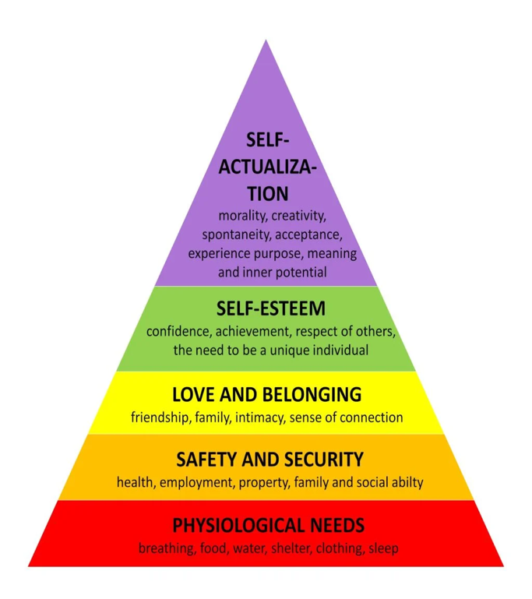
Source: SimplePsychology
Peterborough is a city characterised by its diversity, taking pride in its multi-diverse culture and continuous growth, currently accommodating 215,000 individuals. The population has experienced a notable increase of 17.4% between 2011 and 2021, with numbers rising from approximately 183,600 to around 221,700 (Office for National Statistics, 2023). The primary catalyst for this population growth seems to be natural change, wherein the number of births surpasses the number of deaths. As the Peterborough City Council acknowledged, migration has significantly affected the city's population dynamics. (Peterborough City Council, no date).
According to the most recent 2021 census, the population of Peterborough is primarily composed of individuals who identify as white, accounting for approximately 75% of the total population. The remaining 25% of the population is comprised of non-white minority groups. In the year 2021, the median average age in Peterborough was recorded at 36.6%. Furthermore, individuals aged 18 and above constituted approximately 79.0% of the population. Moreover, the observed sex ratio exhibited a ratio of 97.9 men per 100 females. The predominant religious affiliation in Peterborough is Christianity, representing 46% of the local population. The leading minority group in Peterborough comprises individuals of Asian descent, accounting for 14.3% of the population.
Additionally, 8,751 individuals, constituting 4% of the population, identified as Black. The predominant language spoken by 80% of the people in Peterborough is English, while 15% of the populace demonstrates a proficient or advanced level of English. A total of 3.9% of the population reported that they possessed either well or very well adequate ability of the English language. The remaining 0.7% reported a complete absence of English language skills (Varbes, no date). The Peterborough city council implemented a comprehensive strategy for the future of the city, known as the local plan for 2036. This plan adopts a pro-growth approach and aligns with the principles of sustainable development goals. It aims to foster sustainable development by enhancing the city's economic, social, and environmental aspects. To achieve this, the council has made substantial investments in various areas such as housing, infrastructure, education, and job markets, which have grown by 20% since 2010, and transport for the community's wide variety of needs (invest in Peterborough, no date). Furthermore, a collaborative effort was undertaken by the Cambridgeshire Council and Peterborough City Council in 2022 to form a Joint Health and Wellbeing Board. The joint committee will be convened in collaboration with the Integrated Care Partnership, thus strengthening and uniting the local partnership around integrated health and social care (Peterborough City Council, 2022).

Health and Social Care needs within the Peterborough community

According to Philips and Pittman (2009), conflict theory suggests that conflict is an inherent aspect of social existence. Conflict exists between economic classes, ethnic groups, the youth and older people, men, women, etc.
According to the Peterborough City Council, a disproportionate disparity exists between minority ethnic communities and those residing in the poorest areas. Peterborough City Council (2022) states that the health service is under significant strain and that access to healthcare and preventative healthcare has changed drastically. In addition, there is a need to prioritise safety and the prevention of harm within the delivery of community services, as the main risk factors associated with ill health, such as environmental, social, and behavioural factors, increase service demands. There are obstacles, some of which reflect persistent problems that the city has found challenging to address. Consequently, pockets of According to a report from the city council, the coronavirus has caused immeasurable tragedy and economic damage, and the city encounters many more years of fiscal austerity (Findlay, 2022).

Moreover, a cost of living crisis, primarily driven by inflation and exponential price increase across all sectors, is placing additional strain on an already fragile support system, which is felt most by the community; as a result, residents are at the bottom of too many league tables, with residents more likely to die younger, have poorer health, and have lower levels of education than residents of most other cities.

Prevalence of suicide

Research has shown that individuals from ethnic minority groups are at an increased risk of suicide compared to those from majority ethnic counterparts.

(Knipe, 2022)

An annual review of suicides in Cambridgeshire and Peterborough suggests that the rate of suicide is higher among those born in Eastern Europe. From 2006 to 2015, 16% of suicides in Peterborough were attributed to individuals of Eastern European descent. Nonetheless, the increased suicide rates may be a symptom of health and lifestyle behaviours that are known to be closely associated with mental health problems, including suicide. According to the annual suicide audit conducted by the local authorities of Peterborough and Cambridgeshire, the higher suicide rate among Eastern Europeans is cause for concern (Hartley et al., 2016). The Office for National Statistics cautioned that several factors, including a delay in registrations during the pandemic, could have contributed to the decline.

Source: democracy.peterborough.gov.uk
In addition, men from eastern European migrant populations — Polish and Lithuanian nationals residing in the Peterborough and Fenland regions — are emerging as groups with high suicide risk. Moreover, unemployment, isolation, and rural location are emerging as local risk factors. Local knowledge also increases the risk of suicide for vulnerable and marginalised groups, such as alcohol and drug users, gipsies and travellers, and homeless people (Hartley, 2014-2017). Living in deprived areas, poverty, and racial or ethnic discrimination can refer to both significant, acute experiences of unfair treatment, such as harassment or bullying, and chronic daily injustice racism can have intergenerational effects, with associated trauma, also affecting children from ethnic minority backgrounds as known suicide risk factors. Furthermore, language barriers or reluctance and difficulty in communication distress, mistrust of services and fear of being discriminated against, poorer accessibility and outcomes in primary care, stigma, and conceptions of shame and honour can all contribute to access disparities (Samaritans, no date). A lack of awareness as well as social and cultural factors, an expectation of discrimination and a lack of cultural competence on the part of mental health services; despite this, there are critical dimensions of health inequalities, such as deprivation, employment, income, and educational attainment, that are not protected characteristics under the Equality Act 2010 NHS, Digital (2022) However, according to the Equality Act, individuals who possess a "protected characteristic" are safeguarded and shall not be subjected to discrimination and those providing services must take steps to ensure equality for both those who use their services as well as those who work for them (GOV.UK, 2013)

Approaches and initiatives within the Peterborough community

The NHS Mental Health Implementation Plan 2019/20–2023/24 outlines the strategies and actions required to address disparities in mental health. It aligns with the objectives of the NHS Long Term Plan and emphasises the need for all systems to mitigate mental health inequalities by 2023-2024. The plan is dedicated to enhancing accessibility, improving patient experiences, and achieving equitable outcomes in mental health care (NHS Digital, 2022). Moreover, the Joint Cambridgeshire and Peterborough Suicide Prevention Strategy for 2022-2025 establishes collaborative efforts to reduce suicide rates within the community. The strategy's primary objective is to guarantee equitable access to appropriate care and support for all individuals residing in Cambridgeshire and Peterborough. This involves providing more effective mental health services to those struggling with mental health challenges and actively empowering community members to support one another. The strategy outlines six priority areas for suicide prevention, which serve as a framework for fostering community vigilance and intervention.

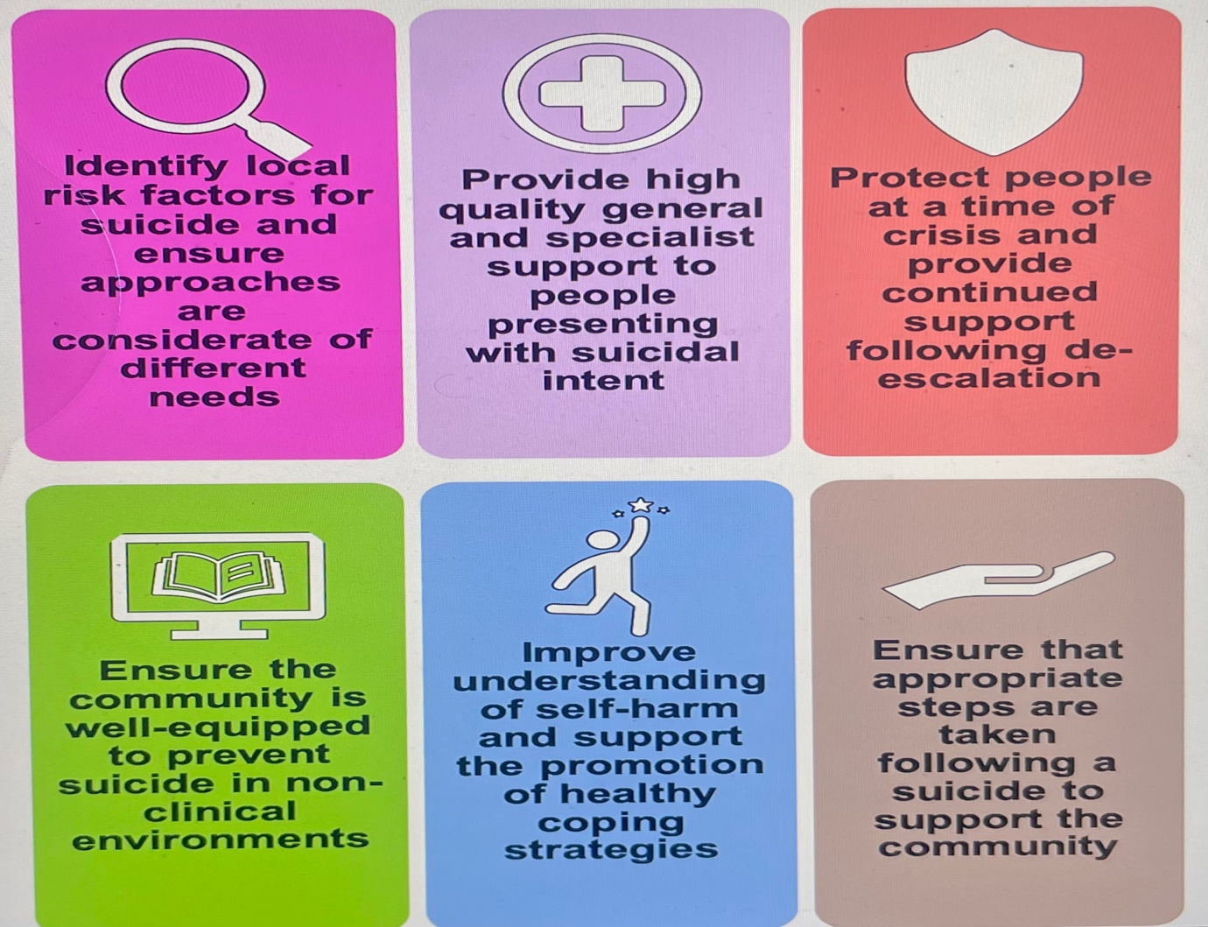
Source: Peterborough.gov.uk

The Suicide Prevention Strategy Implementation Group comprises individuals representing many entities, including the local government, National Health Service (NHS), the justice system, educational institutions, charitable organisations, and individuals with personal experiences related to suicide and mental health challenges. The project, led by the Public Health Directorate, is expected to be implemented during the next three years through collaboration with various stakeholders in the system, including Peterborough City Council (no date). In addition to this, the Cambridgeshire, and Peterborough NHS Foundation Trust (CPFT) has implemented the Zero Suicide Ambition initiatives and strategies, which involve various stakeholders such as partners, local businesses, schools, employment sectors, transport systems, prisons, media outlets, and a wide range of individuals residing in Cambridgeshire and Peterborough. These efforts are integral to the STOP SUICIDE campaign (CPFT, no date).

Campaigns and initiatives

The Stop Suicide campaign launched in 2014 is a suicide prevention programme that has received recognition for its efforts. Its primary objective is to empower communities and individuals in Cambridgeshire, Peterborough, and South Lincolnshire. The campaign is led by CPSL Mind and supported by local NHS and Public Health teams. The objective is to raise awareness among communities in Cambridgeshire and Peterborough regarding indicators of suicidal behaviour and emphasise that adopting an open and transparent attitude towards suicide is the most effective strategy for its prevention. To foster a community that is supportive, and preventative of suicide, individuals, organisations, and relevant stakeholders collaborate to advance public education and awareness initiatives (Stop Suicide, n.d.), including those implemented through online platforms.

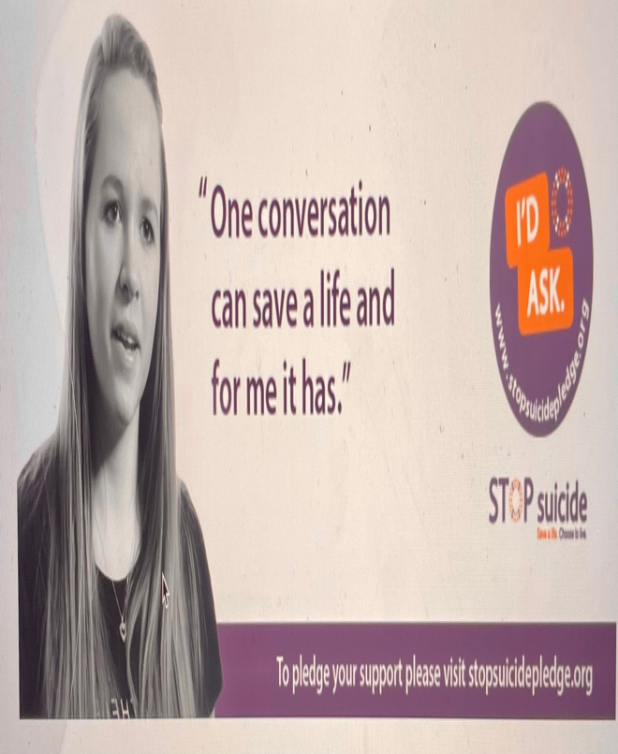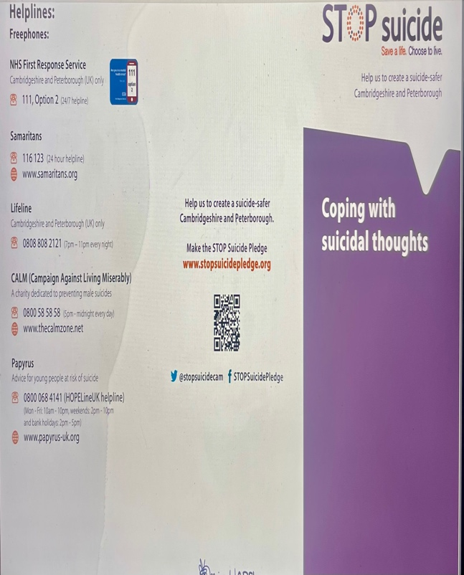



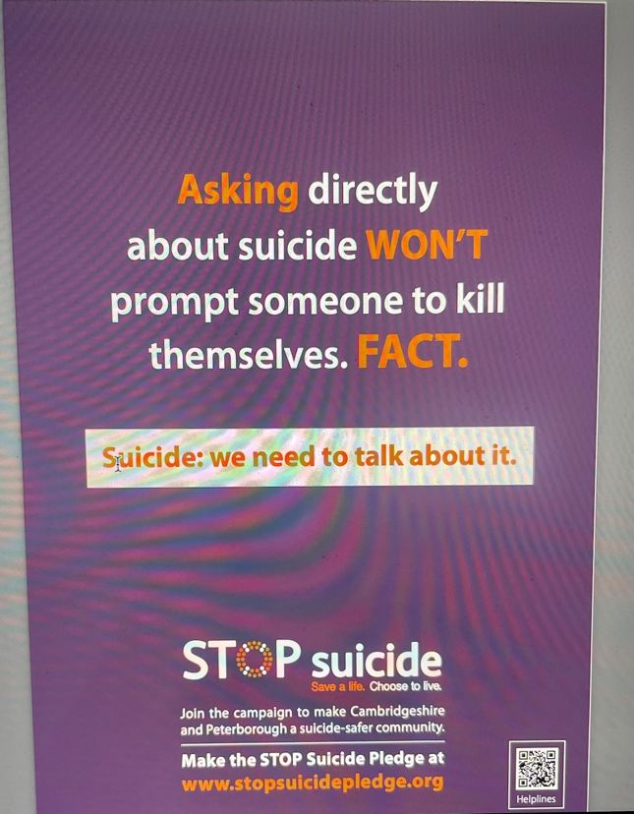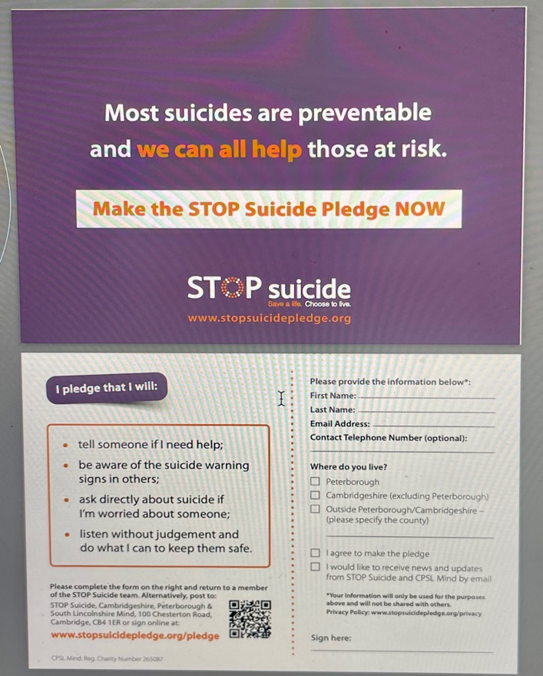



In addition to these campaigns and initiatives, there are a variety of resources and information to help raise suicide awareness, including online resources, websites, advertisements, the STOP Suicide pledge, posters, self-help resources, illustrations, website banners, the crisis Smartphone app, and STOP Suicide resources translated into Polish, Romanian, and Lithuanian.
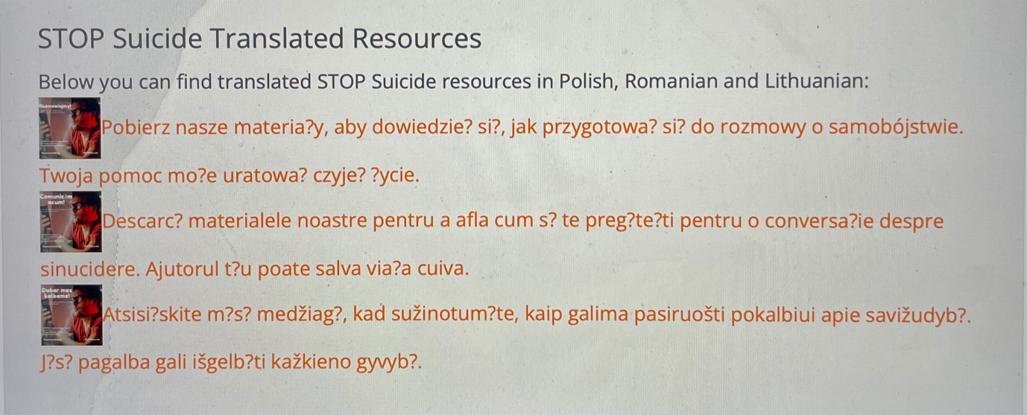
STOP Suicide translated resources.

Method and action approach to raising awareness for positive change
When people in different communities feel secure and safe, they often need to identify with and belong to a social organisation, such as a family, community, and community-based organisation (CBO). Anyanwu et al., (1985) state that love and belonging indicate the need to be part of a group, such as a family, a group of co-workers in the workplace, a friendship, a community, a social group, and others in society.
Unsatisfactory is the current state of the healthcare system for ethnic minority populations. In response to these issues, new policies and practices must be developed (Ajayi, 2021). There is a need for strategies by developing creative and attention-grabbing campaigns or initiatives to capture the community's attention, mobilising communities, and organising grassroots movements to create collective actions, implementing educational programmes or workshops to empower individuals and provide them with the necessary skills for change, and collaborating with other local authorities to successfully plan and deliver services by responding to community needs.

Recommendations
With the growth of the digital world, there has been a notable surge in advancements within digital media. These advancements have shown to be highly beneficial in suicide prevention, as they offer practical methods for dynamically assessing suicide risk, utilising quantitative data-driven approaches (Vahabzadeh et al., 2016). In addition, the use of digital applications, digital treatments, and portable diagnostics allows individuals to enter the digital realm, thereby combining the fragmented aspects of an individual's health and care into a single record managed by the individual. Mistry (2020) discusses the issue of suicide within ethnic minority groups, emphasising the significance of culturally sensitive prevention strategies in the digital realm. The author suggests combining interactive content and leveraging technology, mainly through social media platforms, can effectively address this issue.
Furthermore, using social media platforms to distribute information and engage a wider audience can be enhanced by applying artificial intelligence (AI) to identify individuals belonging to ethnic minority groups at a higher risk. Additionally, collaborative efforts with these platforms can be made to implement warning indicators while partnering with social media companies to promote suicide prevention actively. Moreover, providing resources and helplines within social media is crucial, considering the digital world's significant role in audience reach over the past decade.

Conclusion
The presence of health disparities among individuals with suicidal thoughts is apparent. To address these disparities and promote better outcomes, efforts should be directed towards implementing suicide prevention campaigns and community-based support initiatives. The primary objective of these interventions should be to mitigate the existing disparities. Providing adequate public services to the community necessitates the government's crucial support. To effectively strategize and deliver services, address community cohesion issues, and mitigate health disparities, local authorities must comprehensively understand the demographics and needs of the respective community. This understanding should be coupled with providing equitable access to services for all community members, alongside implementing community education initiatives.

References

Ajayi, S. (2021) ’A perspective on health inequalities in BAME communities and how to improve access to primary care, Future Healthcare Journal, 8(1), pp. 36-39. Available at: https://doi.org/10.7861%2Ffhj.2020-0217/ (Accessed: 11 August 2023).

Bunn, S. and Williams, C. (2022) Mental Health Act Reform – Race and Ethnic Inequalities. Available at: https://post.parliament.uk/research-briefings/post-pn-0671/ (Accessed: 11 August 2023).
Cambridgeshire and Peterborough NHS Foundation Trust (no date) Zero suicide. Available at: https://www.cpft.nhs.uk/zerosuicide/ (Accessed: 9 August 2023).
Findlay, C. (2022) Peterborough faces ‘most challenging times since the Second World War’. Available at: https://www.cambridge-news.co.uk/news/local-news/peterborough-facing-most-challenging-times-25180603/ ([Accessed: 12 August 2023).
GOV.UK (2013) Equality Act 2010: guidance. Available at: https://www.gov.uk/guidance/equality-act-2010-guidance#discrimination-making-a-complaint/ (Accessed: 15 August 2023).
Hartley, K. et al. (2016) Diverse Ethnic Communities Joint Strategic Needs Assessment for Peterborough. Available at: https://democracy.peterborough.gov.uk/documents/s28782/5.%20Appendix%201%20-%20Diverse%20Ethnic%20Communities%20JSNA.pdf/ (Accessed: 23 July 2023).
Hartley, K. (2014-2017) Joint Cambridgeshire and Peterborough Suicide prevention strategy. Available at: https://democracy.peterborough.gov.uk/documents/s22204/7a.%20Appendix%201%20-%20Suicide%20Prevention%20Strategy.pdf/ (Accessed: 11 August 2023).
‌Ikeda Center (no date) What Is Community, and Why Is It Important? Available at: https://www.ikedacenter.org/resources/what-community-and-why-it-important/ (Accessed: 27 July 2023).
Knipe, D. (2022) Suicide rates in ethnic minority groups in the UK. Available at: https://nspa.org.uk/wp-content/uploads/2022/02/Equality-and-diversity-in-suicide-prevention-Dr-Duleeka-Knipe.pdf/ (Accessed: 12 August 2023).
Mistry, P. (2020) The digital revolution. Available at: https://www.kingsfund.org.uk/publications/digital-revolution/ (Accessed: 13 August 2023).
NHS Digital (2022) Inequalities in mental health and why this data is a priority. Available at: https://digital.nhs.uk/data-and-information/data-collections-and-data-sets/data-sets/mental-health-services-data-set/submit-data/data-quality-of-protected-characteristics-and-other-vulnerable-groups/inequalities-in-mental-health-and-why-this-data-is-a-priority/ (Accessed: 10 August 2023).
‌Office for National Statistics (2023) How life has changed in Peterborough: Census 2021. Available at: https://www.ons.gov.uk/visualisations/censusareachanges/E06000031/ (Accessed: 28 July 2023).
Peterborough City Council (2022) Joint Health and Wellbeing Integrated Care Strategy. Available at: https://www.peterborough.gov.uk/council/strategies-policies-and-plans/health-and-social-care-strategies/joint-health-and-wellbeing-integrated-care-strategy/ (Accessed: 11 August 2023).
Peterborough City Council (no date) Suicide Prevention Strategy. Available at: https://www.peterborough.gov.uk/council/strategies-policies-and-plans/health-and-social-care-strategies/suicide-prevention-strategy/ (Accessed: 12 August 2023).
‌
Peterborough City Council (no date) Population. Available at: https://www.peterborough.gov.uk/council/about-peterborough/population/ (Accessed: 28 July 2023).
Samaritans (no date) Ethnicity and suicide. Available at: https://media.samaritans.org/documents/Ethnicity_and_suicide_July_2022.pdf/ (Accessed: 10 August 2023).
Stop Suicide (no date) About Us. Available at: https://stopsuicidepledge.org/about-us/#campaign/ (Accessed 13 Aug. 2023).
The time is now Peterborough (no date) the city of Peterborough. Available at: https://investinpeterborough.co.uk/app/uploads/2020/07/Peterborough_Development_Brochure_Web_2.pdf/ (Accessed: 10 August 2023). ‌
‌Tyler, P., Evenhuis, E. and Martin, R. (2018) Case study report. Available at: https://www.cityevolutions.org.uk/wp-content/uploads/180717-Working-Paper-10-Peterborough-Case-Study-Report-July-2018.pdf/ (Accessed: 12 August 2023).
Varbes (no date) Demographics of Peterborough. Available at: https://www.varbes.com/demographics/peterborough-demographics/ (Accessed: 1 August 2023).
Vahabzadeh, A., Sahin, N. and Kalali, A. (2016) Digital Suicide Prevention: Can Technology Become a Game-changer? 13(5-6), pp.16–20. Available at: https://www.ncbi.nlm.nih.gov/pmc/articles/PMC5077254/ (Accessed: 7 August 2023).

‌World Health Organization (2022) Mental Health. Available at: https://www.who.int/news-room/fact-sheets/detail/mental-health-strengthening-our-response/ (Accessed: 2 August 2023).

