BMIH4006 Operating Hotel Facilities
Component One - Learning Log
Introduction
The component aims to provide a reflective account of a hospitality professional by indicating the key skills related to the housekeeping department. Gibbs’ reflective framework will be used here to focus on the entire journey of the professional which will reflect on the strengths and areas of limitations of the professional. Finally, a strategic action plan will be made to accelerate the performance of the professional within the department.
Brief analysis of Gibbs’ reflective model
Gibbs’ reflective model is one of the most popular frameworks for learning from experiences through a better reflection process. It has six steps which help learners to learn from their experience and take necessary steps to develop their areas of improvement along with the identification of their areas of strengths. Here, the model is used to describe the placement experience of a hospitality professional. Through the six stages of the model, the professional has stated a valuable placement experience encountered through performing housekeeping-related responsibilities (Adeani et al. 2020).
Description
After my placement in the housekeeping department of a leading UK-based hotel Premier Inn, I was selected as a guest room attendant to serve customers. The practical experiences related to the job position taught me a significant lesson regarding hospitality skills along with a deeper knowledge of customer service. The tasks regarding guest room attendance included my responsibilities from greeting the guests to looking after every minute task related to guest satisfaction. The overall guest experience was good and my top management also appreciated my performance along with motivating me towards the development of some of my improvement areas. My strengths included orderliness, cleanliness, time management and attention to detail. My weaknesses included communication, critical thinking, conflict resolution and the command of modern hospitality technology.
Feelings
Being attached to a business organisation like Premier Inn I was excited to perform my duties properly by satisfying my upper management. I felt happy getting positive remarks from the guests for my greetings to them, my time management, friendly behaviours, cleanliness, orderliness etc. They informed me about my cleanliness and organised skills to decorate the rooms in an orderly and clean manner. Though my communication fulfilled the queries of the guests, it was noticed and criticised by my senior managers which threw me a sense of gloominess. Despite my dejection, the criticism also ignited my eagerness to improve my skills.
Evaluation
I was surely motivated by my good experiences which allowed me to continue with my responsibilities and attend to more guests. On the other hand, my bad experiences threw me into challenging situations which reduced my performance temporarily. The changing business environment and customer preferences have impacted the hospitality industry. People want to get more customised experiences and business owners look for efficient multitaskers (Becker, 2024). The positive experiences gained through my areas of strength allowed me to perform better in my position. Gradually I developed my reflection regarding the development of challenging situations.
Analysis
My spontaneous actions towards my time management, orderliness and cleanliness helped me to achieve better customer experiences. Time management is the skill which is one of the most required areas of business management practices. It helps employees along with the management team to utilise their business resources to get more customer reach (Bales et al. 2022). When I proceeded for a deeper explanation of my challenging situation related to communication skills and critical thinking skills, I developed my reflection on the new trends in business communication along with processes of modern conflict resolution.
Conclusion
Reflection on the entire experience gave me scope to learn from the situation by taking greater actions for future improvement. Through the progression of minute analysis, I have understood that I should be updated with present business trends and communication processes which forced me to face challenging situations. The present business environment wants employees with better problem-solving, communication and critical thinking which can give organisations competitive advantages (Fissi et al. 2020). With my practical experiences gained through housekeeping operations in Premier Inn, I realised this fact closely and effectively.
Action Plan
I will proceed with making an effective action plan to develop my areas of improvement. I will abide by and comply with the business regulations and guidelines developed by my senior team. Besides, I will take effective strategies and follow resources to develop my communication, critical thinking, and problem-solving skills. Besides, I will adapt modern technology trends in the hospitality industry. I will fix a specific timeframe to develop my areas of weaknesses to move forward for the improvement of my housekeeping-related duties as well as better career progression in the hospitality industry.
Conclusion
The component has been based on the reflection of a hospitality professional regarding his or her housekeeping responsibilities. The entire analysis is centred on the effective reflective framework of Gibbs’ which has given the professional scope to learn from the situation and take better actions to improve skills and knowledge regarding the housekeeping department.

References
Adeani, I.S., Febriani, R.B. and Syafryadin, S., (2020). Using GIBBS’reflective cycle in making reflections of literary analysis. Indonesian EFL Journal, 6(2), pp.139-148. https://journal.uniku.ac.id/index.php/IEFLJ/article/view/3382
Bales, D.W., Griffeth, L.L. and Campbell, C.A. (2022) Time Management: 10 Strategies for Better Time Management, University of Georgia Extension. Available at: https://extension.uga.edu/publications/detail.html?number=C1042&title=time-management-10-strategies-for-better-time-management (Accessed: 07 February 2024).
Becker, C.U., (2024). Business Ethics: Methods, Theories, and Application. Taylor & Francis.
Fissi, S., Romolini, A. and Gori, E., (2020). Building a business model for a new form of hospitality: the albergo diffuso. International Journal of Contemporary Hospitality Management, 32(1), pp.307-323. https://www.emerald.com/insight/content/doi/10.1108/IJCHM-01-2019-0047/full/html

Component 2
Potential risks and information on industry best practices and regulations related to housekeeping safety
Potential risks: The problems and risks in Premier Inn and the practices in the UK hospitality industry are discussed here. The most noticeable risk of injuries comes from cleaning and handling tools (Ambardar and Raheja, 2017). There are repetitive strain injuries from heavy lifting or any bodily motions. Slips and trips are also part of this work. They often come across chemicals which are used for cleaning floors or rooms, bathrooms or any other places. Risks from damaged electrics are also very concerning (SFC, 2019).
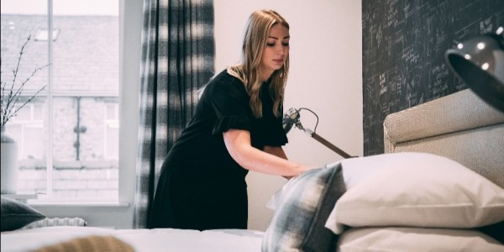
Image 1: Housekeeping staff
Source: (SFC, 2019)
Industry practices and regulations: It is necessary that all the housekeeping staff are trained and knowledgeable about the practices, they have the necessary resources and know how to store and transport wastes (HSA, 2024). Health and Safety at Work 1974, Control of Major Accident Hazards Regulations, Control of Substances Hazardous to Health Regulations 2002 and Reporting of Injuries, Diseases and Dangerous Occurrences Regulations 2013 should be maintained by the hotels for housekeeping safety (UKCPI, 2024).
Precautions: Necessary precautions to prevent accidents and injuries.
1. It is important for the housekeeping team of Premier Inn to clean the floors often with proper tools to avoid trips and slips.
2. Electrical safety should be considered so that any damage, loose wires or fraying can be repaired.
3. Fire extinguishers should be available on every floor.
4. The housekeeping staff members should be trained properly and they should be aware of the procedures of housekeeping (Commodious, 2024).
Procedures: A step-by-step procedure for room cleaning that incorporates safety measures
The steps that can be followed by the management of Premier Inn to mitigate the safety problems have been provided below.
Step 1: Airing out the room is the first step for the housekeeping staff so that fresh air can enter the room.
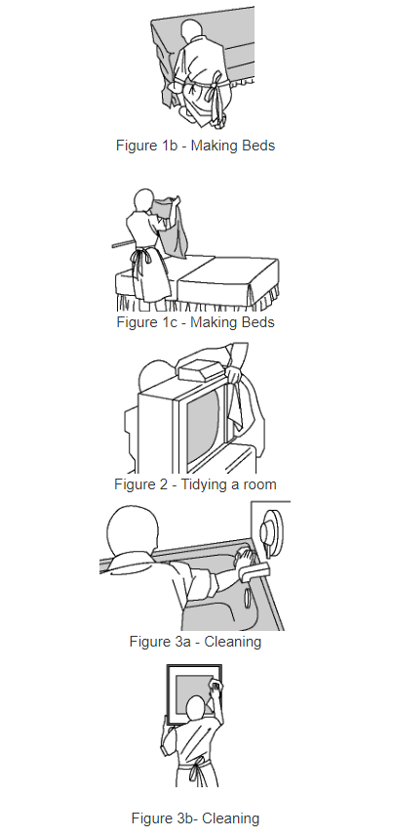
Image 2: Steps to follow in safety measures
Source: (CCOHS, 2023)
Step 2: Remove the used bed linen and transfer it to the laundry.
Step 3: Remove all the dirt and rubbish from the bed and the entire room.
Step 4: Removing the glasses, bins, and cups from the room and placing fresh supplies.
Step 5: Dusting throughout the room and adjusting cupboards, lights and headboards.
Step 6: Vacuuming and cleaning the surfaces using cleaners and chemicals.
Step 7: Sanitising the floors, furniture and other places to avoid safety problems (AllianceOnline, 2024).
Equipment: Essential equipment and tools that should be used safely during room cleaning
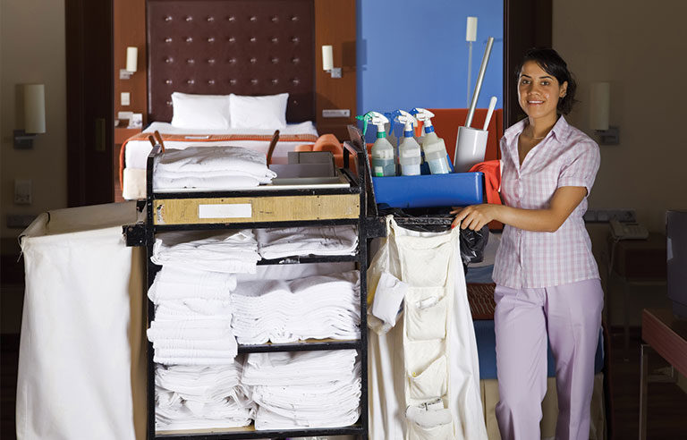
Image 3: Tools and equipment for housekeeping
Source: (SafetyHealth, 2020)
There are many tools and equipment needed for safety while cleaning rooms. Cleaning clothes, bin liners and bags, cleaners like Cif, Dettol, Flash etc.; Trigger Spray Bottles and Sprayers, cleaning trays and trolleys, cleaning gloves, indoor areas, scrubber dryers, steam and carpet cleaners, floor mopping (AllianceOnline, 2024a).
Hazard Mitigation: Potential hazards specific to room cleaning and practical solutions to mitigate them
The process of implementation regarding safety measures and potential hazards has been described below.
Physical injury: The housekeeping staff should tell the employers about the injuries so that proper actions can be taken to prevent injuries in future.
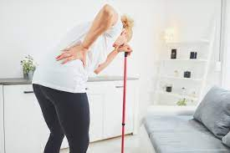
Image 4: Physical hazard
Source: (DiVincenzo, 2020)
Electrical hazards: Sometimes electrical faults can happen and due to working with water it can be very hazardous to health. So, taking immediate steps to prevent fire and any other problem from this is necessary.
Fire hazards: Risk assessments should be done by the management of the hotel. Fire extinguishers should be kept on all floors.
Preventing any falling objects: The objects which can be harmful for staff members like toe tail, ply that is not sitting properly on the ground etc. should be reported.
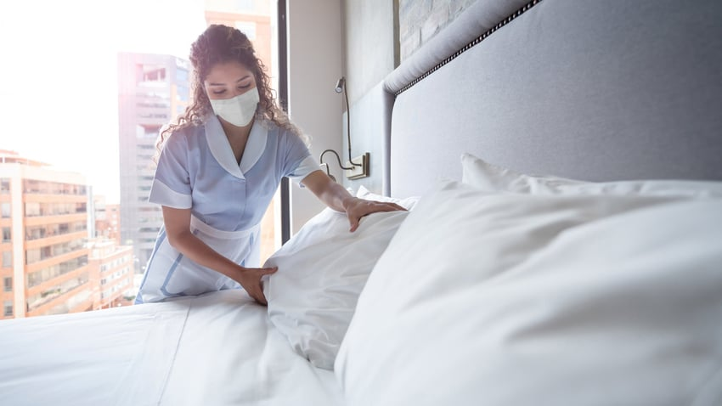
Image 5: Preventing housekeeping hazards
Source: (O’Connor, 2021)
Storing hazards: Keeping the chemicals accordingly, keeping the minimum amount of substances when necessary, cleaning up any kind of leaks, preventing leakages and ensuring there is proper ventilation (EcoOnline, 2023).
References
AllianceOnline (2024) Hotel Housekeeping 101: Tips & Tricks for clean hotel rooms, UK Shop. Available at: https://www.allianceonline.co.uk/blog/2019/06/hotel-housekeeping-101-tips-tricks-for-clean-hotel-rooms/ (Accessed: 07 February 2024).
AllianceOnline (2024a) Hotel Housekeeping Supplies & Equipment, Alliance Online. Available at: https://www.allianceonline.co.uk/hotel-and-leisure/hotel-housekeeping.html (Accessed: 07 February 2024).
Ambardar, A. and Raheja, K., (2017). Occupational Safety and Health of Hotel Housekeeping Employees: A Comparative Study. International Journal of Hospitality & Tourism Systems, 10(2). https://d1wqtxts1xzle7.cloudfront.net/60754554/304-0320190930-32013-1iwrrhb-libre.pdf?1569912003=&response-content-disposition=inline%3B+filename%3DOccupational_Safety_and_Health_of_Hotel.pdf&Expires=1707335221&Signature=Q8rIgwbioTSl7mOr1y66IBhfKUZlKjtN7J5uyNIKJjV1frsKOdZG8oL7yDSS-Xl9xGcb96IRpwvgh9SDKAvQtq577lYNGNdwn6yuymyyLSy4SjF7jKTcCWA8wkSIV6oXt16D43u4WobB4Zjf6Zhek8pow-xr~xL3F6BSt7loYK8E-xxt2KrBlrOnIVF3k~0y7I-D3wiDFMEhdPNehqKt92rGwojejZqqjzXBa5RXSr0WVbhis~rHYuLrIrPUafDsqr5Z6cCLfGkhS99cPmwGRzeObncrrRMU1z7zJo~5zANgZu1QQ231cpgSulra-UgoC~VbeYqf7gE4emF6-V4lfw__&Key-Pair-Id=APKAJLOHF5GGSLRBV4ZA
Commodious (2024) Safe Housekeeping will help prevent fire, Commodious. Available at: https://www.commodious.co.uk/knowledge-bank/hazards/fire-safety/safe-housekeeping-will-help-prevent-fire (Accessed: 07 February 2024).
DiVincenzo, K. (2020) Injury-free hotel housekeeping, Work. Available at: https://www.work-fit.com/blog/injury-free-hotel-housekeeping (Accessed: 08 February 2024).
EcoOnline (2023) 11 tips for Effective Workplace Housekeeping, EcoOnline. Available at: https://www.ecoonline.com/blog/11-tips-for-effective-workplace-housekeeping (Accessed: 07 February 2024).
HSA (2024) Part4 safehospitality - health and safety authority, HSA. Available at: https://www.hsa.ie/eng/your_industry/catering_and_hospitality/housekeeping/ (Accessed: 07 February 2024).
O’Connor, G. (2021) Best practices for room attendants, Hotel Management. Available at: https://www.hotelmanagement.net/housekeeping/best-practices-room-attendants (Accessed: 08 February 2024).
SafetyHealth (2020) California adopts standard to Protect Hotel housekeepers from MSDS, Safety+Health. Available at: https://www.safetyandhealthmagazine.com/articles/16824-california-adopts-standard-to-protect-hotel-housekeepers-from-msds (Accessed: 08 February 2024).
SFC (2019) 4 risks associated with housekeeping and how to avoid them, Shoes for Crews GB. Available at: https://www.sfceurope.com/uk/blog/4-risks-associated-with-housekeeping-and-how-to-avoid-them (Accessed: 07 February 2024).
UKCPI (2024) UKCPI, Go to UKCPI. Available at: https://www.ukcpi.org/professional/ukcpi-professional-cleaning-regulations/ (Accessed: 07 February 2024).

Component 3
Introduction
- The training program will be done to educate the housekeeping workers about the safety measures
- Safety measures and tools to clean rooms will be described
- The hazards in housekeeping and prevention measures will also be stated.
The training program has the aim of providing the housekeeping staff members with knowledge of safety and security. There are many procedures that should be maintained by the housekeeping of Premier Inn. It is necessary for the housekeeping staff to be safe and that they understand how they should act to prevent any issues. For this reason, this training will state the risks associated with housekeeping. Along with that, the regulations practised in this and steps to clean rooms will be elaborated. Some tools will be stated for housekeeping along with some preventive measures to the hazards.
Potential risks of housekeeping
- The most common risk of housekeeping is the physical strain from heavy lifting (Chela-Alvarez et al. 2022).
- They might also face some slips and trips while working
- Problems from chemicals are also a risk for the housekeeping staff of Premier Inn
Premier Inn's issues and the risks related to housekeeping are discussed here. Repetitive strain injuries are the most common problem for housekeeping staff white they doing any stressful physical activity and lift heavy things. Other than that, this work includes trips and slips as well. Housekeeping staff can frequently come into contact with chemicals that are used to clean bathrooms and bedroom floors (Chela-Alvarez et al. 2022).
Industry regulations regarding housekeeping
- There are several acts and regulations taht should maintained by the hotel
- Health and Safety at Work (1974) and Control of Substances Hazardous to Health Regulations (2002) must be maintained
- They should also follow Control of Major Accident Hazards Regulations and Reporting of Injuries, and Diseases.
Premier Inn should prioritise housekeeping safety by adhering to Health and Safety at Work (1974), Control of Major Accident Hazards Regulations, Control of Substances Hazardous to Health Regulations (2002), and Reporting of Injuries, Diseases, and Dangerous Occurrences Regulations (2013) (UKCPI, 2024).
Industry Practices Regarding Housekeeping
- The housekeeping staff should be trained in the processes and tools
- They should know how to manage the operations of cleanliness and hygiene procedures
- Checking all applications should also be done by them (Ryemead, 2022).
The employees should be well-versed in the procedures of housekeeping. When, staff members know how to operate the work processes, the chance of potential risks can be mitigated. Other than that, managing the cleanliness and hygiene processes is also necessary for the housekeeping staff members. When the staff are cleaning the floors and respecting the hygiene processes, they can make the cleaning process improved. Other than this, checking all appliances is also necessary to keep the rooms safe and secure should be maintained by the staff members (Ryemead, 2022).
Precautions to prevent accidents and injuries
- Electrical and Fire safety should be considered by the management
- Cleaning floors properly and keeping a checklist should be done (EHS, 2020).
- The seven principles of cleaning must be maintained (Mahlaha, 2020).
It is important to think about electrical security so that loose cannot be harmful to the staff. It is also very important for the management of Premier Inn's housekeeping staff to regularly clean the floors using the right equipment. so that they reduce the risk of trips and falls. Fire extinguishers are a must for every floor of Premier Inn. The housekeeping employees should receive adequate training and be informed about the procedures involved in maintenance. They must know how to store and keep a housekeeping checklist (EHS, 2020). The measures of housekeeping should be known by the manager and staff which are self-discipline, sorting, standardising, sustaining, setting in order, spirit and safety (Mahlaha, 2020).
Steps to clean rooms following safety measures
- The housekeeping staff should ventilate the rooms and put away the used lines
- They should clean the floors, beds and other supplies and put new materials
- Chemicals should be used to clean and sanitisation should be done (PrenoHQ, 2024).
The first is to get fresh air into the room by airing it out. In the second step, they must gather and put away used bed suppliers for laundry. Their step is cleaning the room to clean all the filth and dust outside the room. Cleaning the bed is necessary in this stage as well. In the next stage, the staff should stock the room with clean glasses, cups and bins. Cleaning floors and other supplies is necessary after putting the supplies. Chemicals should be used in this step to clean thoroughly and sanitisation should also be done (PrenoHQ, 2024).
Equipment and tools for room cleaning
- Microfibre cloth must be used by the housekeeping staff
- Various brushes should also be used
- Vacuum cleaners, floor scrubbers, polishing machines, and steam vapour machines should be used as mechanical equipment (DuplexCleaning, 2024).
The tools that should be used for cleaning are microfibre cloth which should be used by them. Different types of brushes like soft floor brushes, hard floor brushes, toilet brushes, feather brushes, broom, hand brushes and many more. Brooms are also needed for this. In terms of mechanical equipment, Vacuum cleaners, floor scrubbers, polishing machines, steam vapour machines etc. can be used (DuplexCleaning, 2024).
Potential hazards in housekeeping
- Many hazards are faced by the housekeeping staff of Premier Inn
- Fire hazards, electrical hazards, falling objects etc. are some hazards
- These should be maintained by the management of Premier Inn to avoid health hazards (EcoOnline, 2023).
There are many hazards associated with cleaning and the overall housekeeping work. Some of them are physical injury, electrical hazards, fire hazards preventing any falling objects, and storing hazards. These hazards can be harmful to the people and the housekeeping staff of Premier Inn which should be mitigated by the management of the company (EcoOnline, 2023).
Preventing measures against hazards
- To prevent fire and electrical hazards loose wires should be avoided and fire extinguishers should be there
- To reduce the rate of staff injury the causes of injuries should be reported and training should be provided (CCOHS, 2023).
- Storing should be done in a better way and any objects hitting staff should be fixed.
To prevent injury the staff should report any problem to management and train them so that this does not happen later. To reduce the issue of electrical hazards they need to be attentive about loose wires and touching any electric wires or switches after working with water, otherwise it can be very dangerous. Fire extinguishers should be there to avoid fire hazards and any object that can hit staff while working like floor boards, any nails, toe tail etc. should also taken care of. Lastly, to mitigate the issue of storing hazards, any leakage should be prevented, chemical substances should be used lesser and staff members should be trained on using proper ventilation (CCOHS, 2023).
Conclusion
- The presentation discussed a training program for Premier Inn's housekeeping staff
- They must avoid the hazards and risk and keep the premises clean and safe
- There are various tools and measures for this have been discussed.
The goal of the training program is to provide knowledge to the housekeeping staff of Premier Inn about safety and security. It is known that the housekeeping staff must be aware of their safety and know what to do in order to avoid any problems. Because of this, the risks related to housekeeping have been discussed in this training. In addition, the rules followed in housekeeping and the procedures for maintaining clean rooms have been discussed. There are many tools like vacuum cleaners, microfibres, floor scrubbers etc. mentioned for cleaning as well as some precautions against the risks.

References
CCOHS (2023) Hotel Housekeeping, Canadian Centre for Occupational Health and Safety. Available at: https://www.ccohs.ca/oshanswers/occup_workplace/hotel_housekeeping.html (Accessed: 07 February 2024).
Chela-Alvarez, X., Bulilete, O., Garcia-Illan, E., Vidal-Thomàs, M. and Llobera, J., (2022). Hotel housekeepers and occupational health: experiences and perceived risks. Annals of occupational and environmental medicine, 34. https://www.ncbi.nlm.nih.gov/pmc/articles/PMC9685295/
DuplexCleaning (2024) List of cleaning equipment used for housekeeping, commercial cleaning equipment, sales and service. Available at: https://www.duplexcleaning.com.au/blog/list-of-cleaning-equipment-used-for-housekeeping.html (Accessed: 07 February 2024).
EHS (2020) Housekeeping prevents injuries, Environmental Health and Safety. Available at: https://ehs.osu.edu/news/2020/08/05/housekeeping-prevents-injuries (Accessed: 07 February 2024).
Mahlaha, K., (2020). A lean 7S methodology framework to improve efficiency of organisational performance at a packaging and fulfilment SME. University of Johannesburg (South Africa). https://index.ieomsociety.org/index.cfm/article/view/ID/1392
PrenoHQ (2024) Hotel Housekeeping: Tips & Tricks for Cleaning Hotel Rooms, Preno HQ - Hotel Management Software. Available at: https://prenohq.com/blog/hotel-housekeeping-tips-tricks-for-cleaning-hotel-rooms/ (Accessed: 07 February 2024).
Ryemead (2022) Good housekeeping is essential in the hotel sector - ryemead commercial group, Ryemead Commercial Group - Commercial Cleaning Contractors | Commercial | Grounds Maintenance | Office | Education | High Rise. Available at: https://ryemeadgroup.co.uk/good-housekeeping-in-hotel-sector/index.html (Accessed: 07 February 2024).
UKCPI (2024) UKCPI, Go to UKCPI. Available at: https://www.ukcpi.org/professional/ukcpi-professional-cleaning-regulations/ (Accessed: 07 February 2024).

