Nathan Mackechnie
2116209
ACMA6012
2D Diffusion Equation model using the Explicit Finite Difference Method (Report) Word Count: 3296
v

Abstract
The Explicit Finite Difference method has been used to solve the 2D heat equation for an aluminium plate. Heat equitation is a partial differential equation for calculating heat temperature distribution over time. The heat equation is critical for various applications, including HCAV, power plants, electronics, and medical.
The numerical methodology begins with the Taylor series, a mathematical tool for approximating a function by a polynomial expression. Forward, backward, and central difference approximation are methods for approximating derivatives. The Explicit Finite Difference method approach uses FDA to approximate the first derivative and CDA to approximate the second. The stability criterion is derived from the von Neuman Stability analysis, which ensures that for a 2D problem, the Fourier’s number is less than a quarter.
The initial and boundary conditions are set at the beginning of the code, minimising the complexity of the calculations and allowing for an analytical solution. The code created in MATLAB is briefly explained, highlighting key areas with figures and descriptions. Validation of the code by comparing the numerical solution and analytical revealed that the maximum error observed was 0.1442°C, a relatively small number showing the numerical model effectively captures the behaviour of heat transfer across the plate.
A sensitivity analysis of three variables highlights their impact on thermal equilibrium time, introducing stability, truncation, and round-off errors. These are identified as limitations of the model, in addition to its lack of flexibility to handle complex geometries. Other techniques, such as Alternating Direction Implicit, reduce the impact of stability when the Finite Element Method is more flexible for complex geometries. Artificial intelligence serves as a promising technology, enhancing the efficiency of models such as this through machine learning and trend prediction.

Acknowledgements
The university research assistant was used to find various topics through the report.
Grammarly software was used to proofread the report's final draft, checking for grammatical errors.

Table Of Contents

1. Introduction 1
2. Governing Equation of the Problem 1
2.1. Background of the Heat Equation 1
2.2. Importance of the Heat Equation 1
2.3. Mathematical Definition for a 2D Geometry 2
3. Numerical Methodology 2
3.1. Starting point – Taylor Series 3
3.2. Forward, Backward, and Central Differences 3
3.2.1 Forward Difference Approximation 3
3.2.2 Backward Difference Approximation 3
3.2.3 Central Difference Approximation 4
3.2.4 Summary and Considerations of Approximation Methods 4
3.3. Explicit Finite Difference Scheme 4
3.3.1. Spatial discretisation 5
3.3.2. Temporal Discretisation 6
3.3.3. Explicate Finite Difference Form of the Heat Equation 6
3.3.4. Stability Criterion 7
4. The Initial and Boundary Conditions and Analytical Solution 7
4.1. Initial Conditions 7
4.2. Boundary Conditions 8
4.3. Analytical Solution 9
5. Code Details and Explanations 10
5.1. Numerical Solution 10
5.1.1. Introduction and Setup 10
5.1.2. Defining Plate Properties 10
5.1.3. Plate Dimensions User Input 11
5.1.4. Defining and Validating Grid Spacing 11
5.1.5. Initialising the Temperature Matrix and Boundary Conditions 11
5.1.6. Stability Criterion and Time Step Validation 12
5.1.7. Iterative EFDM Solution Loop 12
5.1.8. Display Final Temperature Distribution and Equilibrium Time 13
5.1.9. Visualise Numerical Temperature Distribution 14
5.2. Analytical Solution 14
5.2.1. Calculating the Analytical Solution 15
5.2.1. Visualising Analytical Temperature Solution 15
5.3. Validation of the Code 15
5.3.1. Error Calculation 16
5.3.2. Visualising the Error Distribution 16
6. Analysis of the Validation of the Code 17
6.1. Comparison of the Temperature Maps 17
7. Sensitivity Analysis 18
7.1. Grid Spacing Sensitivity Analysis 19
7.2. Time Step Sensitivity Analysis 20
7.3. Tolerance Sensitivity Analysis 21
8. Limitations of the Model 22
8.1. Numerical Method Limitations 22
8.1.1. Truncation Errors 22
8.1.2. Round-Off-Errors 22
8.1.3. Complex Geometry 23
8.1.4. Stability Issue 23
8.2. Coding Method Limitations 23
8.2.1. Convergence Criterion 23
9. Suggested Improvements and Future Developments 24
9.1. Overcoming Stability Issues 24
9.2. Dealing with Complex Geometries 24
9.3. Further Developments 24
10. Conclusion 25
References 26
Appendices 32
MATLAB Code 32

List of Figures
Figure 1- Spatial Discretion 5
Figure 2- Initial Condition Matrix 8
Figure 3 - Boundary Condition Matrix 9
Figure 4 - Clear MATLAB 10
Figure 5 - Defining plate properties 10
Figure 6 - User prompt to input plate dimensions 11
Figure 7 - Defining and validating grid spacing 11
Figure 8 - Initialise Matrix and Boundary Condition Set Up 12
Figure 9 - Stability criterion and time step validation 12
Figure 10 - Iterative EFDM Solution Loop 13
Figure 11 - Display T2 Matrix and Thermal Equilibrium 14
Figure 12 - Visualise the numerical temperature distribution 14
Figure 13 - Calculating Analytical solution 15
Figure 14 - Visualise the analytical temperature distribution 15
Figure 15 - Code validation through error calculation 16
Figure 16 - Visualising the error distribution 16
Figure 17 - Numerical Solution Matrix 17
Figure 18 - Analytical Solution Matrix 17
Figure 19 - Error Matrix 18
Figure 20 - Error distribution contour plot 18

List of Acronyms
ADI - Alternating Direction Implicit
AI - Artificial Intelligence
BDA – Backwards Difference Approximation
CDA – Central Difference Approximation
CFL - Courant-Friedrichs-Lewy
EFDM - Explicit Finite Difference Method
FDA – Forward Difference Approximation
FDM – Finite Difference Method
FEM - Finite Element Method
IFDM - Implicit Finite Difference Method
PDE – Partial Differential Equation

List of Equations
Equation 1 – 2D Heat Equation
Equation 2 - Taylor Series
Equation 3 – Forward Difference Approximation
Equation 4 – Backward Difference Approximation
Equation 5 – Central Difference Approximation
Equation 6 – Central Difference Approximation of the Second Derivatives
Equation 7 – Central Difference Approximation in ‘x’ Direction
Equation 8 – Central Difference Approximation in ‘y’ Direction
Equation 9 – Temporal Discretion
Equation 10 – EFDM Form of the Heat Equation
Equation 11 – Fourier Number
Equation 12 – Stability Criterion
Equation 13 – Analytical Solution

Introduction
Modelling 2D heat diffusion can be effectively achieved using the Explicit Finite Difference Method (EFDM). A MATLAB code has been developed to solve the heat equation across a 2D aluminium plate. This report discusses the methodology behind these techniques, highlighting their significance to the overall solution. The code will be outlined with concise explanations to clarify the model's key components, followed by an analysis to validate the accuracy of the results.
Through a sensitivity analysis of the code, the report aims to understand the impact of various variables on thermal equilibrium time while also addressing their challenges. The techniques' limitations, potential improvements, and directions for future developments will also be discussed.

Governing Equation of the Problem
The heat equation will be discussed in the following sections to provide an understanding of its background and importance.

2.1. Background of the Heat Equation
The heat equation is a partial differentiation equation (PDE) used to calculate the distribution of heat or temperature in a specified area over time (Orekhov, Rabinskiy, and Fedotenkov, 2024). The origin of heat equations is Joseph Fourier, a French mathematician and physicist in the early nineteenth century (Debnath, 2012).
Fourier’s formulation of the heat equation comes from his study of heat propagation in solids, where temperature changes are linked to spatial and temporal variations in a material. He also introduced Fourier's law, which relates heat flow to temperature gradients, forming the basis for deriving the heat equation (Al-Khaled, 2018).

2.2. Importance of the Heat Equation
The heat equation is crucial for understanding and predicting heat transfer behaviour in various fields and industries. Thermal engineering is widely used to design systems like heat exchangers, thermal insulation, and cooling mechanisms, ensuring they operate efficiently and meet performance standards (Cengel and Ghajar, 2020). It plays a significant role in optimising HVAC systems, helping to improve energy efficiency in buildings while maintaining indoor thermal comfort (Reddy et al., 2016).
The heat equation is fundamental for thermal management in power plants, preventing overheating turbines and managing reactor temperatures. In electronics, Sodan et al., highlight its use in the design of heat dissipation systems for components like microprocessors, ensuring they remain functional and durable under varying loads. In biomedical engineering, the heat equation is applied in thermal treatments, such as hyperthermia, to predict how heat distributes in human tissue, ensuring treatment precision and safety (Pennes, 1948).

2.3. Mathematical Definition for a 2D Geometry
The heat equation for a 2D geometry describes heat diffusion across a domain over time. For a homogeneous and isotropic material with no internal heat sources, it is expressed as (Leyli et al., 2021),
$$\frac{∂^{2}T}{∂x^{2}}+\frac{∂^{2}T}{∂y^{2}}=\frac{1}{α}⋅\frac{∂T}{∂t} (Eq.1)$$
Where,
T – Temperature at a given point in the domain ($℃$)
t – Time (s)
x & y – Spatial coordinates (m)
$α$- Thermal diffusivity (${m^{2} }/{ s^{-1}}$)
$\frac{∂T}{∂t}$- Temperature change rate (${℃ }/{ s}$)
$\frac{∂^{2}T}{∂x^{2}}\&\frac{∂^{2}T}{∂y^{2}}$ - Second Partial Derivatives of temperature with respect to x and y (${℃ }/{ m^{2}}$)

Numerical Methodology
This section outlines the method for discretizing the heat equation using the EFDM approach. It begins with Taylor series expansions to approximate derivatives with linear expressions (Barrio, 2006), which form the basis of the Finite Difference Method (FDM).

3.1. Starting point – Taylor Series
The Taylor series is a mathematical tool used to approximate a function by a polynomial expression. $f(x)$ is expressed as (Chamekh, Elzaki and Ahmed 2024),

$$f\left(x\right)=f\left(x_{0}\right)+f^{'}\left(x_{0}\right)⋅\frac{{\left(x-x_{0}\right)}^{1}}{1!}e+f^{''}\left(x_{0}\right)⋅\frac{{\left(x-x_{0}\right)}^{2}}{2!}+… \left(Eq.2\right)$$

After several terms, the higher-order terms in the Taylor series, which contribute increasingly smaller values, are discarded in a process called truncation (Garcia-Ramirez, Peñaloza-Mejia, and Moog, 2017). Truncation simplifies the expression by retaining only the most significant approximation terms. The omission of these terms introduces a small error known as a truncation error.

3.2. Forward, Backward, and Central Differences
Finite difference approximations for derivatives are derived from the Taylor series. Forward, backwards, and central differences are methods for estimating derivatives (Sun and Cheng, 2010). The following sections will provide these different approximation expressions.

3.2.1 Forward Difference Approximation
The forward difference approximation (FDA) to the first derivative given by (Croft and Liley, 1977),

$$f^{'}\left(x_{0}\right)=\frac{f\left(x_{0}+h\right)-f(x_{0})}{h}+O\left(h\right) (Eq.3)$$
Where,
𝑓($x$0) - Function value at 𝑥0, the location around which the polynomial approximation is generated.
𝑓′$(x$0+ℎ) - Function value at the next point to the right of 𝑥0
O(h) – Truncation error of order h
ℎ - Grid spacing

As defined above, ‘O(h)’ is a truncation error carried through. As the error is multiplied by ‘h’, Quinlan, Basa, and Lastwike (2006) state the importance of ‘h’ being small to minimise the error.

3.2.2 Backward Difference Approximation
The backward difference approximation (BDA) method works in the opposite direction of the FDA by estimating the values at the current and previous grid points. Akrivis and Lubich (2015) highlight that this method effectively maintains numerical stability.
$$f^{'}\left(x_{0}\right)=\frac{ f\left(x_{0}\right)-f\left(x_{0}-h\right)}{h}+O\left(h\right) \left(Eq.4\right)$$
Where,
$f\left(x_{0}-h\right)$ - Function value at the previous point to the left of $x_{0}$

3.2.3 Central Difference Approximation
The central difference approximation (CDA) is considered a more balanced estimate by Wu et al. (2005) by averaging the forward and backward differences. It is derived as,
$f^{'}\left(x0\right)=\frac{f\left(x_{0}+h\right)-f\left(x_{0}-h\right)}{2.h}+0\left(h^{2}\right) \left(Eq.5\right)$
Where,
$O\left(h^{2}\right)$ - Truncation error of order h^2
$2h$- Total grid spacing between the two points $x_{0}-h$ and $x_{0}+h$

CDA is second-order accurate, meaning the error decreases quadratically with the grid spacing (Feng et al., 2018). The CDA also provides an approximation to the second derivative as follows,

$$f^{''}\left(x0\right)=\frac{f\left(x_{0}-h\right)-2f\left(x_{0}\right)+f\left(x_{0}+h\right)}{h^{2}}+0\left(h^{2}\right) \left(Eq.6\right)$$

3.2.4 Summary and Considerations of Approximation Methods
Central, forward, and backward difference methods vary in accuracy and stability. CDA is generally more accurate due to its symmetric nature, leading to lower truncation errors compared to FDA and BDA (Verzhbitskii, 2015). In addition to truncation errors, round-off errors can accumulate over iterative computations, further causing challenges with accuracy (Kehlet and Logg, 2017).

3.3. Explicit Finite Difference Scheme
The EFDM approach approximates the first derivative using FDA and the second derivative using CDA (Cui, 2021).

3.3.1. Spatial discretisation
The temperature cannot be calculated across the entire plate, which would be considered an infinite number. To address this, the spatial domain is divided evenly into grid points through spatial discretion, each separated by a specified distance, as illustrated in Figure 1.

Figure 1- Spatial Discretion
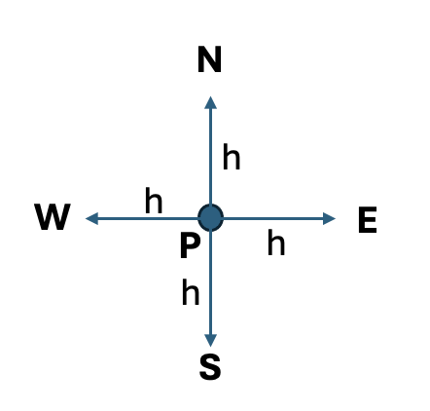
Where the centre point p is the evaluation point, the points to the North, East, South, and West are separated by ‘h’.
Using CDA in the ‘x’ direction to the left and right of the location ‘P’,

$$\frac{∂^{2}T_{p}}{∂x^{2}}=\frac{T_{E}-2T_{p}+T_{W}}{2h}+O\left(h\right) \left(Eq.7\right)$$
Where,
$T_{E}$- Temperature at the point East to the evaluation point
$T_{P}$- Evaluation Point
$T_{W}$- Temperature at the point West of the evaluation point
$h$- Distance between the points (Grid spacing)

Using CDA in the ‘y’ direction to the left and right of the location ‘P’,

$$\frac{∂^{2}T}{∂y^{2}}=\frac{T_{N}-2T_{p}+T_{S}}{2h}+O\left(h\right) \left(Eq.8\right)$$
Where,
$T_{N}$- Temperature at the point North of the evaluation point
$T_{S}$- Temperature at the point South of the evaluation point

3.3.2. Temporal Discretisation
The time is subdivided into specific increments, which define the time step. Therefore, using FDA,
$$\frac{∂T}{∂t}=\frac{T^{t+∆T}+T_{P}^{t}}{2h}+O\left(∆t\right) \left(Eq.9\right)$$
Where,
$T_{p}^{t+∆t}$- Temperature at location P at the next time step
$T_{p}^{t}$-Temperature at location P at the current time
$O\left(∆t\right)$ - Time step truncation error

3.3.3. Explicate Finite Difference Form of the Heat Equation
Utilising CDA and FDA to discretise the spatial and temporal domains respectively. The EFDM form of the heat equation can be derived (Ilhan, Isik and Bozkurt, 2023).

$$T_{P}^{t+∆t}=F_{0}\left(T_{E}^{t}+T_{W}^{t}+T_{N}^{t}+T_{S}^{t}-\left(4-\frac{1}{F_{0}}\right)⋅T_{P}^{t}\right) \left(Eq.10\right)$$
Where,
$F_{0}$- Fourier number

The Fourier number is a dimensionless parameter. For a 2D problem; it is defined as (Temoltzi, 2024),

$F_{0}=\frac{α∆t}{h^{2}}≤\frac{1}{4} \left(Eq.11\right)$

3.3.4. Stability Criterion
The stability criterion is derived from the Von Neumann Stability analysis, which ensures that the numerical errors do not amplify uncontrollably and that the solution remains accurate with respect to time (Alaofi, Ali, and Dragomir, 2021).
The stability criterion is derived from Equation 11,

$$0<F_{0}≤\frac{1}{4 } \left(Eq.12\right)$$

This ensures that the time step must be small relative to the gird spacing to satisfy the condition.

The Initial and Boundary Conditions and Analytical Solution
The initial and boundary conditions are vital in defining the temperature distribution across the aluminium plate over time.

4.1. Initial Conditions
At the beginning of the simulation, where time is zero, it is assumed that the temperature across the plate begins at a neutral state with all interior grid points set to 0°C. In the brief, the initial condition is defined as,

$$T\left(x,y,0\right)=0 , 0<x≪X_{dim} , 0<y<Y_{dim}$$

This initial condition is illustrated in Figure 2.

Figure 2- Initial Condition Matrix
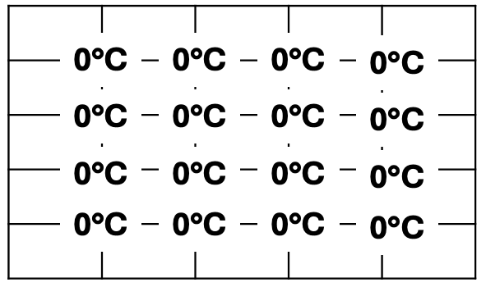
Setting the initial condition is critical for ensuring the numerical solution correctly simulates the thermal behaviour over time.

4.2. Boundary Conditions
At the North boundary, a fixed temperature is specified and defined as,
$$T\left(x,Y_{dim},t\right)=T_{0}$$
The temperature at the South boundary is set to be the inverse temperature of the North boundary and is defined as,
$$T\left(x,0,t\right)=-T_{0}$$
In the model, the East and West boundaries are perfectly insulated. At the West boundary,
$$\frac{∂T\left(0,y,t\right)}{∂x}=0$$
And at the east boundary,
$$\frac{∂T\left(X_{dim},y,t\right)}{∂x}=0$$
An example matrix of the plate considering the initial and boundary conditions is shown in Figure 3.
Figure 3 - Boundary Condition Matrix
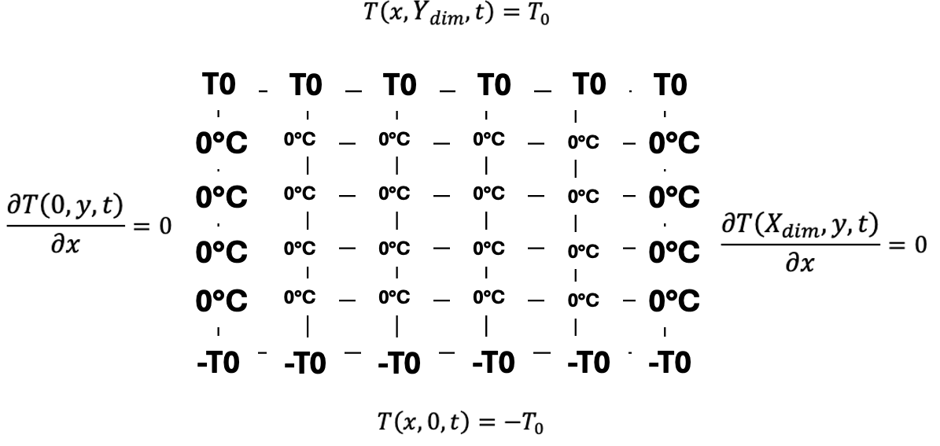Here, the East and West boundaries are updated according to the general temperature distribution of the plate.

4.3. Analytical Solution
The analytical solution provides an exact expression for the temperature distribution at any point across the plate at a steady state (Pagliarini, Spiga, and Vocale, 2021). It can be used as a benchmark for validating the numerical methods by comparing the results obtained through the simulations.
Often, the heat equation cannot be solved analytically, requiring simple geometry and boundary conditions. The initial condition assumes that all temperature across the plate is uniform, simplifying the calculations. This ensures that heat diffusion is only due to the boundary conditions and material properties.
Applying a fixed temperature at the North boundary simplifies the solution by constraining the system to a uniform solution. Setting the South boundary as the inverse of the North ensures that the calculation remains simple with a thermal gradient across the plate from north to South. Fixing the temperature at the East and West boundaries further simplifies the calculations, allowing for easy computation and comparison with numerical solutions. Equation 13 shows the analytical equation provided in the brief of the code (Chang, CY.Y., MA C.C., 2001),

$$T\left(x,y\right)=-T_{0}+\frac{2⋅T_{0}}{Ydim}⋅y+…$$
$$\sum_{k=1}^{∞}{\left(\frac{1}{{\left(100⋅k⋅π\right)}^{2}}⋅\left[1-{\left(-1\right)}^{k}\right]⋅\frac{\sin\left(\frac{k⋅π⋅x}{Ydim}\right)}{\sinh\left(\frac{k⋅π⋅Xdim}{Ydim}\right)}*\left[\cosh\left(\frac{k⋅π⋅y}{Ydim}\right)-\cosh\left(\frac{k⋅π⋅\left(x-X\dim{}\right)}{Ydim}\right)\right]\right) (Eq.13) }$$
Each calculated term is added to the total temperature sum and then used with the boundary conditions to determine the temperature at each point.

Code Details and Explanations
In this section of the report, three main areas of the code will be broken down into sections and explained, focusing on the key areas of the code.

5.1. Numerical Solution
The numerical solution focuses on solving the 2D heat equation using EDFM. The code begins with the numerical solution, defining the plate properties, dimensions, grid spacing and initial conditions.

5.1.1. Introduction and Setup
The first section of the code is shown in Figure 4.
Figure 4 - Clear MATLAB
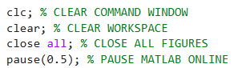
This clears the entire workspace, ensuring any results from previous simulations are cleared.

5.1.2. Defining Plate Properties
Figure 5 defines the plate properties using values from the assignment brief. Correctly defined plate properties are critical for reliability and accuracy.
Figure 5 - Defining plate properties
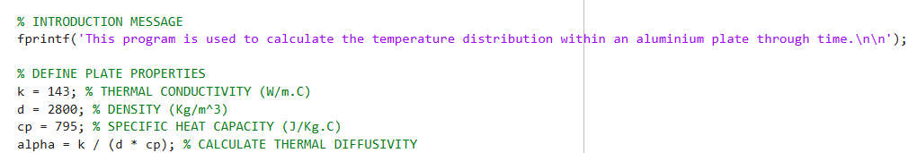
The values defined here could be modified to match other material properties, such as steel.

5.1.3. Plate Dimensions User Input
The user is prompted to enter the plate's length and width in metres. The input value is checked to ensure suitability, as shown in Figure 6.
Figure 6 - User prompt to input plate dimensions
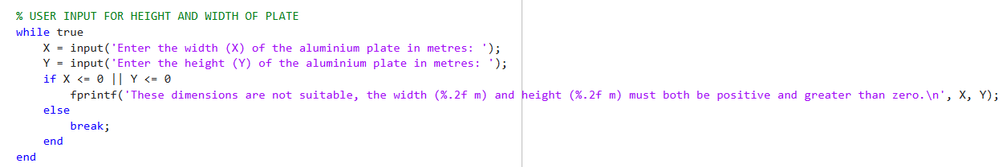
A while loop checks whether inputted values are equal to or less than zero. The user is asked to re-enter a suitable dimension if this statement is true.

5.1.4. Defining and Validating Grid Spacing
The user is prompted to enter a grid space, which is then checked to ensure it is valid and positive and divided evenly into the imputed plate dimensions.
Figure 7 - Defining and validating grid spacing
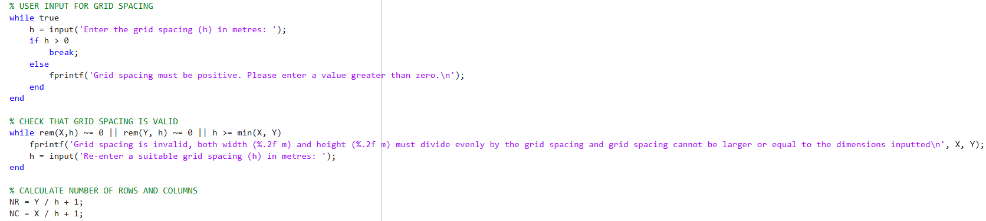
If this grid spacing is greater than zero, the loop breaks. If the loop is equal to or less than zero, the user is prompted to re-enter the grid spacing.

5.1.5. Initialising the Temperature Matrix and Boundary Conditions
In this code section, the matrix is initialised with zeroes at each grid point.
Figure 8 - Initialise Matrix and Boundary Condition Set Up
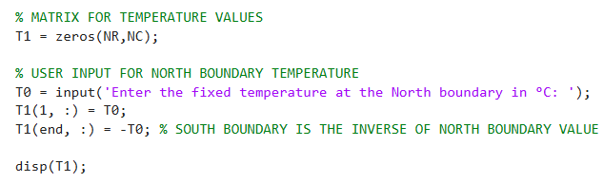
The matrix is created based on the calculated rows and columns. The user sets the north boundary temperature, while the south boundary is its negative. The resulting matrix, T1, is displayed.

5.1.6. Stability Criterion and Time Step Validation
This section calculates the maximum allowable time step for numerical stability and ensures user compliance with this constraint.
Figure 9 - Stability criterion and time step validation
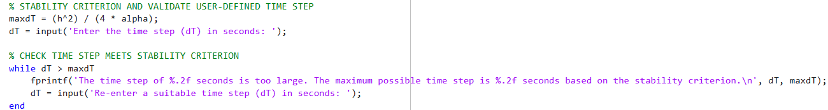
The stability criterion is calculated using the grid spacing and thermal diffusivity. The user inputs the time step, and a while loop ensures the time step satisfies the criterion.

5.1.7. Iterative EFDM Solution Loop
The heat equation is solved iteratively using the EFDM until thermal equilibrium is reached.
Figure 10 - Iterative EFDM Solution Loop
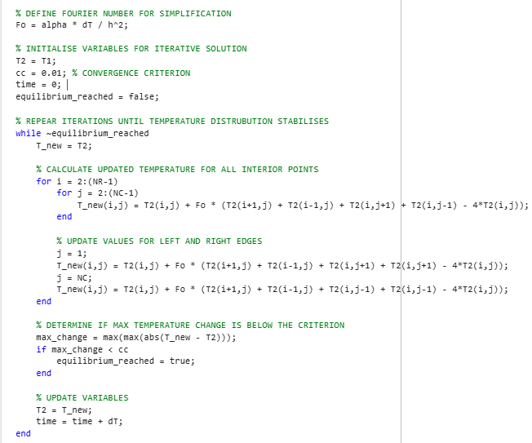
Matrix T2 is initialised with the same values as T1, and the convergence criterion is set to 0.01. The equilibrium_reached flag is initially set to false. A while loop iterates until the maximum temperature change falls below the criterion.
The current matrix T2 is copied to T_new, and grid points are updated based on adjacent values. The left and right columns are similarly updated. If the maximum temperature change is less than 0.01, the loop exits by setting equilibrium_reached to true. The updated T2 replaces the old matrix, concluding the iteration.

5.1.8. Display Final Temperature Distribution and Equilibrium Time
The final temperature distribution matrix is displayed in the command window along with the time it took to reach thermal equilibrium.
Figure 11 - Display T2 Matrix and Thermal Equilibrium
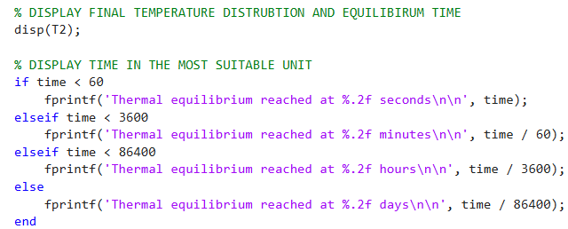
The code ensures that the time it takes to reach thermal equilibrium is displayed in the most suitable format.

5.1.9. Visualise Numerical Temperature Distribution
At the end of the numerical solution section, the temperature distribution is visualised and depicted in ‘Figure 1’ in MATLAB.
Figure 12 - Visualise the numerical temperature distribution
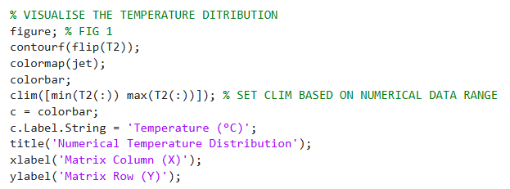
A new figure is created with a contour plot of matrix T2 flipped vertically so the plot aligns with the plate's physical orientation.

5.2. Analytical Solution
The analytical solution calculates the temperature distribution using a series expansion, generating a matrix to compare with the numerical solution for accuracy assessment.

5.2.1. Calculating the Analytical Solution
The temperature distribution is calculated analytically by summing multiple series expansion terms.
Figure 13 - Calculating Analytical solution
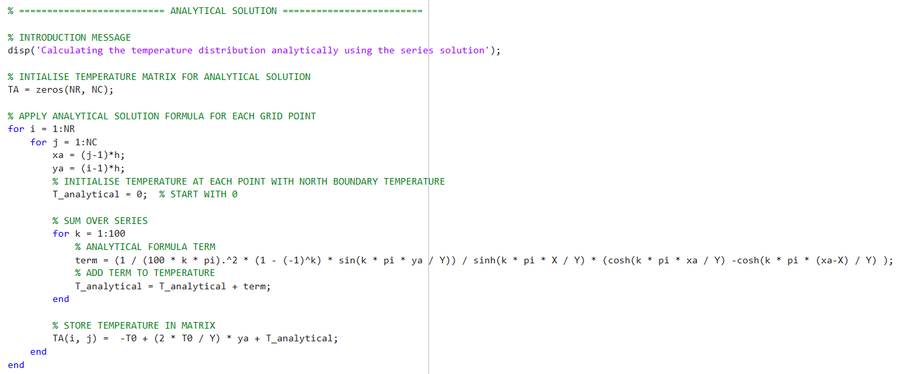
A new matrix is generated, and a for loop is used to iterate through each gird point and calculate the temperature. Following the assignment brief, the analytical solution of the temperature at thermal equilibrium is calculated against Equation 13.

5.2.1. Visualising Analytical Temperature Solution
Like section 5.1.9., the analytical temperature distribution is visualised and shown in ‘Figure 2’ in MATLAB.
Figure 14 - Visualise the analytical temperature distribution
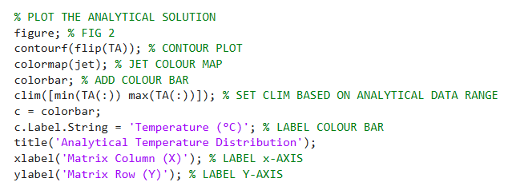

5.3. Validation of the Code
With both numerical and analytical solutions calculated, a comparison can be made to validate the accuracy by calculating the error difference between both solutions.

5.3.1. Error Calculation
By subtracting numerical and analytical solutions, an error matrix is created.
Figure 15 - Code validation through error calculation
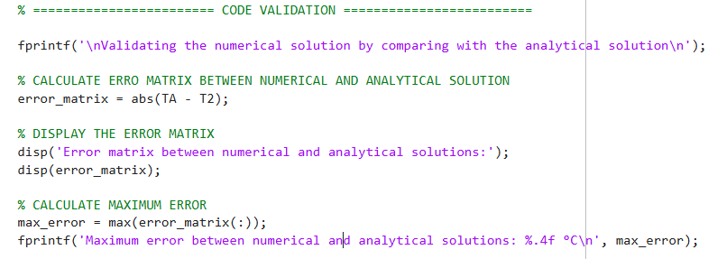
The error matrix is computed and displayed in the user’s command window. The maximum error across all points is identified using the max function and presented in the command window.

5.3.2. Visualising the Error Distribution
The error matrix is visualised in a format like the figures generated in the previous sections regarding titles and matrix names.
Figure 16 - Visualising the error distribution
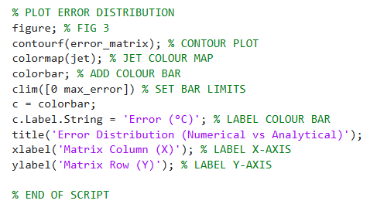
This final figure, ‘Figure 3,’ is displayed to the user in MATLAB, showing the lowest and highest errors across the matrix.

Analysis of the Validation of the Code
As discussed in section 5.3, the accuracy of the code is validated by comparing the temperature map of the numerical and analytical solution, which highlights the magnitude of error at each grid point.

6.1. Comparison of the Temperature Maps
To demonstrate the code's validation, a simulation will be run using a 12m-by-12m plate with a grid spacing of one, a time step of 3600 seconds, and a temperature of 50°C at the North boundary and the inverse at the South. The numerical solution matrix is shown in Figure 17.

Figure 17 - Numerical Solution Matrix
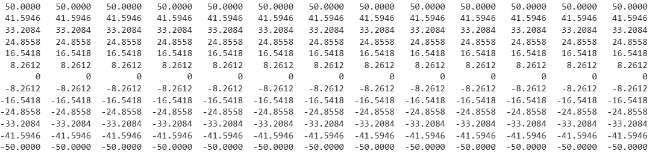

Thermal equilibrium is reached, taking 3.5 days. The analytical solution is then calculated and displayed in the command window shown in Figure 18.

Figure 18 - Analytical Solution Matrix
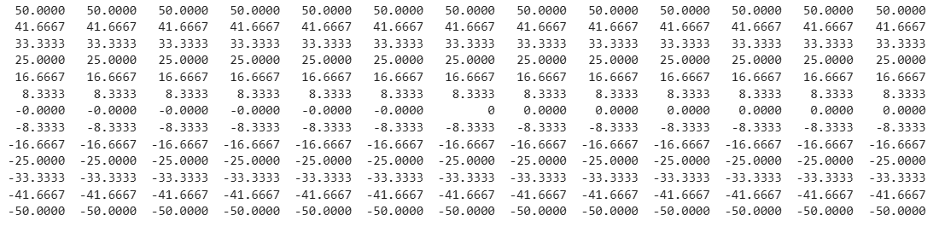

Finally, the error matrix, shown in Figure 19, is completed by subtracting the analytical matrix from the numerical matrix.

Figure 19 - Error Matrix
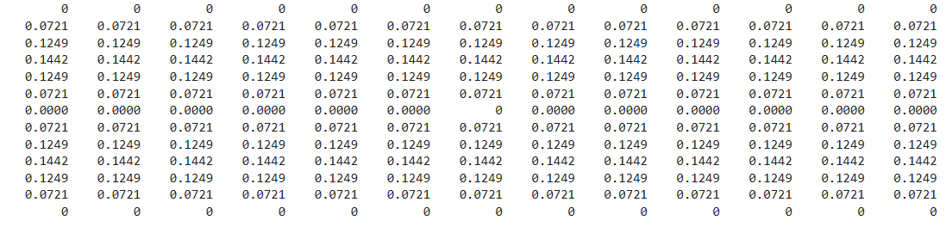
The maximum error observed is 0.1442°C, which is a relatively small value. This suggests that the numerical model effectively captures heat transfer behaviour across the plate.
The error matrix is plotted within the code using a contour map, as illustrated in Figure 20.

Figure 20 - Error distribution contour plot
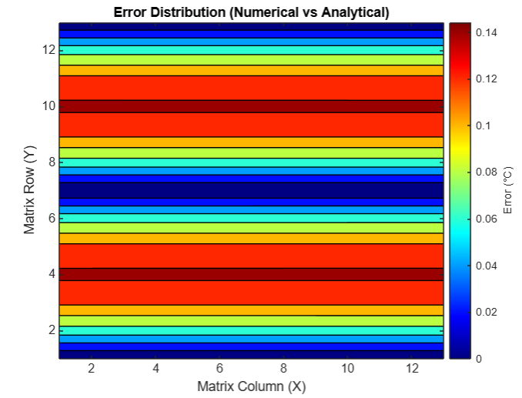
The contour plot visually represents the error matrix, with red indicating the highest error and blue the lowest.

Sensitivity Analysis
In the following sections, a sensitivity analysis will be conducted on the code for a 12m-by-12m plate with 50°C applied at the north boundary. Three variables, the grid spacing, time step, and tolerance (Convergence Criterion), will be analysed.

7.1. Grid Spacing Sensitivity Analysis
First, the influence of the grid spacing on the thermal equilibrium time result will be analysed using the varying grid spacing.
Table 1 - Influence of varying grid spacing
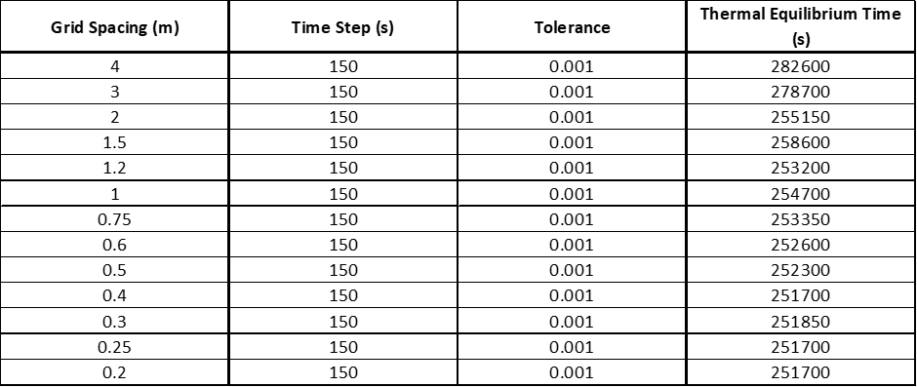

Graph 1 illustrates the relationship between thermal equilibrium and the varying grid spacing.

Graph 1 - Relationship of thermal equilibrium and varying grid spacing

As the grid spacing increases, the equilibrium time increases from the optimum equilibrium time; however, the magnitude of the increase is seen to oscillate. At grid spacings of 0.5m or smaller, changes in equilibrium time become negligible, showing that the equilibrium time is stable, showing diminishing returns in improving accuracy if reduced. As the grid spacing increases, fluctuations in equilibrium time occur before significantly increasing by 23,550s from 2m to 3m grid spacing.
Truncation errors will increase with the grid spacing, resulting in a less accurate solution but quicker computational time. Contrarily, finer grid spacings exhibit fewer truncation errors, resulting in a more accurate solution but however increasing the computation time (Para et al., 2019).

7.2. Time Step Sensitivity Analysis
Varying the time step over multiple simulations will analyse the influence that the time step has on the thermal equilibrium time.
Table 2 - Influence of varying time step
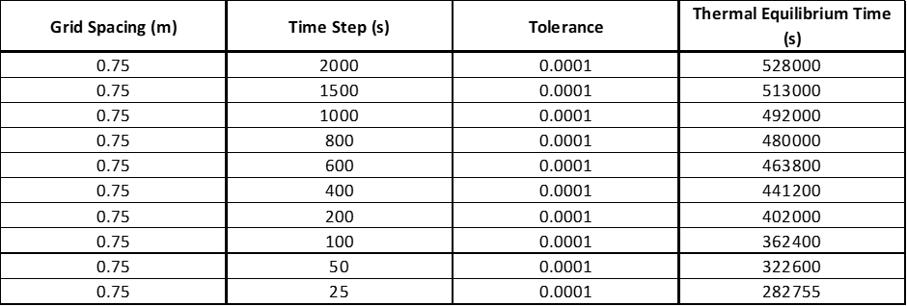

Graph 2 illustrates the relationship between thermal equilibrium and the varying time step.

Graph 2 - Relationship of thermal equilibrium and varying time step
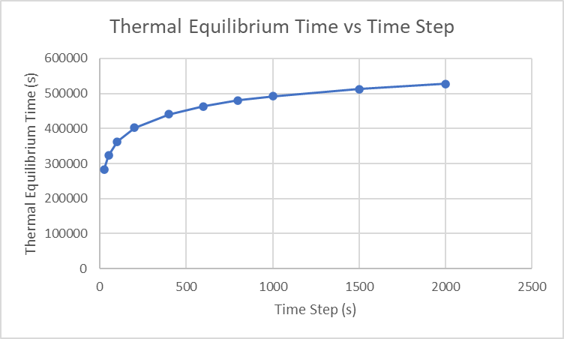
In Graph 2, the thermal equilibrium time increases with the time step. This illustrates the duality of round-off and truncation errors. Increasing the time step amplifies truncation errors, reducing accuracy in the final solution. Round-off errors show an inverse relationship, decreasing as the time step increases. A reduction occurs because few iterations take place with larger time steps, limiting the opportunity for round-off errors to propagate (Hanley and O’Sullivan, 2017).
Larger time steps increase truncation errors, leading to a less accurate temperature change at each step. In contrast, round-off errors decrease with an increase in time step. This is because few iterations are required as the time step increases, reducing the opportunity for round-off error (Jafarzadeh et al., 2023).

7.3. Tolerance Sensitivity Analysis
The tolerance conditions that influence the thermal equilibrium are tested by modifying the convergence criterion in the code and running the simulation with fixed input values, as shown in Table 3.
Table 3 - Influence of varying tolerance

A graphical representation of the relationship between the tolerance condition and thermal equilibrium is shown in Graph 3.

Graph 3 - Relationship of thermal equilibrium and varying tolerance
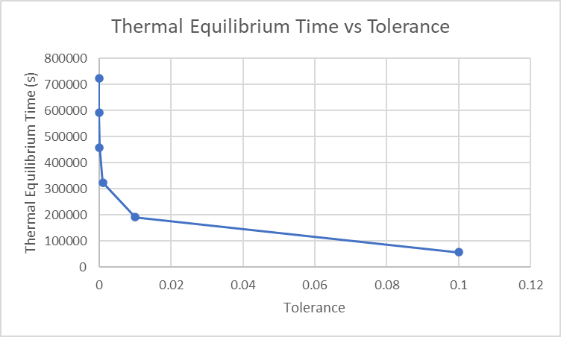
In Graph 3, thermal equilibrium time decreases as the tolerance increases. As the tolerance increases by a factor of ten, the magnitude decrease in thermal equilibrium time is almost consistent.
This trend is due to smaller tolerances requiring more iterations to meet the required accuracy, increasing the equilibrium time. Conversely, larger tolerances allow the system to stop iterating further from true equilibrium, reducing the number of iterations and leading to faster convergence (Svaiter, 2021).

Limitations of the Model
The numerical solution and coding approach for this model has limitations; these are discussed in the following sections.

8.1. Numerical Method Limitations
Based on the chosen numerical method, the model has limitations. Some of these limitations have already been highlighted in previous sections of the report. The following section will provide a further analysis of these limitations.

8.1.1. Truncation Errors
Truncation errors occur as the higher-order terms as the higher-order terms in the Taylor series expansion are neglected (Nishidate, 2023). By neglecting these terms, the complexity of the simulation is reduced, reducing the computation requirements. In addition, if the difference between the evaluation points and adjacent points is small (x – x0), then the impact of neglecting these terms is relatively small.
As demonstrated by the sensitivity analysis in the previous sections, truncation errors are affected by both grid spacing and time steps. Areas with drastic changes in values, such as areas near boundaries, exhibit higher truncation errors due to sharp changes in the solution (Kavetski and Clark, 2010).
While in some cases, the effect of truncation may be minimal, truncation errors result in reduced accuracy. This error is accumulated over time, reducing the model's reliability, especially when high precision is required.

8.1.2. Round-Off-Errors
One cause of round-off errors is computational limits with bits. For example, a 32-bit (Single Precision) computer accounts for seven significant decimal digits of precision, while a 64-bit (Double Precision) computer accounts for 15-16 (Croci et al., 2022). While accuracy is improved with wider bit computers, Lu et al. highlight that computational costs can increase.
As this error decreases with the decrease in time step, optimisation for accuracy becomes challenging. Depending on the overall objective of the code, a balance between round-off and truncation errors is required. Here, accuracy is a trade-off against computational time (Kehlet and Logg, 2017).

8.1.3. Complex Geometry
The EFDM relies on a structured and uniform grid spacing, such as a rectangular shape. The grid is challenging to align with Irregular shapes, leading to poor boundary approximation and inaccurate results (Spitzer, 2024). For example, meshes may not encompass the entire surface with curved geometry, leading to inaccurate heat flow representation.

8.1.4. Stability Issue
Stability is dependent on the size of the time step and spatial discretisation. Time steps are restricted to being relatively small compared to grid spacing, which can increase computation time in some cases. Violating the stability criterion leads to instability, creating oscillations in the solution and decreasing its accuracy and reliability (Gao and Lieu, 2015).

8.2. Coding Method Limitations
The coding method limited the model, introducing inaccuracies in the physical behaviour of heat flow within a system.

8.2.1. Convergence Criterion
In real-world systems, thermal equilibrium is when heat transfer ceases with temperatures becoming uniform across the domain (Kuzkin, 2019). However, the model determines thermal equilibrium by checking the maximum difference between the temperature maps below the predefined tolerance. This approach coding approach does not accurately represent a real-world scenario, decreasing the reliability of the results.
A convergence criterion that best fits the desired output of the simulation must be chosen. For example, a small tolerance would be best suited for an application that requires high precision. However, very small tolerances will increase the computational time without significantly benefiting the overall accuracy.

9. Suggested Improvements and Future Developments
The following sections explore potential improvements and future developments relating to the numerical model developed in this code. The suggested improvements will address some limitations identified in the previous section.

9.1. Overcoming Stability Issues
Large-scale models may require large steps due to the time required to reach thermal equilibrium. As discovered with the EFDM, large time steps cause various issues, such as the accumulation of truncation errors; as an alternative, the Alternating Direction Implicit (ADI) method is more suited for models requiring these large time steps without impacting accuracy (Li et al., 2023).
While this method is considered more complex to solve, there are no stability issues like with the EFDM, allowing for large time steps without impacting the accuracy of the solution (Heh, Tan and Tay, 2016). An additional method which enhances stability is the Implicit Finite Difference Method (IFDM), also improving stability in the numerical solution as the same stability criterion does not govern it as the EFDM (Buraney, Matan and Arshad, 2021).

9.2. Dealing with Complex Geometries
As discussed, the EFDM does not effectively deal with complex geometries such as curved shapes. Other methods, such as the Finite Element Method (FEM), are more flexible due to their ability the generate irregular mesh formations that conform to the boundaries of the domain. FEM. This improvement in adaptability can be beneficial to thermal problems with complex geometries and high mesh densities (Yakupov, Kiyamov and Mukhamedova, 2022).

9.3. Further Developments
The limitations of modelling thermal equilibrium using a convergence criterion have been highlighted as causing inaccuracies. One Alternative method that provides a more accurate representation of thermal equilibrium is using a time-weighted average of temperature changes over the time steps (Carson, 2022).
Future developments could incorporate hybrid approaches, combining artificial intelligence (AI) and traditional methods to improve the accuracy and efficiency of the model. AI technology can predict thermal equilibrium based on trends through machine learning algorithms and dynamically adjust the model for more accurate results (Yu and Tian, 2022).

10. Conclusion
Overall, applying the EFDM to model heat transfer across a 2D aluminium plate is practical but has limitations, which may be negated by using different models. The FDA, BDA, and CDA were explored, providing an understanding of how they are applied to the problem. The code was validated by comparing the numerical and analytical solutions. The outcome was a maximum error of 0.01442 °C, a relatively low error difference; however, it may not be suitable for applications requiring high precision.
Conducting a sensitivity analysis on the code regarding three variables, grid spacing, time step, and tolerance, highlights their impact on thermal equilibrium time. These variables also impact the solutions' accuracy and computation time due to their relationship with truncation and round-off errors.
The code's limitations were further discussed, highlighting that in addition to truncation and round-off errors, there are also issues with stability and the capability to solve complex geometries. The ADI method solves the stability issue, allowing for large-time steps without compromising accuracy. The FEM provides a solution for dealing with complex geometries, improving flexibility for irregular mesh formations. Further improvements include using a time-weighted average instead of a convergence criterion to represent thermal equilibrium accurately. With developments in AI, efficiency in modelling thermal equilibrium will improve. Allowing for predictions to be made through machine learning and trends.

References

Akrivis, G., Lubich, C. (2015). Fully implicit, linearly implicit and implicit–explicit backward difference formulae for quasi-linear parabolic equations. Numerische Mathematik. 131(4), pp.713-735. [Online]. Available at: https://doi.org/10.1007/s00211-015-0702-0 [Accessed 3 January 2025].

Al-Khaled, K. (2018). Finite Fourier transform for solving potential and steady-state temperature problems. Cham: Springer International Publishing; Advances in difference equations. 1(1), pp.1-14. [Online]. Available at: https://doi.org/10.1186/s13662-018-1552-8 [Accessed 23 December 2024].

Alaofi, Z.M., Ali, T.S., Dragomir, S.S. (2021). A numerical solution of the dissipative wave equation by means of the cubic B-spline method. Journal of Physics Communications. 5(10), pp.105014. [Online]. Available at: https://doi.org/10.1088/2399-6528/ac2940 [Accessed 5 January 2025].

Barrio, R. (2006). Sensitivity analysis of ODEs/DAEs using the Taylor Series method. SIAM journal on scientific computing. 27(6), pp.1929-1947. [Online]. Available at: https://doi.org/10.1137/030601892 [Accessed 30 December 2024].

Buranay, S.C., Matan, A.H., Arshad, N. (2021). Two Stage Implicit Method on Hexagonal Grids for Approximating the First Derivatives of the Solution to the Heat Equation. Fractal and Fractional. 5(1), pp. 19-. [Online]. Available at: https://doi.org/10.3390/fractalfract5010019 [Accessed 5 January 2025].

Carson, J.K. (2022). Modelling Thermal Diffusivity of Heterogeneous Materials Based on Thermal Diffusivities of Components with Implications for Thermal Diffusivity and Thermal Conductivity Measurement. International Journal of Thermophysics, 43(7). [Online]. Available at: https://doi.org/10.1007/s10765-022-03037-6 [Accessed 5 January 2025].

Cengal, Y.A., Ghajar, A.J. (2020). Heat and Mass Transfer: Fundamentals & Applications. [Online]. McGraw-Hill Education. Available at: https://www.google.co.uk/books/edition/Heat_and_Mass_Transfer/6KmezQEACAAJ?hl=en [Accessed 23 December 2024].

Chamekh, M., Elzaki, T.M., Ahmed, S.A. (2024). Solution of Lane Emden–Fowler equations by Taylor series method. ournal of Umm Al-Qura University for Applied Sciences. 10(2), pp.274-278. [Online]. Available at: https://doi.org/10.1007/s43994-023-00100-2 [Accessed 24 January 2025].

Chaudhary, R.K., Chaurasiya, V., Awad, M.M., Singh, J. (2022). A numerical study on the thermal response in multi-layer of skin tissue subjected to heating and cooling procedures. European Physical Journal Plus. 137(1), pp.120. [Online]. Available at: https://doi.org/10.1140/epjp/s13360-021-02322-x [Accessed 5 January 2025].

Croci, M., Fasi, M., Higham, N.J., Mary, T., Mikaitis, M. (2022). Stochastic rounding: implementation, error analysis and applications. Royal Society Open Science. 9(3), pp.211631. [Online]. Available at: https://doi.org/10.1098/rsos.211631 [Accessed 5 January 2025].

Croft D.R, Liley, D.G. (1977). Heat Transfer Calculations Using Finite Difference Equations. 7th ed. London: Applied Science.

Cui, M. (2021). Finite difference schemes for the two-dimensional multi-term time-fractional diffusion equations with variable coefficients. Computational & Applied Mathematics. 40(5). [Online]. Available at: https://doi.org/10.1007/s40314-021-01551-1 [Accessed 5 January 2025].

Debnath, L. (2012). A short biography of Joseph Fourier and historical development of Fourier series and Fourier transforms. International journal of mathematical education in science and technology. 43(5), pp.589-612. [Online]. Available at: https://doi.org/10.1080/0020739X.2011.633712 [Accessed 22 December 2024].

Feng, W., Wang, C., Wise, S.M., Zhang, Z. (2018). A second‐order energy stable backward differentiation formula method for the epitaxial thin film equation with slope selection. Numerical Methods for Partial Differential Equations. 34(6), pp.1975-2007. [Online]. Available at: https://doi.org/10.1002/num.22271 [Accessed 3 January 2025].

Gao, J., Liu, S. (2015). Oscillation analysis of numerical solutions in the θ-methods for differential equation of advanced type. Mathematical Methods in the Applied Sciences. 38(18), pp.5271-5278. [Online]. Available at: https://doi.org/10.1002/mma.3458 [Accessed 5 January 2025].

Garcia-Ramirez, E., Peñaloza-Mejia, O., Moog, C.H. (2017). Further comments on Taylor series expansion of the delay/advance operator. Journal of computational and nonlinear dynamics. 12(3), pp.1-3. [Online]. Available at: https://doi.org/10.1115/1.4035058 [Accessed 2 January 2025].

Hanley, K. and O’Sullivan, C. (2017) ‘Analytical study of the accuracy of discrete element simulations’, International journal for numerical methods in engineering, 109(1), pp. 29–51. Available at: https://doi.org/10.1002/nme.5275.

Heh, D.Y., Tan, E.L., Tay, W.C. (2016). Fast alternating direction implicit method for efficient transient thermal simulation of integrated circuits. International Journal of Numerical Modelling. 29(1), pp.93-108. [Online]. Available at: https://doi.org/10.1002/jnm.2049 [Accessed 5 January 2025].

Jafarzadeh, A., Pourreza-Bilondi, M., Akbarpour, A., Khashei-Siuki, A. and Azizi, M. (2023). Sensitivity and Stability Analysis for Groundwater Numerical Modeling: A Field Study of Finite Element Application in the Arid Region. Acta Geophysica, 71(2), pp. 1045–1062. [Online]. Available at: https://doi.org/10.1007/s11600-022-00949-7 [Accessed 5 January 2025].

Kavetski, D. and Clark, M.P. (2010). Ancient Numerical Daemons of Conceptual Hydrological Modeling: 2. Impact of Time Stepping Schemes on Model Analysis and Prediction. Water Resources Research, 46(10). [Online]. Available at: https://doi.org/10.1029/2009WR008896 [Accessed 5 January 2025].

Kehlet, B., Logg, A. (2017). A posteriori error analysis of round-off errors in the numerical solution of ordinary differential equations. Numerical Algorithms. 76(1), pp.191-210. [Online]. Available at: https://doi.org/10.1007/s11075-016-0250-4 [Accessed 5 January 2025].

Kuzkin, V.A. (2019). Thermal equilibration in infinite harmonic crystals. Continuum Mechanics and Thermodynamics. 31(5), pp.1401-1423. [Online]. Available at: https://doi.org/10.1007/s00161-019-00758-2 [Accessed 5 January 2025].

Leyli, A.N., Andleeb, Z., Khawaja, H., Messahel, R., Kanna, R., Moatamedi, M. (2021). Conjugate Heat Transfer Model Based on SIMPLE and Coupled Energy and Heat Equations. The international journal of multiphysics. 15(1), pp.29-47. [Online]. Available at: https://doi.org/10.21152/1750-9548.15.1.29 [Accessed 28 December 2024].

Li, J., Huang, Z., Tang, M. and Mao, J. (2023). A generalized alternating direction implicit method for transient thermal simulation of 2-D structures with locally refined grids. Numerical Heat Transfer, Part B: Fundamentals, 84(1), pp.99–114. [Online]. Available at: https://doi.org/10.1080/10407790.2023.2189187 [Accessed 23 January 2025].

Lu, H., Zhang, M., Han, Y., Wang, Q., Li, H., Li, X. (2020). Architecting Effectual Computation for Machine Learning Accelerators. IEEE Transactions on Computer-Aided Design of Integrated Circuits and Systems. 39(10), pp.2654-2667. [Online]. Available at: https://doi.org/10.1109/TCAD.2019.2946810 [Accessed 5 January 2025].

Nishidate, Y. (2023). Simple and compact finite difference formulae using real and complex variables. International Journal of Computational Science and Engineering. 26(6), pp.684-693. [Online]. Available at: https://doi.org/10.1504/IJCSE.2023.135283 [Accessed 5 January 2025].

Orekhov, A.A., Rabinskiy, L.N., Fedotenkov, G.V. (2024). Fundamental Solutions of the Equations of Classical and Generalized Heat Conduction Models. Kazan Federal University. 165(4), pp.404-414. [Online]. Available at: https://doi.org/10.26907/2541-7746.2023.4.404-414 [Accessed 22 December 2024].

Pagliarini, L., Spiga, M., Vocale, P. (2021). An analytical approach to the cooling of a flat plate. Journal of Physics. Conference Series. 1868(1), pp.012003. [Online]. Available at: https://doi.org/10.1088/1742-6596/1868/1/012003 [Accessed 5 January 2025].

Pare, P.E., Grimsman, D., Wilson, A.T., Transtrum, M.K., Warnick, S. (2019). Model Boundary Approximation Method as a Unifying Framework for Balanced Truncation and Singular Perturbation Approxi.... New York: IEEE; IEEE transactions on automatic control. 64(11), pp.4796-4802. [Online]. Available at: https://doi.org/10.1109/TAC.2019.2908523 [Accessed 2 January 2025].

Quinlan, N.J., Basa, M., Lastiwka, M. (2006). Truncation error in mesh-free particle methods. International Journal for Numerical Methods in Engineering. 66(13), pp.2064-2085. [Online]. Available at: https://doi.org/10.1002/nme.1617 [Accessed 5 January 2025].

Reddy, T.A., Kreider, J.F., Curtiss, P.S., Rabl A. (2016). Heating and Cooling of Buildings: Principles and Practice of Energy Efficient.... [Online]. CRC Press. Available at: https://www.google.co.uk/books/edition/Heating_and_Cooling_of_Buildings/NDqLDQAAQBAJ?hl=en&gbpv=0 [Accessed 23 December 2024].

Sodan, V., Stoffels, S., Oprins, H., Decoutere, S., Altmann, F., Baelmans, M., De Wolf, I. (2018). Fast and distributed thermal model for thermal modeling of GaN power devices. IEEE Transactions on Components, Packaging, and Manufacturing Technology. 8(10), pp.1747-1755. [Online]. Available at: https://doi.org/10.1109/TCPMT.2018.280868 [Accessed 5 January 2025].

Spitzer, K. (2024). Electromagnetic modeling using adaptive grids – error estimation and geometry representation. Surveys in Geophysics. 45(1), pp.277-314. [Online]. Available at: https://doi.org/10.1007/s10712-023-09794-9 [Accessed 5 January 2025].

Sun, J. and Cheng, X. (2010). Iterative methods for a forward-backward heat equation in two-dimension. Applied Mathematics-A Journal of Chinese Universities. 25(1), pp.101-111. [Online]. Available at: https://doi.org/10.1007/s11766-010-1812-1 [Accessed 2 January 2025].

Svaiter, B.F. (2021). A Partially Inexact ADMM with o(1/n) Asymptotic Convergence Rate, (1/n) Complexity, and Immediate Relative Error Tolerance. Optimization, 70(10), pp. 2061–2080. [Online]. Available at: https://doi.org/10.1080/02331934.2020.1772255 [Accessed 5 January 2025].

Verzhbitskii, V.M. (2015). On the instability of symmetric formulas for numerical differentiation and integration. Computational Mathematics and Mathematical Physics. 55(6), pp.917-921. [Online]. Available at: https://doi.org/10.1134/S0965542515060123 [Accessed 5 January 2025].

Wu, B., Bao, H., Ou, J., Tian, S. (2005). Stability and accuracy analysis of the central difference method for real-time substructure testing. Earthquake Engineering & Structural Dynamics. 34(7), pp.705-718. [Online]. Available at: https://doi.org/10.1002/eqe.451 [Accessed 3 January 2025].

Yakupov, N.M., Kiyamov, H.G., Mukhamedova, I.Z. (2022). Studies about Solution Convergence of the Spline Version of the Finite Element Method in Two-Dimensional and Three-Dimensional Formulations. Lobachevskii Journal of Mathematics. 43(5), pp. 1218–1223. [Online]. Available at: https://doi.org/10.1134/S1995080222080364 [Accessed 5 January 2025].

Appendices

Appendix 1 - MATLAB Code

clc; % CLEAR COMMAND WINDOW
clear; % CLEAR WORKSPACE
close all; % CLOSE ALL FIGURES
pause(0.5); % PAUSE MATLAB ONLINE

% ========================== NUMERICAL SOLUTION ==========================

% INTRODUCTION MESSAGE
fprintf('This program is used to calculate the temperature distribution within an aluminium plate through time.\n\n');

% DEFINE PLATE PROPERTIES
k = 143; % THERMAL CONDUCTIVITY (W/m.C)
d = 2800; % DENSITY (Kg/m^3)
cp = 795; % SPECIFIC HEAT CAPACITY (J/Kg.C)
alpha = k / (d * cp); % CALCULATE THERMAL DIFFUSIVITY

% USER INPUT FOR HEIGHT AND WIDTH OF PLATE
while true
X = input('Enter the width (X) of the aluminium plate in metres: ');
Y = input('Enter the height (Y) of the aluminium plate in metres: ');
if X <= 0 || Y <= 0
fprintf('These dimensions are not suitable, the width (%.2f m) and height (%.2f m) must both be positive and greater than zero.\n', X, Y);
else
break;
end
end

% USER INPUT FOR GRID SPACING
while true
h = input('Enter the grid spacing (h) in metres: ');
if h > 0
break;
else
fprintf('Grid spacing must be positive. Please enter a value greater than zero.\n');
end
end

% CHECK THAT GRID SPACING IS VALID
while rem(X,h) ~= 0 || rem(Y, h) ~= 0 || h >= min(X, Y)
fprintf('Grid spacing is invalid, both width (%.2f m) and height (%.2f m) must divide evenly by the grid spacing and grid spacing cannot be larger or equal to the dimensions inputted\n', X, Y);
h = input('Re-enter a suitable grid spacing (h) in metres: ');
end

% CALCULATE NUMBER OF ROWS AND COLUMNS
NR = Y / h + 1;
NC = X / h + 1;

% MATRIX FOR TEMPERATURE VALUES
T1 = zeros(NR,NC);

% USER INPUT FOR NORTH BOUNDARY TEMPERATURE
T0 = input('Enter the fixed temperature at the North boundary in °C: ');
T1(1, :) = T0;
T1(end, :) = -T0; % SOUTH BOUNDARY IS THE INVERSE OF NORTH BOUNDARY VALUE

disp(T1);

% STABILITY CRITERION AND VALIDATE USER-DEFINED TIME STEP
maxdT = (h^2) / (4 * alpha);
dT = input('Enter the time step (dT) in seconds: ');

% CHECK TIME STEP MEETS STABILITY CRITERION
while dT > maxdT
fprintf('The time step of %.2f seconds is too large. The maximum possible time step is %.2f seconds based on the stability criterion.\n', dT, maxdT);
dT = input('Re-enter a suitable time step (dT) in seconds: ');
end

% DEFINE FOURIER NUMBER FOR SIMPLIFICATION
Fo = alpha * dT / h^2;

% INITIALISE VARIABLES FOR ITERATIVE SOLUTION
T2 = T1;
cc = 0.0001; % CONVERGENCE CRITERION
time = 0;
equilibrium_reached = false;

% REPEAR ITERATIONS UNTIL TEMPERATURE DISTRUBUTION STABILISES
while ~equilibrium_reached
T_new = T2;

% CALCULATE UPDATED TEMPERATURE FOR ALL INTERIOR POINTS
for i = 2:(NR-1)
for j = 2:(NC-1)
T_new(i,j) = T2(i,j) + Fo * (T2(i+1,j) + T2(i-1,j) + T2(i,j+1) + T2(i,j-1) - 4*T2(i,j));
end

% UPDATE VALUES FOR LEFT AND RIGHT EDGES
j = 1;
T_new(i,j) = T2(i,j) + Fo * (T2(i+1,j) + T2(i-1,j) + T2(i,j+1) + T2(i,j+1) - 4*T2(i,j));
j = NC;
T_new(i,j) = T2(i,j) + Fo * (T2(i+1,j) + T2(i-1,j) + T2(i,j-1) + T2(i,j-1) - 4*T2(i,j));
end

% DETERMINE IF MAX TEMPERATURE CHANGE IS BELOW THE CRITERION
max_change = max(max(abs(T_new - T2)));
if max_change < cc
equilibrium_reached = true;
end

% UPDATE VARIABLES
T2 = T_new;
time = time + dT;
end

% DISPLAY FINAL TEMPERATURE DISTRUBTION AND EQUILIBIRUM TIME
disp(T2);

% DISPLAY TIME IN THE MOST SUITABLE UNIT
if time < 60
fprintf('Thermal equilibrium reached at %.2f seconds\n\n', time);
elseif time < 3600
fprintf('Thermal equilibrium reached at %.2f minutes\n\n', time / 60);
elseif time < 86400
fprintf('Thermal equilibrium reached at %.2f hours\n\n', time / 3600);
else
fprintf('Thermal equilibrium reached at %.2f days\n\n', time / 86400);
end

% TO SEE THE THERMAL EQUILBIRUM TIME IN SECONDS ONLY, COMMENT THE ABOVE
% SECTION AND UNCOMMENT THE BELOW
% disp(time)

% VISUALISE THE TEMPERATURE DITRIBUTION
figure; % FIG 1
contourf(flip(T2));
colormap(jet);
colorbar;
clim([min(T2(:)) max(T2(:))]); % SET CLIM BASED ON NUMERICAL DATA RANGE
c = colorbar;
c.Label.String = 'Temperature (°C)';
title('Numerical Temperature Distribution');
xlabel('Matrix Column (X)');
ylabel('Matrix Row (Y)');

% ========================== ANALYTICAL SOLUTION =========================

% INTRODUCTION MESSAGE
fprintf('Calculating the temperature distribution analytically using the series solution.\n\n');

% INTIALISE TEMPERATURE MATRIX FOR ANALYTICAL SOLUTION
TA = zeros(NR, NC);

% APPLY ANALYTICAL SOLUTION FORMULA FOR EACH GRID POINT
for i = 1:NR
for j = 1:NC
xa = (j-1)*h;
ya = (i-1)*h;
% INITIALISE TEMPERATURE AT EACH POINT WITH NORTH BOUNDARY TEMPERATURE
T_analytical = 0; % START WITH 0

% SUM OVER SERIES
for k = 1:100
% ANALYTICAL FORMULA TERM
term = (1 / (100 * k * pi).^2 * (1 - (-1)^k) * sin(k * pi * ya / Y)) / sinh(k * pi * X / Y) * (cosh(k * pi * xa / Y) -cosh(k * pi * (xa-X) / Y) );
% ADD TERM TO TEMPERATURE
T_analytical = T_analytical + term;
end

% STORE TEMPERATURE IN MATRIX
TA(i, j) = -T0 + (2 * T0 / Y) * ya + T_analytical;
end
end

% DISPLAY ANALYTICAL SOLUTION RESULTS
TA=flip(TA);
disp('Analytical solution matrix TA:');
disp(TA);

% PLOT THE ANALYTICAL SOLUTION
figure; % FIG 2
contourf(flip(TA)); % CONTOUR PLOT
colormap(jet); % JET COLOUR MAP
colorbar; % ADD COLOUR BAR
clim([min(TA(:)) max(TA(:))]); % SET CLIM BASED ON ANALYTICAL DATA RANGE
c = colorbar;
c.Label.String = 'Temperature (°C)'; % LABEL COLOUR BAR
title('Analytical Temperature Distribution');
xlabel('Matrix Column (X)'); % LABEL x-AXIS
ylabel('Matrix Row (Y)'); % LABEL Y-AXIS

% ======================== CODE VALIDATION =========================
12;
fprintf('Validating the numerical solution by comparing with the analytical solution\n\n');

% CALCULATE ERRO MATRIX BETWEEN NUMERICAL AND ANALYTICAL SOLUTION
error_matrix = abs(TA - T2);

% DISPLAY THE ERROR MATRIX
disp('Error matrix between numerical and analytical solutions:');
disp(error_matrix);

% CALCULATE MAXIMUM ERROR
max_error = max(error_matrix(:));
fprintf('Maximum error between numerical and analytical solutions: %.4f °C\n\n', max_error);

% PLOT ERROR DISTRIBUTION
figure; % FIG 3
contourf(error_matrix); % CONTOUR PLOT
colormap(jet); % JET COLOUR MAP
colorbar; % ADD COLOUR BAR
clim([0 max_error]) % SET BAR LIMITS
c = colorbar;
c.Label.String = 'Error (°C)'; % LABEL COLOUR BAR
title('Error Distribution (Numerical vs Analytical)');
xlabel('Matrix Column (X)'); % LABEL X-AXIS
ylabel('Matrix Row (Y)'); % LABEL Y-AXIS

disp('End of simulation')

% END OF SCRIPT

