ACDA4006 Electrical and Electronic Principles
Resonance
B. ENG Embedded Electronics Systems
Alice Percy (2318126)
Steve Mosey

​​

Table of Contents
Table of Contents 1
List of Figures 1
List of Tables 2
Abstract 2
Introduction 2
What are RLC circuits? 2
RLC Theory 2
Examples of RLC circuits 3
Report Format: 3
Circuit Set-Ups 3
Proteus Circuit Diagram 3
Circuit parameters 4
Circuit Measurements 5
Physical Circuit Set Up 5
Results 7
Table of Frequency Response for a Simulated Circuit 9
Graph of Frequency Response Simulated Circuit (Resonant Frequency) 9
Table of Frequency Response for a Physical Circuit 11
Graph of Frequency Response of Physical Circuit 12
Discussion 13
What do the results show? 13
Why does this happen? 14
Conclusion 15
Nomenclature 15
References 15

List of Figures
Figure 1 Frequency Response of a simulate circuit layout designed in Proteus, contains an oscilloscope, resistor, inductor, capacitor, and signal generator. This is an RLC circuit configured with the resistor in series with a capacitor and inductor that are in parallel. 4
Figure 2 Physical circuit components 5
Figure 3 RLC circuit Bread board 5
Figure 4 Signal generator connected to breadboard 6
Figure 5 Oscilloscope and signal generator connected to RLC breadboard 6
Figure 6 example of inputs on signal generator 6
Figure 7 frequency response of experiment generated on oscilloscope by RLC circuit 7
Figure 8 Oscilloscope connected to breadboard 7
Figure 9 Graph representing the frequency response of a simulated circuit through proteus with a signal output of 2V pk-pk at 100Hz, at a range of frequencies from 100Hz to 20kHz. Graph of Resonant frequency 9
Figure 10 Fl Fh and Rres lines used to calculate the Q factor of the simulated Circuit 10
Figure 13 Q factor of simulated circuit determined using excel sheet provided by course. 10
Figure 14 Simulated circuit, a closer look at the values determining the graph output. 11
Figure 11 Graph representing the frequency response of a physical circuit with a signal output of 2V pk-pk at 100Hz, at a range of frequencies from 100Hz to 20kHz 12
Figure 12 Fl, Fh and Rres lines used to calculate the Q factor of the physical Circuit 12
Figure 15 Q factor of physical circuit using excel sheet provided by course. 13
Figure 16 Physical circuit, a closer look at the values determining the graph output 13
Figure 17 Graph comparing the frequency response of a simulated circuit through proteus with a signal output of 2V pk-pk at 100Hz, at a range of frequencies from 100Hz to 20kHz, and the frequency response of a physical circuit with a signal output of 2V pk-pk 14

List of Tables
Table 1 Frequency Response for a Simulated Circuit 9
Table 2 Frequency Response for a Practical Attenuation Circuit 11
Table 3 Nomenclature- symbols names and measured units of values discussed in report 15

Abstract
The following report is a record and evaluation of conducting an experiment on an RLC circuit. This report examines the fundamental components of the experiment, how the work was simulated in Proteus and then tested physically. The attributed differences and similarities in the results between these circuits are then discussed regarding resonant frequencies and Q (quality) factor. The result of the experiment being that the simulated circuit has a higher Q factor of 40.26 compared to the physical circuit which has a Q factor of 3.812. The report explores how these values were calculated and what the difference means.

Introduction

What are RLC circuits?
RLC circuits are composed of a resistor, inductor and capacitor. These can be wired in a variety of manners either in series, parallel or any configuration of both. In this case the circuit in the experiment is a resistor in series with a parallel inductor and capacitor. Each RLC circuit has a resonant frequency, meaning the input frequency that the circuit displays characteristic behaviour.

RLC Theory
A resistor is used to decrease the current in an electrical circuit. This reduction can be referred to as resistance (R), impedance (Z), or attenuation (α).
A capacitor is ‘an electrical component consisting of two or more conductive plates separated by insulation and used to store energy in an electrostatic field’. Meaning the electric charge is stored between the two terminals in an electric field. The larger the distance between the terminals, the larger the potential energy that can be stored. The potential to store voltage is known as capacitance and is measured in farads (F).
The inductor stores electrical energy in an electromagnetic field that forms when current is passed through a wire wrapped around a magnet. This is measured in Henries (H). The purpose of an inductor is to compete against the change in the direction of flowing current. Capacitors and inductors have impedance, usually detailed by data from manufacturers. The values of these components and how they are configured control how an RLC circuit functions.
The experiment looks at the attenuation of an RLC circuit, and from that we determine the resonant frequency.

Examples of RLC circuits
There are a variety of uses for RLC circuits, for example filters like audio systems, subwoofer, speakers, treble. They also have function outside of filters, and can be used to magnify voltage and a parallel RLC circuit may be used to magnify current. Another use case is induction heating.

Report Format:
The objective of this report is to analyse an RLC circuit and network in a simulated and physical environment using appropriate analysis tools such as proteus, and perform electrical and electronic measurements, record and analyse data and produce a report. The circuit setups will be defined, and then the results will be recorded in table and graph form. From this the resonant frequency, bandwidth and Q factor may be determined. A discussion of the results will follow. The conclusion will contain the outcome of the report.

Circuit Set-Ups
It is an RLC circuit configured with the resistor in series with a capacitor and inductor that are in parallel. The signal generator output is set to 2V pk-pk at 100Hz, once this was set the output voltage was not changed. The voltage was then measured across the resistor and the inductor/ capacitor at a range of frequencies from 100Hz to a maximum of 20kHz. Several closely spaced measurements were taken around the peak of the response in order to determine the peak and the half amplitude points accurately.

Proteus Circuit Diagram
The circuit was built in Proteus, as demonstrated in Figure 1.
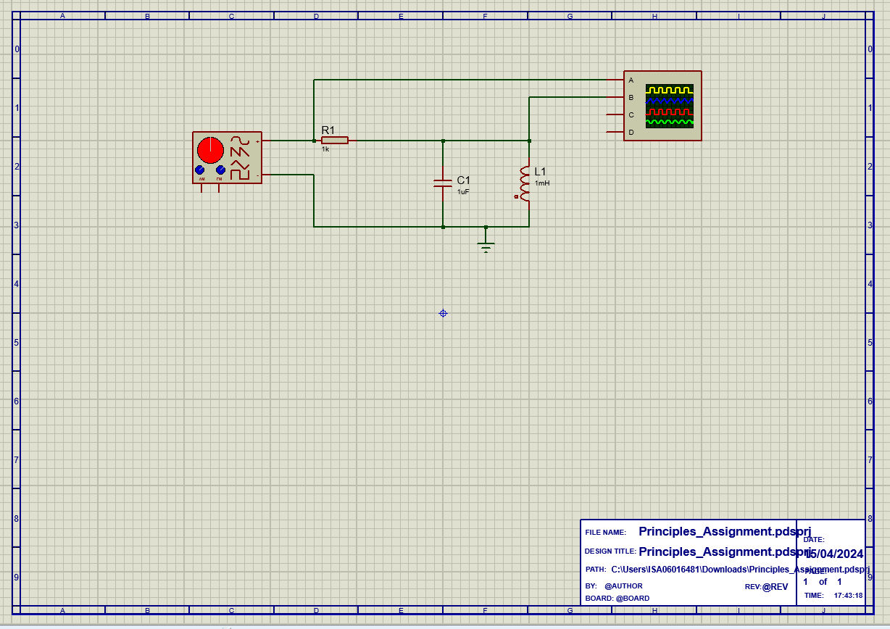
Figure 1 Frequency Response of a simulate circuit layout designed in Proteus, contains an oscilloscope, resistor, inductor, capacitor, and signal generator. This is an RLC circuit configured with the resistor in series with a capacitor and inductor that are in parallel.

Circuit parameters
In the simulated circuit components respective measurement were: resistor 1kΩ, inductor 1mH, and capacitor 1µF. The physical circuit has the same stated values however as observed by Ron Mancini ‘All components have initial and application tolerances which must be accounted for’. Their measured values are as follows:
Resistor:
- stated value - 1 kΩ
- Measured resistance - 979 Ω
- Measured Inductance - 84.5 µH
Inductor:
- stated value - 1 mH
- Measured inductance - 0.994 mH
- Series Resistance - 7.32 Ω
Capacitor:
- stated value - 1µF
- measured capacitance - 1.064µF
- ESR @ 1 kHz - 5.09189 x 10⁻⁵
- ESR @ 10 kHz - 7.63784 x 10⁻⁴

Circuit Measurements
The signal generator output frequencies will remain as defined in the circuit set-up, and the resultant output voltage will then be measured and recorded so that the attenuation (dB) may be calculated and then plotted against the input signal frequency. The resultant graphs will then enable the calculation of resonant frequency ($f_{r}$) from the graph and the ‘Q’ factor. These results may then be compared between the simulated circuit and the physical circuit, highlighting any differences and opening the discussion of the possible reasons for them.

Physical Circuit Set Up
The RLC circuit is constructed on a breadboard using a resistor (1kΩ), inductor (1mH) and a capacitor (1µF).
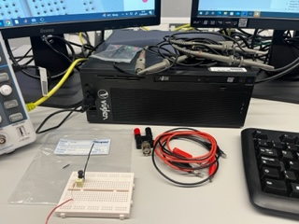
Figure 2 Physical circuit components
The breadboard as well as the probes and wires to connect to the signal generator and oscilloscope are demonstrated in figure 2 and a closer look at the breadboard RLC circuit is visible in figure 3.
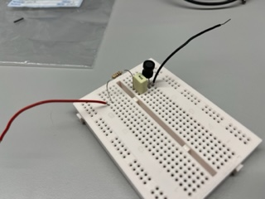
Figure 3 RLC circuit Bread board
The signal generator is connected to the bread board in figure 4, this acts as a way for the user to input different frequencies for the experiment.
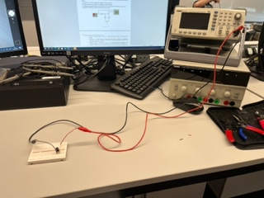
Figure 4 Signal generator connected to breadboard
The oscilloscope probes are connected to the breadboard alongside the signal generator. This is so we may measure the peak to peak voltage of the generated wave form so we may determine the resonant frequency and calculate the attenuation of the outputs.
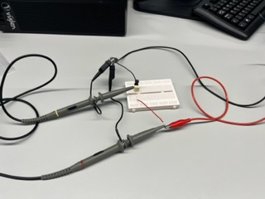
Figure 5 Oscilloscope and signal generator connected to RLC breadboard
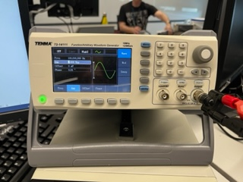
Figure 6 example of inputs on signal generator
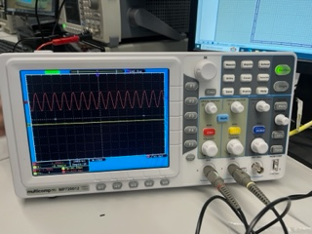
Figure 7 frequency response of experiment generated on oscilloscope by RLC circuit
The oscilloscope as seen in figure 7 and 8 outputs a sine wave, and displays the input voltage and output voltage of the RLC circuit produced by the signal generator relative to the frequency input.
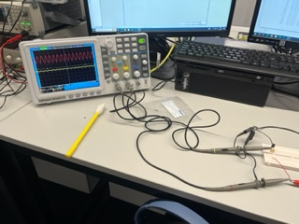
Figure 8 Oscilloscope connected to breadboard

Results
The attenuation (loss of signal amplitude.) of the circuit at the various frequencies was calculated using the equation below:
$$A=20×\log_{10}{\frac{V_{L}}{V_{In}}}$$
Where A is attenuation in dB, $V_{L}$ is the peak-to-peak voltage measured across the inductor, and $V_{In}$ is the peak-to-peak input voltage as set on the signal generator.
The relation between the frequency of the generated signal was then plotted against the corresponding attenuation. The following tables and graph contain and visually demonstrate the results of the experiment, allowing for us to calculate the respective resonant frequencies of the simulated vs physical circuit as well as the Q factor (quality factor).
The resistance across a circuit is calculated using Ohm’s Law:
$$R= \frac{V}{I}$$

The impedance of a capacitor differs by frequency:
$$X_{C}= \frac{1}{2πfC}$$

The impedance of an inductor differs by frequency:

$$X_{L}=2πfL$$

Resonant Frequency occurs when $X_{c}$ = $X_{L}$, to isolate the frequency we must rearrange the equation as follows:
$$\frac{1}{2πfC}= 2πfL$$
$$f=\frac{1}{2π√LC}$$
Considering the component values in the circuit, L is 1x10-3 and C is 1x10-6, therefore the resonant frequency of the circuit would be:
$$f=\frac{1}{2π√(({1x10}^{-3})({1x10}^{-6})}$$
$$f=5032.92 Hz$$
The Q-factor is defined ‘as the quality of the second order filter stages’. It describes the voltage magnification factor attained across the coil and the capacitor in comparison with the supply voltage. Q factor is a ratio it doesn’t have a unit:
$$Q= \frac{f_{r}}{∆f}$$
Simulated circuit Q factor approximation:

$$Q= \frac{5032.92}{(5075-4950)}=40.26$$

Physical circuit Q factor approximation:

$$Q= \frac{5032.92}{(5900-4980)}=3.812$$

Table of Frequency Response for a Simulated Circuit

Frequency (Hz) | Vin | Vout | Attenuation (dB)
100 | 2 | 1.25E-03 | -6.41E+01
200 | 2 | 2.50E-03 | -5.81E+01
500 | 2 | 6.40E-03 | -4.99E+01
1000 | 2 | 0.01325 | -4.36E+01
2000 | 2 | 3.00E-02 | -3.65E+01
4000 | 2 | 0.138 | -2.32E+01
4900 | 2 | 1.10E+00 | -5.19E+00
5000 | 2 | 1.925 | -3.32E-01
5200 | 2 | 0.81 | -7.85E+00
6000 | 2 | 0.175 | -2.12E+01
10000 | 2 | 4.25E-02 | -3.35E+01
15000 | 2 | 0.02376 | -3.85E+01
20000 | 2 | 1.68E-02 | -4.15E+01
5032.92 | 2 |  | 0.00E+00
Table 1 Frequency Response for a Simulated Circuit
Table 1 is a simulated RLC circuit has an input voltage that remained the same throughout the experiment.

Graph of Frequency Response Simulated Circuit (Resonant Frequency)

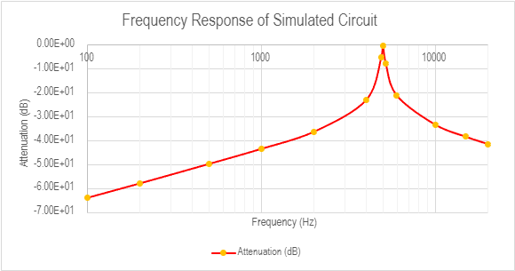
Figure 9 Graph representing the frequency response of a simulated circuit through proteus with a signal output of 2V pk-pk at 100Hz, at a range of frequencies from 100Hz to 20kHz. Graph of Resonant frequency

Figure 10 Fl Fh and Rres lines used to calculate the Q factor of the simulated Circuit
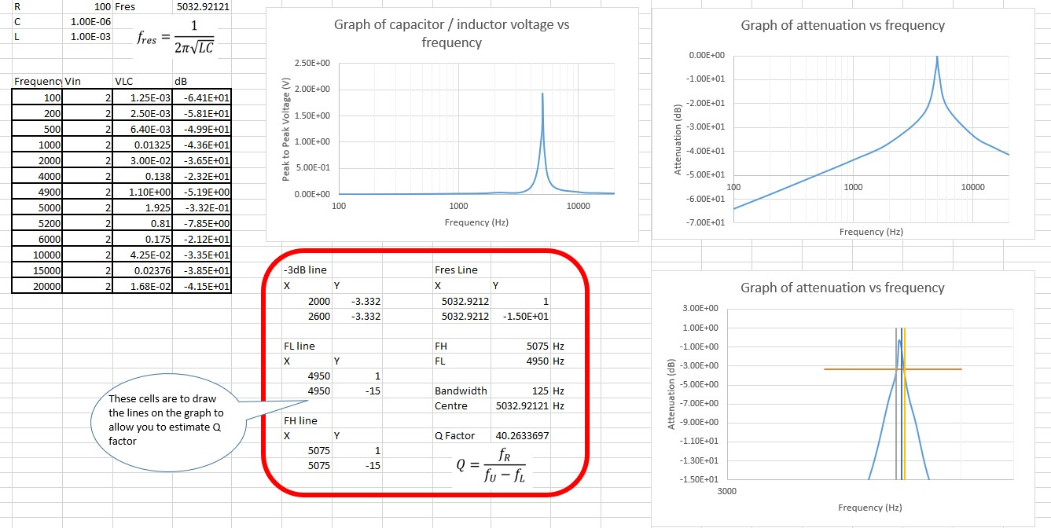
Figure 13 Q factor of simulated circuit determined using excel sheet provided by course.
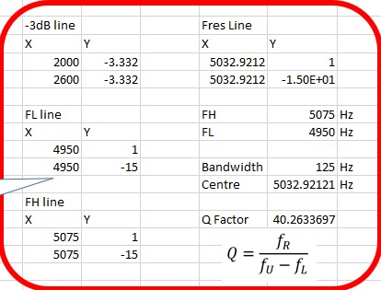
Figure 14 Simulated circuit, a closer look at the values determining the graph output.

Table of Frequency Response for a Physical Circuit

Frequency (Hz) | Vin | Vout | Attenuation (dB)
100 | 1.96 | 1.48E-02 | -4.24E+01
200 | 1.96 | 1.56E-02 | -4.20E+01
500 | 1.96 | 1.68E-02 | -4.13E+01
1000 | 1.88 | 1.96E-02 | -3.96E+01
2000 | 1.88 | 3.20E-02 | -3.54E+01
4000 | 1.88 | 1.06E-01 | -2.49E+01
4900 | 1.96 | 1.99E-01 | -1.99E+01
5000 | 1.96 | 2.24E-01 | -1.88E+01
5032.92 | 1.96 | 2.24E-01 | -1.88E+01
5200 | 1.96 | 2.20E-01 | -1.90E+01
6000 | 1.96 | 1.48E-01 | -2.24E+01
10000 | 1.96 | 4.80E-02 | -3.22E+01
15000 | 1.96 | 2.80E-02 | -3.69E+01
20000 | 1.96 | 2.00E-02 | -3.98E+01
Table 2 Frequency Response for a Practical Attenuation Circuit
Table 2 is a physical circuit has a variable input voltage throughout the experiment, that remains approximately the same. This is because the physical components that are part of the circuit, degrade and are impacted by environmental factors unlike the simulated circuit.

Graph of Frequency Response of Physical Circuit

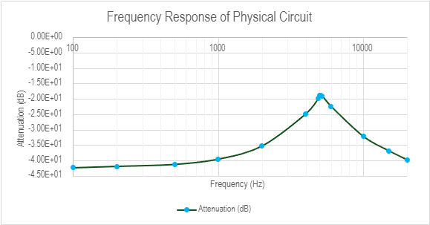
Figure 11 Graph representing the frequency response of a physical circuit with a signal output of 2V pk-pk at 100Hz, at a range of frequencies from 100Hz to 20kHz

Figure 12 Fl, Fh and Rres lines used to calculate the Q factor of the physical Circuit
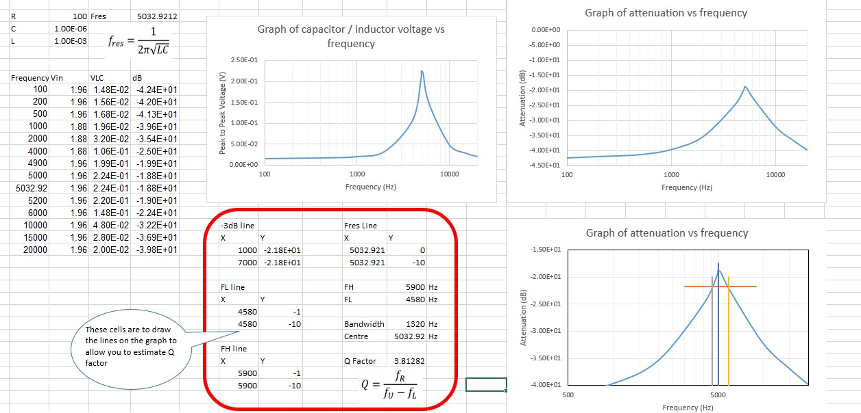
Figure 15 Q factor of physical circuit using excel sheet provided by course.
Figure 16 Physical circuit, a closer look at the values determining the graph output

Discussion

What do the results show?
The results show that the resonant frequency is:
$$f=5032.92 Hz$$

Q factor is a ratio it doesn’t have a unit, it is determined by dividing the resonant frequency by the bandwidth, as demonstrated in the below equation:
$$Q= \frac{f_{r}}{∆f}$$

The Q factor for the simulated circuit was 3.812 as demonstrated in figures 13 and 14. The Q factor for the physical circuit was 40.26 as demonstrated in figures 15 and 16. A response with a high Q will be sharper than a response with a lower Q, as seen in the respective graphs, figure 9 and 10 and figure 11 and 12. Capacitor values have an effect on resonant frequency. Wide bandwidth circuits have a low Q factor and thereby will dampen the signal whereas ‘narrow bandwidth circuits have a high Q and are under damped’. This is demonstrated in figure 14 where the bandwidth of the simulated circuit is defined as 125Hz and the bandwidth of the physical circuit is listed as 1320Hz, over ten times the width. This difference in pk-pk measures is seen in figure 17 below:

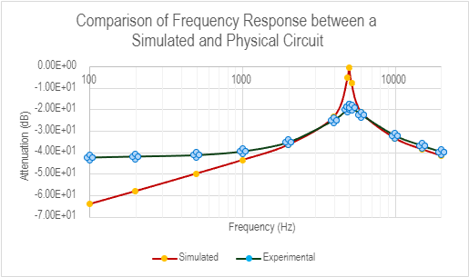
Figure 17 Graph comparing the frequency response of a simulated circuit through proteus with a signal output of 2V pk-pk at 100Hz, at a range of frequencies from 100Hz to 20kHz, and the frequency response of a physical circuit with a signal output of 2V pk-pk
The graph clearly demonstrates that the physical circuit, in green and blue, has a lower peak and a wider bandwidth at the -3dB.

Why does this happen?
The RLC circuit’s resonation causes an AC signal, the frequency the circuit resonates at is called its resonance frequency. The resonance occurs as energy being stored in a capacitor and inductor.
The capacitor is charged by the current passing through and being taken by its electric field. As the capacitor discharges the current continues and flows through the inductor, which will take the current as it creates an electromagnetic field. The current flows between the components since its stored in both their electromagnetic fields. The resistor, which is in series with the parallel components, reduces the current flow rate as well as the amount of current.

The resistor causes the signal frequency to attenuate. Resistors by definition manage current flow by resisting the current, and a capacitors impedance is a function of frequency; it blocks DC and passes AC signals. RLC circuits have a variety of frequencies at which they are effective. This is called the bandwidth of the circuit. The bandwidth work starts at -3dB points of the resonant frequency.

The capacitors impedance is an important part of the circuit and the functionality of the frequency. At lower frequencies the capacitor is capable of blocking signals and at higher frequencies the capacitor is able to pass signals through. A feature of all capacitors that that they have a self-resonant frequency. Essentially the function of the capacitor impedance in the RLC circuit can be observed to decrease until it achieves self-resonance wherein it is at minimum impedance.

The resistor is in series with the other components, and thereby lowers the Q of the inductor. The relationship between the resistor and the inductor must be considered on manufacture, this is because the dimensions of the inductor and the wire surrounding it impact the size of the resistor. Therefore, series resistance and inductance are a compromise that must be determined, ‘the parallel capacitance degrades the inductor performance at high frequencies because it turns the inductor into a parallel resonant circuit’.

The difference in values and the dramatic peak in the simulation is in part because of the lack of variance caused by having physical component that attenuate over time. The physical components allow for a margin of error on their manufacture, which is not identified when creating a simulated circuit. They also lose their effectiveness from use, so in a physical circuit if the components are being reused, or the wires and cabling are damaged from previous use this will affect the output values and create a less dramatic outcome than the simulated circuit.

Conclusion
The aim of the assignment was to provide the student with a laboratory exercise to develop their practical measurement skills and data analysis. To achieve this aim, we were required to perform a laboratory exercise that will be based on software simulation and a practical experiment using real equipment. In this experiment it has been determined that a simulated circuit has a higher Q factor than a physical circuit because it does not deal with resonance in the same manner as a physical circuit, therefore it has a smaller bandwidth and decreased attenuation at the resonant frequency. The difference between the simulated and physical circuits are also because of trace material having variable values which must be considered when measuring and calculating the values in the circuit, as well as the precision of the equipment, such as the cabling and the signal generator and oscillators having a margin of error.

Nomenclature
Symbol | Name | Measured Unit
R | Resistance/ Impedance | Ohm (Ω)
L | Inductance | Henry (H)
C | Capacitance | Farad (f)
I | Current | Amp (A)
V | Voltage | Volts (V)
f | Frequency | Hertz (Hz)
Table 3 Nomenclature- symbols names and measured units of values discussed in report

References
“General Technical Information Film Capacitors.” [online] Available: https://www.vishay.com/docs/26033/gentechinfofilm.pdf

Elton, Martin D. (2017) "Analyzation of the Resistor-Inductor-Capacitor Circuit," Undergraduate Journal of Mathematical Modeling: One + Two: Vol. 7: Iss. 2, Article 1.
DOI: http://doi.org/10.5038/2326-3652.7.2.4876
Available at: https://digitalcommons.usf.edu/ujmm/vol7/iss2/1

Stewart, James. Essential Calculus: Early Transcendentals. Ohio: Brooks/Cole, Cengage Learning. 2007.

Young, Hugh, Freedman, Roger, and Ford, Lewis: University Physics with Modern Physics. CA: Pearson. 2012. Dorf, Richard, Introduction to Electric Circuits. MA, John Wiley & Sons, Inc. 2001.

Terrel, David. Fundamentals of Electrical DC Circuits. New York: Delmar Publishing. 2000

Terrel, David. Fundamentals of Electrical AC Circuits. New York: Delmar Publishing. 2000

P. Horowitz, W. Hill, and P. Horowitz, The art of electronics: the x-chapters. Cambridge ; Cambridge University Press, 2020.
J. O. Bird, Bird’s electrical and electronic principles and technology, Seventh edition. London: Routledge, 2022.

L. A. A. Warnes, Electronic and electrical engineering: principles and practice, 3rd ed. Basingstoke: Palgrave Macmillan, 2003.
I. R. Sinclair and John. Dunton, Practical electronics handbook, 6th ed. Amsterdam ; Newnes, 2007.

“RLC Circuits” Available: http://www.nalanda.nitc.ac.in/industry/appnotes/Texas/analog/sloa027.pdf

“Title: RLC Circuits I. Summary.” Available: https://www.subr.edu/assets/subr/ElectricalEngineering/TargetedInfusion/Files/ENGR-120_RLC-Circuits.pdf ‌
Elton, Martin D. (2017) "Analyzation of the Resistor-Inductor-Capacitor Circuit," Undergraduate Journal of Mathematical Modelling: One + Two: Vol. 7: Iss. 2, Article 1.
Elton, Martin D. (2017) "Analyzation of the Resistor-Inductor-Capacitor Circuit," Undergraduate Journal of Mathematical Modelling: One + Two: Vol. 7: Iss. 2, Article 1.
https://www.subr.edu/assets/subr/ElectricalEngineering/TargetedInfusion/Files/ENGR-120_RLC-Circuits.pdf
(The above values were taken from the shared assignment page on moodle: Steve Mosey)
P. Horowitz, W. Hill, and P. Horowitz, The art of electronics: the x-chapters. Cambridge ; Cambridge University Press, 2020.
P. Horowitz, W. Hill, and P. Horowitz, The art of electronics: the x-chapters. Cambridge ; Cambridge University Press, 2020.
P. Horowitz, W. Hill, and P. Horowitz, The art of electronics: the x-chapters. Cambridge ; Cambridge University Press, 2020.
P. Horowitz, W. Hill, and P. Horowitz, The art of electronics: the x-chapters. Cambridge ; Cambridge University Press, 2020.
Q Factor PowerPoint Steve Mosey, moodle
Elton, Martin D. (2017) "Analyzation of the Resistor-Inductor-Capacitor Circuit," Undergraduate Journal of Mathematical Modelling: One + Two: Vol. 7: Iss. 2, Article 1.
Elton, Martin D. (2017) "Analyzation of the Resistor-Inductor-Capacitor Circuit," Undergraduate Journal of Mathematical Modelling: One + Two: Vol. 7: Iss. 2, Article 1.
“RLC Circuits” Available: http://www.nalanda.nitc.ac.in/industry/appnotes/Texas/analog/sloa027.pdf
Elton, Martin D. (2017) "Analyzation of the Resistor-Inductor-Capacitor Circuit," Undergraduate Journal of Mathematical Modeling: One + Two: Vol. 7: Iss. 2, Article 1.

